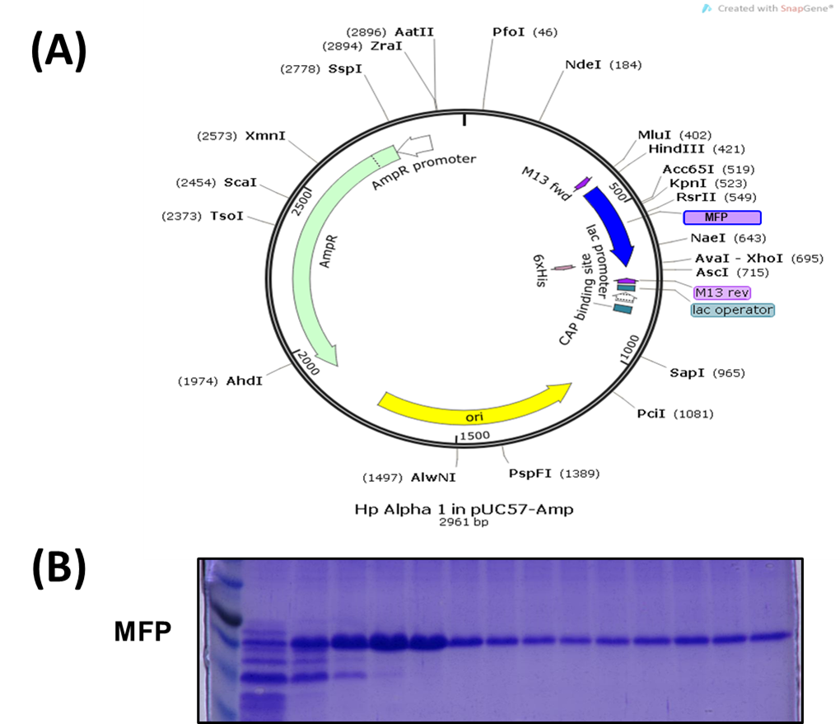Figure S1. Recombinant expression and purification of His-tagged Multiple Functional Peptide (MFP). (A) Schematic representation of the pET-30a(+) bacterial expression vector containing the MFP coding sequence under the control of the T7 promoter, with an N-terminal His-tag for affinity purification. (B) SDS–PAGE analysis (12% gel, Coomassie blue staining) of Ni-NTA–purified MFP eluted using a 50–500 mM imidazole gradient. Lane M: protein molecular weight marker; lanes 1–5: early elution fractions; lanes 6–10: peak MFP enrichment (~25 kDa); lane F: final pooled preparation after concentration and dialysis. The procedure yielded >10 mg of >95% pure MFP per liter of culture following endotoxin removal, confirming robust bacterial expression and suitability for downstream functional assays.

