Supplementary Information for
Thermal state and evolving geodynamic regimes of the Meso- to Neoarchean North China Craton
Guozheng Sun, Shuwen Liu, Peter A. Cawood, Ming Tang, Jeroen van Hunen, Lei Gao, Yalu Hu, Fangyang Hu
The PDF file includes:
- Supplementary Text
- Supplementary Figure 1. (A) The location of the North China Craton in the simplified sketch world map. (B) Tectonic subdivision of the NCC (modified after Zhao et al., 2005), the star showing distribution for the Meso- to Neoarchean TTG gneisses. (C) Age histogram for Meso- to Neoarchean TTG magmatism in the Eastern Block (EB) of NCC.
- Supplementary Figure 2. Detailed geological map of West Shandong province (Modified after Cao, 1996; Wan et al., 2011).
- Supplementary Figure 3. (A) Contour of the NCC (after Zhao, 2001) and locality of Jiaodong terrane. (B) The detailed geological map of Jiaodong terrane (after Liu et al., 2015).
- Supplementary Figure 4. Geologic map of the northeastern part of the NCC illustrating major early Precambrian basement terranes and Paleoproterozoic tectonic framework.
- Supplementary Figure 5. (A) Sketch geological map of the Dengfeng complex in the Junzhao area in the southern NCC (after Zhang et al., 1985). (B) Geological map of the Lushan region, illustrating the distribution of the Taihua group.
- Supplementary Figure 6. Geological sketch map of the Zhongtiao Mountain (after Bai et al., 1997).
- Supplementary Figure 7. (A) The sketch map of Precambrian rocks in the Huoqiu-Bengbu area; (B) Geological map of early Precambrian basement in the Huoqiu area (after Qi, 1987).
- Supplementary Figure 8. Geological map of the Liaodong Peninsula (after Meng et al., 2013).
- Supplementary Figure 9. Simplified geological map and lithological zoning of the metamorphic basement in the East Hebei-West Liaoning Province (after Fu et al., 2019).
- Supplementary Figure 10. Zircon U–Pb concordia diagrams for representative TTG gneiss samples. (A) Granodioritic gneiss (sample 18AHB01-1); (B) granodioritic gneiss (sample 18AHB02-1); (C) trondhjemitic gneiss (sample 18AHB02-3); (D) tonalitic gneiss (sample 18LS02-1); (E) tonalitic gneiss (sample 18LS02-2). Data point error ellipses are 2σ.
- Supplementary Figure 11. Binary element variation diagrams of the Archean TTG gneisses in the EB of NCC.
- Supplementary Figure 12. Histograms of LILEs (for example, K, Rb, and Ba). (A) Archean TTGs and their potential source rocks, including (B) modern middle oceanic ridge basalt (MORB); (C) modern oceanic plateau basalt (OPB); (D) modern island arc basalt (IAB); and (E) Archean ‘arc-like’ basalt. Red and black dashed lines represent the median and mean values, respectively. The shaded columns in (B)–(D) represent the LILE contents required to generated the median values of TTG gneisses by 10–30% batch melting (modified after Ge et al., 2018).

Other Supplementary Information for this manuscript includes the following:
- Supplementary Table 1 (Microsoft Excel format). Summary of zircon age data and sampling locations for Meso- to Neoarchean TTG gneisses in the Eastern Block of NCC.
- Supplementary Table 2 (Microsoft Excel format). Analytical results of major (wt.%) and trace (ppm) elements and calculated parameters for Meso- to Neoarchean TTG gneisses from the Eastern Block of NCC.
- Supplementary Table 3 (Microsoft Excel format). Analyzed zircon U–Pb isotopic data and calculated apparent ages for representative TTG gneisses from the Eastern Block of the NCC.
- Supplementary Table 4 (Microsoft Excel format). Summary of zircon Lu-Hf isotopic data for Meso- to Neoarchean TTG gneisses from the Eastern Block of NCC.
- Supplementary Table 5 (Microsoft Excel format). Average composition of potential source mafic rocks for Archean TTGs compiled from the GEOROC and PetDB databases.
- Supplementary Table 6 (Microsoft Excel format). Starting compositions and mineral partition coefficients used in the trace element modeling of partial melting of mafic rocks.
- Supplementary Table 7 (Microsoft Excel format). Thermodynamic and trace element modelling of partial melting of median Archean arc-like basalt.
- Supplementary Table 8 (Microsoft Excel format). List of the parameters and of their values used in the geothermal models.

Supplementary Text
Geological background
The NCC is one of the largest cratons in eastern Eurasia, with an area of about 300, 000 km² (Fig. S1A), and has been composed of several Archean to Paleoproterozoic crystalline basement blocks covered by younger unmetamorphosed Mesoproterozoic to late Mesozoic stratas. Previous studies revealed that the NCC experienced a long and complicated geological evolution from 3.8 to 2.5 Ga (Wan et al., 2013; Zhao, 2014; Zhai et al., 2016; Kusky et al., 2016). Unlike most other ancient cratons in the world, the NCC is characterized by the strong tectono-magmatic activity at ~2.5 Ga, which is an important window to study the crustal growth and evolution and to explore the Archean thermal state and geodynamic regime (Zhao et al., 2002; Kröner et al., 2005; Wu et al., 2005; Wilde et al., 2005; Zhai and Santosh, 2011). The Precambrian metamorphic basement of the NCC is generally considered to be amalgamated by both the Eastern Block (EB) and the Western Block (WB) along the Trans-North China Orogen (TNCO) at ~1.85 Ga (Fig. S1B; Zhao et al., 2005, 2012).
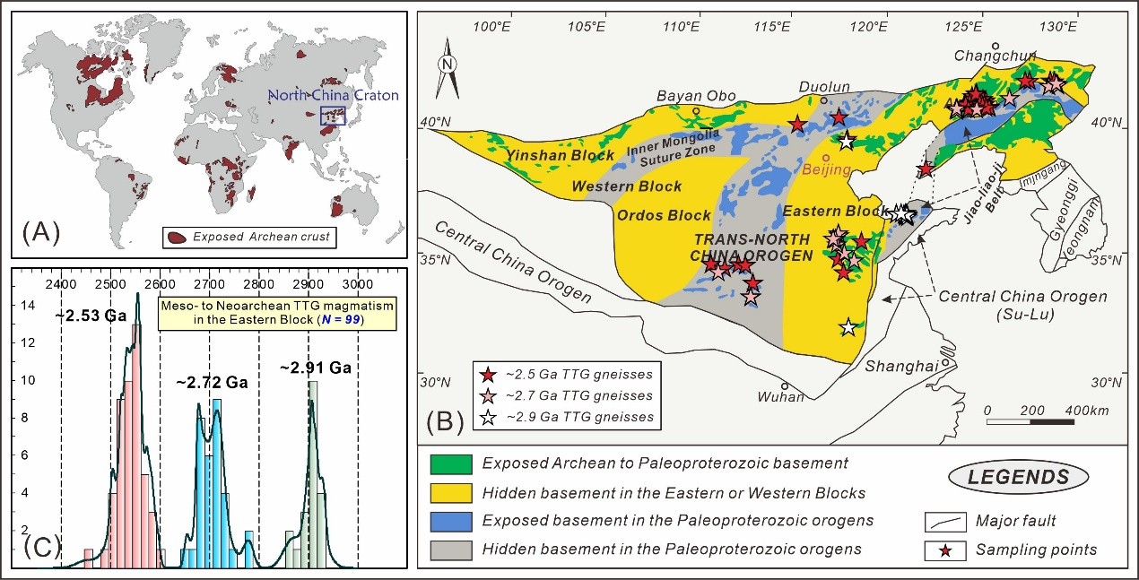
TTG gneisses are the dominantly geological signatures in the Archean basement blocks of NCC. Fig. S1B shows the general spatial and temporal distribution of Meso- to Neoarchean TTG gneisses, and detailed zircon age data and sampling locations are summarized in Supplementary Table S1. The magmatic crystallization ages of TTG gneisses are almost continuously from 3.0 to 2.5 Ga, with the three peaks occurring at ~2.91, ~2.72 and ~2.53 Ga, and reaching the maximum peak at ~2.53 Ga (Fig. S1C). The ~2.9 Ga TTG gneisses are sporadically distributed in Jiaodong, Huoqiu and Eastern Hebei terranes, and ~2.7 Ga ages TTG gneisses exhibit more emergences in North Liaoning-South Jilin, Jiaodong, Western Shandong, Dengfeng-Taihua, Zhongtiao and Fuping-Hengshan terranes, whereas the ~2.5 Ga data are comprehensive from the entire EB of NCC (Fig. S1B). The geological background of each metamorphic terrane is summarized below.
Fig. S1. (A) The location of the North China Craton in the simplified sketch world map. (B) Tectonic subdivision of the NCC (modified after Zhao et al., 2005), the star showing distribution for the Meso- to Neoarchean TTG gneisses. (C) Age histogram for Meso- to Neoarchean TTG magmatism in the Eastern Block of NCC.
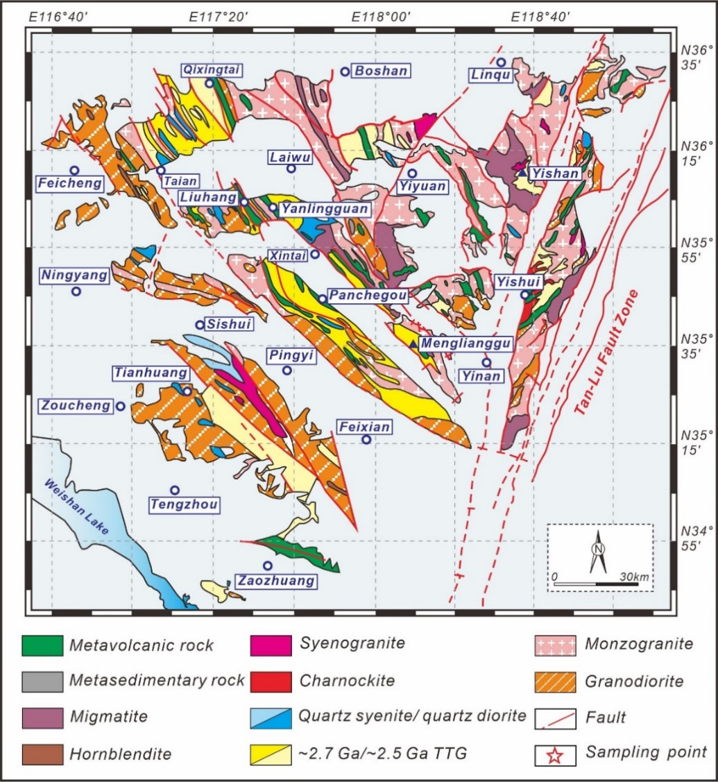
Fig. S2. Detailed geological map of West Shandong province
(Modified after Cao, 1996; Wan et al., 2011).
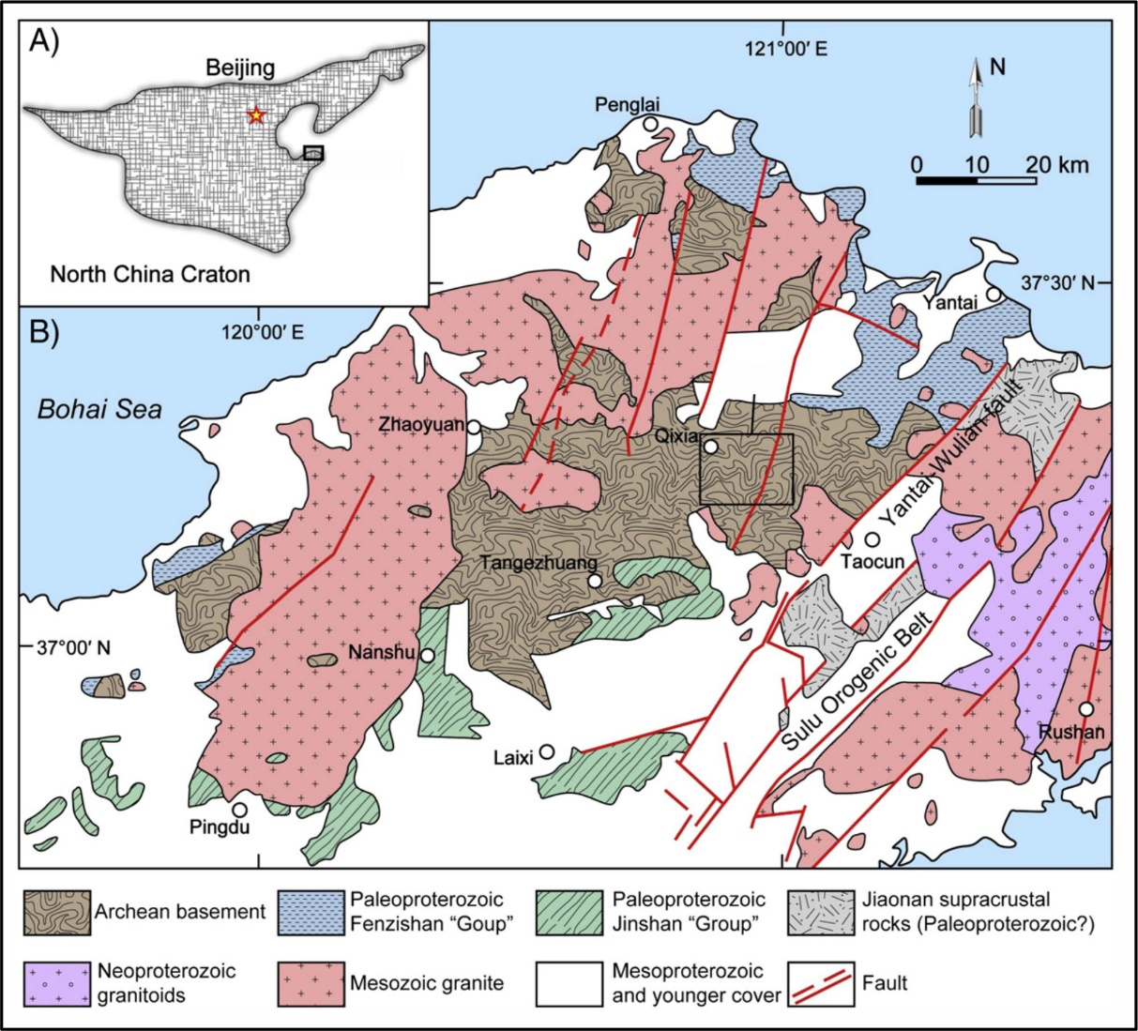
Fig. S3. (A) Contour of the NCC (after Zhao, 2001) and locality of Jiaodong terrane. (B) The detailed geological map of Jiaodong terrane (after Liu et al., 2015).
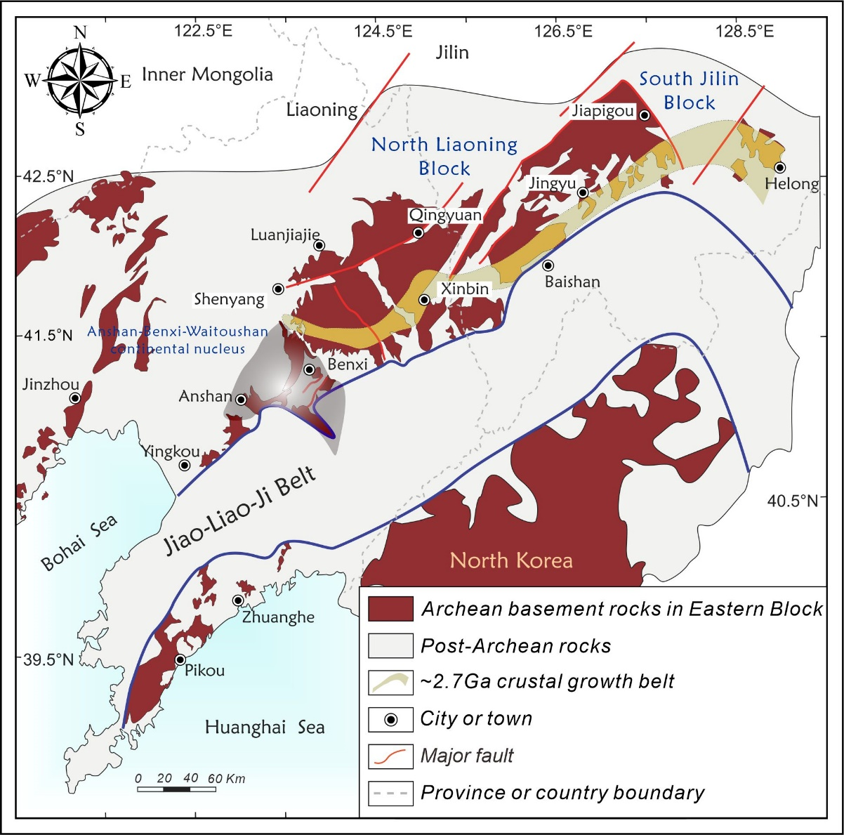
Fig. S4. Geologic map of the northeastern part of the NCC illustrating major early Precambrian basement terranes and Paleoproterozoic tectonic framework.

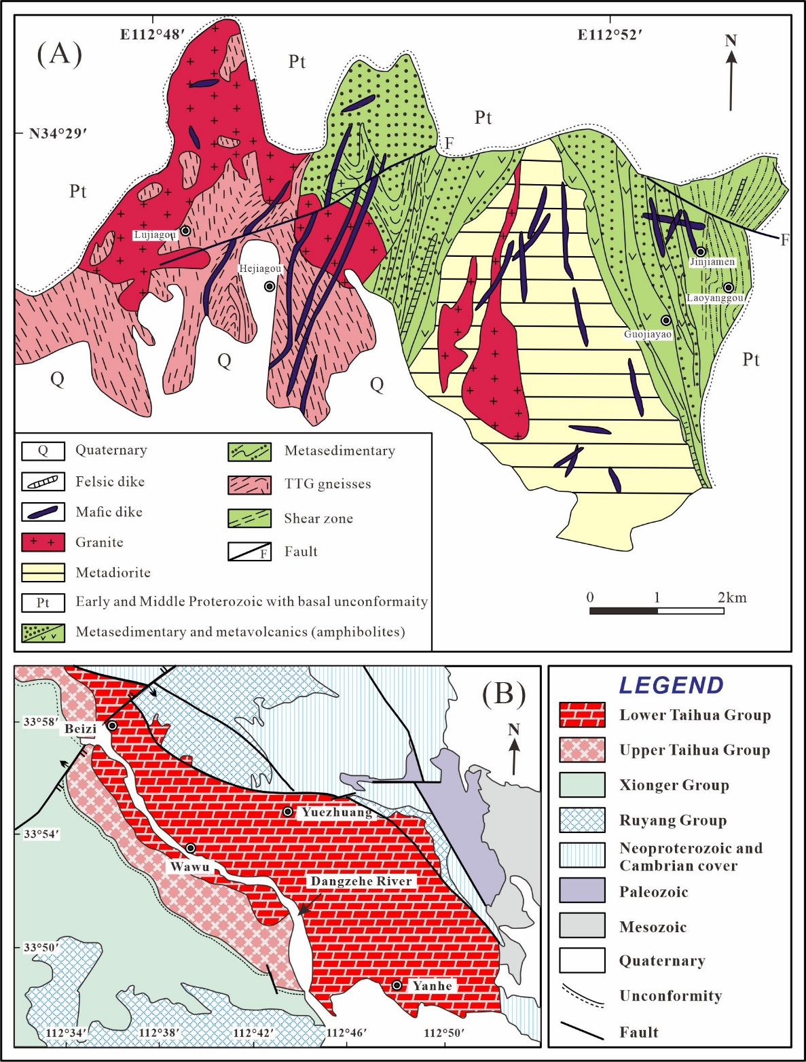
Fig. S5. (A) Sketch geological map of the Dengfeng complex in the Junzhao area in the southern NCC (after Zhang et al., 1985). (B) Geological map of the Lushan region, illustrating the distribution of the Taihua group.
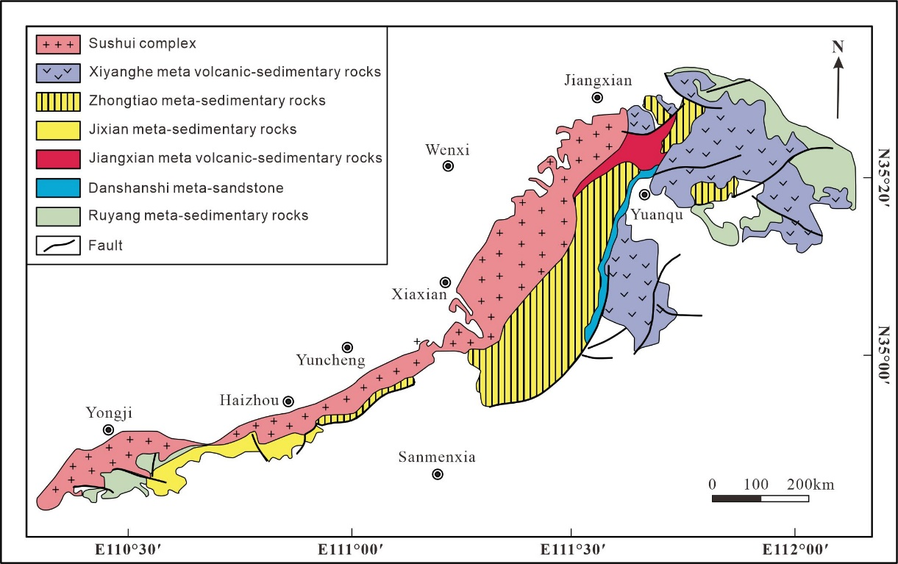
Fig. S6. Geological sketch map of the Zhongtiao Mountain (after Bai et al., 1997).
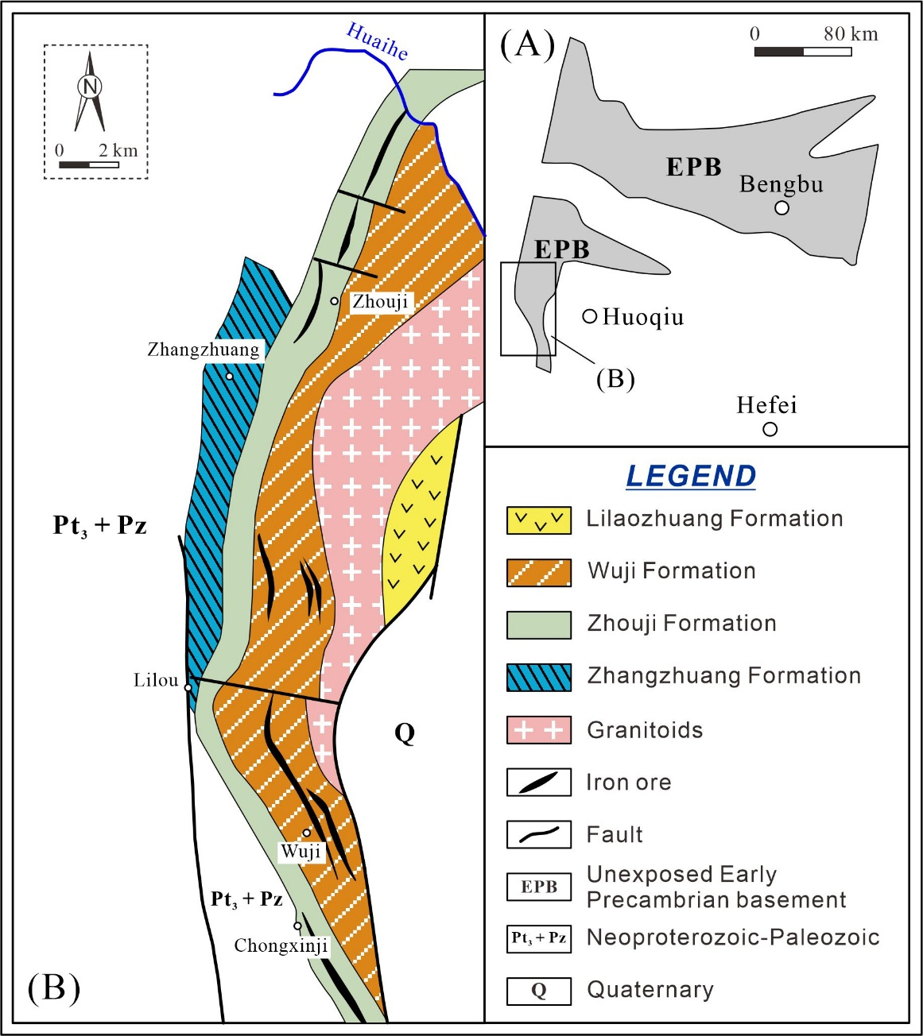
Fig. S7. (A) The sketch map of Precambrian rocks in the Huoqiu-Bengbu area; (B) Geological map of early Precambrian basement in the Huoqiu area (after Qi, 1987).
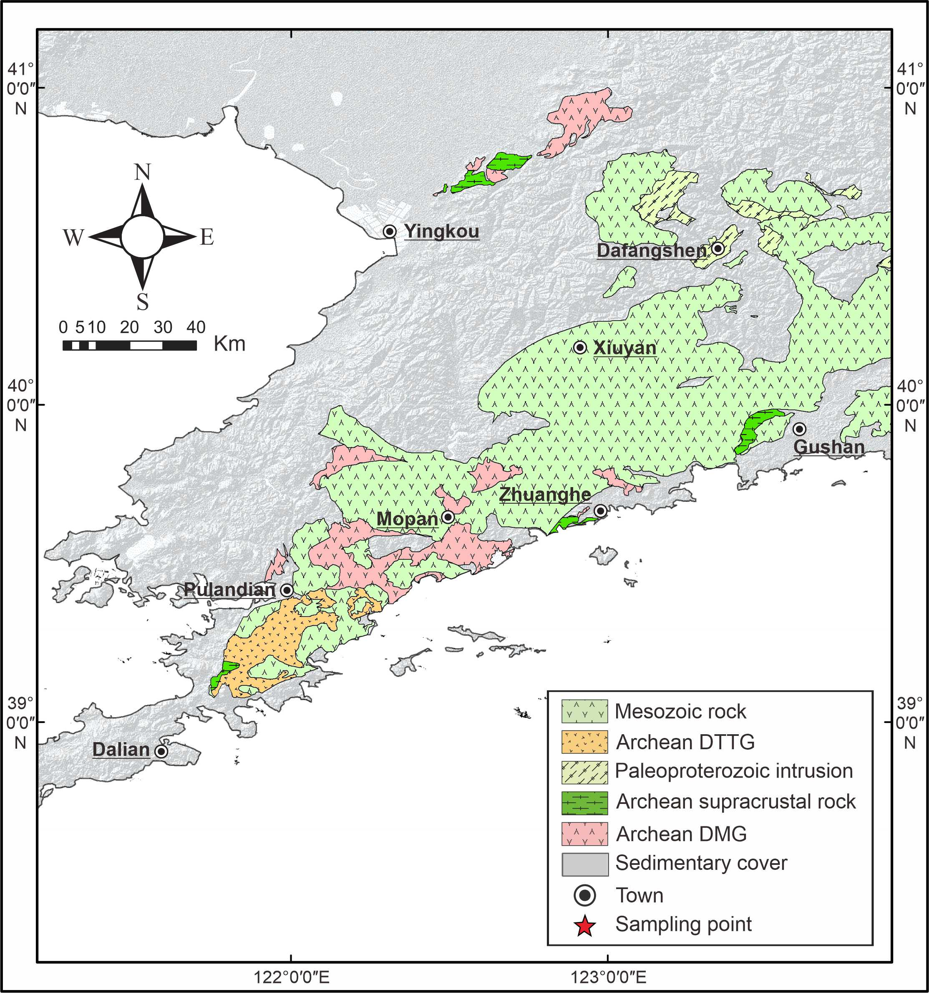
Fig. S8. Geological map of the Liaodong Peninsula (after Meng et al., 2013).
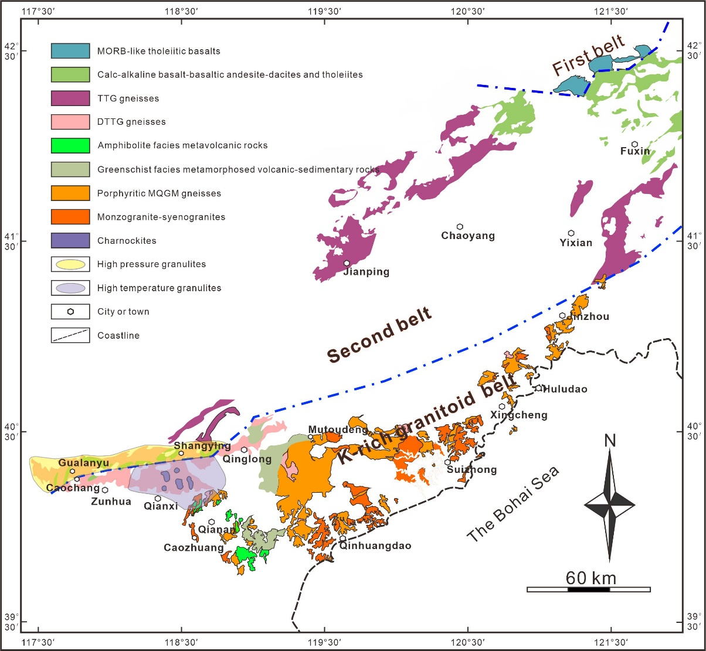
Fig. S9. Simplified geological map and lithological zoning of the metamorphic basement in the East Hebei-West Liaoning Province (after Fu et al., 2019).

Analytical procedures
Whole-rock samples were firstly trimmed to remove the weathered surfaces, and then were chipped and powdered in an agate mill to about 200 mesh. Major elements were analyzed using X-ray Fluorescence (XRF, Thermal Arl Advant XP+) at the Key Laboratory of Orogenic Belts and Crustal Evolution, Ministry of Education, School of Earth and Space Sciences, Peking University. Loss on ignition (LOI) values were determined by measuring the weight loss after heating the powders at 1050 °C for 30 mins. Sample powders were mixed with lithium tetraborate, and then transformed into glassy disk by fusion at 1100 °C in a 34-diameter platinum-alloy crucible. The disks were used for major element analyses by XRF. Standards GSR-9 (diorite) and GSR-14 (granitoid gneiss) were used for calibration. The analytical precision is 0.5% for major element oxides.
Sample powders for trace element analyses were pre-treated at Peking University. Firstly, the powders were in turn weighted (25 mg) into Savillex Teflon beakers, placed in a high-pressure bomb with a 1:1 mixture of HF-HNO3, heated for 24 hours at 80 °C, and then evaporated. After evaporation, 1.5 ml HNO3, 1.5 ml HF and 0.5 ml HClO4 were added, and the beakers were capped for digestion within a high-temperature oven at 180 °C for 48 hours or longer until the powders were completely digested. Finally, the residue was diluted to 50 ml using 1% HNO3. Trace elements, including rare earth elements, were measured using an ELEMENT-I plasma mass spectrometer (Finnigan-MAT Ltd.) at the Key Laboratory of Orogenic Belts and Crustal Evolution. The standards GSR-9 (diorite), and GSR-14 (granitoid gneiss) were used for analytical control. The analytical precisions for the major oxides and trace elements were 0.5% and 0.5‰, respectively.
Zircon grains were separated by standard density and magnetic techniques, and then purified by hand picking under a binocular microscope. These zircon grains were mounted in epoxy resin discs, and polished to half the grain thickness. Prior to analysis, cathodoluminescence (CL) images were obtained using a scanning electron microscope at the SEM Laboratory of Peking University. Then, they were analyzed for U–Pb isotopes and trace elements using Agilent 7500 quadruple-based inductively coupled plasma mass spectrometer (ICP–MS) equipped with a GeoLas 193 nm laser (MicroLas, Göttingen) at the Key Laboratory of Orogenic Belts and Crustal Evolution. The laser beam is 36 μm and frequency is 10 Hz. Harvard zircon 91500 was used as an external standard for zircon U–Th–Pb analyses, and NIST610 as an external standard to calculate the contents of U, Th, Pb, and other trace elements. The ²⁰⁷Pb/²⁰⁶Pb and ²⁰⁶Pb/²³⁸U ratios were calculated using the GLITTER program (van Achterbergh et al., 2001), and common Pb was corrected using the method of Anderson (2002). Age calculations and concordia plotting were carried out using Isoplot (ver. 3.0) (Ludwig, 2003). Details of the analytical techniques are documented by Yuan et al. (2004).
Zircon Lu–Hf isotopic analyses were conducted on the same or adjacent internal domains as the original pit used for U–Pb isotopic analyses, using a Neptune Plus MC–ICPMS (Thermal Fisher Scientific, Germany) attached to a Geolas 2005 excimer ArF laser ablation system (Lambda physik, Göttingen, Germany) at the state Key Laboratory of Geological Processes and Mineral Resources, China University of Geosciences in Wuhan. Beam diameter of 44 μm and repetition rate of 6 Hz were applied, and zircon 91500 and GJ-1 were used as the external standard and the unknown, respectively. During analysis, every eighth analysis of an unknown was followed by analyses of 91500 and GJ-1. Details of the analytical techniques are documented by Hu et al. (2012).

Zircon U-Pb ages of individual samples
Six samples of the Archean TTG gneisses from the Eastern Block were dated by in-situ zircon U–Pb methods using LA–ICP–MS at the Key Laboratory of Orogenic Belts and Crustal Evolution, Ministry of Education, School of Earth and Space Sciences, Peking University. Cathodoluminescence images reveal that some zircon grains exhibit oscillatory or banded zoning, sometimes surrounded by thin dark rims, whereas others are blurred zoned or structureless domains with either bright or dark color. Twenty-five analyses were conducted on samples 18AHB01-1 (granodioritic gneiss), 18AHB02-3 (trondhjemitic gneiss), 18LS02-1 (tonalitic gneiss), 18LS02-2 (tonalitic gneiss) and 18ZT01-1 (tonalitic gneiss), and twenty-six analyses for sample 18AHB02-1 (granodioritic gneiss). Most analyses have Th/U ratios of 0.11–8.60, though some yield lower values of 0.08–0.10. These features indicate that most zircons are of magmatic origin and underwent varying degrees of recrystallization during later tectonothermal events. Analyses of samples 18AHB01-1, 18AHB02-1, 18AHB02-3 and 18ZT01-1 yield four discordant lines, with upper intercept ages of 2911 ± 7, 2930 ± 6, 2931 ± 5 and 2703 ± 6 Ma, respectively (MSWD = 0.47, 0.94, 1.5 and 0.41, Fig. S10A, B, C and F). These analyses give weighted average mean ages of 2911 ± 10 Ma for 18AHB01-1 (MSWD = 0.16, n = 25), 2934 ± 8 Ma for 18AHB02-1 (MSWD = 0.26, n = 18), 2930 ± 7 Ma for 18AHB02-3 (MSWD = 0.43, n = 20) and 2703 ± 6 Ma for 18ZT01-1 (MSWD = 0.21, n = 25). For samples 18LS02-1 and 18LS02-2, most analyses fall on the concordia lines and yield two concordia ages of 2772 ± 7 Ma (MSWD = 0.0071, n = 19) and 2780 ± 5 Ma (MSWD = 0.022, n = 18) (Fig. S10D and E). In summary, the TTG gneisses were emplaced during 2703 ± 6 to 2934 ± 8 Ma and subjected to variable degrees of Pb loss.
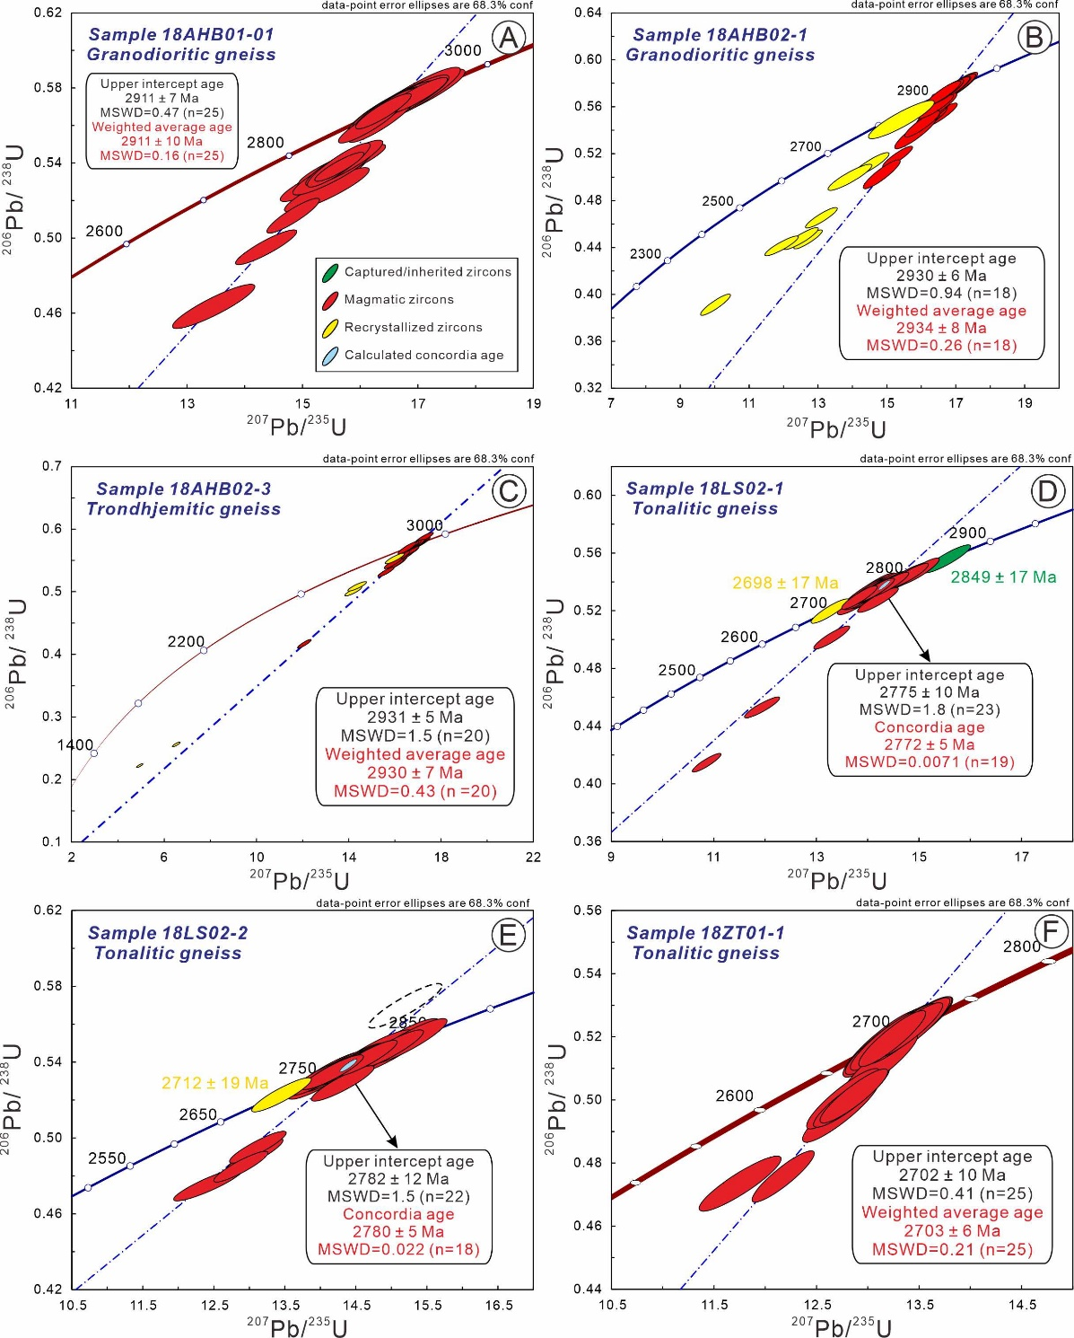
Fig. S10. Zircon U–Pb concordia diagrams for representative TTG gneiss samples. (A) Granodioritic gneiss (sample 18AHB01-1); (B) granodioritic gneiss (sample 18AHB02-1); (C) trondhjemitic gneiss (sample 18AHB02-3); (D) tonalitic gneiss (sample 18LS02-1); (E) tonalitic gneiss (sample 18LS02-2). Data point error ellipses are 2σ.

Effects of metamorphic and alteration on geochemical compositions
The above petrologic data on the Archean TTG gneisses with different ages in the EB of NCC reveal that these granitoids experienced multiple deformation and metamorphism. Therefore, it is crucial to evaluate the effects of post-magmatic alteration and metamorphism on whole-rock chemical compositions. The studied samples are fresh and the (loss on ignition) values are relatively low (0.16–3.03 wt.%), less than those of altered samples (mostly > 6.0 wt.%; Polat et al., 2002). The uniform chondrite-normalized REE patterns and the absence of evident Ce anomaly (Ce_{N}/sqrt(La_{N} × Pr_{N}) of 0.77–1.38) indicate that the original chemical features of these granitoids have not been significantly modified during later metamorphism and alteration (Polat and Hofmann, 2003). In general, Zr is viewed as one of the most immobile element, which can be applied to assess the mobility of other trace elements (Polat et al., 2002). Fig. S11 shows that La, Sm, Yb, Nb, Ta, Hf, Rb and Sr show good correlations with Zr for the analyzed samples, indicating that these elements were essentially immobile. On the contrary, most samples display poor correlations for Ba, Th and U with Zr, suggesting that these three elements were possibly mobilized. Accordingly, we propose that most TTG gneiss samples preserved the primary geochemical compositions with respect to REE, HFSE, Rb and Sr, whereas Ba, Th and U were modified during the later metamorphic event(s).
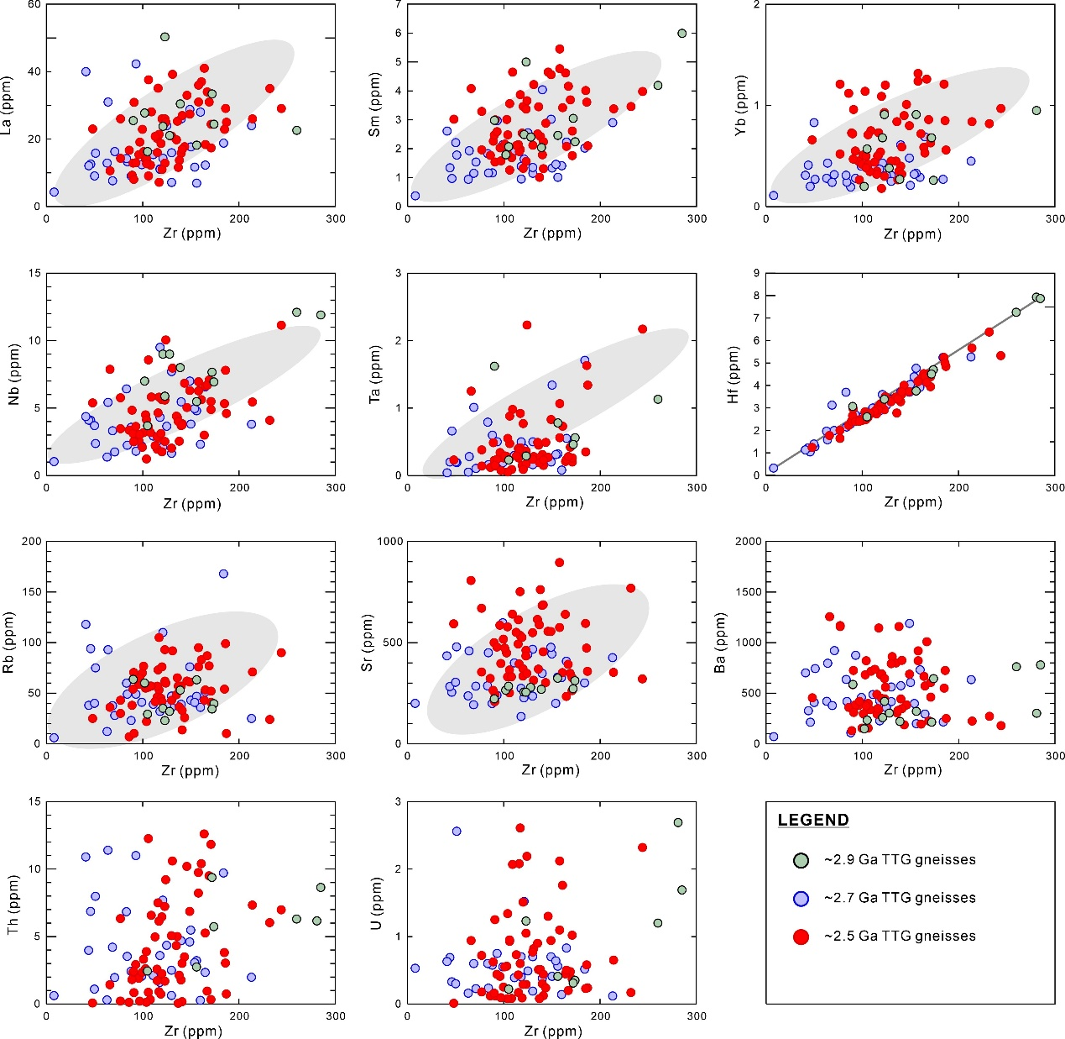
Fig. S11. Binary element variation diagrams of the Archean TTG gneisses in the EB of NCC.

Selection of mafic source rock
The potential mafic source rocks for Archean TTG magmas mainly consist of mid-ocean ridge basalts (MORBs), oceanic plateau basalts (OPBs), island arc basalts (IABs) and Archean ‘arc-like’ basalts according to their tectonic setting (Ge et al., 2018). Note that the Archean ‘arc-like’ basalts are chiefly composed of moderately enriched tholeiitic basalts, which have similar lithological assemblages and trace element compositions with those found in modern oceanic arcs. The average composition of four types of potential mafic source rocks for Archean TTG gneisses are summarized in Supplementary Table S4. Simple batch partial melting modeling using the highly incompatible large ion lithophile elements (LILEs; such as, Rb, Ba, and K) provides important constraints on the source of TTGs. Geochemical modeling results clearly show that most MORBs and OPBs are too depleted in LILEs to generate Archean TTGs, whereas the IABs are slightly too enrich. The most likely mafic source rock for Archean TTGs is Archean ‘arc-like’ basalt (Fig. S12).

MATLAB code
Calculation process of heat flow value
- load qT_data_1.mat % qT,z,TT data group;
- load z_matrix.mat
- load TT.mat % 0 set;
parameters
- qT = qT_data_1*10^(-3); % W/m^2;
- z = z_matrix; % H(crust)-km;
- %----------------------------------------------%
- deltaz = 100; % m, 0.1km;
- A = Heat production; % W/m^3;
- k = thermal conductivity; % W/m/K;
equation
- for a=1:n % A total of n sets of data;
    - qT_0=qT; % Assign initial value;
    - TT_0=TT;
- for iteration =1:(z(a,1)*10)
    - TB_x = TT_0(a,1)+((qT_0(a,1)/k)*deltaz)-(A*(deltaz^2)/(2*k));
    - qB_x = qT_0(a,1)-A*deltaz;
    - TT_0(a,1)=TB_x;
    - qT_0(a,1)=qB_x;
    - end
- TB(a,1)=TB_x;
- qB(a,1)=qB_x;
- end
result
- TB;
- qB=qB*1000;
- qB

Build of geotherm model
parameters
- qT = Heat flow at the top of the layer; % W/m^2;
- z = Moho depth; % H(crust)-km;
- TT = 0 ; % ℃;
- deltaz = 100; % m, 0.1km;
- A = Heat production; % W/m^3;
- k = thermal conductivity; % W/m/K;
equation
- a=[];
for iteration =1:(z*10)
    - TB = TT+((qT/k)*deltaz)-(A*(deltaz^2)/(2*k));
    - qB = qT-A*deltaz;
    - TT=TB;
    - qT=qB;
    - a(iteration)=TB;
    - end
- b=[];
- H=0;
for iteration =1:(z*10)
    - H=H+0.1;
    - b(iteration)=H;
    - end
result
- a;
- b;
- figure
- plot(a,b,'m');
- set(gca, 'YDir','reverse'); % Reverse y-axis;
- set(gca,'YAxisLocation','right'); % Y-axis of the calibration set to the right;
- set(gca,'XAxisLocation','top'); % X-axis of the calibration set to the top;
- xlabel('Temperature (℃) ');
- ylabel('Depth (km)');
- grid on
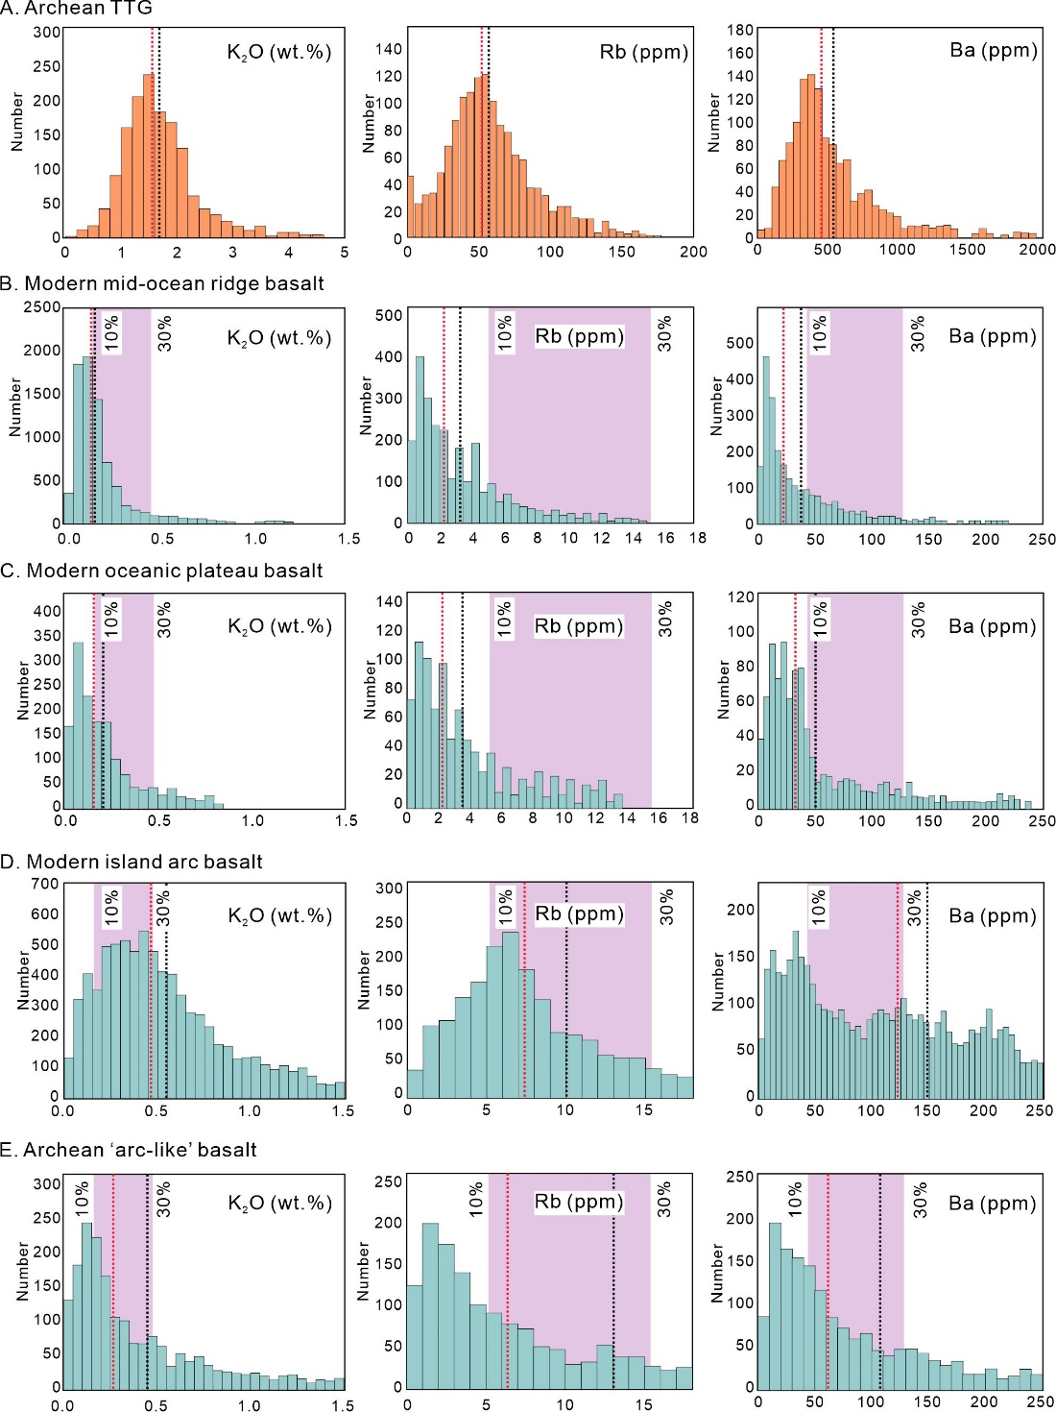
Fig. S12. Histograms of LILEs (for example, K, Rb, and Ba). (A) Archean TTGs and their potential source rocks, including (B) modern middle oceanic ridge basalt (MORB); (C) modern oceanic plateau basalt (OPB); (D) modern island arc basalt (IAB); and (E) Archean ‘arc-like’ basalt. Red and black dashed lines represent the median and mean values, respectively. The shaded columns in (B)–(D) represent the LILE contents required to generated the median values of TTG gneisses by 10–30% batch melting (modified after Ge et al., 2018).

References
- Anderson, T. Correlation of common lead in U–Pb analyses that do not report ²⁰⁴Pb. Chem. Geol. 192, 59–79 (2002).
- Bai, J., Yu, Z. X. & Yan, Y. Y. Precambrian Geology of Zhongtiaoshan. Tianjin: Tianjin Science and Technology Press, 1–143 (1997) (in Chinese with English abstract).
- Cao, G. Q. Early Precambrian Geology of Western Shandong. Geological Publishing House, Beijing, pp. 1–210 (1996).
- Fu, J. H., Liu, S. W., Zhang, B., Guo, R. R. & Wang, M. J. A Neoarchean K-rich granitoid belt in the northern North China Craton. Precambrian Res. 328, 193–216 (2019).
- Ge, R. F., Zhu, W. B., Wilde, S. A. & Wu, H. L. Remnants of Eoarchean continental crust derived from a subducted proto-arc. Sci. Adv. 4, eaao3159 (2018).
- Hu, Z. C. et al. Improved in situ Hf isotope ratio analysis of zircon using newly designed X skimmer cone and jet sample cone in combination with the addition of nitrogen by laser ablation multiple collector ICP-MS. J. Anal. Atom. Spectrom. 27, 1391–1399 (2012).
- Kröner, A., Wilde, S. A., Li, J. H. & Wang, K. Y. Age and evolution of a late Archean to early Paleoproterozoic upper to lower crustal section in the Wutaishan/Hengshan/Fuping terrane of northern China. J. Asian. Earth. Sci. 24, 577–595 (2005).
- Kusky, T. M. et al. Insights into the tectonic evolution of the North China Craton through comparative tectonic analysis: A record of outward growth of Precambrian continents. Earth Sci. Rev. 162, 387–432 (2016).
- Liu, S. J. et al. Neoarchean to Paleoproterozoic high-pressure mafic granulite from the Jiaodong Terrain, North China Craton: Petrology, zircon age determination and geological implications. Gondwana Res. 28, 493–508 (2015).
- Ludwig, K. R. Berkeley Geochronology Center Special Publication, vol. 4 (2003).
- Meng, E. et al. Zircon U-Pb and Lu-Hf isotopic constraints on Archean crustal evolution in the Liaonan Complex of northeast China. Lithos 177, 164–183 (2013).
- Polat, A., Hofmann, A. W. & Rosing, M. T. Boninite-like volcanic rocks in the 3.7–3.8 Ga Isua greenstone belt, West Greenland: geochemical evidence for intra-oceanic subduction zone processes in the early Earth. Chem. Geol. 184, 231–254 (2002).
- Polat, A. & Hofmann, A. W. Alteration and geochemical patterns in the 3.7–3.8 Ga Isua greenstone belt, West Greenland. Precambr. Res. 126, 197–218 (2003).
- Qi, R. Z. Genesis of BIF of the Precambrian Huoqiu Group. Bulletin of Nanjing Institute of Geology, Chinese Academy of Geological Sciences 8, 1–20 (1987).
- van Achterbergh, E., Ryan, C., Jackson, S. & Griffin, W. L. In: Sylvester, P. (Ed.), Appendix 3 Data Reduction Software for LA-ICP-MS in ‘‘Laser-Ablation-ICPMS in the Earth Sciences”: Mineralogical Association of Canada Short Course 29, 239–243 (2001).
- Wan, Y. S. et al. ~2.7 Ga juvenile crust formation in the North China Craton (Taishan–Xintai area, western Shandong Province): further evidence of an understated event from U–Pb dating and Hf isotopic composition of zircon. Precambr. Res. 186, 169–180 (2011).
- Wan, Y. S. et al. Extreme zircon O isotopic compositions from 3.8 to 2.5 Ga magmatic rocks from the Anshan area, North China Craton. Chem. Geol. 352, 108–124 (2013).
- Wilde, S. A., Cawood, P. A., Wang, K. Y. & Nemchin, A. A. Granitoid evolution in the Late Archean Wutai Complex, North China Craton. J. Asian. Earth. Sci. 24, 597–613 (2005).
- Wu, F. Y., Zhao, G. C., Wilde, S. A. & Sun, D. Y. Nd isotopic constraints on crustal formation in the North China Craton. J. Asian. Earth. Sci. 24, 523–545 (2005).
- Yuan, H. L. et al. Accurate U–Pb age and trace element determinations of zircon by laser ablation inductively coupled plasma-mass spectrometry. Geostand. Geoanal. Res. 28, 353–370 (2004).
- Zhai, M. G. & Santosh, M. The Early Precambrian odyssey of the North China Craton: a synoptic overview. Gondwana Res. 20, 6–25 (2011).
- Zhai, M. G., Zhao, Y. & Zhao, T. P. Main Tectonic Events and Metallogeny of the North China Craton. Springer, pp. 1–535 (2016).
- Zhang, G. W. et al. Composition and evolution of the Archean crust in central Henan, China. Precambr. Res. 27, 7–35 (1985).
- Zhao, G. C. Paleoproterozoic assembly of the North China Craton. Geol. Mag. 138, 87–91 (2001).
- Zhao, G. C., Wilde, S. A., Cawood, P. A. & Sun, M. SHRIMP U–Pb zircon ages of the Fuping Complex: implications for late Archean to Paleoproterozoic accretion and assembly of the North China Craton. Am. J. Sci. 302, 191–226 (2002).
- Zhao, G. C., Sun, M., Wilde, S. A. & Li, S. Z. Late Archean to Paleoproterozoic evolution of the North China Craton: key issues revisited. Precambr. Res. 136, 177–202 (2005).
- Zhao, G. C. et al. Amalgamation of the North China Craton: key issues and discussion. Precambr. Res. 222–223, 55–76 (2012).
- Zhao, G. C. Precambrian Evolution of the North China Craton. Elsevier, pp. 1–194 (2014).

