Appendix
Table 3 Electronic database Search Strategy from inception up to 16 June 2021
Database | Terms used | Hits
PubMed | ((((((Vitamin D[MeSH Terms]) OR (Vitamin D Deficiency[MeSH Terms])) OR (Cholecalciferol[MeSH Terms])) OR (Ergocalciferols[MeSH Terms])) OR (Calcifediol[MeSH Terms])) OR (25-Hydroxyvitamin D 2[MeSH Terms])) AND ((Malaysia[MeSH Terms]) OR (Malaysia[Text Word])) | 69
Scopus | (TITLE ( "Vitamin D" OR "Vitamin D Deficiency" OR "Cholecalciferol" OR "Ergocalciferols" OR "Calcifediol" OR "25-Hydroxyvitamin D 2" ) AND TITLE-ABS-KEY ( Malaysia OR Perlis OR Kedah OR Perak OR Selangor OR "Kuala Lumpur" OR Putrajaya OR Melaka OR "Negeri Sembilan" OR Johor OR Pahang OR Kelantan OR Terengganu OR Sabah OR Sarawak OR Labuan ) ) | 72
Web of Science (WoS) | ts = (" vitamin D" AND "Malaysia") | 88
MyJurnal  www.myjurnal.my | Vitamin D only | 24

Table 4 Quality assessment of studies included

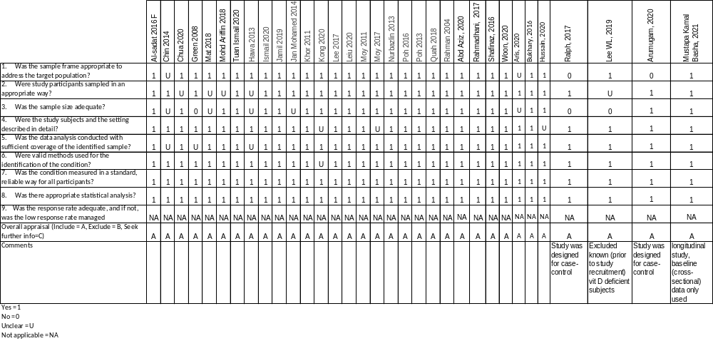

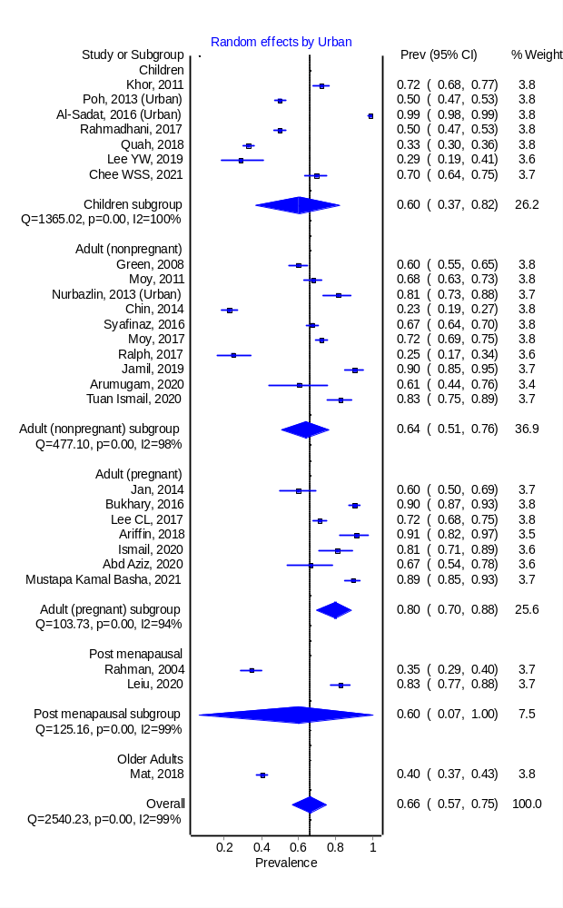
Fig. 6 Pooled prevalence of 25-hydroxyvitamin D level <50 nmol/L for urban individuals
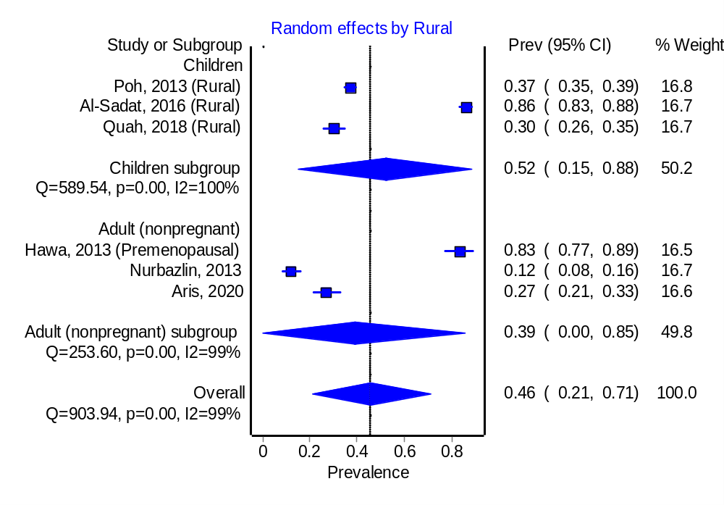
Fig. 7 Pooled prevalence of 25-hydroxyvitamin D level <50 nmol/L for rural individuals

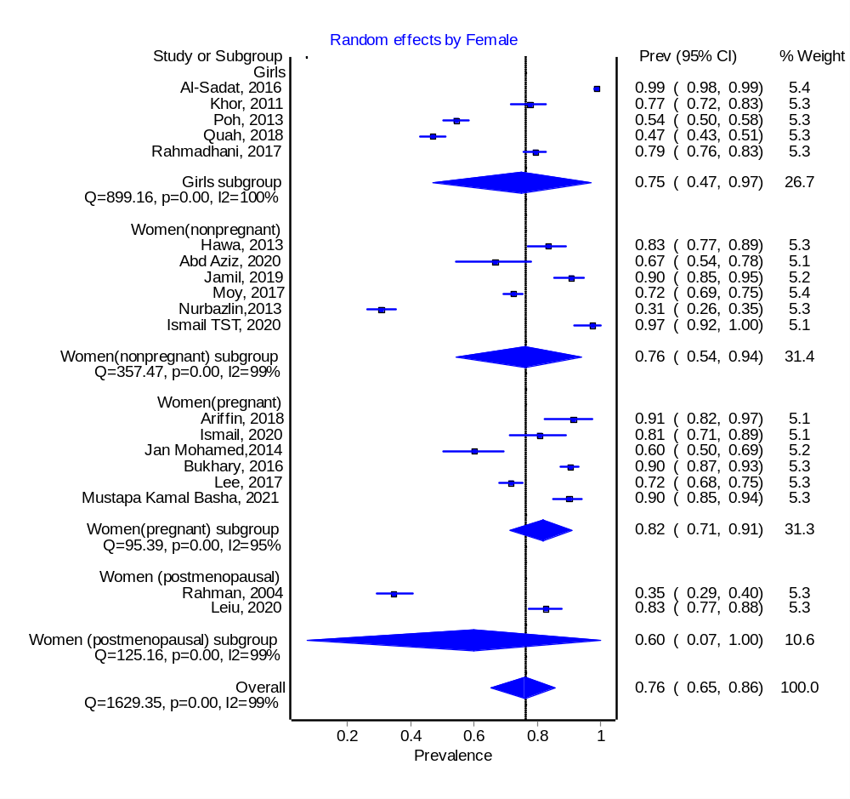
Fig. 8 Pooled prevalence of 25-hydroxyvitamin D level <50 nmol/L for female gender

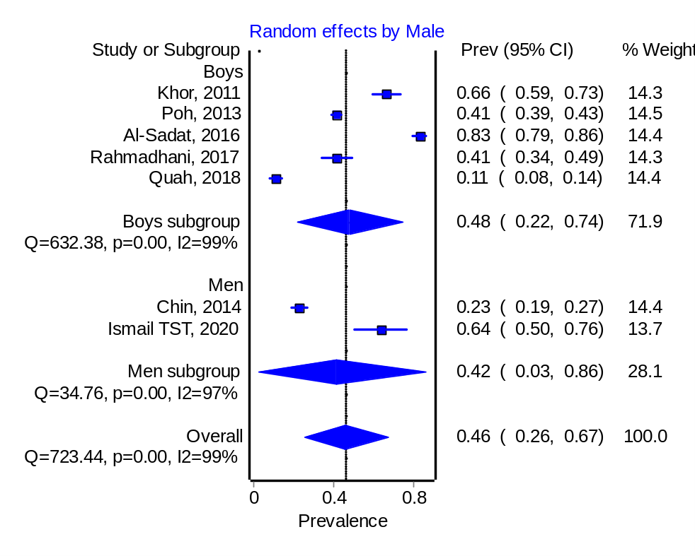
Fig. 9 Pooled prevalence of 25-hydroxyvitamin D level <50 nmol/L for male gender

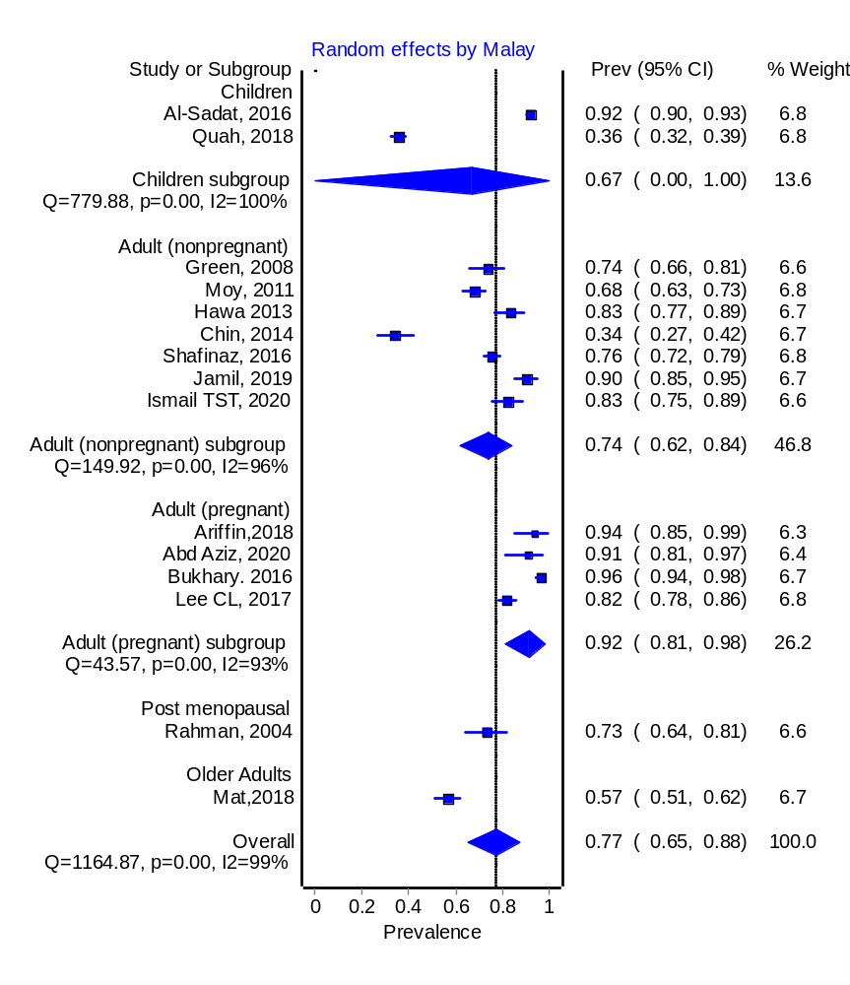
Fig. 10 Pooled prevalence of 25-hydroxyvitamin D level <50 nmol/L for Malay

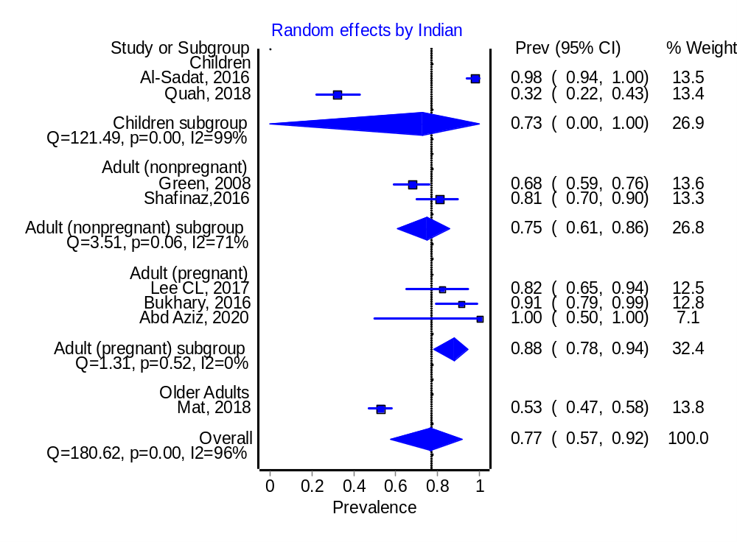
Fig. 11 Pooled prevalence of 25-hydroxyvitamin D level <50 nmol/L for Malaysian Indian
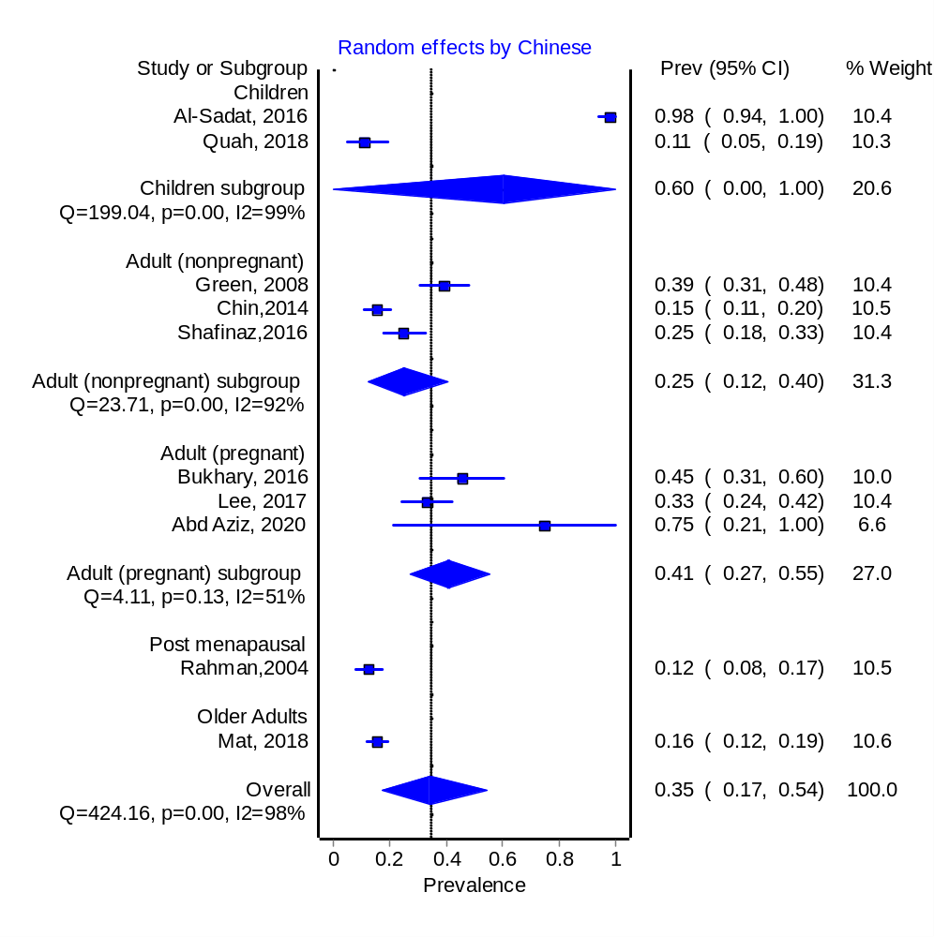
Fig. 12 Pooled prevalence of 25-hydroxyvitamin D level <50 nmol/L for Malaysian Chinese

