Supporting Information

Interfacial Microenvironment Engineering in Pickering Emulsion Electrocatalytic System for Selective Hydrogenation of 4-Nitrostyrene
Yifan Wang¹, Lijun Li¹, Yuliang Gao¹, Xuzhuang Yang¹, and Chenhui Han^{1*}
¹School of Chemistry and Chemical Engineering, Inner Mongolia University, Hohhot, P. R. China.
Email: hanchenhui@imu.edu.cn

Supplementary Methods
Supplementary Figures and Tables
Supplementary References

Supplementary Methods

Materials
Multi-walled carbon nanotubes (MWCNTs) were purchased from Shandong Dazhan Nano Materials Co., Ltd. Thionyl chloride (99%, Meryer), 1,8-diazabicyclo[5.4.0]undec-7-ene (DBU, 99%, Aladdin), octylamine (99%, Macklin), octadecylamine (97%, Aladdin), platinum bis(acetylacetonate) (99%, Macklin), oleylamine (70%, ACMEC), oleic acid (AR, Macklin), 1-octadecene (90%, Macklin), borane triethylamine complex (97%, Aladdin), p-nitrostyrene (97%, Macklin), silver foil (0.1 mm thick, 99.998%, Taizhou Sante Mstar Technology Co., Ltd.), anhydrous ethanol, anhydrous N,N-dimethylformamide (DMF, 99.8%), cyclohexane (99.5%, Meryer), toluene (AR), ethyl acetate (AR), diethyl ether (AR), n-hexane (98%), deuterium oxide (D₂O, 99.9%, J&K), deuterosulfuric acid (D₂SO₄, 99.5%, Aladdin), 4-vinylaniline (95%, Macklin), 4-nitroethylbenzene (99%, Aladdin), 4-ethylaniline (95%, Macklin), Cy5-NH₂ (Shanghai Yuanyang Biotechnology Co., Ltd.), and Cy3-NH₂ (95%, Macklin) were used as received without further purification. Ultrapure water (18.2 MΩ·cm) used in all experiments was obtained from a Synergy UV Water Purification System.

Synthesis of Monodisperse Pt Nanoparticles
Monodisperse Pt nanoparticles were synthesized by first mixing 10 mL of oleylamine with 10 mL of 1-octadecene in a glass vessel, followed by the addition of 0.5 mL of oleic acid. The mixture was stirred and heated at 120°C for 20 minutes to remove residual moisture and oxygen, resulting in a pale-yellow solution. The solution was then heated to 300°C, upon which 5 mL of an oleylamine solution containing 20 mg of platinum(II) acetylacetonate and 120 mg of triethylamine borane was rapidly injected. The vessel was immediately sealed and purged with argon to maintain an inert atmosphere, and the reaction was allowed to proceed with vigorous stirring at 300°C for 1 hour. After cooling to room temperature, 40 mL of acetone was added to precipitate the nanoparticles. The black solid product was collected by centrifugation, yielding monodisperse Pt nanoparticles. The nanoparticles were further purified with an acetone-n-hexane mixture and ultimately dispersed in n-hexane for storage.

Preparation of CNTs-AT
The synthesis of the CNTs-AT support followed a previously reported procedure¹. Briefly, 5 g of pristine CNTs were treated with 500 mL of a mixed acid solution (comprising 65% nitric acid and 98% sulfuric acid in a 1:1 ratio) to remove metallic impurities and introduce oxygen-containing functional groups onto the CNT surfaces. The mixture was heated at 105°C for 4 hours. The resulting solid product was thoroughly washed with ultrapure water several times. The final dried material was denoted as CNTs-AT.

Preparation of CNTs-C18
The hydrophobic modification of CNTs-AT was conducted under an argon atmosphere. In a typical procedure, 100 mg of CNTs-AT was placed in a glass container, followed by the addition of 2 mL of thionyl chloride. The mixture was stirred at 30°C for 2 hours. After removing thionyl chloride under reduced pressure, 10 mL of octadecylamine solution was added, and the reaction was continued at 120°C for 3 hours with stirring. The resulting solid product was purified through repeated washing with acetone and centrifugation. After drying, the final product CNTs-C18 was obtained.

Preparation of CNTs-C8
The synthesis of CNTs-C8 followed a procedure analogous to that of CNTs-C18. Under an argon atmosphere, 100 mg of CNTs-AT was placed in a glass vessel and treated with 2 mL of thionyl chloride, followed by stirring at 30°C for 2 hours. After removing thionyl chloride under reduced pressure, 10 mL of n-octylamine solution was added, and the reaction mixture was stirred at 120°C for 3 hours. The resulting solid was washed with acetone and dried.

Deposition of monodisperse Pt nanoparticles on CNTs
Pt nanoparticles were deposited onto CNTs, CNTs-AT, CNTs-C8, and CNTs-C18 with a controlled loading of 5 wt%. Using CNTs-AT as a representative example, 100 mg of CNTs-AT was first ultrasonically dispersed in a mixed solvent of isopropanol and hexane (4:1 v/v). A hexane solution containing the pre-synthesized Pt NPs (equivalent to 5 mg Pt) was diluted to 5 mL with hexane and then injected into the CNTs-AT dispersion. The mixture was subjected to ultrasonication for 1 hour, after which the solid product was collected by centrifugation. The collected material was subsequently treated with acetic acid at elevated temperature for 2 hours, followed by washing with hexane and drying to obtain the final electrocatalyst.

Labeling CNTs-AT with Cy3-NH₂
CNTs-AT (30 mg) and N-hydroxysuccinimide (NHS, 15 mg) were dispersed in 15 mL of N,N-dimethylformamide (DMF) via ultrasonication to form a homogeneous suspension. Subsequently, 3 mL of Cy3-NH₂ solution (1×10⁻⁴ M) was added, and the reaction mixture was stirred at room temperature under dark conditions for 20 hours. The solid product was isolated by centrifugation and washed with an acetone-water mixture.

Labeling CNTs-C18 with Cy5-NH₂
Following a procedure analogous to the Cy3-NH₂ labeling of CNTs-AT, 20 mg of CNTs-C18 was dispersed in 10 mL of toluene via ultrasonication. Subsequently, 10 mg of NHS and 2 mL of Cy5-NH₂ solution (1×10⁻⁴ M) were added to the dispersion. The reaction mixture was stirred at room temperature under dark conditions for 24 hours. The solid product was collected and washed with an acetone-water mixture.

Electrochemical Testing in PEES
6.5 mg of electrocatalyst was dispersed in 8 mL of 0.5 M H₂SO₄ in a 20 mL vial, and an equal mass of CNTs-AT was added to facilitate emulsification. In another 20 mL vial, 0.2 mmol of 4-nitrostyrene was dissolved in 6.5 mL of cyclohexane. The anode compartment of the electrochemical reactor was filled with 80 mL of 0.5 M H₂SO₄ solution. The Pt/CNTs-AT dispersion and the 4-nitrostyrene cyclohexane solution were transferred to the cathode compartment, which was separated from the anode by a Nafion 117 proton exchange membrane. The mixture in the cathode compartment was emulsified using a homogenizer operated at 10,000 rpm for 2 minutes to form a stable Pickering emulsion. The cathode headspace was purged with argon at a flow rate of 30 mL/min for 10 minutes, and all ports were subsequently sealed. An Ag/AgCl electrode (3 M KCl) served as the reference electrode, and a platinum wire was employed as the counter electrode. Constant potential electrolysis was performed at room temperature at -0.4 V_{RHE} with 70% iR compensation, continuing until the charge consumption reached 6 F/mol. After the reaction, the contents of the cathode compartment were extracted and neutralized to pH 7 with an aqueous KOH solution for gas chromatographic (GC) yield analysis.

Electrochemical Testing in H-Cell

Preparation of Pt/CNT Electrodes
Using Pt/CNTs-AT as a representative example, the catalyst ink was prepared by thoroughly mixing 5 mg of Pt/CNTs-AT powder with 1 mL of isopropanol and 50 μL of Nafion dispersion. The mixture was subjected to ultrasonication for 1 hour to achieve a homogeneous suspension. A carbon paper (CP) electrode (1 × 1.5 cm² geometric area) was prepared with 1 cm² exposed surface area. The well-dispersed catalyst ink was then drop-coated onto the exposed CP surface to ensure uniform catalyst distribution. Pt/CNTs-C8, Pt/CNTs, and Pt/CNTs-C18 electrodes were fabricated following this procedure.

Electrochemical Performance Evaluation in H-cell
The catholyte was prepared by mixing 0.5 M H₂SO₄ aqueous solution with methanol in a 1:1 volume ratio. The system was purged with argon for 30 minutes prior to reaction initiation to remove dissolved oxygen. The cathode compartment contains 0.2 mmol of 4-NS, while the anode compartment was filled with 0.5 M H₂SO₄ solution, with the two chambers separated by a Nafion 117 proton exchange membrane. A standard three-electrode configuration was employed, with the prepared Pt/CNT electrode (1.0 cm × 1.0 cm effective area) as the working electrode, a platinum wire as the counter electrode, and an Ag/AgCl electrode (3 M KCl) as the reference electrode. Prior to catalytic testing, the working electrode was preconditioned by electrochemical reduction at -0.6 V_{RHE} in 0.05 M H₂SO₄ for 5 minutes to remove surface impurities and oxides. The ECH process required electron inputs of 6 F/mol and 2 F/mol for Pt/CNTs-AT and Pt/CNTs-C18 catalysts, respectively. Upon reaction completion, the catholyte was neutralized to pH 7 using KOH solution, and the products were extracted with 6.5 mL of cyclohexane for subsequent gas chromatographic analysis.

Electrochemical Testing Methods
The measured potentials were converted to the reversible hydrogen electrode (RHE) scale using the Nernst equation.
E_{RHE} = E_{Ag/AgCl} + (0.198 V)+ (0.0597 V) × pH.
Unless otherwise stated, all potentials reported in this work are referenced against the reversible hydrogen electrode (RHE). All linear sweep voltammetry (LSV) measurements were performed at a scan rate of 20 mV/s with 90% iR compensation applied.
Electrochemical impedance spectroscopy (EIS) measurements were carried out in the PEES, using 0.05 M H₂SO₄ (pH = 1) as the electrolyte. The measurements were conducted over a frequency range of 10⁵ to 0.1 Hz with an AC amplitude of 5 mV, scanning the potential from −0.05 V_{RHE} to −0.30 V_{RHE} at 50 mV intervals. The key parameters extracted include the charge transfer resistance (R_{ct}), differential capacitance (C_{dl}), and solution resistance (R_{s}). The collected EIS data were fitted with the equivalent circuit model presented in Figure S24. The double-layer capacitance was quantified using Equation (1)², where CPE denotes the constant-phase element and n represents the corresponding fitting parameter derived from the Nyquist plot fitting.
${\overline{C}}_{dl}=\frac{{(CPE∙R_{ct})}^{1/n}}{R_{ct}}$ (1)

Characterization and analysis
ICP-OES analysis was performed using an Agilent 5100 (OES) atomic emission spectrometer in axial detector mode. Scanning electron microscopy (SEM) images were acquired on an S-4800 field emission scanning electron microscope. Transmission electron microscopy (TEM) images were obtained on a JEM-F200 FEI Tecnai G2 F20 FEI Talos F200s field emission transmission electron microscope at an acceleration voltage of 200 kV. Raman spectra were collected using a confocal Raman microscope (Horiba LabRAM HR Evolution) with 532 nm laser excitation. X-ray photoelectron spectroscopy (XPS) was performed using a Thermo Escalab 250 spectrometer (equipped with a Cu Kα X-ray source). All binding energies were calibrated relative to the C 1s peak at 284.8 eV. Electrochemical experiments were performed using a BioLogic SAS SP-300 potentiostat. Liquid samples were analyzed using an Agilent 8860 gas chromatograph equipped with an FID detector and HP-5 column. Confocal laser scanning microscopy (CLSM) and Z-stack 3D CLSM images were acquired using a Nikon A1R laser confocal microscope. The excitation wavelengths were 550 nm for Cy3-NH₂, 650 nm for Cy5, 488 nm for FITC, and 552 nm for Nile Red.

Products analysis
Product identification was accomplished via gas chromatography-mass spectrometry (GC-MS) using a Shimadzu QP2020 NX (Figure S25-28). At the end of the reaction, the organic phase was isolated by filtering 1 mL of emulsions, and the filtrate was subjected to analysis by a GC-FID. Quantification of all reactants and products was accomplished using the external standard method. Calibration curves were established using authentic standards of 4-nitrostyrene, 4-nitroethylbenzene, 4-aminostyrene, and 4-aminoethylbenzene (Figure S29). The concentration of each compound was determined from the respective chromatographic peak area using the corresponding calibration curve.

Calculation
Faraday efficiency (FE) and selectivity for a specific product are calculated using the following equations:
$FE \left(\%\right)=\frac{（Mole of produced product）×n×F}{Total charged passed}×100\%$ (1)
$Selectivity \left(\%\right)=\frac{Mole of certain product}{Mole of all the detected products}×100\%$ (2)
Where n denotes the number of electrons transferred for the formation of each product, while F represents the Faraday constant (96485 C·mol⁻¹).

MD simulation
Classical molecular dynamics (MD) simulations were employed to investigate the structural and dynamic properties of the mixed solution at the solid-liquid interface with atomic-level resolution. A confined simulation system was constructed to accurately model the interfacial environment.
The simulation model was composed of 25 ion pairs of (H₃O)₂SO₄, 300 cyclohexane molecules, 3600 water molecules, and two functionalized substrates. Specifically, the bottom substrate was constructed by grafting octadecylamine molecules onto its surface via amide linkages, whereas the top substrate was modified with carboxylic acid groups. The initial system configuration was generated using PACKMOL software³. The initial configuration is shown in Figure S30-31.
All molecules were described using the OPLS-AA (Optimized Potentials for Liquid Simulations - All Atom) force field⁴. The water model was specifically adapted for compatibility with the OPLS-AA framework. Atomic charges were assigned using the CM5 charge model implemented in the AuToFF network server⁵.
The molecular force field encompasses both non-bonded and bonded interactions. Non-bonded interactions include van der Waals (vdW) forces and electrostatic interactions, which are described by Equation 1 and Equation 2, respectively.
$E_{LJ}\left(r_{ij}\right)=4ε_{ij}\left({\left(\frac{{\text{σ}}_{ij}}{r_{ij}}\right)}^{12}-{\left(\frac{{\text{σ}}_{ij}}{r_{ij}}\right)}^{6}\right)$ (1)
$E_{c}\left(r_{ij}\right)=\frac{q_{i}q_{j}}{4πε_{o}ε_{r}r_{ij}}$ (2)
In the equation, $q_{i}$、$q_{j}$ are atomic charge, $r_{ij}$is the distance between atoms, $\text{σ}$ is the atomic diameter, $ε$ is the atomic energy parameter.
For van der Waals (vdW) interactions between different atom types, the geometric mixing rule was employed as defined in Equation 3. The cutoff distance for both van der Waals and electrostatic interactions was set to 1.5 nm.
$σ_{ij}={\left(σ_{ii}*σ_{jj}\right)}^{\frac{1}{2}};ε_{ij}={\left(ε_{ii}*ε_{jj}\right)}^{\frac{1}{2}}$ (3)
The simulations were conducted in the canonical (NVT) ensemble. The system initially underwent energy minimization to eliminate unfavorable atomic contacts. Subsequently, equilibration was performed using a 1.0 fs time step at 298.15 K, with temperature control maintained by a Nosé-Hoover thermostat. The equilibration phase spanned 10.0 nanoseconds, followed by a 1.0-nanosecond production run using a 1.0 fs time step for trajectory collection. Atomic coordinates were recorded every 1.0 ps for subsequent analysis (Figure S32).
Throughout all molecular dynamic simulations, atomic motions were governed by classical Newtonian equations of motion, which were numerically integrated using the velocity-Verlet algorithm. All simulations were executed with the GROMACS 2022.2⁶ software package. Result visualization and analysis were conducted using the OVITO software platform⁷.

Derivation and Assumptions for the Relationship Between Interfacial Tension and Surface Excess⁸
According to the Gibbs interfacial model, the surface excess (Γ) is defined as the difference, per unit area, between the amount of solute actually present in the interfacial region and the amount that would be present if the bulk phase concentrations extended uniformly up to the dividing surface. It is postulated that a thin interfacial layer (on the order of several molecular diameters) exists at the liquid–liquid interface, where the solute concentration differs markedly from that in the adjacent bulk phases. This region is designated as the surface phase (σ). A Gibbs dividing surface (ss′) is defined within this surface phase. The concentration in phase α below this surface (or phase β above it) is assumed to be homogeneous and equal to the respective bulk phase concentration.
$\begin{aligned}n^{α}=V^{α}c^{α} \\ n^{β}=V^{β}c^{β}\end{aligned}$ (1)
$Γ=\frac{n_{0}-(n^{α}+n^{β})}{A_{s}}$ (2)
Where Γ is the surface excess, $n_{0}$ is the total molar quantity of the substance, and $A_{s}$ is the phase interface area.

Derivation of the Gibbs Adsorption Equation for Surface Adsorption:
For a binary system at constant temperature and pressure, we have
$dG^{σ}=γdA_{s}+μ_{1}dn_{1}^{σ}+μ_{2}dn_{2}^{σ}$ (3)
Where μ₁ and μ₂ represent the chemical potentials of the solvent and solute in the surface phase, respectively; $n_{1}^{σ}$ and $n_{2}^{σ}$ denote the excess amounts of the solvent and solute, respectively.
$dG^{σ}=γdA_{s}+A_{s}dγ+μ_{1}dn_{1}^{σ}+n_{1}^{σ}dμ_{1}+μ_{2}dn_{2}^{σ}+n_{2}^{σ}dμ_{2}$ (4)
$dγ=-(Γ_{1}dμ_{1}+Γ_{2}dμ_{2})$ (5)
According to the Gibbs surface model, the solvent has Γ=0. After reorganization, we obtain:
$Γ_{2}=-\frac{dγ}{RTdlna_{2}}=-\frac{a_{2}}{RT}⋅\frac{dγ}{da_{2}}$ (6)
For experimental conditions, assuming the solution is close to an ideal dilute solution, substituting the solute concentration for activity yields:
$Γ=-\frac{c}{RT}⋅\frac{dγ}{dc}$ (7)

Derivation of the Gibbs Adsorption Equation at the Interface:
Similarly, for ternary systems at the interface, there is
$dσ_{12}=[Γ^{(1)}+Γ^{(2)}\frac{x_{3}^{(2)}x_{1}^{(1)}-x_{3}^{(1)}x_{1}^{(2)}}{x_{2}^{(2)}x_{1}^{(1)}-x_{2}^{(1)}x_{1}^{(2)}}RTdlna_{3}$ (8)
Here, x_{i} denotes the molar fraction of component i; superscripts (1) and (2) represent liquid phase 1 and liquid phase 2, respectively; $σ_{12}$ indicates the interfacial tension at the interface between the two liquid phases.
If the system under consideration satisfies any of the following assumptions:
Phase 2 is non-surfactant, i.e., $Γ^{(2)}$= 0;
The solute and liquid 1 are completely insoluble in phase 2;
The molar ratio of the solute and liquid 1 is identical in both phases;
Equation (8) can be simplified to
$-dσ_{12}=Γ^{(1)}RTdlna_{3}$ (9)
Derivation of the Langmuir Adsorption Equation for Interfacial Tension and Interfacial Concentration:
According to the Gibbs adsorption formula and Langmuir adsorption equation, it can be seen that:
$$-dσ_{12}=Γ^{(1)}RTdlna_{3}$$
$Γ=Γ_{∞}\frac{kc}{1+kc}$ (10)
where k is the adsorption kinetic constant; $Γ_{∞}$ is the maximum interfacial excess.
$Γ_{∞}\frac{kc}{1+kc}=-\frac{c}{RT}*\frac{dσ}{dc}$ (11)
$\int_{σ_{0}}^{σ}{d}σ=-\int_{0}^{c}{Γ_{∞}}*RT*\frac{k}{1+kc}dc$ (12)
$σ=-aln(1+bc)+σ_{0}$ (13)
Where $σ_{0}$ is the interfacial tension at the two-phase interface when the solute concentration is zero, and a and b are adsorption kinetic coefficients.
Based on the above derivation results, the relationship between interfacial excess and concentration can be obtained from the relationship between interfacial tension and concentration.

Computational Study on Langmuir-Hinshelwood (L-H) and Eley-Rideal (E-R) Mechanisms⁹
As discussed in the main text, styrene reduction proceeds via an adsorbed hydrogen-assisted mechanism (Langmuir-Hinshelwood type), whereas nitrobenzene reduction follows a proton-coupled electron transfer (PCET) pathway (Eley-Rideal type). The detailed computational procedures for analyzing both mechanisms are outlined below:
For the reduction of styrene on Pt/CNT, H* and C=C adsorb onto the surface and compete for active sites. Regarding the overall equilibrium of active sites, we have:
${[*]}_{0}=[H^{*}]+[*]+[C=C^{*}]$ (1)
Among these, ${[*]}_{0}$represents the total number of active sites; $[H^{*}]$represents the number of active sites occupied by adsorbed H; $[*]$represents the number of remaining active sites; $[C=C^{*}]$represents the number of active sites occupied by C=C.
$θ_{H^{*}}=\frac{[H^{*}]}{{[*]}_{0}}=\frac{[H^{*}]}{[H^{*}]+[*]+[C=C^{*}]}$ (2)
$θ_{C=C^{*}}=\frac{\left[C=C^{*}\right]}{{\left[*\right]}_{0}}=\frac{\left[H^{*}\right]}{\left[H^{*}\right]+\left[*\right]+\left[C=C^{*}\right]}$ (3)
Here, $θ_{H^{*}}$represents the proportion of sites covered by adsorbed hydrogen, while $θ_{C=C^{*}}$ represents the proportion of sites covered by C=C.
Here, we assume that the adsorption and desorption of C=C* and H* rapidly reach equilibrium:
$ν_{ads,C=C}=ν_{des,C=C}$ (4)
$k_{ads,C=C}×[C=C]×[*]=k_{des,C=C}×[C=C^{*}]$ (5)
$[C=C^{*}]=K_{C=C}×[C=C]×[*]$ (6)
Among these, $ν_{ads,C=C}$and $ν_{des,C=C}$represent the adsorption and desorption rates of C=C, respectively. [C=C] denotes the concentration of styrene in the electrolyte, while $K_{C=C}$is the equilibrium constant for C=C adsorption/desorption.
For the adsorption/desorption of $[H^{*}]$, we can derive a similar expression:
$ν_{ads,H}=ν_{des,H}$ (7)
$k_{ads,H}×[H_{3}O^{+}]×[*]=k_{des,H}×[H^{*}]$ (8)
$\left[H^{*}\right]=K_{H}×[H_{3}O^{+}]×\left[*\right]$ (9)
Among these, $ν_{ads,H}$ and $ν_{des,H}$ represent the adsorption and desorption rates of adsorbed hydrogen, respectively. $[H_{3}O^{+}]$ denotes the activity of hydrogen ions in the electrolyte, and $K_{H}$ is the equilibrium constant for hydrogen adsorption/desorption.
Combining the above equations, we can derive expressions for $θ_{C=C^{*}}$ and $θ_{H^{*}}$:
$θ_{C=C^{*}} =\frac{K_{C=C}×\left[C=C\right]×\left[*\right]}{K_{C=C}×\left[C=C\right]×\left[*\right]+K_{H}×\left[H_{3}O^{+}\right]×\left[*\right]+\left[*\right]}$
$=\frac{K_{C=C}×[C=C]}{K_{C=C}×[C=C]+K_{H}×[H_{3}O^{+}]+1}$ (10)
$θ_{H^{*}}=\frac{K_{H}×\left[H_{3}O^{+}\right]×\left[*\right]}{K_{H}×\left[C=C\right]×\left[*\right]+K_{H}×\left[H_{3}O^{+}\right]×\left[*\right]+\left[*\right]}$
$=\frac{K_{H}×\left[H_{3}O^{+}\right]}{K_{C=C}×[C=C]+K_{H}×[H_{3}O^{+}]+1}$ (11)
During the L-H adsorption process, when both the C=C* and H* are adsorbed onto the electrode surface, we assume that styrene and hydrogen compete for adsorption on the Pt surface. We express the reaction rate in the following form:
$r_{L-H}=k_{T}×θ_{C=C^{*}}×θ_{H^{*}}$ (12)
$=\frac{k_{T}×K_{C=C}×[C=C]×K_{H}×[H_{3}O^{+}]}{{(1+K_{C=C}×[C=C]+K_{H}×[H_{3}O^{+}])}^{2}}$ (13)
$=\frac{k_{T}×K_{H}×[H_{3}O^{+}]}{{(\sqrt{K_{C=C}×[C=C]}+\frac{1+K_{H}×[H_{3}O^{+}]}{\sqrt{K_{C=C}×[C=C]}})}^{2}}$ (14)
Equation 14 reveals that the overall reaction rate exhibits a non-monotonic dependence on styrene concentration: it initially increases with increasing styrene concentration from zero, reaches a maximum, and subsequently decreases. This trend is consistent with the observed variation in the reaction order of styrene with respect to its concentration.
For the reduction of nitrobenzene on Pt/CNT, the nitro group adsorbs at the active site and reacts with protons near the electrolyte or electrode-electrolyte interface. For this process, we have:
${[*]}_{0}=[*]+[NO_{2}^{*}]$ (16)
Among these, ${[*]}_{0}$ represents the total number of active sites; $[*]$ represents the number of remaining active sites; $[NO_{2}^{*}]$ represents the number of active sites occupied by -NO₂.
$θ_{NO_{2}^{*}}=\frac{[NO_{2}^{*}]}{{\left[*\right]}_{0}}=\frac{[NO_{2}^{*}]}{\left[*\right]+[NO_{2}^{*}]}$ (17)
Here, $θ_{NO_{2}^{*}}$ represents the proportion of sites covered by nitro groups.
We assume that adsorption and desorption of -NO₂ rapidly reach equilibrium:
$ν_{ads,NO_{2}}=ν_{des,NO_{2}}$ (18)
$k_{ads,NO_{2}}×[NO_{2}]×[*]=k_{des,NO_{2}}×[NO_{2}^{*}]$ (19)
$[NO_{2}^{*}]=K_{NO_{2}}×[NO_{2}]×[*]$ (20)
Among these, $ν_{ads,NO_{2}}$and $ν_{des,NO_{2}}$ represent the adsorption and desorption rates of nitro groups, respectively. $[NO_{2}]$ denotes the concentration of nitrobenzene in the electrolyte, and $K_{NO_{2}}$ is the equilibrium constant for nitro group adsorption/desorption.
Combining the above equations, we can derive the expression for $θ_{NO_{2}^{*}}$:
$θ_{NO_{2}^{*}}=\frac{K_{NO_{2}}×[NO_{2}]×[*]}{K_{NO_{2}}×[NO_{2}]×[*]+\left[*\right]}$
$=\frac{K_{NO_{2}}×[NO_{2}]}{K_{NO_{2}}×[NO_{2}]+1}$ (21)
During the E-R adsorption process, nitro groups adsorb onto active sites and acquire H⁺ from the electrolyte or the electrode-electrolyte interface. Therefore, the reaction rate can be expressed as follows:
$r_{E-R}=k_{T}×θ_{NO_{2}^{*}}×\left[H_{3}O^{+}\right]$
$=\frac{k_{T}×K_{NO_{2}}×[NO_{2}]×[H_{3}O^{+}]}{K_{NO_{2}}×[NO_{2}]+1}$ (22)
Equation 22 demonstrates that the overall reaction rate displays a characteristic saturation behavior with respect to nitrobenzene concentration: it increases initially as the concentration rises from zero, then approaches a plateau at higher concentrations. This observed trend is consistent with the corresponding variation in the reaction order of nitrobenzene with concentration.

Supplementary Figures

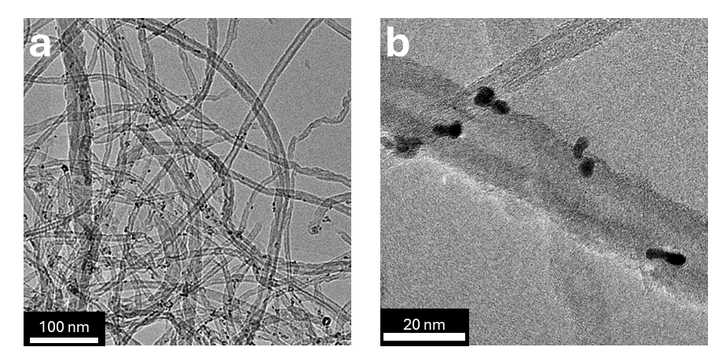
Figure S1. TEM images of Pt/CNTs-C18.

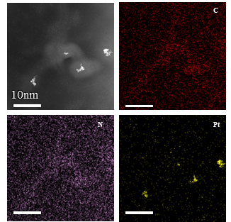
Figure S2. TEM images and the corresponding EDS mapping of Pt/CNTs-AT.
Figure S3. XPS surveys of Pt/CNTs-AT and Pt/CNTs-C18.

Figure S4. (a) Appearance of the four catalysts before and after emulsification, from left to right: Pt/CNTs-AT, Pt/CNTs-C8, Pt/CNTs, and Pt/CNTs-C18. (b) Stability evaluation of the four Pickering emulsions.
Figure S5. Optical microscope image of (a) Pt/CNTs-AT PE, (c) Pt/CNTs-C18 PE, and (b, d) corresponding droplet size distribution.

Figure S6. SEM images of four Pickering emulsions after freeze-drying: (a) Pt/CNTs-AT PE, (b) Pt/CNTs-C8 PE, (c) Pt/CNTs PE, and (d) Pt/CNTs-C18 PE.
Figure S7. SEM image of the surface of a solidified Pickering emulsion droplet.

Figure S8. Fluorescence confocal microscopy images of (a) Cy3-labeled CNTs-AT stabilized emulsion droplet and (b) Cy5-labeled CNTs-C18 stabilized emulsion droplet.

Figure S9. Fluorescence confocal microscopy images of CNTs-AT stabilized Pickering emulsions, with (a) the aqueous phase stained by FITC and (b) the oil phase stained by Nile Red.

Figure S10. Zeta-potential of CNTs-AT at different pH.

Figure S11. Faradaic efficiencies of the four catalysts in H-Cell.

Figure S12. Faradaic efficiencies of the four catalysts in PEES.

Figure S13. Product selectivity under different reaction conditions.

Figure S14. Schematic illustration of two configurations. (a) Pt/CNTs-AT catalyst coated onto the Ag current collector, with the cathode cell filled with inert CNTs-AT stabilized Pickering emulsions. (b) The typical Pt/CNTs-AT PEES.
Figure S15. Faradaic efficiency of the two configurations.

Figure S16. Schematic illustration of the Raman spectroscopy experimental setup.

Figure S17. (a) Comparison of Raman signals from emulsions stabilized by surfactants versus carbon nanotubes. Raman spectrum of the (b) Pt/CNTs-AT PEES and (c) Pt/CNTs-C18 PEES.
When the laser spot is focused on droplets adjacent to the quartz vessel wall, the detected Raman signal consists of three distinct components: the aqueous-phase signal derived from the inter-droplet gaps, the interfacial signal originating from the vicinity of carbon nanotubes, and the cyclohexane signal transmitted through the carbon nanotube network.
As shown in Figure S17a, the emulsion stabilized by CTAB exhibits a markedly different cyclohexane Raman intensity relative to CNT-stabilized emulsions. This disparity stems from the strong laser absorption and significant light scattering induced by the dense carbon nanotube network. In contrast, CTAB displays negligible light absorption at the oil-water interface, therefore yielding a more intense cyclohexane Raman signal.
Based on this observation, the pronounced laser scattering effect of carbon nanotubes at the oil-water interface results in significant attenuation of the bulk cyclohexane signal transmitted through the CNT layer; thus, the acquired Raman signal primarily reflects the molecular characteristics of the emulsion interfacial region.

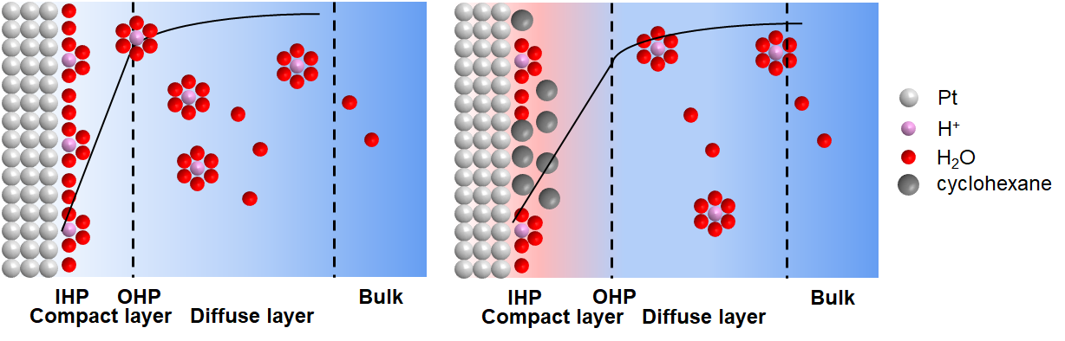
Figure S18. Schematic illustration of the electrochemical double-layer structure
According to the Gouy-Chapman-Stern (GCS) model, the electric double layer (EDL) is conceptually divided into two distinct regions: the compact (Stern) layer and the diffuse (Gouy-Chapman) layer. The compact layer is further subdivided into the inner Helmholtz plane (IHP), defined by the locus of specifically adsorbed ions, and the outer Helmholtz plane (OHP), defined by the closest approach of non-specifically adsorbed, solvated ions. The total capacitance of the EDL (C_{dl}) is modeled as a series combination of the compact layer capacitance (C_{H}) and the diffuse layer capacitance (C_{GC}).
$$\frac{1}{C_{dl}}=\frac{1}{C_{H}}+\frac{1}{C_{GC}}$$
Under the specified experimental conditions (0.05 M H₂SO₄ electrolyte), the predominant potential drop occurs across the compact layer of the electric double layer. The incorporation of hydrophobic Pt/CNTs-C18 facilitates the penetration of cyclohexane molecules into this compact layer region. This process significantly reduces the local dielectric constant at the interface and consequently suppresses the adsorption of hydrated protons (H₃O⁺) as well as the subsequent interfacial charge transfer kinetics.

Figure S19. Nyquist and Bode plots for Pt/CNTs-C18 PEES (a, b) without and (c, d) with 30 mM 4-NS.
Figure S20. Nyquist and Bode plots for Pt/CNTs-AT PEES (a, b) without and (c, d) with 30 mM 4-NS.

Figure S21. Product selectivity of ECH of 4-nitrostyrene in Pt/CNTs-AT PEES at different potentials.
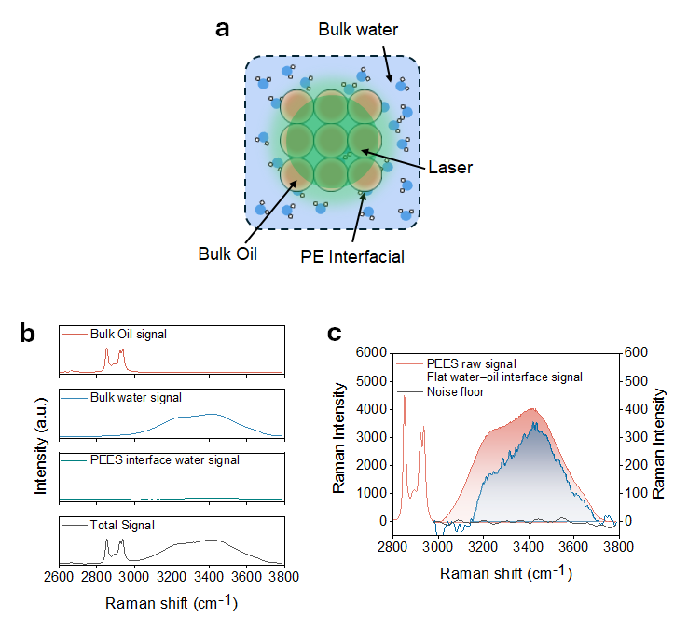
Figure S22. (a) Schematic diagram of Raman signal acquisition. (b) The Raman signals of oil phase and water phase, and the signals of interfacial water and the total signal obtained after mathematical processing; four signals are under the same intensity scale. (c) Raw Raman signal of the PEES, signal of water at the interface, and the background noise floor.
The measured Raman signal (D) is modeled as a linear combination of three distinct spectral components: the bulk water signal (S_{w}), the bulk oil signal (S_{o}), and the characteristic signal originating from the Pickering emulsion electrocatalytic system interface (S_{in})¹⁰.
$$D=C_{w}S_{w}+C_{o}S_{o}+C_{in}S_{in}$$
In the acquired Raman spectra, the distinct spectral separation between cyclohexane and water signals enables straightforward isolation of the water spectral component. To specifically extract the interfacial water signal originating from the PEES, the non-negative minimum area difference method is applied between the composite signal (D) and the bulk water reference (S_{w}), thereby effectively eliminating the contribution from bulk water. The resulting residual spectrum directly reflects the characteristic vibrational features of water molecules residing at the PEES interface.
Furthermore, two independent control experiments were performed on pure water samples. The difference spectrum, obtained by subtracting these two control measurements, exhibited a background noise level substantially lower than the characteristic signals detected from the emulsion interface (Figure S22c). This result conclusively validates the reliability of both the experimental methodology and the computational analysis employed in this study.

Figure S23. KIE of styrene and nitrobenzene hydrogenation on Pt/CNTs-AT

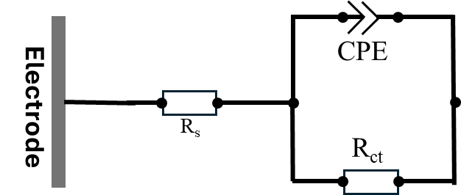
Figure S24. The equivalent circuit of all systems.
Here, R_{s} denotes the solution resistance, R_{ct} represents the charge transfer resistance, and CPE stands for the constant phase element.

Figure S25. Mass spectra of 4-aminoethylbenzene.

Figure S26. Mass spectra of 4-aminostyrene.

Figure S27. Mass spectra of 4-nitroethylbenzene.

Figure S28. Mass spectra of 4-nitrostyrene.

Figure S29. Calibration curves for (a) 4-aminoethylbenzene, (b) 4-aminostyrene, (c) 4-nitroethylbenzene, and (d) 4-nitrostyrene.

Figure S30. Molecular structures of (a) cyclohexane, (b) H₂O, (c) H₃O⁺, (d) SO₄⁻, (e) CNTs-C18 substrate, and (f) CNTs-AT substrate.
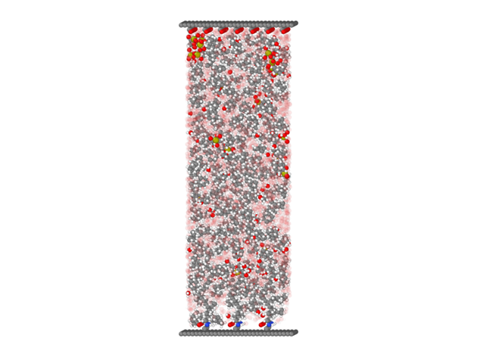
Figure S31. The initial configuration of the MD simulation model (3.8*4.3*10.0nm).

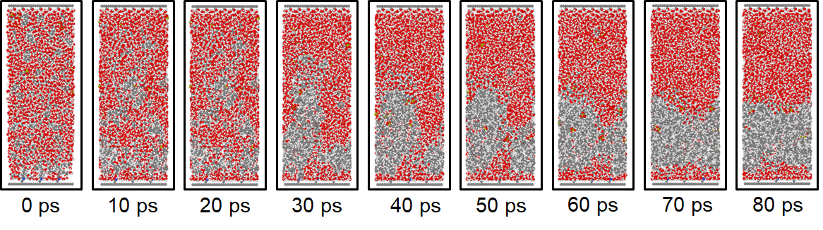
Figure S32. System evolution within 80 picoseconds.

Supplementary Tables

Table 1. Physicochemical properties of the solvents used in this work^{11–13}.
 | MM  $$\text{(g/mol)}$$ | ρ  $$\left(\text{g/}{\text{cm}}^{\text{3}}\right)$$ | AN | DN  (kcal/mol) | α | β | $${\text{ε}}_{\text{rel}}$$ | μ  （D）
Acetic acid | 60.06 | 1.049 | 52.8 | 17.0 | 1.12 | 0.45 | 6.20 | 1.74
Acetone | 58.09 | 0.785 | 12.5 | 17.0 | 0.08 | 0.43 | 20.7 | 2.88
Acetonitrile | 41.06 | 0.786 | 18.9 | 14.1 | 0.19 | 0.4 | 37.5 | 3.92
DMF | 73.11 | 0.944 | 16.0 | 26.6 | 0.00 | 0.69 | 36.7 | 3.82
Ethanol | 46.08 | 0.789 | 37.1 | 19.2 | 0.86 | 0.75 | 2 4.6 | 1.69
Ethyl acetate | 88.12 | 0.902 | 18.5 | 17.1 | 0.00 | 0.45 | 6.02 | 1.78
Methanol | 32.05 | 0.792 | 41.1 | 19.0 | 0.98 | 0.66 | 32.7 | 1.70
n-Heptane | 86.20 | 0.655 | 0.00 | 0.00 | 0.00 | 0.00 | 1.89 | 0.00
Pyridine | 79.11 | 0.982 | 14.2 | 33.1 | 0.00 | 0.64 | 12.3 | 2.19
THF | 72.12 | 0.889 | 8.00 | 20.0 | 0.00 | 0.55 | 7.52 | 1.75
Water | 18.00 | 1.000 | 54.8 | 18.0 | 1.17 | 0.47 | 78.5 | 1.85
Molar mass (MM); density at 25℃ (ρ); Gutmann acceptor number (AN); Gutmann donor number (DN); Kamlet-Taft parameters for hydrogen bond donating (α) and hydrogen bonding accepting ability (β; dielectric constant values relative to air (εrel); dipole moment (μ).

Supplementary References
1. Han, C. et al. Electrocatalytic hydrogenation of alkenes with Pd/carbon nanotubes at an oil–water interface. Nature Catalysis 5, 1110–1119 (2022).
2. Ge, W. et al. Dynamically Formed Surfactant Assembly at the Electrified Electrode–Electrolyte Interface Boosting CO2 Electroreduction. J. Am. Chem. Soc. 144, 6613–6622 (2022).
3. Martínez, L., Andrade, R., Birgin, E. G. & Martínez, J. M. PACKMOL: A package for building initial configurations for molecular dynamics simulations. Journal of Computational Chemistry 30, 2157–2164 (2009).
4. Kaminski, G. A., Friesner, R. A., Tirado-Rives, J. & Jorgensen, W. L. Evaluation and Reparametrization of the OPLS-AA Force Field for Proteins via Comparison with Accurate Quantum Chemical Calculations on Peptides. J. Phys. Chem. B 105, 6474–6487 (2001).
5. Wang, C.; Li, W.; Liao, K.; Wang, Z.; Wang, Y.; Gong, K. AuToFF Program, Vesrion 1.0. Hzwtech. Shanghai 2023, see https://cloud.hzwtech.com/web/product-service?id=36.
6. Abraham, M. J. et al. GROMACS: High performance molecular simulations through multi-level parallelism from laptops to supercomputers. SoftwareX 1–2, 19–25 (2015).
7. A. Stukowski, Visualization and analysis of atomistic simulation data with OVITO - the Open Visualization Tool, Modelling Simul. Mater. Sci. Eng. 18, 015012 (2010).
8. Láng, G. G. Basic interfacial thermodynamics and related mathematical background. ChemTexts 1, 16 (2015).
9. Ji, K. et al. Steering Selectivity in Electrocatalytic Furfural Reduction via Electrode–Electrolyte Interface Modification. J. Am. Chem. Soc. 146, 11876–11886 (2024).
10. Shi, L. et al. Water structure and electric fields at the interface of oil droplets. Nature 640, 87–93 (2025).
11. Gutmann, V. Solvent effects on the reactivities of organometallic compounds. Coordination Chemistry Reviews 18, 225–255 (1976).
12. Kamlet, M. J. & Taft, R. W. The solvatochromic comparison method. I. The .beta.-scale of solvent hydrogen-bond acceptor (HBA) basicities. J. Am. Chem. Soc. 98, 377–383 (1976).
13. Appendix A. Properties, Purification, and Use of Organic Solvents. in Solvents and Solvent Effects in Organic Chemistry 549–586 doi:10.1002/9783527632220.app1 (2010).

