Supplementary File
Facile synthesis of metal doped graphite carbon nitride for photocatalytic degradation of tetracycline under visible light irradiation

1. Results and discussion
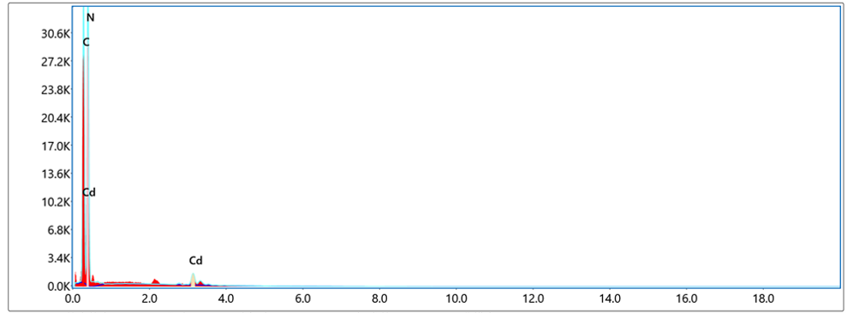
Figure S1. Zeiss SmartEDX of 10 Cd/g-C₃N₄.

Table S1. The proportion of each element in the 10 Cd/g-C₃N₄ material.
elements | Weight ratio% | Atomic percentage | Error% | intensity | K ratio
C K | 25.73 | 32.09 | 3.62 | 2391.51 | 0.2314
N K | 61.98 | 66.28 | 7.98 | 2651.52 | 0.2666
Cd L | 12.28 | 1.64 | 6.51 | 202.16 | 0.0802
Table S1. The analysis of energy-dispersive X-ray spectra (EDS) directly shows the atomic concentrations of Cd in the samples of Cd/g-C₃N₄ sample are 1.64%. Elemental mapping confirmed the uniform dispersion of Cd in the g-C₃N₄ layer structure, which illustrated that the cadmium was well doped in the g-C₃N₄ with a slight atomic ratio.

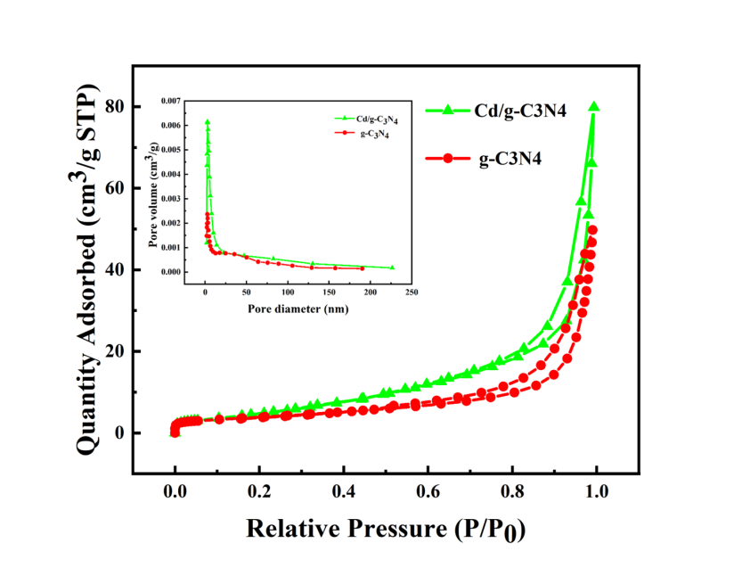
Figure S2. N₂ adsorption−desorption isotherms of pure g-C₃N₄ and 10 Cd/g-C₃N₄ composite. The inset image is the pore size distributions of pure g-C₃N₄ and 10 Cd/g-C₃N₄ composite.

Table S2 Surface area, pore volume and pore size parameters for pure g-C₃N₄ and 10 Cd/g-C₃N₄.
Samples | Surface area¹ (m² /g) | Pore volume² (cm³ /g) | Pore size³ (nm)
g-C₃N₄ | 13.467 | 0.077 | 22.131
Cd/g-C₃N₄ | 16.460 | 0.123 | 25.917

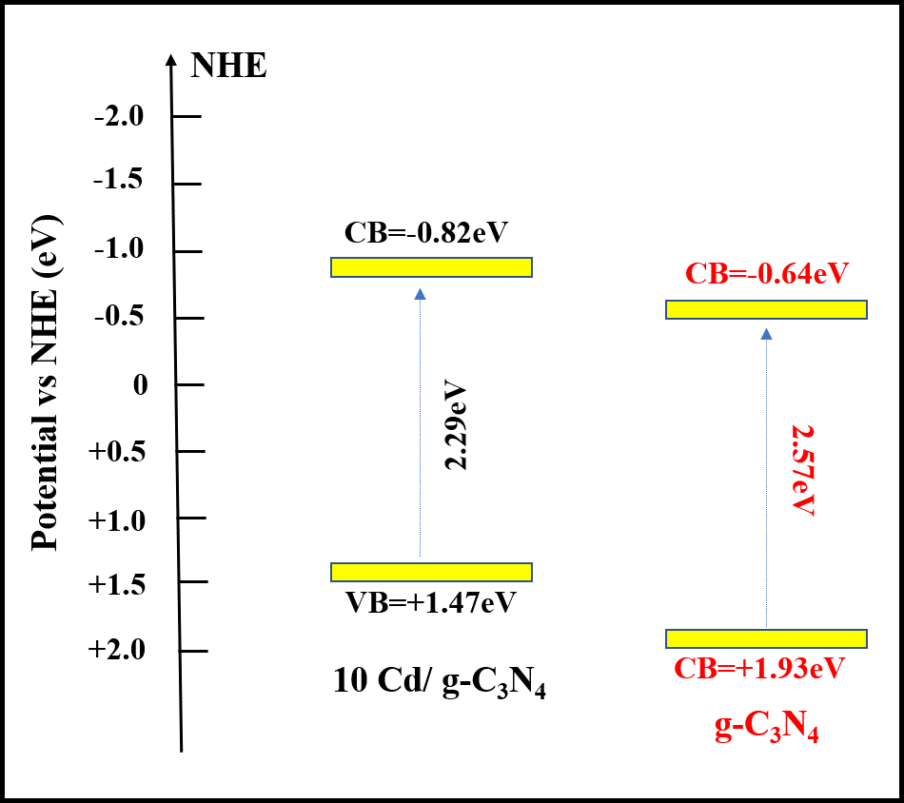
Figure S3. Band structure diagram of pristine g-C₃N₄ and 10 Cd/g-C₃N₄.

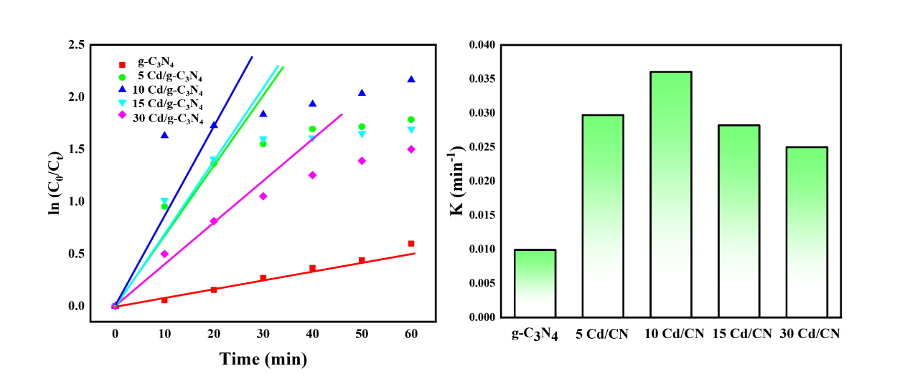
Figure S4. First-order plots of photocatalytic degradation with different amounts cadmium catalysts.

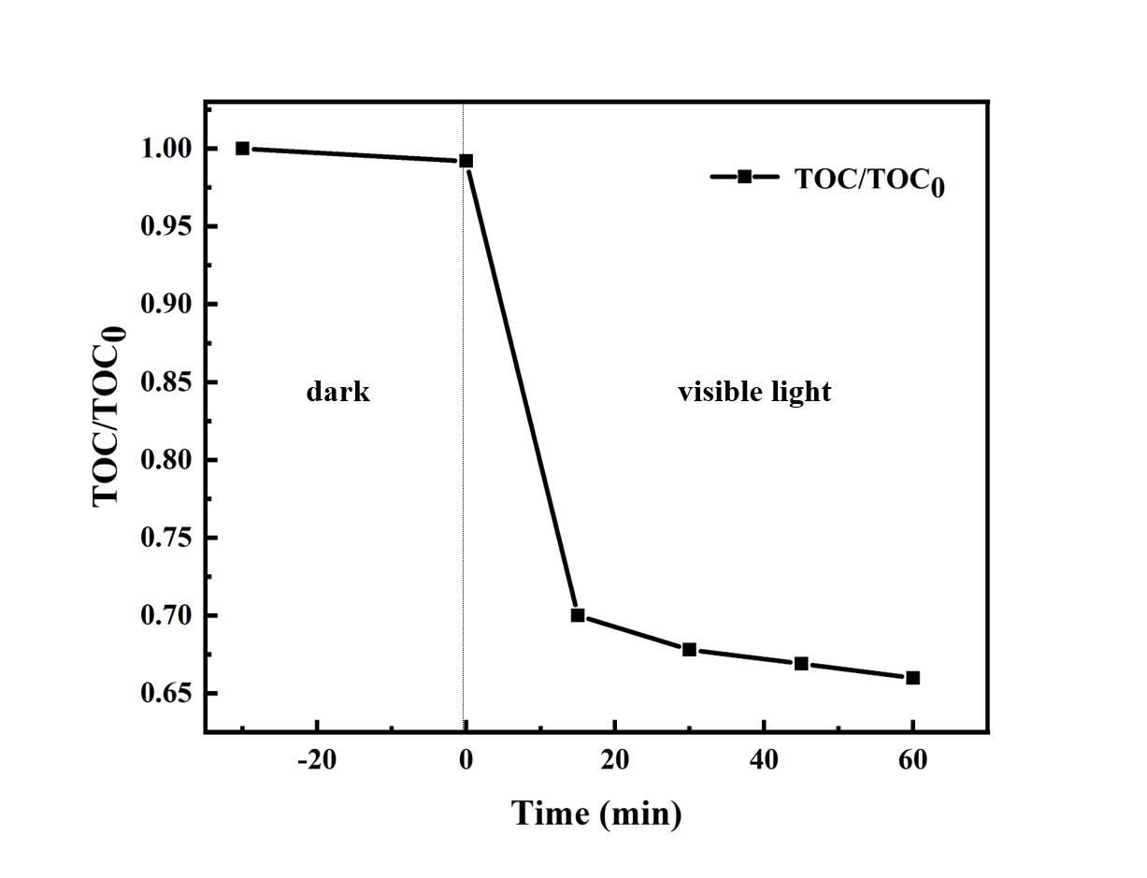
Figure S5. TOC removal curves of TC on 10 Cd/g-C₃N₄.

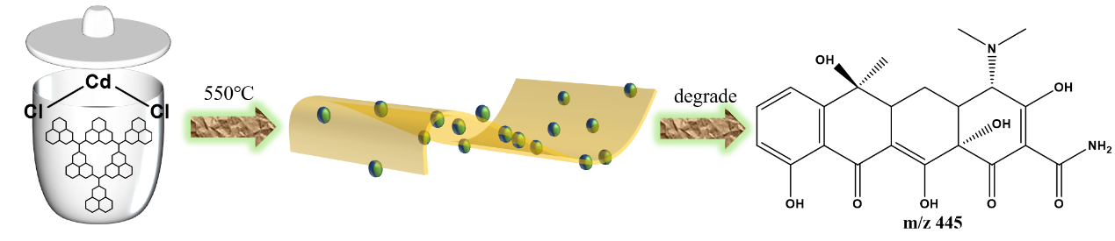
Scheme 1. The brief diagram of Cd/g-C₃N₄ prepared process.

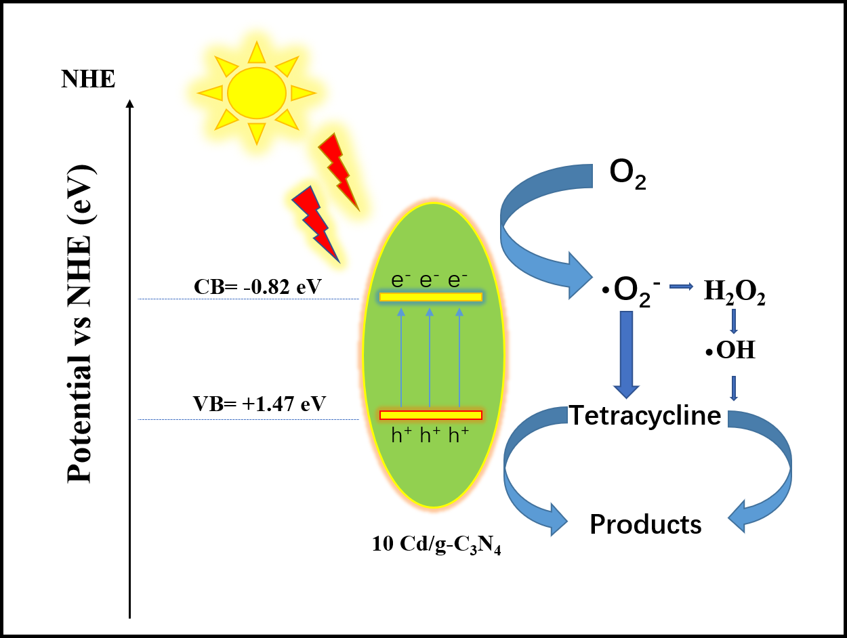
Scheme 2. The transfer and separation of charges and degradation mechanisms in the 10 Cd/g-C₃N₄ composite under visible-light irradiation.

