Closed-Loop Workflow of High-Entropy Materials Discovery: Efficient and Accurate Synthesizability Prediction via Domain-Specific Local LLMs
Yeongjun Yoonª, Geun Ho Gu^{b}, and Kyeounghak Kim^{a,c*}
ª Department of Chemical Engineering, Hanyang University, 222 Wangsimni-ro, Seongdong-gu, Seoul, 04763, South Korea
^{b}Department of Energy Engineering, Korea Institute of Energy Technology (KENTECH), Naju 58330, Republic of Korea
^{c} Clean-Energy Research Center, Hanyang University, 222 Wangsimni-ro, Seongdong-gu, Seoul, 04763, South Korea

Methods
Data Curation via PU Learning with stoi-CGNF
To rigorously address the Positive-Unlabeled (PU) nature of materials discovery, where "unlabeled" (U) compositions may contain undiscovered synthesizable materials (hidden positives), we implemented a data filtering pipeline using the Stoichiometric Crystal Graph Neural Fingerprint (stoi-CGNF) framework.¹ Instead of naively treating all unlabeled data as negative (N), which introduces label noise, we identified and removed compositions with high synthesizability scores to construct a set of "Reliable Negatives" (RN).
We employed a transductive bootstrap aggregating (bagging) strategy with 100 iterations. The classifier architecture consisted of a 5-layer Multi-Layer Perceptron (MLP) with 450 hidden units per layer and Softplus activation functions, taking 90-dimensional elemental embedding vectors as input. In each iteration, a balanced training set was constructed by sampling pseudo-negatives from the unlabeled pool equal to the number of positive (P) samples. The model was then trained to predict the synthesizability probability of the remaining out-of-bag unlabeled (U) compositions.
The final synthesizability score for each unlabeled composition was determined by averaging the predicted probabilities across the ensemble of 100 bagging models. To rigorously identify potential hidden positives within the unlabeled dataset, we applied a confidence threshold of 0.741, a value derived from the class prior estimation method established in the reference study. Out of the total pool of 352,092 unlabeled (U) candidates, 31,009 compositions (approximately 8.8 %) exhibited synthesizability scores exceeding this threshold. These high-scoring candidates were identified as likely synthesizable materials and were consequently excluded from the negative training set to prevent false-negative supervision during the LLM fine-tuning process. The remaining 321,083 compositions, which consistently showed low synthesizability scores, were designated as "Reliable Negatives" (RN) and labeled as "Not Synthesizable (N)" for the subsequent training phase.

Model Architecture and Implementation
We fine-tuned three open-weight large language models (LLMs) to classify high-entropy material (HEM) compositions as synthesizable ("P") or not ("N"): gpt-oss-20b,² Qwen3-14b,³ and DeepSeek-R1-Distill-Qwen-14B.⁴⁻⁵ All models were loaded in 4-bit precision via Unsloth from Hugging Face, specifically: unsloth/gpt-oss-20b-bnb-4bit,⁶ unsloth/Qwen3-14B-unsloth-bnb-4bit,⁷ and unsloth/DeepSeek-R1-Distill-Qwen-14B-unsloth-bnb-4bit.⁸

Fine-tuning methodology
We employed Quantized Low-Rank Adaptation⁹ (QLoRA) for efficient fine-tuning, maintaining 4-bit NF4 base weights with double-quantization where available. Only the LoRA adapters were trained while the frozen base model participated in backpropagation through quantized weights.
Each training example was formatted using the target model's chat template with explicit pad tokens (defaulting to EOS tokens when unavailable). The supervision signal was focused on a single terminal token: each sample concluded with either "P" or "N", and only this final token contributed to the loss calculation, with all preceding tokens masked. We implemented a focal loss variant specifically tuned for the P/N class imbalance, with hyperparameters α = 0.25, γ = 2.0, and λ = 0.1. The models were trained using AdamW optimizer (fused variant) with the following configurations:
- Qwen3-14b and DeepSeek-R1-Distill-Qwen-14b: 10 epochs, 180-token context window, learning rate 2×10⁻⁴, per-device batch size of 32, gradient accumulation steps 30 (effective batch size ≈ 960), LoRA parameters (r=64, α=128, dropout=0.0).
- gpt-oss-20b: Identical configuration except for per-device batch size of 60 to accommodate the larger model size.
The fine-tuned models are available at:
https://huggingface.co/collections/evenfarther/synthesizability-PN-prediction-balance-tpr-tnr.

Inference Protocol
For inference, we employed deterministic decoding with temperature=0 and max_new_tokens=1, effectively selecting the argmax over the next-token logits for "P" versus "N" classification. This approach ensures reproducible predictions while maintaining computational efficiency.
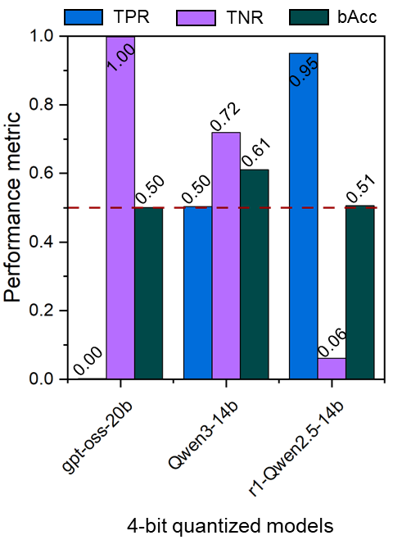
Figure S1: Performance of open-weight LLMs for synthesizability prediction.
Model | gpt-oss-20b |  |  | Qwen3-14b |  |  | r1-Qwen2.5-14b
Epoch | TPR | TNR | bAcc | TPR | TNR | bAcc | TPR | TNR | bAcc
0 | 0.0016 | 0.9983 | 0.4999 | 0.5032 | 0.7187 | 0.6110 | 0.9502 | 0.0613 | 0.5057
1 | 0.7649 | 0.9709 | 0.8679 | 0.9224 | 0.9555 | 0.9390 | 1.0000 | 0.0018 | 0.5009
2 | 0.9852 | 0.9023 | 0.9438 | 0.9713 | 0.9408 | 0.9560 | 1.0000 | 0.1055 | 0.5527
3 | 0.9772 | 0.9374 | 0.9573 | 0.9595 | 0.9622 | 0.9609 | 0.9998 | 0.5567 | 0.7783
4 | 0.9465 | 0.9652 | 0.9558 | 0.9424 | 0.9750 | 0.9587 | 0.9998 | 0.5585 | 0.7791
5 | 0.8990 | 0.9786 | 0.9388 | 0.9176 | 0.9812 | 0.9494 | 0.9936 | 0.8681 | 0.9309
6 | - | - | - | - | - | - | 0.9884 | 0.9058 | 0.9471
7 | - | - | - | - | - | - | 0.9722 | 0.9305 | 0.9514
8 | - | - | - | - | - | - | 0.9702 | 0.9363 | 0.9532
9 | - | - | - | - | - | - | 0.9750 | 0.9362 | 0.9556
10 | - | - | - | - | - | - | 0.9467 | 0.9607 | 0.9537
Table S1: Evolution of performance metrics during QLoRA fine-tuning for three open-weight models. The table lists True Positive Rate (TPR), True Negative Rate (TNR), and Balanced Accuracy (bAcc) for each epoch. The highest bAcc achieved for each model is highlighted in bold.

References
(1) Kim, S.; Jung, Y.; Schrier, J. J. Am. Chem. Soc. 2024, 146, 19654–19659.
(2) OpenAI; Agarwal, S.; Ahmad, L.; Ai, J.; Altman, S.; Applebaum, A.; Arbus, E.; Arora, R. K.; Bai, Y.; Baker, B.; et al. gpt-oss-120b & gpt-oss-20b Model Card. arXiv 2025, arXiv:2508.10925.
(3) Yang, A.; Li, A.; Yang, B.; Zhang, B.; Hui, B.; Zheng, B.; Yu, B.; Gao, C.; Huang, C.; Lv, C.; et al. Qwen3 Technical Report. arXiv 2025, arXiv:2505.09388.
(4) Guo, D.; Yang, D.; Zhang, H.; et al. DeepSeek-R1 incentivizes reasoning in LLMs through reinforcement learning. Nature 2025, 645, 633–638. (5) Yang, A.; Yu, B.; Li, C.; Liu, D.; Huang, F.; Huang, H.; Jiang, J.; Tu, J.; Zhang, J.; Zhou, J.; et al. Qwen2.5-1M Technical Report. arXiv 2025, arXiv:2501.15383.
(5) Yang, A.; Yu, B.; Li, C.; Liu, D.; Huang, F.; Huang, H.; Jiang, J.; Tu, J.; Zhang, J.; Zhou, J.; et al. Qwen2.5-1M Technical Report. arXiv 2025, arXiv:2501.15383.
(6) Unsloth. gpt-oss-20b-bnb-4bit.
https://huggingface.co/unsloth/gpt-oss-20b-bnb-4bit.
(7) Unsloth. Qwen3-14B-unsloth-bnb-4bit.
https://huggingface.co/unsloth/Qwen3-14B-unsloth-bnb-4bit.
(8) Unsloth. DeepSeek-R1-Distill-Qwen-14B-unsloth-bnb-4bit.
https://huggingface.co/unsloth/DeepSeek-R1-Distill-Qwen-14B-unsloth-bnb-4bit.
(9) Dettmers, T.; Pagnoni, A.; Holtzman, A.; Zettlemoyer, L. QLoRA: Efficient Finetuning of Quantized LLMs. arXiv 2023, arXiv:2305.14314.

