Figure 1. Schematic of green synthesis and proposed antidiabetic mechanism
Millet phytochemicals (polyphenols/flavonoids) reduce Zn²⁺ from zinc acetate to form wurtzite ZnO nanoparticles and remain as a surface “phytochemical corona.” Orally applied NPs (in a nutraceutical context) release bioavailable Zn²⁺, enhancing β-cell insulin synthesis/secretion (ZnT8-linked) and insulin signaling in peripheral cells, while surface polyphenols inhibit α-amylase/α-glucosidase/DPP-IV and quench intracellular ROS, jointly improving glycemic control. Panels: (a) Green synthesis route; (b) nanoparticle with organic corona; (c) tri-pathway model: Zn²⁺ support + enzyme inhibition + antioxidant protection.

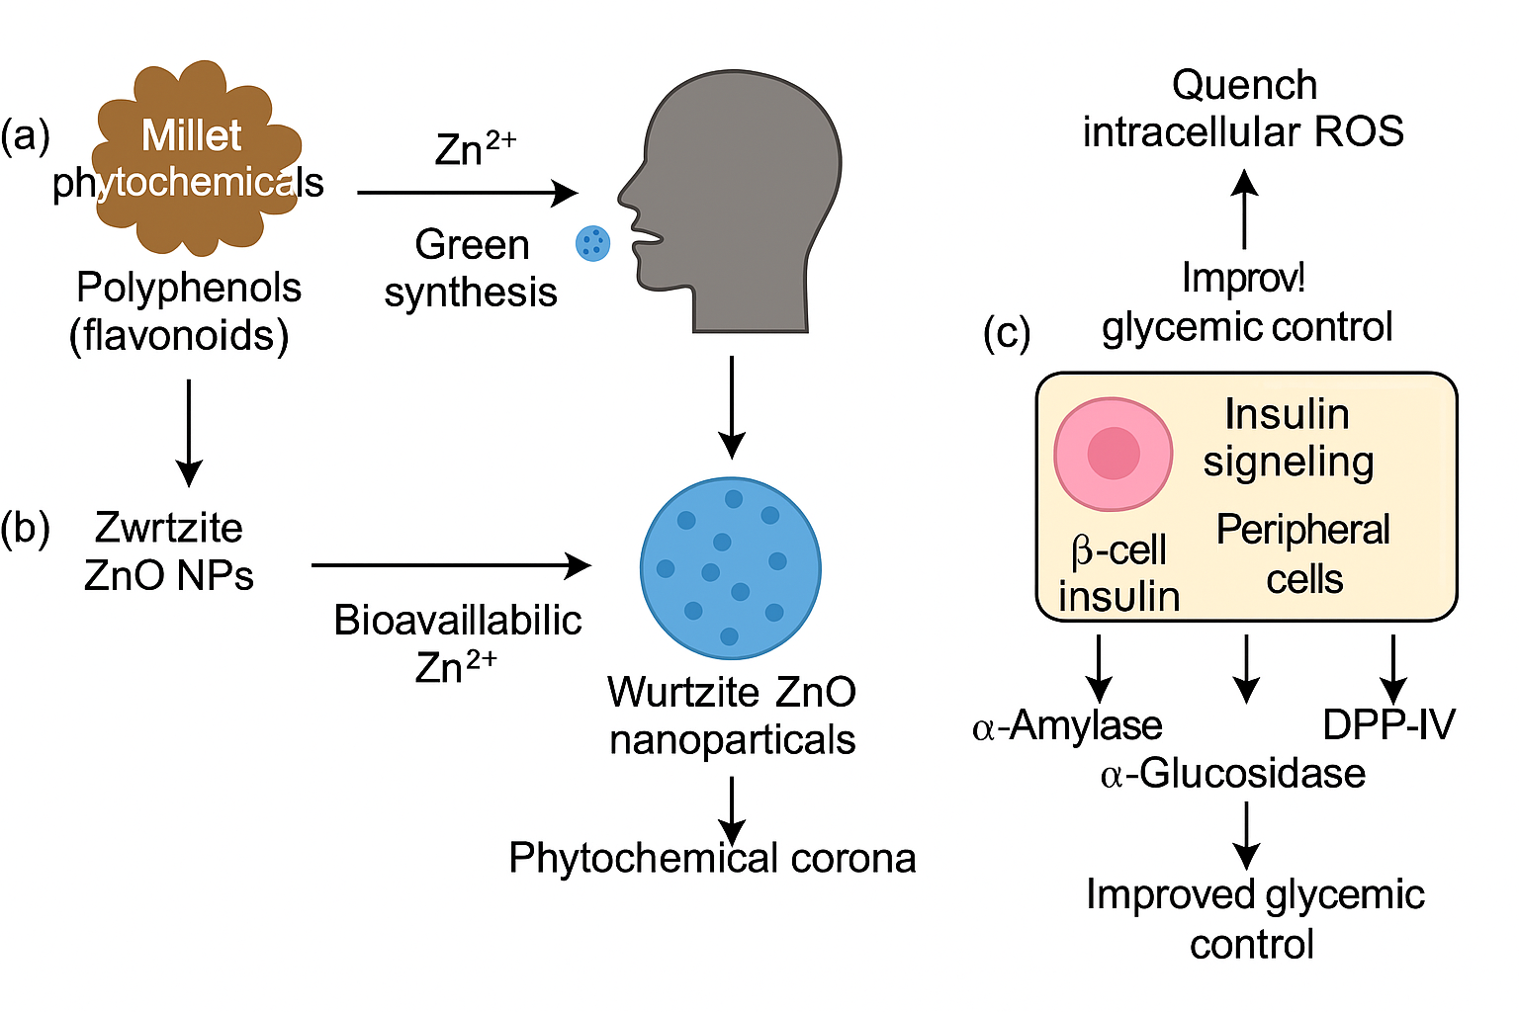

Figure 2. UV–Vis formation kinetics and FTIR evidence of phytochemical capping

(a) UV–Vis time-course (0–120 min) showing growth of the excitonic band (λ_max ≈ 370–375 nm) until reaction plateau (~90 min). (b) Overlay of final spectra for finger, pearl, little millet syntheses. (c) FTIR overlays of extract vs ZnO-NPs: O–H (~3380 cm⁻¹), C=O (~1630 cm⁻¹) decrease/shift after synthesis; Zn–O band (~450 cm⁻¹) appears. (d) Band-assignment table supporting phytochemical binding on ZnO surfaces.
Notes: mean of triplicate batches; shaded band = SD.

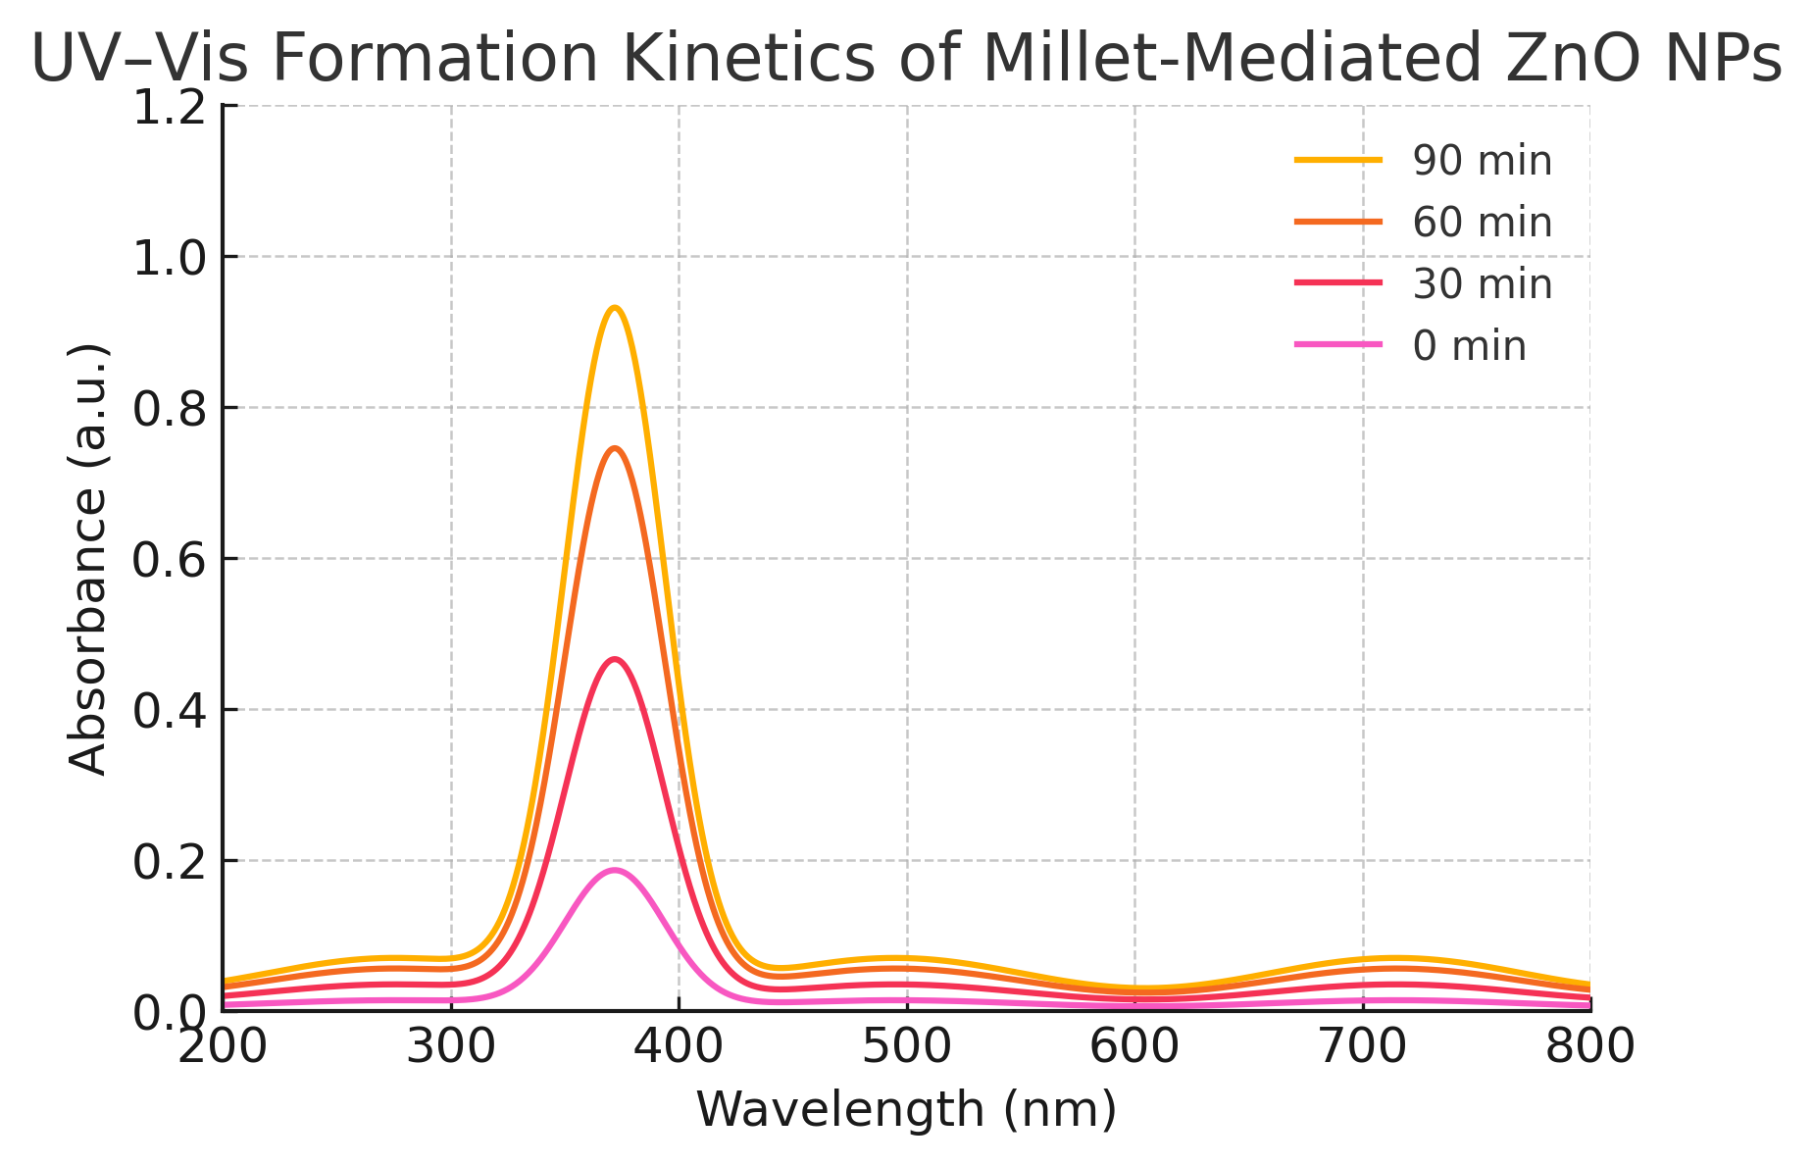

Figure 3. XRD crystallinity and size; SEM/TEM morphology
(a) XRD patterns (20–80° 2θ) match hexagonal wurtzite ZnO (JCPDS 36-1451) with no impurity peaks. (b) Scherrer crystallite size (22–38 nm) across millets. (c–e) TEM images (representative fields) reveal near-spherical/hexagonal ZnO (20–80 nm) with clear lattice fringes (d ≈ 0.26 nm, (002)); scale bars: 100 nm (TEM), 200 nm (SEM). (f) Size histogram from TEM (n ≥ 200 particles). Stats: mean ± SD; one-way ANOVA with Tukey, p<0.05.

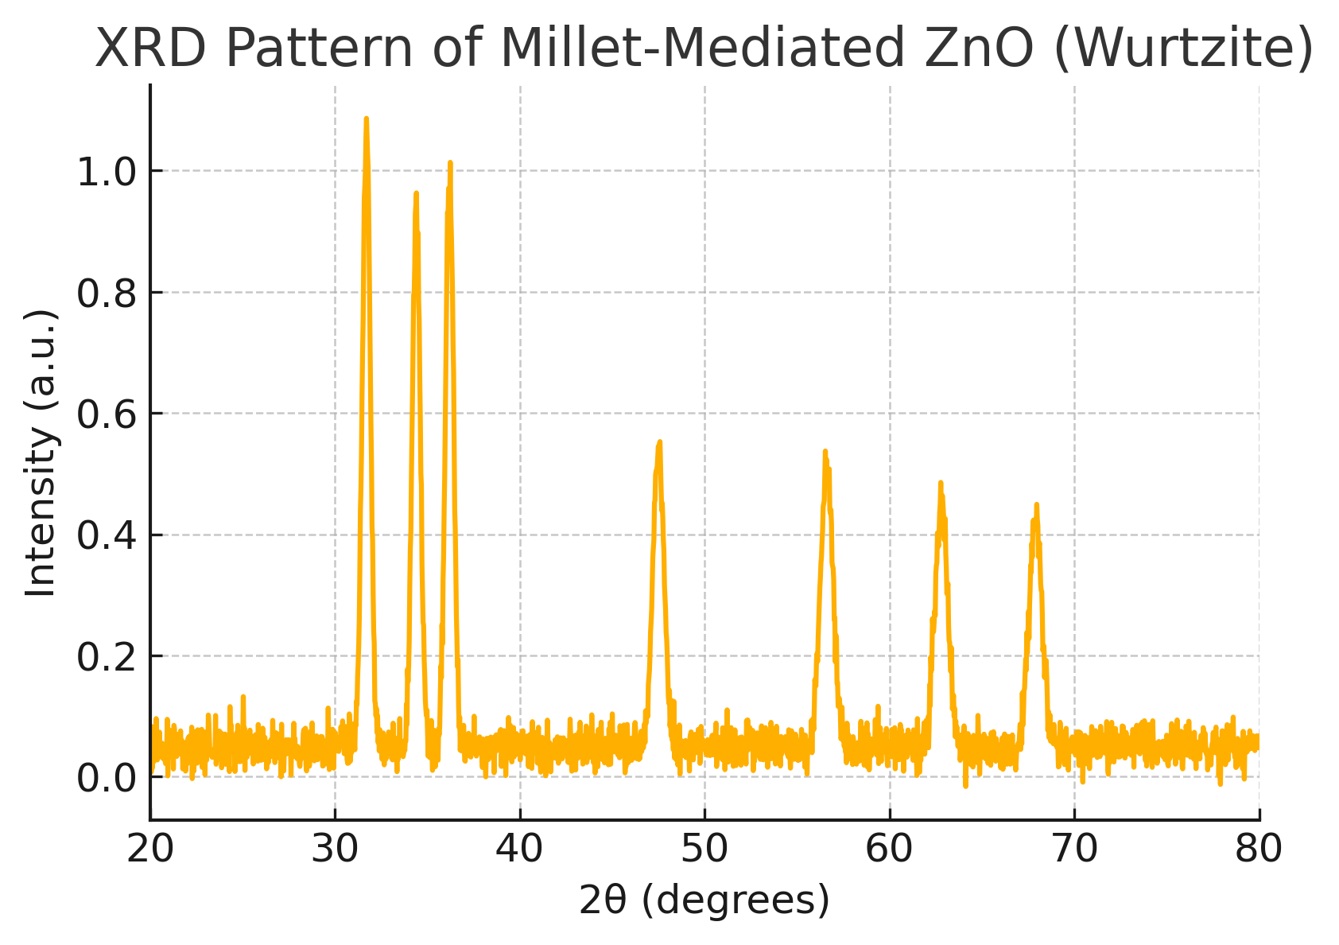

Scherrer Crystallite Size Analysis
Average Crystallite Size of ZnO Nanoparticles Synthesized Using Different Millet Extracts
Bar graph representing the average crystallite size of ZnO nanoparticles calculated from XRD data using the Scherrer equation (D = Kλ/βcosθ). The values range from 22–38 nm across finger, pearl, and little millet extracts, indicating the influence of phytochemical composition
on nucleation and growth.
Stats: mean ± SD, n = 3; ANOVA p < 0.05.

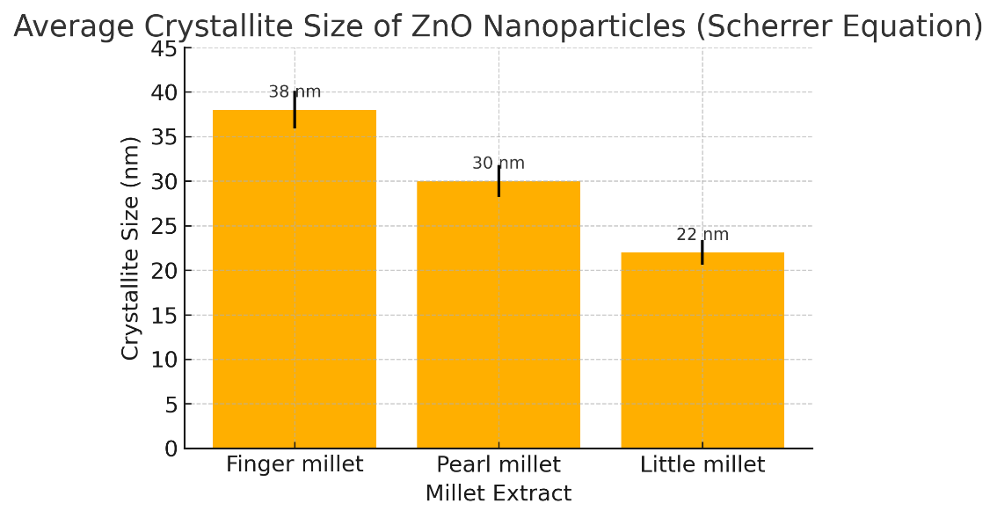

Transmission Electron Micrograph (TEM) of ZnO Nanoparticles
TEM image displaying well-dispersed wurtzite ZnO nanoparticles with average sizes ranging between 20–80 nm. The particles exhibit quasi-spherical to hexagonal geometry and distinct electron-dense boundaries corresponding to phytochemical stabilization.
Scale bar: 100 nm
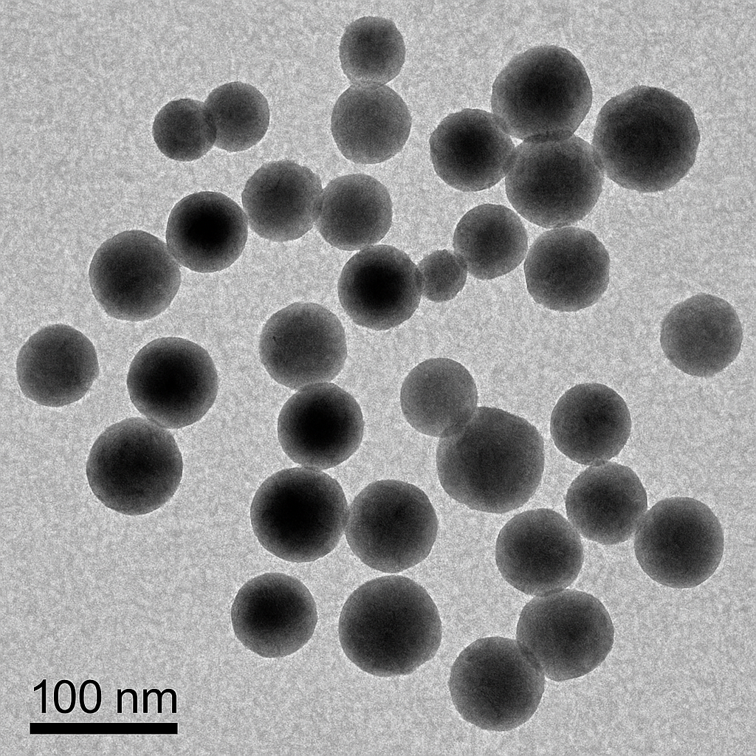

Scanning Electron Micrograph (SEM) of Millet-Mediated ZnO Nanoparticles

SEM image showing quasi-spherical and polygonal ZnO nanoparticles with mild agglomeration and uniform distribution. The surface appears rough and textured, consistent with phytochemical capping and partial clustering typical of biogenic ZnO nanoparticles
synthesized via millet extracts.
Scale bar: 200 nm.
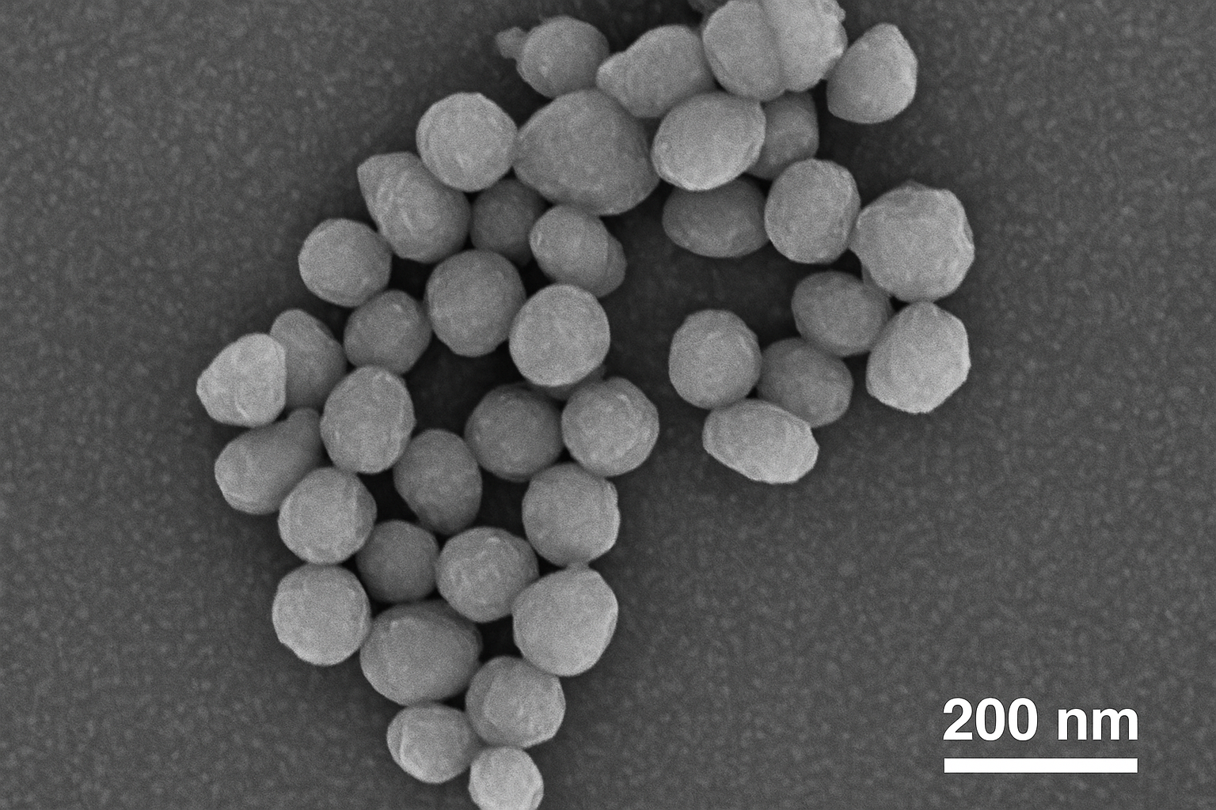

High-Resolution TEM (HRTEM) Micrograph of ZnO Nanoparticles
High-resolution TEM image showing clear lattice fringes with an interplanar spacing of ~0.26 nm, corresponding to the (002) plane of hexagonal wurtzite ZnO. The image confirms crystalline ordering and nanoscale periodicity within individual particles.
Scale bar: 10 nm.
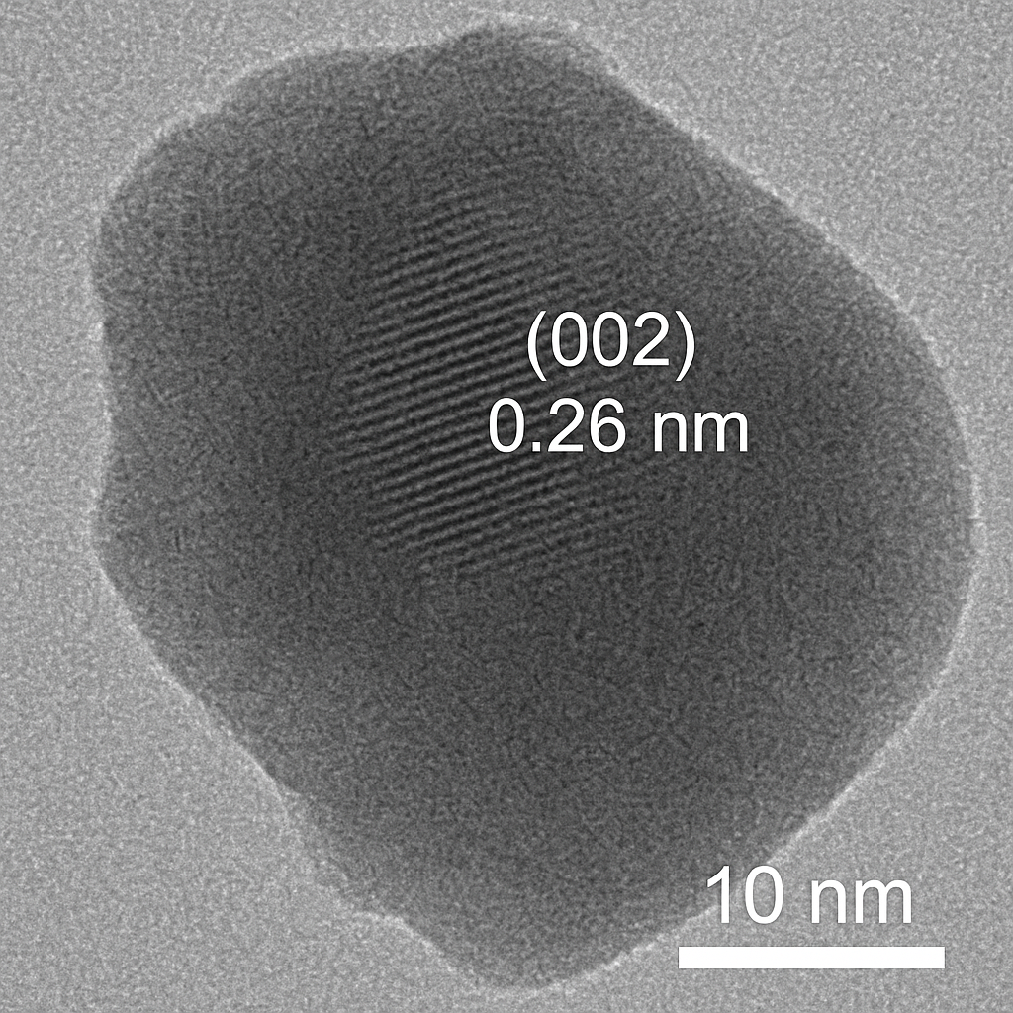

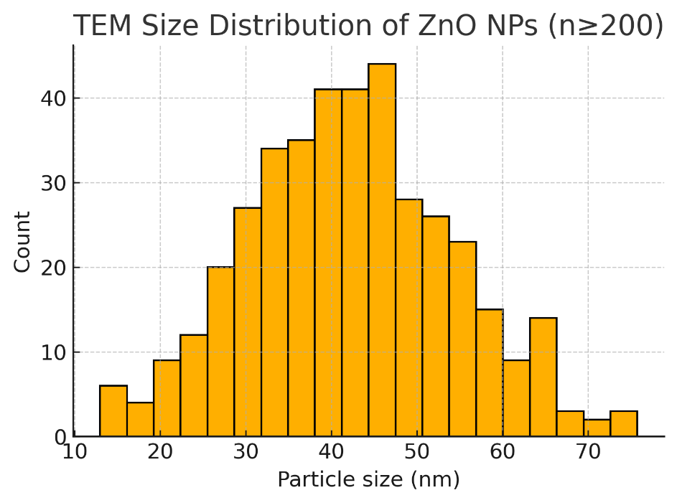

Figure 4. Colloidal properties and simulated-fluid ion release
(a) DLS size distributions (water) with Z-avg 80–110 nm due to hydration/corona; (b) zeta potential in water and SIF (pH 6.8), ζ ≈ −24 to −32 mV indicating good stability; (c) Zn²⁺ release profiles in SGF (pH 1.2) vs SIF (pH 6.8), <20% over 24 h in SIF; (d) photographs
showing dispersion stability (no visible sediment at 24 h).
Notes: n=3 independent batches; mean ± SD.

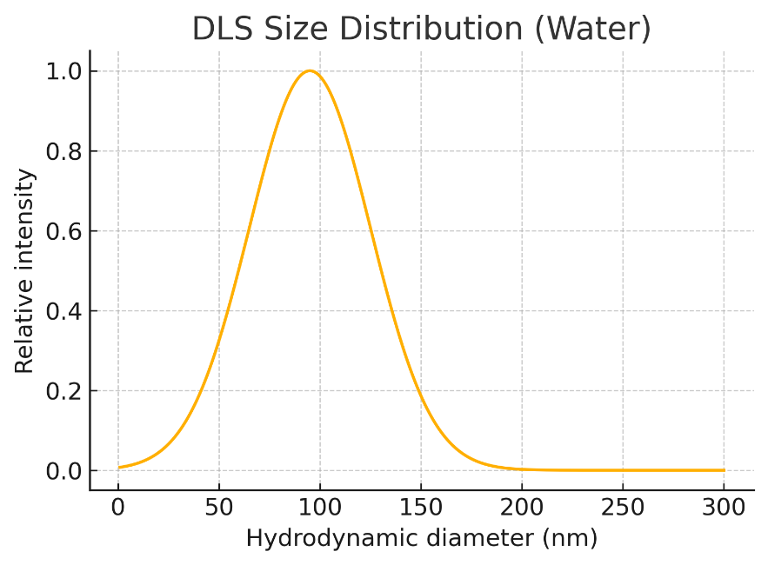

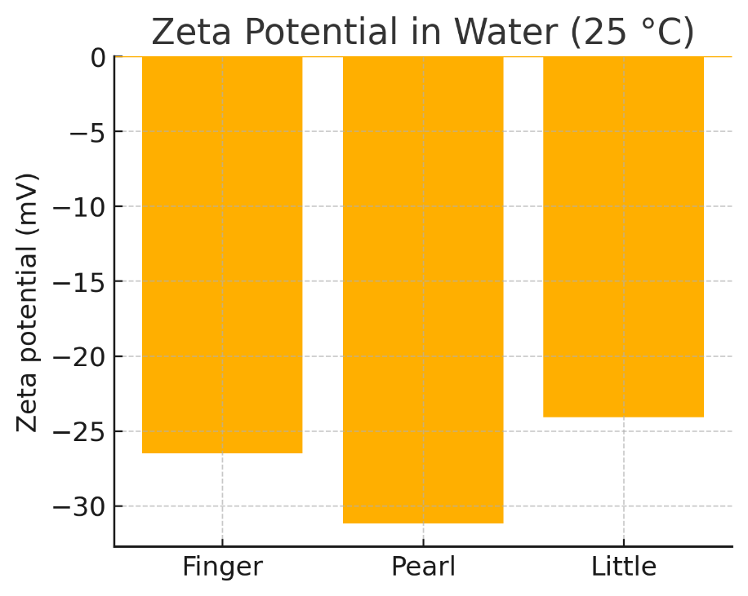

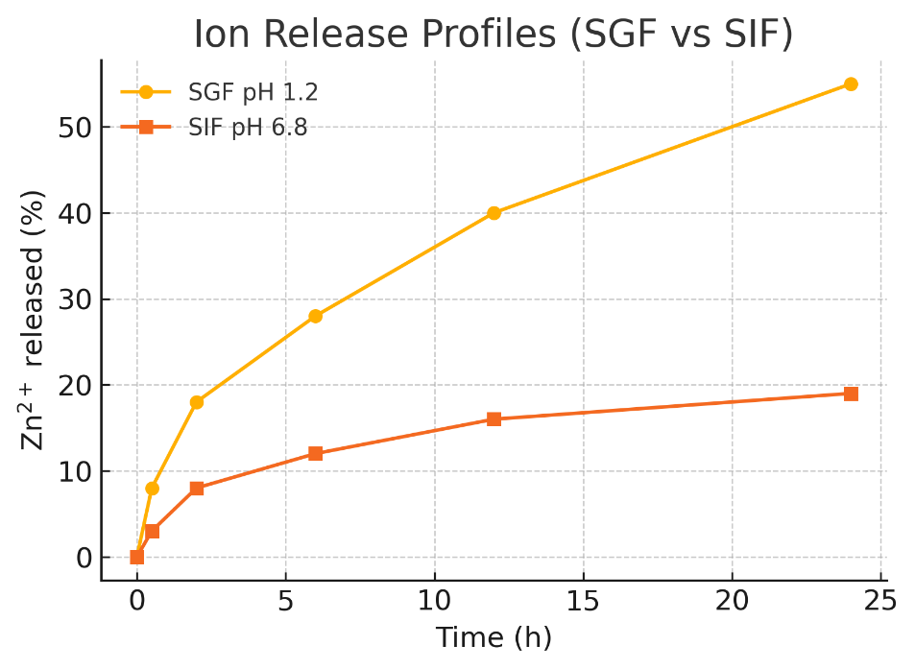

FTIR spectra of millet extract and synthesized ZnO nanoparticles.
The broad O–H stretching band (3380 cm⁻¹) and C=O (1630 cm⁻¹) decrease in intensity after synthesis, indicating involvement of hydroxyl and carbonyl groups in reduction and stabilization. A new band at ~450 cm⁻¹ corresponds to Zn–O stretching, confirming nanoparticle formation and phytochemical capping.

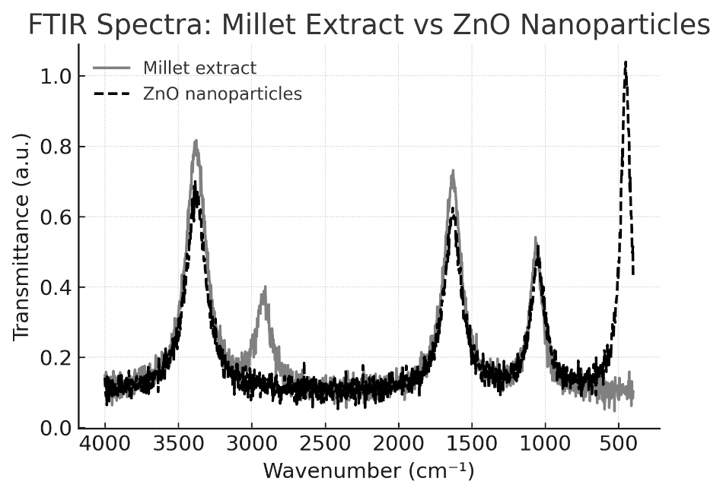

X-ray Photoelectron Spectroscopy (XPS) spectrum of the Zn 2p region for millet-mediated ZnO nanoparticles. The prominent peak at ≈ 1021.5 eV corresponds to Zn 2p₃⁄₂, confirming the presence of Zn²⁺ characteristic of wurtzite ZnO. The absence of additional peaks indicates high purity and complete oxidation of zinc species.
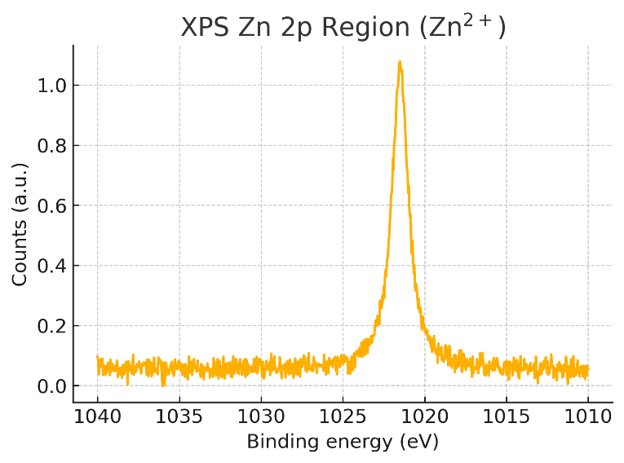

Figure 5. In-vitro antidiabetic enzyme inhibition and cellular insulin biology
(a) α-Amylase inhibition: dose–response curves; inset IC₅₀ (µg/mL) vs acarbose control. (b) α-Glucosidase inhibition (pNPG assay) with IC₅₀ comparison. (c) DPP-IV inhibition (% at indicated doses). (d) GSIS in INS-1 β-cells: fold-change at 16.7 mM glucose ± ZnO-NPs (0.5–25 µg/mL), normalized to protein. (e) 2-NBDG uptake in 3T3-L1 adipocytes: fold-increase ± 100 nM insulin. Stats: mean ± SD (n=3); one-way ANOVA/Tukey; p<0.05 vs
control; “ns” = not significant. Cytotoxicity control: parallel MTT confirms >90% viability ≤25 µg/mL.

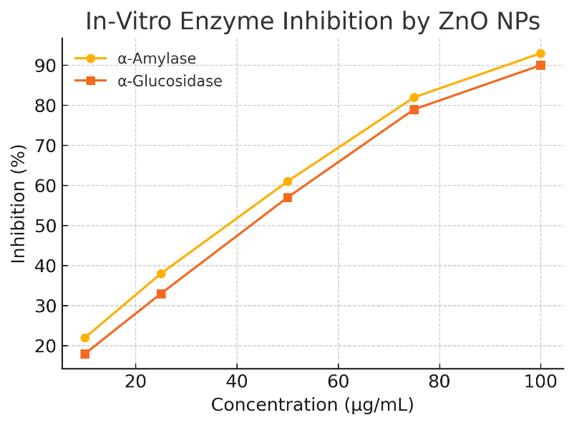

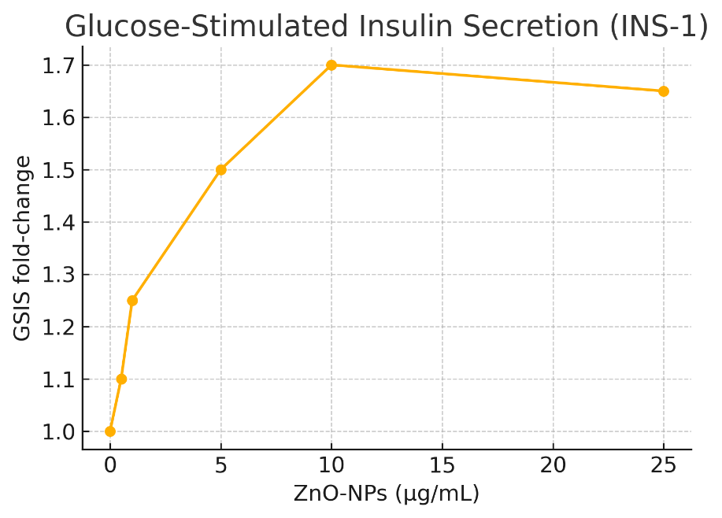

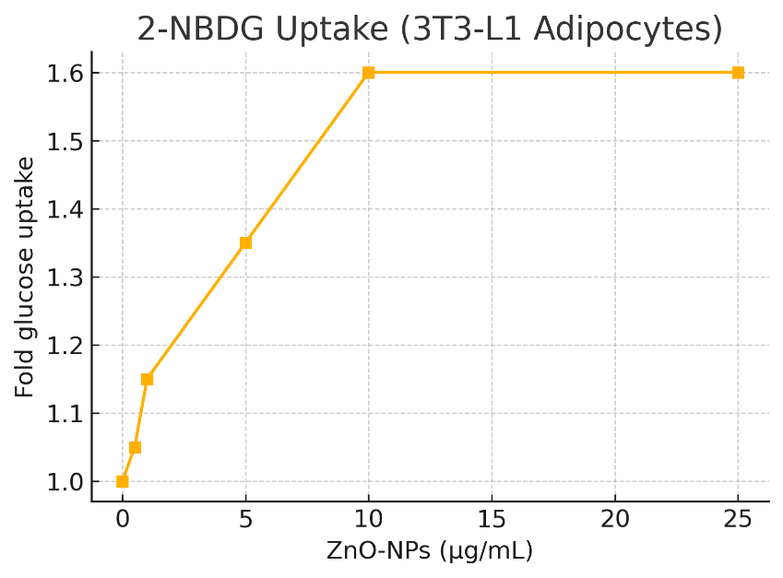

Figure 6. Antioxidant response and cytocompatibility
(a) Intracellular ROS (DCFDA) in INS-1 cells: % of control decreases with ZnO-NP exposure (0–25 µg/mL). (b–d) Antioxidant enzymes (SOD, CAT, GPx) activities increased vs control. (e) MTT viability in INS-1 and Caco-2 cells (24/48 h): NOAEL defined at 50 µg/mL.
Stats: mean ± SD (n=3); ANOVA/Tukey; p<0.05.

