Supplementary information

Design and procedure

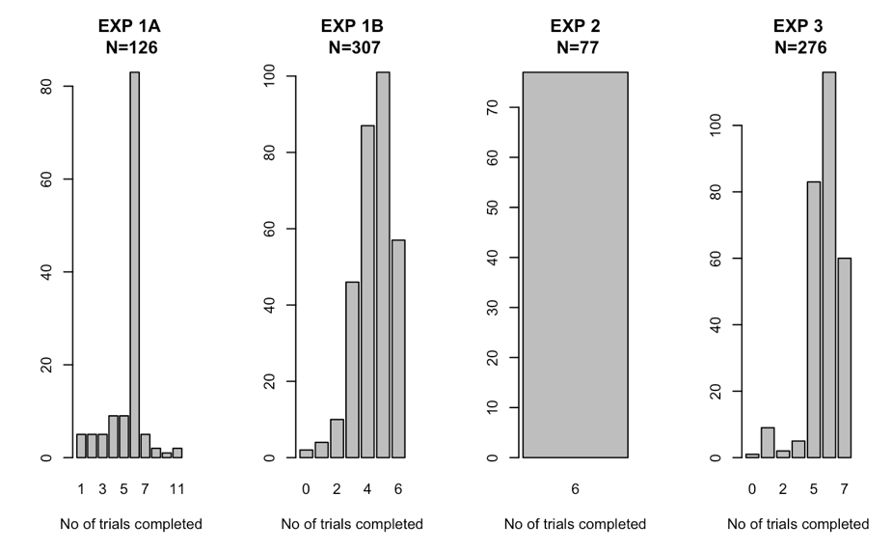

Figure SI A1. Number of trials completed by participants across the three experiments.
In Experiment 1a, 126 participants rated the accuracy of standalone statements on a 6-point Likert scale: the target (Baseline condition), the accurate dressing claim, the inaccurate context claim. Each participant was presented with multiple vignettes, which were pseudo-randomly assigned to one of the three types of statements. On average, participants completed 6 unique vignettes (66%, range: 1-11 vignettes) and saw vignettes in all conditions.

A different group of 307 participants took part in Experiment 1b. They assessed multiple different vignettes (at most 6), which were pseudo-randomly selected from the Experimental and Control conditions in a within-participant design. Additionally, the order of the context claims and the target claim (i.e., presented before or after the target claim) was manipulated. Participants also viewed vignettes in which the inverse target claim was used.

Experiment 2 also had a within-participants design: all 77 participants completed 6 different vignettes, randomly assigned to the Experimental or Control conditions. The critical difference was that the context and the target claims were produced by different communicators.

Experiment 3 was a replication using a betting paradigm instead of accuracy ratings. In a within-participants design, participants saw at most 7 vignettes, randomly assigned to the Baseline condition or the Experimental Condition.

B. Supplementary figures
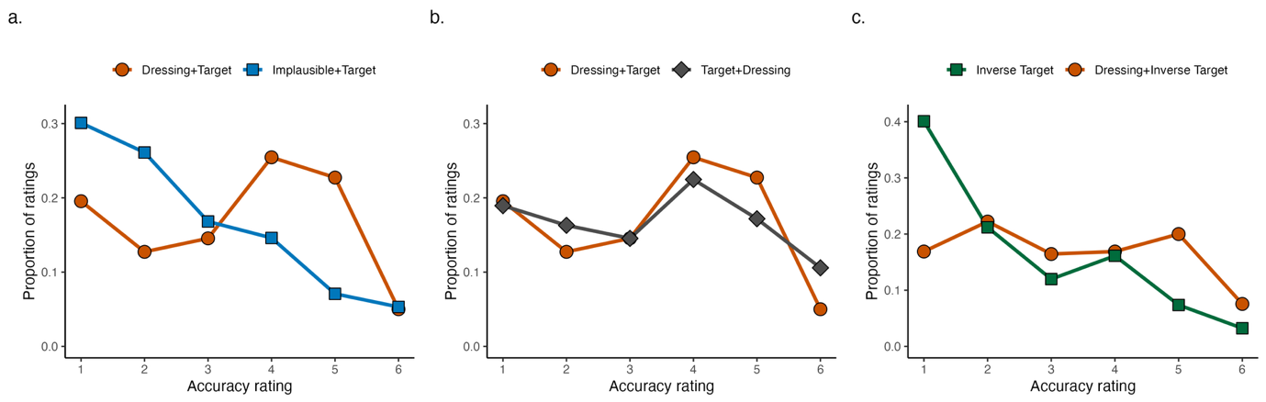
Figure SI B 1 Target claim accuracy ratings in Experiment 1: (a) Prior implausible claims decrease perceived target accuracy; (b) The order of the dressing and target claim does not affect the dressing-up effect; (c) The dressing claim also improves the perceived accuracy of the inverse of the target claim.

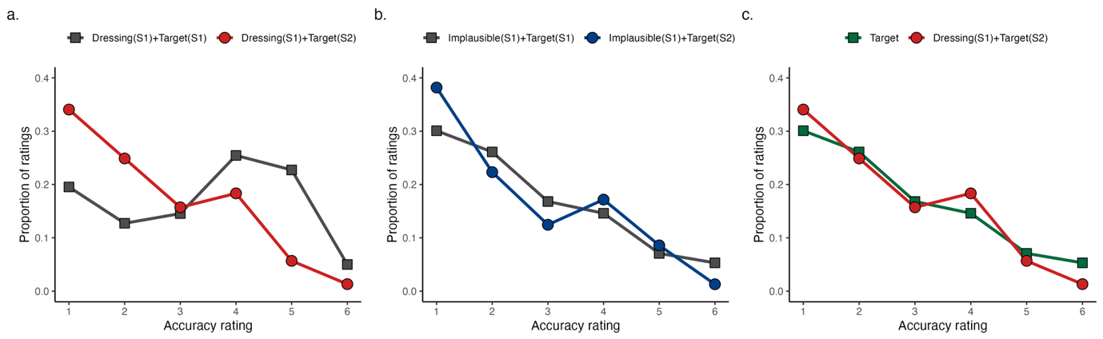
Figure SI B 2. Target claim accuracy ratings in Experiment 2: (a)Target claims were perceived to be more accurate when the dressing claim was produced by the same communicator; (b) There was no difference in target claim perceived accuracy endorsed by the same or another communicator who previously produced an implausible claim. (c) The dressing-up effect does not occur when the dressing and target claims are produced by different communicators.
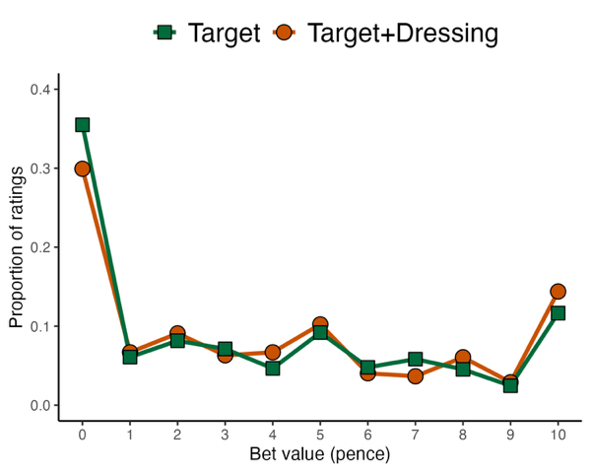
Figure SI B 3. Distribution of bets placed by participants in Experiment 3 as a function of condition.

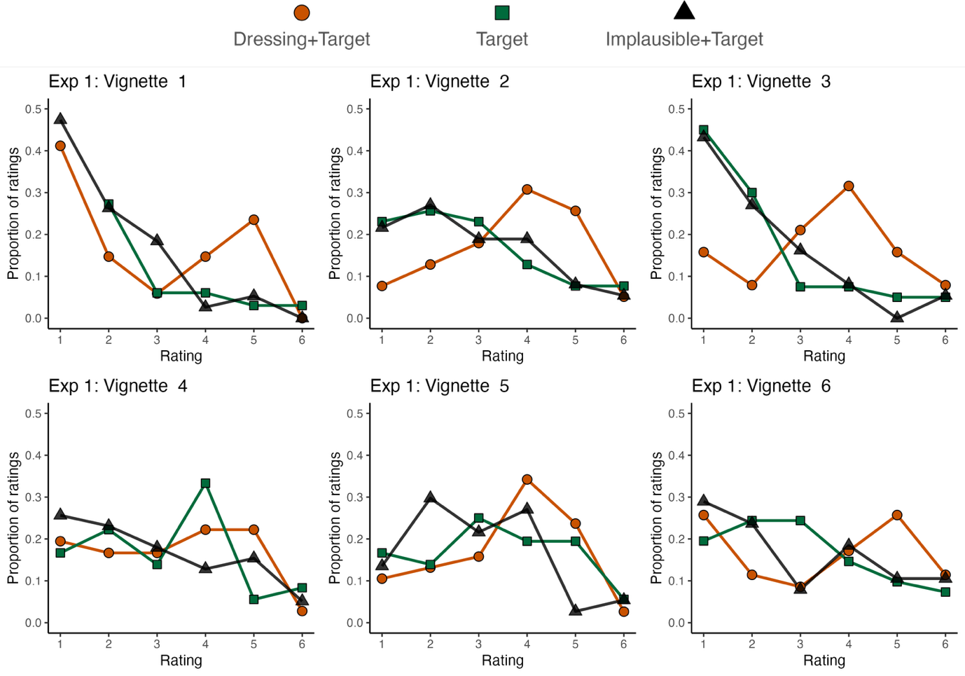
Figure SI B 4. Target claim accuracy ratings in Experiment 1 broken down by vignette identity.

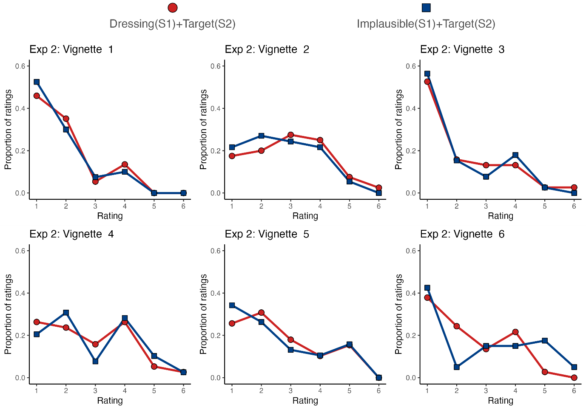

Figure SI B 5. Target claim accuracy ratings in Experiment 2 by vignette identity.

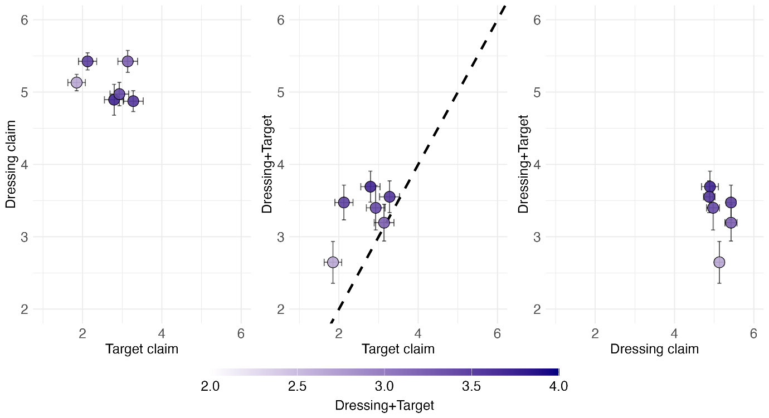
SI B 6. Mean ratings (+/- SEM). Each dot is a vignette, and the colour indicates the magnitude of Dressing+Target condition. The prediction of a rational model (at the individual level) is that the target claim accuracy rating after the dressing claim should be higher when the target claim is more believable (middle) and when the dressing claim is more believable (right). Note that the target claim is more (or at least as) believable after the dressing claim for all vignettes (all dots are above the diagonal in the middle plot).

Supplementary tables

Fixed effects | β | SE | df | t | p
Intercept | 3.37 | .20 | 7.71 | 16.79 | <.001
Condition: Baseline | -.69 | .15 | 391.81 | -4.48 | <.001
Condition:  Control | -.76 | .14 | 628.46 | -5.59 | <.001
Random effects | Variance
Participant | .50
Vignette | .18
Residual | 1.69
Table SI C1. Mixed effects model results for rating accuracy in Experiment 1 (based on n = 350, trials = 671). β = unstandardized coefficient. SE = standard error. df = degrees of freedom. The reference condition is Experimental.

Fixed effects | β | SE | df | t | p
Intercept | 3.37 | .18 | 8.92 | 18.69 | <.001
Condition:Control | -.76 | .13 | 897.37 | -5.84 | <.001
Different sources: yes | -.94 | .15 | 381.01 | -6.21 | <.001
Condition:Different sources | .71 | .18 | 842.60 | 3.98 | <.001
Random effects | Variance
Participant | .68
Vignette | .37
Residual | 1.24
Table SI C2. Mixed effects model results for rating accuracy in Experiment 2 (n = 320, trials = 908). β = unstandardized coefficient. SE = standard error. df = degrees of freedom. The reference condition is Experimental.

Fixed effects | β | Exp(β) | SE | z | p
Intercept | 1.02 | 2.78 | .23 | 4.35 | <.001
Condition: Baseline | -.31 | .73 | .12 | -2.58 | .01
Random effects | Variance
Participant | .69
Vignette | .27
Table SI C3. Binomial generalized linear mixed effects model results for betting in Experiment 3 (n = 275, trials = 1564). β = unstandardized coefficient (log odds). Exp(β) = estimated odds ratios. SE = standard error. df = degrees of freedom. The reference condition is Experimental.

