Supplementary Information
Table S1. Selected chemical properties of soils at the study site.
Location | pH | P | N | K | C | Mg | Ca | EC
Dump-site | 7.4 | 10.99 | 0.35 | 0.56 | 2.10 | 1.30 | 7.21 | 1.97
Upslope control site | 6.74 | 5.77 | 0.16 | 0.11 | 1.36 | 0.82 | 5.90 | 1.31
*EC = electrical conductivity. Units: P, N, K, C, Mg, Ca in g kg⁻¹; EC in dS m⁻¹.
Table S2. Average daily intake (ADI; mg kg⁻¹ day⁻¹) for ingestion and inhalation pathways.
Metal | ADI Ing. Adults | ADI Inh. Adults | ADI Ing. Children | ADI Inh. Children
As | 6.29E−4 | 1.26E−4 | 3.52E−3 | 1.11E−4
Pb | 5.70E−2 | 1.14E−2 | 3.22E−1 | 1.01E−2
Cd | 4.60E−4 | 9.14E−3 | 2.56E−3 | 8.06E−5
Fe | 1.03E+00 | 2.06E−1 | 5.76E+00 | 1.81E−1
Zn | 6.14E−4 | 1.23E−4 | 3.44E−3 | 1.08E−4
Table S3. Monte Carlo simulation summary statistics (ADI proxy; ×10⁻³ mg kg⁻¹ day⁻¹ unless stated).
Statistic | As (Adults) | Pb (Adults) | Cd (Adults) | As (Children) | Pb (Children) | Cd (Children)
Mean | 0.711 | 65.50 | 52.40 | 3.99 | 365.0 | 289.0
Median | 0.616 | 57.10 | 45.50 | 3.46 | 316.0 | 249.0
5th Percentile | 0.248 | 22.90 | 18.00 | 1.41 | 128.0 | 102.0
95th Percentile | 1.490 | 138.0 | 111.0 | 8.43 | 764.0 | 604.0
Std Deviation | 0.413 | 37.70 | 30.80 | 2.34 | 214.0 | 168.0
Table S4. Reference doses and Slope Factors used in computation.
Metal Element | Rf​D Ingestion (mg/kg·day) | Rf​D Inhalation (mg/kg·day) | SF Ingestion (mg/kg·day)⁻¹ | SF Inhalation (mg/kg·day)⁻¹
As | 3.00E-04 | 3.01E-04 | 1.50E+00 | 1.51E-01
Pb | 3.50E-03 | 3.25E-03 | 8.50E-03 | —
Cd | 1.00E-03 | 5.70E-05 | 3.80E-01 | 6.30E+00
Fe | 7.00E-01 | 7.00E-01 | — | —
Zn | 3.00E-01 | 3.00E-01 | — | —
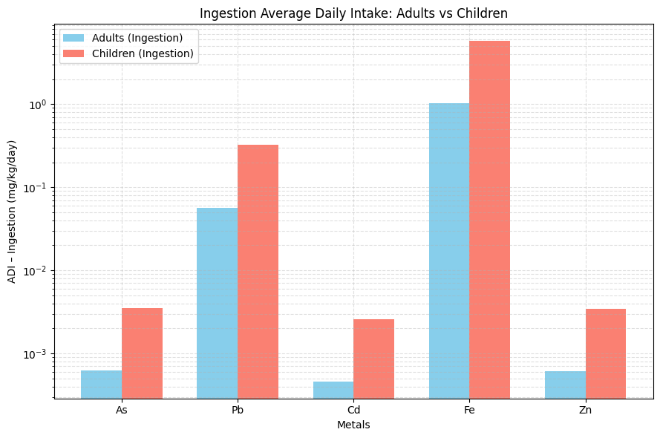
Figure S1. ADI comparison of Adult against Children for ingestion
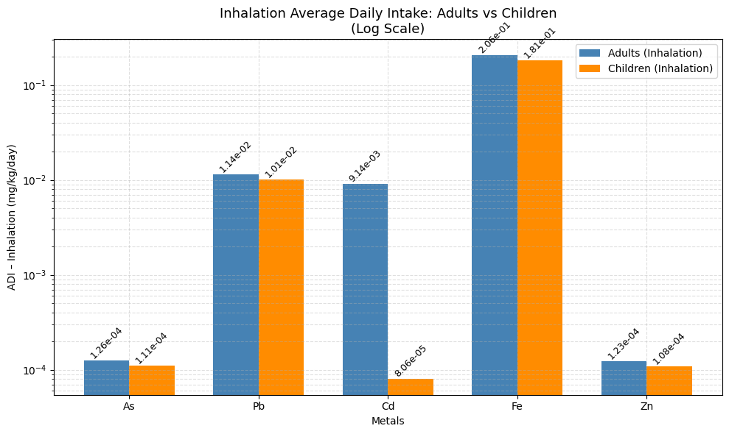
Figure S2. ADI Inhalation comparison for adult vs children
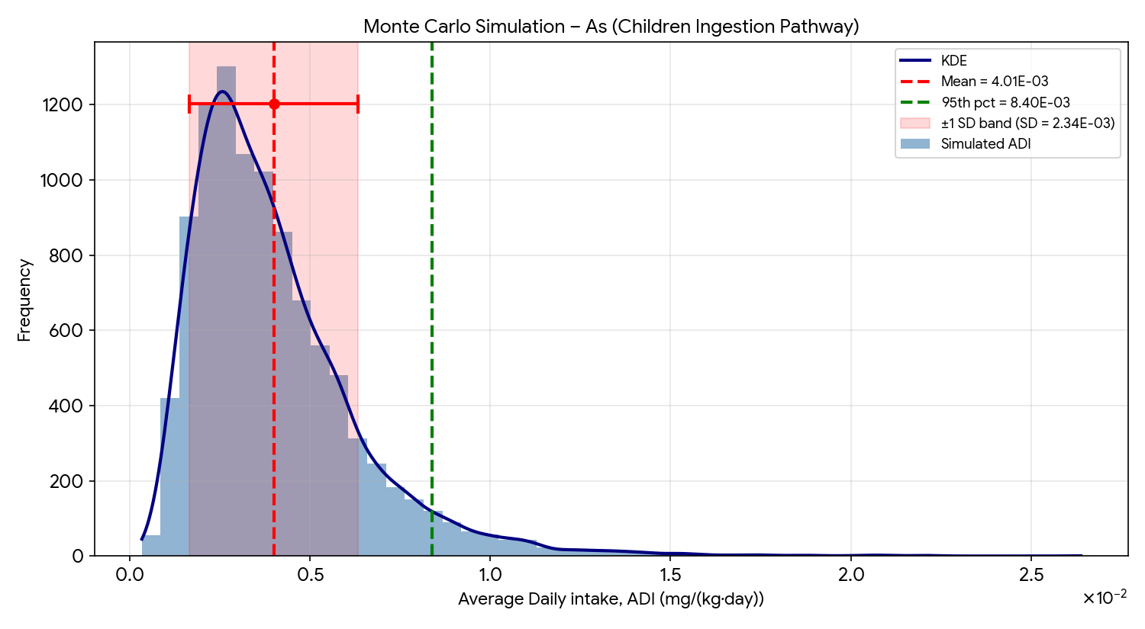
Figure S3. MCS distribution for As (Children Ingestion pathway)
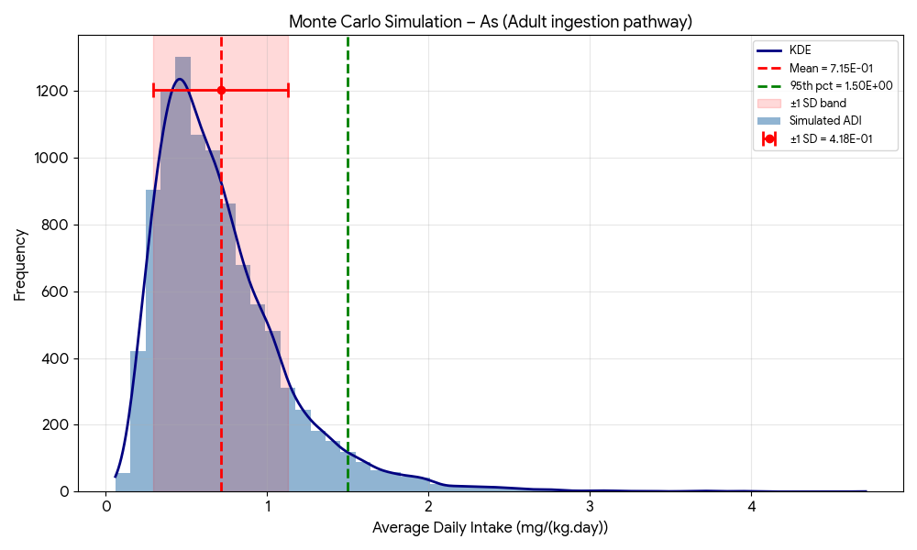
Figure S4: MCS distribution for As (Adult Ingestion pathway)
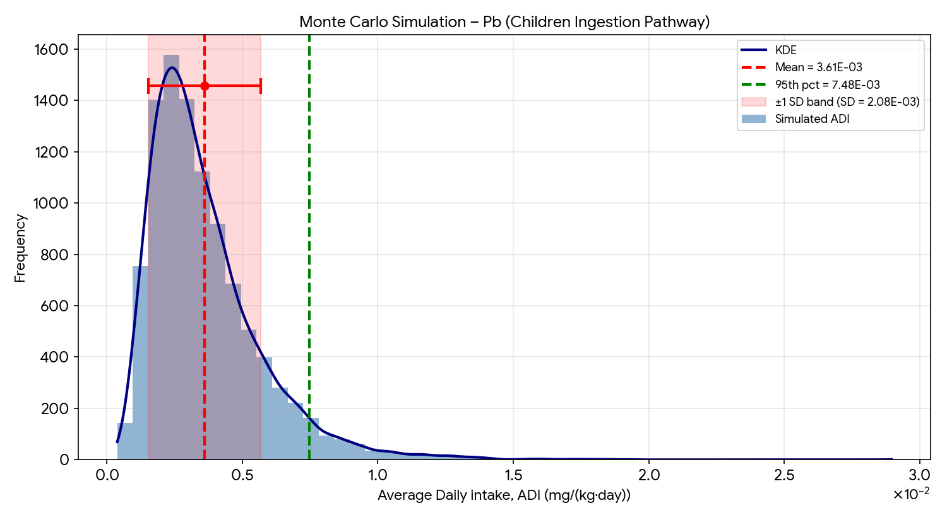
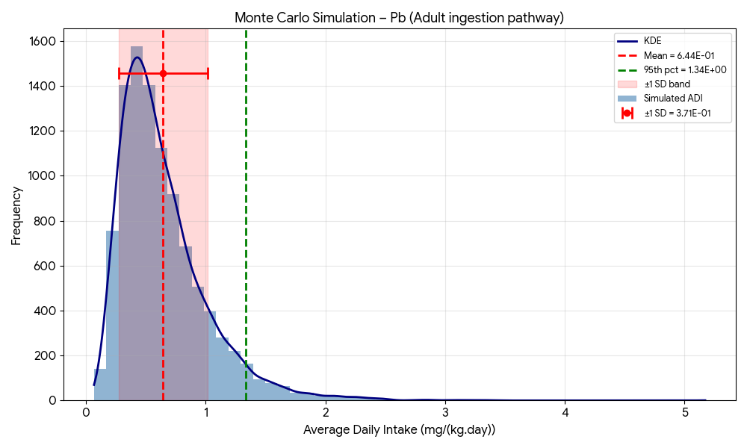
Figure S5: MCS distribution for Pb (Children Ingestion pathway)
Figure S6: MCS distribution for Pb (Adult Ingestion pathway)
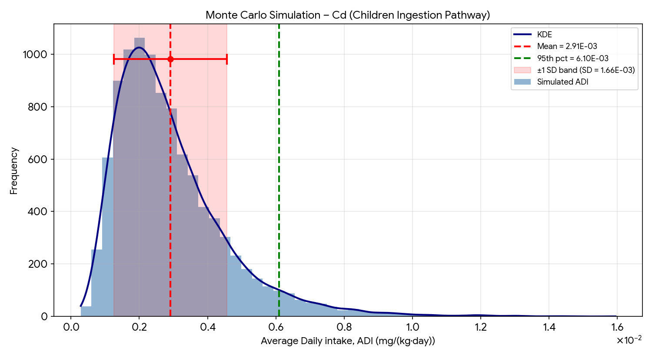
Figure S7: MCS distribution for Cd (Children Ingestion pathway)
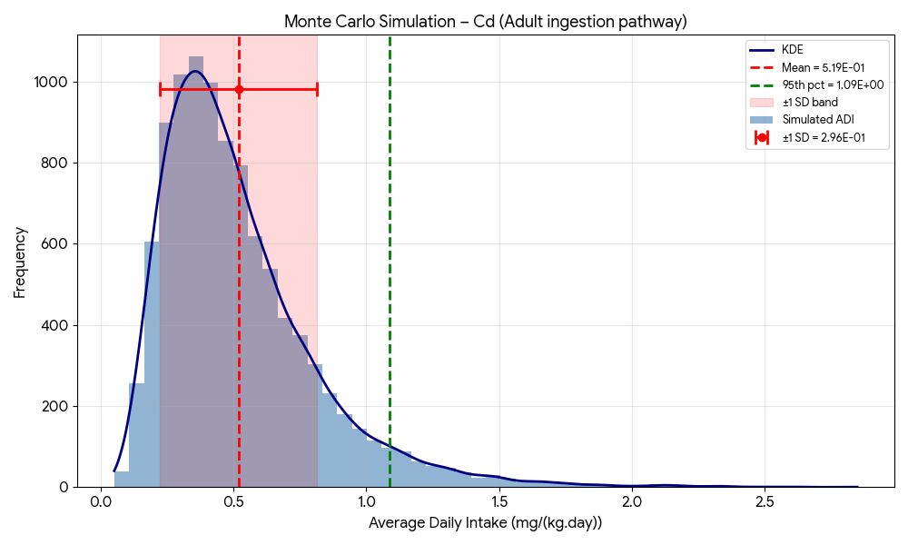
Figure S8: MCS distribution for Cd (Adult Ingestion pathway)

