The effects of oral health education on patients receiving radiation therapy for head and neck cancer in terms of their oral health behaviors, cognition, awareness, and long-term oral hygiene
Chenxi Sun ^{1,†},Qiang Lin ^{2,†},Fengping Zhang ¹, Yunxia Fu ¹,Chenqu Guo ¹,Wenpeng He ^{2,*} and Xi Rui ^{2,*}

¹ School of Stomatology, Jinan University, Guangzhou 510632, China
² Hospital of Stomatology, The First Affiliated Hospital of Jinan University, Guangzhou, 510630, China

* Correspondence:
Wenpeng He, E-mail: hewengpeng@jnu.edu.cn;
Xi Rui, E-mail: ruixi1993@jnu.edu.cn.

† This authors were contributed equally to this work.

Supplementary material
Appendix 1 Stages of nasopharyngeal carcinoma
 | T | N | M
Stage 0 | Tis | N0 | M0
Stage I | T1 | N0 | M0
Stage II | T0-1 | N1 | M0
Stage II | T2 | N0-1 | M0
Stage III | T0-2 | N2 | M0
Stage III | T3 | N0-2 | M0
Stage IVA | T4 | N0-2 | M0
Stage IVA | Any T | N3 | M0
Stage IVB | Any T | Any N | M1

Appendix 2 Stages of Oral Cancer and Oropharyngeal Cancer
 | T | N | M
Stage 0 | Tis | N0 | M0
Stage I | T1 | N0 | M0
Stage II | T2 | N0 | M0
Stage III | T1-2 | N1 | M0
Stage III | T3 | N0-1 | M0
Stage IVA | T1-3 | N2 | M0
Stage IVA | T4a | N0-2 | M0
Stage IVB | T4b | Any N | M0
Stage IVB | Any T | N3 | M0
Stage IVC | Any T | Any N | M1

Appendix 3 Staging of Salivary Gland Cancer
 | T | N | M
Stage 0 | Tis | N0 | M0
Stage I | T1 | N0 | M0
Stage II | T2 | N0 | M0
Stage III | T3 | N0 | M0
Stage III | T0-3 | N1 | M0
Stage IVA | T0-3 | N2 | M0
Stage IVA | T4a | N0-2 | M0
Stage IVB | T4b | Any N | M0
Stage IVB | Any T | N3 | M0
Stage IVC | Any T | Any N | M1

Appendix 4 Questionnaire on the general situation of respondents
Questionnaire on the general situation of respondents
Name: Gender: Age:
Outpatient/inpatient number: Date of survey:
1. Your place of origin:
2. Your highest level of education？
A. uneducated B. primary C. Junior/Secondary/High School D. Bachelor's Degree, Master's Degree and above
3. The type of illness you have is (to be completed by your physician):
4. The stage of your illness is (to be completed by your physician):

Appendix 5 Oral Health Behaviour Questionnaire
Name:
Outpatient/inpatient number: Date of survey:
1. Do you smoke?
A. Smoking B. Never smoked C. Quit smoking after the illness
2. Do you drink alcohol?
A. Every day (more than 1 time/day) B. Weekly (more than 3 times/week) C. Rarely D. Never E. Quit drinking after an illness
3. How often do you brush your teeth?
A. more than or equal to 2 times a day B. 1 time a day C. seldom/never
4. How often do you use toothpicks to clean food debris?
A. more than or equal to 2 times a day B. 1 time a day C. Rarely/never
5. How often do you use toothpick floss to clean food debris?
A. more than or equal to 2 times a day B. 1 time a day C. Rarely/never
6. Do you use toothpaste to clean your teeth?
A. Yes B. No C. Not sure
7. Do you use toothpaste to clean your teeth?
A. Yes B. No C. Not sure

Appendix 6 Oral Health Awareness Survey Scale
1. Do you know how to maintain your oral health?
A. Strongly disagree=1 B. Disagree=2 C. Neutral=3 D. Agree=4 E. Strongly agree=5
2. Do you know the importance of regular visits to the dentist to check for oral problems?
A. Strongly disagree=1 B. Disagree=2 C. Neutral=3 D. Agree=4 E. Strongly agree=5
3. Do you know the oral complications that may result from radiotherapy for head and neck cancer?
A. Strongly disagree=1 B. Disagree=2 C. Neutral=3 D. Agree=4 E. Strongly agree=5
4. Do you know the importance of oral treatment before radiotherapy for head and neck cancer?
A. Strongly disagree=1 B. Disagree=2 C. Neutral=3 D. Agree=4 E. Strongly agree=5
5. Do you know the importance of your own oral hygiene in radiotherapy for head and neck cancer?
A. Strongly disagree=1 B. Disagree=2 C. Neutral=3 D. Agree=4 E. Strongly agree=5
6. Do you know what radiomandibular osteomyelitis is?
A. Strongly disagree=1 B. Disagree=2 C. Neutral=3 D. Agree=4 E. Strongly agree=5
7. Do you know the effects of radiation osteomyelitis of the jaw on your body?
A. Strongly disagree=1 B. Disagree=2 C. Neutral=3 D. Agree=4 E. Strongly agree=5
8. How much do you know about the treatment process and recovery after treatment for radiomandibular osteomyelitis?
A. Strongly disagree=1 B. Disagree=2 C. Neutral=3 D. Agree=4 E. Strongly agree=5
9. Do you know the changes in your oral cavity after radiotherapy for head and neck cancer?
A. Strongly disagree=1 B. Disagree=2 C. Neutral=3 D. Agree=4 E. Strongly agree=5
Appendix 7 Oral Health Awareness Survey Scale
1. Would you like to have your teeth cleaned in the dentistry department before undergoing radiotherapy for head and neck cancer?
A. Strongly disagree=1 B. Disagree=2 C. Neutral=3 D. Agree=4 E. Strongly agree=5
2. If you have severe tooth decay in your mouth that has lost the appearance of normal teeth, would you be willing to have them removed?
A. Strongly disagree=1 B. Disagree=2 C. Neutral=3 D. Agree=4 E. Strongly agree=5
3. If you have a decayed tooth in your mouth, but the tooth has a normal appearance and you have symptoms such as soreness or pain when you bite something, would you be willing to have it removed?
A. Strongly disagree=1 B. Disagree=2 C. Neutral=3 D. Agree=4 E. Strongly agree=5
4. If you have a tooth in your mouth that is very loose and has made it impossible for you to eat or bite, would you be willing to have it removed?
A. Strongly disagree=1 B. Disagree=2 C. Neutral=3 D. Agree=4 E. Strongly agree=5
5. If you have a tooth in your mouth that is slightly loose, but you can still barely eat with it, would you be willing to have it removed?
A. Strongly disagree=1 B. Disagree=2 C. Neutral=3 D. Agree=4 E. Strongly agree=5
6. If you have a tooth in your mouth that is slightly loose, and the X-ray film shows that the bone around the root is badly resorbed, but it does not affect your ability to eat and bite, would you be willing to have it extracted?
A. Strongly disagree=1 B. Disagree=2 C. Neutral=3 D. Agree=4 E. Strongly agree=5
7. If you have braces or dentures in your mouth and they have caused inflammation and pain in your teeth, would you be willing to have the painful teeth removed?
A. Strongly disagree=1 B. Disagree=2 C. Neutral=3 D. Agree=4 E. Strongly agree=5
8. If you have metal dentures or braces in your mouth, would you be willing to have them removed?
A. Strongly disagree=1 B. Disagree=2 C. Neutral=3 D. Agree=4 E. Strongly agree=5
9. If you have a rotten tooth root in your mouth, would you be willing to have it removed?
A. Strongly disagree=1 B. Disagree=2 C. Neutral=3 D. Agree=4 E. Strongly agree=5
10. If you have wisdom teeth that are crooked or have had inflammation in your mouth, would you be willing to have them removed?
A. Strongly disagree=1 B. Disagree=2 C. Neutral=3 D. Agree=4 E. Strongly agree=5
11. If you have ever had a dental implant that contains metal, would you be willing to have it replaced with a metal-free material?
A. Strongly disagree=1 B. Disagree=2 C. Neutral=3 D. Agree=4 E. Strongly agree=5

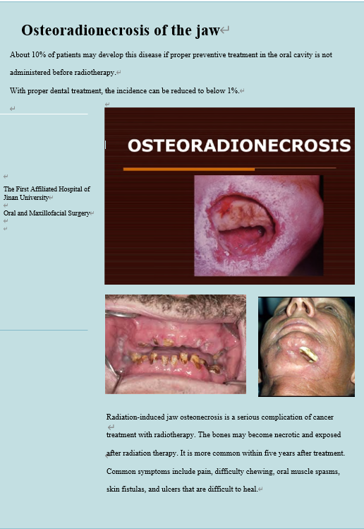
Appendix 8

.

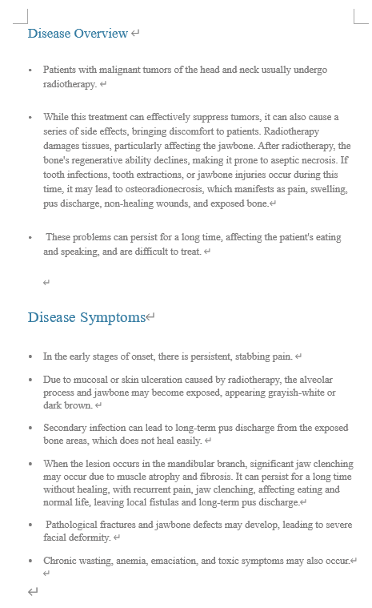
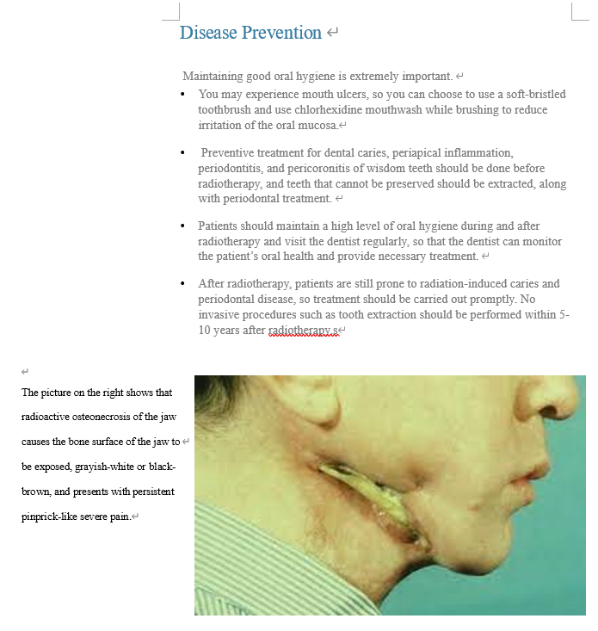

Appendix 9
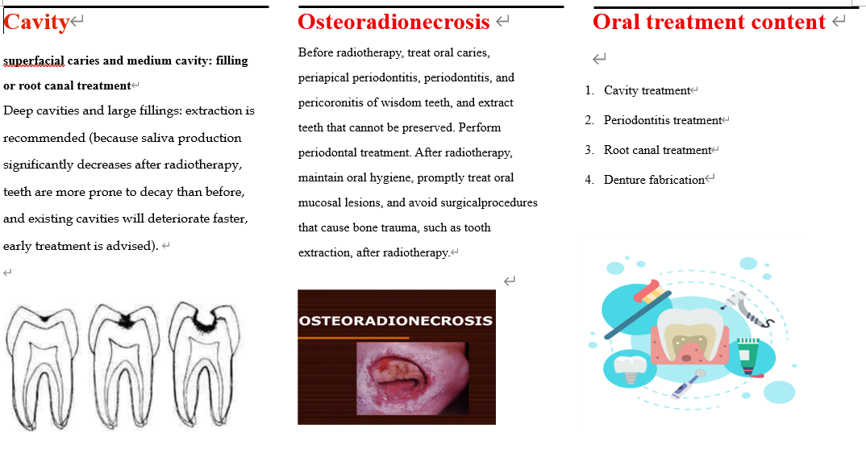

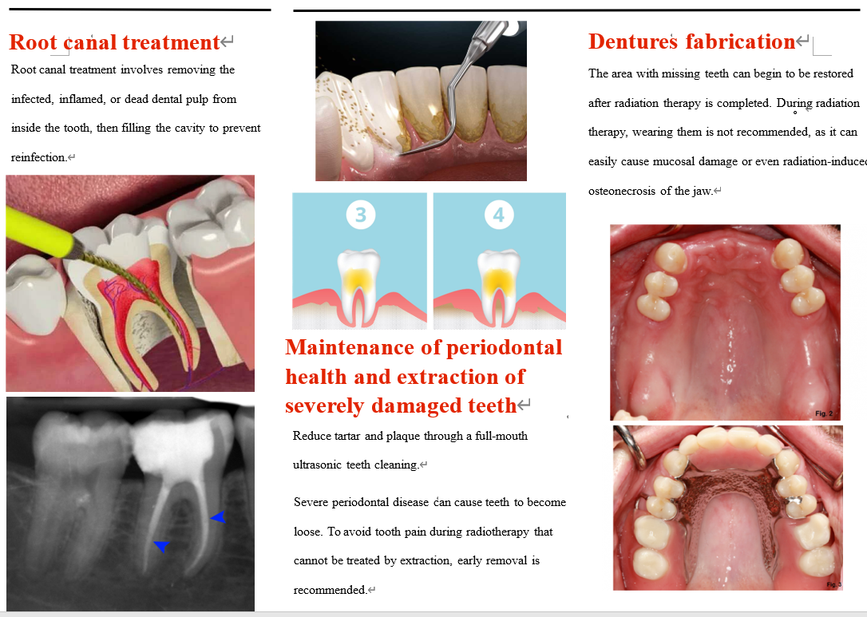

Appendix 10
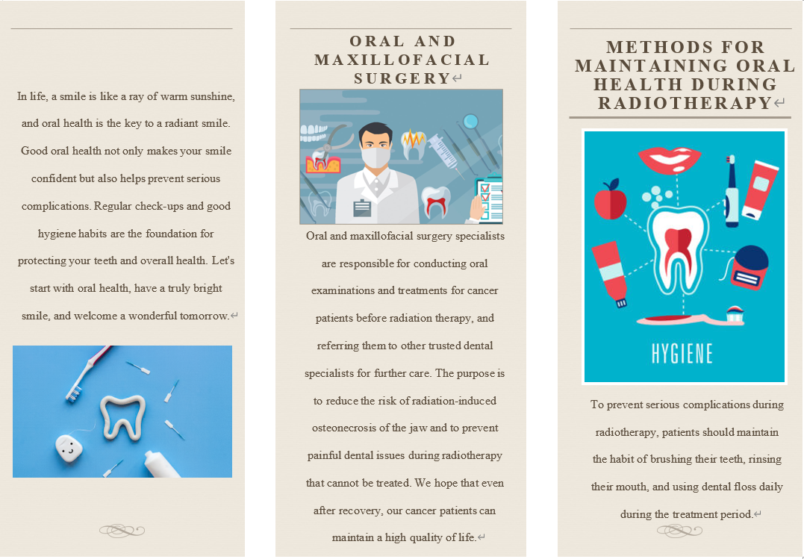

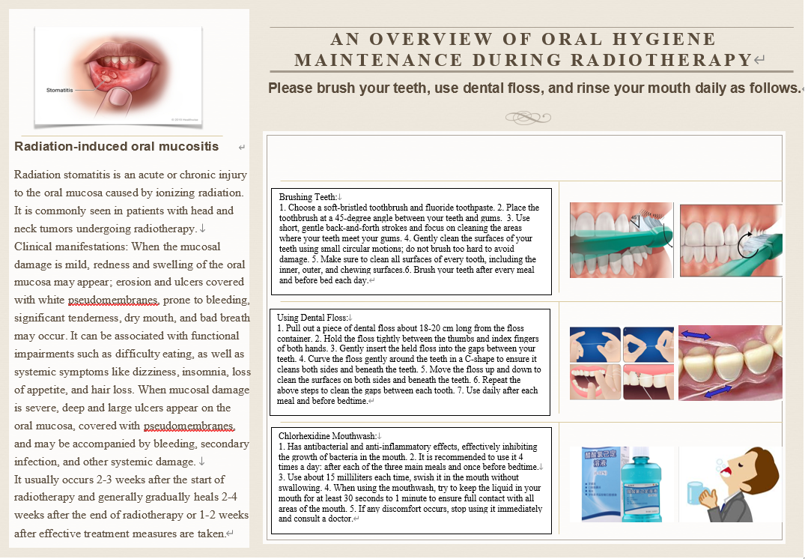

Appendix 11
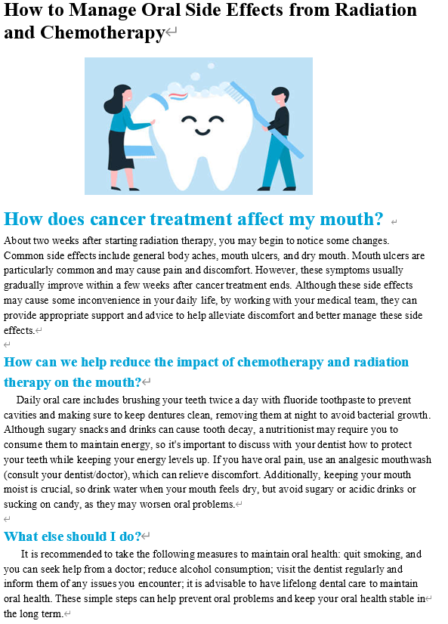

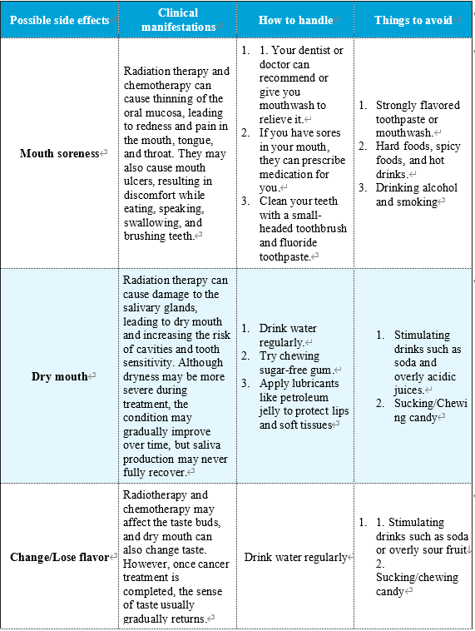

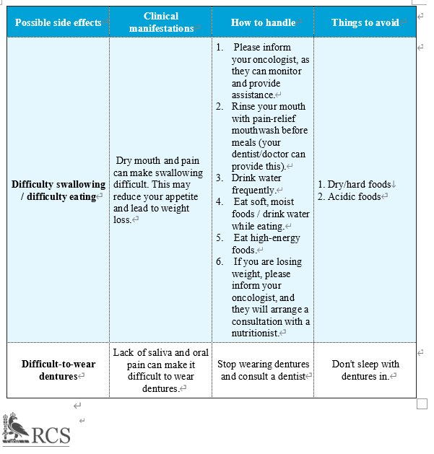
Appendix 12 Oral Health Index
Scoring criteria for Debris Index (DI): 0 = no soft tartar on the tooth surface; 1 = soft tartar covering less than 1/3 of the tooth surface; 2 = soft tartar covering between 1/3 and 2/3 of the tooth surface; 3 = soft tartar covering more than 2/3 of the tooth surface.
Calculus Index (CI) scoring criteria: 0 = supragingival and subgingival no tartar; 1 = supragingival stone covers less than 1/3 of the tooth surface; 2 = supragingival stone covers between 1/3 and 2/3 of the tooth surface, or there are scattered subgingival stones in the neck of the tooth; 3 = supragingival stone covers more than 2/3 of the tooth surface, or there is a continuous and thick subgingival stone in the neck of the tooth.
Plaque index (plaque index, PLI) scoring criteria: 0 = no plaque near the gingival margin; 1 = thin plaque near the gingival margin, but visual inspection is not visible, if the side of the probe tip can be scraped plaque; 2 = in the gingival margin or the neighbouring surfaces of the moderate amount of plaque; 3 = the gingival sulcus or the gingival margin and the neighbouring surfaces of a large number of plaque.
Scoring criteria for the gingival index (CI): 0 = healthy gingiva; 1 = mild inflammation of the gingiva, mild change in gingival colour, mild oedema, no bleeding on palpation; 2 = moderate inflammation of the gingiva, red gingival colour, shiny oedema, bleeding on palpation; 3 = severe inflammation of the gingiva, with marked redness, swelling and ulceration of the gingiva, and a tendency to bleed spontaneously.

Appendix 13 Participants' oral health cognition before and after oral health education
Variable | Before oral education | After oral education
Drinking?
Every day (More than 1 time a day) | 3 (4.8) | 0.0
Every week (More than 3 times a week) | 3 (4.8) | 0 (0)
Seldom | 22 (34.9) | 2 (3.2)
Never | 24 (38.1) | 49 (77.8)
Have quit drinking after being ill | 11 (17.5) | 12 (19.0)
Smoking？
Yes | 20 (31.7) | 11 (17.5)
Never | 23 (36.5) | 22 (34.9)
Have quit smoking after being ill | 20 (31.7) | 30 (47.6)
How often you brush your teeth?
More than twice a day | 26 (41.3) | 56 (88.9)
Once a day | 35 (55.6) | 7 (11.1)
Seldom/never | 2 (3.2) | 0 (0)
How often you use toothpicks?
More than twice a day | 28 (44.4) | 39 (61.9)
Once a day | 12 (19.0) | 15 (23.8)
Seldom/never | 23 (36.5) | 9 (14.3)
How often you use dental floss?
More than twice a day | 3 (4.8) | 9 (14.3)
Once a day | 3 (4.8) | 14 (22.2)
Seldom/never | 57 (90.5) | 40 (63.5)
Do you use toothpaste?
Yes | 63 (100) | 63 (100)
No | 0 (0) | 0 (0)
No Opinion | 0 (0) | 0 (0)
Do you use Fluoride toothpaste?
Yes | 34 (54.0) | 63 (100)
No | 6 (9.5) | 0 (0)
No Opinion | 23 (36.5) | 0 (0)

Appendix 14 Participants' oral health cognition before oral health education
Variable | Strongly Agree | Agree | Netural | Disagree | Strongly Disagree
You know how to maintain your oral hygiene. | 3 (4.8) | 7 (11.1) | 23 (36.5) | 18 (28.6) | 12 (19.0)
You know the importance of regular dental visits to check for oral problems. | 3 (4.8) | 3 (4.8) | 11 (17.5) | 26 (41.3) | 20 (31.7)
You know the oral complications that can result after radiation therapy for head and neck cancers. | 1 (1.6) | 4 (6.3) | 8 (12.7) | 20 (31.7) | 30 (47.6)
You know the importance of oral treatment before radiotherapy for head and neck cancers. | 2 (3.2) | 2 (3.2) | 9 (14.3) | 19 (30.2) | 31 (49.2)
You know the importance of oral hygiene in radiation therapy for head and neck cancers. | 3 (4.8) | 2 (3.2) | 7 (11.1) | 21 (33.3) | 30 (47.6)
You know the definition of radiation osteomyelitis of the jaw. | 1 (1.6) | 2 (3.2) | 5 (7.9) | 20 (31.7) | 35 (55.6)
You know the effects of radiation osteomyelitis on your body. | 1 (1.6) | 2 (3.2) | 5 (7.9) | 21 (33.3) | 34 (54.0)
You know the course of treatment for radiation jaw osteomyelitis and the recover after treatment. | 1 (1.6) | 2 (3.2) | 4 (6.3) | 21 (33.3) | 35 (55.6)
You know what happens in your mouth after radiation therapy for head and neck cancer. | 1 (1.6) | 2 (3.2) | 7 (11.1) | 18 (28.6) | 35 (55.6)

Appendix 15 Participants' oral health cognition after oral health education.
Variable | Strongly Agree | Agree | Netural | Disgree | Strongly Disagree
You know how to maintain your oral hygiene. | 4 (6.3) | 34 (54.0) | 23 (36.5) | 2 (3.2) | 0 (0.0)
You know the importance of regular dental visits to check for oral problems. | 4 (6.3) | 35 (55.6) | 22 (34.9) | 2 (3.2) | 0 (0.0)
You know the oral complications that can result after radiation therapy for head and neck cancers. | 3 (4.8) | 23 (36.5) | 31 (49.2) | 6 (9.5) | 0 (0.0)
You know the importance of oral treatment before radiotherapy for head and neck cancers. | 3 (4.8) | 23 (36.5) | 31 (49.2) | 6 (9.5) | 0 (0.0)
You know the importance of oral hygiene in radiation therapy for head and neck cancers. | 3 (4.8) | 22 (34.9) | 32 (50.8) | 6 (9.5) | 0 (0.0)
You know the definition of radiation osteomyelitis of the jaw. | 2 (3.2) | 20 (31.7) | 36 (57.1) | 5 (7.9) | 0 (0.0)
You know the effects of radiation osteomyelitis on your body. | 2 (3.2) | 20 (31.7) | 36 (57.1) | 5 (7.9) | 0 (0.0)
You know the course of treatment for radiation jaw osteomyelitis and the recover after treatment. | 2 (3.2) | 20 (31.7) | 35 (55.6) | 6 (9.5) | 0 (0.0)
You know what happens in your mouth after radiation therapy for head and neck cancer. | 2 (3.2) | 20 (31.7) | 36 (57.1) | 5 (7.9) | 0 (0.0)

Appendix 16 Participants' oral health awareness before oral health education
Variable | Strongly Agree | Agree | Netural | Disgree | Strongly Disagree
You are willing to have your teeth cleaned before radiotherapy for head and neck cancer. | 11 (17.5) | 19 (30.2) | 16 (25.4) | 8 (12.7) | 9 (14.3)
If you have severe tooth decay which have lost the normal shape, you are willing to have it removed. | 8 (12.7) | 26 (41.3) | 10 (15.9) | 13 (20.6) | 6 (9.5)
If you have tooth decay but have a normal appearance, they have symptoms such as soreness or pain when biting, you are willing to have it removed. | 6 (9.5) | 25 (39.7) | 5 (7.9) | 19 (30.2) | 8 (12.7)
If you have a tooth that is very loose and can no longer eat, you are willing to have it removed. | 8 (12.7) | 29 (46.0) | 10 (15.9) | 12 (19.0) | 4 (6.3)
If you have a slightly loose tooth but can still barely eat with it, you are willing to have it removed. | 6 (9.5) | 16 (25.4) | 11 (17.5) | 22 (34.9) | 8 (12.7)
If you have a tooth that is slightly loose and X-rays show that the bone around the root of the tooth is resorbent, but does not interfere with eating, you are willing to have it removed. | 5 (7.9) | 15 (23.8) | 10 (15.9) | 24 (38.1) | 9 (14.3)
If you have dentures and they have caused your teeth to become inflamed and painful, you are willing to have the painful teeth removed. | 8 (12.7) | 26 (41.3) | 12 (19.0) | 11 (17.5) | 6 (9.5)
If you have dentures or crowns that contain metal, you are willing to remove them. | 10 (15.9) | 19 (30.2) | 14 (22.2) | 15 (23.8) | 5 (7.9)
If you have a rotten tooth root, you are willing to have it removed. | 13 (20.6) | 27 (42.9) | 10 (15.9) | 9 (14.3) | 4 (6.3)
If your wisdom teeth are crooked or have been inflamed in the past, you are willing to have them removed. | 14 (22.2) | 22 (34.9) | 13 (20.6) | 11 (17.5) | 3 (4.8)
If you have had a tooth in the past and it is made of metal, you are willing to replace it with a metal-free material. | 11 (17.5) | 18 (28.6) | 23 (36.5) | 7 (11.1) | 4 (6.3)

Appendix 17 Participants' oral health awareness after oral health education
Variable | Strongly Agree | Agree | Netural | Disagree | Strongly Disagree
You are willing to have your teeth cleaned before radiotherapy for head and neck cancer. | 25 (39.7) | 29 (46.0) | 8 (12.7) | 1 (1.6) | 0 (0.0)
If you have severe tooth decay which have lost the normal shape, you are willing to have it removed. | 25 (39.7) | 27 (42.9) | 10 (15.9) | 1 (1.6) | 0 (0.0)
If you have tooth decay but have a normal appearance, they have symptoms such as soreness or pain when biting, you are willing to have it removed. | 24 (38.1) | 27 (42.9) | 11 (17.5) | 1 (1.6) | 0 (0.0)
If you have a tooth that is very loose and can no longer eat, you are willing to have it removed. | 25 (39.7) | 25 (39.7) | 10 (15.9) | 3 (4.8) | 0 (0.0)
If you have a slightly loose tooth but can still barely eat with it, you are willing to have it removed. | 24 (38.1) | 24 (38.1) | 13 (20.6) | 2 (3.2) | 0 (0.0)
If you have a tooth that is slightly loose and X-rays show that the bone around the root of the tooth is resorbent, but does not interfere with eating, you are willing to have it removed. | 24 (38.1) | 23 (36.5) | 13 (20.6) | 3 (4.8) | 0 (0.0)
If you have dentures and they have caused your teeth to become inflamed and painful, you are willing to have the painful teeth removed. | 24 (38.1) | 26 (41.3) | 11 (17.5) | 2 (3.2) | 0 (0.0)
If you have dentures or crowns that contain metal, you are willing to remove them. | 26 (41.4) | 19 (30.2) | 16 (25.4) | 2 (3.2) | 0 (0.0)
If you have a rotten tooth root, you are willing to have it removed. | 28 (44.4) | 23 (36.5) | 10 (15.9) | 2 (3.2) | 0 (0.0)
If your wisdom teeth are crooked or have been inflamed in the past, you are willing to have them removed. | 2 (3.2) | 23 (36.5) | 12 (19.0) | 2 (3.2) | 0 (0.0)
If you have had a tooth in the past and it is made of metal, you are willing to replace it with a metal-free material. | 25 (39.7) | 19 (30.2) | 17 (27.0) | 2 (3.2) | 0 (0.0)

