Supplement 4: Replication of the CII in the NHS2 cohort
Contents
Questions used for derivation of the neuroticism score in the NHS2 2
Neuroticism distribution in the UKB EUR women 2
Neuroticism distribution in the NHS2 : 2
Questions used in the UKB to assess neuroticism (QU1-QU12) and their suggested equivalents in the NHS2 (QN1-QN32) 3
Table N1: NHS2 questions used as an equivalent to each of 12 neuroticism score questions used to assess neuroticism in the UKB. 1
CII among UKB women and in the NHS2 cohort 1
Table N2: Baseline characteristics of N=164,462 genotyped, European ancestry women from the UK Biobank with available CII assessments, by CII value and CII components. 1
Table N3: Characteristics of N=11,351 genotyped, European ancestry women from the NHS2 with available CII assessments, by CII value and CII components. 3
Age adjusted odds ratios for estimated cardiovascular-kidney-metabolic (eCKM) risk in the Nurses’ Health Study II 5
Table N4: Age adjusted odds ratios (ORs) with 95% CI for estimated cardiovascular kidney-metabolic (eCKM) risk among N= 50,900 European ancestry female nurses from the Nurses’ Health Study II (NHS2) stratified by Circadian Imbalance Index (CII) 5
Table N5. Age adjusted odds ratios (ORs) with 95% CI for estimated cardiovascular-kidney-metabolic (eCKM) risk among N= 50,900 European ancestry female nurses from the Nurses’ Health Study II (NHS2) stratified by Circadian Imbalance Index (CII) levels and a cumulative duration of shift work (never, less than 20 years or 20+years of shift work). 5
Table N6. Age adjusted* odds ratios (ORs) with 95% CI for estimated cardiovascular-kidney-metabolic (eCKM) risk among N= 50,900 European ancestry female nurses from the Nurses’ Health Study II (NHS2) stratified by Circadian Imbalance Index (CII) levels and a cumulative duration of shift work (never, less than 5 years or 5+ years of shift work). 6
Table N7. Age adjusted* odds ratios (ORs) with 95% CI for estimated cardiovascular-kidney-metabolic (eCKM) risk among N=11,344 European ancestry female nurses from the Nurses’ Health Study II (NHS2) stratified by cumulative duration of shift work (never, less than 5 years or 5+ years of shift work). 6
Distributions of the CII and its components in the UKB women and NHS2 7
Figure N1. Correlation between the CII and its components in the NHS2 8
References 9

Questions used for derivation of the neuroticism score in the NHS2
In the UKB neuroticism was defined as described in Smith et.al ¹, based on 12 questions, categorized in three neuroticism clusters: worry, depressed affect and sensitivity to environmental stress and adversity (SESA). To construct neuroticism in the NHS2 we collected questions from NHS2 questionnaires capturing the same or closely related aspects of personality (Table N1) and combined responses to them as a replacement for each UKB question. Responses to each question were dichotomized (Table N1) and - in case of repeated assessments for a participant over years and in case of several NHS2 questions corresponding to one UKB question- NHS2 responses were combined into one using ‘OR’ logic. (1=YES, 0=NO).

Neuroticism distribution in the UKB EUR women
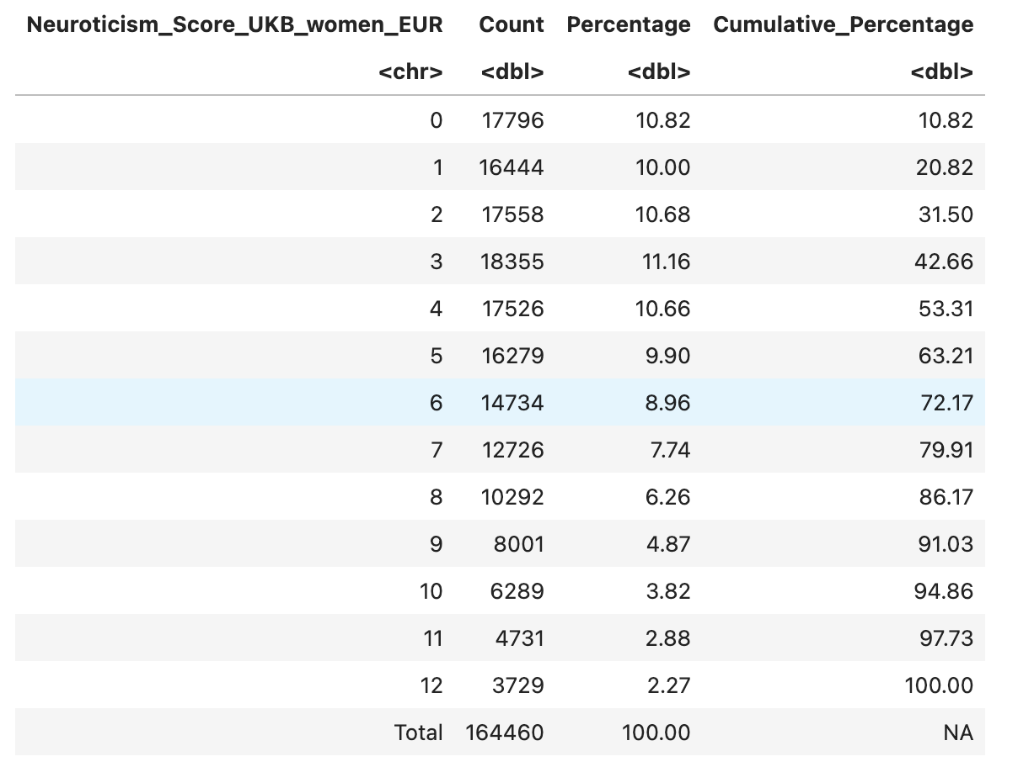

Neuroticism distribution in the NHS2 :
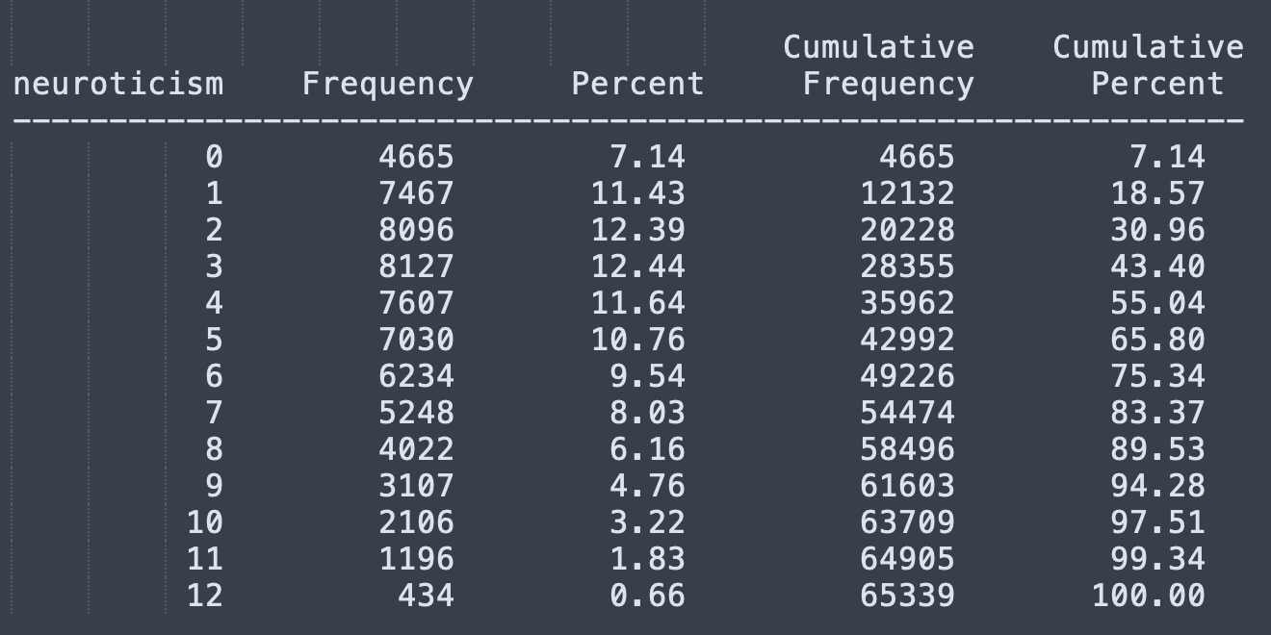

Questions used in the UKB to assess neuroticism (QU1-QU12) and their suggested equivalents in the NHS2 (QN1-QN32)
Worry (QU1-QU4)
QU1: Are you a worrier? Data-Field 1980
Distribution among UKB EUR women
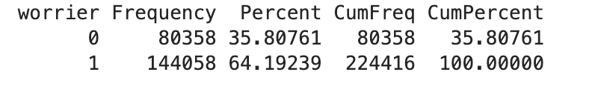
Assessment in the NHS2 (QN1 -QN4):
QN1:Over the last 4 weeks, how often have you been bothered by any of the following problems? Not being able to stop or control worrying
QN2: Feeling afraid as if something awful might happen
QN3 Do you find yourself worrying about getting some incurable illness?
QN4 Do you worry unduly when relatives are late coming home?
Distribution among NHS2 women
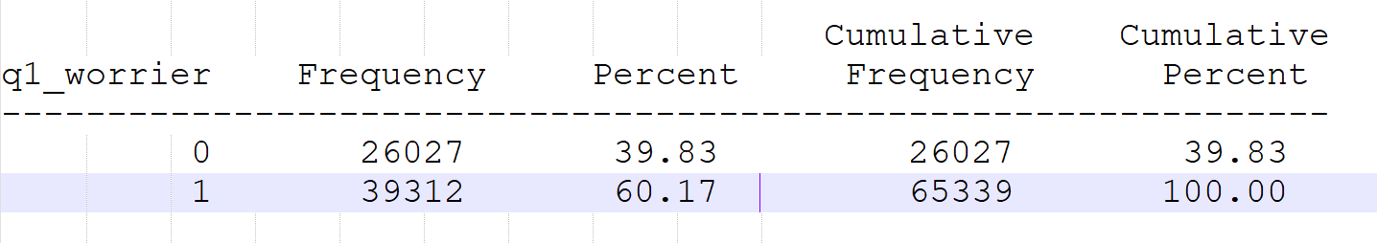

QU2: Do you suffer from 'nerves'? Data Field 2010
Distribution among UKB EUR women
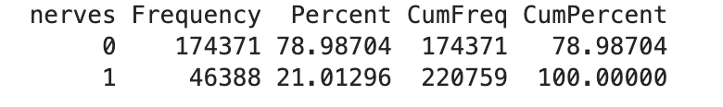
Assessment in the NHS2: (QN5-QN6)
QN5:Over the last 4 weeks, how often have you been bothered by any of the following problems? Feeling nervous, anxious or on edge
QN6 During the past 4 weeks, have you had any of the following problems with your work or other regular daily activities as a result of any emotional problems (such as feeling depressed or anxious)? Cut down the amount of time you spent on work or other activities
Distribution among NHS2 women
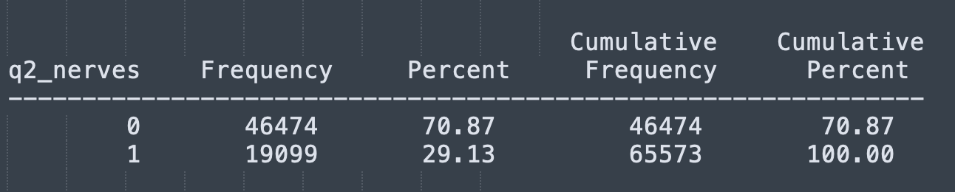

QU3: Would you call yourself a nervous person? Data field 1970
Distribution among UKB EUR women
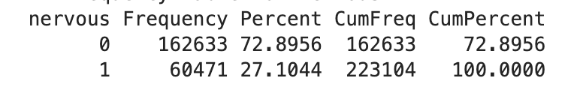
Assessment in the NHS2: QN7
QN7:How much of the time during the past 4 weeks: Have you been a very nervous person?
Distribution among NHS2 women
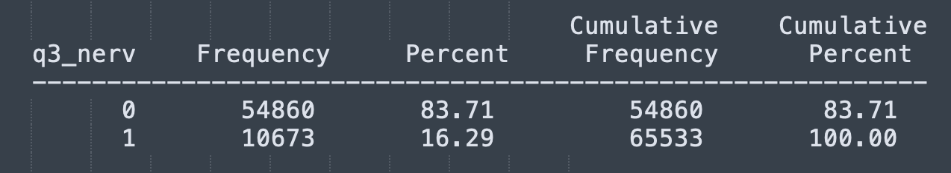

QU4: Would you call yourself tense or 'highly strung'? Data field 1990
Distribution among UKB EUR women
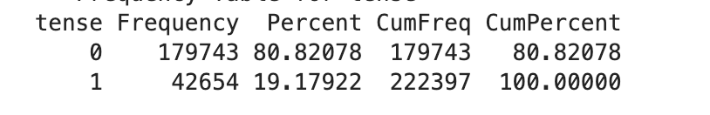
Assessment in the NHS2: (QN8-QN9)
QN8: Over the last 4 weeks, how often have you been bothered by any of the following problems?
- Trouble relaxing
- Being so restless that it is hard to sit still
QN9: How much of the time during the past 4 weeks :Have you felt calm and peaceful?
Distribution among NHS2 women
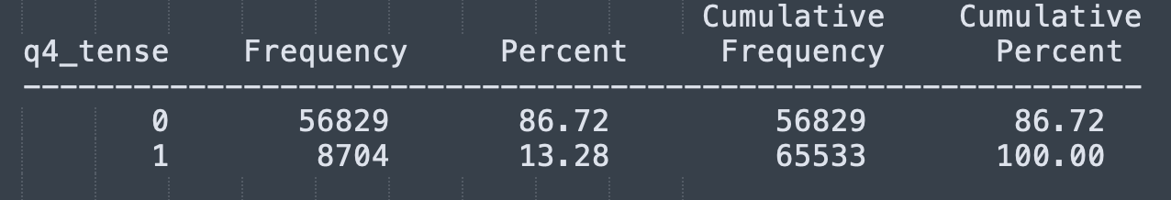

Depressed affect (QU5-QU8)

QU5: Do you often feel lonely? Data field 2020
Distribution among UKB EUR women
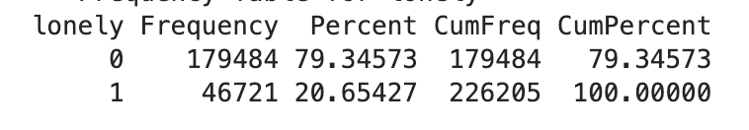
Assessment in the NHS2: QN10
QN10:during the past month : I felt lonely
Distribution among NHS2 women
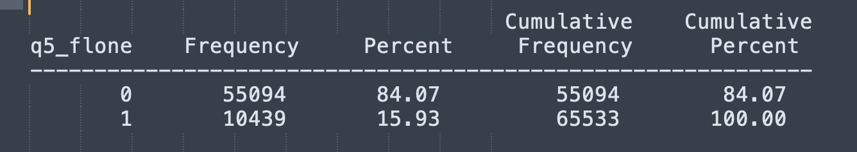
QU6: Do you ever feel 'just miserable' for no reason? Data field 1930
Distribution among UKB EUR women
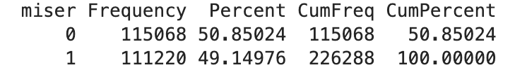
Assessment in the NHS2: (QN11-QN15)
QN11:How much of the time during the past 4 weeks
- Have you felt so down in the dumps nothing could cheer you up?
- Have you felt downhearted and blue?
- Did you feel worn out?

QN12:during the past month.
- I felt depressed.
- I felt that everything I did was an effort.
- I could not “get going”.
- I felt fearful.

QN13:Over the last 2 weeks, how often have you been bothered by the following problems? Feeling down, depressed, or hopeless
QN14 In your lifetime, have you ever had two weeks or longer when nearly every day you felt sad, blue, or depressed for most of the day?
QN15 In the past two years, has there been a time lasting 2 weeks or longer: When most of the day you felt sad, empty or depressed?
Distribution among NHS2 women
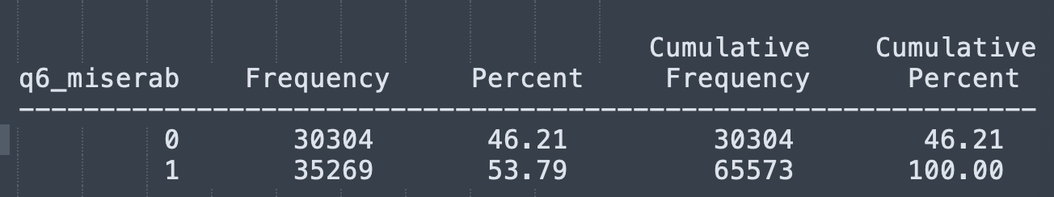

QU7: Does your mood often go up and down? Data field 1920
Distribution among UKB EUR women
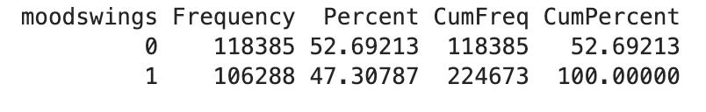
Assessment in the NHS2: QN16
QN16: Please indicate how often you have felt this way. During the past month I was bothered by things that usually don’t bother me.
Distribution among NHS2 women
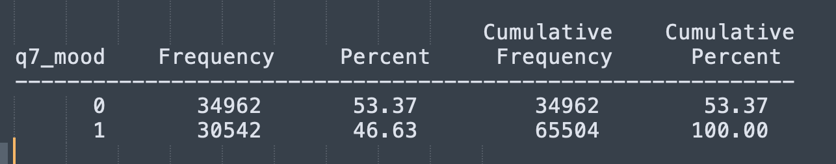

QU8: Do you often feel 'fed-up'? Data field 1960
Distribution among UKB EUR women
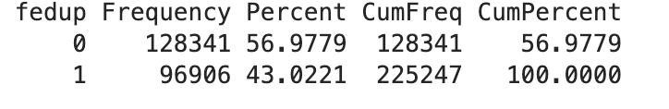
Assessment in the NHS2: (QN17-QN19)
QN17 How much of the time during the past 4 weeks...
- Have you felt no interest in things?
- Did you feel tired?

QN18 In the past two years, has there been a time lasting 2 weeks or longer:
- When most of the day you were very discouraged about how things were going in your life?
- When you lost interest in most things you usually enjoy like work, hobbies, and personal relationships?

QN19 There are many ways to try to deal with problems. These items ask what you do, in general, to cope with the stress in your life.
- I give up trying to deal with things.
- I give up the attempt to cope.

Distribution among NHS2 women
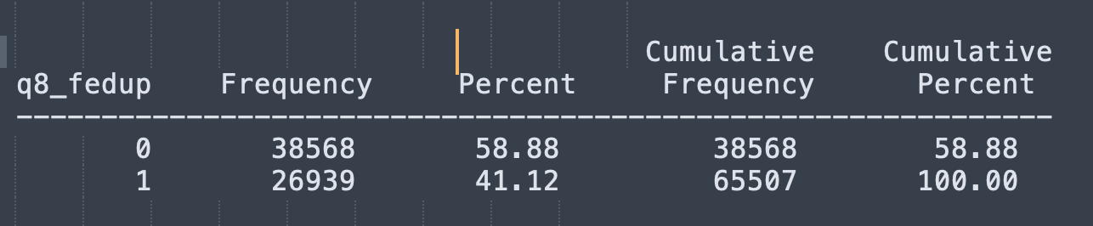

SESA (sensitivity to environmental stress and adversity; QU9-QU12)
QU9: Are your feelings easily hurt? Data field 1950
Distribution among UKB EUR women
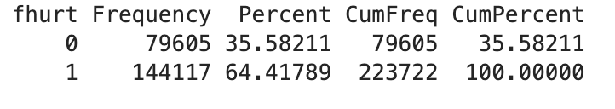
Assessment in the NHS2: (QN20-QN21)
QN20: In the past two years, has there been a time lasting 2 weeks or longer: When most days you felt much more anxious and worried than other people with the same problems as you?
QN21 Please indicate the extent to which you agree or disagree with the following statements.
- If something can go wrong with me, it will.
- I hardly ever expect things to go my way.
- I rarely count on good things happening to me.

Distribution among NHS2 women
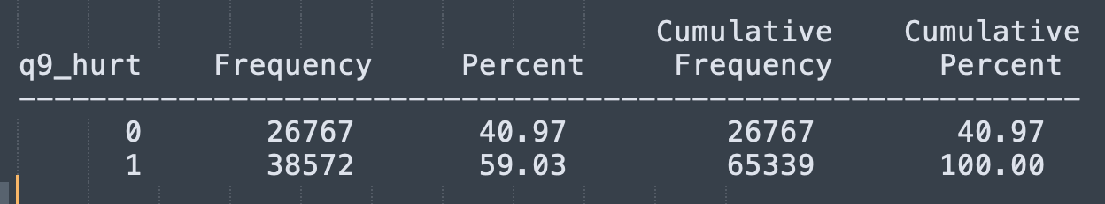

QU10: Do you worry too long after an embarrassing experience? Data field 2000
Distribution among UKB EUR women
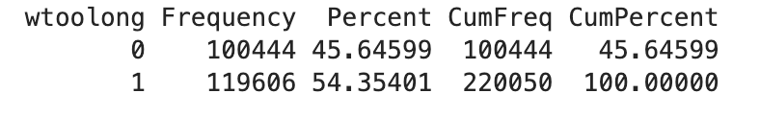
Assessment in the NHS2: QN22
QN22:Over the last 4 weeks, how often have you been bothered by any of the following problems? Worrying too much about different things
Distribution among NHS2 women
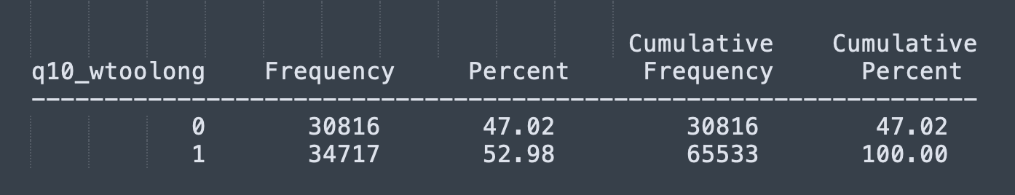

QU11: Are you often troubled by feelings of guilt? Data field 2030
Distribution among UKB EUR women
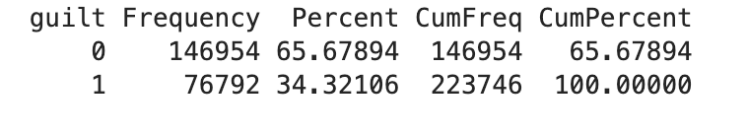
Assessment in the NHS2: (QN23-QN24)
QN23:What you do, in general, to cope with the stress in your life.
- I blame myself for things that happened.
- I criticize myself.

QN24 In your life, have you ever had any experience that was so frightening, horrible, or upsetting that, in the past month, you: Felt guilty or unable to stop blaming yourself or others for the event
Distribution among NHS2 women
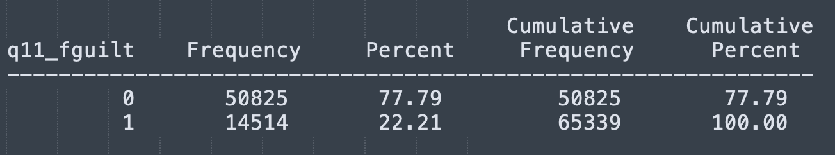

QU12: Are you an irritable person? Data field 1940
Distribution among UKB EUR women
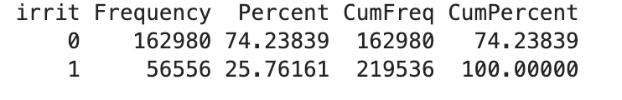
Assessment in the NHS2: (QN25-QN26)
QN25:How much of the time during the past 4 weeks: Did you feel full of pep?
QN32: Over the last two weeks, how often have you been bothered by the following problems? Becoming easily annoyed or irritable
Distribution among NHS2 women
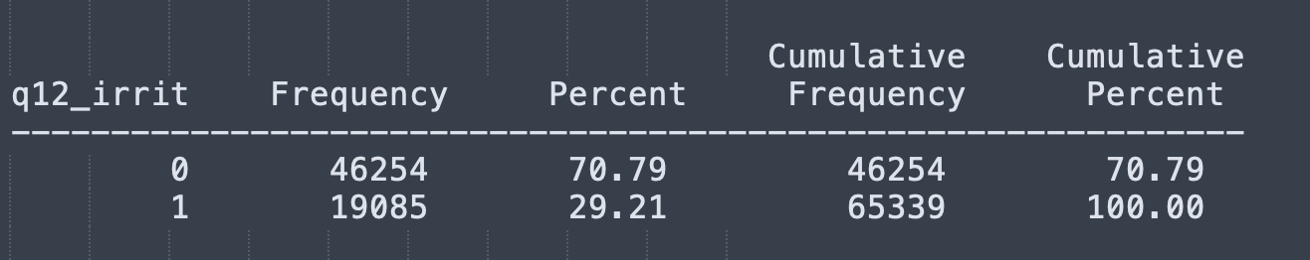

Table N1: NHS2 questions used as an equivalent to each of 12 neuroticism score questions used to assess neuroticism in the UKB.
Neuroticism cluster | UKBB question | Possible answers | NHS2 questions | Possible answers/ Coding (0=No; 1=Yes) | NHS2 question’s assessment years
Worry | QU1:Are you a worrier? | Yes  No  Do not know  Prefer not to answer | QN1:Over the last 4 weeks, how often have you been bothered by any of the following problems?  Not being able to stop or control worrying  QN2: Feeling afraid as if something awful might happen  QN3 Do you find yourself worrying about getting some incurable illness?  QN4 Do you worry unduly when relatives are late coming home? | Nearly every day=1  More than half the days=1  Several days=1  Not at all=0  not at all=0  several days=1  >half the days=1  nearly every day=1  often=1  sometimes=0  never=0  Yes=1  No=0 | 2013, 2017  2013, 2017  1993,2005  1993,2005
Worry | QU2:Do you suffer from 'nerves'? | Yes  No  Do not know  Prefer not to answer | QN5:Over the last 4 weeks, how often have you been bothered by any of the following problems?  Feeling nervous, anxious or on edge  QN6 During the past 4 weeks, have you had any of the following problems with your work or other regular daily activities as a result of any emotional problems (such as feeling depressed or anxious)?  - Cut down the amount of time you spent on work or other activities | Nearly every day=1  More than half the days=1  Several days=0  Not at all=0  Yes=1  No=0 | 2013, 2017  1993, 1997, 2001
Worry | QU3:Would you call yourself a nervous person? | Yes  No  Do not know  Prefer not to answer | QN7:How much of the time during the past 4 weeks  - Have you been a very nervous person? | All of the time=1  Most of the time=1  A Good Bit of the time =1  Some of the time=0  A tittle of the time=0  None of the time=0 | 1993, 1997, 2001
Worry | QU4:Would you call yourself tense or 'highly strung'? | Yes  No  Do not know  Prefer not to answer | QN8:Over the last 4 weeks, how often have you been bothered by any of the following problems?  - Trouble relaxing  - Being so restless that it is hard to sit still  QN9:How much of the time during the past 4 weeks  - Have you felt calm and peaceful? | Nearly every day=1  More than half the days=1  Several days=0  Not at all=0  All of the time=0  Most of the time=0  A Good Bit of the time=0  Some of the time=0  A tittle of the time=0  None of the time=1 | 2013, 2017  1993,1997, 2001
Depressed affect | QU5:Do you often feel lonely? | Yes  No  Do not know  Prefer not to answer | QN10:during the past month.  I felt lonely | All of the time=1  Occasionally or a moderate amount of time=1  Some or a little of the time=0  Rarely or none of the time=0 | 2013,2017
Depressed affect | QU6:Do you ever feel 'just miserable' for no reason? | Yes  No  Do not know  Prefer not to answer | QN11:How much of the time during the past 4 weeks  - Have you felt so down in the dumps nothing could cheer you up?  - Have you felt downhearted and blue?  - Did you feel worn out?  QN12:during the past month.  a:I felt depressed.  b:I felt that everything I did was an effort.  c:I could not “get going”.  d)I felt fearful.  QN13 In your lifetime, have you ever had two weeks or longer when nearly every day you felt sad,  blue, or depressed for most of the day?  QN14 In the past two years, has there been a time lasting 2 weeks or longer:  When most of the day you felt sad, empty or depressed? | All of the time=1  Most of the time=1  A Good Bit of the time =1  Some of the time =0  A tittle of the time=0  None of the time=0  All of the time=1  Occasionally or a moderate amount of time=1  Some or a little of the time=0  Rarely or none of the time=0  Yes=1  No=0  Yes=1  No=0 | 1993, 1997, 2001  2013,2017  2001,2003,05,07,09,2011,2015,  2013
Depressed affect | QU7:Does your mood often go up and down?  Refers to emotional stability | Yes  No  Do not know  Prefer not to answer | QN15: During tho past 4 weeks, how much of the time has your physical health or emotional problems interfered with your social activities (like visiting with friends, relatives, etc.)?  QN16 During the past 4 weeks, to what extent has your physical health or emotional problems interfered with your normal social activities with family, friends, neighbors, or groups?  QN17 Please indicate how often you have felt this way.  During the past month I was bothered by things that usually don’t bother me. | All of the time =1  Most of the time =1  Some of the time =1  A little of the time=0  None of the time=0  Not at all =0  Slightly =0  Moderately =0  Quite a bit =1  Extremely =1  Rarely=0  little of time=1  moderate amount=1  all of the time=1 | 1993, 1997, 2001  1993, 1997, 2001  2013,2017
Depressed affect | QU8:Do you often feel 'fed-up'? | Yes  No  Do not know  Prefer not to answer | QN18 How much of the time during the past 4 weeks...  Have you felt no interest in things?  Did you feel tired?  QN19 In the past two years, has there been a time lasting 2 weeks or longer:  b. When most of the day you were  very discouraged about how things  were going in your life?  c. When you lost interest in most things  you usually enjoy like work, hobbies,  and personal relationships?  QN20 There are many ways to try to deal with problems. These items ask what  you do, in general, to cope with the stress in your life.  I give up trying to deal with things.  I give up the attempt to cope. | All of the time=1  Most of the time=1  A Good Bit of the time=1  Some of the time =1  A tittle of the time=1  None of the time=0  All of the time =1  Most of the time=1  A Good Bit of the time=1  Some of the time=1  A tittle of the time=0  None of the time=0  Yes=1  No=0  not at all=0  a little bit=1  a medium amount of time=1  a lot=1  not at all=0  a little bit=0  a medium amount of time=1  a lot=1 | 2001  1993, 1997, 2001  2013  2001  2001
SESA (sensitivity to environmental stress and adversity) | QU9:Are your feelings easily hurt? | Yes  No  Do not know  Prefer not to answer | QN21: In the past two years, has there been a time lasting 2 weeks or longer:  When most days you felt much more anxious and worried than other people with the same problems as you?  QN22 Please indicate the extent to which you agree or disagree with the following statements..  - If something can go wrong with me, it will.  - I hardly ever expect things to go my way.  - I rarely count on good things happening to me. | Yes=1  No=0  Disagree strongly=0  Neither agree nor disagree=0  Disagree a little=1  Agree a little=1  Agree strongly=1 | 2013  2017
SESA (sensitivity to environmental stress and adversity) | QU10:Do you worry too long after an embarrassing experience? | Yes  No  Do not know  Prefer not to answer | QN23:Over the last 4 weeks, how often have you been bothered by any of the following problems?  Worrying too much about different things | Nearly every day=1  More than half the days=1  Several days=1  Not at all=0 | 2013, 2017
SESA (sensitivity to environmental stress and adversity) | QU11:Are you often troubled by feelings of guilt? | Yes  No  Do not know  Prefer not to answer | QN24:What you do, in general, to cope with the stress in your life.  - I blame myself for things that happened.  - I criticize myself.  QN25 In your life, have you ever had any experience that was so frightening, horrible, or upsetting that, in the past month, you:  Felt guilty or unable to stop blaming yourself or others for the event? | Not at all=0  A little Bit=0  A medium Amount=1  A lot=1  Yes =1  No=0 | 2001  2017
SESA (sensitivity to environmental stress and adversity) | QU12:Are you an irritable person? | Yes  No  Do not know  Prefer not to answer | QN26:How much of the time during the past 4 weeks  - Did you feel full of pep?  QN27: Over the last two weeks, how often have you been bothered by the following problems?  Becoming easily annoyed or irritable | All of the time=1  Most of the time=0  A Good Bit of the time=0  Some of the time =0  A tittle of the time=0  None of the time=0  Not at all=0  Several days=1  More than half the days=1  Nearly every day=1 | 1993, 1997, 2001  2013, 2017

CII among UKB women and in the NHS2 cohort

Table N2: Baseline characteristics of N=164,462 genotyped, European ancestry women from the UK Biobank with available CII assessments, by CII value and CII components.
 |  | CII value
 |  | 0 | 1 | 2 | 3 | 4 | 5 | Total
N (%) |  | 13,728 (8.3) | 43,775 (26.6) | 55,061 (33.5) | 35,986 (21.9) | 13,473 (8.2) | 2,439 (1.5) | 164,462 (100.0)
Age* |  | 57.46 (7.77) | 56.69 (7.93) | 56.23 (7.98) | 55.68 (8.03) | 55.20 (7.98) | 54.67 (7.99) | 56.2 (8.0)
Average total household income before tax, N (%) | Less than £18,000 | 2,212 (16.1) | 7,375 (16.9) | 1,0347 (18.8) | 7,771 (21.6) | 3,534 (26.4) | 794 (32.8) | 32,033 (19.5)
Average total household income before tax, N (%) | £18,000 to £31,000 | 3,000 (21.9) | 9,740 (22.3) | 12,095 (22.0) | 8,099 (22.6) | 2,980 (22.2) | 508 (21.0) | 36,422 (22.2)
Average total household income before tax, N (%) | £31,000 to £52,000 | 3,116 (22.7) | 9,904 (22.7) | 12,407 (22.6) | 7,851 (21.9) | 2,765 (20.6) | 455 (18.8) | 36,498 (22.2)
Average total household income before tax, N (%) | £52,000 to £100,000 | 2,537 (18.5) | 8,016 (18.3) | 9,669 (17.6) | 5,684 (15.8) | 1,764 (13.2) | 251 (10.4) | 27,921 (17.0)
Average total household income before tax, N (%) | Greater than £100,000 | 831 ( 6.1) | 2,364 ( 5.4) | 2,499 ( 4.5) | 1,232 ( 3.4) | 386 ( 2.9) | 50 ( 2.1) | 7,362 ( 4.5)
Average total household income before tax, N (%) | Unknown | 2021 (14.7) | 6316 (14.4) | 7,944 (14.5) | 5,259 (14.7) | 1,981 (14.8) | 364 (15.0) | 23,885 (14.6)
Education, N (%) | College or University degree | 4,688 (34.1) | 14,664 (33.5) | 17,705 (32.2) | 10,495 (29.2) | 3,500 (26.0) | 554 (22.7) | 51,606 (31.4)
Education, N (%) | Other | 7,092 (51.7) | 22,541 (51.5) | 28,444 (51.7) | 18,991 (52.8) | 7,086 (52.6) | 1,323 (54.2) | 85,477 (52.0)
Education, N (%) | Unknown | 1,948 (14.2) | 6,570 (15.0) | 8,912 (16.2) | 6,500 (18.1) | 2,887 (21.4) | 562 (23.0) | 27379 (16.6)
BMI* |  | 25.71 (4.13) | 26.29 (4.58) | 26.99 (5.10) | 27.63 (5.49) | 28.36 (5.91) | 29.37 (6.40) | 27.0 (5.1)
Shift workers, N (%^{(a)}) |  | 779 (11.1) | 2,929 (12.0) | 4,277 (13.4) | 3,206 (15.4) | 1,338 (17.8) | 276 (23.0) | 12,805 (7.8%)
 |  | CII components
 |  | Evening Person | Short Or Long Sleep | High Neuroticism | No Or High Caffeine | Low Vit D | Total
N (%) |  | 55,730 (33.9) | 50,798 (30.9) | 45,764 (27.8) | 88,703 (53.9) | 86,947 (52.9) | 164,462 (100.0)
Age* |  | 55.49 (8.16) | 57.06 (7.72) | 55.18 (7.94) | 55.85 (8.02) | 55.84 (8.03) | 56.22 (7.99)
Average total household income before tax, N (%) | Less than £18,000 | 10,810 (19.4) | 12,320 (24.3) | 10,455 (22.9) | 17,921 (20.3) | 17,982 (20.7) | 32,033 (19.5)
Average total household income before tax, N (%) | £18,000 to £31,000 | 12,287 (22.1) | 11,370 (22.5) | 10,160 (22.3) | 19,761 (22.3) | 19,109 (22.0) | 36,422 (22.2)
Average total household income before tax, N (%) | £31,000 to £52,000 | 12,640 (22.7) | 10,174 (20.1) | 9,870 (21.6) | 19,521 (22.1) | 19,401 (22.4) | 36,498 (22.2)
Average total household income before tax, N (%) | £52,000 to £100,000 | 9,781 (17.6) | 6,772 (13.4) | 6,925 (15.2) | 14,518 (16.4) | 14,721 (17.0) | 2,7921 (17.0)
Average total household income before tax, N (%) | Greater than £100,000 | 2,564 ( 4.6) | 1,667 ( 3.3) | 1,460 ( 3.2) | 3,508 ( 4.0) | 3,653 ( 4.2) | 7,362 ( 4.5)
Average total household income before tax, N (%) | Unknown | 7,518 (13.5) | 8,332 (16.5) | 6,760 (14.8) | 13,262 (15.0) | 11,853 (13.7) | 23,885 (14.6)
Education, N (%) | College or University degree | 18,147 (32.6) | 13,152 (25.9) | 12,330 (26.9) | 25,622 (28.9) | 29,078 (33.4) | 51,606 (31.4)
Education, N (%) | Other | 29,377 (52.7) | 26,710 (52.6) | 24,353 (53.2) | 47,259 (53.3) | 43,662 (50.2) | 85,477 (52.0)
Education, N (%) | Unknown | 8,206 (14.7) | 10,936 (21.5) | 9,081 (19.8) | 15,822 (17.8) | 14,207 (16.3) | 27,379 (16.6)
Shift workers, N (%^{(a)}) |  | 4,933 (15.2) | 4,444 (17.2) | 3,881 (15.0) | 7,316 (14.4) | 7,259 (14.1) | 12,805 (13.8)
BMI* |  | 27.29 (5.30) | 27.60 (5.47) | 27.16 (5.39) | 27.15 (5.24) | 27.79 (5.59) | 26.98 (5.13)
N: sample size; BMI: Body mass index;
*Values are means ± standard deviations;
^{(a)} Percentages among N=92,838 genotyped European ancestry female UKB participants with all CII components available, who replied to the baseline questionnaire (2006-2010) and answered to the question if their primary job involved shift work (defined as work schedules outside 9am-5pm). Shift workers are those who answered with ‘sometimes’, ‘usually’ or ‘always’. Participants who answered with ‘prefer not to answer’ and ‘do not know’ were excluded from this analysis

Table N3: Characteristics of N=11,351 genotyped, European ancestry women from the NHS2 with available CII assessments, by CII value and CII components.
 | CII value
 | 0 | 1 | 2 | 3 | 4 | 5 | Total
N (%) | 801(7.1) | 2,739(24.1) | 3,633(32.0) | 2,748(24.2) | 1,195(10.5) | 235(2.1) | 11,351
Age* | 55.64(4.24) | 55.51(4.45) | 55.31(4.44) | 55.38(4.35) | 55.36(4.36) | 54.65(4.49) | 55.39(4.40)
Socio-economic status*^{(a)} | 0.81(4.12) | 0.40 (3.98) | -0.13 (3.78) | -0.56 (3.64) | -0.81 (3.44) | -0.80 (3.30) | -0.12 (3.81)
Shift workers, N (%^{(b)}) | 537 (67.04) | 1,900 (69.37) | 2,589 (71.30) | 2,021(73.54) | 889 (74.58) | 188 (80.69) | 8,124 (71.6)
BMI* | 24.09(3.25) | 25.23(4.68) | 27.12(5.96) | 28.86(6.77) | 30.40(6.92) | 33.12(7.36) | 27.34(6.22)
 | CII components
 | Evening Person | Short Or Long Sleep | High Neuroticism | No Or High Caffeine | Low Vit D | Total
N (%) | 3,862 (34.0) | 4,425 (39.0) | 2,960 (26.1) | 7,281(64.1) | 5,676 (50.0) | 11,351
Age* | 55.35(4.43) | 55.32(4.38) | 55.11(4.36) | 55.28(4.47) | 55.51(4.30) | 55.39(4.40)
Socio-economic status*^{(a)} | -0.25 (3.80) | -0.29 (3.66) | -0.27 (3.74) | -0.27 (3.79) | -0.75 (3.44) | -0.12 (3.81)
Shift workers, N (%^{(b)}) | 2,821 (34.72) | 3,323 (40.90) | 2,224 (27.38) | 5,155 (63.45) | 4,114 (50.64) | 8,124 (71.6)
BMI* | 28.28(6.59) | 27.79(6.57) | 28.05(6.65) | 27.54(6.38) | 30.39 (6.75) | 27.34(6.22)
N: sample size; BMI: Body mass index;
*Values are means (standard deviations);
^{(a)} Socio economic status in the NHS2 was evaluated as in DeVille et.al.² using a composite neighborhood SES (nSES) index derived from nine census tract–level variables capturing education, employment, housing, wealth, racial/ethnic, and population composition. For each participant address, variables were obtained from the U.S. Census (1990, 2000, or 2010) corresponding to the address period, z-standardized, and summed to generate the nSES score, with higher values indicating higher neighborhood SES.
^{(b)} Percentages among N=11,344 genotyped European ancestry NHS2 women with all CII components available, with shift work assessment. Shift workers in the NHS2 were defined as ever performing shift work (before assessment year 2009). Among 11,344 women with shift work assessments N=8,124 (71.6%) were shift workers and N=3,220 (28.4%) never performed shift work (before year 2009

Age adjusted odds ratios for estimated cardiovascular-kidney-metabolic (eCKM) risk in the Nurses’ Health Study II

Table N4: Age adjusted odds ratios (ORs) with 95% CI for estimated cardiovascular kidney-metabolic (eCKM) risk among N= 50,900 European ancestry female nurses from the Nurses’ Health Study II (NHS2) stratified by Circadian Imbalance Index (CII)
CII | N | Cases (%of N) | OR (95%CI) | P_{trend}
0-1 | 15,672 | 894 (5.7) | Reference | <.0001
2 | 16,407 | 1,529 (9.3) | 1.71 (1.57;1.87)
3 | 12,421 | 1,625 (13.1) | 2.52 (2.31;2.74)
4 | 5,368 | 895 (16.7) | 3.39 (3.07;3.74)
5 | 1,032 | 216 (20.9) | 4.58 (3.88;5.40)

Table N5. Age adjusted odds ratios (ORs) with 95% CI for estimated cardiovascular-kidney-metabolic (eCKM) risk among N= 50,900 European ancestry female nurses from the Nurses’ Health Study II (NHS2) stratified by Circadian Imbalance Index (CII) levels and a cumulative duration of shift work (never, less than 20 years or 20+years of shift work).
Characteristic | N | Cases (%) | OR (95% CI) | P_{trend}
Low CII (0-1)
Day workers | 4900 | 276 (5.6) | Reference | 0.3441
Night shift work< 20 years | 10663 | 608 (5.7) | 1.05 (0.91;1.22)
Night shift work>= 20 years | 109 | 10 (9.2) | 1.56 (0.81;3.04)
Middle CII (2-3)
Day workers | 8279 | 858 (10.4) | 1.97 (1.71;2.26) | 0.0027
Night shift work< 20 years | 20220 | 2246 (11.1) | 2.19 (1.93;2.49)
Night shift work>= 20 years | 329 | 50 (15.2) | 2.82 (2.03;3.90)
High CII (4-5)
Day workers | 1614 | 267 (16.5) | 3.44 (2.88;4.12) | 0.0423
Night shift work< 20 years | 4660 | 808 (17.3) | 3.73 (3.23;4.31)
Night shift work>= 20 years | 126 | 36 (28.6) | 6.42 (4.28;9.64)
*Model adjusted for age at CII and eCKM assessment (2009);

Table N6. Age adjusted* odds ratios (ORs) with 95% CI for estimated cardiovascular-kidney-metabolic (eCKM) risk among N= 50,900 European ancestry female nurses from the Nurses’ Health Study II (NHS2) stratified by Circadian Imbalance Index (CII) levels and a cumulative duration of shift work (never, less than 5 years or 5+ years of shift work).
Characteristic | N | Cases | OR (95% CI) | P_{trend}
Low CII (0-1)
Day workers | 4900 | 276 (5.6) | Reference | 0.0086
Night shift work< 5 years | 7825 | 410 (5.2) | 0.96 (0.82;1.12)
Night shift work>= 5 years | 2947 | 208 (7.1) | 1.34 (1.11;1.61)
Middle CII (2-3)
Day workers | 8279 | 858 (10.4) | 1.97 (1.71;2.26) | <.0001
Night shift work< 5 years | 13806 | 1448 (10.5) | 2.05 (1.79;2.34)
Night shift work>= 5 years | 6743 | 848 (12.6) | 2.53 (2.20; 2.91)
High CII (4-5)
Day workers | 1614 | 267 (16.5) | 3.45 (2.88;4.12) | 0.013
Night shift work< 5 years | 3023 | 500 (16.5) | 3.53 (3.02;4.12)
Night shift work>= 5 years | 1763 | 344 (19.5) | 4.29 (3.62;5.09)
*Model adjusted for age at CII and eCKM assessment (2009);

Table N7. Age adjusted* odds ratios (ORs) with 95% CI for estimated cardiovascular-kidney-metabolic (eCKM) risk among N=11,344 European ancestry female nurses from the Nurses’ Health Study II (NHS2) stratified by cumulative duration of shift work (never, less than 5 years or 5+ years of shift work).
Characteristic | N | Cases | OR (95% CI) | P_{trend}
Low CII (0-1)
Day workers | 4900 | 276 (5.6) | Reference | 0.0086
Night shift work< 5 years | 7825 | 410 (5.2) | 0.96 (0.82;1.12)
Night shift work>= 5 years | 2947 | 208 (7.1) | 1.34 (1.11;1.61)
Middle CII (2-3)
Day workers | 8279 | 858 (10.4) | 1.97 (1.71;2.26) | <.0001
Night shift work< 5 years | 13806 | 1448 (10.5) | 2.05 (1.79;2.34)
Night shift work>= 5 years | 6743 | 848 (12.6) | 2.53 (2.20; 2.91)
High CII (4-5)
Day workers | 1614 | 267 (16.5) | 3.45 (2.88;4.12) | 0.013
Night shift work< 5 years | 3023 | 500 (16.5) | 3.53 (3.02;4.12)
Night shift work>= 5 years | 1763 | 344 (19.5) | 4.29 (3.62;5.09)
*Model adjusted for age at CII and eCKM assessment (2009);

Distributions of the CII and its components in the UKB women and NHS2

CII in the UKB EUR women CII in the NHS2 :
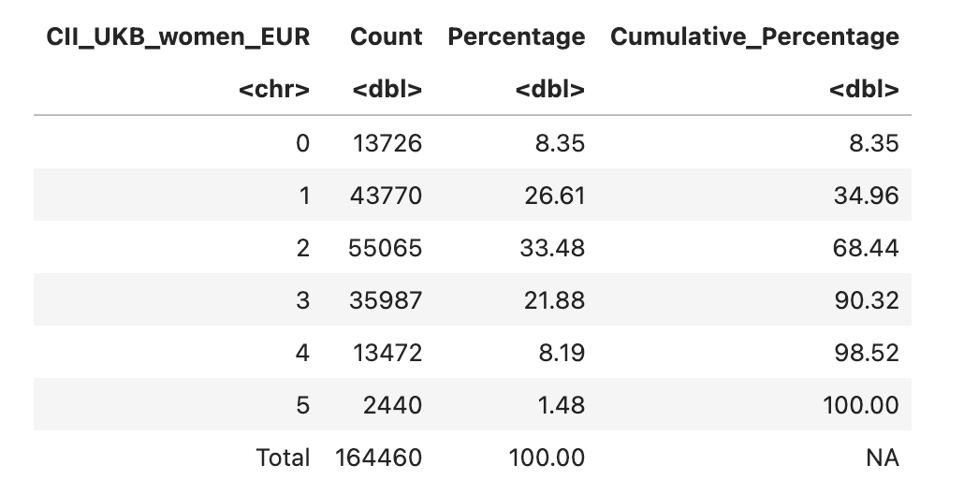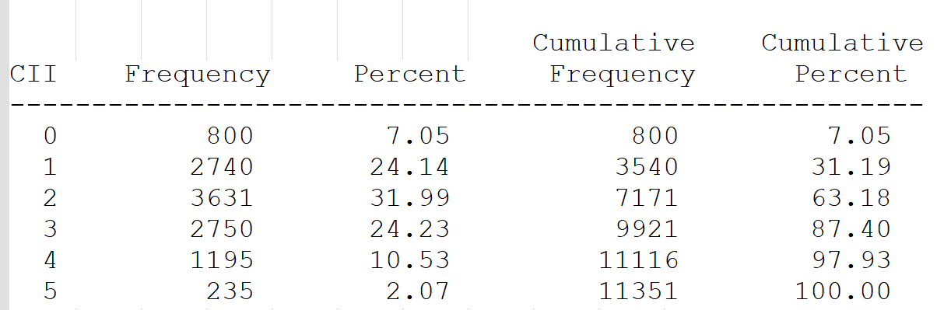
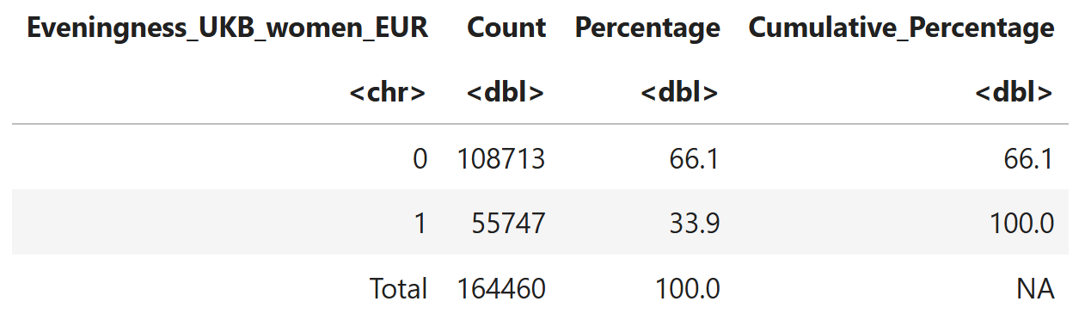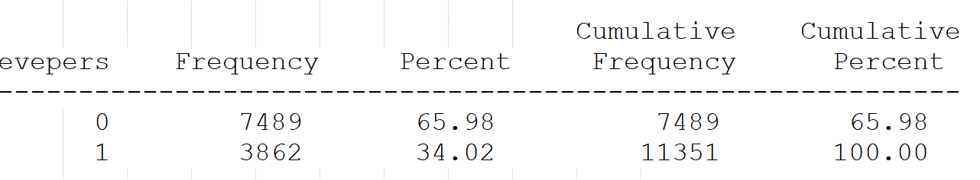
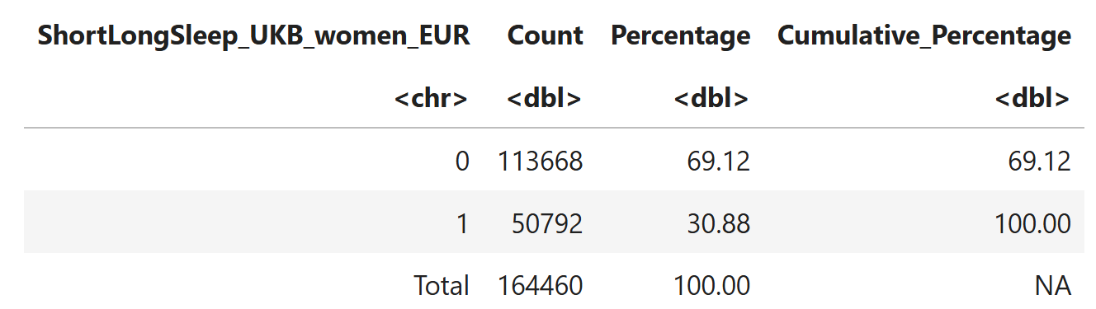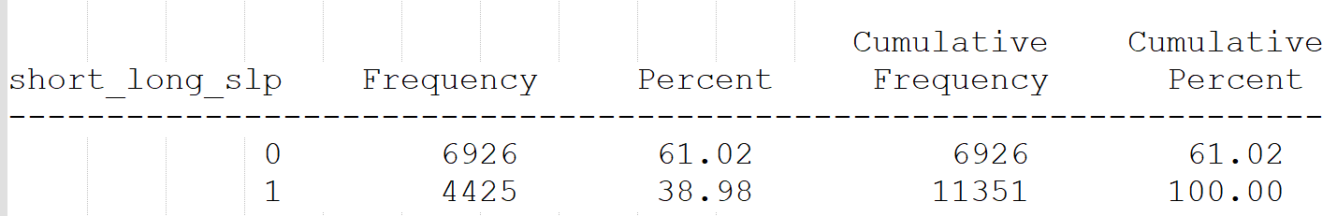
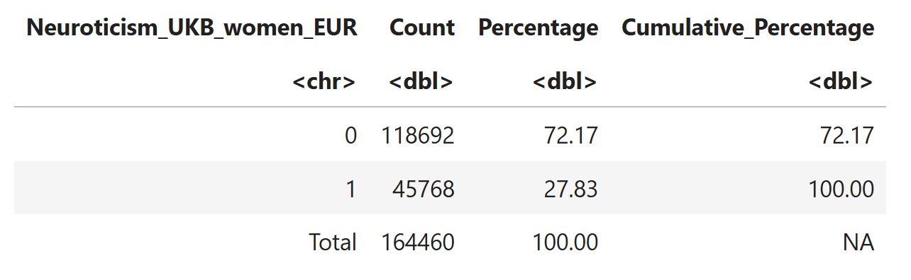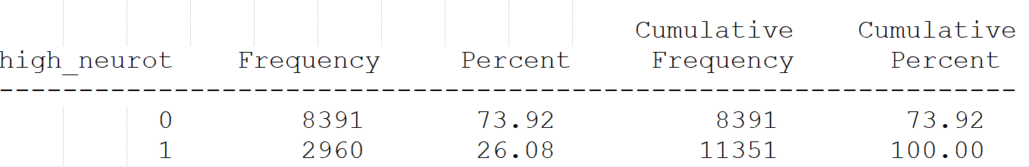
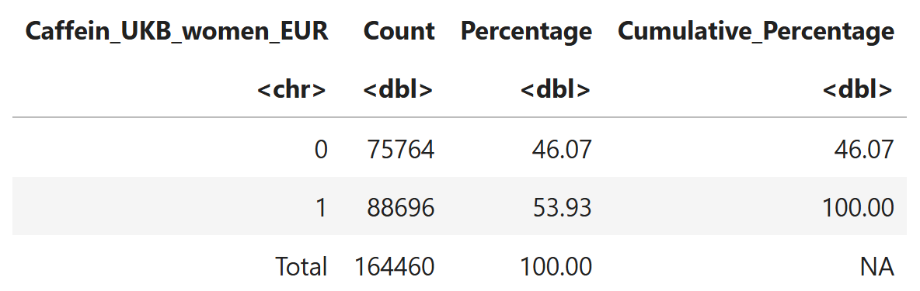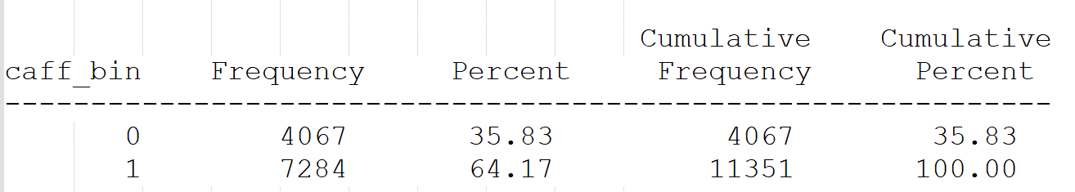
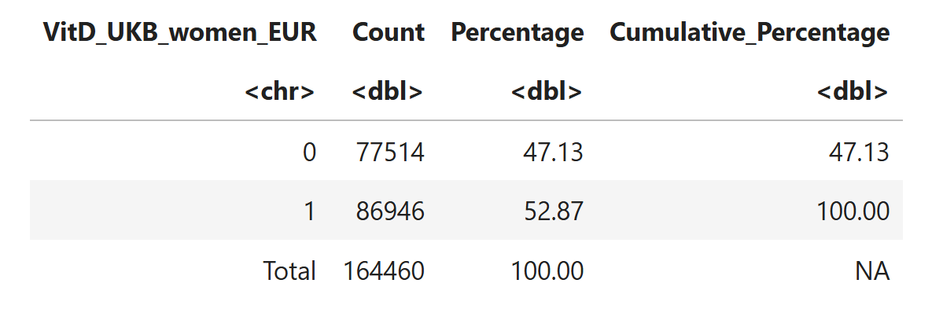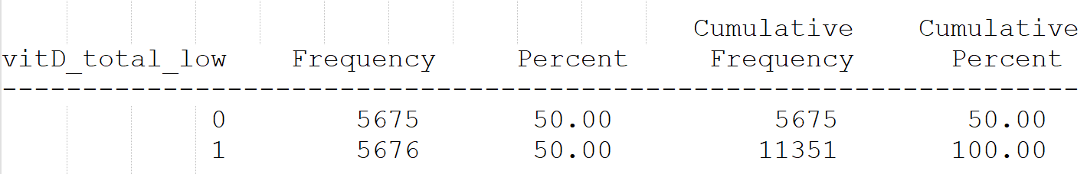
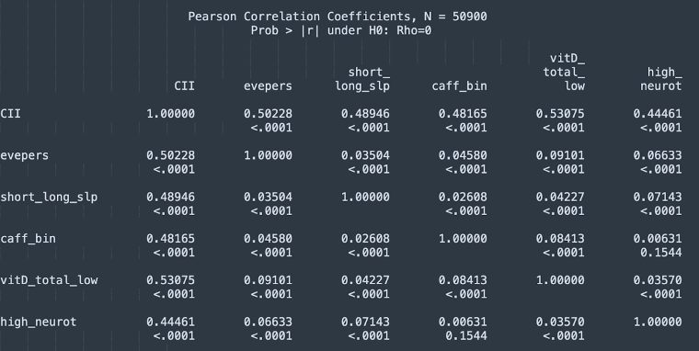

Figure N1. Correlation between the CII and its components in the NHS2

References
1. Smith, D. J. et al. Prevalence and Characteristics of Probable Major Depression and Bipolar Disorder within UK Biobank: Cross-Sectional Study of 172,751 Participants. PLoS ONE 8, e75362 (2013).
2. DeVille, N. V. et al. Neighborhood socioeconomic status and mortality in the nurses’ health study (NHS) and the nurses’ health study II (NHSII). Environ. Epidemiol. 7, e235 (2023).

