Support information for:
Optimising Viscoelastic Window in Reversible Liquid Crystal Elastomer-Based Pressure Sensitive Adhesives via Chain-Transfer
Lichang Lu ª, Kailing Lin ª, Mohand O Saed ^{a*}
ª Cavendish Laboratory, University of Cambridge, J.J. Thomson Avenue, Cambridge CB3 0HE, U.K.

Table S1 Detailed rubbery modulus and crosslink density for various formulations
Formulation | E’ at 100 °C (MPa) | $d$ (mol cm⁻³)
1:1 | 1.69 | 1.81×10⁻⁴
1:1.5 | 0.95 | 1.02×10⁻⁴
1:2 | 0.023 | 2.47×10⁻⁶

Table S2 Characteristic temperatures of LCE adhesives with various formulations
Formulation | T_{g} _{(measured by DSC)} | T_{g} _{(measured by DMA)} | T_{ni} (°C)
1:1 | 0.59 | 3.97 | 51.67
1:1.5 | -11.57 | -3.10 | 34.80
1:2 | -19.80 | -10.95 | 23.49

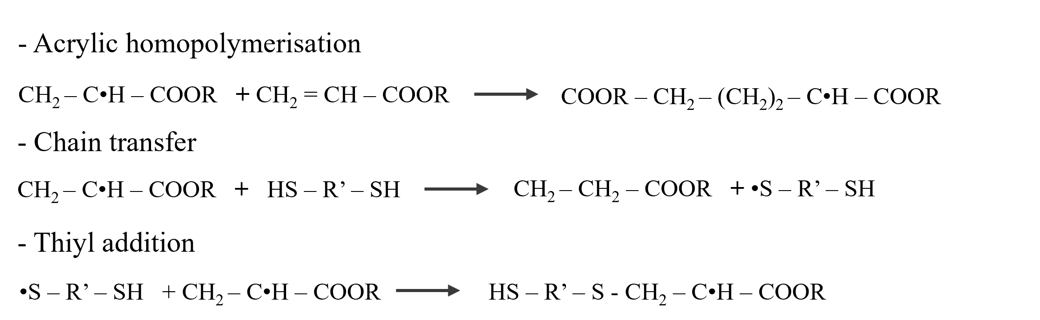
Figure S1 The working principle of the chain transfer reaction
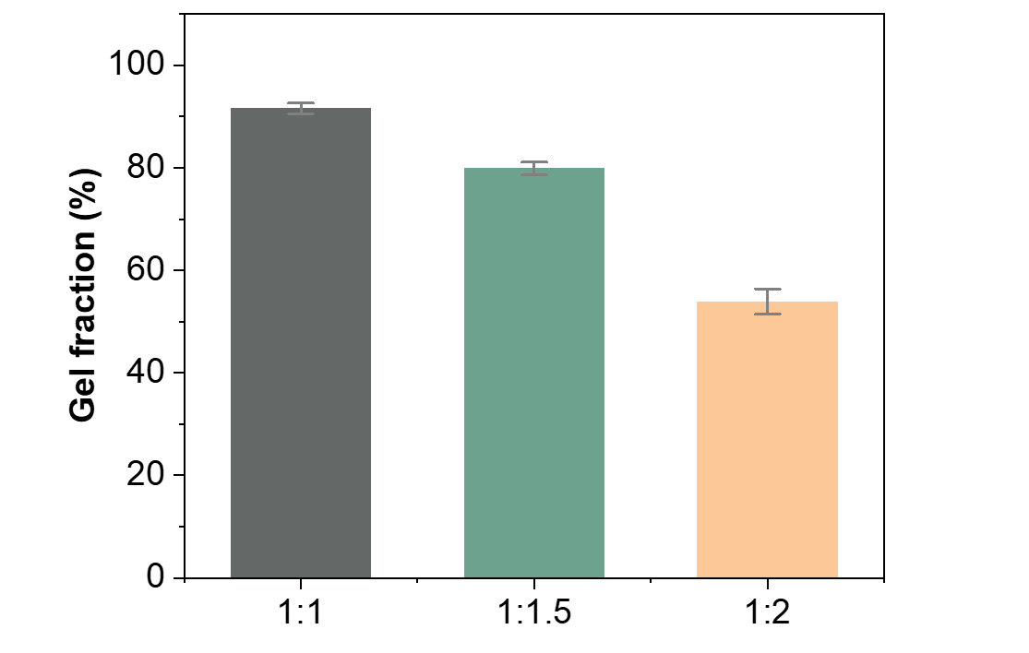
Figure S2 Gel fraction of each LCE formulation

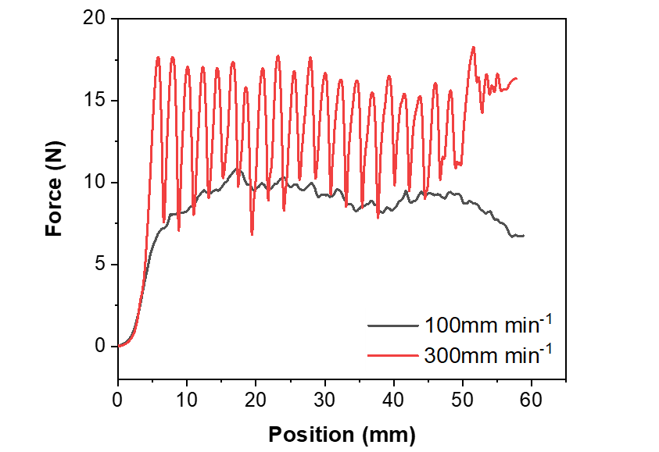
Figure S3 Comparison of the peel force – displacement curves of the LCE adhesive at slow (100 mm min⁻¹) and fast (300 mm min⁻¹) peeling rate

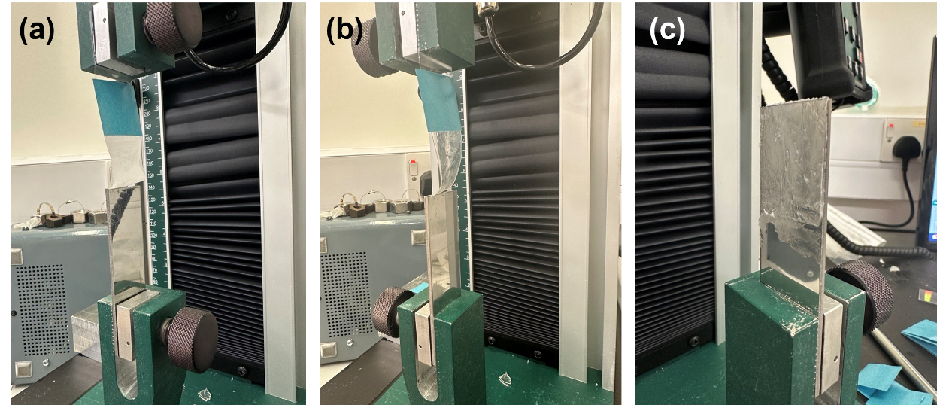
Figure S4 Representative failure modes of the LCE adhesives: (a) adhesive failure at room temperature, (b) adhesive failure at elevated temperature, and (c) cohesive failure.

