Supplementary Information

Temperature Dominance in Governing Nanoplastic Release and Leachate Composition from Polylactic Acid–Based Disposable Plastics

Ao Guo¹, Xing Chen¹, Tong Yang², Ailin Zhao¹, Jing Yang¹, Changzhi Shi¹*, Mingliang Fang¹*
¹ Shanghai Key Laboratory of Atmospheric Particle Pollution and Prevention (LAP3), National Observations and Research Station for Wetland Ecosystems of the Yangtze Estuary, Department of Environmental Science & Engineering, Fudan University, Shanghai 200438, China
² Department of Environmental Health, Harvard T.H. Chan School of Public Health, Harvard University, Boston, MA 02115, USA
*Correspondence and requests for materials should be addressed to CS (email: czshi22@m.fudan.edu.cn) and MF (email: mlfang@fudan.edu.cn)

Contents
Supplementary Notes
Note S1 Calculation of particulate OLA mass concentration 5
Note S2 Preparation of OLA standards and deuterated OLA internal standards 5
Note S3 Characterization of disposable cup materials 5
Note S4 Nanoparticle Tracking Analysis Procedure 6
Note S5 Sample preparation procedures for quantification of PLA-leached chemicals 6
Note S6 Concentration of short-chain OLAs 7
Note S7 Estimation of global and regional exposure to PLA-leached chemicals 7
Note S8 Exposure estimation considering country-specific drinking habits 8
Note S9 Exposure estimation from different beverage types 8
Supplementary Figures
Fig. S1 Size distributions of NPs released from PP-DCs and PLA-DCs into 50 °C water at 0.5, 1, 2, and 4 h. 9
Fig. S2 FTIR spectra of DC materials before and after simulated use for 4 h. 10
Fig. S3 GPC analysis of PLA-DC materials before use and after 4 h of water standing. 11
Fig. S4 Dissolution efficiencies of 20% (v/v) EtOH, 80% EtOH, and EtOH on the PLA NP reference standard and the mixed synthetic OLA standard 12
Fig. S5 Linear calibration ranges obtained by NTA using PS particle standards in water and 60% EtOH. 13
Fig. S6 Normalized size distributions of NPs from PLA-DCs before and after dissolution using 60% EtOH. 14
Fig. S7 Eight-point calibration curve for LA obtained by LC–MS/MS with ¹³C₃-LA as the internal standard. 15
Fig. S8 Depolymerization efficiencies of the mixed OLA standard and the PLA NP reference standard at 0, 0.5, 1, and 2% (w/v) NaOH after 4 h-reaction at 121 °C. 16
Fig. S9 Alkaline depolymerization of PLA NP reference standard (1% NaOH, 121 °C): photographs taken at 0 h, 2 h, and 4 h. 17
Fig. S10 LC–MS/MS calibration curve for the PLA NP reference standard using ¹³C₃-LA as the internal standard. 18
Fig. S11 Normalized concentration profiles of OLA₂, OLA₄, OLA₆, OLA₇, OLA₈, OLA₁₀, and OLA₁₂ released from PLA-DCs during simulated drinking water standing. 19
Fig. S12 Suggested usage tips for PLA-DCs. 20
Fig. S13 Share of PLA-DCs in total disposable cup demand in China during 2016–2024, along with the projected share for 2030. 21
Fig. S14 Global market scales of DCs and PLA-DCs in 2021–2024 and projected for 2030, separated by cold-drink and hot-drink cups. 22
Fig. S15 Regional market scales of PLA-DCs in 2024 across the Asia–Pacific, Europe, North America, Latin America, and Middle East & Africa regions. 23
Fig. S16 Daily consumption of coffee DCs in 2018 among six major coffee-consuming countries, including the United States, China, Russia, Germany, the United Kingdom, and Australia. 24
Fig. S17 Daily per capita beverage consumption across 13 representative countries in Asia, Europe, and the Americas, stratified by beverage type. 25
Fig. S18 Material characterization of PLA-CP-DC, PLA-IM-DC, and PP-DC. 26
Fig. S19 Comparison of recoveries of OLA₂, OLA₄, OLA₆, OLA₇, OLA₁₀, and OLA₁₂ using three different concentration methods. 27
Supplementary Tables
Table S1 Method validation for PLCs: method detection limits, method quantification limits, and recoveries in water samples 28
Table S2 Method validation for short-chain OLAs: MDLs, MQLs, and recoveries in water samples 29
Table S3 Per-cup exposure to leachates from PLA-based disposable cups used for different beverages 30
Table S4 LC-MS/MS instrument parameters for quantification of LA 31
Table S5 Multiple reaction monitoring transitions of target LA in LC-MS/MS. 32
Table S6 LC-MS/MS instrument parameters for quantification of OLAs 33
Table S7 MRM transitions of target OLAs in LC-MS/MS. 34
References 35

Supplementary Notes

Note S1 Calculation of particulate OLA mass concentration
In the NTA-derived particle size distribution, each diameter bin (d) corresponds to a measured particle count (N_{d}). Assuming all particles are spherical, the mass of a single particle (M_{d}) can be calculated according to Eq. (1), where ρ_{PLA} denotes the density of PLA (1.25 g cm⁻³). The total mass of particles in the sample (M) is obtained by summing across all size bins (Eq. (2)).
$M_{d}=ρ_{PLA}×\frac{4}{3}π{\left(\frac{d}{2}\right)}^{3}$ (1)
$M=\sum_{d}{\left(M_{d}×N_{d}\right)}$ (2)
Using this approach, the total nanoparticle mass in the raw water sample (M_{NP}) and the residual PLA NP mass after 60% (v/v) ethanol (EtOH) selective dissolution (M_{PLA NP}) were determined. The difference between the two values represents the particulate OLA mass (M_{OLA NP}), as shown in Eq. (3).
$M_{OLA NP}=M_{NP}-M_{PLA NP}$ (3)

Note S2 Preparation of OLA standards and deuterated OLA internal standards
Since no commercial OLA standards are currently available, sequence-defined short-chain OLA_{n} (n = 2, 4, 6, 7, 8, 10, and 12) standards were synthesized following a modified version of a previously published procedure¹. Briefly, benzyl (Bn) and tert-butyldimethylsilyl (TBDMS) protecting groups were applied to control esterification and iterative chain-length extension. After coupling and final deprotection, monodisperse OLA_{n} oligomers with ∼95% purity were obtained. OLA mixtures were generated by subjecting PLA MPs to methanol (MeOH)-based alcoholysis under two incubation conditions (20 °C/2 h and 60 °C/2 h), followed by filtration and solvent removal².
Isotopically substituted OLAs are also unavailable commercially. A “one-pot” route was applied to synthesize multiple d-OLA internal standards³. Isotopically substituted OLAs are also unavailable commercially. A “one-pot” route was applied to synthesize multiple d-OLA internal standards. Olefins were reacted with D₂O to produce deuterated LA, followed by polycondensation under controlled temperature and reduced pressure to generate d-OLAs covering degree of polymerization 2–13.

Note S3 Characterization of disposable cup materials
Both PLA-DCs and PP-DCs used in the NP release experiments were characterized before and after exposure. Cup walls were cut into 5 × 5 cm pieces, and surface morphology was examined using a ThermoFisher Quattro S scanning electron microscope (SEM) operated at 5 kV high voltage, with magnifications ranging from 10,000× to 50,000×. The same cut pieces were analyzed using Fourier-transform infrared spectroscopy (FTIR) (IS 20, Thermo Nicolet Corp., Madison, WI) at a spectral resolution of 4 cm⁻¹. Infrared data processing was performed using OMNIC.
Gel permeation chromatography (GPC) analysis was also conducted. For PLA-coated paper cups (PLA-CP-DCs), the PLA coating layer was peeled off after immersion in 95% (v/v) EtOH for 10 min, air-dried, and 2 g of coating material was collected⁴. For PP-DCs, 2 g of cup wall fragments were directly prepared. All samples were dissolved in N,N-dimethylformamide (DMF), and analysis was performed on an Agilent 1260 HPLC system equipped with a G7111A pump and a G7162A refractive index detector, using DMF as eluent at 50 °C and a flow rate of 1.0 mL min⁻¹. Apparent molecular weights were calibrated using PMMA standards and determined on a PLgel MIXED-C column.
Differential scanning calorimetry (DSC) was used to analyze the thermal properties of the materials. The same procedure was applied to the coating material of PLA-CP-DCs and the cup-wall fragments of PP-DCs. DSC measurements were performed on a Discovery X3 differential scanning calorimeter (TA Instruments) using 5–10 mg of sample sealed in hermetic aluminum pans (DSC Consumables). Each DSC run consisted of two heating–cooling cycles at a rate of 10 °C min⁻¹, with 5-min isothermal holds between each heating and cooling ramp. PLA samples were scanned from 0 to 220 °C, and PP samples were scanned from –50 to 200 °C.

Note S4 Nanoparticle Tracking Analysis Procedure
NTA measurements were performed using a ZetaView system (Particle Metrix, Germany) equipped with integrated video-based image analysis for particle concentration and size distribution quantification. Prior to measurement, instrument calibration and auto-focus optimization were conducted using a 10⁷ particles mL⁻¹ polystyrene (PS) standard suspension. The measurement chamber was then rinsed twice with ultrapure water, the sample was vortexed for 15 s to ensure homogeneous dispersion, and the test suspension was subsequently injected into the chamber. For each sample, automated scanning was performed across 11 predefined positions, and only valid frames were retained. Final particle size and concentration outputs were obtained by averaging the valid measurements across all positions.

Note S5 Sample preparation procedures for quantification of PLA-leached chemicals
Three different workflows were used to quantify free LA, LA + OLAs, and total LA + OLAs + PLA NPs in water samples:
(1) C_{LA}
A 1 mL aliquot of sample was spiked with 2 μg of ¹³C₃-LA as internal standard, freeze-dried, and reconstituted in 1 mL acetonitrile (ACN). The solution was centrifuged at 15,000 rpm for 30 min to remove particulates. A 100 μL aliquot of the supernatant was transferred to LC–MS/MS vials for the determination of free LA (C_{LA}).
(2) C_{LA+OLA}
A 1 mL aliquot of sample was spiked with 2 μg of ¹³C₃-LA, freeze-dried, reconstituted in 1 mL of 60% EtOH, and loaded into a 10 kDa ultrafiltration tube. After centrifugation at 12,000 rpm for 30 min, the membrane was rinsed twice with 1 mL EtOH. The filtrates were combined, evaporated under a gentle nitrogen stream at 40 °C, and reconstituted in 1 mL of 1% (w/v) NaOH solution. Depolymerization was conducted in a flat-bottom glass vial inside an autoclave at 121 °C for 240 min. The hydrolysate was neutralized to pH 7 with 1 M HCl, freeze-dried to remove salt, reconstituted in 1 mL MeOH, centrifuged (15,000 rpm, 30 min), and 100 μL of supernatant was used for LC–MS/MS analysis to obtain C_{LA+OLA}.
(3) Total C_{LA+OLA+PLA}
A 1 mL aliquot of sample was spiked with 2 μg of ¹³C₃-LA, freeze-dried, reconstituted in 1 mL dichloromethane (DCM), and transferred to a flat-bottom glass vial. After solvent evaporation under a mild nitrogen stream, the residue was reconstituted in 1 mL of 1% (w/v) NaOH. Depolymerization, neutralization, desalting, and MeOH reconstitution were performed identically to Note S5 Section (2). A 100 μL aliquot of final supernatant was subjected to LC–MS/MS to determine C_{LA+OLA+PLA}.

Note S6 Concentration of short-chain OLAs
Short-chain OLAs released during simulated PLA-DC use were generally below the instrumental detection limit and therefore required a ten-fold pre-concentration step prior to analysis. Three enrichment approaches—refrigerated centrifugation, freeze-drying, and solid-phase extraction (SPE) using a MAX cartridge (Waters Oasis MAX, 6 cc/150 mg)—were compared using OLA standards to evaluate recovery performance. Refrigerated centrifugation yielded the highest and most consistent recoveries (65.0–99.4%) and was selected as the final method. Heating-based concentration methods (e.g., rotary evaporation, nitrogen blow-down) were intentionally avoided to minimize thermally induced hydrolysis of OLAs.

Note S7 Estimation of global and regional exposure to PLA-leached chemicals
Exposure estimation calculations were based on the experimentally measured concentration of PLA-leached chemicals (C_{PLCs}, ng·mL⁻¹) at 0.5 h under the corresponding use conditions (temperature, beverage type, etc.). A standardized cup volume of 250 mL was applied, representing the most common commercial PLA-DC serving size⁵. The average price of a single PLA-DC was assumed to be 0.05 USD; therefore, the annual number of PLA-DCs consumed can be estimated from the total DCs market value. Accordingly, the exposure per cup (E_{cup}, Eq. (4)), the annual number of PLA-DCs used (N_{cup, yr}, Eq. (5)), and the annual PLC exposure (E_{year}, Eq. (6))) were calculated as follows:
${\text{E}}_{\text{cup}}\text{=}{\text{C}}_{\text{PL}\text{C}\text{s}}\text{×250}$ (4)
${\text{N}}_{\text{cup}\text{,} \text{yr}}\text{=}{\text{P}}_{\text{PLA}}\text{×}\frac{{\text{M}}_{\text{cup}}}{\text{0.05}}$ (5)
${\text{E}}_{\text{year}}\text{=}{\text{E}}_{\text{cup}}\text{×}{\text{N}}_{\text{cup}\text{,} \text{yr}}$ (6)
Where P_{PLA} is the annual market share of PLA cups, and M_{cup} is the total DCs market value (USD).

Note S8 Exposure estimation considering country-specific drinking habits
The coffee-related exposure (E_{coffee}) was calculated from the daily number of coffee PLA-DCs consumed and the experimentally measured PLC concentration under coffee conditions (Eq. (7)). For non-coffee beverages, country-specific drinking habits were also considered. In the United States, PLA-DCs are predominantly used for cold water consumption (30 °C), whereas in China they are mainly used with hot water (70 °C). Accordingly, the non-coffee exposure for the United States (E_{non-coffee, US}) and China (E_{non-coffee, CN}) was calculated as follows (Eq. (8), (9)):
${\text{E}}_{\text{coffee}}\text{=}{\text{N}}_{\text{coffee}}\text{×}{\text{C}}_{\text{PL}\text{C}\text{s}}^{\text{coffee}}\text{×250}$ (7)
${\text{E}}_{\text{non-coffee}\text{,} \text{US}}\text{=}{\text{N}}_{\text{non-coffee}\text{,} \text{US}}\text{×}{\text{C}}_{\text{PL}\text{C}\text{s}}^{\text{30 ℃}}\text{×250}$ (8)
${\text{E}}_{\text{non-coffee}\text{,} \text{CN}}\text{=}{\text{N}}_{\text{non-coffee}\text{,} \text{CN}}\text{×}{\text{C}}_{\text{P}\text{LC}\text{s}}^{\text{70 ℃}}\text{×250}$ (9)
Where N_{coffee}, N _{non-coffee, US}, and N_{non-coffee, CN} represent the daily consumption of coffee and non-coffee PLA-DCs in each country.

Note S9 Exposure estimation from different beverage types
Assuming all beverages are consumed using PLA-DCs, the beverage exposure was estimated based on both the daily intake volume and the corresponding PLC leaching concentration for each beverage type. If V_{i} represents the daily intake volume of beverage type i, and C_{i} represents the corresponding PLC concentration measured under the relevant use conditions, the daily exposure from beverage type i (E_{bev}, Eq. (10)) and the total daily exposure per person (E_{total}, Eq. (11)) were calculated as follows:
$E_{bev}=V_{i}×C_{i}$ (10)
$E_{total}=\sum_{i}{(V_{i}×C_{i})}$ (11)

Supplementary Figures
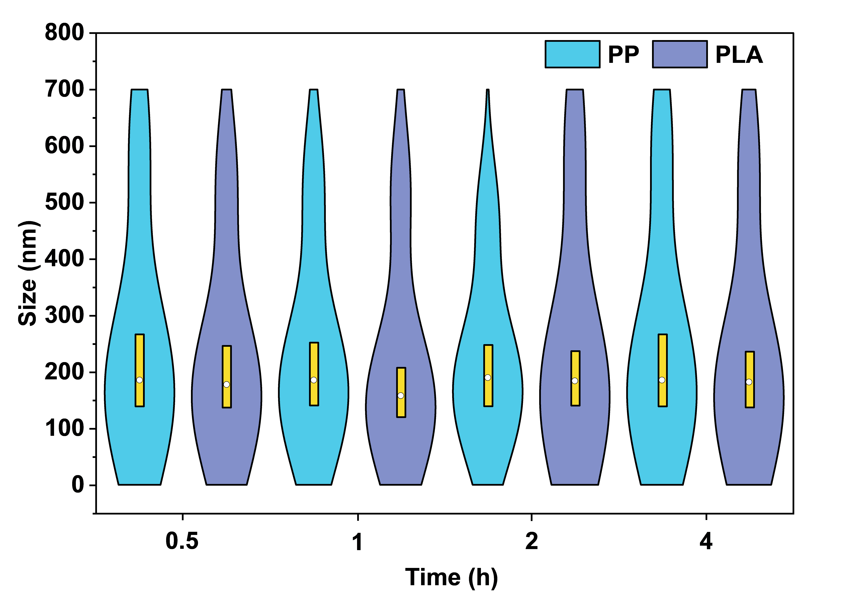

Fig. S1 Size distributions of NPs released from PP-DCs and PLA-DCs into 50 °C water at 0.5, 1, 2, and 4 h.

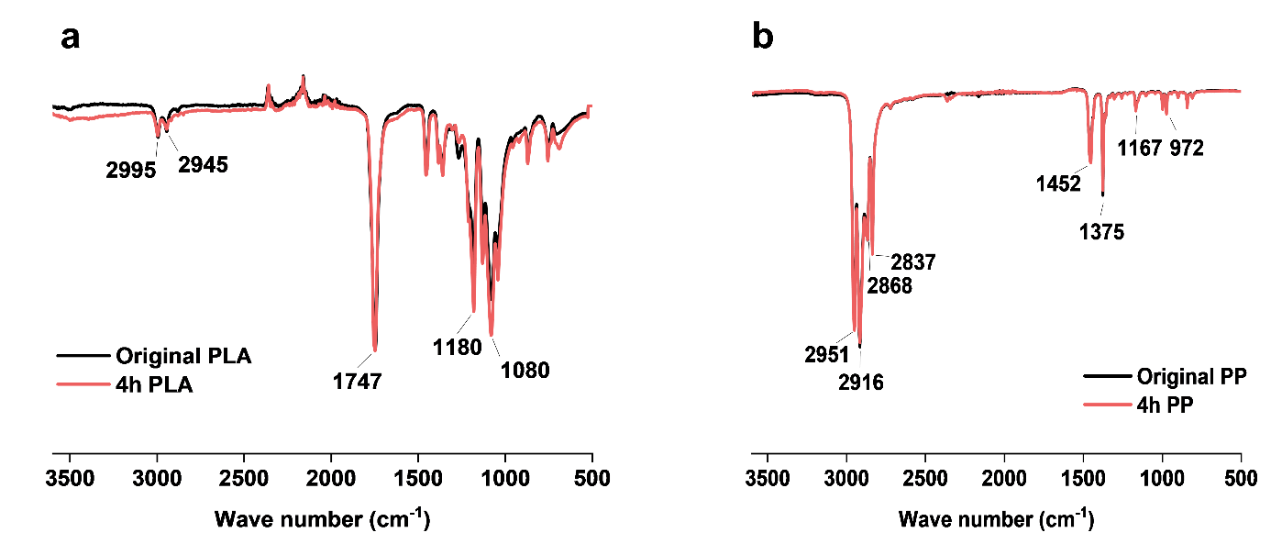

Fig. S2 FTIR spectra of DC materials before and after simulated use for 4 h. (a) FTIR spectra of PP-DCs before use (original PP) and after 4 h of water standing (4h PP), showing no observable changes in characteristic functional groups. (b) FTIR spectra of PLA-DCs before use (original PLA) and after 4 h of water standing (4h PLA), also showing no substantial changes in major characteristic absorption bands.

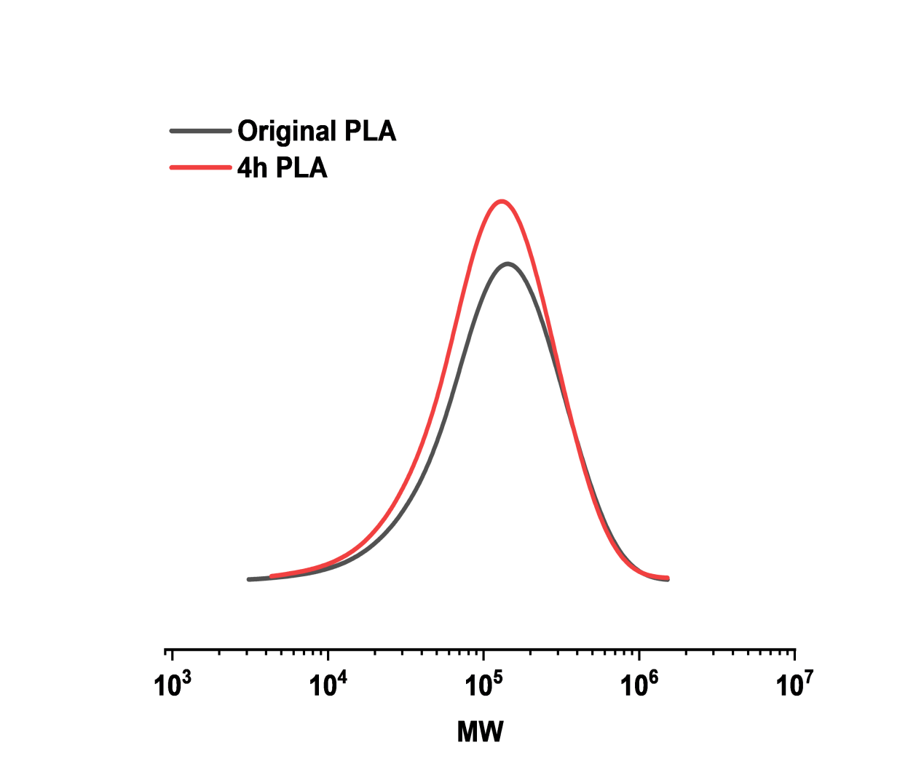

Fig. S3 GPC analysis of PLA-DC materials before use (Original PLA) and after 4 h of water standing (4h PLA), showing no substantial changes in molecular weight (MW) distribution.

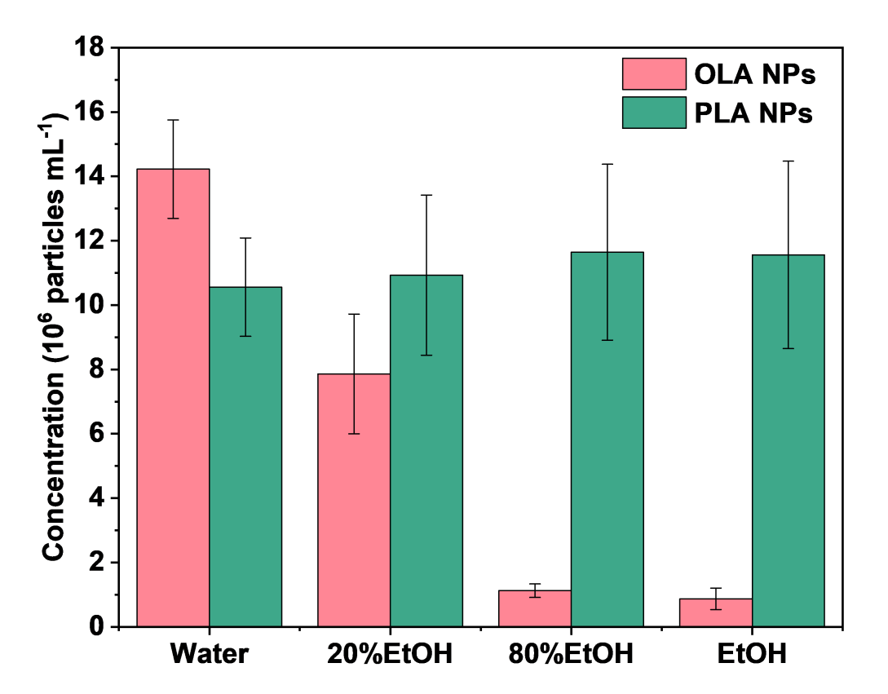

Fig. S4 Dissolution efficiencies of 20% (v/v) EtOH, 80% (v/v) EtOH, and EtOH on the PLA NP reference standard (100 nm in diameter) and the mixed synthetic OLA standard (mean ± s.d., n = 3).

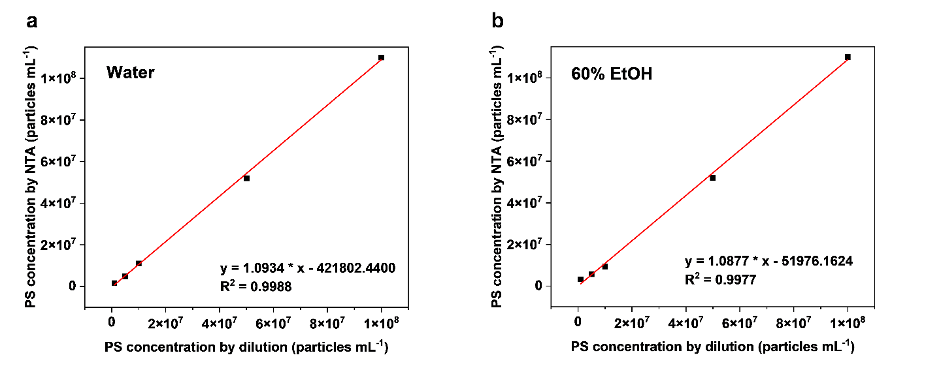

Fig. S5 Linear calibration ranges obtained by NTA using PS particle standards (1×10⁶–1×10⁸ particles mL⁻¹) in water and 60% EtOH. (a) Calibration curve obtained in water. (b) Calibration curve obtained in 60% EtOH.

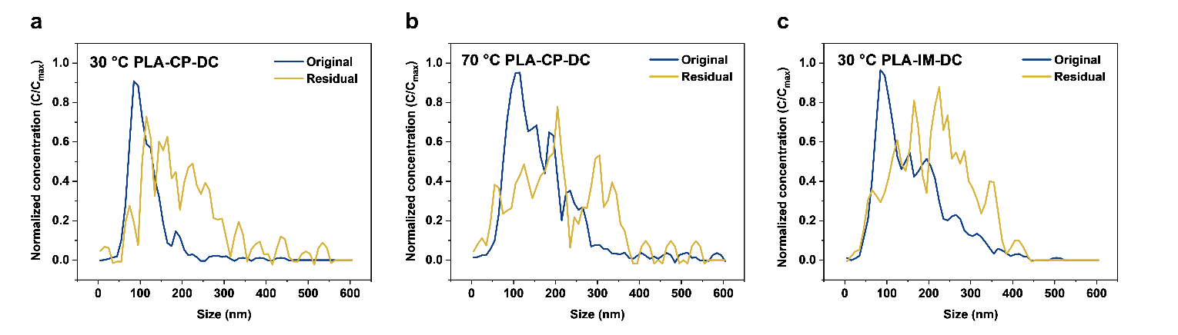

Fig. S6 Normalized size distributions of NPs from PLA-DCs before and after dissolution using 60% EtOH. (a) 30 °C, PLA-CP-DC. (b) 70 °C, PLA-CP-DC. (c) 30 °C, PLA-IM-DC. “Original” refers to the NP size distribution prior to dissolution, and “Residual” refers to the remaining NPs after dissolution.

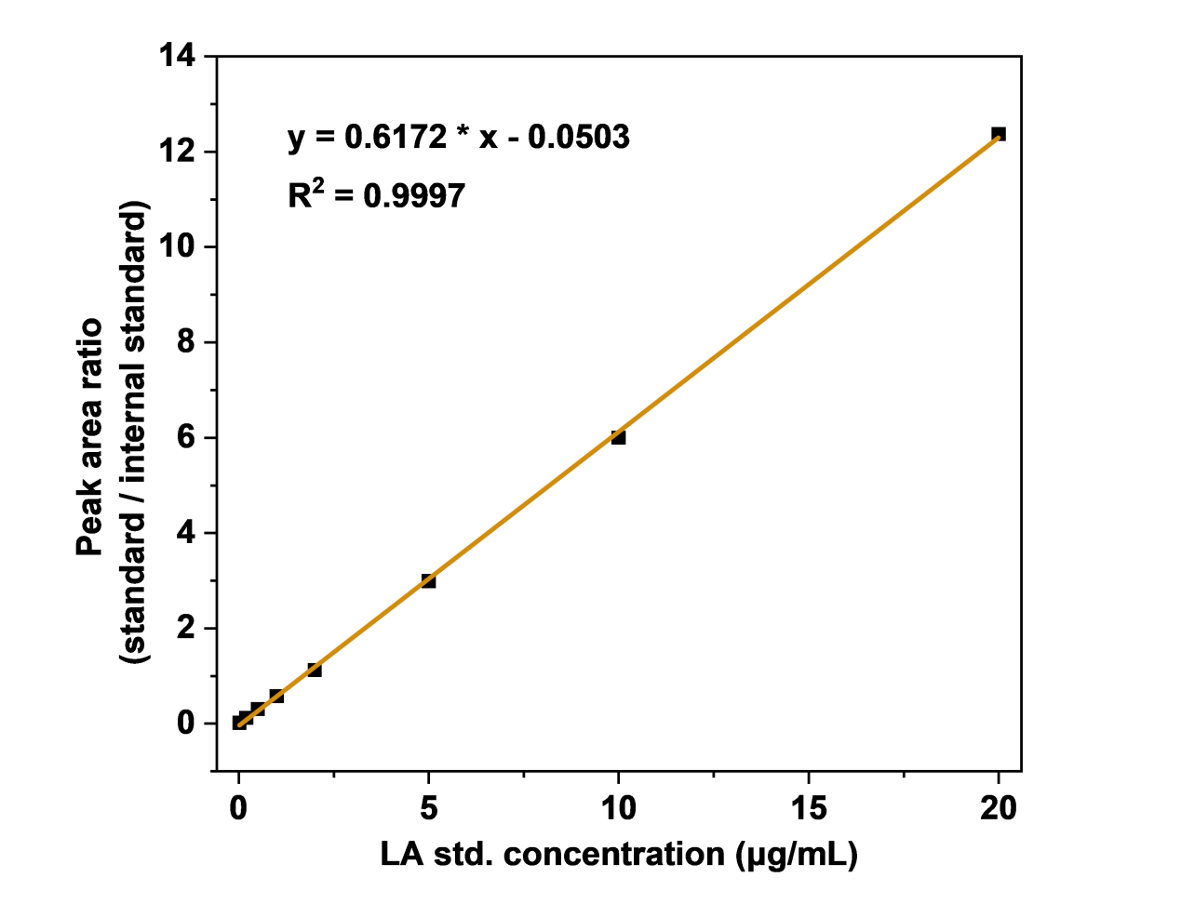

Fig. S7 Eight-point calibration curve for LA (0.02–20 μg mL⁻¹) obtained by LC–MS/MS with ¹³C₃-LA as the internal standard.

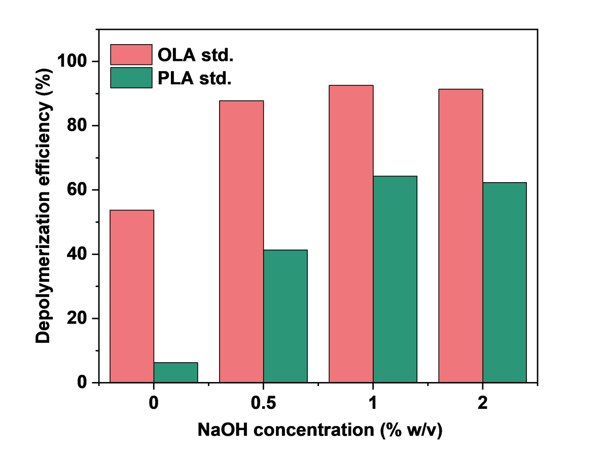

Fig. S8 Depolymerization efficiencies of the mixed OLA standard (OLA std.) and the PLA NP reference standard (PLA std.) at 0, 0.5, 1, and 2% (w/v) NaOH after 4 h-reaction at 121 °C, respectively.

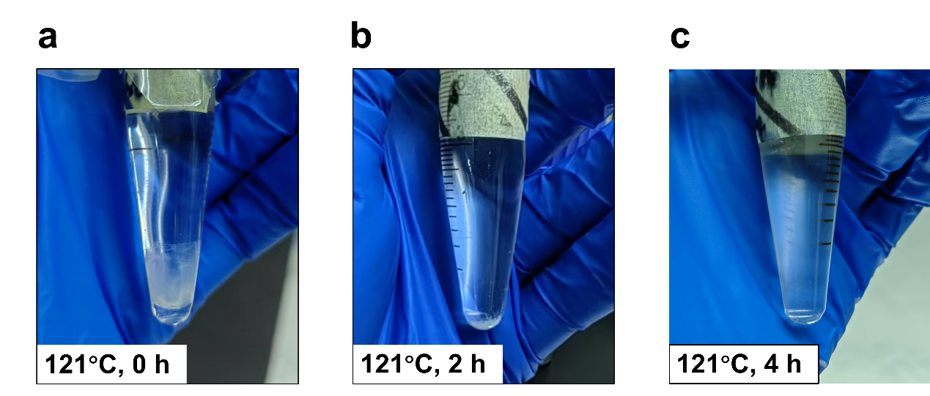

Fig. S9 Alkaline depolymerization of PLA NP reference standard (1% NaOH, 121 °C): photographs taken at (a) 0 h, (b) 2 h, and (c) 4 h. The PLA NP gradually degraded and was no longer visible by 4 h.

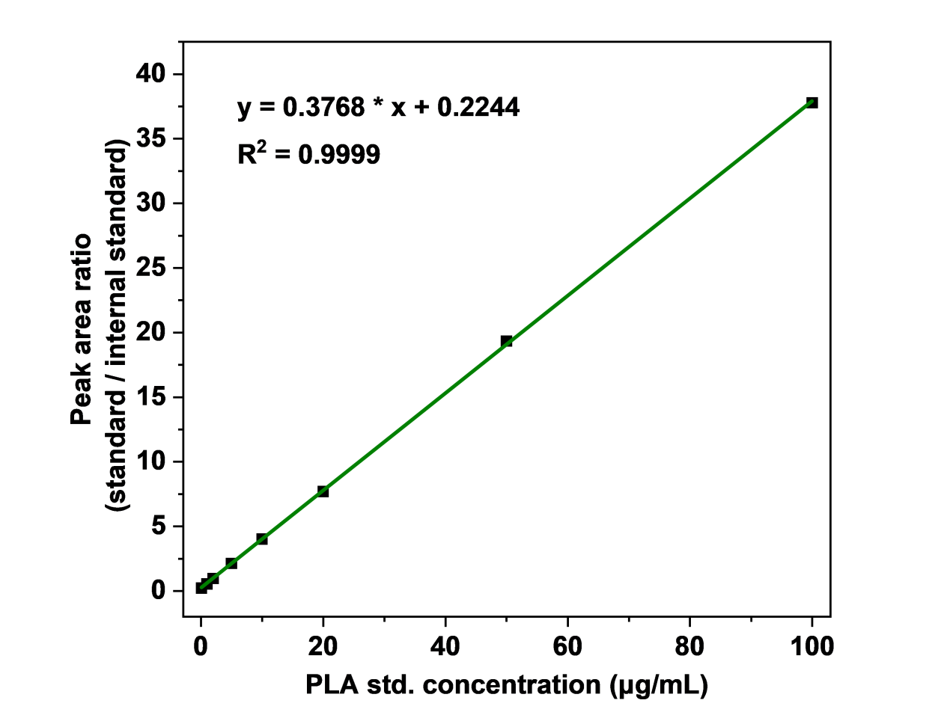

Fig. S10 LC–MS/MS calibration curve for the PLA NP reference standard (0.1–100 μg mL⁻¹) using ¹³C₃-LA as the internal standard.

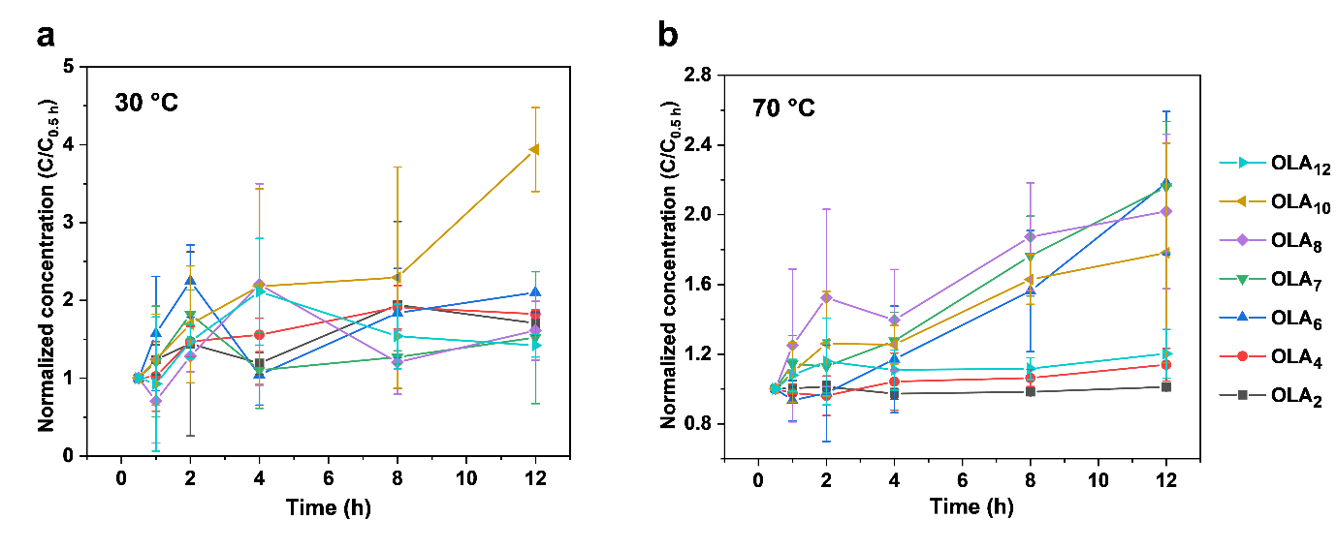

Fig. S11 Normalized concentration profiles of OLA₂, OLA₄, OLA₆, OLA₇, OLA₈, OLA₁₀, and OLA₁₂ released from PLA-DCs during simulated drinking water standing, collected at 0.5, 1, 2, 4, 8, and 12 h (mean ± s.d., n = 3). All concentrations were normalized to each compound’s 0.5 h-value. (a) 30 °C. (b) 70 °C.

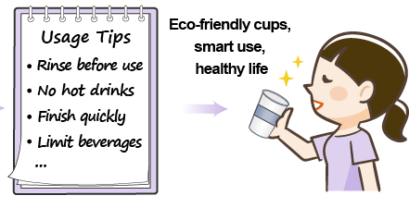

Fig. S12 Suggested usage tips for PLA-DCs, including rinsing with cold water before use, avoiding hot drinks, finishing beverages quickly, and limiting consumption of acidic or alcoholic drinks.

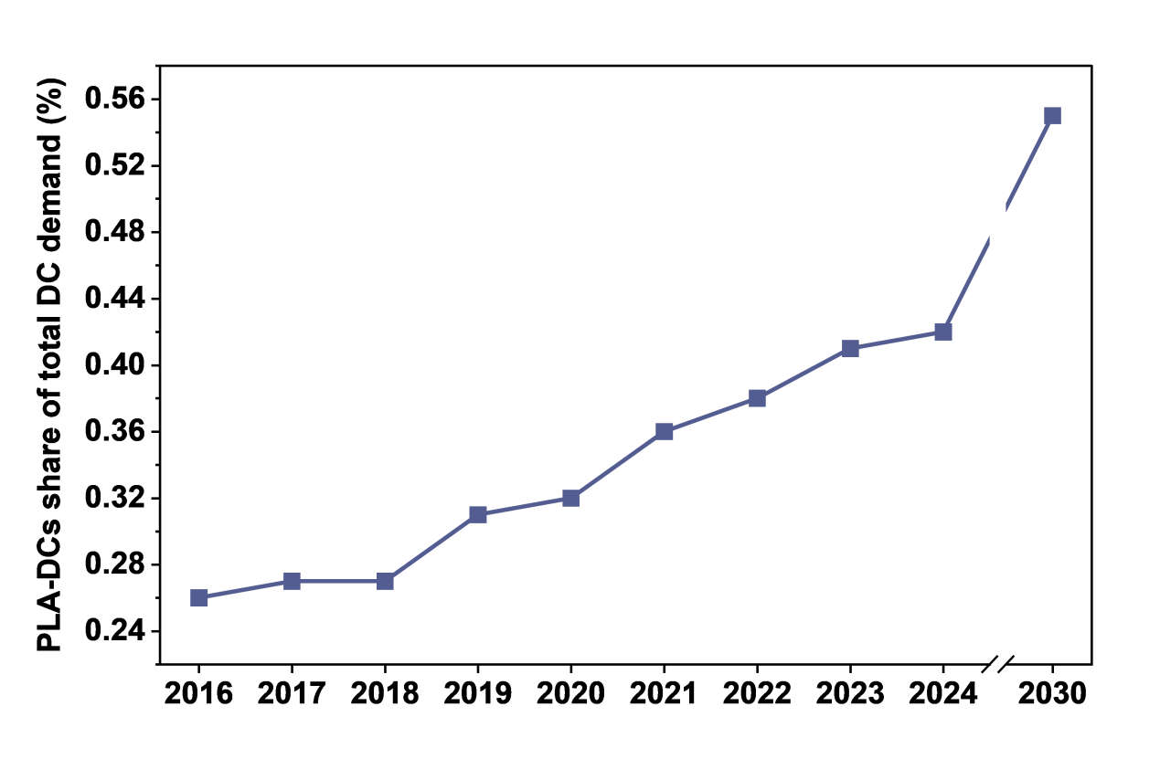

Fig. S13 Share of PLA-DCs in total disposable cup demand in China during 2016–2024, along with the projected share for 2030⁶. Modified from Ref. [6].

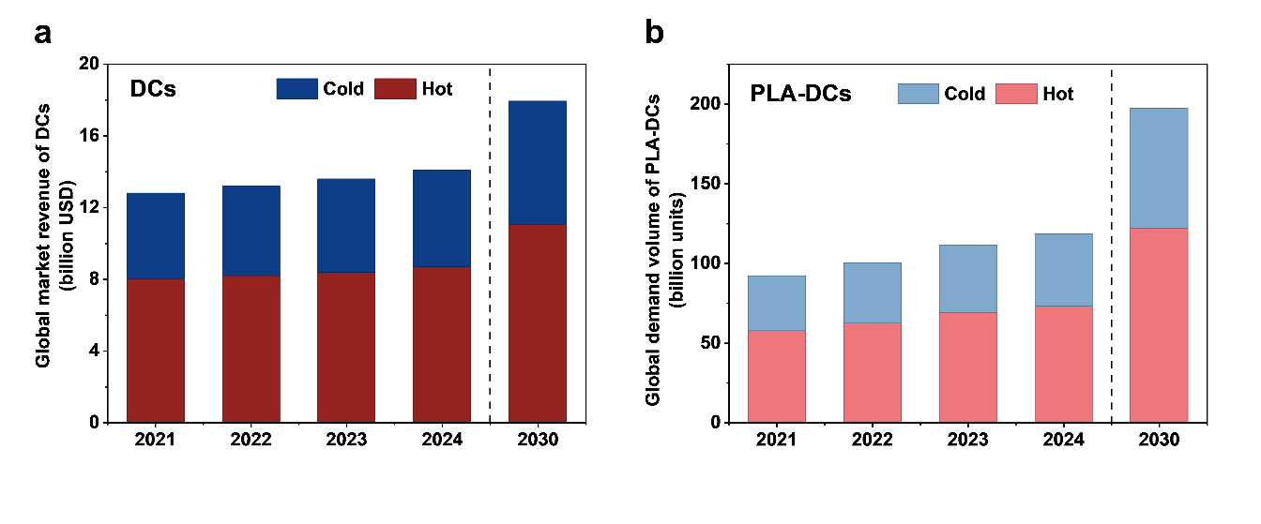

Fig. S14 Global market scales of DCs and PLA-DCs in 2021–2024 and projected for 2030, separated by cold-drink and hot-drink cups⁵. (a) Annual market revenue of total DCs (in USD). (b) Annual demand volume of PLA-DCs. Modified from Ref. [5].

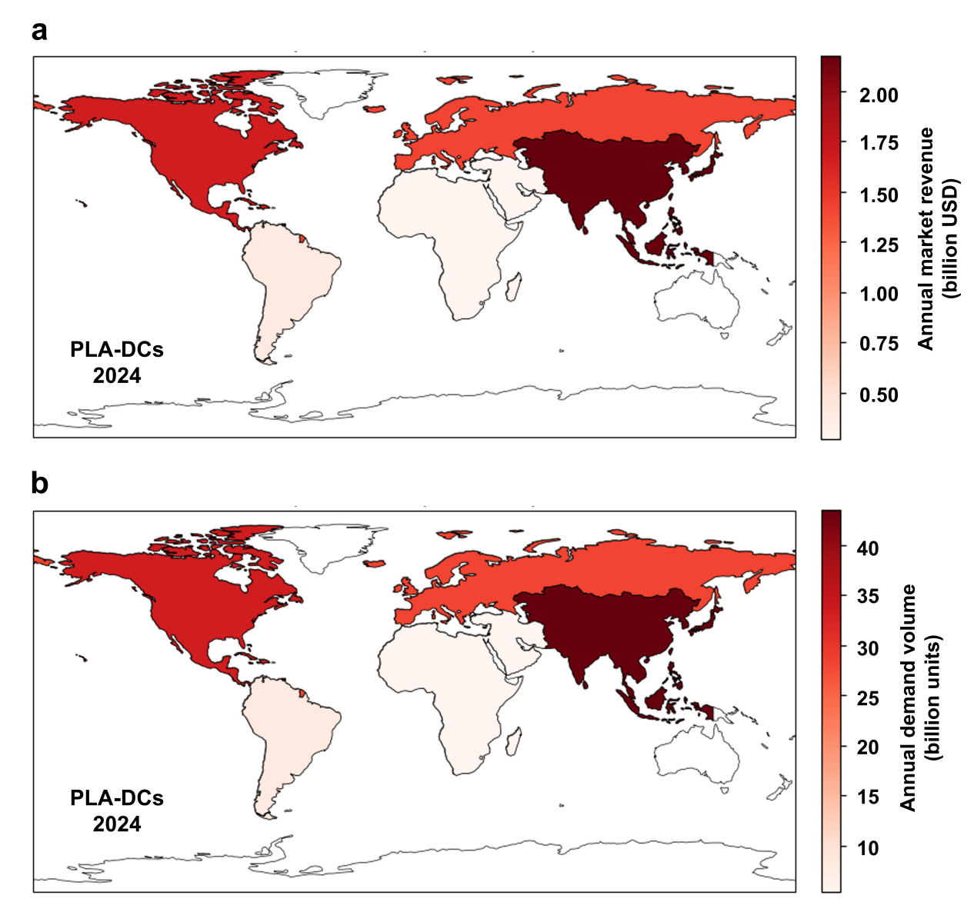

Fig. S15 Regional market scales of PLA-DCs in 2024 across the Asia–Pacific, Europe, North America, Latin America, and Middle East & Africa regions⁵. (a) Annual market revenue (in USD). (b) Annual demand volume. Modified from Ref. [5].

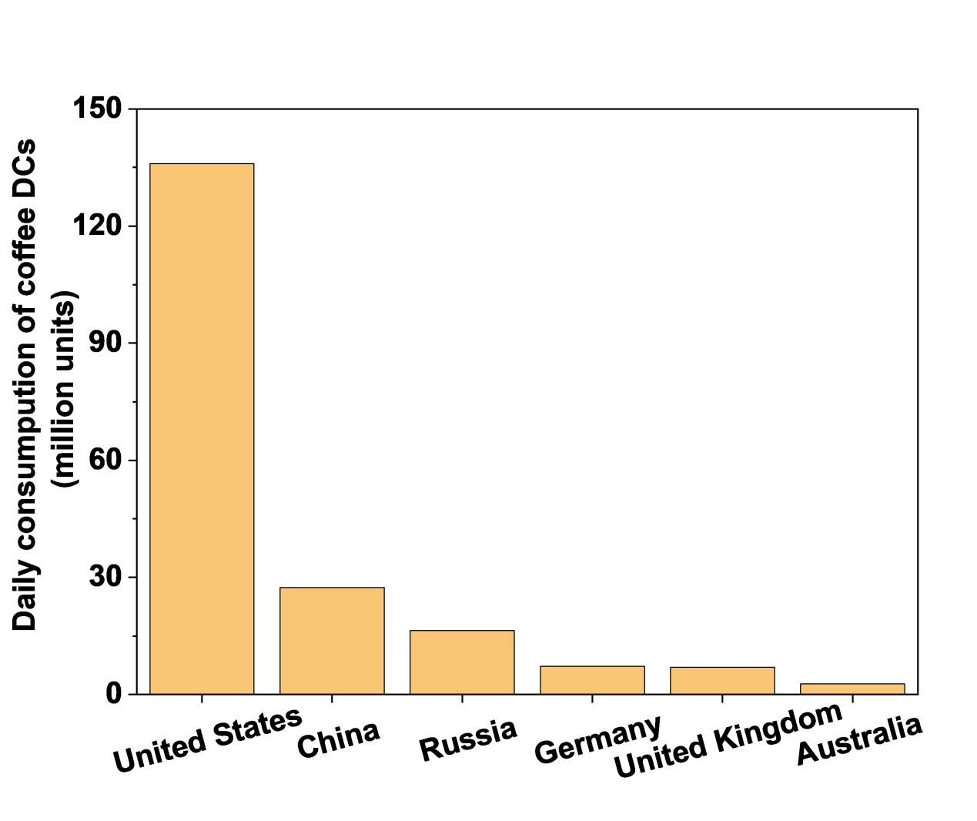

Fig. S16 Daily consumption of coffee DCs in 2018 among six major coffee-consuming countries, including the United States, China, Russia, Germany, the United Kingdom, and Australia⁷. Modified from Ref. [7].

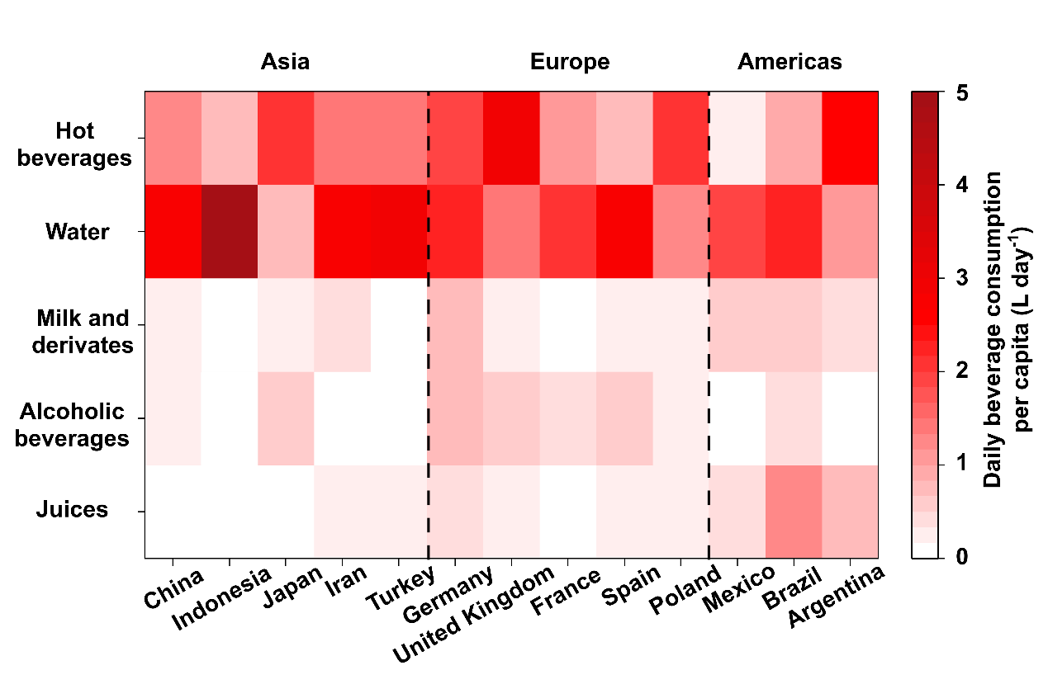

Fig. S17 Daily per capita beverage consumption across 13 representative countries in Asia, Europe, and the Americas, stratified by beverage type⁸. Modified from Ref. [8].

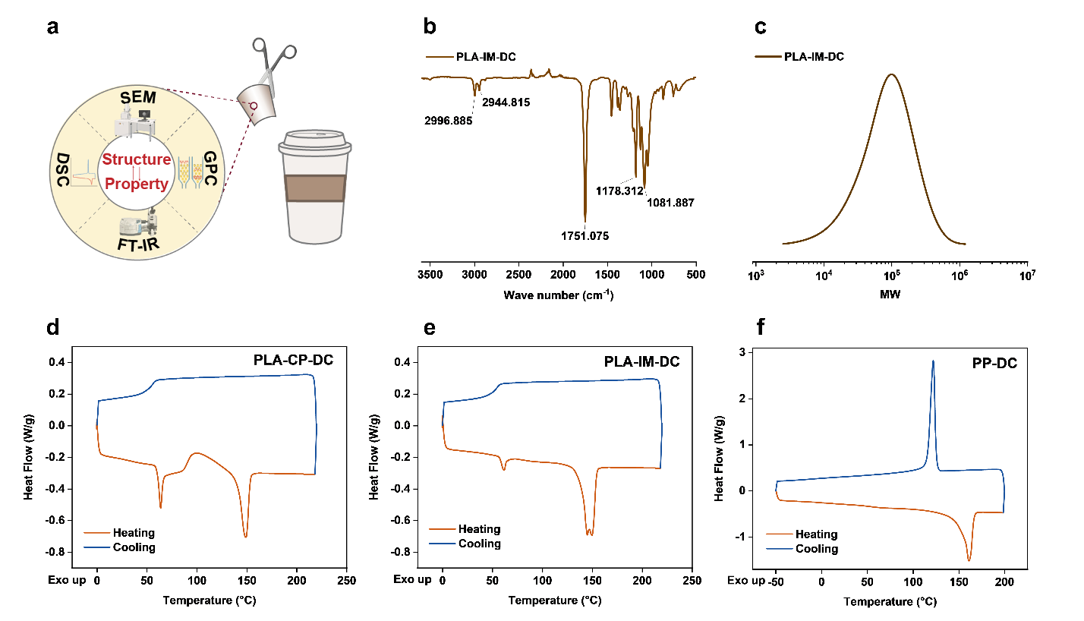

Fig. S18 Material characterization of PLA-CP-DC, PLA-IM-DC, and PP-DC. (a) Illustration of the overall characterization framework. (b) FTIR spectrum of PLA-IM-DC. (c) GPC molecular weight distribution of PLA-IM-DC. (d) DSC heating and cooling curves of PLA-CP-DC. (e) DSC heating and cooling curves of PLA-IM-DC. (f) DSC heating and cooling curves of PP-DC.

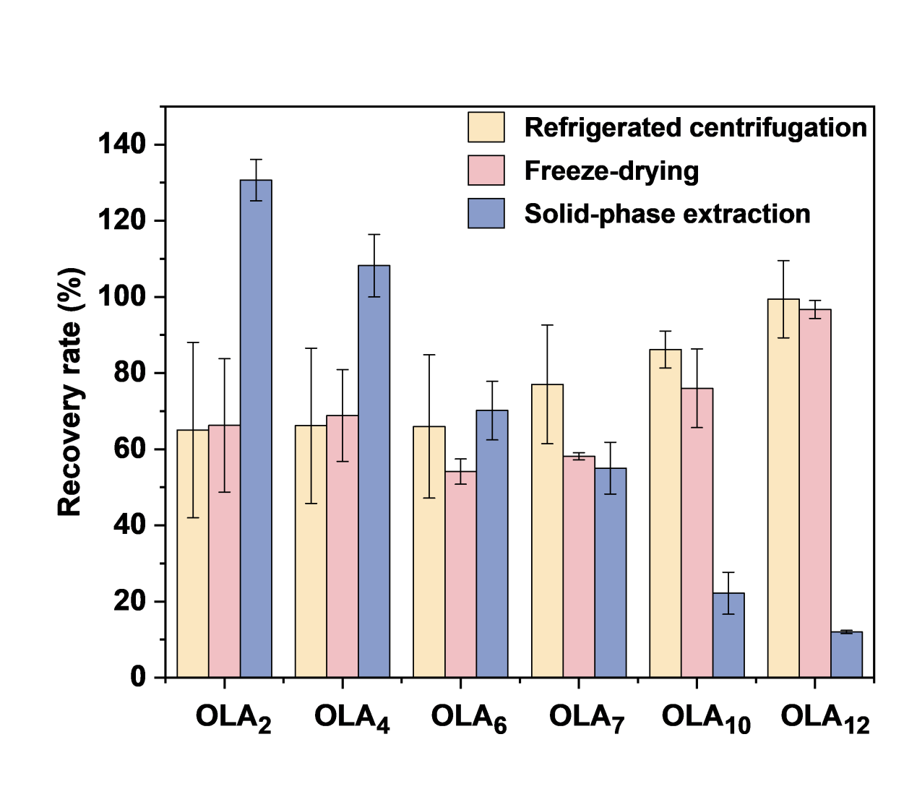

Fig. S19 Comparison of recoveries of OLA₂, OLA₄, OLA₆, OLA₇, OLA₁₀, and OLA₁₂ using three different concentration methods: refrigerated centrifugation, freeze drying, and solid-phase extraction (SPE) with MAX cartridges (mean ± s.d., n = 3).

Supplementary Tables

Table S1 Method validation for PLCs: method detection limits (MDLs), method quantification limits (MQLs), and recoveries in water samples
 | MDL  (ng mL⁻¹) | MQL  (ng mL⁻¹) | Recovery in water samples (%)ª
 | MDL  (ng mL⁻¹) | MQL  (ng mL⁻¹) | 20 ng mL⁻¹ | 200 ng mL⁻¹ | 2000 ng mL⁻¹
LA | 3.54 | 11.26 | 108.90±10.15 | 97.03±1.69 | 98.91±2.40
OLAs | 2.69 | 8.56 | 77.06±7.18 | 72.23±1.26 | 70.47±1.71
PLA NPs | 12.45 | 39.60 | <MQL | 98.20±0.75 | 98.34±1.89
ª Data are presented as mean ± SD of three independent repeats.

Table S2 Method validation for short-chain OLAs: MDLs, MQLs, and recoveries in water samples
 | MDL (ng mL⁻¹) | MQL (ng mL⁻¹) | Recovery (%)ª
OLA₂ | 1.99 | 6.33 | 83.35±11.03
OLA₄ | 0.22 | 0.71 | 86.47±8.15
OLA₆ | 0.11 | 0.35 | 86.39±7.53
OLA₇ | 0.21 | 0.65 | 90.40±4.12
OLA₈ | 0.29 | 0.92 | 90.81±6.24
OLA₁₀ | 0.28 | 0.88 | 94.47±1.95
OLA₁₂ | 0.14 | 0.45 | 99.76±4.06
ª Data are presented as mean ± SD of three independent repeats.

Table S3 Per-cup exposure to leachates from PLA-based disposable cups used for different beverages ª
Leachate species | Cold water (μg)^{b} | Hot water (μg)^{b} | Juices (μg)^{c} | Alcoholic beverages, milk and derivates (μg)^{c} | Hot beverages (μg)^{c}
OLAs | 2.72 | 4830.38 | 3.07 | 5.88 | 10447.84
PLA NPs | 5.14 | 5649.68 | 5.81 | 11.13 | 12219.95
PLCs | 13.79 | 10613.39 | 15.58 | 29.83 | 22956.17
ª Data were estimated under the conditions of a 250 mL PLA-DC volume and a stand time of 0.5 h.
^{b} Cold water exposure was derived from the 30 °C water dataset, and hot water exposure from the 70 °C water dataset.
^{c} Juices exposure was estimated from 30 °C acetic acid simulant; alcoholic beverages, milk, and derivatives were estimated from 30 °C EtOH simulant; hot beverages were estimated from 70 °C EtOH simulant.

Table S4 LC-MS/MS instrument parameters for quantification of LA
Instrument | 1290 Infinity II LC system coupled with 6495 triple quadrupole mass spectrometer  (Agilent, Santa Clara, CA, USA)
Analytical column | HILIC column (150 × 2.1 mm, 5 μm, HILICON, Sweden)
Injection volume | 5 μL
Mobile phase | A: 20 mM NH₄OAc + 5% ACN in water; pH 9.2 (NH₄OH), B: ACN
Liquid chromatography
  Time (min) | Temp (°C) | Flow  (mL min⁻¹) | A (%) | B (%)
  0.00 | 30 | 0.2 | 5 | 95
  6.00 | 30 | 0.2 | 50 | 50
  8.00 | 30 | 0.2 | 50 | 50
  8.10 | 30 | 0.2 | 5 | 95
  12.00 | 30 | 0.2 | 5 | 95
Mass spectrometry parameters | Sheath Gas Temperature: 350 °C  Drying Gas Temperature: 250 °C  Capillary Voltage: 3500 V  Nozzle Voltage: 1000 V  Nebulizer: 35 psi  Sheath Gas Flow: 11 L/min  Drying Gas Flow: 15 L/min  Delta EMV(-): 200 V

Table S5 Multiple reaction monitoring (MRM) transitions of target LA in LC-MS/MS.
Compound | Mass transition | Collision  energy (V) | Retention  time (min) | Dwell | Polarity
LA | 89>43* | 10 | 5.920 | 20 | Negative
LA | 89>45 | 10 | 5.920 | 20 | Negative
³C₁₃-LA | 92>45* | 9 | 5.924 | 20 | Negative
³C₁₃-LA | 92>46 | 9 | 5.924 | 20 | Negative
* indicates quantitative ion pairs; others are qualitative ion pairs.

Table S6 LC-MS/MS instrument parameters for quantification of OLAs
Instrument | 1290 Infinity II LC system coupled with 6495 triple quadrupole mass spectrometer  (Agilent, Santa Clara, CA, USA)
Analytical column | C18 column (50 × 2.1 mm, 1.8 μm, Agilent, USA)
Injection volume | 5 μL
Mobile phase | A: 0.1% FA in water,, B: ACN
Liquid chromatography gradient
  Time (min) | Temp (°C) | Flow (mL/min) | A (%) | B (%)
  0.00 | 40 | 0.25 | 95 | 5
  1.00 | 40 | 0.25 | 95 | 5
  6.00 | 40 | 0.25 | 0 | 100
  7.00 | 40 | 0.25 | 0 | 100
  8.00 | 40 | 0.25 | 95 | 5
  9.00 | 40 | 0.25 | 95 | 5
Mass spectrometry parameters | Sheath Gas Temperature: 350 °C  Drying Gas Temperature: 250 °C  Capillary Voltage: 3500 V  Nozzle Voltage: 1000 V  Nebulizer: 25 psi  Sheath Gas Flow: 11 L/min  Drying Gas Flow: 15 L/min  Delta EMV(-): 200 V

Table S7 MRM transitions of target OLAs in LC-MS/MS.
Compound | Mass transition | Collision  energy (V) | Retention  time (min) | Internal standard | Mass  transition of d-OLAs
OLA₂ | 161.04>89.02* | 8 | 0.642 | d-OLA₂ | 162.05>89.02*
OLA₄ | 305.09>89.02* | 16 | 3.451 | d₂-OLA₄ | 307.1>89.02*
OLA₄ | 305.09>161.04 | 4 | 3.451 | d₂-OLA₄ | 307.1>89.02*
OLA₆ | 449.1>89.02* | 44 | 4.117 | d₃-OLA₆ | 452.1>89.02*
OLA₆ | 449.1>377.11 | 8 | 4.117 | d₃-OLA₆ | 452.1>89.02*
OLA₇ | 521.1>89.02* | 52 | 4.379 | d₃-OLA₇ | 524.1>89.02*
OLA₇ | 521.1>449.13 | 12 | 4.379 | d₃-OLA₇ | 524.1>89.02*
OLA₈ | 593.1>89.02* | 72 | 4.600 | d₄-OLA₈ | 597.1>89.02*
OLA₈ | 593.1>521.15 | 12 | 4.600 | d₄-OLA₈ | 597.1>89.02*
OLA₁₀ | 737.2>89.02* | 68 | 4.937 | d₅-OLA₁₀ | 742.2>89.02*
OLA₁₀ | 737.2>665.19 | 16 | 4.937 | d₅-OLA₁₀ | 742.2>89.02*
OLA₁₂ | 881.2>89.02* | 72 | 5.294 | d₅-OLA₁₂ | 886.2>89.02*
OLA₁₂ | 881.2>809.24 | 24 | 5.294 | d₅-OLA₁₂ | 886.2>89.02*
* indicates quantitative ion pairs; others are qualitative ion pairs.

References
1 Xu, C. et al. Regio-and sequence-controlled conjugated topological oligomers and polymers via boronate-tag assisted solution-phase strategy. Nature Communications 12, 5853 (2021).
2 Shi, C. et al. Precise characterization of the presence and fate of plastic oligomers in water. Nature Water 3, 1–12 (2025).
3 Yang, J. et al. The analysis of polylactic acid oligomers and their fate in laboratory and agricultural soil. Environmental Science & Technology 59, 9235–9244 (2025).
4 Chinese National Standards. GB/T 36392—2018 PE (PP, PET) coated paper and board for food packaging. Chinese National Standards, Beijing, China (2018).
5 Global Market Insights Inc. Paper Cups Market Size – By Type, By Wall Type, By Capacity, and By End-use – Global Forecast, 2025–2034. Global Market Insights Inc., Selbyville, Delaware, USA (2025).
6 Zhiyan Consulting. China Paper Cup Industry Market Development Potential and Investment Risk Forecast Report (2026–2032). Zhiyan Consulting, Beijing (2025).
7 Triantafillopoulos, N. & Koukoulas, A. A. The future of single-use paper coffee cups: current progress and outlook. BioResources 15, 7260–7287 (2020).
8 Guelinckx, I. et al. Intake of water and different beverages in adults across 13 countries. European Journal of Nutrition 54 (Suppl 2), 45–55 (2015).

