Supporting Information

Table 1. Environmental characteristics of the twelve Mark-Recapture plots. Means and Standard Deviation (SD) are derived from the survey-level measurements from the 15 surveys from 2017 - 2020. The plot column indicates High or Low elevation, and the replicate Close, Medium, and Far from stream plots.
Plot | Air Temp (C) | Air Temp SD | Relative Humidity (%) | Relative Humidity SD | Belowground Soil Temp (C) | Belowground Soil Temp SD | Surface Soil Temp | Surface Soil Temp SD
High
Close | 18.61 | 1.99 | 84.19 | 8.96 | 18.19 | 8.37 | 15.19 | 1.95
Close | 18.54 | 2.58 | 83.17 | 9.17 | 16.10 | 1.27 | 15.20 | 2.17
Medium | 18.58 | 1.95 | 83.97 | 10.00 | 16.27 | 1.33 | 15.21 | 1.78
Medium | 17.98 | 1.99 | 83.44 | 9.75 | 16.09 | 1.53 | 17.37 | 9.03
Far | 17.88 | 2.03 | 86.33 | 8.10 | 15.79 | 1.24 | 15.00 | 1.98
Far | 17.79 | 1.92 | 85.33 | 10.28 | 18.60 | 9.35 | 14.82 | 2.29
Low
Close | 21.59 | 2.84 | 84.22 | 7.20 | 18.13 | 0.99 | 17.26 | 1.43
Close | 20.31 | 1.68 | 80.84 | 8.31 | 18.83 | 1.13 | 17.50 | 2.23
Medium | 22.64 | 3.06 | 79.95 | 11.16 | 22.81 | 14.30 | 18.40 | 1.55
Medium | 21.24 | 2.17 | 80.46 | 8.77 | 18.74 | 1.15 | 18.24 | 2.23
Far | 22.24 | 1.52 | 78.33 | 7.74 | 19.39 | 1.12 | 18.80 | 1.86
Far | 21.17 | 1.77 | 77.19 | 9.90 | 18.71 | 1.33 | 18.28 | 2.34

Figure 1. Representative individuals of (A) high elevation “pure” P. shermani and (B) low elevation P. shermani x P. teyahalee hybrid. The red vertical lines in (A) show the 4-body region designation that the P. teyahalee characteristic white spots were counted to include in the hybrid score PCA. The white arrow in (B) shows examples of the white spots.

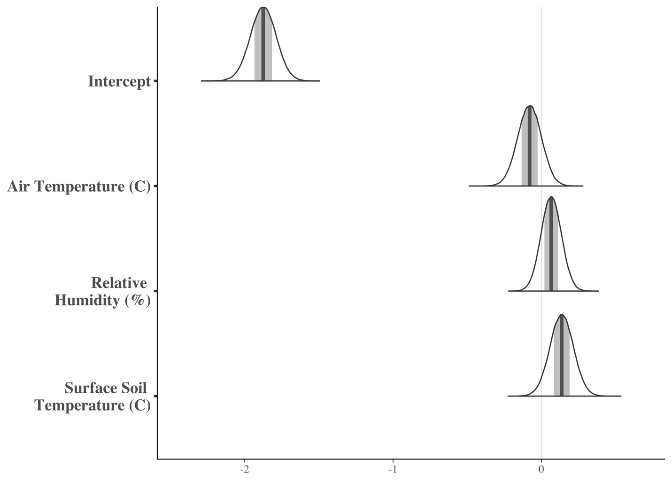
Figure 2. Posterior mean density estimates for the detection covariates of P. shermani estimated in the sCJS. The shaded region includes 75% of the posterior

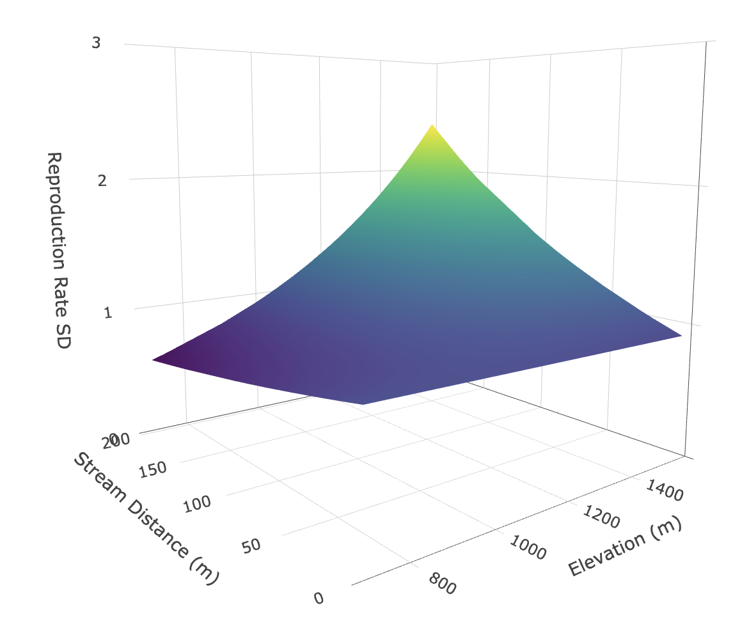

Figure 3: The standard deviation in reproductive rate estimates in the interaction between elevation and stream distance in P. shermani from the SEIPM

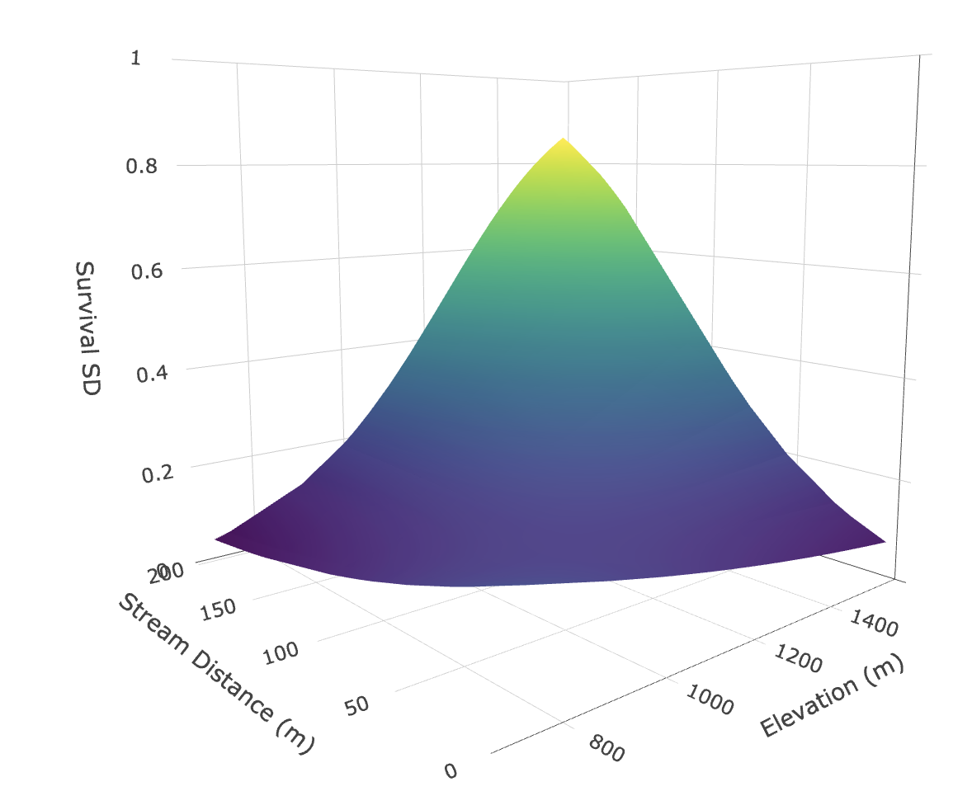

Figure 4: The standard deviation in survival estimates in the interaction between elevation and stream distance in P. shermani from the SEIPM.

