Supplementary Fig. S1 Bioinformatic analysis of prolamins in foxtail millet and other species: (a) gene structure, (b) conserved motifs, (c) domain analysis, (d) gene location, (e) cis-acting elements, and (f) collinearity analysis. The red lines represent interspecies collinear gene pairs, with “Si” for foxtail millet, “Sb” for sorghm and “Zm” for maize.
Supplementary Fig. S2 Sequences and peaks of representative heterozygous mutation types of base editing of Seita.8G190200 in ko3, ko4, and ko5. Graphical representation of the guide RNA sequence with protospacer adjacent motif (PAM) and a putative cutting site on the vector used to generate α-prolamin CRISPR/Cas9 mutants. The black boxes and solid black lines represent gene exons and chromosomes, respectively. Nucleotides in blue represent the target sequences. Nucleotides are underlined for the PAM. The red indicates the positions of these base editing mutations.
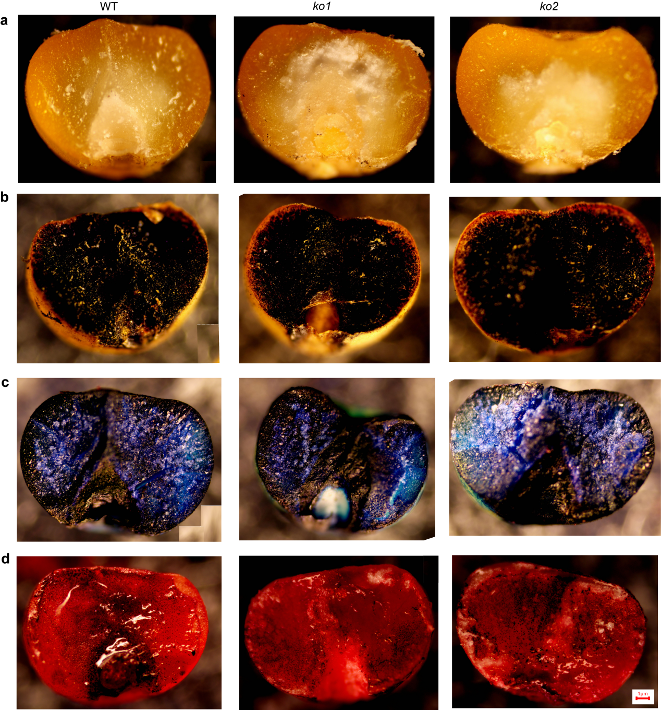
Supplementary Fig. S3 Staining analysis of storage product accumulation of the foxtail millet hulled grain. (a) Transversely sectioned hulled grain of WT, ko1 and ko2. (b) Transversely sectioned hulled grain of WT, ko1 and ko2 stained with Lugol's iodine for analysis of starch accumulation. (c) Transversely sectioned hulled grain of WT, ko1 and ko2 stained with toluidine blue to observe the accumulation of endosperm storage products. (d) Transversely sectioned hulled grain of WT, ko1 and ko2 stained with Sudan red IV for lipid accumulation. Scale bar=1 µm
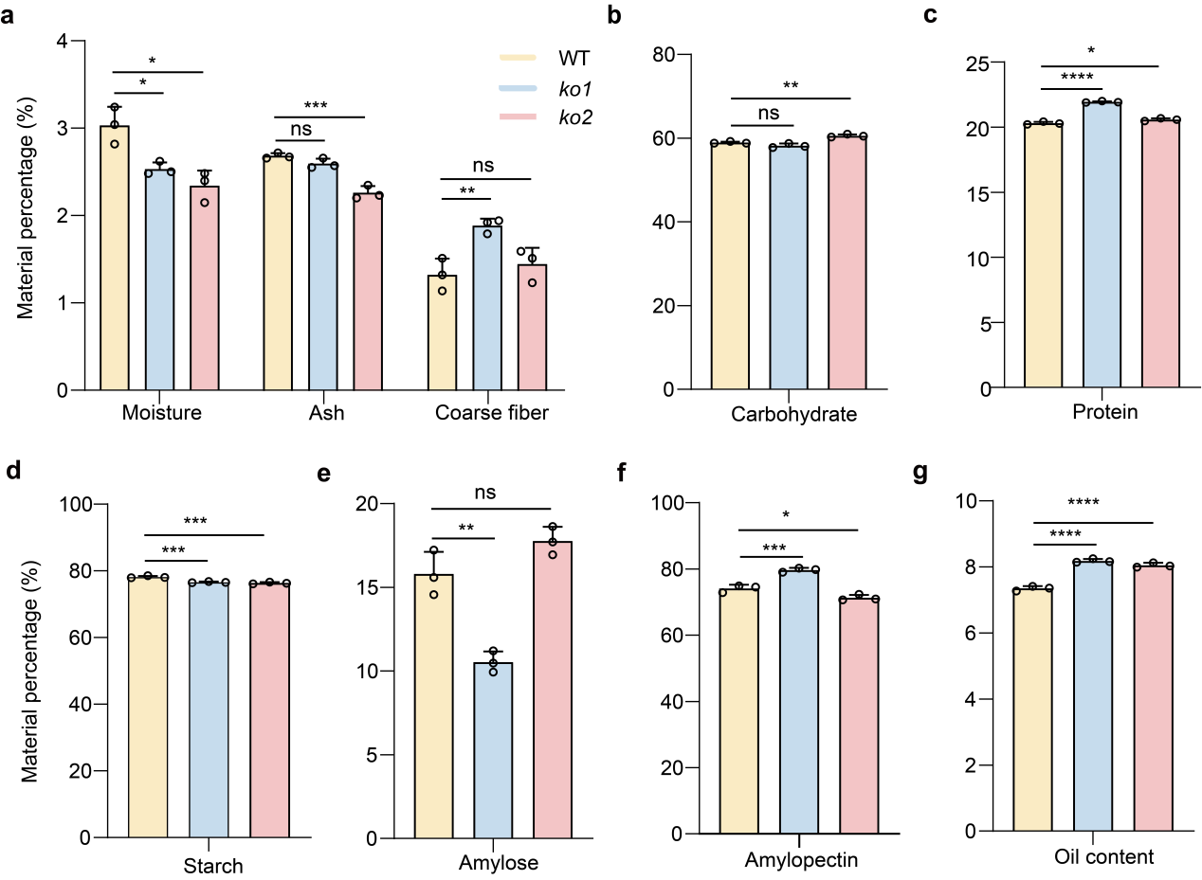
Supplementary Fig. S4 The components of WT, ko1 and ko2 were detected and compared by near infrared spectrometer (NIRS). Comparison of predicted moisture, ash, coarse fiber (a), carbohydrate content (b), protein wet base (c), starch dry base (d), amylose (e), amylopectin (f) and oil content (g). The mean ± SE of three biological replicates are shown. The significant differences are established by Tukey multiple comparison test. Each little circle indicates phenotype value of each sample in (a-g). *P < 0.05. **P < 0.01. ***P < 0.001. ****P < 0.0001. ns, no significant difference.

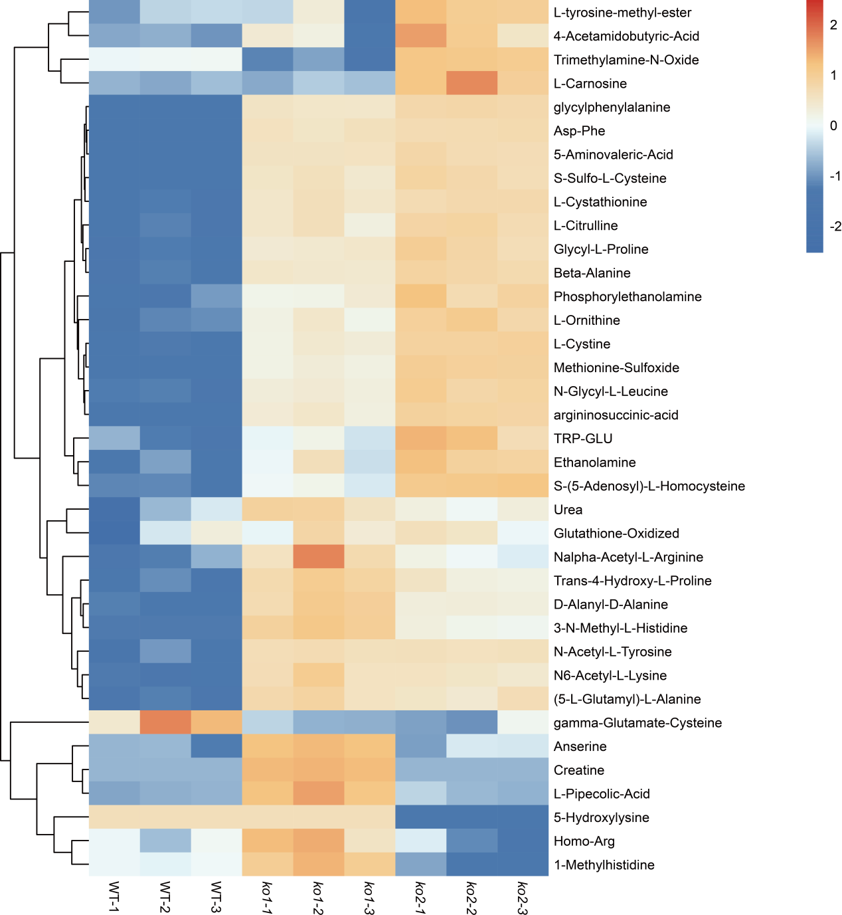
Supplementary Fig. S5 Cluster heatmap of residual amino acids and their derivatives in wild type versus gene editing lines.
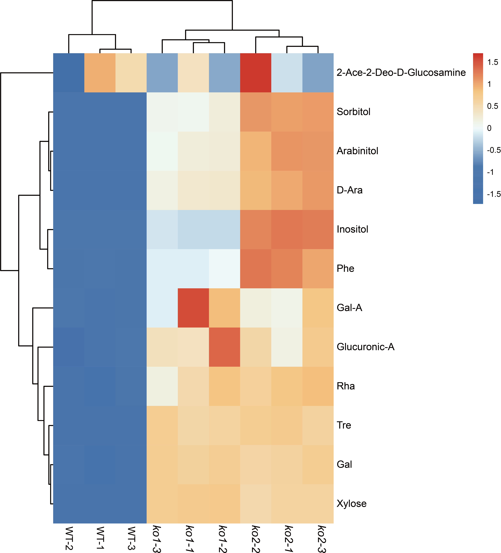
Supplementary Fig. S6 Clustered heatmap of monosaccharide and disaccharide content in wild type and gene editing lines.
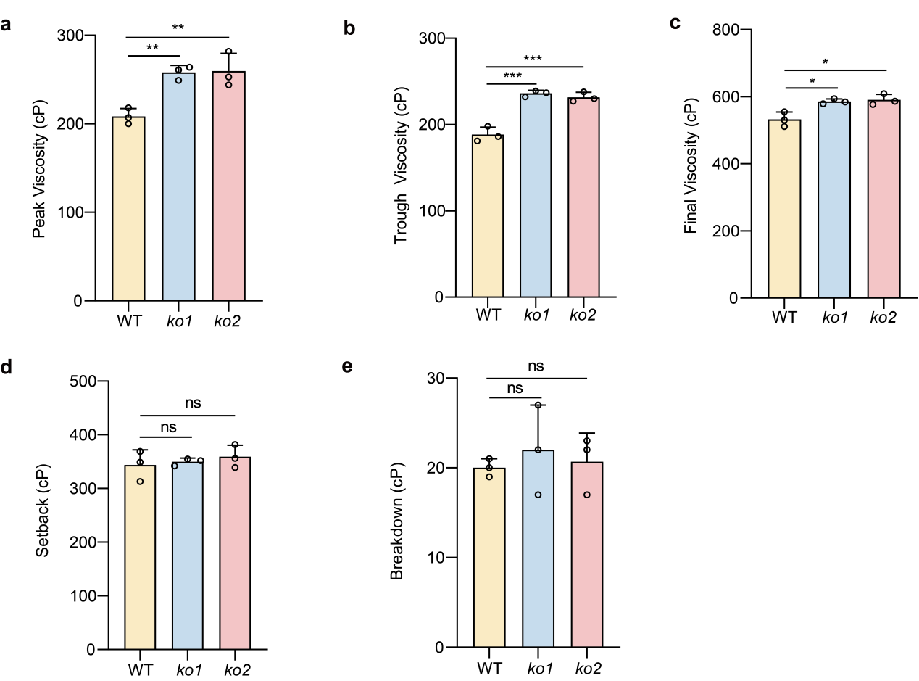
Supplementary Fig. S7 RVA analysis of wild type and the gene editing lines. (a-e) Peak viscosity (a), trough viscosity (b) and final viscosity (c) of ko1 and ko2 were all significantly higher compared to wild type plants, while setback (d) and breakdown (e) did not change significantly. The mean ± SE of three biological replicates are shown. The significant differences are established by Tukey multiple comparison test. Each little circle indicates phenotype value of each sample in (a-e). *P < 0.05. ns, no significant difference.
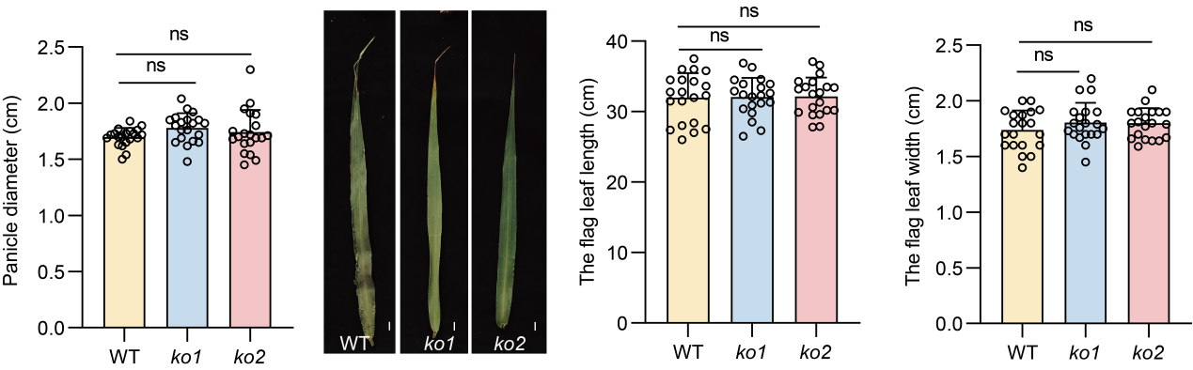
Supplementary Fig. S8 Panicle and flag leaf analysis of the wild type, ko1 and ko2. Scale bar=1 cm. The mean ± SE of twenty biological replicates are shown. The significant differences are established by Tukey multiple comparison test. Each little circle indicates phenotype value of each sample. ns, no significant difference.
Supplementary Table S1 Potential off-target effects of gRNA used for Seita.8G190200 mutation.
Target | Target site and potential off-target site | Putative off-target locus | Target region | No. of mismatching bases | No. of plants sequenced | No. of plants with mutations
Seita.8G190200 | On-target | Seita.8G190200 | TACAACAACAGTCTGCCCTGTGG | / | / | /
Seita.8G190200 | Off-target 1 | Seita.5G335300 | TAGAAGAAATGTCTACCCTGTGG | 5 | 14 | 0
Seita.8G190200 | Off-target 2 | Seita.3G022600 | GACAACAACGGTGTGCCCTGTGG | 3 | 14 | 0

The PAM sequences and the mismatches to the target sequence in the potential off-target region are highlighted in green and red, respectively.
Supplementary Table S2 Primer sequences used in this study.
Name | Sequence (5′-3′)
Primers for constructing knockout vector.
MT1T2-F | AATAATGGTCTCAGGCGTACAACAACAGTCTGCCCTGGTTTTAGAGCTAGAAATAGC
MT1T2-R | ATTATTGGTCTCTAAACCAGGGCAGACTGTTGTTGTACGCTTCTTGGTGCC
Primers for identification of transgenic seedlings.
19CR-F | GACCCAGTAGCAGAAATTGAAACCCAC
19CR-R | GCAGTTGTTGACGGAAGACATTCGC

Material and methods
1. Phylogenetic analysis of Seita.8G190200 gene families in foxtail millet
First, we used the phytozome website (https://phytozome-next.jgi.doe.gov/) to download the genome sequence and amino acid sequence of foxtail millet, sorghum and maize. The protein sequences of Seita.8G190200 were queried, and the whole cereal genome was blasted using tb tools. The threshold was set to be less than 1×10⁻⁵. MEGA11 software was employed to establish an evolutionary tree including members of the Seita.8G190200 gene families, and the evolutionary tree was beautified using ITOL online website (https://itol.embl.de/).
2. The conserved motifs, domains, gene structures and cis-acting regulatory elements of Seita.8G190200 gene families were analyzed
TBtools software was used to analyze the foxtail millet Gff3 file, extract the Seita.8G190200 gene sequence, and complete the visual analysis of gene structure. The identification and characterization of conserved protein motifs in foxtail millet were performed using the MEME (https://meme-suite.org/index.html)^{[1]} for computational analysis. The result were subsequently visualized and annotated through TBtools, enabling detailed structural and functional interpretation of the identified conserved domains. TBtools software is utilized to extract Seita.8G190200 gene upstream members start codon 2000 bp sequence, in PlantCARE (http://bioinformatics.psb.ugent.be/)^{[2]} online website predict the cis element, it is also visualized by TBtools software.
3. Chromosomal localization and collinearity analysis of Seita.8G190200 gene family members
The chromosome locations of Seita.8G190200 were located using the GTF/GFF gene location visualization tool in TBtools. In addition, collinearity analysis of Seita.8G190200 family genes was performed using one-step MCScanX^{[3]}, and the results were visualized using TBtools' Advanced Circos program.
4. Plasmid construction and functional verification of transgenic seedlings in foxtail millet
Targeted to knock out Seita.8G190200, a platform (https://home.firefoxchina.cn/) is used to design sgRNA oligonucleotides. It was cloned into the CRISPR/Cas9 vector pHUE411 to create the pHUE411-Cas9 knockout construct. They were transformed into Escherichia coli, identified by PCR, sent for sequencing, and then shaken to extract plasmid. Then the plasmid was sent to Wuhan BioRun Bio-Tech Co., Ltd and transformed into callus induced by mature seeds of foxtail millet variety Ci846 for genetic transformation using the Agrobacterium tumefaciens-mediated (EHA105) transformation method^{[4]}. All transgenic lines were confirmed by targeted genome sequencing. Primers of plasmid vector construction for genome editing of Seita.8G190200 are listed in Supplementary Table S2.
5. Plant materials and growth conditions
During the 2024 growing season (May-October), the experimental materials, including Ci846 along with ko1 and ko2, were cultivated at the Shenfeng experimental station located in Jinzhong City, Shanxi Province, China (geographical coordinates: 37°25′ N, 112°35′ E). For comprehensive phenotypic evaluation, ten randomly selected seeds from both the wild type and the gene editing lines were subjected to detailed morphological characterization. Quantitative measurements of key agronomic traits, including grain length, grain width and 1000-grain weight, were performed using the automated seed analysis system (Model SC-G, Wanshen).
6. Genotyping of edited plants
To identify of the gene editing lines, genomic DNA extraction was performed using the standardized CTAB (cetyltrimethylammonium bromide) protocol^{[5]}. Amplification of genomic regions flanking CRISPR/Cas9 target sites was achieved through PCR using specific primers (Supplementary Table S1). The resulting amplicons were subjected to Sanger sequencing, and the electrophoretograms were subsequently analyzed using the Degenerate Sequence Decoding algorithm to precisely identify and characterize the mutation^{[6]}.
7. Prolamin protein measurement
A total of 50 mg grains were precisely weighed from individual samples of both wild type and gene editing lines. Prolamin protein quantification was performed according to the manufacturer's protocol using a commercial Plant Gliadin ELISA Kit (JINZHIYAN Biotechnology Co., Ltd., Beijing).
8. Amino acid metabolites profling
Amino acids and their metabolites were analyzed utilizing the AB Sciex QTRAP 6500 LC-MS/MS platform through collaboration with MetWare (http://www.metware.cn/). Seed samples from the wild type and the gene editing lines were initially thawed and mechanically homogenized. For extraction, 0.05 g aliquots of homogenized samples were mixed with 500 µL of 70% methanol aqueous solution. Following vortex mixing at 2500 rpm for 3 minutes, the samples were centrifuged at 12000 rpm (4 °C) for 10 minutes. A 300 μL aliquot of the resulting supernatant was transferred to a fresh centrifuge tube and incubated at -20 °C for 30 minutes. Subsequent centrifugation was performed under identical conditions (12000 rpm, 4 °C, 10 minutes). Finally, 200 μL of the clarified supernatant was filtered through a protein precipitation plate prior to LC-MS analysis.
9. The sugar metabolites profling
Sugar contents were detected by MetWare (http://www.metware.cn/) based on the Agilent 8890-5977B platform. Seed samples from both wild type and gene editing lines were homogenized using a Retsch MM 400 mixer mill equipped with zirconia beads (30 Hz, 1.5 min). A 20 mg aliquot of the resulting powder was extracted with 500 μL of methanol: isopropanol: water (3:3:2, v/v/v) through sequential vortexing (3 min) and ultrasonication (30 min). Following centrifugation (12,000 rpm, 4 °C, 3 min), 50 μL of supernatant was combined with 20 μL internal standard solution (1000 μg/mL) and concentrated under nitrogen. The concentrated extract was lyophilized, and the resulting residue was reserved for subsequent derivatization.
Derivatization was performed by sequentially adding 100 μL of methoxyamine hydrochloride in pyridine (15 mg/mL) to each sample, followed by incubation at 37 °C for 2 hours. Subsequently, 100 μL of BSTFA was introduced, and the mixture was vortexed and maintained at 37 °C for an additional 30 minutes. The derivatized samples were diluted to optimal concentrations for GC-MS analysis, following established protocols^{[7-10]}. All analyses were conducted in triplicate.
10. Near infrared analyzer
The contents of moisture, ash, oil, protein, coarse fiber, starch, amylose, amylopectin, and carbohydrate in foxtail millet were determined by near infrared analyzer (NIRS, DA7250, PerkinElmer).
11. Paste viscosity
Paste characteristics were analyzed using a Ingredient Performance Analyzerr (Perkinelmer, America). A precisely weighed 3 g (dry basis) of foxtail millet flour was combined with distilled water in an RVA canister to achieve a total mass of 28 g. The mixture was homogenized using a specialized plastic paddle and subjected to a controlled thermal cycle at constant shear rate. The temperature protocol consisted of: initial equilibration at 50 °C (1 min), heating to 95 °C (12 °C/min), maintenance at 95 °C (2.5 min), cooling to 50 °C (12 °C/min), and final equilibration at 50 °C (2 min).
12. Stereo microscopic analysis
The changes of starch or lipid in WT, ko1 and ko2 grains were compared by stereo microscope (SZX16, Olympus, Japan). Median transverse sections of foxtail millet grains were manually prepared using a razor blade for histological analysis. The sections were sequentially stained with Lugol's iodine for starch detection, 0.1% (w/v) toluidine blue for general tissue visualization, and 0.5% (w/v) Sudan IV in chloroform for lipid identification. Stained sections were immediately examined and imaged using a microscope (BX51, Olympus, Japan).
13. Staining procedures
Hand sections are done with a sharp razor. Histochemical staining was performed using toluidine blue (0.1%), Sudan IV (0.5%), and Lugol's iodine (Coolaber, Beijing, China) following established protocols with minor modifications^{[11,12]}. Tissue sections were treated with toluidine blue (4 h) and Lugol's iodine (5 min), followed by distilled water rinsing. For lipid visualization, sections were stained with Sudan IV (24 h), washed with 70% alcohol, and transferred to distilled water. All stained sections were examined and documented using a microscope (BX51, Olympus, Japan).
14. Statistical analysis
Statistical analysis was performed using Prism 8.0 software (GraphPad Software, INC., USA). Data significance was assessed through one-way ANOVA, with Duncan's multiple comparison test applied for post-hoc analysis. A p-value threshold of less than 0.05 was set to determine statistical significance.

References
[1] Bailey TL, Boden M, Buske FA, Frith M, Grant CE, et al. 2009. MEME SUITE: tools for motif discovery and searching. Nucleic acids research 37:W202-W08
[2] Lescot M, Déhais P, Thijs G, Marchal K, Moreau Y, et al. 2002. PlantCARE, a database of plant cis-acting regulatory elements and a portal to tools for in silico analysis of promoter sequences. Nucleic acids research 30:325-27
[3] Wang Y, Tang H, DeBarry JD, Tan X, Li J, et al. 2012. MCScanX: a toolkit for detection and evolutionary analysis of gene synteny and collinearity. Nucleic acids research 40:e49-e49
[4] Santos C, Romeiro D, Silva J, Basso M, Molinari H, Centeno D. 2020. An improved protocol for efficient transformation and regeneration of Setaria italica. Plant Cell Reports 39:501-10
[5] Murray M, Thompson W. 1980. Rapid isolation of high molecular weight plant DNA. Nucleic acids research 8:4321-26
[6] Liu W, Xie X, Ma X, Li J, Chen J, Liu Y-G. 2015. DSDecode: a web-based tool for decoding of sequencing chromatograms for genotyping of targeted mutations. Molecular Plant 8:1431-33
[7] Wu X, Liu J, Li D, Liu CM. 2016. Rice caryopsis development II: Dynamic changes in the endosperm. Journal of integrative plant biology 58:786-98
[8] Zheng H, Zhang Q, Quan J, Zheng Q, Xi W. 2016. Determination of sugars, organic acids, aroma components, and carotenoids in grapefruit pulps. Food Chemistry 205:112-21
[9] Medeiros PM, Simoneit BR. 2007. Analysis of sugars in environmental samples by gas chromatography–mass spectrometry. Journal of Chromatography A 1141:271-78
[10] Gómez-González S, Ruiz-Jimenez J, Priego-Capote F, Luque de Castro MaD. 2010. Qualitative and quantitative sugar profiling in olive fruits, leaves, and stems by gas chromatography− tandem mass spectrometry (GC-MS/MS) after ultrasound-assisted leaching. Journal of agricultural and food chemistry 58:12292-99
[11] Wu X, Liu J, Li D, Liu CM. 2016. Rice caryopsis development I: dynamic changes in different cell layers. Journal of integrative plant biology 58:772-85
[12] Grimault A, Gendrot G, Chamot S, Widiez T, Rabillé H, et al. 2015. Zm ZHOUPI, an endosperm‐specific basic helix–loop–helix transcription factor involved in maize seed development. The Plant Journal 84:574-86

