Supplementary Table 1. List of patient eligibility criteria.
Inclusion criteria | Exclusion criteria
- Fulfilment of the American College of Rheumatology (ACR) classification criteria for clinical Knee OA.  - Aged between 60 and 70 years.  - Knee radiography (performed in the previous 12 months) graded 2 or 3 according to Kellgren and Lawrence (KL) scale.  - Presence of symptomatology (pain, dysfunction and/or effusion) in the last 3 months.  - Ability to provide written informed consent. | - OA presence exclusively in either the lateral femorotibial or the patellofemoral compartments.  - Presence of secondary OA:  - Partial or total meniscectomy.  - Inflammatory or connective tissue diseases.  - Overuse of the joint from work or sporting activities.  - Pathological varus or valgus deformity.  - Presence of microcrystals in the articular space.  - Fibromyalgia.  - Underlying uncompensated health condition.  - Need for assistance or support to walk (crutch, walker).  - MRI contraindications.  - Use of the following OA treatments in the indicated period previous to the clinical visits:  - NSAIDs: 1 week.  - Morphics: 1 week.  - Corticosteroids: 1 month.  - SYSADOA: 2 months.  - Intraarticular hyaluronic acid: 3 months.  - Abuse substances use in the 6 months prior to the study

Supplementary Table 2. Statistical power analysis for detecting amygdala and nucleus accumbens activation differences, with an alpha level of 0.05 in a two-tailed test and sample sizes of 20 and 11 participants respectively.
 | Statistical power | SD | Mean CM group | Mean TKR group
Amygdala_Left | 87% | 0.509 | -0.328 | 0.260
Amygdala_Right | 90% | 0.385 | -0.396 | 0.069
Nucleus accumbens_Left | 8% | 0.332 | -0.001 | 0.061
Nucleus accumbens_Right | 3% | 0.341 | 0.054 | 0.052
CM, conservative management; TKR: Total knee replacement; SD: standard desviation.

Supplementary Table 3. Sex and age differences in activation patterns during pressure stimulation.
 | Cluster-level |  |  | Peak-level
 | Voxels | P_{FWE-corr} |  | x y z | t-value | p-value
Sex (women > men)
Knee interline
Right occipital cortex | 3327 | <0.001 |  | 21 -85 22 | 5.6 | <0.001
Left occipital cortex | sc | sc |  | -21 -85 22 | 4.6 | <0.001
Cerebellum | sc | sc |  | 12 -64 -29 | 4.4 | <0.001
Tibial surface
Motor cortex | 450 | 0.010 |  | -42 -7 61 | 5.3 | <0.001
Cerebellum | 493 | 0.007 |  | 33 -61 -23 | 4.1 | <0.001
Age (positive correlation)
Knee interline
Posterior cingulate cortex | 464 | 0.008 |  | 0 -49 19 | 4.9 | <0.001
x y z, coordinates given in Montreal Neurological Institute (MNI) space. Statistics correspond to a corrected threshold P_{FWE} (PFWE-corr) < 0.05 estimated using SPM. sc: same cluster.

Supplementary Figure 1. Sex differences in brain activation during pressure stimulation. Figure illustrates regions where women participants showed increased activation relative to men. A, knee interline; B, tibial surface. Color bars represent t-values.
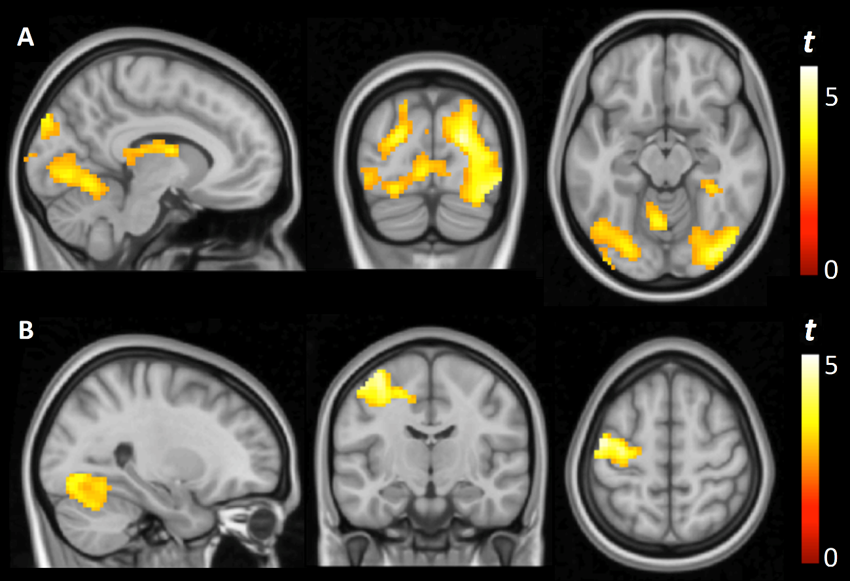

Supplementary Figure 2. Age-related effects on brain activation during knee interline pressure stimulation. Figure illustrates the brain region where activation increases with age across participants. Color bar represents t-values.
