Supplementary Information

Reactivation of Mthfd2 during heart failure drives cardiac remodeling

Yue Lu, Na Yang, Beiduo Tian, Jiawei Wu, Hailei Sun, Yaxin Song, Chenlu Yuan, Yongning Lv, Haizhu Zhang, Zihao Ren, Dan Hu, Buyun Liu, Chao Gao, Xinya Li, Tao Li, Yu-Chen Wang, and Yang Cao

TABLE OF CONTENTS
1. Supplementary Tables 1-6
2. Supplementary Figure 1

Supplementary Table 1
Primers used for mouse genotyping
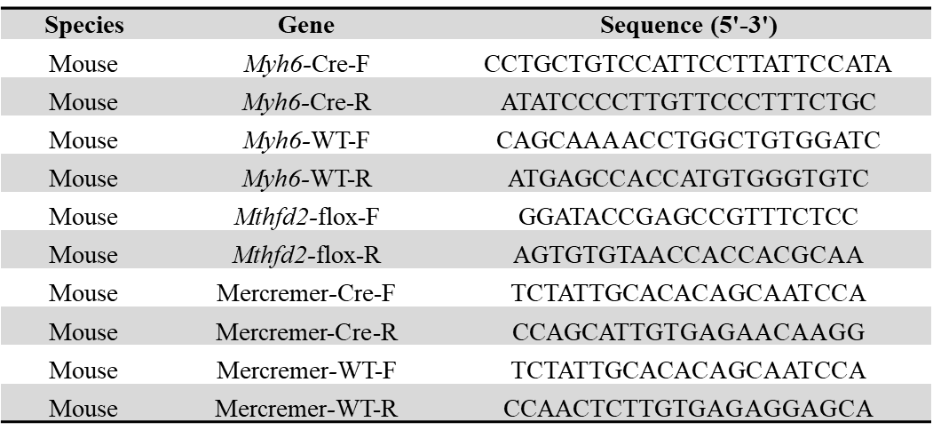

Supplementary Table 2
Clinical characteristics of NHF and HFpEF patients
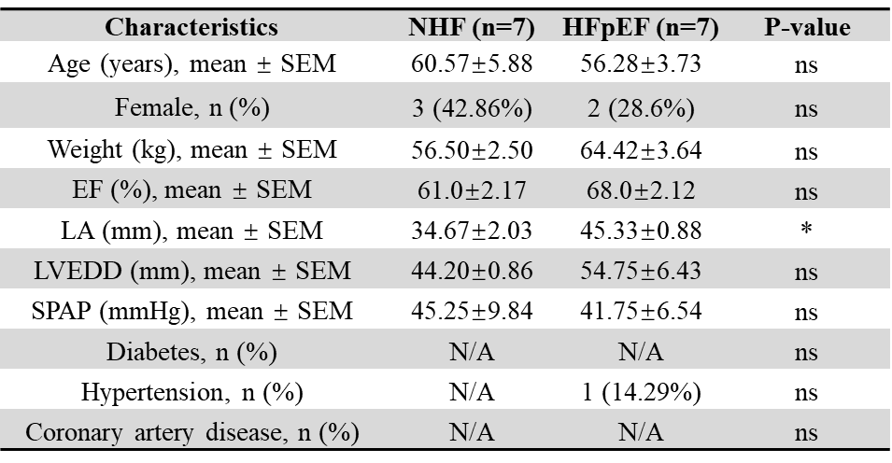
ns, not significant. *P<0.05 by Student’s t test. NHF. NHF, non-heart failure. HFpEF, heart failure with preserved ejection fraction. EF, ejection fraction. LA, left atrium. LVEDD, left ventricular end-diastolic diameter. SPAP, systolic pulmonary artery pressure.

Supplementary Table 3
Echocardiography data of the groups of mice used in the studies
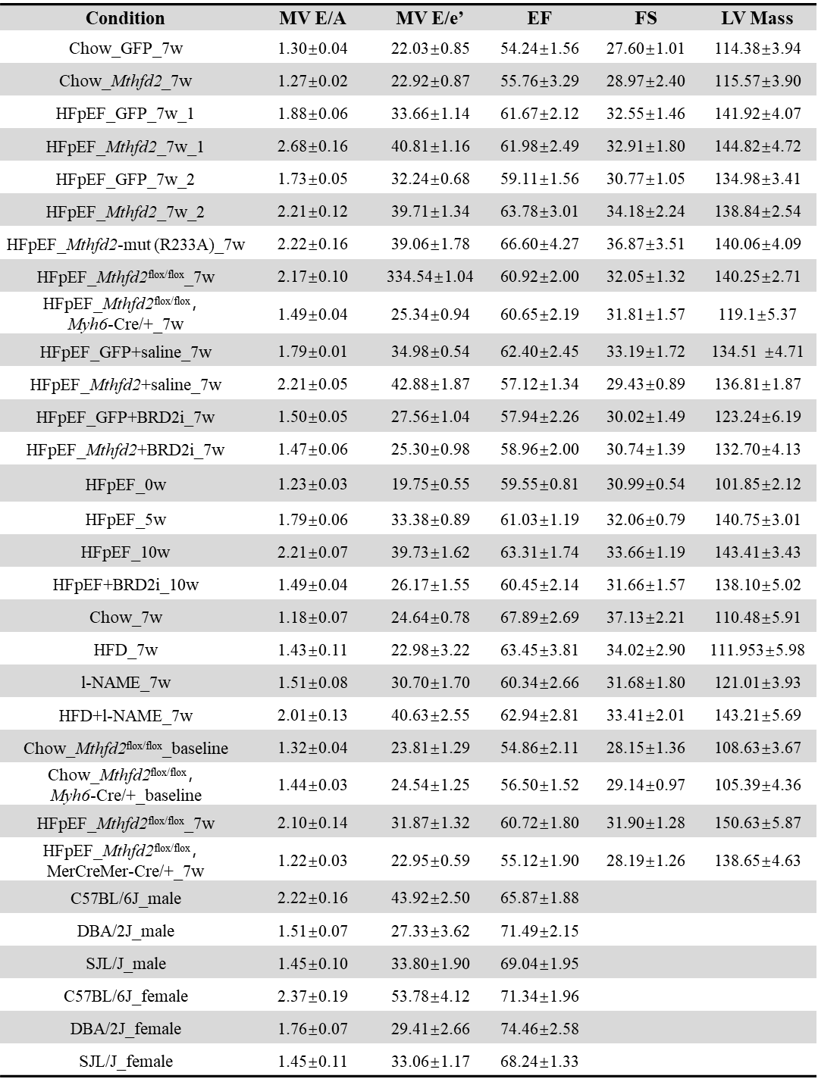

Supplementary Table 4
Primers used for quantitative RT-PCR
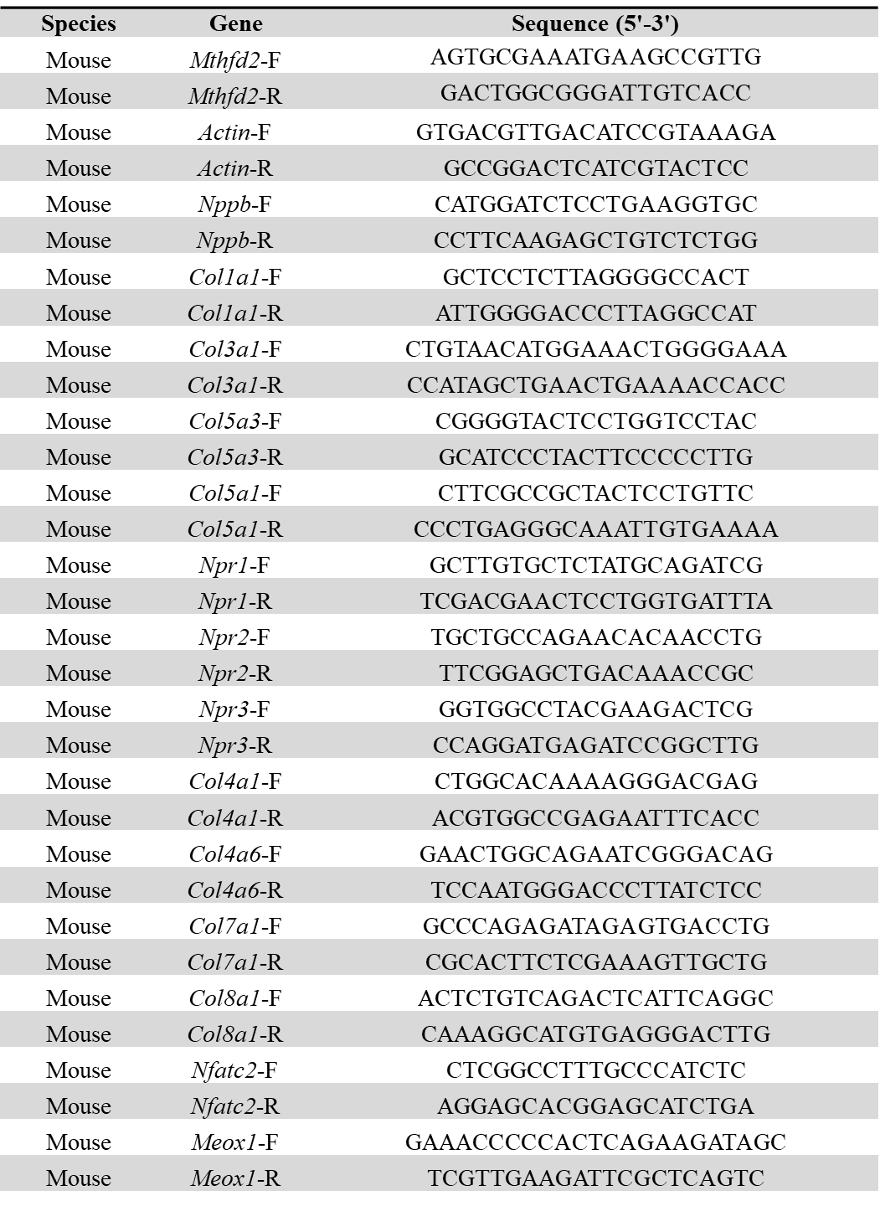

Supplementary Table 4 (continued)
Primers used for quantitative RT-PCR
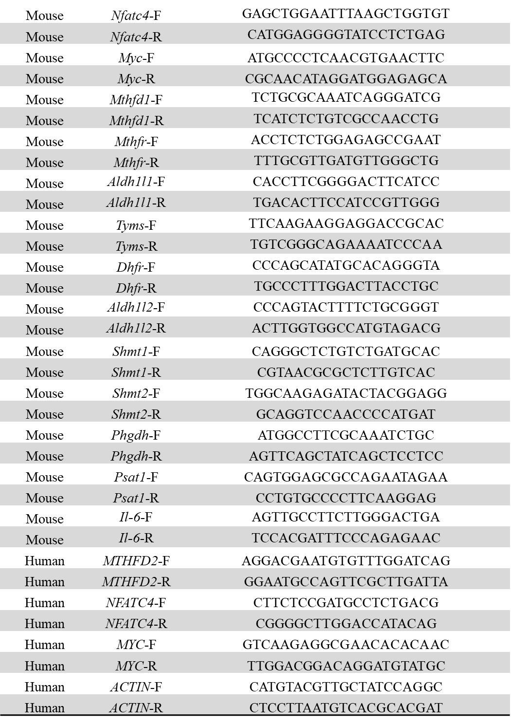

Supplementary Table 5
Primers used for Cut & Tag-qPCR
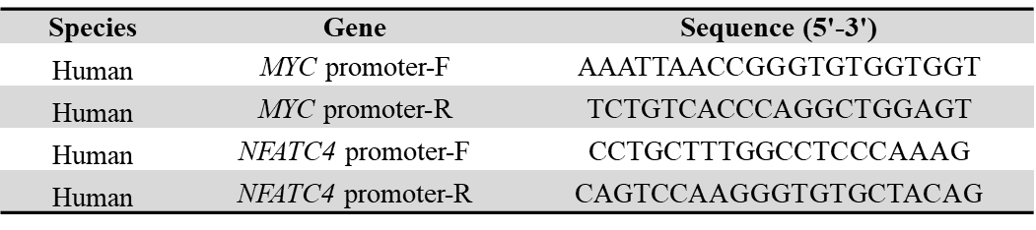

Supplementary Table 6
Primers used for ChIP-qPCR
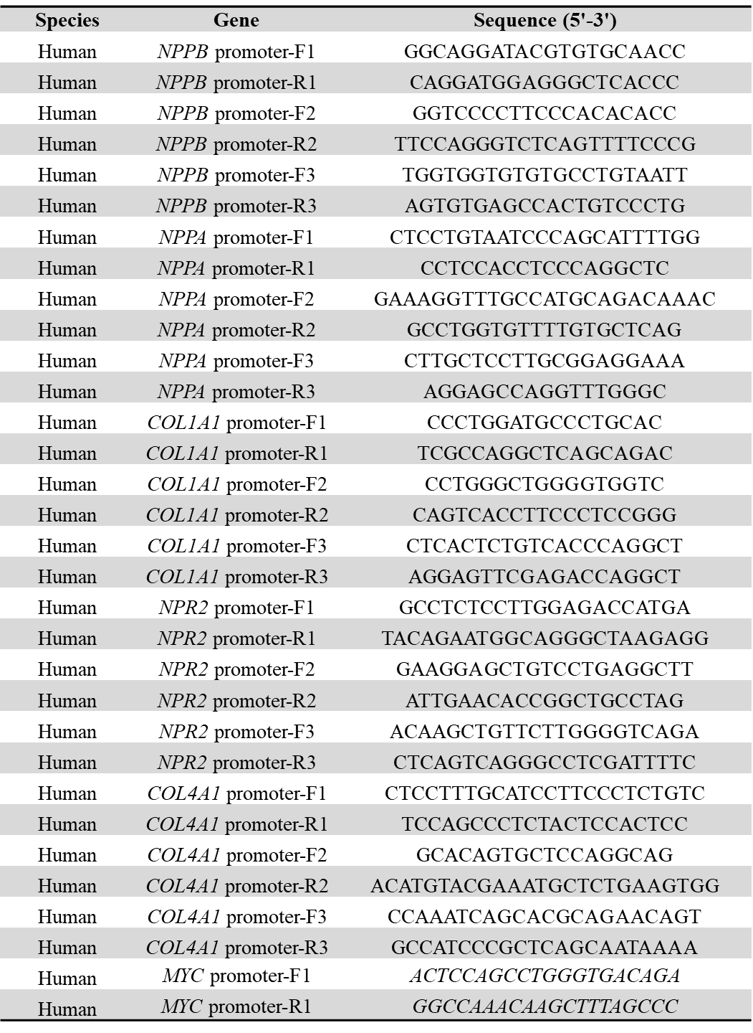

Supplementary Table 6 (continued)
Primers used for ChIP-qPCR
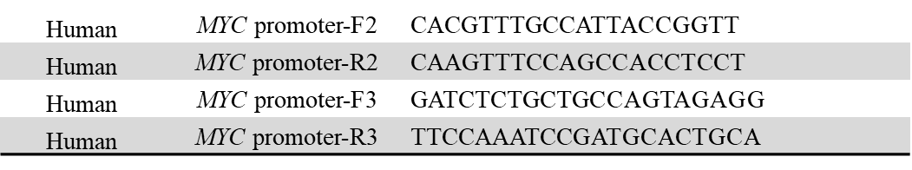

Supplementary Figure 1
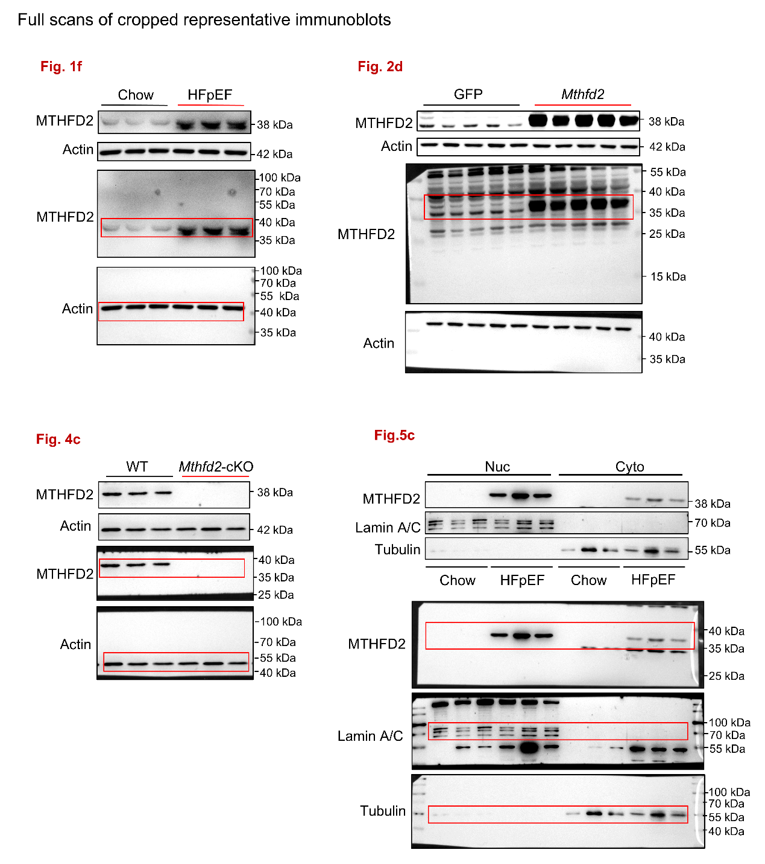

Supplementary Figure 1 (continued)
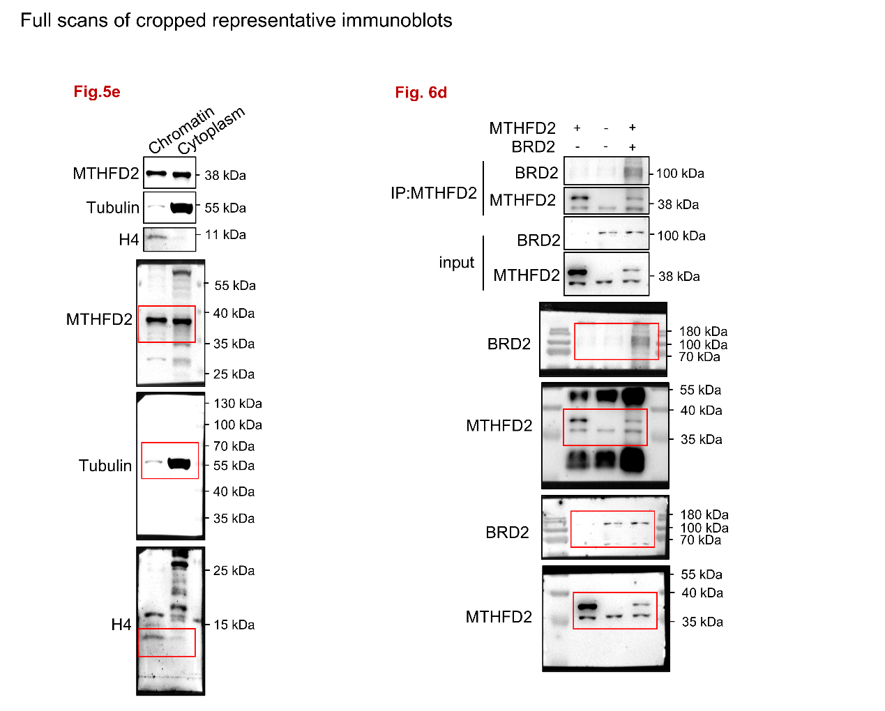

Supplementary Figure 1 (continued)
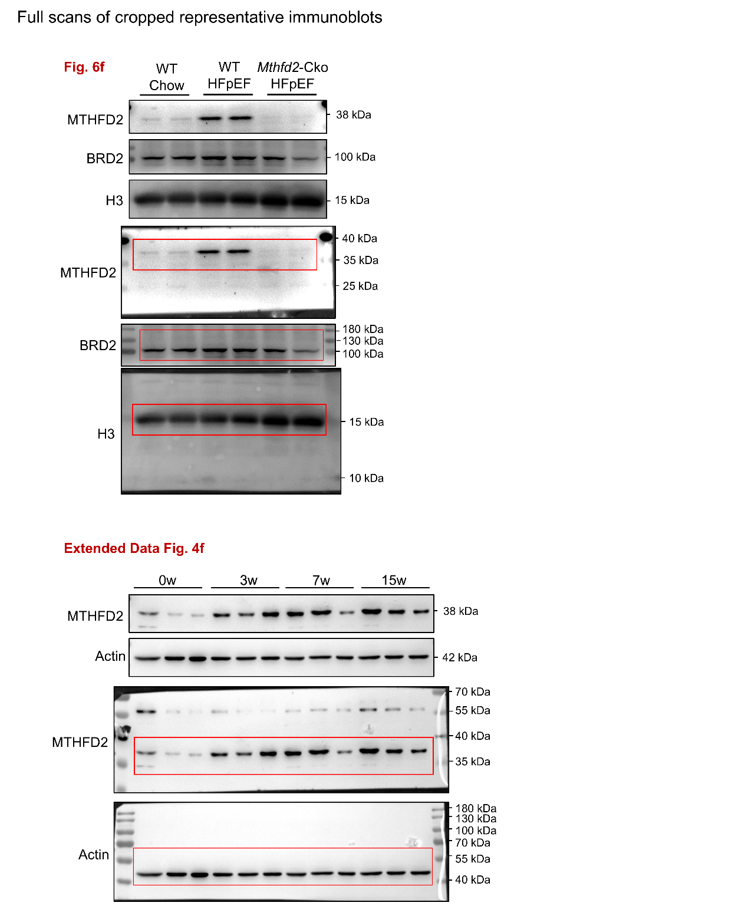

Supplementary Figure 1 (continued)
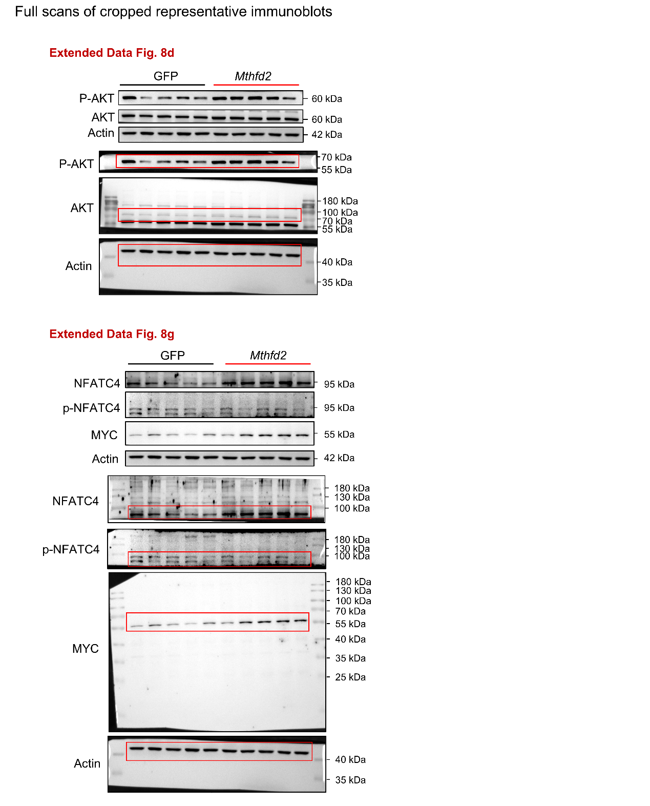

Supplementary Figure 1 (continued)
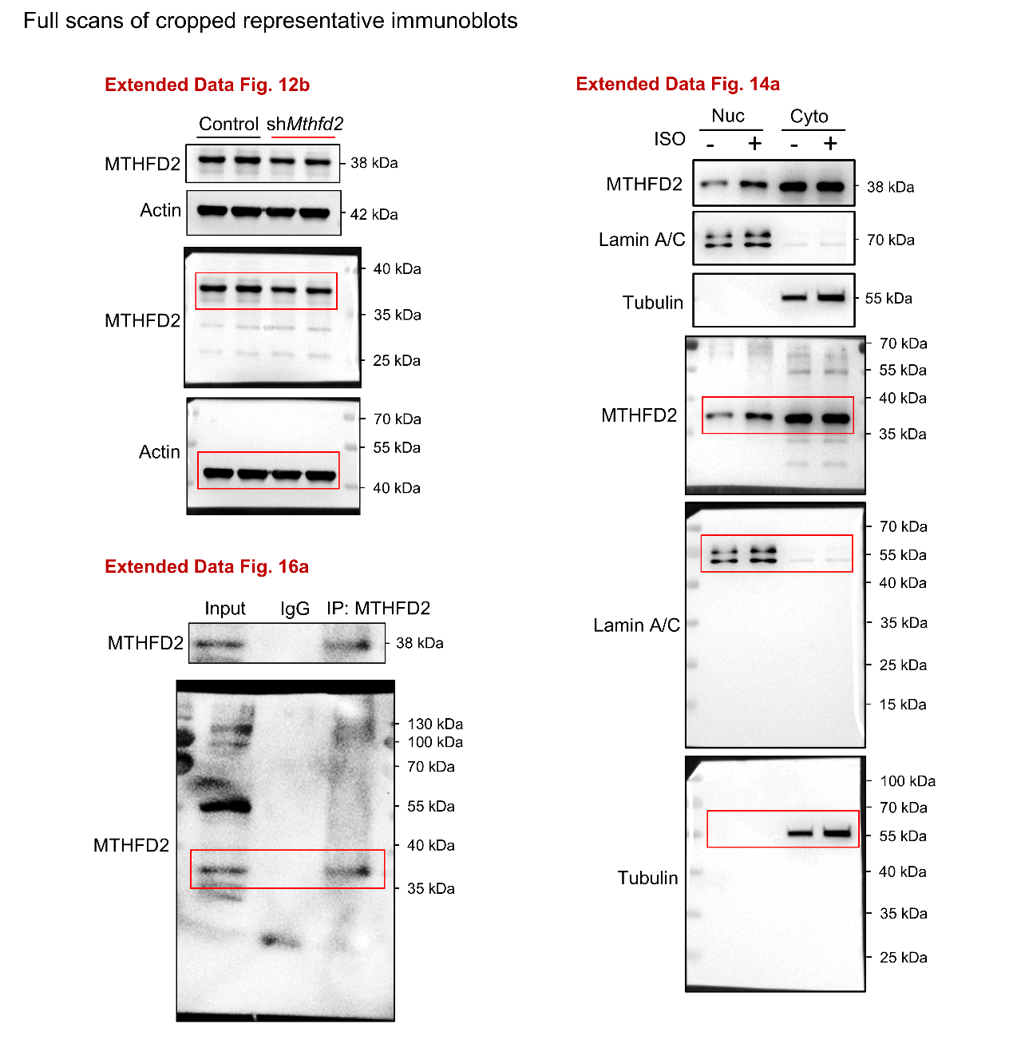

Supplementary Figure 1 (continued)
