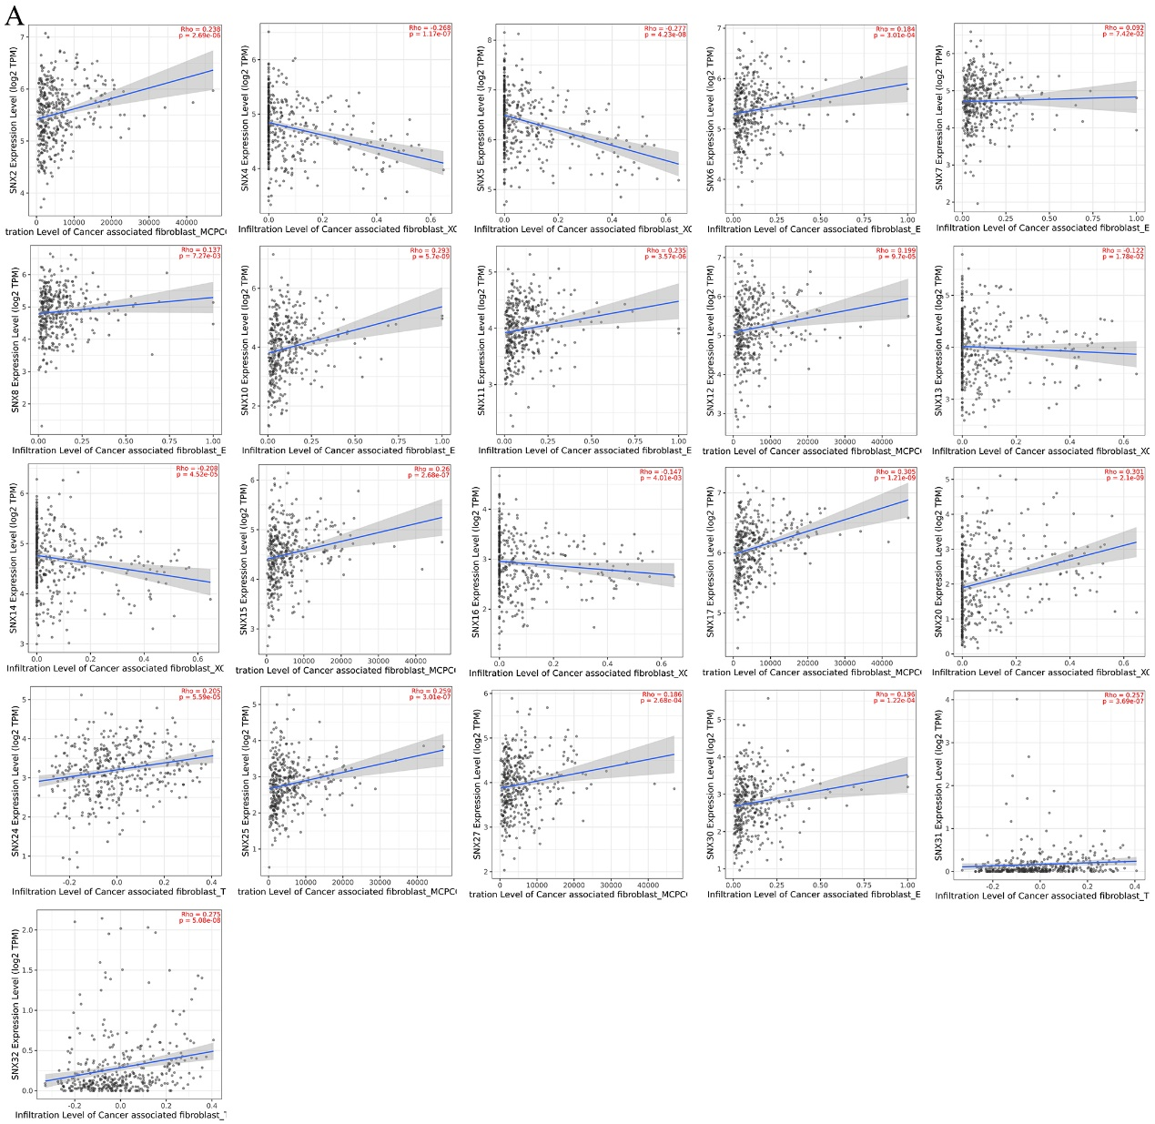
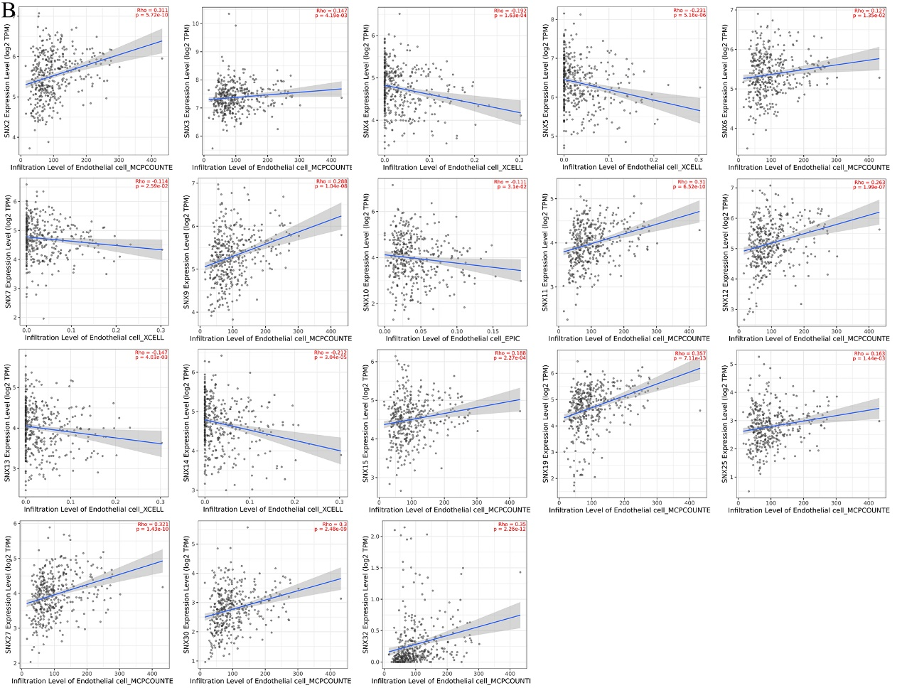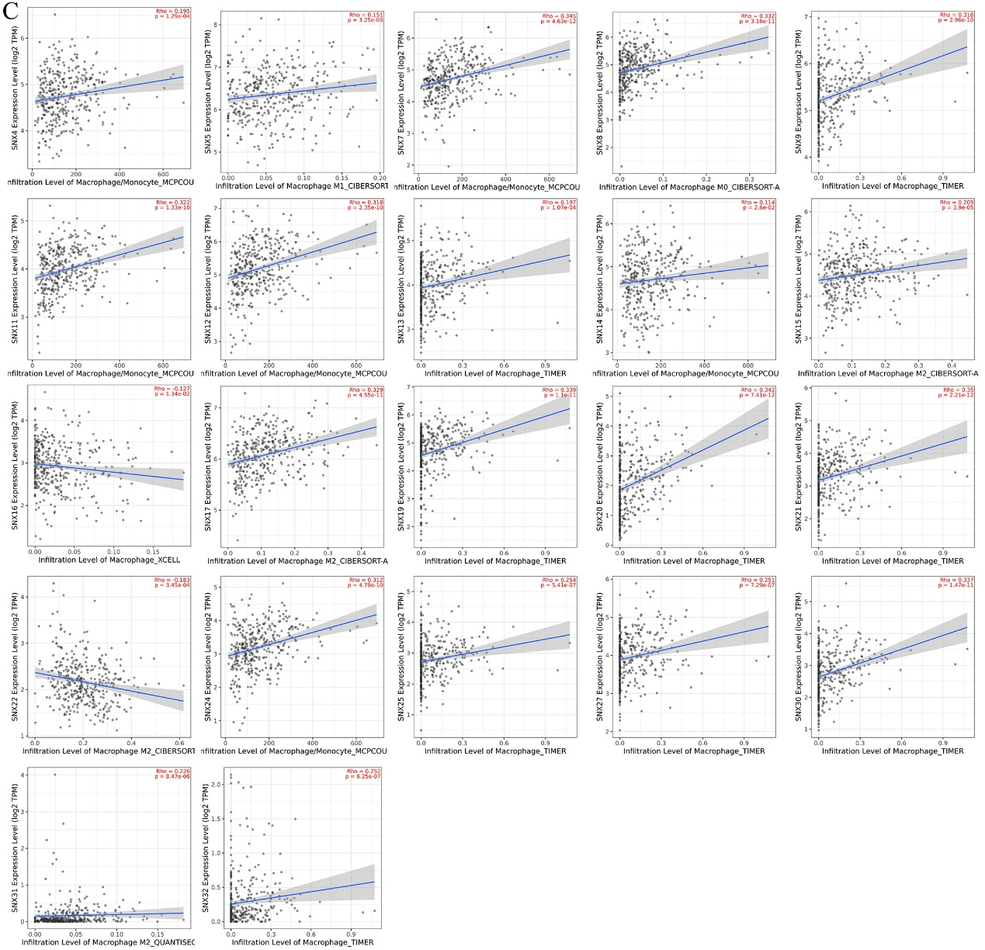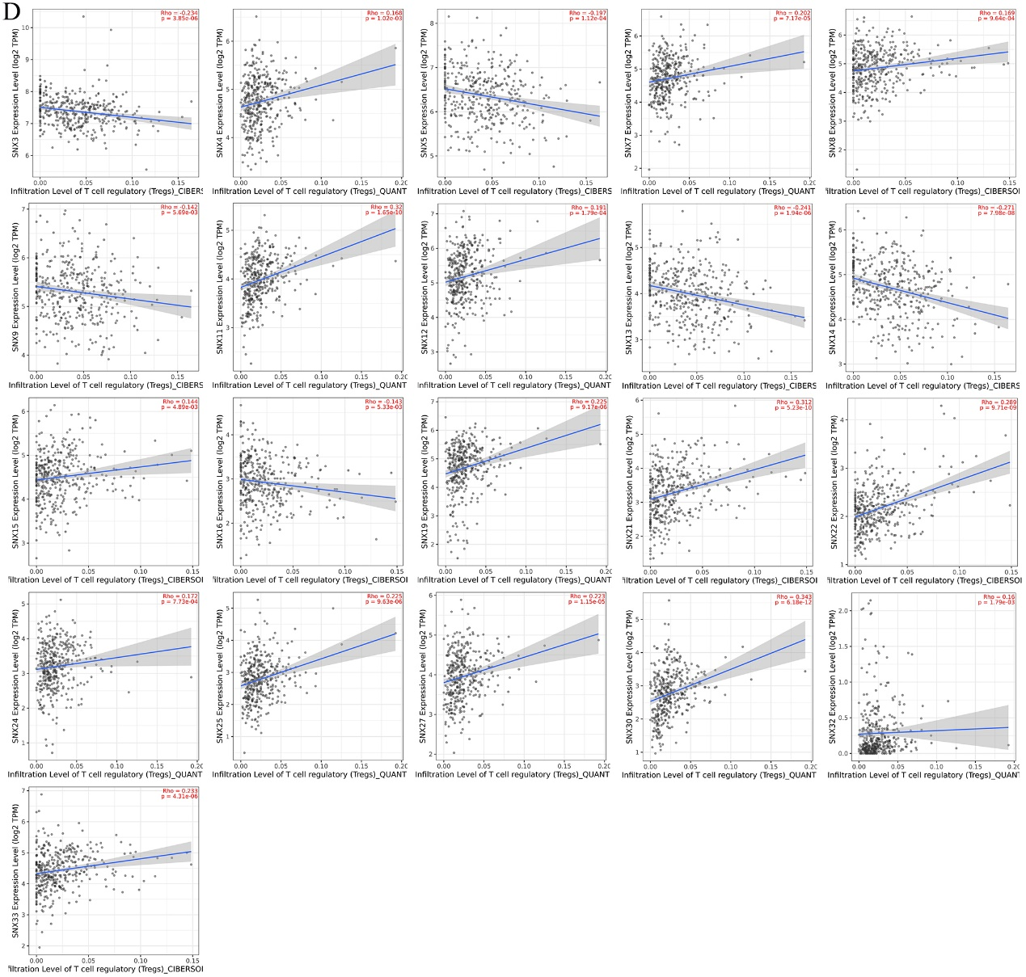
Figure S1. SNXs demonstrated to be statistical significance in Spearman relevance analysis between transcriptional level of SNXs and abundance of TIICs. Besides the top-8 SNXs with the highest Spearman coefficient, mRNA expression of SNX2/4/5/6/7/8/10/11/12/13/14/15/16/17/20/24/25/27/30/31/32 (A) , SNX2/3/4/5/6/7/9/10/11/12/13/14/15/19/25/27/30/32 (B) , SNX4/5/7/8/9/11/12/13/14/15/16/17/19/20/21/22/24/25/27/30/31/32 (C) , SNX3/4/5/7/8/9/11/12/13/14/15/16/19/21/22/24/25/27/30/32/33 (D) were shown to be correlated with cancer associated fibroblast, endothelial cells, macrophages and regulatory T cells, respectively. All the analysis was performed based on Timer database, in which SNX23/26/28 were not recorded.

