Supporting Information for
All-day uninterrupted power generator: Harvesting energy from the sun and cold space
Shuai Zhang^{1,2,3§}, Zhenhua Wu^{1,2,3§}, Zekun Liu^{1,2,3}, Erzhen Mu⁴, Yang Liu^{1,2,3}, Yongbo Lv⁵, Thomas Thundat⁶, Zhiyu Hu^{1*}
1 National Key Laboratory of Science and Technology on Micro/Nano Fabrication, Shanghai Jiao Tong University, Shanghai 200240, PR China
2 Department of Micro/Nano Electronics, Shanghai Jiao Tong University, Shanghai 200240, PR China
3 Institute of Nano/Micro Energy, Shanghai Jiao Tong University, Shanghai 200240, PR China
4 School of Materials Science and Engineering, Henan Polytechnic University, Henan, 454003, PR China
5 School of Physics and Astronomy, Shanghai Jiao Tong University, Shanghai 200240, PR China
6 Department of Chemical and Biological Engineering, University at Buffalo, The State University of New York, Buffalo, 14260, USA
§ These authors contributed equally to this work
* Corresponding author. Email: zhiyuhu@sjtu.edu.cn (Z. Hu).

Table of Contents
1 Materials
2 Measurements
3 Experimental details and theoretical model
3.1 The preparation, characterization and theoretical model of solar absorber (SA)
3.2 The preparation and theoretical model radiative cooling emitter (RCE)
3.3 The fabrication and characterization of ultrathin MEMS thermoelectric device (TEG)
3.4 The installation and energy exchange of the power generation device (SA-RCE-TEG)
4 References

1 Materials

Aniline, Ammonium persulfate, ((NH₄)₂S₂O₈), Phytic acid (50%) was purchased from the Aladdin Chemistry Co., Ltd. Anodic aluminum oxide（AAO）with a honeycomb-like structure was provided by Shenzhen Topmembranes Technology Co., Ltd. SYLGARDt 184, a silicone elastomer of PDMS was purchased from Dow Corning.
2 Measurements
The spectral reflectance and transmittance were separately determined in an ultraviolet, visible and near-infrared (UV-Vis-NIR, 0.3-2.5μm) spectrophotometer (Lamda 950, PerkinElmer, USA) with a 150 mm integrating sphere optional. The total reflectance and emittance spectra of the sample at wavelength range of 2.5-18 mm was characterized in a Fourier Transform infrared (FTIR) spectrometer (Nicolet 6700, Thermo Fisher Scientific, USA) equipped with a gold integrating sphere. The morphology and 3D topography were captured by field-emission scanning electron microscopy (Ultra Plus, Zeiss, Germany) and Laser scanning confocal microscope (VK-X3000, Keyence, USA). The temperature evolution was measured by K-type thermocouples (TT-K, Omega, China) connected with a data collector (DAQ6510, Tektronix, USA).
3 Experimental details and theoretical model
3.1 The preparation, characterization and theoretical model of solar absorber (SA)
Porous anodic aluminum oxide coated with polyaniline (PANI@AAO) is used for solar absorbers (SA) in this work. Phytic acid (PA) can improve the adhesion between polyaniline (PANI) and anodic aluminum oxide (AAO). Phytic acid can form coordinate bond with AAO and hydrogen bond with PANI. In this system, PANI is the main photothermal conversion material, and AAO provides abundant polymerization sites and plays the role of heat conduction^{[1,2]}.
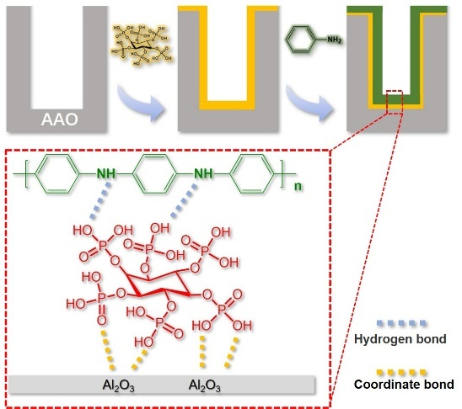
Figure S1: Schematic illustration of the preparation and formation mechanism of the SA(PANI@AAO).
The specific details are as follows. The clean porous anodic aluminum oxide was washed ultrasonically with absolute ethanol, acetone, and deionized water for 15 seconds, repeated three times, and dried in an oven at 60℃ for 12 hours. Cut the porous anodic aluminum oxide into a size of 4*4 cm and immerse it in 20 mL absolute ethanol/deionized water with a volume ratio of 1:1 and ultrasonic for 15 seconds, then add 2 ml of phytic acid solution and 0.5 ml of aniline, and ultrasound for 15 seconds. Add 2 ml of 0.286 g/mL ammonium persulfate and mix quickly and store in refrigeration (5℃). After standing for 24 hours, take out the film sample and wash with absolute ethanol, acetone, and deionized water for three times to remove unreacted components and excess polymers. After drying in an oven at 60℃ for 12 hours, a polyaniline-coated porous alumina composite material (PANI@AAO) was obtained.
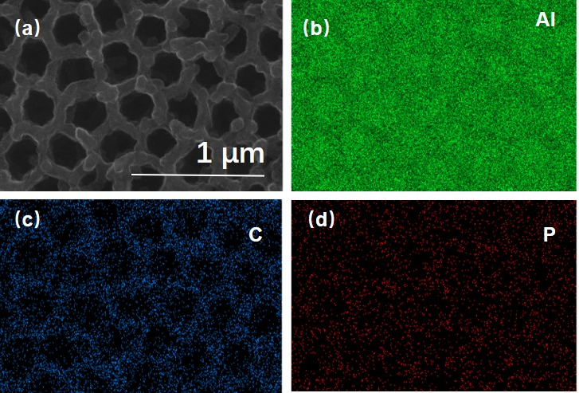
Figure S2: (a)SEM and (b-d) EDS images of the SA(PANI@AAO).
The uniform element distribution of the solar absorber (PANI@AAO) indicates that PANI adheres to the AAO surface stably.
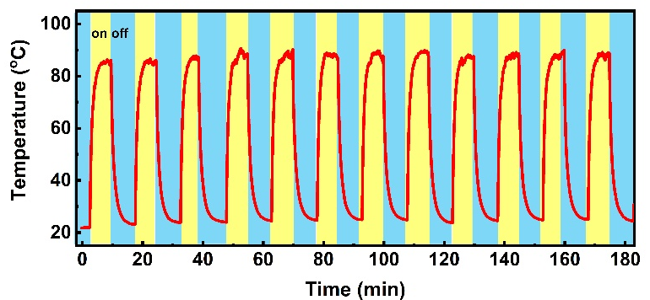
Figure S3: the stability of SA
Because the SA has long and narrow channels with a convex structure, it can form optical traps to improve the conversion effect of light capture^{[9]}. When the light enters the channels, it will be continuously reflected and absorbed, and finally completely captured. In addition, there is almost no change of the surface temperature when the samples are tested for more than 12 cycles, which indicates that the samples have good stability and can be used for complex natural environment.
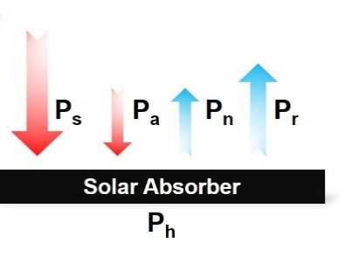
Figure S4: The energy exchange and theoretical model of SA
When the solar absorber (SA) is exposed to a clear sky, a heat-transfer model could be established in order to better understand the thermal radiation ($P_{r}$) 、the solar irradiance ($P_{s}$)、the atmospheric downward thermal radiation ($P_{a}$)、the convective and conductive loss ($P_{n}$) in the experiment^{[7,8]}.
The net heating power (P_{h}) of the SA is given by:
$P_{h}\left(T\right)=P_{s}+P_{a}\left(T_{a}\right)-P_{r}\left(T\right)-P_{n}$ (1)
Where T is the surface temperature of the SA/RCE and the $T_{a}$ is the ambient temperature. $P_{r}\left(T\right)$ is the power radiated by the SA/RCE and $P_{a}\left(T_{a}\right)$ is the absorbed atmosphere thermal radiation at $T_{a}$. $P_{s}$ is the incident solar irradiation absorbed by the SA/RCE, and $P_{n}$ is the power lost due to convection and conduction. These parameters can be calculated by the following equations:
$P_{r}\left(T\right)=A\int{dΩ\cos{θ\int_{0}^{∞}{dλI_{BB}}}}\left(T.λ\right)ε\left(λ.θ\right)$ (2)
$P_{r}\left(T\right)$ is determined by the spectral data of the SA/RCE. According to Kirchhoff’ law of thermal radiation, the emissivity of an arbitrary body is equal to its absorptivity. Where $A$ is the surface area of the SA/RCE and $\int{dΩ=2π\int_{0}^{π/2}{dθ\sin{θ}}}$ is the angular integral over a hemisphere,$λ$ is the wavelength and $ε\left(λ.θ\right)$ is the thermal emitter’ emissivity.$I_{BB}\left(T.λ\right)=\frac{2hc^{2}}{λ^{5}}\frac{1}{e^{h_{c}/\left(λk_{B}T\right)}-1}$ is the spectral radiance of a blackbody at temperature T.
$P_{a}\left(T_{a}\right)=A\int{dΩ\cos{θ\int_{0}^{∞}{dλI_{BB}}}}\left(T_{a}.λ\right)ε\left(λ.θ\right)ε_{a}\left(λ.θ\right)$ (3)
P_{a} (T_{a}) is determined by the emissivity spectrum of the atmosphere according MODTRAN of Mid-Latitude Summer Atmosphere Model. Where $I_{BB}\left(T_{a}.λ\right)$ is the spectral radiance of a blackbody defined by Planck's law at temperature $T_{a}$. $ε_{a}\left(λ.θ\right)=1-τ\left(λ\right)1/\cos{θ}$ is the angel-dependent emissivity of atmosphere.
$P_{s}=A\int_{0}^{∞}{dλε\left(λ.θ_{s}\right)I_{AM1.5}}\left(λ\right)$ (4)
where $ε\left(λ.θ_{s}\right)$ is the thermal emitter's emissivity dependence on the solar incident angle $θ$ and $I_{AM1.5}(λ)$ represents the solar illumination of the AM1.5 spectrum.
$P_{n}=Ah_{c}\left(T_{a}-T\right)$ (5)
where $h_{c}$ is a combined non-radiative heat coefficient, equaling to the sum of heat convection coefficient and heat conduction coefficient ($h_{c}=h_{conv}+h_{cond}$), which depends on the environment conditions.
Numerical calculations were performed using MATLAB software. In order to simplify the calculation, we ignored the effect of incidence angles $θ$ during the calculation of $ε\left(λ.θ\right)$ and the power of solar radiation is set to approximately 1000 W/m².

3.2 The preparation and theoretical model of radiative cooling emitter (RCE)
Magnetron sputtering was used to deposit Ag on the surface of a silicon wafer, and then spin-coated a uniformly mixed PDMS-curing agent mixture with a mass ratio of 10:1 on the surface and thermally cured at 80°C for 2 hours. After slowly cooled down to ambient temperature, the radiative cooling emitter with a reflective layer (50 nm Ag) and a radiation layer (150 μm PDMS) on a silicon wafer was obtained^{[3]}.
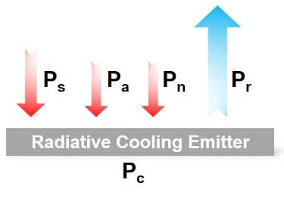
Figure S5: The energy exchange and theoretical model of RCE
The net cooling power (P_{c}) of the RCE is given by:
$P_{c}\left(T\right)=P_{r}\left(T\right)-P_{a}\left(T_{a}\right)-P_{s}-P_{n}$ (6)

3.3 The fabrication and characterization of ultrathin MEMS thermoelectric device (TEG)
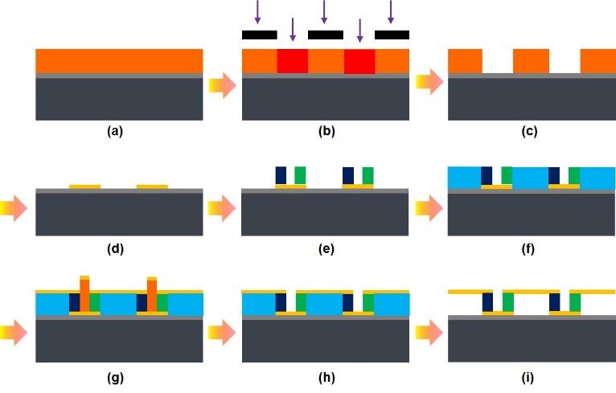
Figure S6: Cross-sectional view of schematic fabrication steps for MEMS-TEG. (a) Photoresist coating. (b) UV exposure with a photo mask. (c) Developing. (d) Patterning Au bottom electrodes. (e) Patterning Sb₂Te₃ and Bi₂Te₃ legs. (f) Sacrificial photoresist coating and fabrication. (g) Patterning Au upper electrodes. (h) Lifting-off. (i) Dry etching.
The integration of TEG is one of the primary factors limiting its output performance which is directly proportional to the number of PN pairs. Nowadays, micro-nano fabrication technology provides the possibility for large integration manufacturing. However, the high precision patterning technology and complex thin film deposition process is a real challenge for handmade devices at the chip level.
Photolithography and physical vapor deposition technology was used to fabricate a submicron-thick, highly integrated MEMS-TEG on a monocrystalline silicon substrate covered with a SiO₂ layer. Each pair of thermoelectric modules is composed of P-Type (Sb₂Te₃) and N-type (Bi₂Te₃) materials and equivalent to a micro-generator. A MEMS-TEG includes 572 thermoelectric modules connected with Au electrodes in series in 1×0.7 cm area, which improve the utilization of small temperature difference.
In our previous work, we have given specific methods and details for fabricating the ultrathin thermoelectric device, and proved the reliability and effectiveness of this process^{[4,5]}.
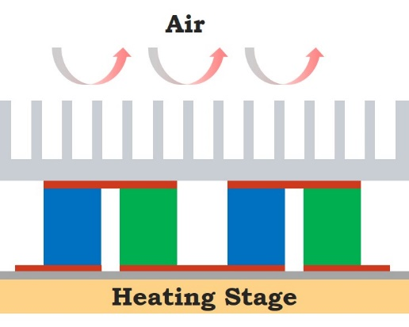
Figure S7. Schematic of the testing setup
When test the output performance of the MEMS-TEG, the MEMS-TEG is sandwiched between the heating stage and the aluminum radiator through a thermal pad. The temperature and output voltage are recorded with a data acquisition instrument.
3.4 The Installation and energy exchange of the power generation device (SA-RCE-TEG)
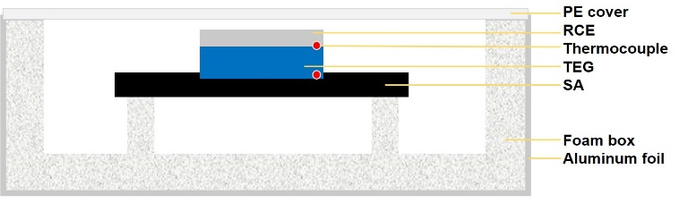
Figure S8: Schematic diagram of all-day power generation device (SA-RCE-TEG).
When performed a continuous experiment in a building roof, the generator (SA-RCE-TEG) is placed in the polyurethane (PU) foam box wrapped with aluminum foil to minimize the impact of direct sunlight and non-radiative heat losses.
The top of the box is covered by a highly infrared-transparent polyethylene (PE) film to prevent the influence of the outdoor environment. Two k-type thermocouples as labeled in the figure are used to measure the temperatures of the SA and RCE (two ends of TEG), respectively.
For outdoor measurement, the power generation device was placed on a flat building roof without a windshield in Shanghai (31°1ʹ50ʺ N, 121°26 ʹ 26 ʺ E), China from May 29 to June 1, 2021, and the weather conditions was estimated based on the data on the Weather Underground website^{[6]}.
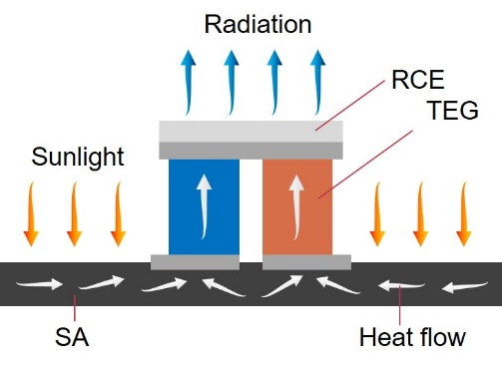
Figure S9: The energy exchange of SA-RCE-TEG
The SA and RCE are used as the heat source and cold source of the TEG. The SA absorbs solar energy and converts it into heat, which is transmitted from bottom to top along the TEG. The RCE at the top reflects the sunlight and radiates the heat into cold space under a clear sky. The stable energy exchange process will build a temperature difference between the two ends of the TEG to generate power.
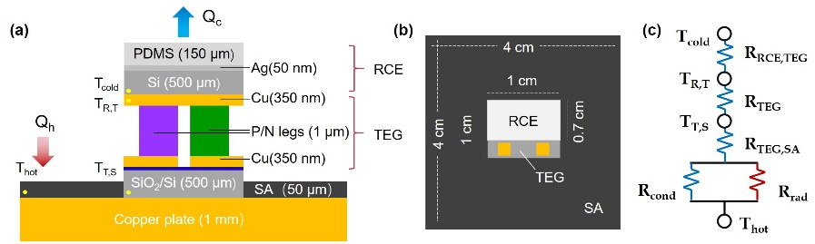
Figure S10: The structure, size(a-b) and energy flow(c) diagram of the SA-RCE-TEG
the generator (SA-RCE-TEG) consists of three parts (RCE, TEG and SA) and connected by thermal adhesive to minimize interfacial thermal resistance. The SA is fixed on the conductive copper plate and cut into a zigzag pattern. The TEG is filled in the groove of the SA, and covered with RCE. It is worth noting that we are only demonstrating the feasibility of such a generator demo, so the area and ratio of the three parts are still worth further optimization.

4 References
[1] Li, H., Wu, L., Zhang, H., Dai, W., Hao, J., Wu, H., Ren, F., Liu, C. Self-assembly of carbon black/AAO templates on nanoporous Si for broadband infrared absorption. ACS Appl. Mater. Interfaces 12, 4081-4087 (2020).
[2] Haberkorn, N., Weber, Stefan A. L., Berger, R., Theato, P. Template-based preparation of free-standing semiconducting polymeric nanorod arrays on conductive substrates. ACS Appl. Mater. Interfaces 2, 1573-1580 (2010).
[3] Zhou, Y., Song, H., Liang, J., Singer, M., Zhou, M., Stegenburgs, E., Zhang, N., Xu, C., Ng, T., Yu, Z., Ooi, B., Gan, Q. A polydimethylsiloxane-coated metal structure for all-day radiative cooling. Nat. Sustain. 2, 718-724 (2019).
[4] Mu, E., Wu, Z., Wu, Z., Chen, G., Liu, Y., Fu, X., Hu, Z. A novel self-powering ultrathin TEG device based on micro/nano emitter for radiative cooling. Nano Energy 55, 494-500 (2019).
[5] Mu, E., Yang, G., Fu, X., Wang, F., Hu, Z. Fabrication and characterization of ultrathin thermoelectric device for energy conversion. J. Power Source, 395, 17-25 (2018).
[6] Weather Underground. Historical weather. https://www.wunderground.com/history
[7] Raman, A., Anoma, M., Zhu, L., Rephaeli, E., Fan, S. Passive radiative cooling below ambient air temperature under direct sunlight. Nature 515, 540-544 (2014).
[8] Wang, T., Wu, Y., Shi, L., Hu, X., Chen, M., Wu, L. A structural polymer for highly efficient all-day passive radiative cooling. Nat. Commun. 12, 365 (2021).
[9] Mizuno, K., Ishii, J., Kishida, H., Hayamizu, Y., Yasuda, S., Futaba, D., Yumura, M., Hata, K. A black body absorber from vertically aligned single-walled carbon nanotubes. Proc. Natl. Acad. Sci. U.S.A. 160, 6044-6047 (2009).

