Supplementary information
Effect of soluble phenolic compounds from hydrothermally pretreated wheat straw on cellulose degrading enzymes: Compositional analysis and inhibition experiments data
Anna S. Borisova¹, Ville Pihlajaniemi^{1,3}, Riin Kont², Klaus Niemelä¹, Taru Koitto^{1,4}, Atte Mikkelson¹, Priit Väljamäe², Kristiina Kruus^{1,5}, Kaisa Marjamaa¹
¹VTT Technical Research Centre of Finland Ltd, P.O. Box 1000, 02044 VTT, Finland 2Institute of Molecular and Cell Biology, University of Tartu, Riia 23b - 202, 51010 Tartu, Estonia
³current address: eniferBio Oy, Peuraniitty 5 B 25, 02750 Espoo, Finland
⁴current address: Aalto University, School of Chemical Technology, Department of Bioproducts and Biosystems, Espoo, Finland, P.O. Box 16300, FI-00076 AALTO, Finland.
⁵current address: Aalto University School of Chemical engineering, P.O. Box 16100. FI-00076 AALTO, Finland

Corresponding author: Anna S. Borisova (anna.borisova@vtt.fi)

Abstract
The data provides additional information on inhibition experiments of purified cellulases and commercial cellulolytic cocktails by hydrothermally pretreated wheat straw liquor and its fractions, described in [1]. The data includes information on enzymes used in experiments and compositional analysis of raw material: chopped wheat straw, pretreated wheat straw solids and pretreatment liquor (PL), analysed with HPLC. Calculation data of correlation factor for isolated phenolic fraction (Phe-Fr) and effect of phenolics in reducing sugar assay method (PAHBAH) [2] are shown, as well as chromatograms for separation on a DB-5 column of the Phe-Fr trimethylsilylated compounds, used in GC/MS analysis [1]. Data on hydrolysis of Phe-Fr carbohydrates by Cellic Ctec2 is presented, quantified with PAHBAH assay. Data on inhibitory power of PL and its fractions, including isolated Phe-Fr and enzymatically pretreated fraction CTec-PL, is presented as IC50 values for the inhibition of Celluclast 1.5L and Cellic Ctec2, and two purified CBHs (TrCel7A and TrCel6A) acting on 14C-BMCC substrate. Data on tannic acid inhibition of purified cellulases and CellicCtec2 represents effect of high molecular weight phenols in Phe-Fr and is quantified with PAHBAH assay.

Table S1. Molar extinction coefficients and masses of the enzymes used in screening for inhibitory effects of phenolic fraction (Phe-Fr).
Enzyme | MW (kDa) | Molar extinction coefficient, M⁻¹⋅cm⁻¹
TrCel7A (CBH1) | 55.8 | 83 000
TrCel6A (CBHII) | 56.7 | 104 000
TrCel7B (EGI) | 51.9 | 70 000
TrCel5A (EGII) | 48.2 | 91 000
TrCel12A (EGIII) | 25.1 | 73 500
TrCel45A (EG5) | 24.4 | 48 900
TrCel11 (Xyn2) | 20.8 | 58 330
AnCel3A | 115.6 | 180 000

Table S2. Compositions of chopped wheat straw, pretreated wheat straw solids and pretreatment liquor (PL). Chopped wheat straw was pre-soaked with water to 50% DM content and loaded into a 30-L pressure reactor with a batch size of 1.71 kg (DM). The material was heated to 195 °C with direct steam injection and a pressurized water jacket, and the temperature was maintained for 15 min. After the treatment, the material was quickly cooled to 80 °C with the water jacket, and dissolved material was extracted by pumping 80 °C water through the material bed. The first 6 L of extract was collected and this material is hereafter referred to as pretreatment liquor (PL). The pretreated wheat straw solids were collected manually.
 | Wheat straw solids,  % DM | Pretreated wheat straw solids, % DM | Combined PL¹, g/L
Glucose total1 | 32.24 | 41.47 | 1.42
Glucose monomeric |  |  | 0.19
Xylose total | 14.58 | 7.30 | 12.23
Xylose monomeric |  |  | 2.10
Arabinose total | 1.64 | 0.48 | 0.94
Fructose total |  |  | 0.66
Galactose total | 0.56 | 0.23 | 0.69
Mannose total | 0.40 | 0.23 | 0.41
Total carbohydrates | 49.75 | 49.81 | 15.76
Lignin | 20.30 | 24.50
Extractives | 0.88 | 1.15
Ash | 6.36 | 5.79
5-Hydroxymethylfurfural |  |  | <0.04
Furfural |  |  | 1.65
Soluble phenolics (UV) |  |  | 4.55
Acetic acid |  |  | 3.99
¹ Pretreatment liquor from 6 wheat straw batches pretreated in conditions described in the legend and in the Materials and methods [1].

Figure S1. Correlation coefficient between total solids freeze-dried phenolic fraction (Phe-Fr) and UV-phenolics. In combined PL the concentration of UV-phenolics was 4.5 g/L, which corresponds to 9 g/L total solids concentration of freeze-dried phenolic fraction. The correlation factor was calculated by linear regression 0.48 ± 0.07 (g UV-phenolics/g total solids).

Figure S2. Effect of phenolic fraction (Phe-Fr) on the reducing sugars assay (PAHBAH). The PAHBAH assay was carried out for several dilutions of glucose in presence of Phe-Fr total solids 0-0.5 g /L. The values presented in the figure are averages of 3 measurements with standard deviation. In performed experiments phenolic concentration was not greater than 0.2 g/L total solids and the slope was varied insignificantly within a range of standard deviation (see equations next to the legends). Intercept value was correlated well with blank measurement. The PAHBAH assay was thus considered suitable for assays including Phe-Fr within above mentioned limitations.

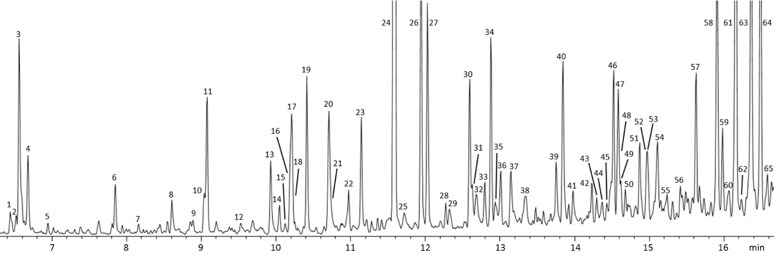
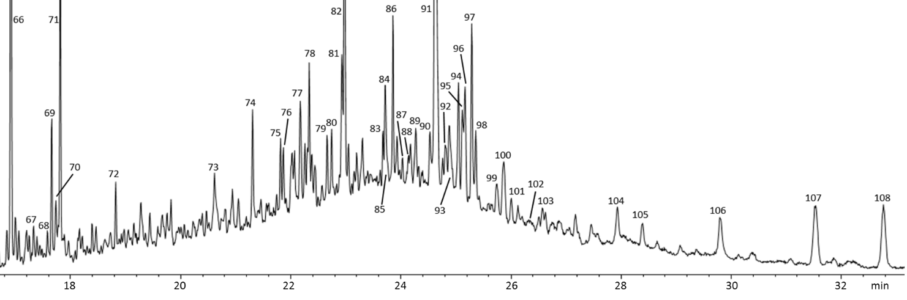
Figure S3. Separation on a DB-5 column of the trimethylsilylated compounds in the isolated phenolic fraction (Phe-Fr): 1, oxalic acid; 2, 2-furancarboxylic acid; 3-4, isomeric hydroxypyridines; 5, dodecamethylpentasiloxane (from column); 6, guaiacol; 7, benzoic acid; 8, 4-vinylphenol; 9, a cyclohexanedione (dienol); 10, succinic acid; 11, catechol; 12, fumaric acid; 13, 4-hydroxybenzaldehyde; 14, 3-methylcatechol; 15, 4-ethylguaiacol; 16, 4-methylcatechol; 17, syringol; 18, hydroquinone; 10, a hydroxy-methoxyacetophenone (tentative); 20, 4-vinylguaiacol; 21, reductic acid; 22, 2-methylhydroquinone; 23, 1-(4-hydroxyphenyl)ethanol; 24, salicylic acid (internal standard); 25, pyroglutamic acid; 26, vanillin; 27, a hydroxy-dimethoxyacetophenone (tentative; methoxy derivative of peak 19); 28, 3-hydroxybenzoic acid; 29, eugenol (+ unknown); 30, 1-guaiacylethanol; 31, unknown (m/z 281, 100%); 32, unknown phenolic (MW, 282); 33, 3,4,5-trimethoxyphenol (tentative); 34, 3,4-dihydroxybenzaldehyde; 35, acetovanillone; 36, 4-hydroxybenzoic acid; 37, guaiacylacetone; 38, two unknowns co-eluting; 39, 3,4-dihydroxyacetophenone; 40, syringaldehyde; 41, unknown (m/z 169, 100%); 42, 2,3-dihydroxybenzoic acid; 43, unknown phenolic (MW, 296); 44, unknown (m/z 359, 100%); 45, unknown (m/z 373, 100%); 46, vanillic acid; 47, acetosyringone; 48, homovanillic acid; 49, a dihydroxybenzoic acid; 50, a dihydroxyacetophenone (enol); 51, azelaic acid; 52, a dihydroxybenzeneacetic acid (2,3-isomer?); 53, 3,4-dihydroxybenzoic acid; 54, coniferyl alcohol + unknown phenolic; 55, a guaiacyl compound; 56, acetosyringone (enol); 57, unknown catecholic compound (MW, 398); 58, syringic acid; 59, homosyringic acid; 60, a guaiacyl compound; 61, 3-(2,3-dihydroxyphenyl)propanoic acid; 62, 1-guaiacyl-3-hydroxyacetone (keto form); 63, p-coumaric acid; 64, unknown phenolic (MW, 380); 65, sinapyl alcohol; 66, 3,8-dihydroxy-2-methylchromone (alginetin); 67, unknown (m/z 335, 100%; MW, 426); 68, 1-hydroxy-3-syringylacetone (keto form); 69, 1-guaiacyl-3-hydroxyacetone (enol form); 70, syringyl compound (m/z 327, 100%); 71, ferulic acid; 72, 1-hydroxy-3-syringylacetone (enol form); 73, dilignol (m/z 223, 100%); 74, p-coumaric acid ester (m/z 219, 100%; m/z 351, 38%; MW, 454); 75, unknown [m/z 492 (MW), 100%]; 76, dilignol (MW, 566); 77, disaccharide; 78, ferulic acid ester (m/z 249, 100%; m/z 381, 22%; MW, 484); 79, dilignol (MW, 522); 80, syringyl dilignol (m/z 327, 100%); 81, syringyl dilignol (m/z 327, 100%); 82, dilignol (m/z 235, 100%; MW, 510); 83, unknown (m/z 463, 100%; MW, 668); 84, 5-O-p-coumaroylpentose; 85, 4,4´-dihydroxy-3,3´-dimethoxystilbene; 86, dilignol (m/z 265, 100%; MW, 540); 87, p-coumaric acid ester; 88, ferulic acid ester; 89, p-coumaric acid ester; 90, ferulic acid ester; 91, 5-O-feruloylpentose; 92, 5-O-feruloylpentose; 93, 4,4´-dihydroxy-3,3´,5-trimethoxystilbene; 94, dilignol (MW, 708); 95, ferulic acid ester (MW, 678); 96, feruloylpentose (m/z 249, 100%; m/z 381, 29%; MW, 614); 97, feruloylpentose (m/z 249, 100%; m/z 338, 62%; MW, 614); 98, dilignol (MW, 690); 99, ferulic acid ester (m/z 338, 100%; MW, 676); 100, ferulic acid ester (m/z 338, 100%; MW, 588); 101, ferulic acid ester (m/z 338, 100%); 102, 4,4´-dihydroxy-3,3´,5,5´-tetramethoxystilbene; 104-105, syringyl dilignols (m/z 327, 100%); 106, dilignol (m/z 498, 100%); 107, syringyl dilignol; and 108, syringaresinol.

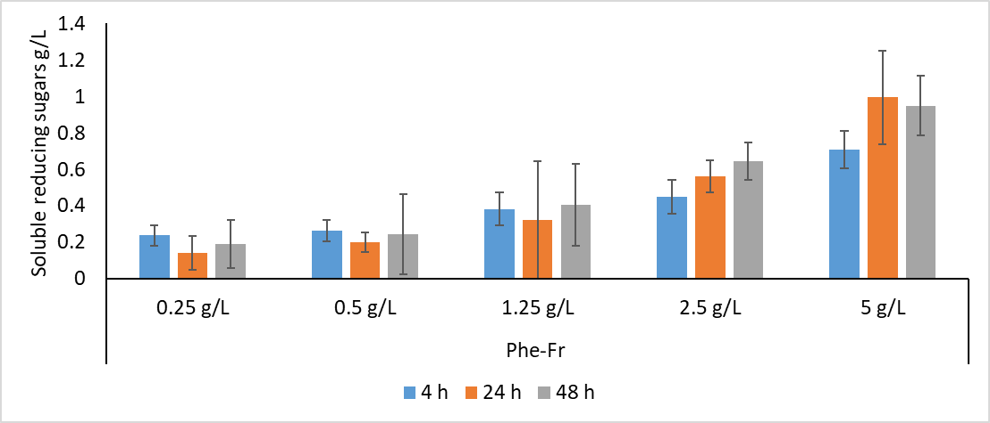
Figure S4: Hydrolysis of phenolic fraction (Phe-Fr) carbohydrates by Cellic Ctec2. Reducing sugars were quantified with PAHBAH assay. Reactions were performed at 45 ˚C in 50 mM NaAc buffer pH 5.0 in duplicates for 4 or 24 or 48 h. Phe-Fr concentration was 0.25-5 g/L UV-phenolics. Concentration of Cellic Ctec2 was 0.1 g/L.

Table S3. IC50 values for the inhibition of Celluclast 1.5L and Cellic Ctec2, and two purified CBHs (TrCel7A and TrCel6A) acting on 14C-BMCC substrate.
Enzyme | IC50 value
Enzyme | volume fraction (%)¹ |  |  |  | phenolics (g/L)²
Enzyme | PL | Phe-Fr | CTec-PL |  | Phe-Fr
TrCel7A | 1.0 ± 0.1 | 3.8 ± 0.4 | 51.2 ± 5.1 |  | 0.17 ± 0.02
TrCel6A | 0.5 ± 0.2 | 2.2 ± 0.3 | 51.9 ± 7.9 |  | 0.10 ± 0.01
Celluclast 1.5L | 2.0 ± 0.4 | 8.0 ± 1.2 | 20.2 ± 1.8 |  | 0.36 ± 0.05
Cellic CTec2 | 5.0 ± 0.8 | 15.3 ± 0.6 | 22.0 ± 7.1 |  | 0.70 ± 0.03
¹ The volume fractions of Phe-Fr and Ctec-PL were calculated based on their concentration of the UV-phenolics (Table 1). In doing so the concentration of UV-phenolics in PL (4.55 g/L) was taken equal to 100% volume fraction.
² IC50 value for Phe-Fr expressed in the units g/L UV-phenolics.

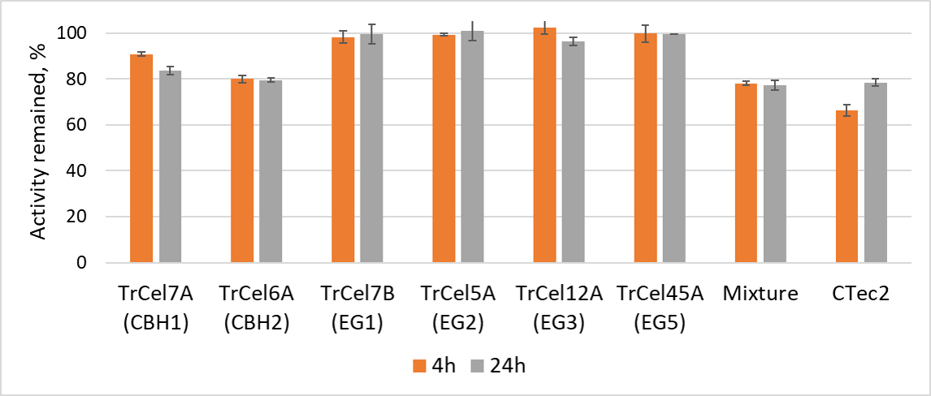
Figure S5. Effect of tannic acid on the enzymatic hydrolysis of cellulose. All hydrolysis reactions were performed at 45 ˚C in 50 mM NaAc buffer pH 5.0 with Avicel concentration 10 g/L in duplicates. Tannic acid concentration was 0.1 g/L, corresponding to 10 % w/w HMW phenolics (MW>1700 Da) in Phe-Fr. Concentrations of Cellic Ctec2 and purified enzymes (Tr Cel7A, Tr Ce6A, Tr Cel5A, Tr Cel12A, Tr Cel45A, Tr Xyn11) were 0.1 g/L. The reactions with purified enzymes were supplemented with β-glucosidase An Cel3A (5000 nkat/L). Reducing sugars were quantified with PAHBAH assay.

References
[1] A. S. Borisova, V. Pihlajaniemi, R. Kont, K. Niemelä, T. Koitto, A. Mikkelson, P. Väljamäe, K. Kruus, K. Marjamaa, Effect of soluble phenolic compounds from hydrothermally pretreated wheat straw on cellulose degrading enzymes, Biotechnology for Biofuels. In Press.:
[2] Lever, M. (1972) ‘A new reaction for colorimetric determination of carbohydrates’, Analytical Biochemistry, 47(1), pp. 273–279. doi: 10.1016/0003-2697(72)90301-6.

