DUSP4 activates adipocyte thermogenesis via Crtc3 dephosphorylation-dependent UCP1 expression

Min Jeong Son¹, Hae Un Kook¹, Jaeeun Jung^{1,2}, Se-Jun Park³, Young Joo Jeon¹, Kyoung-Jin Oh^{1,2}, Eun-Woo Lee^{1,2}, Baek Soo Han^{2,4}, Jang Hyun Choi^{5,*}, Kwang-Hee Bae^{1,**} and Won Kon Kim^{1,2,***}

¹Metabolic Regulation Research Center, Korea Research Institute of Bioscience and Biotechnology (KRIBB), Daejeon 34141, Republic of Korea
²Department of Functional Genomics, KRIBB School of Bioscience, Korea University of Science and Technology (UST), Daejeon 34141, Republic of Korea
³Division of Biotechnology, College of Life Sciences and Biotechnology, Korea University, 145, Anam-ro, Seongbuk-gu, Seoul 02841, Republic of Korea
⁴Biodefense Research Center, Korea Research Institute of Bioscience and Biotechnology (KRIBB), Daejeon 34141, Republic of Korea
⁵Department of Biological Sciences, Ulsan National Institute of Science and Technology (UNIST), Ulsan 44919, Republic of Korea

Address correspondence to:
*Jang Hyun Choi, Department of Biological Sciences, Ulsan National Institute of Science and Technology (UNIST), Ulsan 44919, Republic of Korea. Phone: 82-52-217-2543; email: janghchoi@unist.ac.kr;
**Kwang-Hee Bae, Metabolic Regulation Research Center, Korea Research Institute of Bioscience and Biotechnology (KRIBB), Daejeon 34141, Republic of Korea. Phone: 82-42-860-4268; email: khbae@kribb.re.kr;
***Won Kon Kim, Metabolic Regulation Research Center, Korea Research Institute of Bioscience and Biotechnology (KRIBB), Daejeon 34141, Republic of Korea. Phone: 82-42-860-4265, email: wkkim@kribb.re.kr

Material and method
Animal experiments
B6:129-Dusp^{tm1Jmol}/J mice (MGI:4456264) were obtained from the Jackson Laboratory (Bar Harbor, ME, USA). This strain was generated using 129-derived embryonic stem cells in which exons 2 and 3 of the Dusp4 gene were replaced with a neomycin resistance cassette. The donating laboratory maintained the mice on a mixed C57BL/6–129 genetic background, and the line was further backcrossed to the C57BL/6 strain for five generations to standardize the genetic background. All animals were housed in a specific pathogen-free facility. All procedures were reviewed and approved by the Institutional Animal Care and Use Committee of the Korea Research Institute of Bioscience and Biotechnology (KRIBB) and were conducted in accordance with the Guide for the Care and Use of Laboratory Animals of the U.S. National Institutes of Health.

Quantitative real-time PCR
Total RNA was isolated from cells using TRIzol reagent (Thermo Fisher Scientific, 15596018). cDNA was synthesized from 2 µg of RNA using random primers (10 pmol), dNTPs, reverse transcriptase, and RNasin. Quantitative PCR was performed with primers targeting lipogenic genes (Srebp1c, Acc, Fas), lipolytic genes (Plin1, Adrb3, Pde3 β), and β-oxidation genes (F0f1atpase, Accβ, Cpt1β, Mcad). Gene expression levels were normalized to L32 as the reference gene. qPCR assays were conducted on a CFX Maestro system (Bio-Rad) using 20× EvaGreen Supermix (Solgent, 31000-B500) according to the manufacturer’s instructions.

Western blot
Total proteins were extracted using NP-40 lysis buffer (1% NP-40, 2.5 mM sodium phosphate, 1 mM EDTA, and 150 mM NaCl). A quantitative analysis of total protein concentration was performed using the Bradford Protein Assay (Bio-Rad, 5000002). Cell lysates were incubated with primary antibodies for Hsp90 (Santa Cruz, 1:5,000), Dusp4 (Santa Cruz, 1:1,000), Flag (Sigma, 1:5,000). Following primary antibody incubation, membranes were washed and probed with secondary antibodies (Santa Cruz, 1:2,000). Signals were detected using an enhanced chemiluminescence (ECL) system (GE Healthcare, RPN2232).

Supplementary Figures
Supplementary Fig 1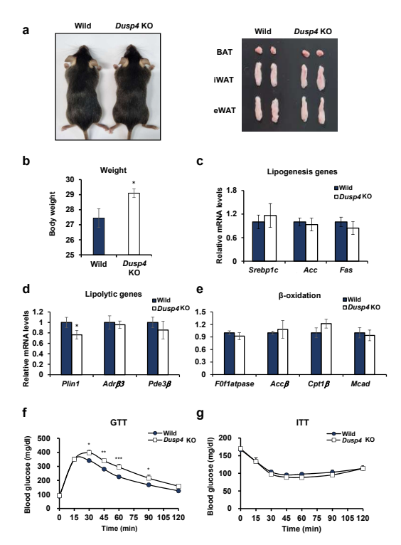
Supplementary Fig. 1 Metabolic phenotype of Dusp4 knockout mice under normal chow diet (NCD). To assess the baseline metabolic characteristics of Dusp4-deficient mice in the absence of dietary challenge, Dusp4 knockout (KO) and wild-type (WT) were maintained on a normal chow diet (NCD) and subjected to morphological, molecular, and metabolic evaluations. a Representative images of whole-body morphology (left) and dissected adipose tissues (right) from WT and Dusp4 KO mice reveal no gross anatomical differences under NCD conditions. b Longitudinal body weight measurements show no significant difference between genotypes (n = 5-6 per group). c, d, e, Quantitative real-time PCR analyses of inguinal white adipose tissue (ingWAT) demonstrated a modest reduction in lipogenic gene expression in KO mice (c), while expression of genes involved in lipolysis (d) and β-oxidation (e) remains largely unchanged compared to WT controls. f, g, Dusp4 KO mice exhibited significantly improved glucose clearance during the glucose tolerance test (GTT) (f), while the insulin tolerance test (ITT) (g) revealed no notable changes. These findings indicate that under normal chow diet, Dusp4 KO mice exhibit a largely normal metabolic phenotypes, with only subtle impairments in thermogenic gene expression and glucose homeostasis, suggesting that DUSP4’s protective role becomes more prominent under metabolic stress such as high-fat diet. Data are presented as mean ± SEM. Statistical comparisons were made using two-tailed unpaired Student’s t-test; *p<0.01, **p<0.005, ***p<0.0005.

Supplementary Fig 2
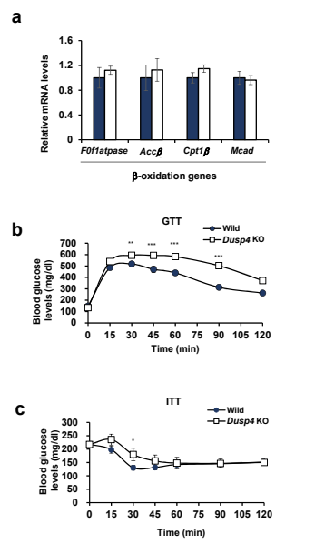
Supplementary Fig. 2 Metabolic phenotype of Dusp4 knockout mice under under high-fat diet (HFD). a Relative mRNA expression of key metabolic genes was measured by real-time PCR in ingWAT from Dusp4 KO and wild-type (WT) mice after 10 weeks of HFD feeding (n = 5-8 per group). b, c, Glucose tolerance test (GTT) and insulin tolerance test (ITT) were performed to assess systemic insulin sensitivity in HFD-fed Dusp4 KO and WT mice (n =10 per group). Dusp4 KO mice showed impaired glucose clearance compared to WT controls, as assessed by the glucose tolerance test (GTT) (b). In contrast, insulin tolerance test (ITT) results revealed no significant differences (c). Data are presented as mean ± SEM. Statistical significance was determined using unpaired two-tailed Student’s t-test. *p < 0.01, **p < 0.005, ***p < 0.0005.
Supplementary Fig 3
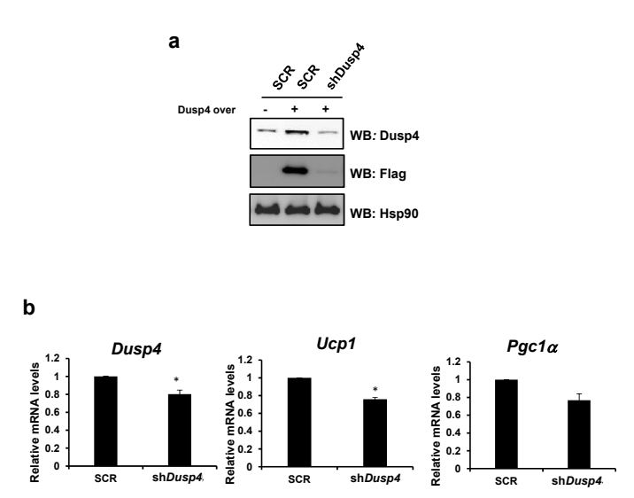
Supplementary Fig.3 Knockdown of Dusp4 decreases thermogenic gene expression in adipocytes. To investigate the cell-autonomous role of Dusp4 in regulation of thermogenic genes in adipocytes, mature inguinal white adipocytes were subjected to Dusp4 knockdown followed by NE stimulation to induce a thermogenic response. a Western blot analysis confirmed a reduction in Dusp4 protein levels upon knockdown in HEK293T. b Quantitative real-time PCR further demonstrated that knockdown of Dusp4 significantly decreased the mRNA levels of thermogenic genes, such as Ucp1 and Pgc1α in response to NE treatment, relative to control cells (n = 3). These findings suggest that Dusp4 is required for the full induction of thermogenic gene program in white adipocytes under adrenergic stimulation. Data are expressed as mean ±SEM. Statistical analysis was performed using a two-tailed unpaired Student’s t-test; *p < 0.01, **p < 0.005, ***p< 0.0005.

