Appendix A

 |  | WALK |  |  | SLS
 |  | Peak values (range) |  | RMSD | Peak values (range) |  |  | RMSD
 |  | CGM2.3 | PiG |  | CGM2.3 |  | PiG
Joint | Plane | degrees | degrees | degrees | degrees |  | degrees | degrees
Hip
 | Sagittal | 33.59  (21.94 - 43.35) | 34.69  (21.13 - 44.90) | 2.27 | 93.09  (73.58 - 111.45) |  | 87.85  (68.61 - 102.73) | 5.09
 | Frontal | 8.97  (3.06 - 13.05) | 6.00  (-0.26 - 10.37) | 3.27 | 12.61  (1.41 - 23.52) |  | 10.84  (0.02 - 21.28) | 3.43
 | Transversal | 1.10  (-12.83 - 14.10) | 5.16  (-7.36 - 19.58) | 5.03 | -2.17  (-18.83 - 10.27) |  | 2.90  (-13.08 - 20.07) | 8.96
Knee
 | Sagittal | 43.08  (34.88 - 50.57) | 38.87  (28.82 - 47.81) | 2.61 | 92.36  (75.06 - 115.37) |  | 88.06  (60.38 - 111.98) | 4.37
 | Frontal | 3.05  (-2.92 - 10.20) | 4.53  (-1.12 - 11.35) | 2.31 | 2.62  (-6.36 - 11.31) |  | 7.59  (-4.18 - 19.66) | 6.95
 | Transversal | -1.22  (-13.10 - 11.03) | 15.77  (4.59 - 27.47) | 17.78 | -0.66  (-15.03 - 11.20) |  | 31.02  (11.94 - 53.77) | 29.15

Supplementary Table 1. Kinematic peak values of CGM2.3 and PiG and RMSD values of the whole movement, between of the models in WALK and SLS. The peak values are presented as the average peak value, and the lowest and highest values are in parentheses. N = 72 steps N = 72 squats.

 |  | WALK |  |  |  | SLS
 |  | Peak values  (range) |  |  | RMSD | Peak values  (range) |  | RMSD
 |  | CGM2.3 | PiG |  |  | CGM2.3 | PiG
Joint | Plane | Nm/kg |  | Nm/kg | Nm/kg | Nm/kg | Nm/kg | Nm/kg
Hip
 | Sagittal | 0.98  (0.63 - 1.31) |  | 1.46  (0.70 - 2.21) | 0.33 | 2.35  (1.33 - 3.45) | 2.34  (1.29 - 3.40) | 0.2
 | Frontal | 0.91  (0.69 - 1.20) |  | 0.96  (0.67 - 1.31) | 0.15 | 0.84  (0.59 - 1.07) | 0.93  (0.51 - 1.23) | 0.23
 | Transversal | 0.13  (0.02 - 0.21) |  | 0.15  (0.05 - 0.21) | 0.03 | 0.01  (-0.09 - 0.09) | 0.01  (-0.08 - 0.09) | 0.05
Knee
 | Sagittal | 0.68  (0.23 - 1.16) |  | 0.52  (0.16 - 0.81) | 0.15 | 1.98  (1.31 - 2.89) | 0.97  (0.40 - 1.57) | 0.68
 | Frontal | 0.57  (0.29 - 0.88) |  | 0.73  (0.44 - 1.28) | 0.1 | 0.70  (0.35 - 0.94) | 1.32  (0.74 - 2.04) | 0.47
 | Transversal | 0.17  (0.08 - 0.24) |  | 0.18  (0.09 - 0.23) | 0.02 | 0.12  (0.03 - 0.23) | 0.16  (0.06 - 0.32) | 0.05

Supplementary Table 2. Kinetic peak values of CGM2.3 JCS and PiG and RMSD values of the whole movement between the models in WALK and SLS. The peak values are presented as the average peak value, and the lowest and highest values are in parentheses. N = 72 steps N = 72 squats.

Appendix B
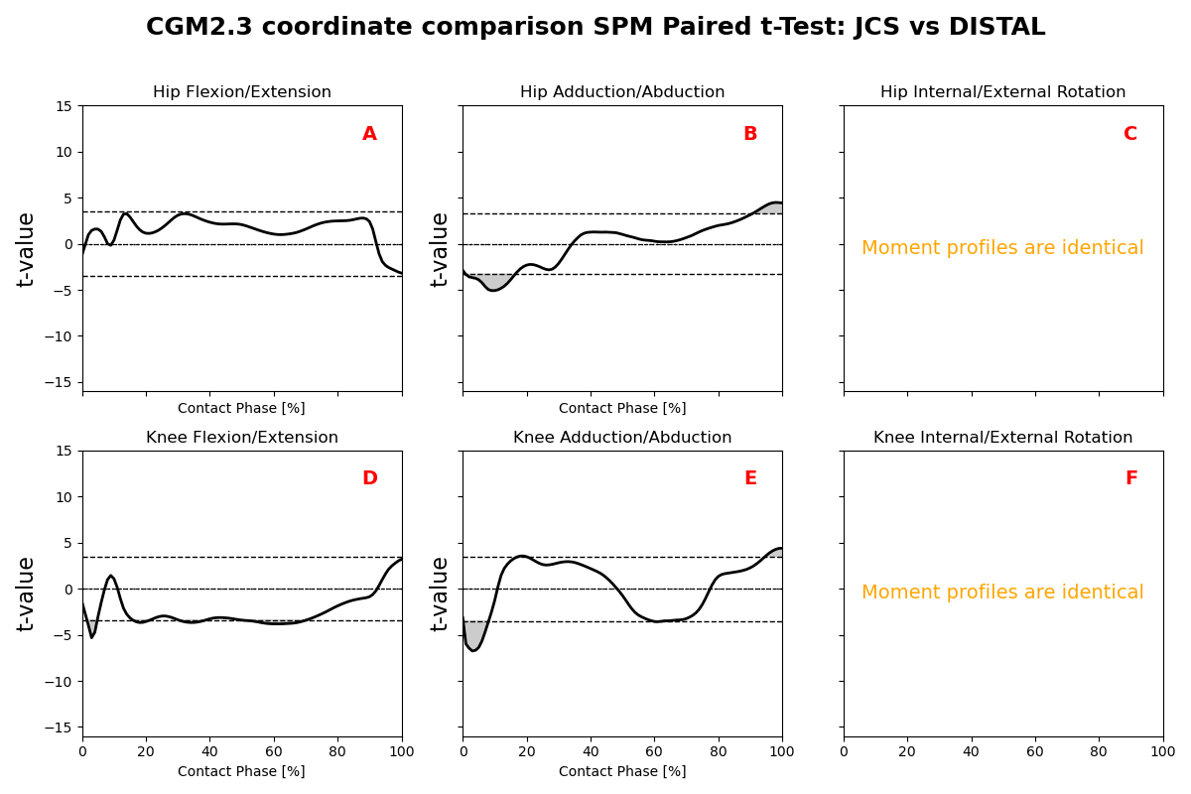
Supplementary Figure 1. Comparison of CGM2.3 JCS and distal coordinate systems on WALK.
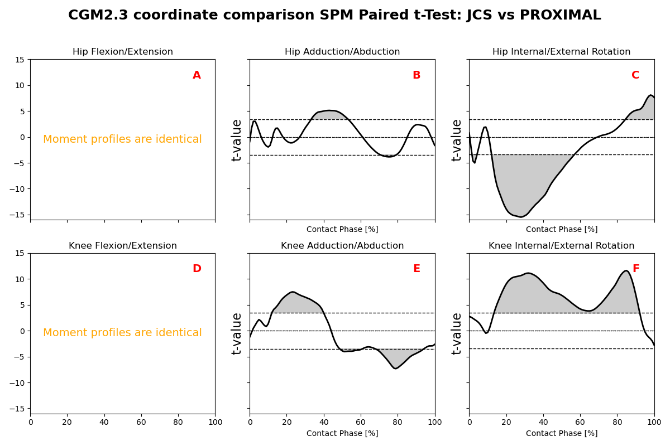Supplementary Figure 2. Comparison of CGM2.3 JCS and proximal coordinate systems on WALK.

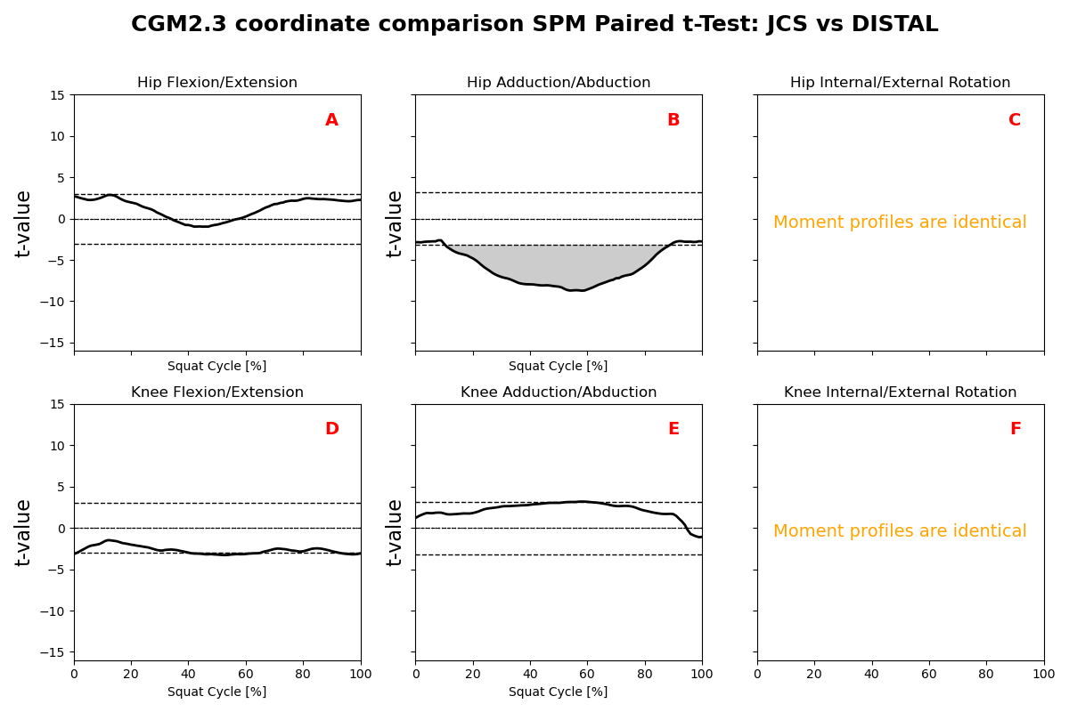
Supplementary Figure 3. Comparison of CGM2.3 JCS and distal coordinate systems on SLS.

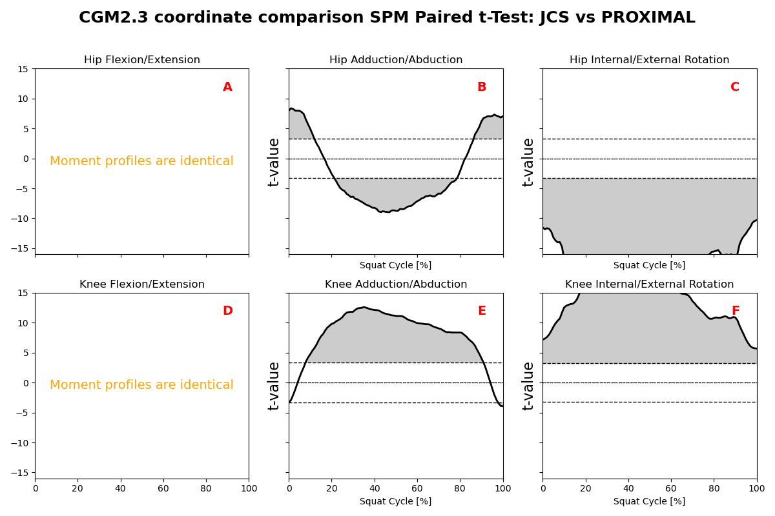
Supplementary Figure 4. Comparison of CGM2.3 JCS and proximal coordinate systems on SLS.

