Atmospheric Resuspension of Insoluble Radioactive Cesium Particles Found in the Difficult-to-Return Area in Fukushima
Peng Tang,¹ Kazuyuki Kita,^{*1} Yasuhito Igarashi,^{*1, 2} Yukihiko Satou,³ Koutarou Hatanaka,¹ Kouji Adachi,⁴ Takeshi Kinase,⁵ Kazuhiko Ninomiya,⁶ Atsushi Shinohara⁶

¹Graduate School of Science and Engineering, Ibaraki University, 2-1-1 Bunkyo, Mito, Ibaraki, 310-8512, Japan
²Institute for Integrated Radiation and Nuclear Science, Kyoto University, 2-chome, Asashiro-Nishi, Kumatori, Sennan, Osaka, 590-0494, Japan
³Collaborative Laboratories for Advanced Decommissioning Science (CLADS), Japan Atomic Energy Agency (JAEA), 790-1 Otsuka, Motooka, Tomioka, Fukushima 979-1195, Japan
⁴Meteorological Research Institute (MRI), Japan Meteorological Agency (JMA), Tsukuba, Ibaraki, Japan
⁵Japan Agency for Marine-Science and Technology, Research Institute for Global Change (RIGC), Institute of Arctic Climate and Environment Research (IACE)
⁶Graduate School of Science, Osaka University, 1-1 Machikaneyama, Toyonaka, Osaka 560-0043, Japan

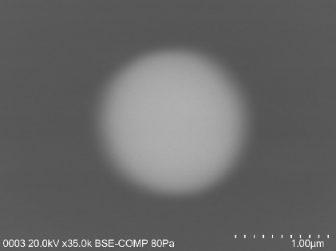
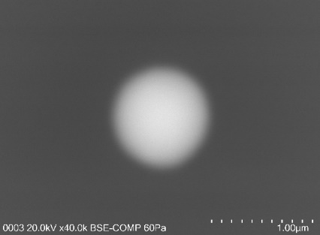
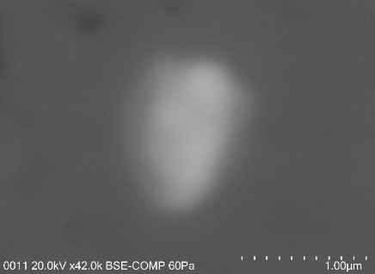
#2 NHVA-270504-Fri-Q-b
#3 NHVA-270618-Wed-Q-a
#1 NHVA-270504-Fri-Q-a

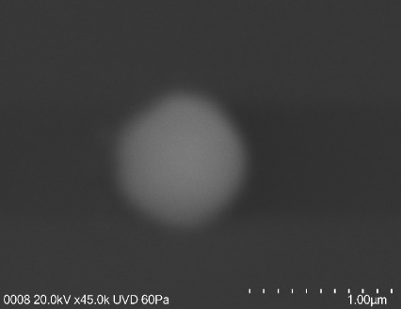
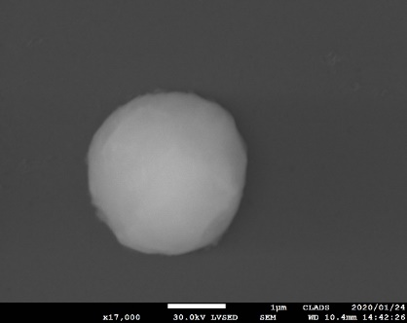
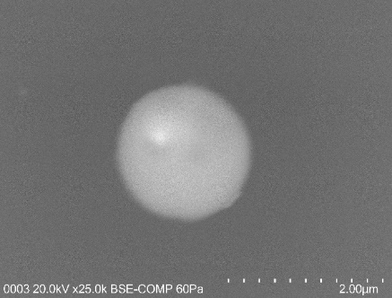
#6 NHVA-271105-Tue-Q
#5 NHVA-271015-Mon-Q
#4 NHVF-270730-J-Q3

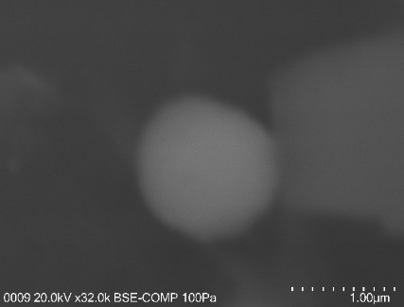
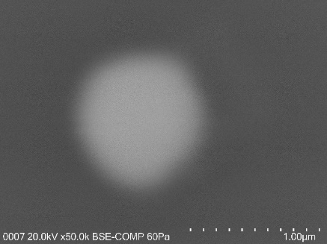
#9 NHVB-280429-I-Q7
#7 NHVF-280128-Q
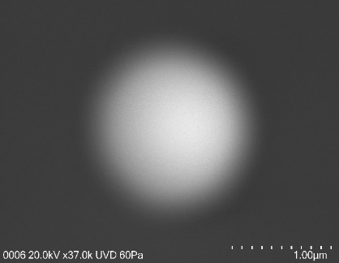
#8 NHVB-280310-I-Q7

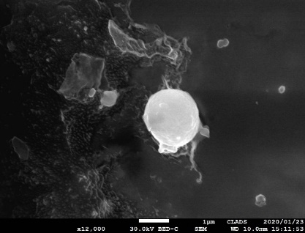
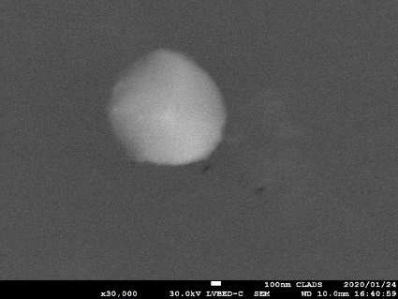
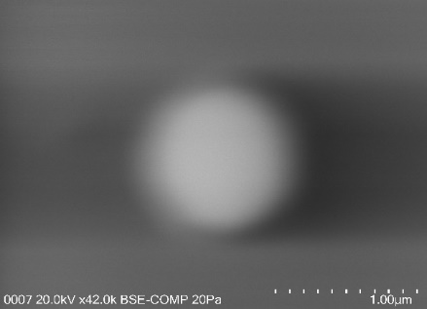
#11 NHVF-300601-Q
#12 NHVF-300906-Q
#10 NHVF-300322-Q-b

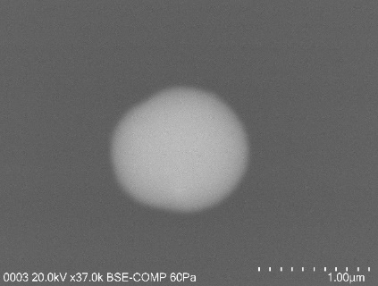
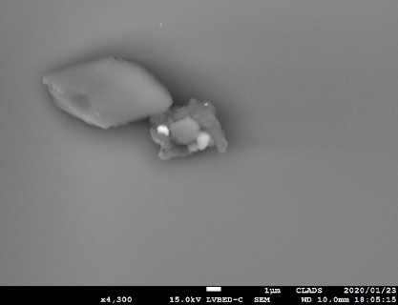
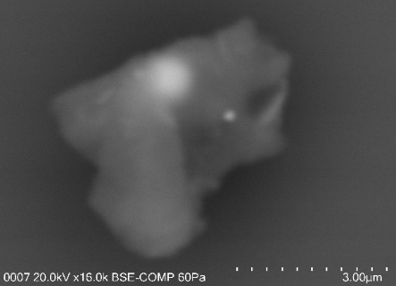
#15 NHVA-190919-A-Q
#14 NHVA-190425-B-Q
#13 NHVA-190327-C-Q-b

Figure S1. SEM images of 15 single A-CsMPs isolated from the aerosol filter samples.

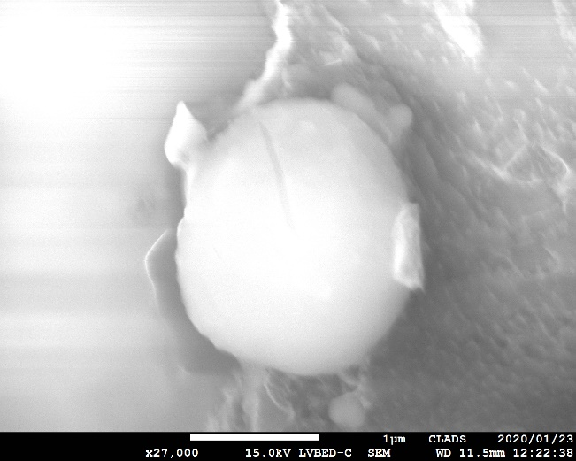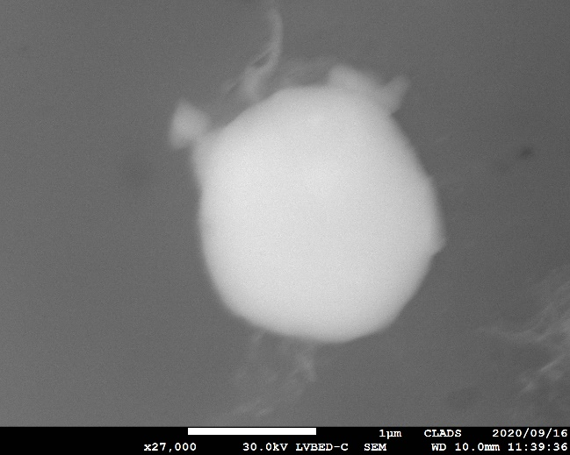
#12 after immersion
#11 after immersion
#11 before immersion
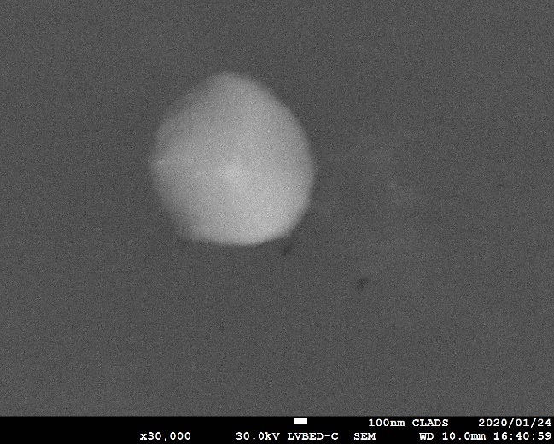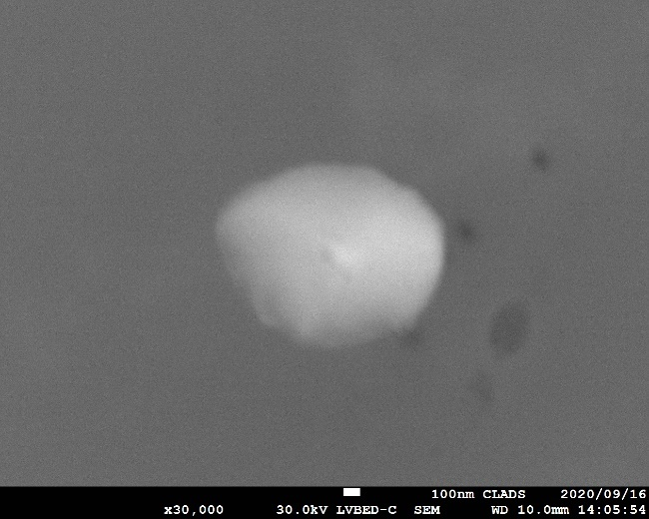
#12 before immersion

Figure S2. SEM images of A-CsMPs before and after immersion into the pure water for 24 h (#11 NHVF-300601-Q) and 48 h (#12 NHVF-300906-Q).

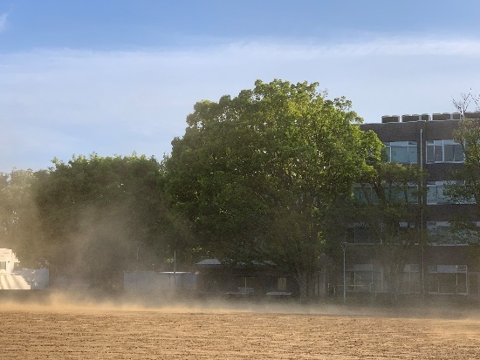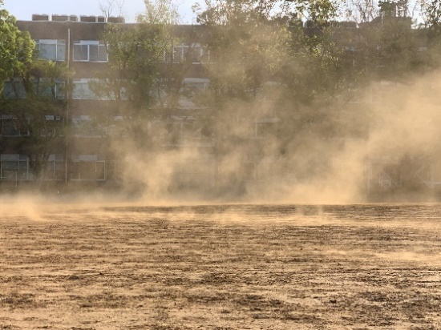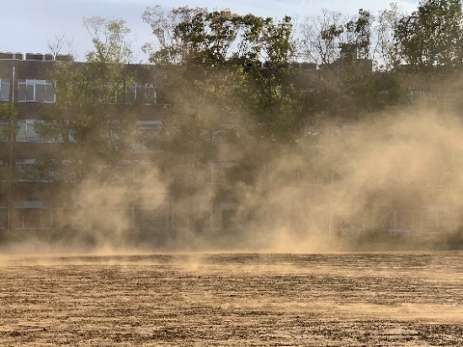

Time | Temperature | Humidity | Wind speed(m/s) |  |  | Time | Temperature | Humidity | Wind speed(m/s)
Time | (℃) | (％) |  |  |  | Time | (℃) | (％)
Time |  |  | Average | Wind gust |  | Time |  |  | Average | Wind gust
9:30 | 19.6 | 25 | 2.1 | 5.3 |  | 13:30 | 25 | 13 | 5 | 14.4
9:40 | 20.3 | 22 | 2.9 | 4.9 |  | 13:40 | 24.5 | 11 | 4 | 11.3
9:50 | 20.2 | 21 | 2.8 | 5.1 |  | 13:50 | 24.3 | 12 | 3.8 | 11.4
10:00 | 20.6 | 21 | 2.9 | 5.1 |  | 14:00 | 24.5 | 10 | 3.2 | 10.3
10:10 | 21.1 | 20 | 2.2 | 4.4 |  | 14:10 | 24.5 | 9 | 4.1 | 10.3
10:20 | 22.4 | 20 | 2.3 | 7.1 |  | 14:20 | 24.6 | 10 | 3.6 | 10.3
10:30 | 22.2 | 18 | 2.6 | 6 |  | 14:30 | 23.9 | 10 | 3.4 | 8.9
10:40 | 22.3 | 15 | 2.4 | 5.1 |  | 14:40 | 24.2 | 11 | 2.3 | 9.1
10:50 | 22.5 | 14 | 2.4 | 5.7 |  | 14:50 | 23.4 | 12 | 2.8 | 9.7
11:00 | 23 | 15 | 2.7 | 5.7 |  | 15:00 | 20.4 | 32 | 4.6 | 7.8

Figure S3. Suspension of surface soil on the playground of Ibaraki University on April 22, 2021, when wind gust speed was higher than 4 m s⁻¹. The weather information obtained from Japan Meteorological Agency, http://www.data.jma.go.jp/obd/stats/etrn/index.php.

Figure S4. The annual information of gust speed, the average wind speed, the mean soil-water-content and relative humidity (RH) have been collected at our sampling site in 2015.

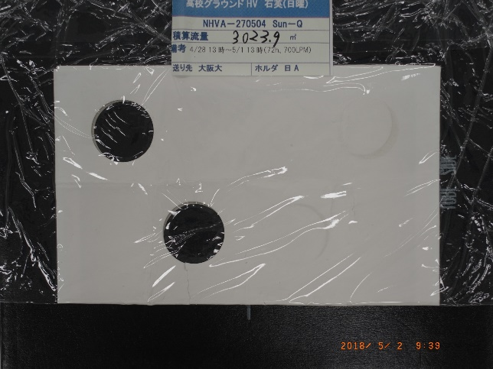
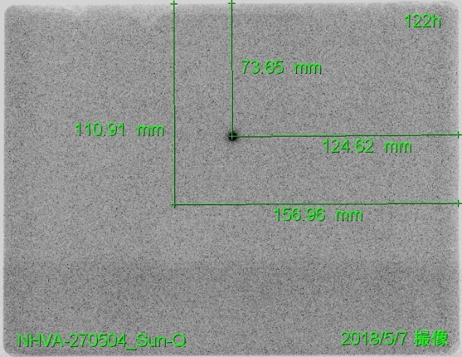

Figure S5. The IP image of the aerosol-filter-samples after separating A-CsMPs, which can still detect the radioactive spot after covering for 122 h (it may be attributed to the low-level radioactive CsMPs or bioaerosol/soil particles carrying radiocesium, and it is not going to be further isolated because of the excessive amount of time would be required for the extracting extraction procedure).

Table S1. Elemental compositions of 15 insoluble A-CsMPs (the main elements are O, Si, Na, S, Cl, Fe and Zn, which are consistent with other Type A CsMPs^{1, 2})
No. | Sample ID | d/ um | O | Na | Mg | Al | Si | P | S | Cl | K | Ca | Cr | Mn | Ti | Fe | Zn | In | Sn | Cs | Ba | U
1 | NHVA-270504_Fri-Q-a | 1.2 | 46.34 | 7.19 |  |  | 31.91 |  | 0.24 |  | 3.56 | 4.86 |  |  |  | 0.68 | 2.77 |  |  | 0.97 | 0.01
2 | NHVA-270504_Fri-Q-b | 2.0 | 47.40 | 7.00 |  |  | 31.14 |  | 0.14 | 0.21 | 3.92 | 5.13 |  |  |  | 1.34 | 3.77 |  |  | 0.85 | 1.34
3 | NHVA-270618_Wed-Q-a | 1.7 | 52.68 | 0.77 |  | 0.06 | 39.46 | 0.02 | 0.03 | 0.31 |  |  |  |  |  | 1.30 | 3.04 | 0.46 | 0.05 | 1.38
4 | NHVF-270730-J-Q3 | 1.2 | 54.08 | 1.10 |  |  | 38.03 |  |  | 0.23 |  |  | 0.49 | 0.16 |  | 1.88 | 0.62 | 0.53 |  | 0.74 |  | 2.15
5 | NHVA-271015_Mon-Q | 2.5
6 | NHVA-271105_Tue-Q | 1.9 | 53.80 | 0.37 |  |  | 41.58 |  | 0.03 | 0.20 | 0.02 |  |  |  |  | 0.83 | 1.33 | 0.39 | 0.36 | 0.99
7 | NHVF-280128-Q | 1.8 | 46.84 | 6.91 |  |  | 29.84 |  | 0.15 | 0.23 | 3.18 | 4.21 |  |  | 0.26 | 1.18 | 4.07 |  | 0.70 | 1.66 | 1.40
8 | NHVB-280310-I-Q7 | 1.4 | 51.80 |  |  |  | 38.15 |  | 0.03 | 0.48 | 0.26 |  |  |  |  | 2.09 | 3.15 | 0.38 | 0.58 | 0.34
9 | NHVB-280429-I-Q7 | 1.8 | 46.24 | 7.01 |  |  | 30.38 | 0.14 | 0.16 | 0.25 | 3.30 | 4.33 |  |  | 0.27 | 1.19 | 3.57 |  | 0.83 | 1.09 | 1.24
10 | NHVF-300322-Q-b | 1.5 | 53.60 | 0.62 |  |  | 40.71 |  | 0.03 | 0.20 | 0.25 |  |  |  |  | 0.75 | 2.07 |  | 0.55 | 1.11
11 | NHVF-300601-Q | 2.0
12 | NHVF-300906-Q | 1.4
13 | NHVA-190327-C-Q-b | 3.0 | 52.41 | 0.76 | 0.14 | 0.19 | 40.98 |  | 0.20 | 0.28 | 0.38 |  |  |  |  | 1.12 | 1.76 |  | 0.40 | 1.01
14 | NHVA-190425-B-Q | 2.0
15 | NHVA-190919-A-Q | 1.2 | 51.51 | 0.19 |  |  | 45.97 |  | 0.09 | 0.11 | 0.04 |  |  |  |  | 0.37 | 0.91 |  | 0.34 | 0.49
average value |  | 1.8 | 50.61 | 3.19 | 0.14 | 0.13 | 37.10 | 0.08 | 0.11 | 0.25 | 1.66 | 4.63 | 0.49 | 0.16 | 0.27 | 1.16 | 2.46 | 0.44 | 0.48 | 0.97 | 1.00 | 2.15
Median |  | 1.8 | 51.80 | 0.94 | 0.14 | 0.13 | 38.15 | 0.08 | 0.12 | 0.23 | 0.38 | 4.60 | 0.49 | 0.16 | 0.27 | 1.18 | 2.77 | 0.43 | 0.48 | 0.99 | 1.29 | 2.15
Standard deviation |  | 0.5 | 3.21 | 3.31 |  | 0.09 | 5.43 | 0.08 | 0.08 | 0.10 | 1.75 | 0.44 |  |  | 0.01 | 0.51 | 1.19 | 0.07 | 0.24 | 0.37 | 0.66
Table S2. Elemental compositions of 3 insoluble S-CsMPs (O, Si, Na, S, Cl, Fe, Zn and Cs are also the main elements, which are consistent with A-CsMPs and Type A CsMPs)

No. | Sample ID | d/ um | O | Na | Al | Si | P | S | Cl | K | Ca | Fe | Zn | Cs
1 | NA-3 (S-CsMPs-1) | 1.8 | 23.78 | 1.79 |  | 14.13 | 0.27 |  | 1.10 | 0.83 |  | 4.69 | 8.83 | 4.52
2 | NA-4 (S-CsMPs-2) | 1.6 | 32.58 | 0.49 | 0.04 | 2.15 |  |  | 0.07 | 0.07 |  | 0.53 | 0.70 | 0.18
3 | NA-6 (S-CsMPs-3) | 1.8 | 31.23 | 0.56 |  | 2.88 |  | 0.01 | 0.05 | 0.09 | 0.02 | 0.45 | 0.87 | 0.28
Average value |  | 1.7 | 29.20 | 0.95 | 0.04 | 6.39 | 0.27 | 0.01 | 0.41 | 0.33 | 0.02 | 1.89 | 3.47 | 1.66
 | Median | 1.8 | 31.23 | 0.56 | 2.88 | 2.88 | 0.27 | 0.01 | 0.07 | 0.09 | 0.02 | 0.53 | 0.87 | 0.28
Standard deviation |  | 0.1 | 4.74 | 0.73 |  | 6.72 |  |  | 0.60 | 0.43 |  | 2.43 | 4.65 | 2.48

Table S3. The information of 165 aerosol filters, which has been used for autoradiographic measurement. The rows shadowed in light gray show the aerosol CsMPs have been detected in these aerosol filter samples.

No. | Sample ID |  | Sampling year | Sampling volume  (m³) | ¹³⁷Cs (Bq)  in Filter  (T) | Error | Concentration of ¹³⁷Cs  (Bq m⁻³) | Error
1 | NHVF-270129-C-Q3 |  | 2015 | 12967.5 | 0.12 | 0.01 | 9.02E-06 | 9.30E-07
2 | NHVF-270326-A | Q1 | 2015 | 10930.5 | 0.09 | 0.01 | 8.34E-06 | 9.47E-07
2 | NHVF-270326-A | Q2 | 2015 | 10930.5 | 0.21 | 0.02 | 1.88E-05 | 1.46E-06
2 | NHVF-270326-A | Q3 | 2015 | 10930.5 | 0.11 | 0.01 | 1.01E-05 | 1.05E-06
2 | NHVF-270326-A | Q7 | 2015 | 10930.5 | 1.14 | 0.03 | 1.04E-04 | 2.73E-06
3 | NHVF-270425-A-Q3 |  | 2015 | 6633.0 | 0.17 | 0.01 | 2.52E-05 | 2.00E-06
4 | NHVA-270504-Sun-Q |  | 2015 | 2782.0 | 1.93 | 0.12 | 6.93E-04 | 4.3537E-05
5 | NHVA-270504-Fri-Q |  | 2015 | 2781.9 | 2.03 | 0.12 | 7.28E-04 | 4.40E-05
6 | NHVA-270504-Sat-Q |  | 2015 | 2782.0 | 0.73 | 0.12 | 2.62E-04 | 4.41E-05
7 | NHVA-270514-Sat-Q |  | 2015 | 3091.0 | 2.33 | 0.16 | 7.55E-04 | 5.33E-05
8 | NHVA-270514-Sun-Q |  | 2015 | 3091.1 | 2.19 | 0.12 | 7.09E-04 | 3.93E-05
9 | NHVB-270514-D | Q1 | 2015 | 8375.6 | 0.01 | 0.00 | 1.27E-06 | 3.11E-07
9 | NHVB-270514-D | Q2 | 2015 | 8375.6 | 0.47 | 0.02 | 5.64E-05 | 2.32E-06
9 | NHVB-270514-D | Q3 | 2015 | 8375.6 | 0.13 | 0.01 | 1.54E-05 | 1.26E-06
9 | NHVB-270514-D | Q7 | 2015 | 8375.6 | 2.84 | 0.05 | 3.39E-04 | 5.46E-06
10 | NHVA-270604-Sun-Q |  | 2015 | 2419.1 | 3.53 | 0.12 | 1.46E-03 | 4.97E-05
11 | NHVA-270604-Tue-Q |  | 2015 | 2419.1 | 2.78 | 0.12 | 1.15E-03 | 4.98E-05
12 | NHVA-270604-Thr-Q |  | 2015 | 2419.1 | 3.10 | 0.12 | 1.28E-03 | 4.97E-05
13 | NHVA-270604-Fri-Q |  | 2015 | 2419.1 | 8.41 | 0.12 | 3.48E-03 | 4.96E-05
14 | NHVA-270604-Sat-Q |  | 2015 | 2419.1 | 3.12 | 0.12 | 1.29E-03 | 4.97E-05
15 | NHVA-270604-Mon-Q |  | 2015 | 2419.1 | 2.10 | 0.12 | 8.68E-04 | 4.98E-05
16 | NHVA-270604-Wed-Q |  | 2015 | 2419.1 | 2.63 | 0.12 | 1.09E-03 | 4.97E-05
No. | Sample ID |  | Sampling year | Sampling volume  (m³) | ¹³⁷Cs (Bq)  in Filter  (T)) | Error | Concentration of ¹³⁷Cs  (Bq m⁻³) | Error
17 | NHVB-270604-C | Q1 | 2015 | 17257.8 | 0.50 | 0.02 | 2.89E-05 | 1.14E-06
17 | NHVB-270604-C | Q2 | 2015 | 17257.8 | 0.83 | 0.03 | 4.81E-05 | 1.50E-06
17 | NHVB-270604-C | Q7 | 2015 | 17257.8 | 5.07 | 0.06 | 2.94E-04 | 3.48E-06
18 | NHVB-270604-H | Q1G | 2015 | 16666.0 | 1.91 | 0.04 | 1.15E-04 | 2.14E-06
18 | NHVB-270604-H | Q2G | 2015 | 16666.0 | 1.66 | 0.03 | 9.99E-05 | 1.99E-06
18 | NHVB-270604-H | Q7G | 2015 | 16666.0 | 2.78 | 0.05 | 1.67E-04 | 2.81E-06
19 | NHVA-270618-Sat-Q |  | 2015 | 1612.7 | 5.74 | 0.12 | 3.56E-03 | 7.46E-05
20 | NHVA-270618-Sun-Q |  | 2015 | 1612.7 | 1.69 | 0.12 | 1.05E-03 | 7.55E-05
21 | NHVA-270618-Tue-Q |  | 2015 | 1430.8 | 1.82 | 0.12 | 1.27E-03 | 8.49E-05
22 | NHVA-270618-Wed-Q |  | 2015 | 1612.7 | 1.53 | 0.12 | 9.50E-04 | 7.58E-05
23 | NHVF-270618-J | Q1 | 2015 | 9601.3 | 0.34 | 0.02 | 3.55E-05 | 1.91E-06
23 | NHVF-270618-J | Q2 | 2015 | 9601.3 | 0.58 | 0.02 | 6.05E-05 | 2.18E-06
23 | NHVF-270618-J | Q3 | 2015 | 9601.3 | 0.77 | 0.02 | 7.97E-05 | 2.15E-06
23 | NHVF-270618-J | Q7 | 2015 | 9601.3 | 5.43 | 0.06 | 5.66E-04 | 6.48E-06
24 | NHVA-270709-Sun-Q |  | 2015 | 2419.1 | 1.23 | 0.12 | 5.09E-04 | 5.03E-05
25 | NHVF-270709-C | Q1 | 2015 | 12912.8 | 0.21 | 0.01 | 1.64E-05 | 1.11E-06
25 | NHVF-270709-C | Q2 | 2015 | 12912.8 | 0.86 | 0.02 | 6.68E-05 | 1.54E-06
25 | NHVF-270709-C | Q3 | 2015 | 12912.8 | 0.80 | 0.02 | 6.23E-05 | 1.64E-06
25 | NHVF-270709-C | Q7 | 2015 | 12912.8 | 0.07 | 0.01 | 5.77E-06 | 1.02E-06
26 | NHVF-270730-J | Q1 | 2015 | 15148.2 | 0.39 | 0.02 | 2.61E-05 | 1.49E-06
26 | NHVF-270730-J | Q2 | 2015 | 15148.2 | 1.58 | 0.04 | 1.04E-04 | 2.75E-06
26 | NHVF-270730-J | Q3 | 2015 | 15148.2 | 2.44 | 0.06 | 1.61E-04 | 4.03E-06
26 | NHVF-270730-J | Q7 | 2015 | 15148.2 | 0.22 | 0.02 | 1.46E-05 | 1.47E-06
No. | Sample ID |  | Sampling year | Sampling volume  (m³) | ¹³⁷Cs (Bq)  in Filter  (T) | Error | Concentration of ¹³⁷Cs  (Bq m⁻³) | Error
27 | NHVA-270819-Mon-Q |  | 2015 | 2419.1 | 1.40 | 0.17 | 5.77E-04 | 6.85E-05
28 | NHVA-270819-Sun-Q |  | 2015 | 2419.0 | 1.48 | 0.17 | 6.12E-04 | 6.85E-05
29 | NHVA-270819-Thr-Q |  | 2015 | 2419.1 | 1.76 | 0.17 | 7.26E-04 | 6.85E-05
30 | NHVF-270819-I | Q1 | 2015 | 13890.3 | 0.57 | 0.03 | 4.08E-05 | 1.97E-06
30 | NHVF-270819-I | Q2 | 2015 | 13890.3 | 2.09 | 0.05 | 1.51E-04 | 3.34E-06
30 | NHVF-270819-I | Q3 | 2015 | 13890.3 | 2.60 | 0.05 | 1.88E-04 | 3.89E-06
30 | NHVF-270819-I | Q7 | 2015 | 13890.3 | 0.14 | 0.02 | 1.02E-05 | 1.24E-06
32 | NHVA-270828-Sat-Q |  | 2015 | 2146.5 | 1.39 | 0.17 | 6.48E-04 | 7.71E-05
33 | NHVA-270828-Wed-T |  | 2015 | 188.3 | 1.15 | 0.17 | 6.13E-03 | 8.82E-04
34 | NHVF-270828-C | Q1 | 2015 | 2359.0 | 0.09 | 0.01 | 3.80E-05 | 5.00E-06
34 | NHVF-270828-C | Q2 | 2015 | 2359.0 | 0.42 | 0.02 | 1.80E-04 | 9.77E-06
34 | NHVF-270828-C | Q3 | 2015 | 2359.0 | 0.71 | 0.03 | 2.99E-04 | 1.38E-05
34 | NHVF-270828-C | Q7 | 2015 | 2359.0 | 0.05 | 0.01 | 2.02E-05 | 5.97E-06
35 | NHVA-270907-Mon-T |  | 2015 | 2628.7 | 1.25 | 0.17 | 4.75E-04 | 6.31E-05
36 | NHVF-270907-I | Q1 | 2015 | 4514.4 | 0.17 | 0.02 | 3.79E-05 | 3.87E-06
36 | NHVF-270907-I | Q2 | 2015 | 4514.4 | 0.99 | 0.04 | 2.20E-04 | 8.17E-06
36 | NHVF-270907-I | Q3 | 2015 | 4514.4 | 0.76 | 0.03 | 1.69E-04 | 6.99E-06
36 | NHVF-270907-I | Q7 | 2015 | 4514.4 | 0.27 | 0.02 | 5.92E-05 | 5.20E-06
37 | NHVA-270917-Fri-Q |  | 2015 | 2966.89 | 2.46 | 0.16 | 8.29E-04 | 5.55E-05
38 | NHVA-270917-Mon-T |  | 2015 | 2612.4 | 2.28 | 0.17 | 8.73E-04 | 6.33E-05
39 | NHVF-270917-C | Q1 | 2015 | 5025.7 | 0.19 | 0.02 | 3.87E-05 | 3.60E-06
39 | NHVF-270917-C | Q2 | 2015 | 5025.7 | 2.03 | 0.05 | 4.04E-04 | 9.69E-06
39 | NHVF-270917-C | Q3 | 2015 | 5025.7 | 1.14 | 0.04 | 2.26E-04 | 7.29E-06
39 | NHVF-270917-C | Q7 | 2015 | 5025.7 | 0.10 | 0.01 | 1.89E-05 | 2.30E-06
No. | Sample ID |  | Sampling year | Sampling volume  (m³) | ¹³⁷Cs (Bq)  in Filter  (T) | Error | Concentration of ¹³⁷Cs  (Bq m⁻³) | Error
40 | NHVA-270926-Sat-Q |  | 2015 | 2947.2 | 1.34 | 0.17 | 4.54E-04 | 5.63E-05
41 | NHVA-270926-Tue-T |  | 2015 | 2698.9 | 1.70 | 0.12 | 6.30E-04 | 4.48E-05
42 | NHVA-271015-Mon-Q |  | 2015 | 2540.1 | 1.77 | 0.12 | 6.96E-04 | 4.75E-05
43 | NHVF-271015-J | Q1 | 2015 | 20115.1 | 0.52 | 0.03 | 2.60E-05 | 1.32E-06
43 | NHVF-271015-J | Q2 | 2015 | 20115.1 | 2.90 | 0.06 | 1.44E-04 | 2.81E-06
43 | NHVF-271015-J | Q3 | 2015 | 20115.1 | 1.91 | 0.05 | 9.47E-05 | 2.27E-06
43 | NHVF-271015-J | Q7 | 2015 | 20115.1 | 1.51 | 0.04 | 7.49E-05 | 2.05E-06
44 | NHVA-271105-Tue-Q |  | 2015 | 2540.1 | 1.61 | 0.12 | 6.34E-04 | 4.76E-05
45 | NHVF-271105-C | Q1 | 2015 | 16003.3 | 0.49 | 0.02 | 3.05E-05 | 1.53E-06
45 | NHVF-271105-C | Q2 | 2015 | 16003.3 | 0.50 | 0.03 | 3.14E-05 | 1.56E-06
45 | NHVF-271105-C | Q7 | 2015 | 16003.3 | 1.70 | 0.05 | 1.06E-04 | 2.85E-06
46 | NHVF-271126-J | Q1 | 2015 | 12644.7 | 0.20 | 0.02 | 1.57E-05 | 1.40E-06
46 | NHVF-271126-J | Q2 | 2015 | 12644.7 | 0.36 | 0.02 | 2.88E-05 | 1.92E-06
46 | NHVF-271126-J | Q3 | 2015 | 12644.7 | 0.34 | 0.02 | 2.70E-05 | 1.61E-06
47 | NHVF-271217-C | Q1 | 2015 | 14782.2 | 0.21 | 0.02 | 1.45E-05 | 1.14E-06
47 | NHVF-271217-C | Q2 | 2015 | 14782.2 | 0.32 | 0.02 | 2.18E-05 | 1.34E-06
47 | NHVF-271217-C | Q3 | 2015 | 14782.2 | 0.34 | 0.02 | 2.27E-05 | 1.38E-06
47 | NHVF-271217-C | Q7 | 2015 | 14782.2 | 0.22 | 0.02 | 1.46E-05 | 1.24E-06
48 | NHVB-280107-H | Q1 | 2015 | 17158.3 | 0.62 | 0.03 | 3.61E-05 | 1.55E-06
48 | NHVB-280107-H | Q2 | 2015 | 17158.3 | 0.25 | 0.02 | 1.45E-05 | 9.74E-07
48 | NHVB-280107-H | Q7 | 2015 | 17158.3 | 0.13 | 0.00 | 7.38E-06 | 2.25E-07
49 | NHVB-280107-J | Q1 | 2015 | 16820.7 | 0.20 | 0.01 | 1.19E-05 | 8.54E-07
49 | NHVB-280107-J | Q2 | 2015 | 16820.7 | 0.29 | 0.02 | 1.75E-05 | 1.15E-06
49 | NHVB-280107-J | Q3 | 2015 | 16820.7 | 0.20 | 0.02 | 1.21E-05 | 9.11E-07
49 | NHVB-280107-J | Q7 | 2015 | 16820.7 | 0.59 | 0.03 | 3.50E-05 | 1.62E-06
No. | Sample ID |  | Sampling year | Sampling volume  (m³) | ¹³⁷Cs (Bq)  in Filter  (T) | Error | Concentration of ¹³⁷Cs  (Bq m⁻³) | Error
50 | NHVF-280128-Q |  | 2016 | 17805.5 | 0.84 | 0.07 | 4.70E-05 | 3.69E-06
51 | NHVB-280128-A | Q1 | 2016 | 17427.2 | 0.96 | 0.03 | 5.51E-05 | 1.93E-06
51 | NHVB-280128-A | Q2 | 2016 | 17427.2 | 0.19 | 0.01 | 1.09E-05 | 7.89E-07
52 | NHVB-280128-I | Q1 | 2016 | 16800.7 | 0.16 | 0.02 | 9.73E-06 | 1.23E-06
52 | NHVB-280128-I | Q2 | 2016 | 16800.7 | 0.23 | 0.02 | 1.35E-05 | 9.46E-07
52 | NHVB-280128-I | Q7 | 2016 | 16800.7 | 0.37 | 0.02 | 2.19E-05 | 1.30E-06
53 | NHVF-280218-Q |  | 2016 | 17667.1 | 1.12 | 0.07 | 6.37E-05 | 4.01E-06
54 | NHVB-280218-C | Q1 | 2016 | 16812.7 | 0.25 | 0.02 | 1.51E-05 | 1.03E-06
54 | NHVB-280218-C | Q2 | 2016 | 16812.7 | 0.31 | 0.02 | 1.82E-05 | 1.11E-06
54 | NHVB-280218-C | Q7 | 2016 | 16812.7 | 0.71 | 0.03 | 4.21E-05 | 1.74E-06
55 | NHVB-280218-H | Q1 | 2016 | 17549.7 | 0.88 | 0.03 | 4.99E-05 | 1.78E-06
55 | NHVB-280218-H | Q2 | 2016 | 17549.7 | 0.30 | 0.02 | 1.70E-05 | 1.10E-06
55 | NHVB-280218-H | Q7 | 2016 | 17549.7 | 0.12 | 0.01 | 6.93E-06 | 4.69E-07
56 | NHVF-280310-Q |  | 2016 | 18024.1 | 1.34 | 0.06 | 7.44E-05 | 3.54E-06
57 | NHVB-280310-A | Q1 | 2016 | 17595.7 | 0.99 | 0.04 | 5.61E-05 | 2.13E-06
57 | NHVB-280310-A | Q2 | 2016 | 17595.7 | 0.53 | 0.02 | 3.03E-05 | 1.26E-06
57 | NHVB-280310-A | Q7 | 2016 | 17595.7 | 0.14 | 0.01 | 7.99E-06 | 7.85E-07
58 | NHVB-280310-I | Q1 | 2016 | 16813.4 | 0.30 | 0.02 | 1.77E-05 | 1.02E-06
58 | NHVB-280310-I | Q2 | 2016 | 16813.4 | 0.30 | 0.02 | 1.81E-05 | 1.14E-06
58 | NHVB-280310-I | Q7 | 2016 | 16813.4 | 1.36 | 0.04 | 8.09E-05 | 2.39E-06
59 | NHVB-280409-C | Q1 | 2016 | 24068.7 | 0.49 | 0.02 | 2.03E-05 | 1.00E-06
59 | NHVB-280409-C | Q2 | 2016 | 24068.7 | 0.56 | 0.02 | 2.35E-05 | 9.84E-07
59 | NHVB-280409-C | Q7 | 2016 | 24068.7 | 1.14 | 0.03 | 4.74E-05 | 1.05E-06
60 | NHVF-280410-Q |  | 2016 | 26780.7 | 2.88 | 0.14 | 1.07E-04 | 5.27E-06
61 | NHVF-280429-Q |  | 2016 | 15560.3 | 2.94 | 0.10 | 1.89E-04 | 6.18E-06
No. | Sample ID |  | Sampling year | Sampling volume  (m³) | ¹³⁷Cs (Bq)  in Filter  (T) | Error | Concentration of ¹³⁷Cs  (Bq m⁻³) | Error
62 | NHVB-280429-I | Q1 | 2016 | 16568.6 | 0.49 | 0.02 | 2.95E-05 | 1.46E-06
62 | NHVB-280429-I | Q2 | 2016 | 16568.6 | 0.56 | 0.02 | 3.41E-05 | 1.43E-06
62 | NHVB-280429-I | Q7 | 2016 | 16568.6 | 1.91 | 0.05 | 1.15E-04 | 3.27E-06
63 | NHVF-280603-Q |  | 2016 | 30262.9 | 7.44 | 0.14 | 2.46E-04 | 4.51E-06
64 | NHVB-280603-C | Q1 | 2016 | 29205.2 | 0.70 | 0.03 | 2.40E-05 | 9.13E-07
64 | NHVB-280603-C | Q2 | 2016 | 29205.2 | 1.32 | 0.04 | 4.51E-05 | 1.43E-06
64 | NHVB-280603-C | Q7 | 2016 | 29205.2 | 2.77 | 0.06 | 9.50E-05 | 2.17E-06
65 | NHVF-280624-Q |  | 2016 | 16262.1 | 2.69 | 0.08 | 1.65E-04 | 4.98E-06
66 | NHVB-280624-I | Q1 | 2016 | 17542.2 | 0.48 | 0.02 | 2.76E-05 | 1.24E-06
66 | NHVB-280624-I | Q2 | 2016 | 17542.2 | 0.72 | 0.03 | 4.13E-05 | 1.70E-06
66 | NHVB-280624-I | Q3 | 2016 | 17542.2 | 0.73 | 0.03 | 4.14E-05 | 1.65E-06
66 | NHVB-280624-I | Q7 | 2016 | 17542.2 | 0.34 | 0.02 | 1.94E-05 | 1.20E-06
67 | NHVF-280716-Q |  | 2016 | 16915.1 | 3.56 | 0.12 | 2.10E-04 | 7.27E-06
68 | NHVB-280716-A | Q1 | 2016 | 17542.4 | 0.67 | 0.03 | 3.84E-05 | 1.64E-06
68 | NHVB-280716-A | Q2 | 2016 | 17542.4 | 1.27 | 0.04 | 7.26E-05 | 2.32E-06
68 | NHVB-280716-A | Q3 | 2016 | 17542.4 | 1.23 | 0.03 | 6.99E-05 | 1.96E-06
68 | NHVB-280716-A | Q7 | 2016 | 17542.4 | 0.12 | 0.01 | 6.92E-06 | 3.37E-07
69 | NHVB-280716-C | Q1 | 2016 | 18237.1 | 0.43 | 0.02 | 2.36E-05 | 1.20E-06
69 | NHVB-280716-C | Q2 | 2016 | 18237.1 | 0.84 | 0.03 | 4.63E-05 | 1.66E-06
69 | NHVB-280716-C | Q3 | 2016 | 18237.1 | 1.22 | 0.04 | 6.67E-05 | 2.01E-06
69 | NHVB-280716-C | Q7 | 2016 | 18237.1 | 0.16 | 0.02 | 8.86E-06 | 1.15E-06
70 | NHVB-280811-H | QG1 | 2016 | 20864.5 | 0.98 | 0.03 | 4.68E-05 | 1.67E-06
70 | NHVB-280811-H | QG2 | 2016 | 20864.5 | 1.74 | 0.04 | 8.33E-05 | 2.07E-06
70 | NHVB-280811-H | QG3 | 2016 | 20864.5 | 1.87 | 0.04 | 8.97E-05 | 2.11E-06
70 | NHVB-280811-H | QG7 | 2016 | 20864.5 | 0.16 | 0.01 | 7.83E-06 | 6.75E-07
No. | Sample ID |  | Sampling year | Sampling volume  (m³) | ¹³⁷Cs (Bq)  in Filter  (T) | Error | Concentration of ¹³⁷Cs  (Bq m⁻³) | Error
71 | NHVF-280811-Q |  | 2016 | 21561.6 | 4.66 | 0.10 | 2.16E-04 | 4.53E-06
72 | NHVB-280811-I | Q1 | 2016 | 21675.8 | 0.54 | 0.02 | 2.47E-05 | 1.05E-06
72 | NHVB-280811-I | Q2 | 2016 | 21675.8 | 1.33 | 0.04 | 6.14E-05 | 1.77E-06
72 | NHVB-280811-I | Q3 | 2016 | 21675.8 | 1.38 | 0.04 | 6.35E-05 | 1.95E-06
72 | NHVB-280811-I | Q7 | 2016 | 21675.8 | 0.24 | 0.01 | 1.09E-05 | 5.22E-07
73 | NHVB-280902-C | Q1 | 2016 | 18266.2 | 0.47 | 0.02 | 2.59E-05 | 1.29E-06
73 | NHVB-280902-C | Q2 | 2016 | 18266.2 | 1.15 | 0.04 | 6.32E-05 | 2.06E-06
73 | NHVB-280902-C | Q3 | 2016 | 18266.2 | 1.30 | 0.04 | 7.10E-05 | 2.08E-06
73 | NHVB-280902-C | Q7 | 2016 | 18266.2 | 0.32 | 0.02 | 1.77E-05 | 1.08E-06
74 | NHVB-281005-I | Q1 | 2016 | 27403.0 | 0.76 | 0.03 | 2.76E-05 | 1.09E-06
74 | NHVB-281005-I | Q2 | 2016 | 27403.0 | 4.06 | 0.07 | 1.48E-04 | 2.38E-06
74 | NHVB-281005-I | Q7 | 2016 | 27403.0 | 0.24 | 0.02 | 8.66E-06 | 6.59E-07
75 | NHVB-281029-C | Q1 | 2016 | 19993.5 | 0.40 | 0.02 | 1.99E-05 | 1.06E-06
75 | NHVB-281029-C | Q2 | 2016 | 19993.5 | 0.93 | 0.03 | 4.64E-05 | 1.61E-06
75 | NHVB-281029-C | Q3 | 2016 | 19993.5 | 0.64 | 0.03 | 3.20E-05 | 1.33E-06
75 | NHVB-281029-C | Q7 | 2016 | 19993.5 | 0.30 | 0.01 | 1.51E-05 | 6.87E-07
76 | NHVB-281120-I | Q3 | 2016 | 18399.0 | 0.30 | 0.02 | 1.66E-05 | 9.59E-07
76 | NHVB-281120-I | Q7 | 2016 | 18399.0 | 0.29 | 0.02 | 1.56E-05 | 1.16E-06
77 | NHVF-281217-Q |  | 2016 | 23423.2 | 1.24 | 0.06 | 5.31E-05 | 2.42E-06
78 | NHVB-281217-C | Q1 | 2016 | 22646.9 | 0.33 | 0.02 | 1.46E-05 | 8.09E-07
78 | NHVB-281217-C | Q2 | 2016 | 22646.9 | 0.34 | 0.02 | 1.49E-05 | 8.70E-07
78 | NHVB-281217-C | Q7 | 2016 | 22646.9 | 0.38 | 0.02 | 1.69E-05 | 9.07E-07
79 | NHVB-290914-C-Q3 |  | 2017 | 17220.4 | 0.84 | 0.02 | 4.87E-05 | 1.12E-06
80 | NHVB-291005-I-Q3 |  | 2017 | 17470.1 | 0.73 | 0.02 | 4.17E-05 | 1.01E-06
81 | NHVB-291116-I-Q3 |  | 2017 | 17553.9 | 0.24 | 0.01 | 1.37E-05 | 7.35E-07
No. | Sample ID |  | Sampling year | Sampling volume  (m³) | ¹³⁷Cs (Bq)  in Filter  (T) | Error | Concentration of ¹³⁷Cs  (Bq m⁻³) | Error
82 | NHVB-291207-C-Q3 |  | 2017 | 17611.5 | 0.06 | 0.01 | 3.53E-06 | 5.60E-07
83 | NHVB-291228-E-Q3 |  | 2017 | 17674.9 | 0.06 | 0.01 | 3.64E-06 | 3.65E-07
79 | NHVF-300208-Q |  | 2018 | 19534.9 | 0.61 | 0.05 | 3.11E-05 | 2.49E-06
80 | NHVF-300301-Q |  | 2018 | 18198.6 | 0.55 | 0.03 | 3.04E-05 | 1.43E-06
81 | NHVF-300322-Q |  | 2018 | 17531.8 | 1.16 | 0.03 | 6.59E-05 | 1.90E-06
82 | NHVF-300420-Q |  | 2018 | 25750.3 | 1.29 | 0.03 | 5.02E-05 | 1.31E-06
83 | NHVB-300420-E-Q3 |  | 2018 | 24326.0 | 0.10 | 0.01 | 4.12E-06 | 4.19E-07
84 | NHVF-300518-Q |  | 2018 | 20468.5 | 2.67 | 0.04 | 1.30E-04 | 2.19E-06
85 | NHVA-300518-Sat-Q |  | 2018 | 2539.2 | 0.24 | 0.02 | 9.52E-05 | 8.46E-06
86 | NHVA-300518-Sun-Q |  | 2018 | 2539.2 | 0.28 | 0.02 | 1.09E-04 | 8.68E-06
87 | NHVA-300518-Mon-Q |  | 2018 | 2539.2 | 0.35 | 0.02 | 1.39E-04 | 9.17E-06
88 | NHVA-300518-Tue-Q |  | 2018 | 2538.4 | 0.43 | 0.02 | 1.68E-04 | 9.70E-06
89 | NHVA-300518-Wed-Q |  | 2018 | 2539.1 | 0.36 | 0.02 | 1.41E-04 | 9.41E-06
90 | NHVA-300518-Thr-Q |  | 2018 | 2535.7 | 0.35 | 0.02 | 1.38E-04 | 9.48E-06
91 | NHVA-300518-Imp-Q |  | 2018 | 2538.1 | 0.86 | 0.03 | 3.38E-04 | 1.19E-05
92 | NHVA-300518-Nep-Q |  | 2018 | 2706.0 | 0.75 | 0.03 | 2.77E-04 | 1.06E-05
93 | NHVA-300518-QB(D) |  | 2018 | 2539.1 | 0.36 | 0.02 | 1.41E-04 | 8.18E-06
94 | NHVA-300601-Mon-Q |  | 2018 | 1269.8 | 0.17 | 0.02 | 1.31E-04 | 1.68E-05
95 | NHVF-300601-Q |  | 2018 | 12092.8 | 1.73 | 0.03 | 1.43E-04 | 2.37E-06
96 | NHVA-300601-Sat-Q |  | 2018 | 2116.5 | 0.12 | 0.02 | 5.54E-05 | 9.34E-06
97 | NHVA-300601-Sun-Q |  | 2018 | 846.6 | 0.13 | 0.02 | 1.56E-04 | 2.41E-05
98 | NHVA-300601-Tue-Q |  | 2018 | 1269.8 | 0.10 | 0.02 | 7.88E-05 | 1.57E-05
99 | NHVA-300601-Wed-Q |  | 2018 | 1269.8 | 0.10 | 0.02 | 7.88E-05 | 1.57E-05
100 | NHVA-300601-Thr-Q |  | 2018 | 1269.8 | 0.10 | 0.02 | 7.66E-05 | 1.64E-05
101 | NHVA-300601-Imp-Q |  | 2018 | 1269.8 | 0.12 | 0.02 | 9.37E-05 | 1.60E-05
No. | Sample ID |  | Sampling year | Sampling volume  (m³) | ¹³⁷Cs (Bq)  in Filter  (T) | Error | Concentration of ¹³⁷Cs  (Bq m⁻³) | Error
102 | NHVA-300601-Ura-Q |  | 2018 | 1269.8 | 0.16 | 0.02 | 1.26E-04 | 1.71E-05
103 | NHVA-300601-Nep-Q |  | 2018 | 1033.4 | 0.03 | 0.02 | 2.51E-05 | 1.70E-05
104 | NHVB-300601-G-Q3 |  | 2018 | 11719.1 | 0.13 | 0.01 | 1.07E-05 | 6.50E-07
105 | NHVF-300614-Q |  | 2018 | 10324.5 | 0.86 | 0.05 | 8.37E-05 | 4.95E-06
106 | NHVA-300614-Sat-Q |  | 2018 | 1693.2 | 0.15 | 0.02 | 8.65E-05 | 1.15E-05
107 | NHVA-300614-Sun-Q |  | 2018 | 846.6 | 0.08 | 0.02 | 9.75E-05 | 2.31E-05
108 | NHVA-300614-Mon-Q |  | 2018 | 1269.8 | 0.07 | 0.02 | 5.89E-05 | 1.48E-05
109 | NHVA-300614-Tue-Q |  | 2018 | 846.6 | 0.11 | 0.02 | 1.30E-04 | 2.27E-05
110 | NHVA-300614-Wed-Q |  | 2018 | 1269.8 | 0.06 | 0.02 | 5.01E-05 | 1.65E-05
111 | NHVA-300614-Thr-Q |  | 2018 | 1269.8 | 0.09 | 0.02 | 6.71E-05 | 1.63E-05
112 | NHVA-300614-Fri-Q |  | 2018 | 1269.8 | 0.09 | 0.02 | 7.05E-05 | 1.52E-05
113 | NHVA-300614-Imp-Q |  | 2018 | 1269.8 | 0.12 | 0.02 | 9.54E-05 | 1.55E-05
114 | NHVA-300614-Nep-Q |  | 2018 | 1003.3 | 0.08 | 0.02 | 8.39E-05 | 2.07E-05
115 | TJHV-300614-Q |  | 2018 | 8490.1 | 0.32 | 0.02 | 3.79E-05 | 2.88E-06
116 | NHVB-300614-G-Q3 |  | 2018 | 10808.4 | 0.15 | 0.01 | 1.36E-05 | 9.89E-07
117 | NHVF-300712-Q |  | 2018 | 23500.3 | 1.95 | 0.04 | 8.32E-05 | 1.65E-06
118 | NHVA-300712-Sat-Q |  | 2018 | 2539.2 | 0.22 | 0.02 | 8.76E-05 | 8.52E-06
119 | NHVA-300712-Sun-Q |  | 2018 | 2539.2 | 0.19 | 0.02 | 7.43E-05 | 8.91E-06
120 | NHVA-300712-Mon-Q |  | 2018 | 2538.8 | 0.22 | 0.02 | 8.54E-05 | 9.14E-06
121 | NHVA-300712-Tue-Q |  | 2018 | 2537.8 | 0.16 | 0.02 | 6.27E-05 | 8.00E-06
122 | NHVB-300712-I-Q3 |  | 2018 | 23326.8 | 0.51 | 0.02 | 2.19E-05 | 6.93E-07
123 | NHVB-300810-G-Q3 |  | 2018 | 24098.6 | 0.69 | 0.02 | 2.86E-05 | 6.85E-07
125 | NHVF-300906-Q |  | 2018 | 21920.3 | 3.55 | 0.05 | 1.62E-04 | 2.28E-06
126 | NHVB-300906-I-Q3 |  | 2018 | 22411.6 | 0.99 | 0.02 | 4.42E-05 | 6.97E-07
127 | NHVB-301004-G-Q3 |  | 2018 | 23290.6 | 1.97 | 0.03 | 8.46E-05 | 1.18E-06
No. | Sample ID |  | Sampling year | Sampling volume  (m³) | ¹³⁷Cs (Bq)  in Filter  (T) | Error | Concentration of ¹³⁷Cs  (Bq m⁻³) | Error
128 | NHVF-301101-Q |  | 2018 | 24231.9 | 3.31 | 0.05 | 1.37E-04 | 2.01E-06
129 | NHVB-301101-I-Q3 |  | 2018 | 23354.4 | 0.80 | 0.02 | 3.41E-05 | 7.54E-07
130 | NHVF-301129-Q |  | 2018 | 25036.8 | 1.49 | 0.04 | 5.97E-05 | 1.46E-06
131 | NHVB-301129-J-Q3 |  | 2018 | 23411.6 | 0.36 | 0.01 | 1.56E-05 | 6.07E-07
132 | NHVF-301227-Q |  | 2018 | 26743.4 | 0.45 | 0.03 | 1.67E-05 | 9.38E-07
133 | NHVF-20190124-Q |  | 2018 | 25728.812 | 0.58 | 0.03 | 2.26E-05 | 1.07E-06
134 | NHVA-20190327-Sun-Q |  | 2019 | 5926.9 | 0.74 | 0.02 | 1.25E-04 | 2.89E-06
135 | NHVA-20190327-Sat-Q |  | 2019 | 5927.0 | 0.36 | 0.01 | 6.09E-05 | 1.69E-06
136 | NHVA-20190327-Mon-Q |  | 2019 | 5927.0 | 0.65 | 0.02 | 1.10E-04 | 2.96E-06
137 | NHVA-20190327-Tue-Q |  | 2019 | 4152.9 | 0.35 | 0.02 | 8.35E-05 | 3.80E-06
138 | NHVA-20190425-Mon-Q |  | 2019 | 5927.0 | 1.35 | 0.01 | 2.28E-04 | 2.51E-06
139 | NHVA-20190425-Sat-Q |  | 2019 | 5927.0 | 0.28 | 0.01 | 4.70E-05 | 2.18E-06
140 | NHVA-20190425-Sun-Q |  | 2019 | 5927.0 | 0.33 | 0.01 | 5.53E-05 | 1.69E-06
141 | NHVA-20190425-Tue-Q |  | 2019 | 6745.5 | 0.67 | 0.02 | 9.89E-05 | 2.68E-06
143 | NHVA-20190506-Sat-Q |  | 2019 | 5926.9 | 0.20 | 0.01 | 3.30E-05 | 1.96E-06
144 | NHVA-20190523-Tue-Q |  | 2019 | 5927.0 | 1.38 | 0.02 | 2.33E-04 | 3.69E-06
145 | NHVA-20190523-Mon-Q |  | 2019 | 5927.0 | 0.59 | 0.02 | 1.00E-04 | 2.68E-06
146 | NHVA-20190523-Sun-Q |  | 2019 | 5927.0 | 1.57 | 0.02 | 2.64E-04 | 3.85E-06
147 | NHVA-20190620-Sat-Q |  | 2019 | 5927.0 | 1.63 | 0.02 | 2.76E-04 | 3.93E-06
148 | NHVR-20190620-Q |  | 2019 | 3968.9 | 0.35 | 0.01 | 8.85E-05 | 3.43E-06
149 | NHVA-20190620-Sat-Q |  | 2019 | 5927.0 | 1.63 | 0.02 | 2.76E-04 | 3.93E-06
150 | NHVA-20190620-Mon-Q |  | 2019 | 5927.0 | 0.63 | 0.01 | 1.07E-04 | 1.68E-06
151 | NHVA-20190620-Sun-Q |  | 2019 | 5927.0 | 0.52 | 0.01 | 8.78E-05 | 1.78E-06
152 | NHVA-20190620-Tue-Q |  | 2019 | 5927.0 | 1.01 | 0.02 | 1.71E-04 | 2.66E-06
153 | NHVA-20190718-Sat-Q |  | 2019 | 5927.0 | 0.73 | 0.01 | 1.23E-04 | 1.84E-06
No. | Sample ID |  | Sampling year | Sampling volume  (m³) | ¹³⁷Cs (Bq)  in Filter  (T) | Error | Concentration of ¹³⁷Cs  (Bq m⁻³) | Error
154 | NHVA-20190718-Mon-Q |  | 2019 | 5927.0 | 0.88 | 0.01 | 1.48E-04 | 1.93E-06
155 | NHVA-20190718-Sun-Q |  | 2019 | 5926.9 | 0.52 | 0.02 | 8.77E-05 | 2.80E-06
156 | NHVA-20190718-Tue-Q |  | 2019 | 5927.0 | 1.43 | 0.02 | 2.42E-04 | 3.98E-06
157 | NHVA-20190822-Sat-Q |  | 2019 | 5926.9 | 1.56 | 0.02 | 2.63E-04 | 3.87E-06
158 | NHVA-20190822-Mon-Q |  | 2019 | 5927.0 | 1.19 | 0.02 | 2.01E-04 | 3.71E-06
159 | NHVA-20190822-Tue-Q |  | 2019 | 5926.96 | 1.02 | 0.02 | 1.72E-04 | 3.07E-06
160 | NHVA-20190822-Thr-Q |  | 2019 | 5926.96 | 0.80 | 0.02 | 1.35E-04 | 2.85E-06
161 | NHVR-20190822-Q |  | 2019 | 3178.0 | 0.70 | 0.01 | 2.21E-04 | 4.12E-06
162 | NHVA-20190919-Sat-Q |  | 2019 | 5927.0 | 0.91 | 0.02 | 1.53E-04 | 3.42E-06
163 | NHVA-20190919-Mon-Q |  | 2019 | 5927.0 | 1.44 | 0.02 | 2.42E-04 | 3.74E-06
164 | NHVA-20190919-Sun-Q |  | 2019 | 5926.9 | 1.47 | 0.02 | 2.48E-04 | 4.09E-06
165 | NHVA-20190919-Tue-Q |  | 2019 | 5820.9 | 1.27 | 0.02 | 2.18E-04 | 2.98E-06
Sum |  |  |  | 1669478.1 | 262.70 |  | 1.57E-04
PS: the sum resuspension contribution ratio was estimated to be 2.0% (=5.30 Bq/262.70 Bq)
¹³⁷Cs radioactivity ratio of soil CsMPs to the total soil sample was 8.0% (=13.40 Bq/166.20 Bq)
It is implied the possibility that A-CsMPs may be resulted from S-CsMPs’ resuspension.

References
(1) Satou, Y.; Sueki, K.; Sasa, K.; Yoshikawa, H.; Nakama, S.; Minowa, H.; Abe, Y.; Nakai, I.; Ono, T.; Adachi, K.; Igarashi, Y., Analysis of two forms of radioactive particles emitted during the early stages of the Fukushima Dai-ichi Nuclear Power Station accident. Geochemical Journal 2018, 52, (2), 137-143.
(2) Igarashi, Y.; Kogure, T.; Kurihara, Y.; Miura, H.; Okumura, T.; Satou, Y.; Takahashi, Y.; Yamaguchi, N., A review of Cs-bearing microparticles in the environment emitted by the Fukushima Dai-ichi Nuclear Power Plant accident. Journal of Environmental Radioactivity 2019, 205-206, 101-118.

