Table 1: Patient demographics and clinical characteristics
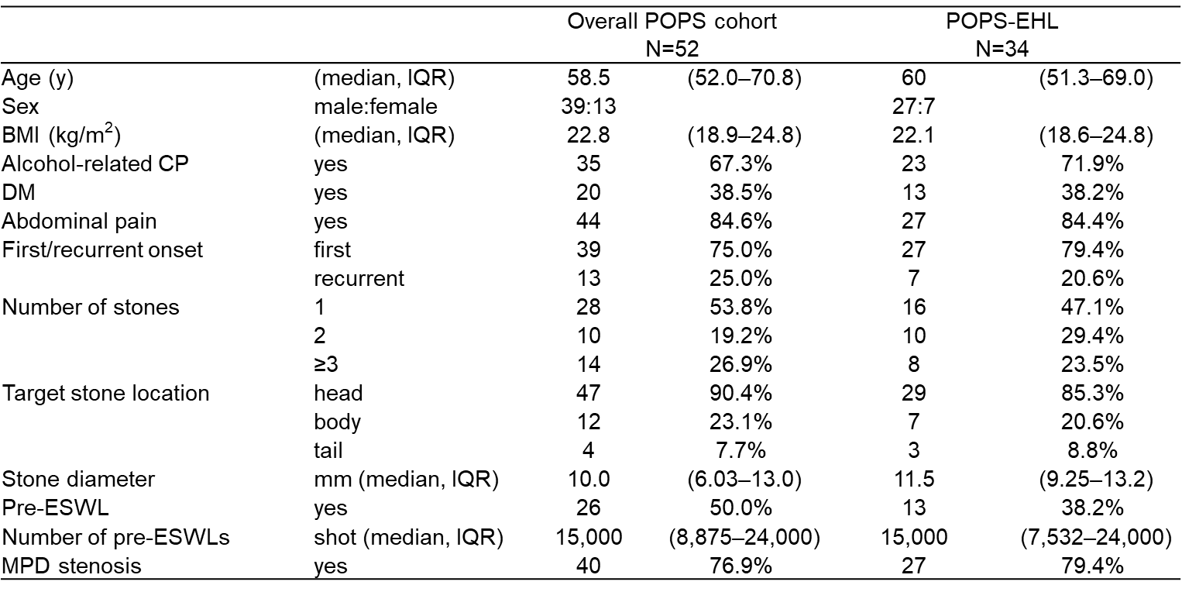
BMI, body mass index; CP, chronic pancreatitis; DM, diabetes mellitus; EHL, electrohydraulic lithotripsy; ESWL, extracorporeal shock wave lithotripsy; IQR, interquartile range; MPD, main pancreatic duct; POPS, peroral pancreatoscopy.

Table 2: POPS-EHL procedure details
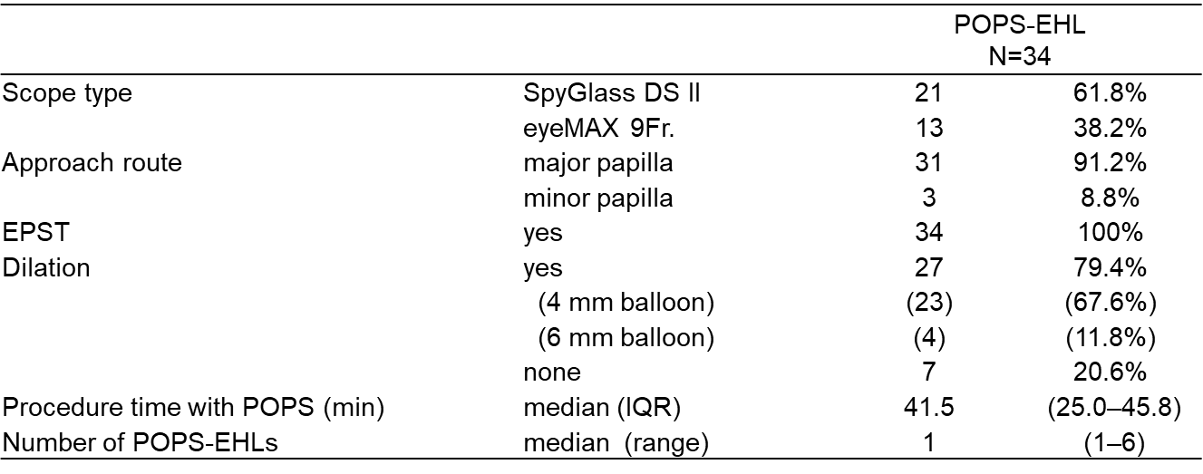
EHL, electrohydraulic lithotripsy; EPST, endoscopic pancreatic sphincterotomy; IQR, interquartile range; POPS, peroral pancreatoscopy.

Table 3: Factors associated with completed/incomplete-EHL
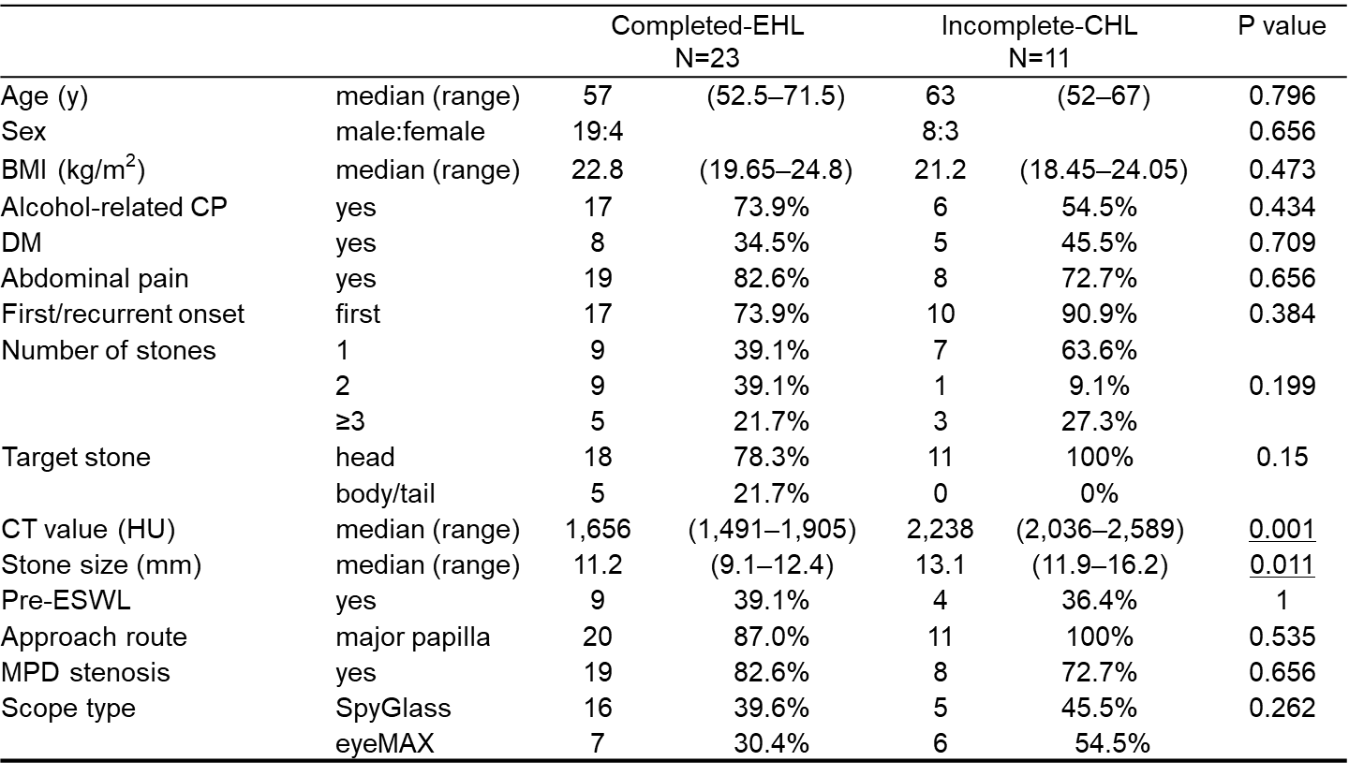
BMI, body mass index; CP, chronic pancreatitis; DM, diabetes mellitus; EHL, electrohydraulic lithotripsy; ESWL, extracorporeal shock wave lithotripsy; HU, Hounsfield units; MPD, main pancreatic duct.
Underlined values indicate statistically significant results.

Table 4: Factors Associated with incomplete-EHL: Univariate and Multivariate Analysis
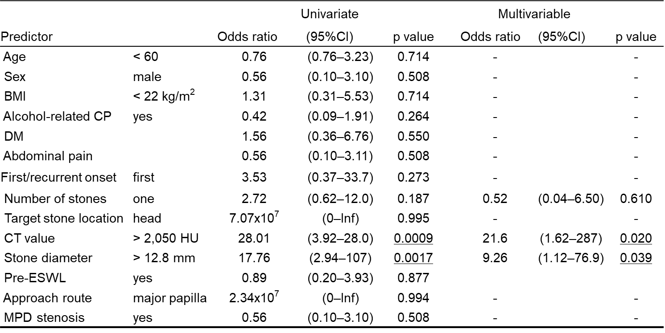
BMI, body mass index; CP, chronic pancreatitis; DM, diabetes mellitus; EHL, electrohydraulic lithotripsy; ESWL, extracorporeal shock wave lithotripsy; HU, Hounsfield units; MPD, main pancreatic duct; POPS, peroral pancreatoscopy. Underlined values indicate statistically significant results.
Table 5: Clinical outcomes
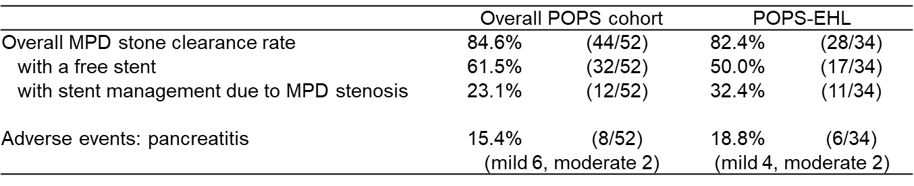
EHL, electrohydraulic lithotripsy; MPD, main pancreatic duct; POPS, peroral pancreatoscopy.

