Supporting material for
Effect of a short-term light stress on resistance, signaling, metabolism, and cell division of Ulva prolifera revealed by omics

Kai Gu^{1a}, Yuling Liu^{1a}, Ting Jiang¹, Chuner Cai^{1,2,3*},Hui Zhao¹, Xuanhong Liu¹, Peimin He^{1,2,3}

1 College of Marine Ecology and Environment, Shanghai Ocean University, Shanghai, China
2 National Demonstration Center for Experimental Fisheries Science Education (Shanghai Ocean University), Shanghai, China
3 Co-Innovation Center of Jiangsu Marine Bio-industry Technology, Lianyungang 222005, China

ªCo-first author: Kai Gu, Shanghai Ocean University, Shanghai, China-201306; Yuling Liu, Shanghai Ocean University, Shanghai, China-201306.
*Corresponding Author：Dr. Chuner Cai, College of Marine Ecology and Environment, Shanghai Ocean University, Shanghai, China-201306, Email:cecai@shou.edu.cn
Content

Tables
Table S1. Primer design of nine different genes
Table S2. QC data information statistics of transcriptome samples
Table S3. Statistics of transcriptome assembly results

Table S4. Statistics of lipid molecules with significant differences

Figures
Fig. S1. Gene annotation Venn diagram in transcriptome
Fig. S2. Volcano map of proteins expressed differently between groups in proteome
Fig. S3. Orthogonal partial least-squares discriminant analysis of cation group and anion group in metabolome, respectively

Fig. S4. Model displacement test chart of orthogonal partial least-squares discriminant analysis of cation group and anion group in metabolome, respectively.
Fig. S5. Statistical map of lipid subclasses and lipid molecule numbers
Fig. S6. Correlation analysis of lipid moleculars which was significant differences between the high-light treated group and the control group

Table S1. Primer design of nine different genes
Gene | Forward primer（5’-3’） | Reverse primer（5’-3’） | Length(bp)
18s rDNA | TGCCTAGTAAGCGCGAGTCA | AAACGATGGGCAGGGAAAC | 119
TRINITY_DN5118_c0_g1 | CTGACAACCTACCCATCCCC | CGTTTGTGGGCTTGCTGATG | 101
TRINITY_DN5090_c1_g6 | GCAGAACAACCGCACTGT | CCGACGTCTCCGAAATAGATG | 120
TRINITY_DN5143_c0_g2 | ACACCTTTCTTTACTTTAAACTGGT | AGCTAAATGATGGTGTGCTGT | 120
TRINITY_DN3918_c0_g1 | TGTGCGACAGGTGCAACAT | GGGAGCACATCAGGCTATTGA | 120
TRINITY_DN6178_c1_g6 | GTTCACCACGATCTTCCGCT | CCACTGTTTCAAGGGCATCG | 109
TRINITY_DN6515_c0_g5 | CTCCTTCAGCGCCTCATACT | CGTTCCACGCGTTTGCTC | 77
TRINITY_DN4211_c0_g1 | TCGGCGTTCAACAACATC | TTCCTCCTCCTGCTTCAGAG | 570
TRINITY_DN4291_c0_g1 | CAGAGAAGCTATCAACGCCA | CGAAGCTGGTCGAGTTCAAAAA | 78
TRINITY_DN4172_c0_g2 | GTATCCAGAGTTCCCGACCA | GCGCGACATACAATGACTTGG | 104
Table S2. QC data information statistics of transcriptome samples

 | A1 | A2 | A3 | C1 | C2 | C3
Total Reads Count(#) | 41327280 | 50009912 | 41377612 | 42682868 | 39023236 | 40460552
Total Bases Count(bp) | 5921667415 | 7183791842 | 5926713744 | 6133118947 | 5579132287 | 5831055701
Average Read Length(bp) | 143.29 | 143.65 | 143.23 | 143.69 | 142.97 | 144.12
Q30 Bases Count(bp) | 5710561628 | 6930427868 | 5718061370 | 5909513053 | 5382059322 | 5614990342
Q30 Bases Ratio(%) | 96.44% | 96.47% | 96.48% | 96.35% | 96.47% | 96.29%
GC Bases Count(bp) | 3529771433 | 4279597016 | 3545467511 | 3653070737 | 3351054782 | 3511594826
GC Bases Ratio(%) | 59.61% | 59.57% | 59.82% | 59.56% | 60.06% | 60.22%
Note:
Total Reads Count: the number of all reads in the sample
Total Base Count: the number of bases, i.e. the amount of data
Average Read Length：mean sequence length
Q30 Base Count: the number of bases whose quality is above 30
Q30 Base Ratio: the percentage of bases whose quality is above 30
GC Base Count: The number of GC base
GC Base Ratio: The percentage of GC base

Table S3. Statistics of transcriptome assembly results

 | No. | ≥500bp | ≥1000bp | N50 | N90 | Maximum length | Minimum length | Total length | Average length
Transcript | 108031 | 86318 | 75243 | 5355 | 1804 | 26903 | 201 | 339698065 | 3144.45
Unigene | 28362 | 13216 | 9470 | 3512 | 445 | 26903 | 201 | 39882047 | 1406.18
Note:

Transcript: Spliced transcript sequence.
Unigene: Unredundant spliced transcript sequence
N50/N90 is defined as the sequence of spliced transcripts from largest to smallest by length, with the length of the accumulated transcripts to the length of the spliced transcripts not less than 50%/90% of the total length.

Table S4. Statistics of lipid molecules with significant differences
Lipid Ion |  | Class | VIP |  | p-value | FC | RT-(min)
DGDG(16:4/18:4)+HCOO |  | DGDG | 1.26 |  | 0.008 | 3.01 | 6.56
MGDG(16:0/16:4)+HCOO |  | MGDG | 1.19 |  | 0.013 | 0.69 | 10.17
 | MGMG(16:1)+HCOO | MGMG | 3.44 |  | 0.014 | 0.60 | 2.82
MGMG(16:2)+HCOO |  | MGMG | 2.70 |  | 0.039 | 0.72 | 2.36
TG(18:4/16:0/18:3)+NH₄ |  | TG | 1.97 |  | 0.041 | 0.57 | 18.78

Fig. S1. Gene annotation Venn diagram in transcriptome
Venn diagram was used to reflect the commonality and specificity of different data sets. Different databases were represented in different colors, and the numbers represented the quantity of genes expressed specifically or in common. The overlap region represented the number of shared genes expressed in different databases, while the non-overlap region represented the number of unique genes expressed in different databases.

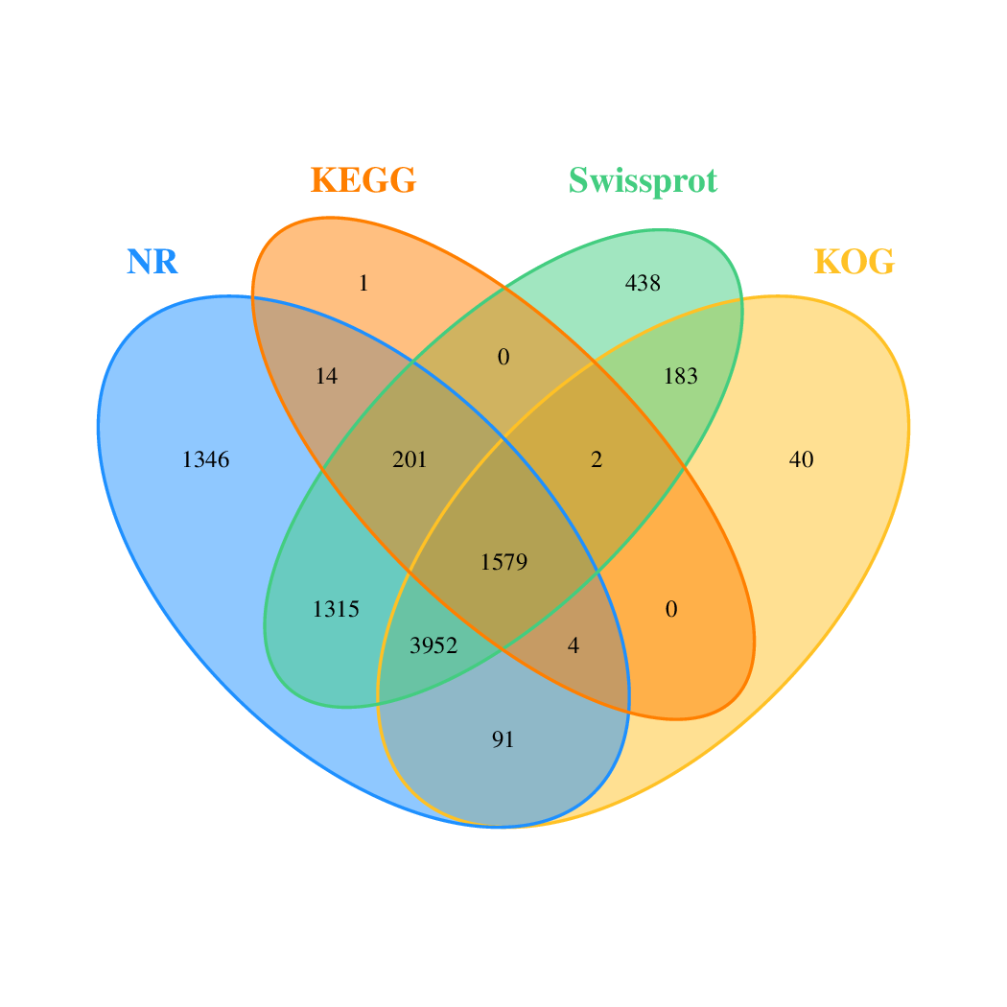
Fig. S2. Volcano map of proteins expressed differently between groups in proteome
The horizontal axis was the fold-change (log2 (ratio of T/C)) value of protein expression difference between samples of different groups, and the vertical axis was the -log10(p-value) representing the statistical significance of protein expression changes. Each dot represents a gene, with red representing the up-regulated gene, green the down-regulated gene, and brown the non-differential gene.
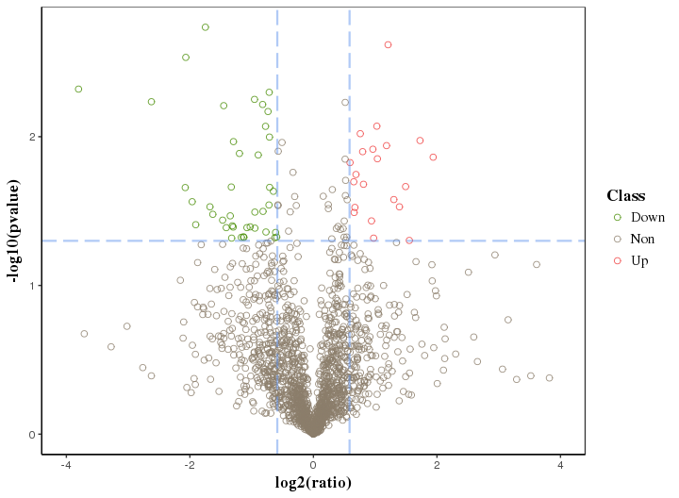

Fig. S3. Orthogonal partial least-squares discriminant analysis of cation group (A) and anion group (B) in metabolome, respectively
This method was modified on the basis of partial least squares discriminant analysis. The abscissa t[1] represented the principal component 1 (PC1), and the ordinate t[2] represented the principal component 2 (PC2). The map showed that each group could be well separated, and all within the confidence interval, there was a good separation trend between groups.
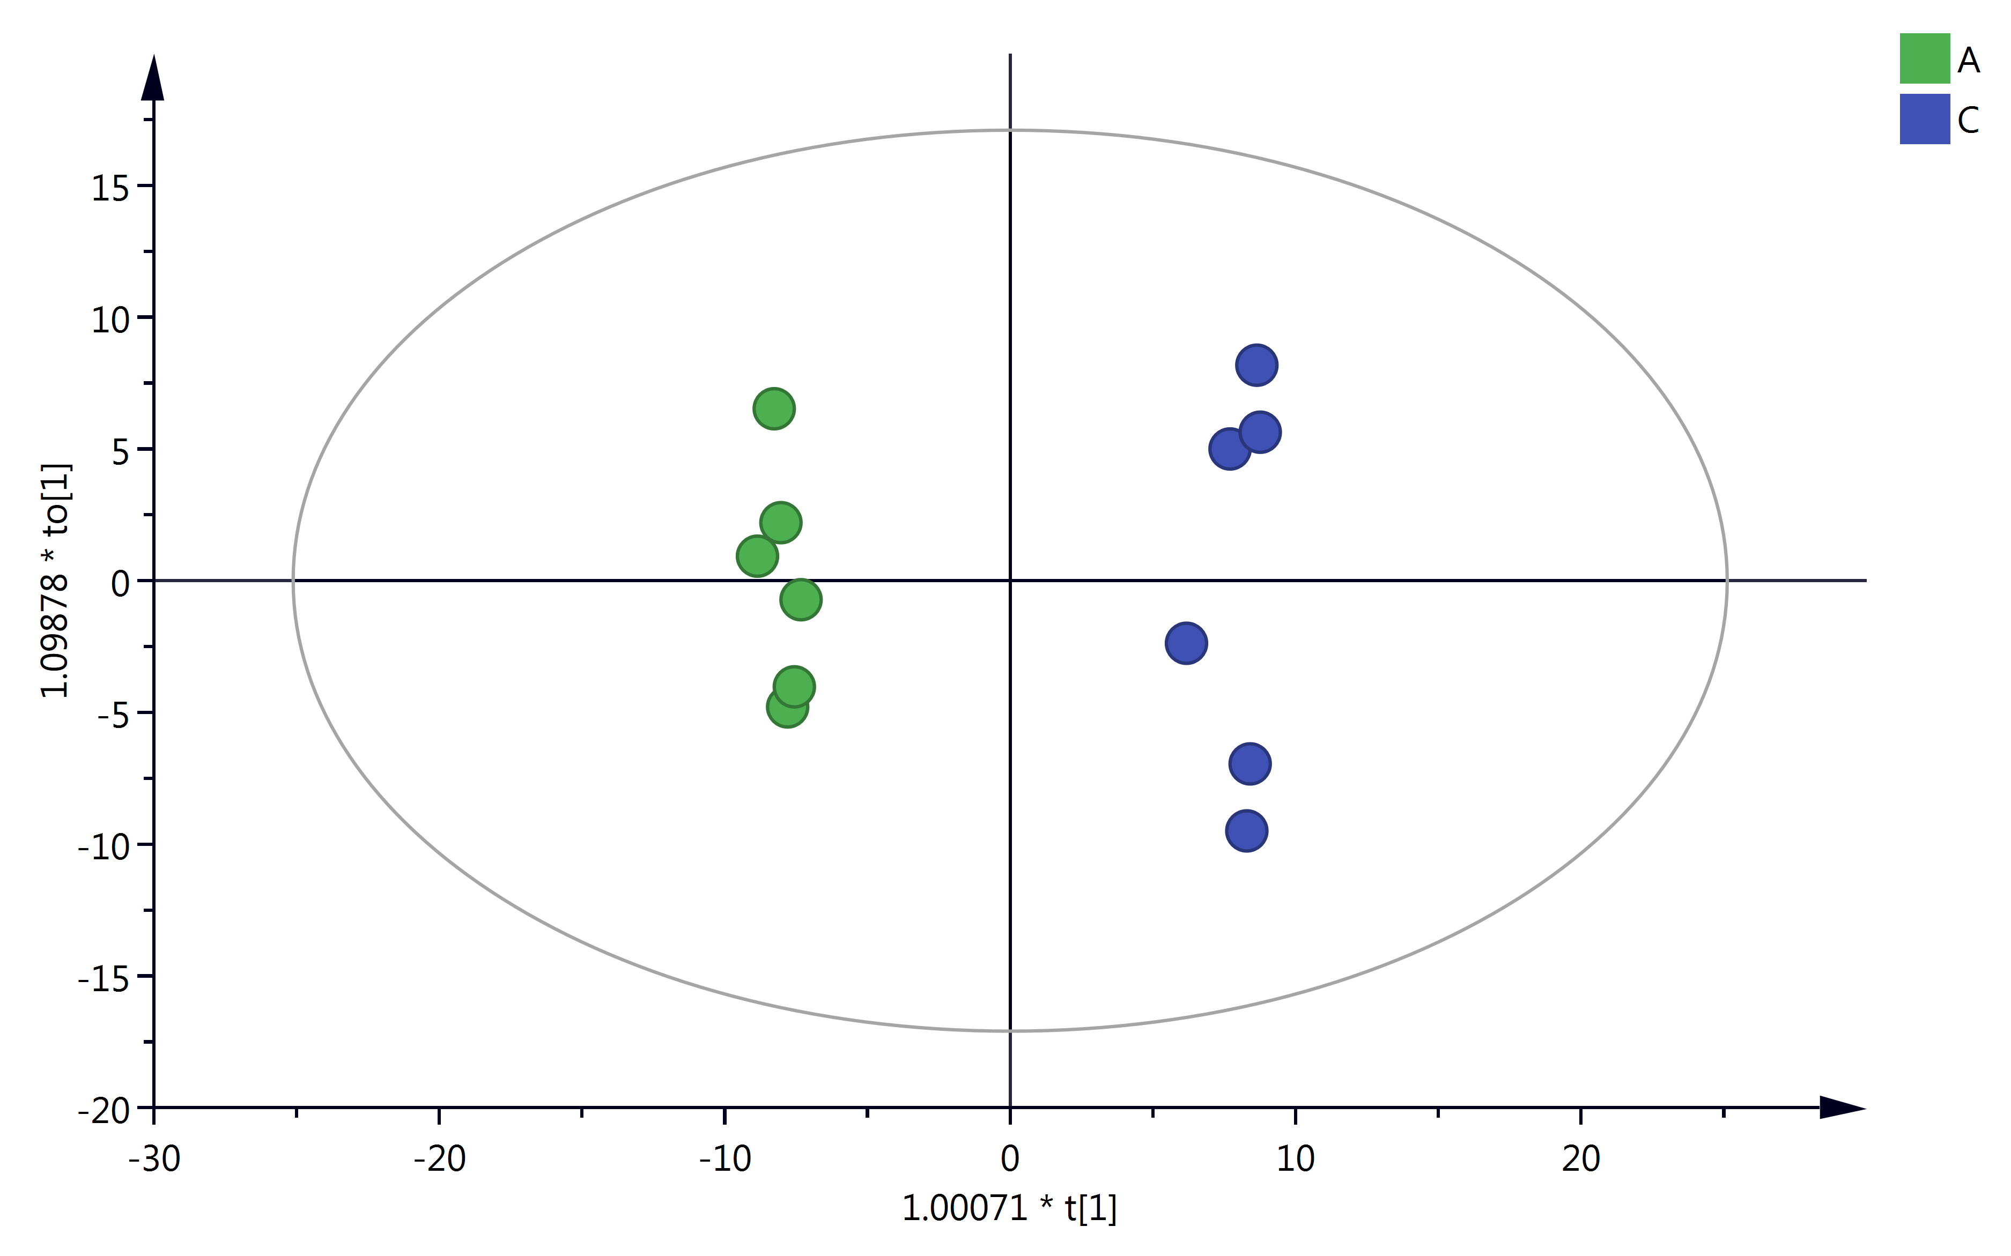
A
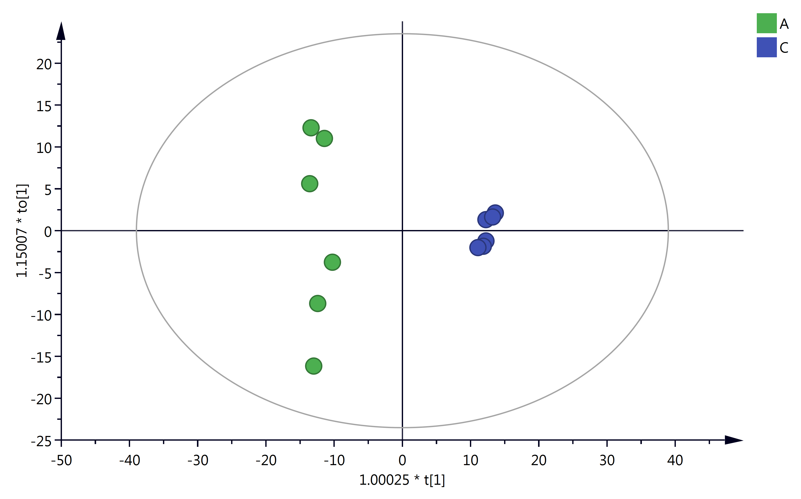
B
Fig. S4. Model displacement test chart of orthogonal partial least-squares discriminant analysis of cation group (A) and anion group (B) in metabolome, respectively
R2 represented the model interpretation rate (the ability of the model to reflect the differences between the two groups of samples or the ability of the model to correctly classify the samples). Q2 indicated the predictive ability of the model (the ability to effectively predict which category a new sample belongs to).
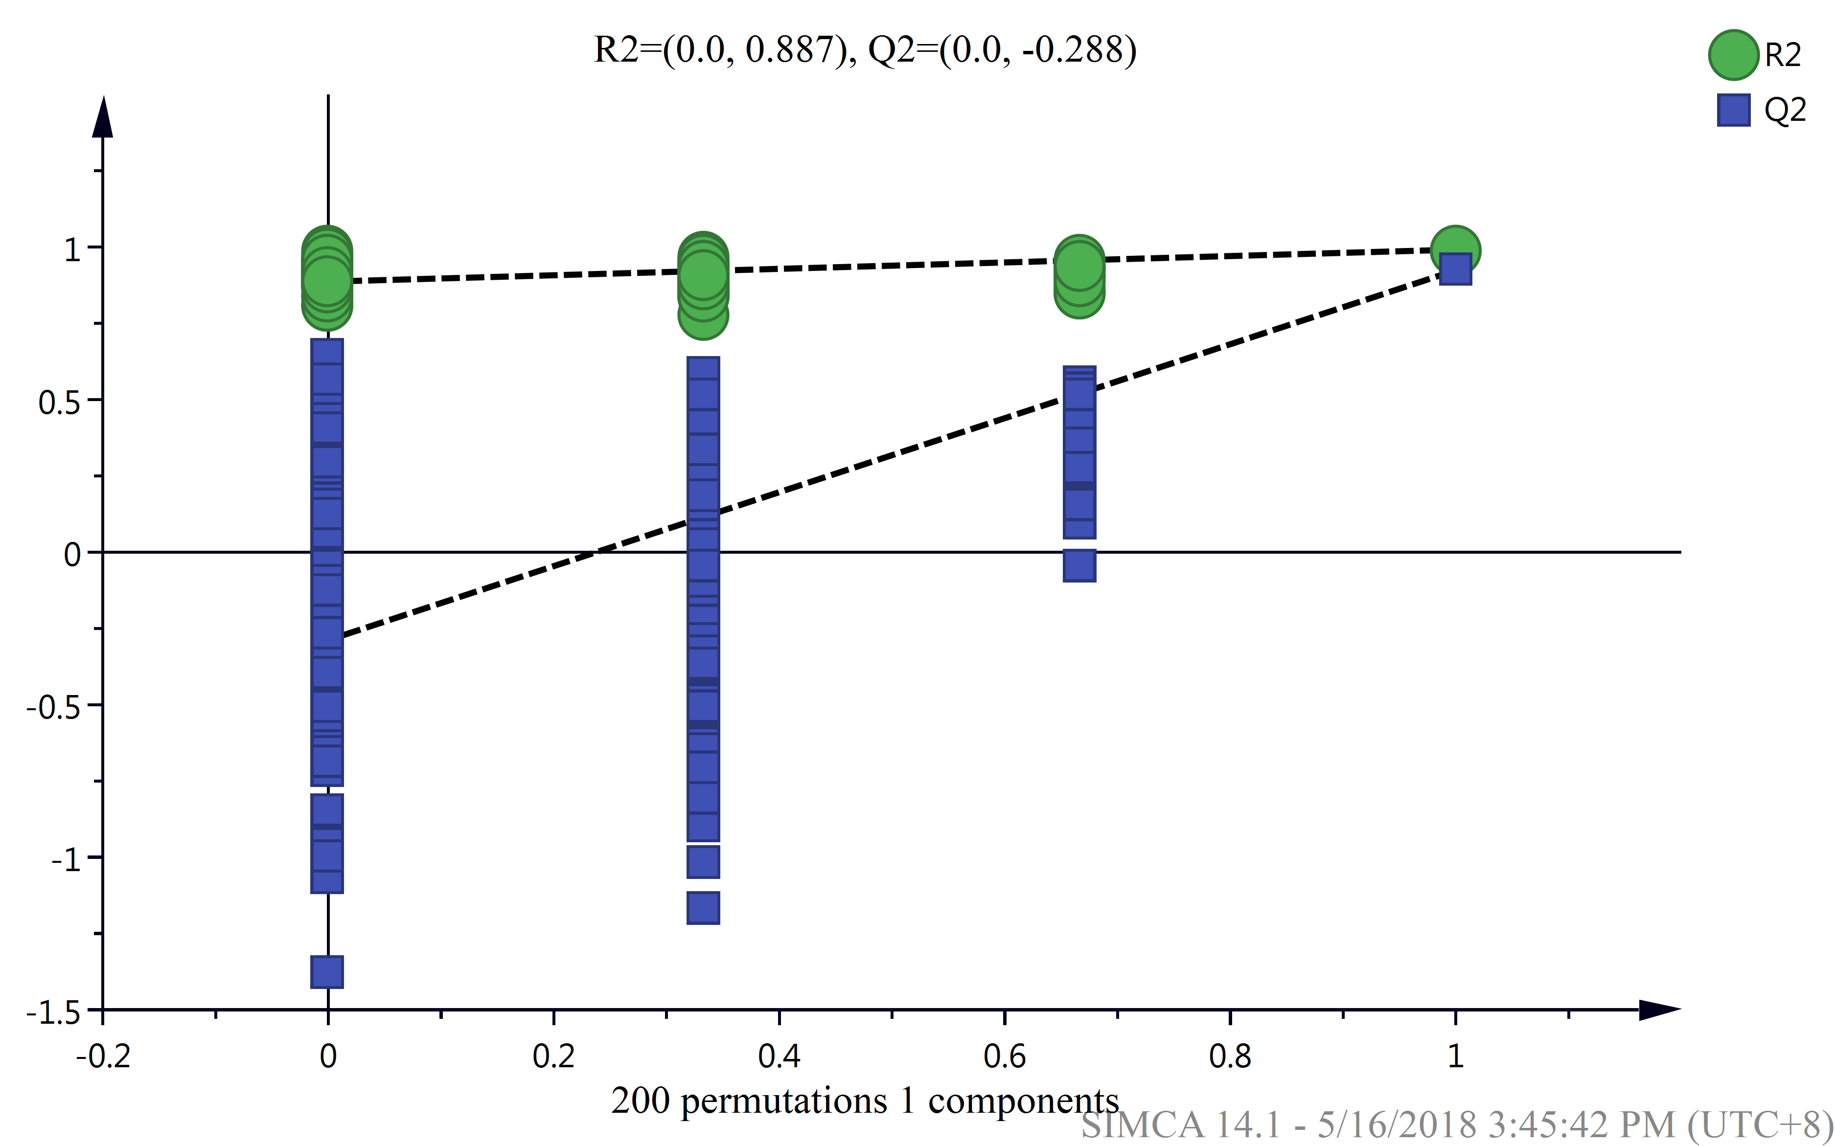
A
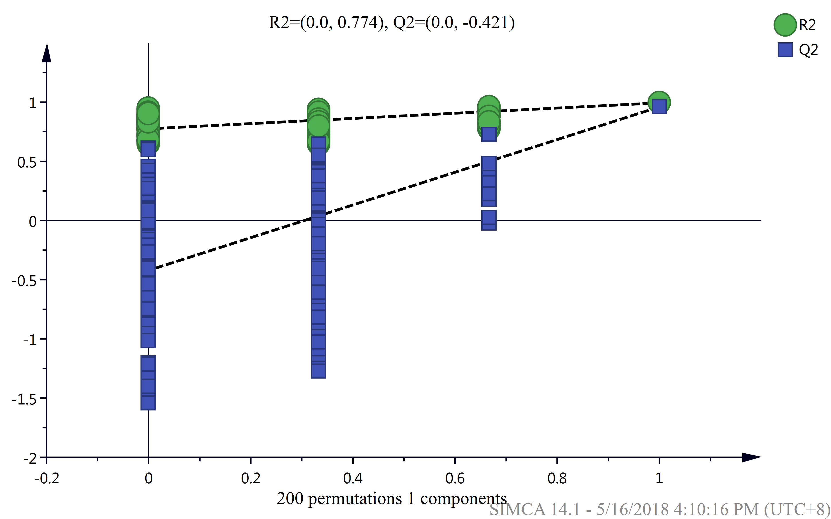
B

Fig. S5. Statistical map of lipid subclasses and lipid molecule numbers
Note: Cer: ceramides; CerG1: ceramidesglycerol 1; Co: colipase; DG: diacylglycerol; DGDG: di-galactosyl diacyl glycerol; DGMG: diacylglycerol monoacylglycerol; FA: fatty acids; LPG: lysophosphatidyl glycerol; MG: monoacylglycerol; MGDG: mono-galactosyl diacyl glycerol; MGMG: monogalactosyl monoacylglycerol; PA: phosphatidic acids ; PE: phosphatidylethanolamines; PG: phosphatidylglycerol; PI: phosphatidylinositols; PIP: phosphoinositides; PS: phosphatidylserines; So: sphingosine; SQDG: sulfoquinovosyl diacylglycerol; SQMG: sulfoquinovosyl monoglycerides; TG: triglyceride
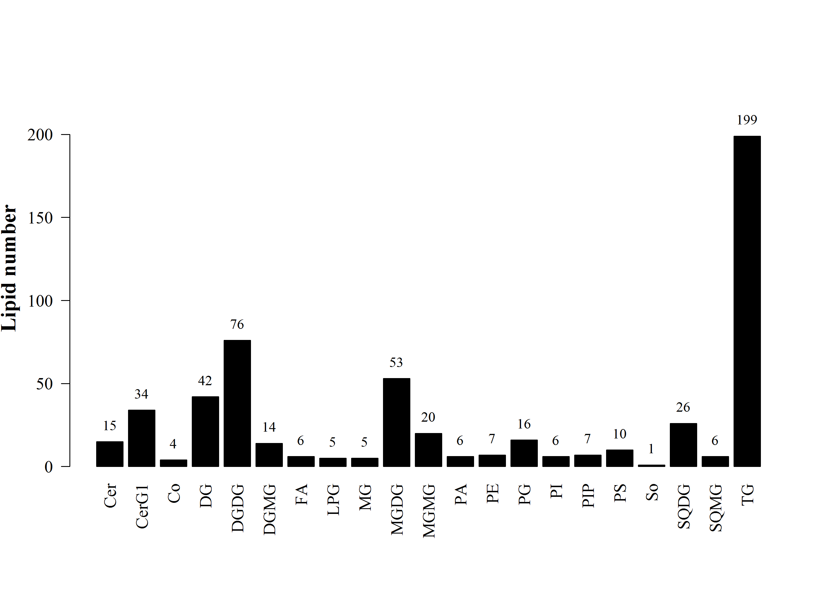

Fig. S6. Correlation analysis of lipid moleculars which was significant differences between the high-light treated group and the control group
Note: DGDG: digalactosyl; MGDG: monogalactosyl diacylglycerols; MGMG: monogalactosyl monoglycerides; TG: triacylglycerols

