Extended Data
Extended Data Figure 1. The homebrew Simoa planar array p24 ELISA. (A) SP-X image plate of a standard curve of HIV p24 from 2,000 to 0.128 pg/ml. (B) Standard curve analyzed using the SP-X analysis software. Upper limit of quantification (ULOQ), low limit of quantification (LLOQ) and low limit of detection (LOD) are indicated with horizontal lines. (C) ULOQ, LLOQ, LOD and regression line fit (R²) values for the standard curve indicated in (B). (D) Mean Intensity, % of the coefficient of variation (%CV) and % of recovery (%RE) for each of the standard curve concentrations shown in (B).

Extended Data Figure 2. Cross-comparison of the homebrew Simoa planar p24 ELISA immunoassay in diverse matrixes. (A) Compilation of the limit of detection (LOD) for each of the matrixes. NaCitrate plasma was above the upper limit of quantification (ULOQ) of the standard. (B) Compilation of the limit of quantification (LOQ) for each of the matrixes. NaCitrate plasma was above the upper limit of quantification of the standard. (C). Compilation of the light intensity (IV) units for each of the matrixes background in the absence of p24 protein. (D) Correlation of the IV units given by the background in each matrix and the LOD for that matrix, calculated using Pearson correlation. (E) Correlation of the IV units given by the background in each matrix and the LOQ for that matrix, calculated using Pearson correlation. (F) Correlation of LOD in each matrix and the LOQ for that matrix, calculated using Pearson correlation. NaCitrate plasma was removed of the analysis for D, E and F as the LOD and LOQ was unable to be calculated.
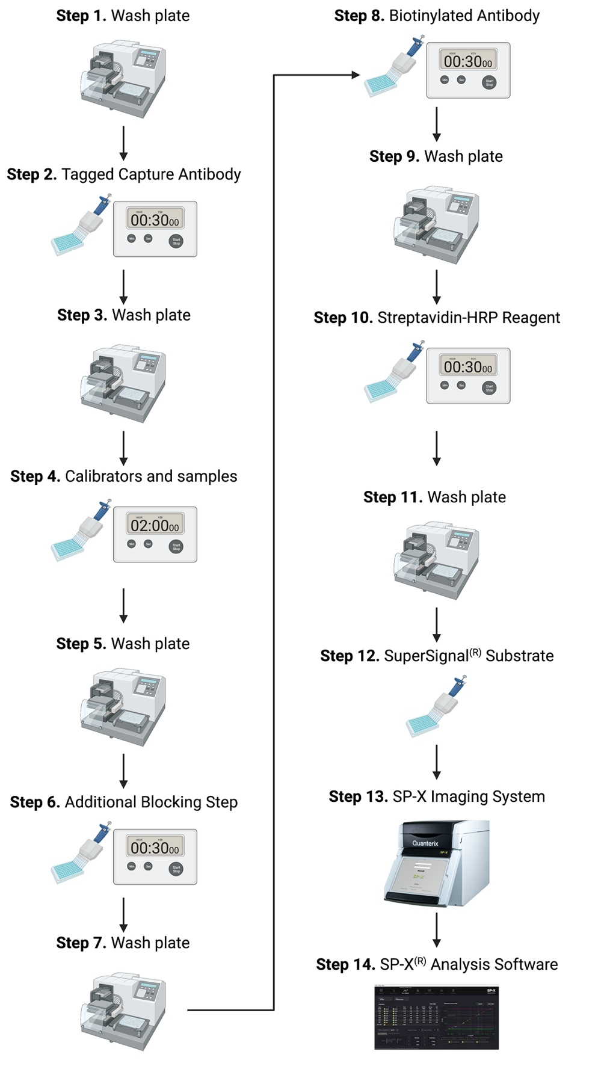
Extended Data Figure 3. Overview of the homebrew Simoa planar p24 ELISA immunoassay protocol. Created with Biorender.com
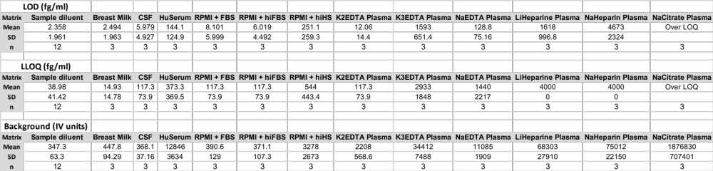
Extended Table I. Assay performance in diverse matrixes.

