Supporting Information

Supplementary Figures

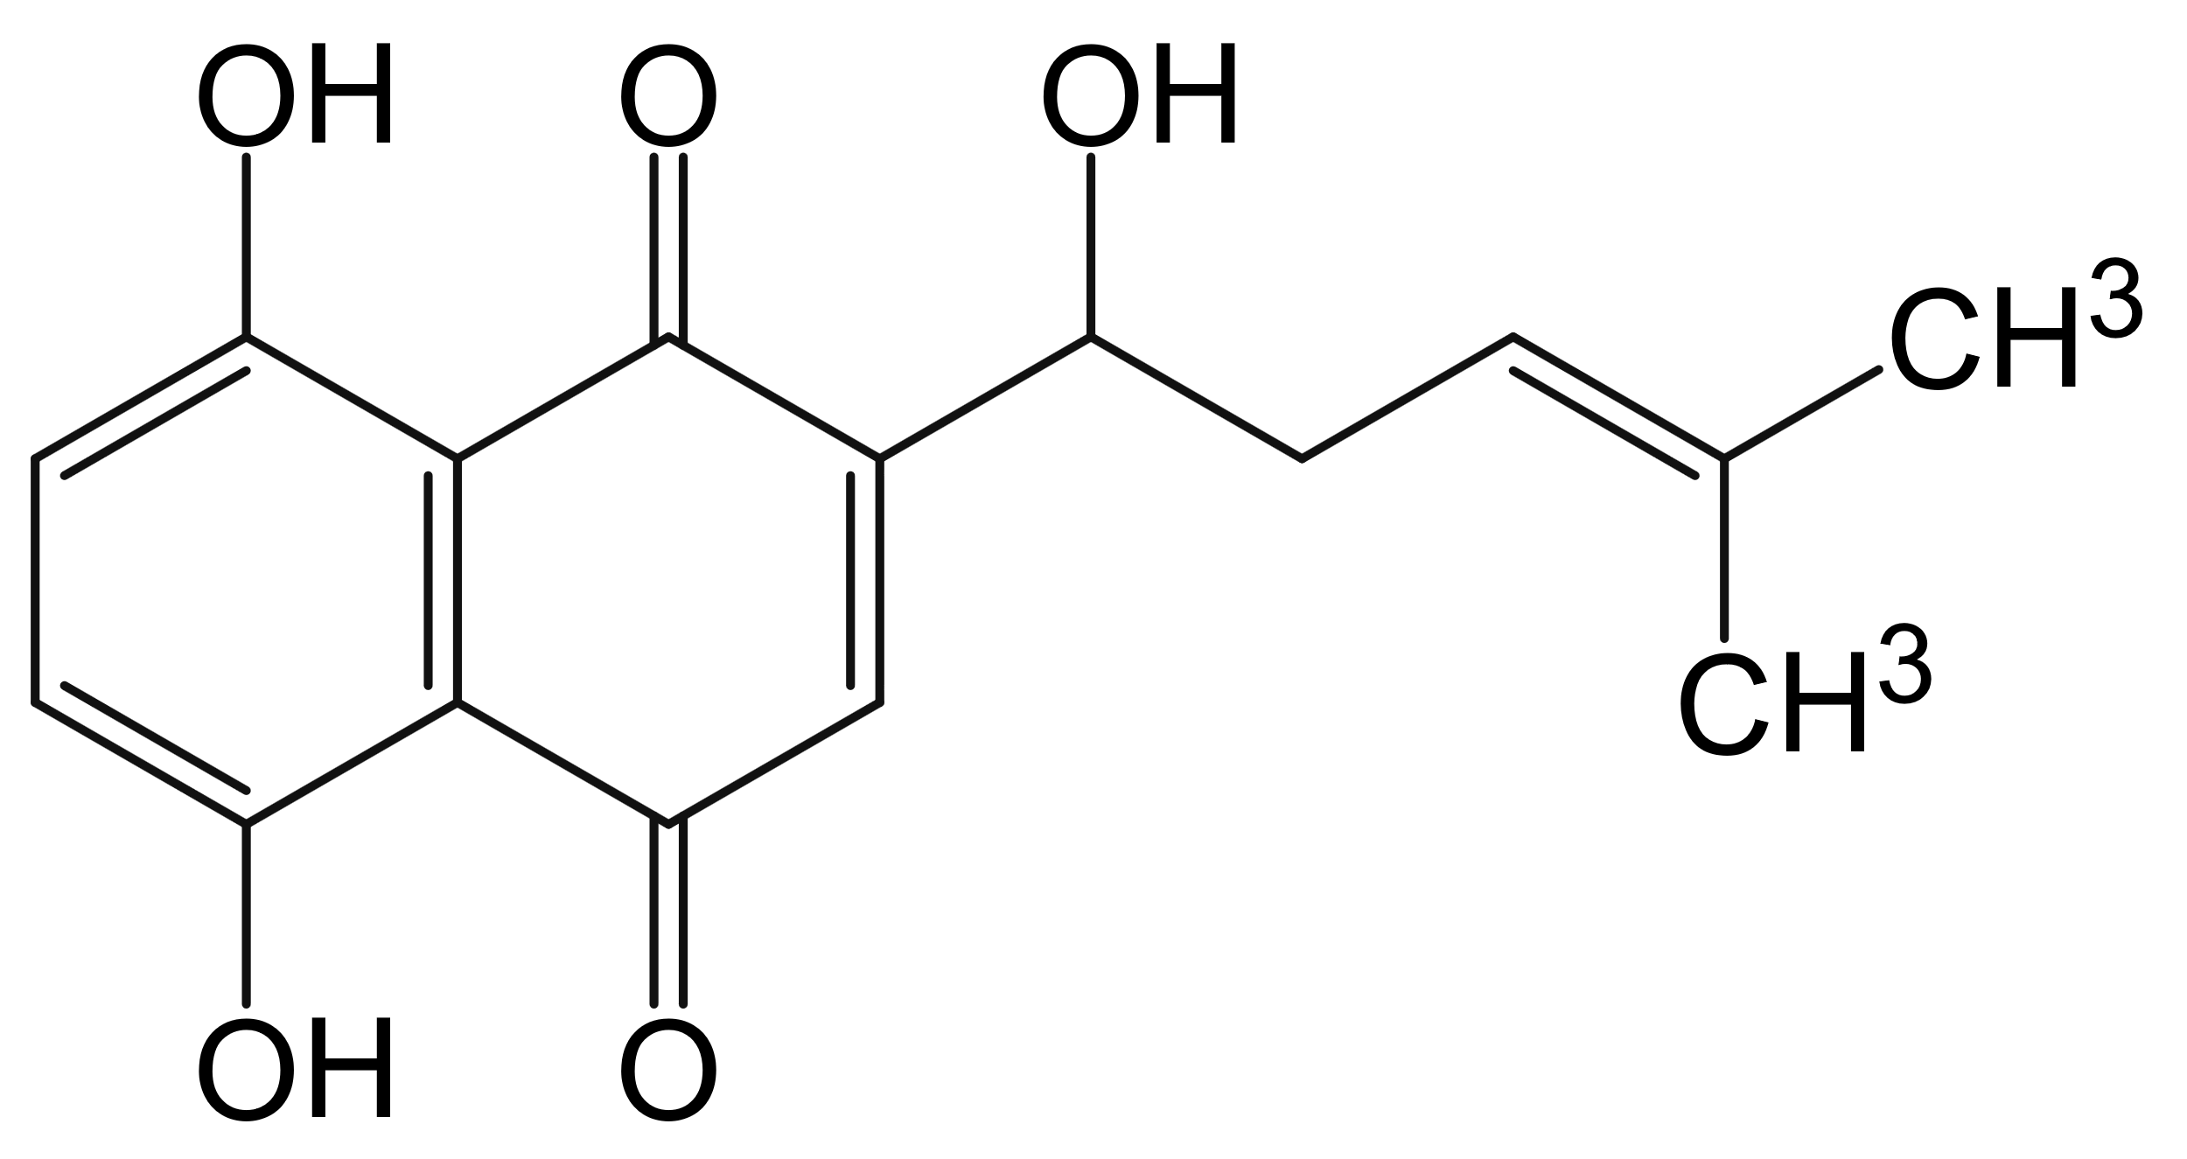
Figure 1. The chemical structure of shikonin. Shikonin features a naphthoquinone core. Structurally, it contains a 1,4-dihydroxy-2,5-dioxonaphthoquinone skeleton, with a side chain attached to the naphthoquinone ring. This side chain incorporates a hydroxyl group, an alkenyl chain (with a double bond), and two methyl groups bound to the terminal carbon of the alkenyl chain. For conciseness: Shikonin is composed of a 1,4-dihydroxy-2,5-dioxonaphthoquinone core linked to a side chain containing a hydroxyl group, an alkenyl moiety, and two methyl groups.

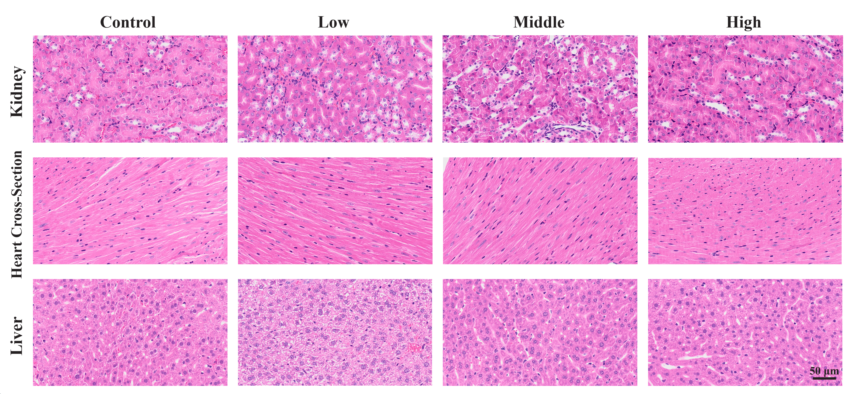
Figure 2. Toxicity assessment of SK in multiple organs. The figure displays H&E staining results of kidney, heart cross-section, and liver tissues from mice treated with control, low, medium, and high concentrations of SK. Histopathological analysis revealed no significant toxic alterations in any of the tested tissues, confirming the safety profile of SK.
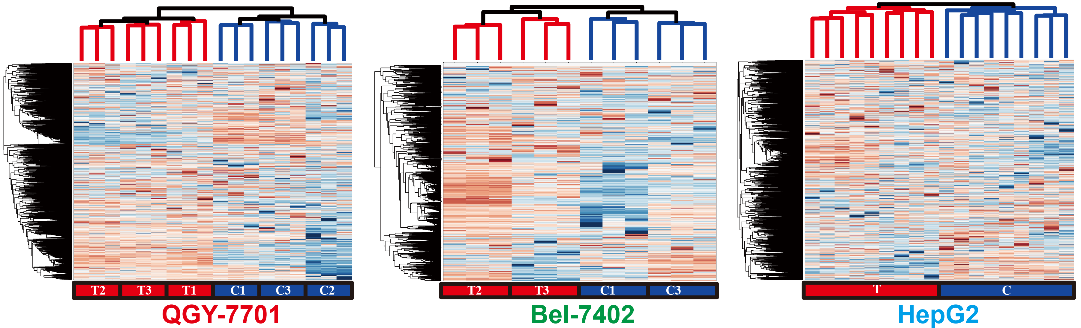
Figure 3. Hierarchical clustering of DIA proteome for three cancer cell lines. All biological replicates have been clustered together, and the reproducibility of the proteome is good enough to screen for more reliable DEPs.

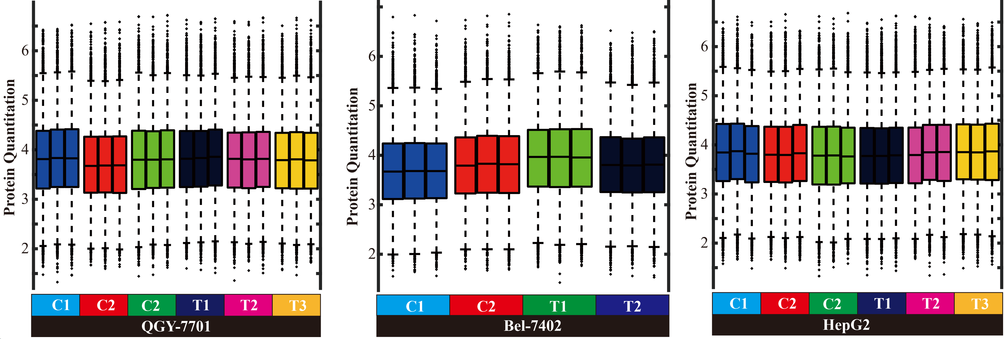
Figure 4. Boxplot of DIA proteome for three cancer cell lines. All biological replicates of the proteomic data are nearly identical.
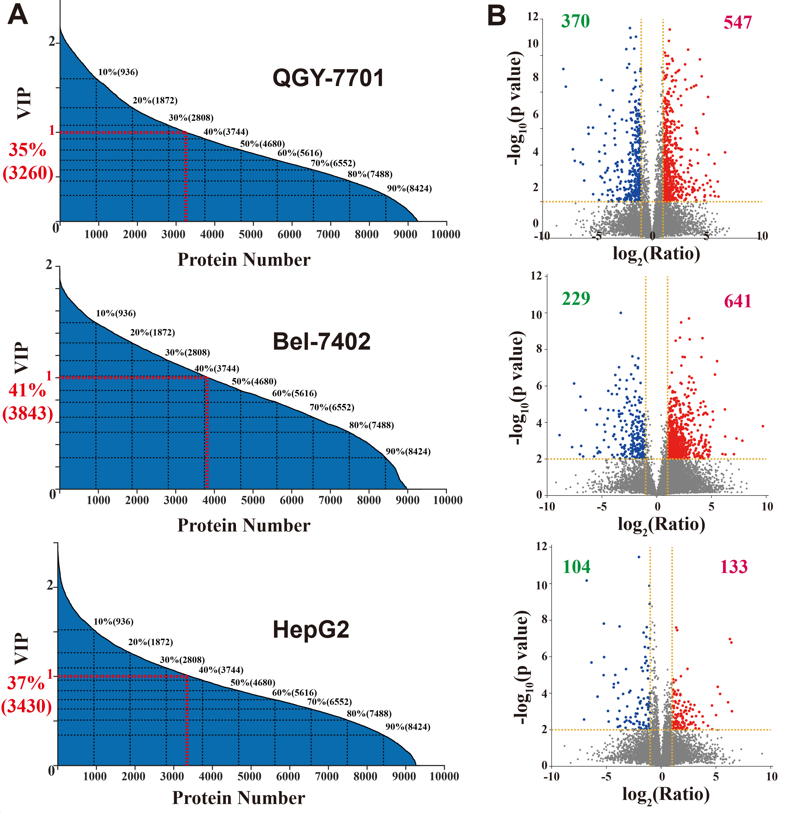
Figure 5. Screening results of DEPs for three cancer cell lines. DEPs were derived from overlap of OPLS-DA and Volcano plots.
- Distribution of VIP (Variable Importance in Projection) index derived from OPLS-DA (Orthogonal Partial Least Squares Discriminant Analysis). VIP index greater than 1 was highlighted with red lines.
- Volcano plots for the corresponding cell lines, with the red numbers indicating the number of upregulated proteins and the green numbers indicating the number of downregulated proteins.

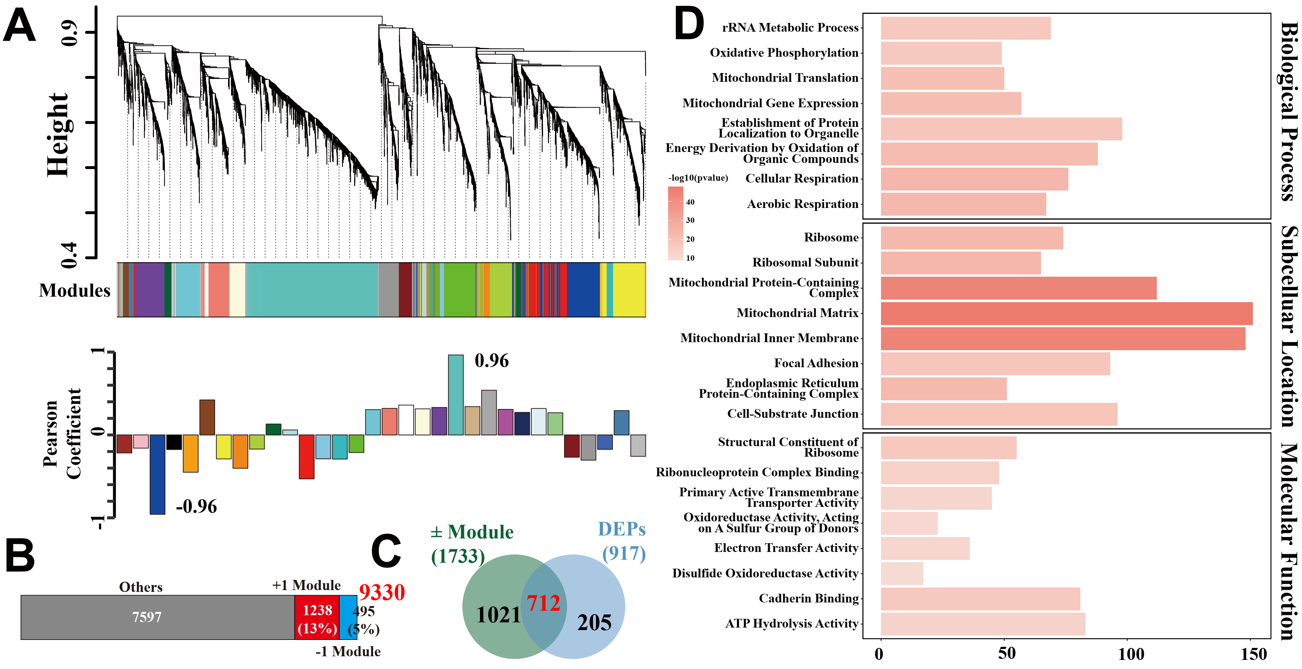
Figure 6. Functional enrichment analysis was performed on the protein list derived from consensus DEPs for QGY-7701 cell line.
- The figure depicts the results of WGCNA. The upper section shows a hierarchical clustering tree (dendrogram) of genes, with branches representing gene clusters. Genes were grouped into distinct modules, each assigned a unique color (displayed in the middle section, labeled "Modules"). The lower section illustrates the correlation analysis between modules and traits, presented via Pearson correlation coefficients. Positive/negative coefficients (ranging from -1 to 1) indicate the strength and direction of associations between modules and specific traits. The top positive and negative module were marked.
- This bar chart summarizes the gene count distribution across different modules. Notably, the top positive module (+1 Module) contained 1238 genes (accounting for 13.24%), while other modules collectively comprised 7597 genes.
- A Venn diagram visualizes the overlap between genes in the top positive and negative modules (1733 genes) and DEPs (917 genes). The intersection (consensus DEPs, 712 genes) represents genes simultaneously identified in both the top modules and DEP list.

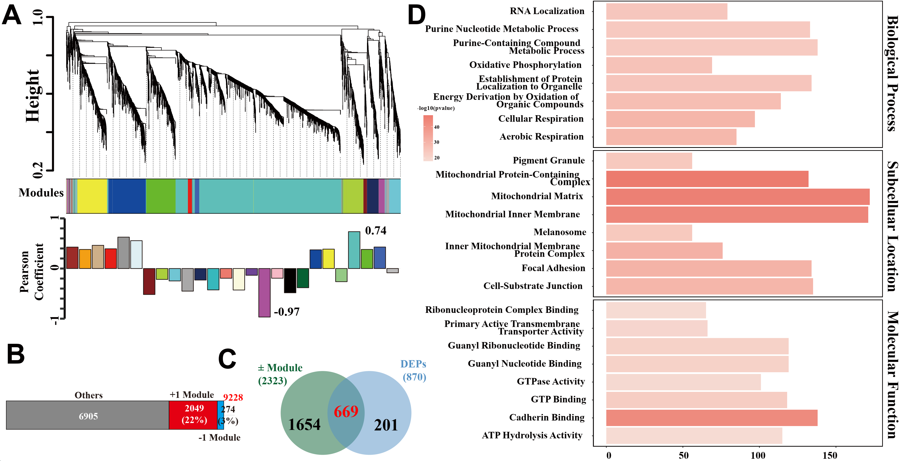
Figure 7. Functional enrichment analysis was performed on the protein list derived from consensus DEPs for Bel-7402 cell line.
- The figure depicts the results of WGCNA. The correlation coefficient of the top positive module was 0.74, while the top negative module was -0.97.
- This bar chart summarizes the gene count distribution across different modules. Notably, the top positive module contained 2049 genes (accounting for 22%), while other modules collectively comprised 6905 genes.
- A Venn diagram visualizes the overlap between genes in the top positive and negative modules (1654 genes) and DEPs (201 genes). The intersection (669 genes) represents genes simultaneously identified in both the top modules and DEP list.

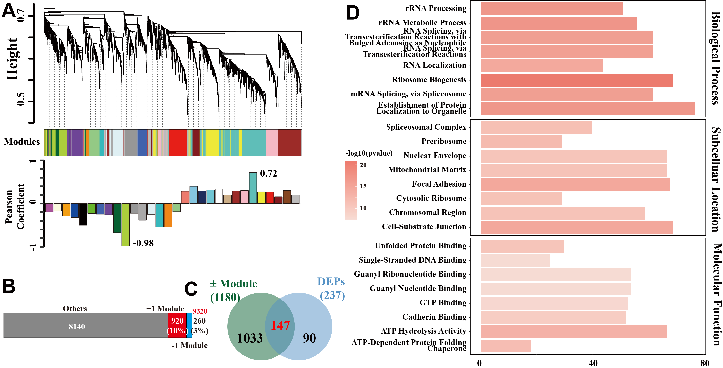
Figure 8. Functional enrichment analysis was performed on the protein list derived from consensus DEPs for HepG2 cell line.
- The figure depicts the results of WGCNA. The correlation coefficient of the top positive module was 0.72, while the top negative module was -0.98.
- This bar chart summarizes the gene count distribution across different modules. Notably, the top positive module contained 920 genes (accounting for 10%), while other modules collectively comprised 8140 genes.
- A Venn diagram visualizes the overlap between genes in the top positive and negative modules (1033 genes) and DEPs (90 genes). The intersection (147 genes) represents genes simultaneously identified in both the top modules and DEP list.

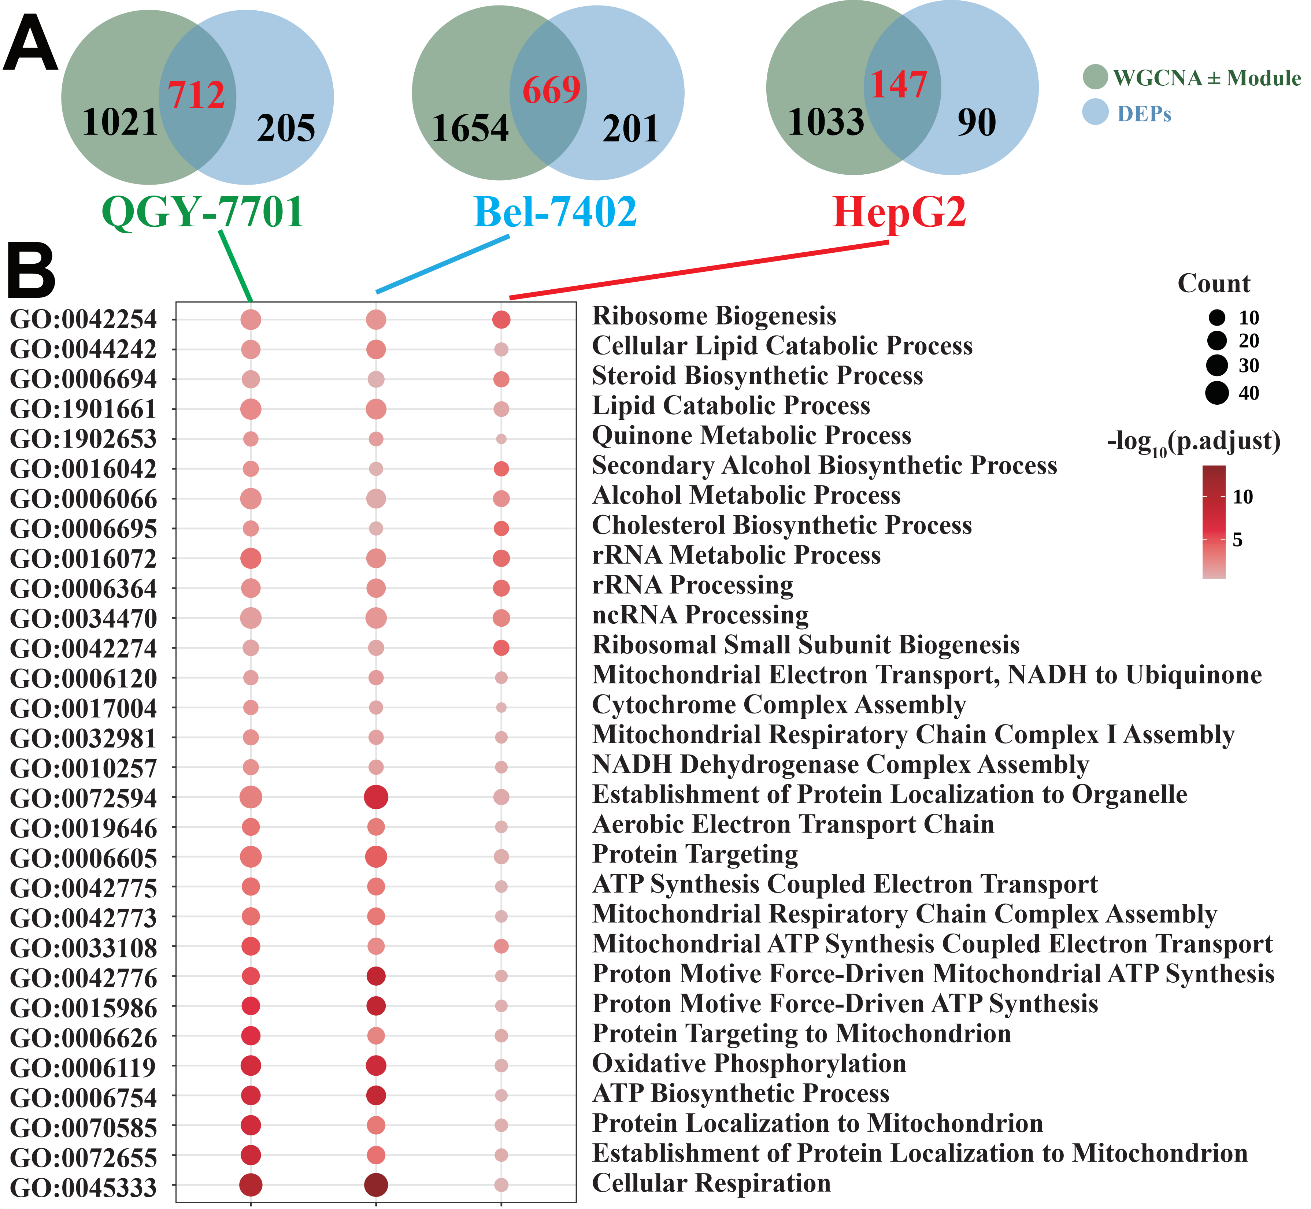
Figure 9. Functional enrichment analysis was performed on the protein list derived from consensus DEPs for three cancer cell line.
- The Venn diagram illustrates the quantitative overlap between the top-ranked positive and negative WGCNA and the consensus DEPs across the three cancer cell lines
- Dotplot of GO enrichment analysis across the three cancer cell lines. Mitochondrial related terms were significant enriched.

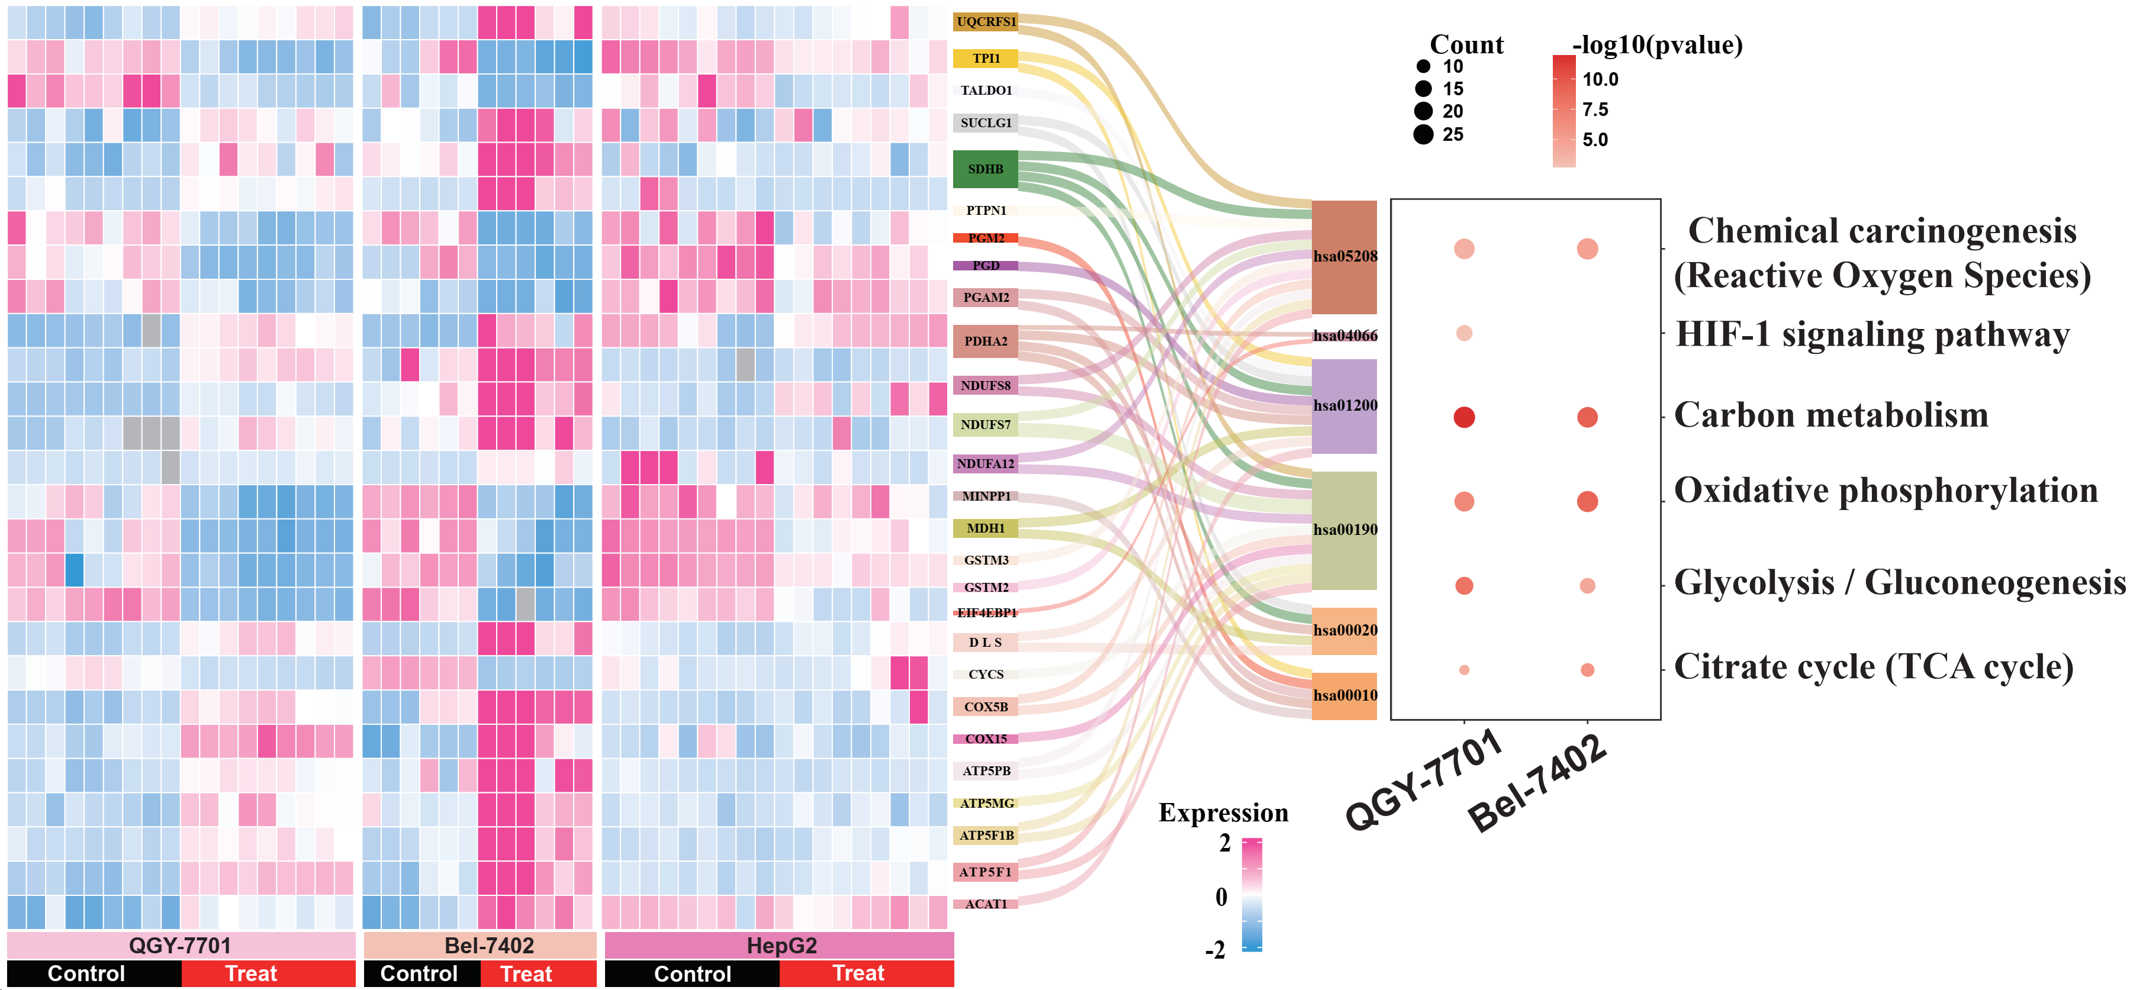
Figure 10. The top enriched KEGG pathways for DEPs of three cancer cell line. The left heatmap displays gene expression patterns across control versus treat groups in each cell line, with color gradients indicating expression levels. On the right, the bigger and colored dots represent significant enriched KEGG pathways, such as Chemical carcinogenesis (Reactive Oxygen Species), HIF-1 signaling pathway, carbon metabolism, oxidative phosphorylation, glycolysis/gluconeogenesis, and citrate cycle (TCA cycle) are enriched.

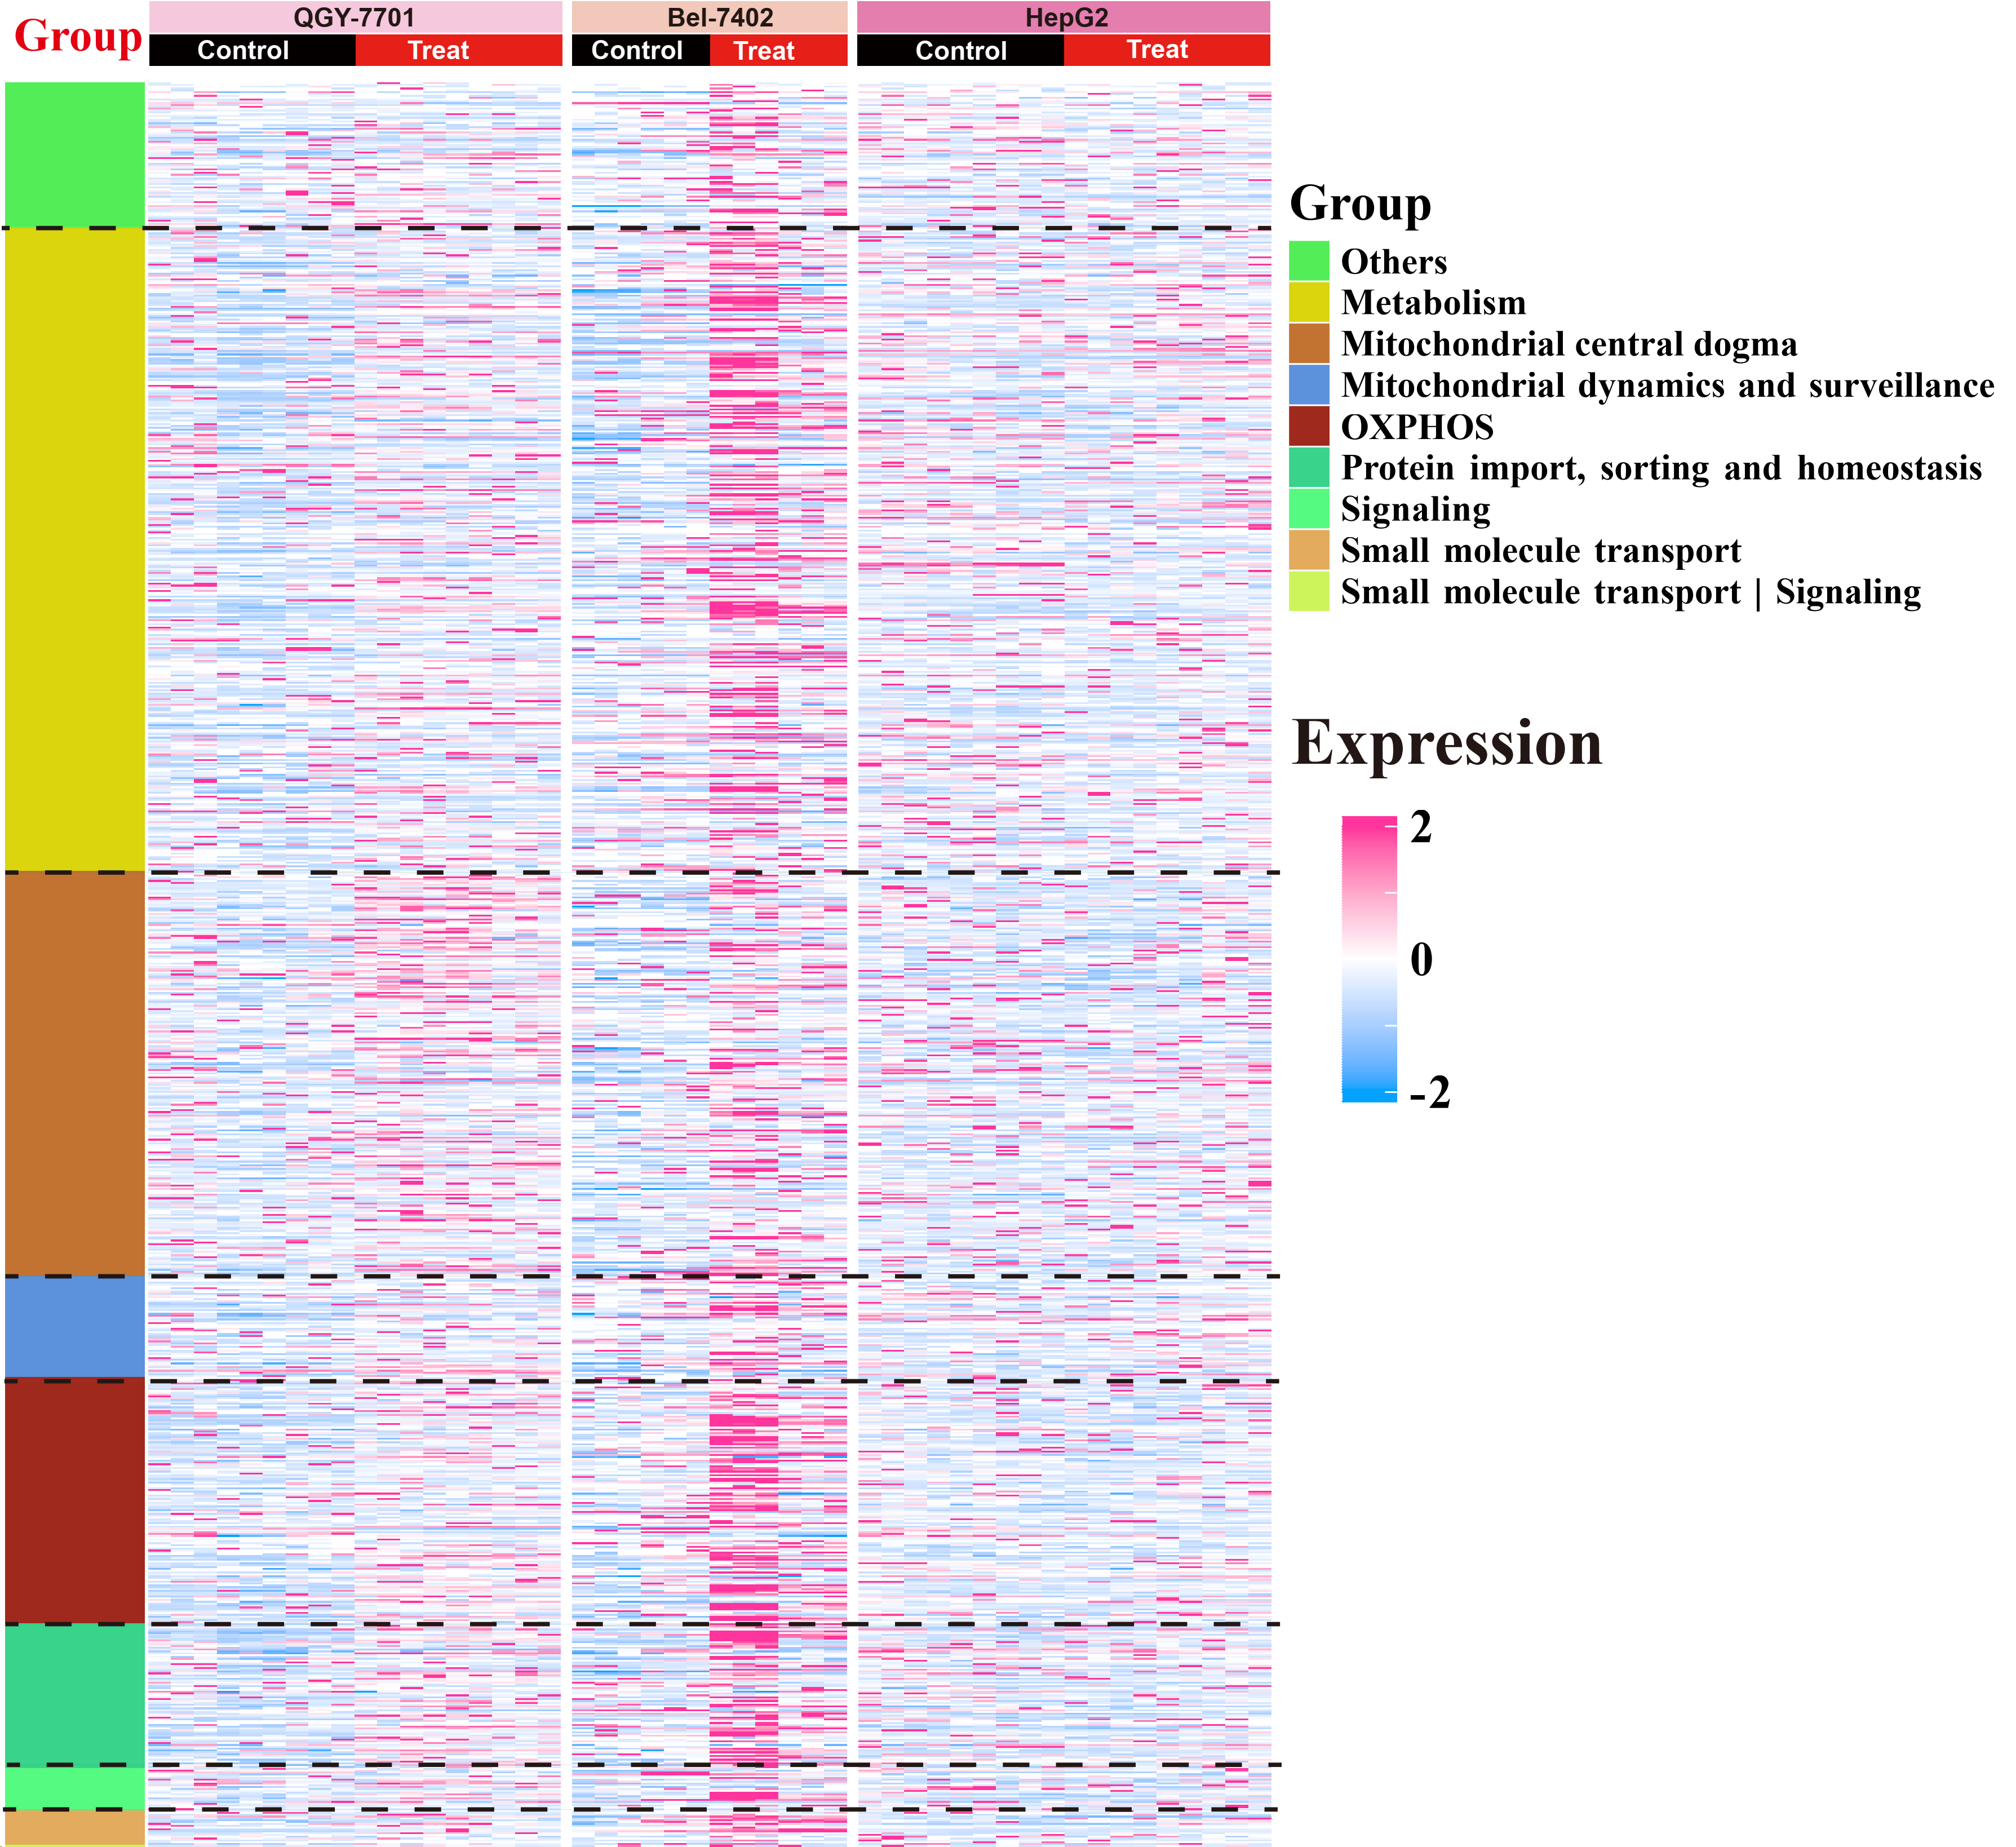
Figure 11. Survey of mitochondrial related DEPs by MitoCarta 3.0. This heatmap displays the protein expression profiles in three cancer cell lines across control and treat groups. Each row corresponds to a protein, with expression levels visualized via a color scale. Mitochondrial related DEPs were divided into 9 groups: Metabolism, Mitochondrial central dogma, Mitochondrial dynamics and surveillance, OXPHOS, Protein import, sorting and homeostasis, Signaling, Small molecule transport, and a combined small molecule transport with signaling group. The black lines separated each group. In the Bel-7402 cell line, a significant upregulation of protein expression was observed in the treatment group compared to the control group.

Supplementary Tables

Table 1. Nine DEPs with differential expression in three liver cancer cells
ID | ProteinName | GeneName | Location | Regulated | Type | Prognostic marker
S2512_HUMAN | Calcium-binding mitochondrial carrier protein Aralar1 | SLC25A12 | Mitochondrion | up | Transporter | renal cancer (favorable) and endometrial cancer (unfavorable)
MIA40_HUMAN | Mitochondrial intermembrane space import and assembly protein 40 | CHCHD4 | Mitochondrion | down | Enzyme | renal cancer (favorable)
NDUS7_HUMAN | NADH dehydrogenase [ubiquinone] iron-sulfur protein 7, mitochondrial | NDUFS7 | Mitochondrion | up | Enzyme | renal cancer (favorable) and cervical cancer (favorable)
CENPV_HUMAN | Centromere protein V | CENPV | Nucleus | up | Other | Gene product is not prognostic
TR112_HUMAN | Multifunctional methyltransferase subunit TRM112-like protein | TRMT112 | Nucleus | up | Enzyme | head and neck cancer (unfavorable) and renal cancer (unfavorable)
UB2V1_HUMAN | Ubiquitin-conjugating enzyme E2 variant 1 | UBE2V1 | Nucleus | down | Transcription Regulator | renal cancer (unfavorable)
GP180_HUMAN | Integral membrane protein GPR180 | GPR180 | Membrane | up | Other | renal cancer (unfavorable)
YIF1A_HUMAN | Protein YIF1A | YIF1A | Membrane | up | Other | urothelial cancer (unfavorable)
ACTS_HUMAN | Actin, alpha skeletal muscle | ACTA1 | Cytoskeleton | down | Other | Gene product is not prognostic

