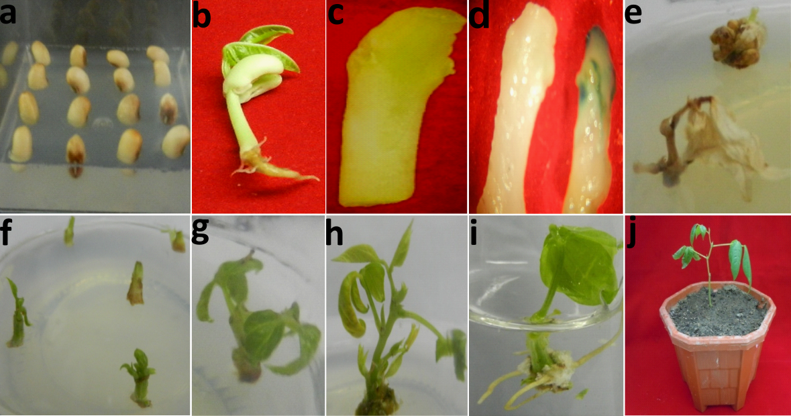
SI Figure 1: Stages of cowpea (Vigna unguiculata) cv. PUSA KOMAL through Agrobacterium-mediated transformation a. Cowpea seeds in germination media b. Four days old cowpea seedling c. Cotyledonary node explants at the time of culture d. Transient gus expression in control (left) and transformed cotyledonary node (right) explants after 3 days of co-cultivation e. Control explants cultured on selection media f. Selection of transformed explants on selection media g. Shoot proliferation from explant in subsequent subculture h. Elongation of shoot within 4 week of culture i. In vitro rooting of selected shoot j. Plant hardened and maintained in transgenic green house.
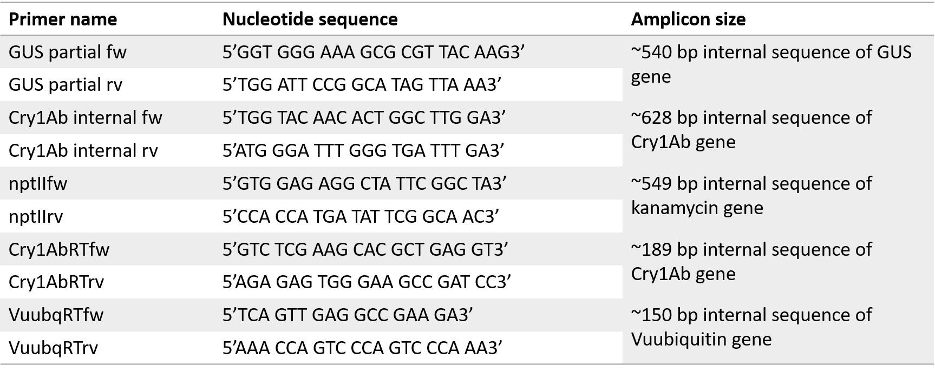
SI table 1. Primers used in our study.
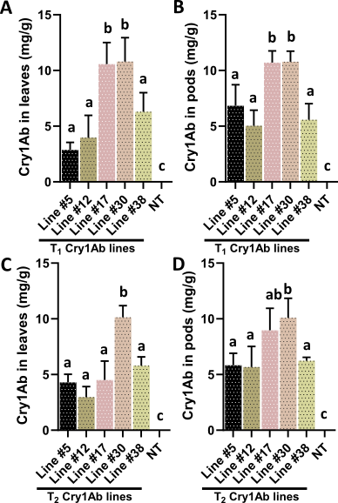
SI Figure 2. Quantitative estimation of Cry1Ab protein in T₁ and T₂ transgenic leaves (Line #5-38) (A, C), pods (Line #5-38) and non-transgenics (NT) (B, D) using Cry1Ab-enzyme conjugate. Average quantity of total Bt-Cry protein of the transgenics is represented as mg g⁻¹ TSP. Bars represent mean values ± standard deviation (SD) from n=3 biological replicates. Statistical significance was determined using one-way ANOVA followed by Tukey’s multiple comparison test in GraphPad Prism 8.0. Bars shares at least one common letter (a, b and c) are not significantly different from each other (P> 0.05), while bars labelled with different letters indicate statistically significant differences (P< 0.05).
SI Figure 3. Representative ¹H-NMR spectra obtained at 600 MHz from cowpea pods expressing cry1Ab are provided. The Aliphatic, carbohydrate, and aromatic regions within the spectra are highlighted. The individual compounds present in these regions are marked and shown.

SN | Metabolites | Chemical shifts (ppm) | Multiplicity
1 | Leucine | 0.96 | d
2 | Valine | 0.99 | d
3 | Isoleucine | 1.01 | m
4 | Lactate | 1.33 | d
5 | Threonine | 1.42 | dd
6 | Alanine | 1.47 | d
7 | Arginine | 1.91 | dd
8 | Glutamate | 2.08 | m
9 | Glutamine | 2.12 | m
10 | Proline | 3.33 | m
11 | Methionine | 3.99 | s
12 | 4-Aminobutyrate | 3.01 | d
13 | succinylacetone | 3.85 | s
14 | Isocitrate | 4.05 | s
15 | N-Carbomylaspartate | 4.22 | d
16 | Trans-4-Hydroxyl-L-Proline | 3.47 | dd
17 | Citrate | 2.49 | d
18 | Asparagine | 2.94 | dd
19 | Aspartate | 3.89 | dd
20 | Malate | 4.34 | d
21 | Cysteine | 3.98 | m
22 | Xylose | 3.52 | m
23 | Glucose | 4.64 | m
24 | Maltose | 4.65 | m
25 | Methanol | 3.35 | s
26 | Mannose | 3.57 | m
27 | Glucose-1-Phosphate | 3.36 | m
28 | Cellobiose | 3.96 | m
29 | S-Sulfocysteine | 4.17 | dd
30 | Galactose | 3.98 | m
31 | Glucose-6-Phosphate | 3.6 | m
32 | Arabinose | 3.78 | m
33 | Fructose | 4.05 | m
34 | Ribose | 4.21 | m
35 | Mannitol | 3.86 | dd
36 | Sucrose | 5.41 | d
37 | Ascorbate | 4.01 | m
38 | 2-Phosphoglycerate | 4.47 | m
39 | Betaine | 3.27 | s
40 | O-Phosphoserine | 4.18 | m

SI Table 2: Identification of metabolites in the pods of both transgenic and non-transgenic cowpea expressing cry1Ab with their chemical shift and multiplicity.
SI Figure 4: Top 30 metabolites (variables) present in transgenics (line #5:TR1, line #12:TR2, line #17:TR3, line #30:TR4, and line #38:TR5) and non-transgenic (WT) based on VIP score.

