Supplementary Information
Control of zeolite local microenvironment by organofluorination engineering toward efficient c-C₄F₈/C₃F₈ separation
Rui Sun^{1,2,‡}, Zicheng Wan^{1,‡}, Yaqi Wu*¹, Yaohan Fu¹, Yang Zhang¹, Chenyang Yang¹, Heng Zhao*², Ziqi Tian*¹ and Liang Chen*¹

¹Materials Tech Laboratory for Hydrogen & Energy Storage, Zhejiang Key Laboratory of Advanced Fuel Cells and Electrolyzers Technology, Ningbo Institute of Materials Technology and Engineering, Chinese Academy of Sciences, Ningbo, Zhejiang 315201, P. R. China
²College of Engineering, Eastern Institute of Technology, Ningbo, Zhejiang, 315200, P. R. China

‡ The authors contributed equally to this work.
*Corresponding authors.
*E-mail addresses: wuyaqi@nimte.ac.cn (Y. Wu), tianziqi@nimte.ac.cn (Z. Tian), hzhao@eitech.edu.cn (H. Zhao), and chenliang@nimte.ac.cn (L. Chen)

Table of Contents
1. Supplementary Figures 1
2. Supplementary Tables 14
3. References 17

1. Supplementary Figures
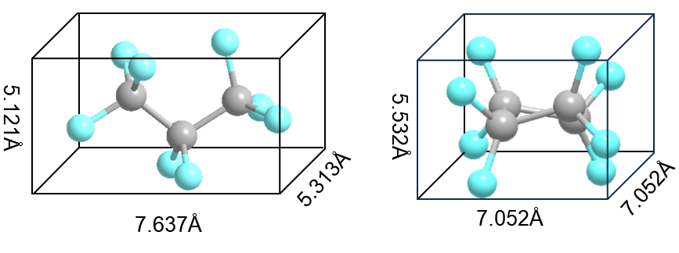
Supplementary Fig. 1. Molecular dimensions of C₃F₈ and c-C₄F₈. The unit of length is angstrom (Å).
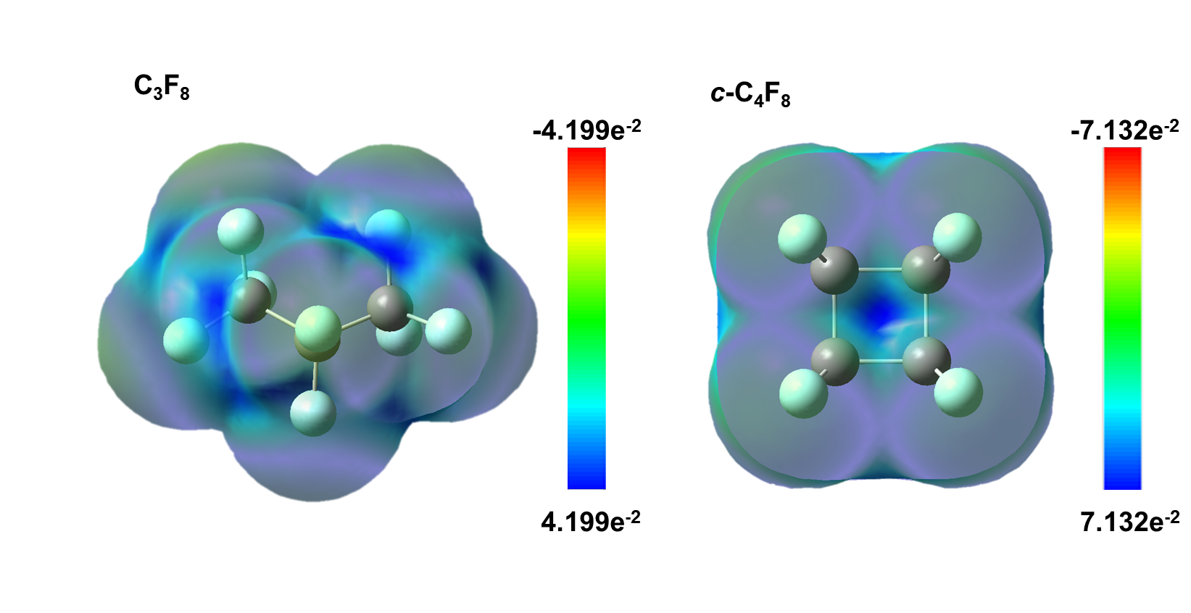
Supplementary Fig. 2. The surface electrostatic potential of C₃F₈ and c-C₄F₈.
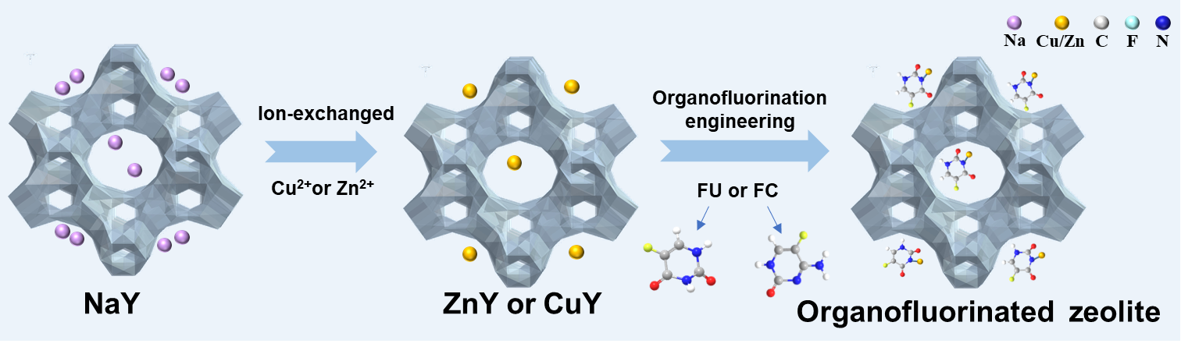
Supplementary Fig. 3. Schematic illustration of preparation process for organofluorinated zeolite.
Supplementary Fig. 4. PXRD patterns of NaY, ZnY-FU, ZnY-FC, CuY-FU and CuY-FC.

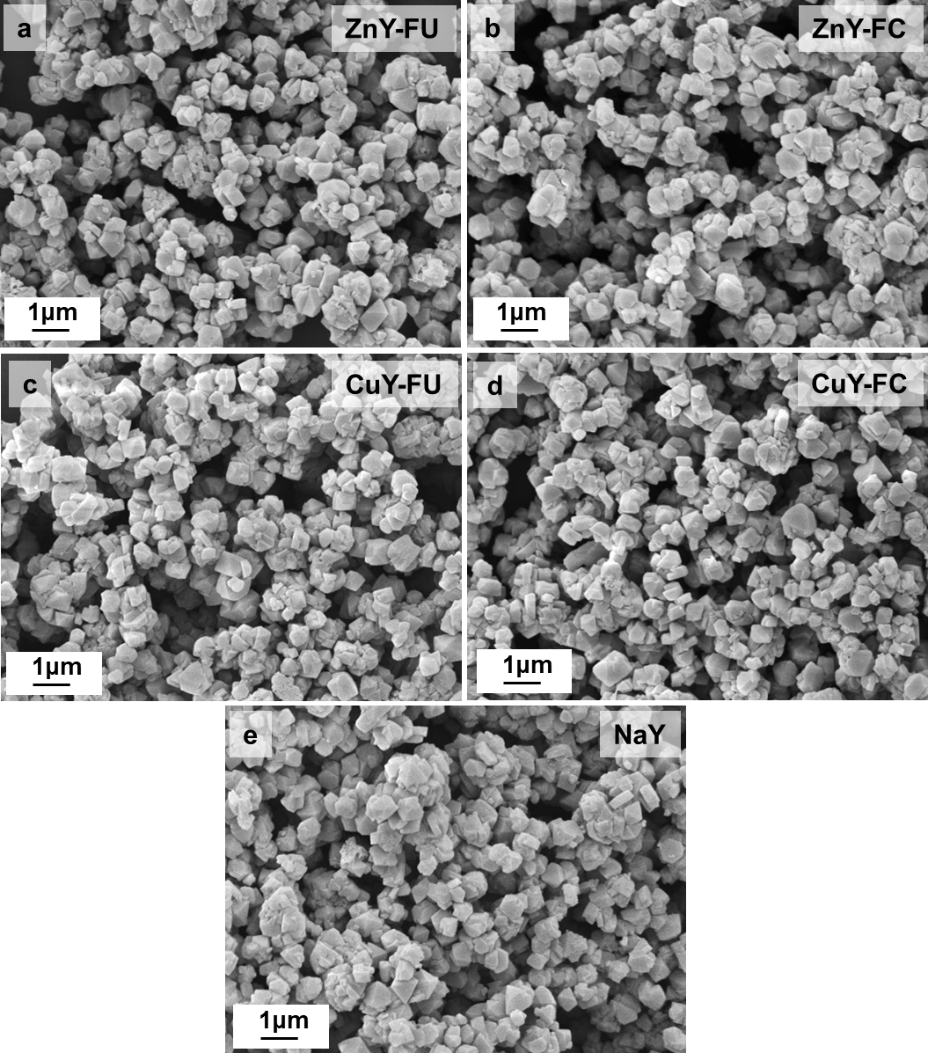
Supplementary Fig. 5. SEM images of (a) ZnY-FU, (b) ZnY-FC, (c) CuY-FU and (d) CuY-FC, (e) NaY.
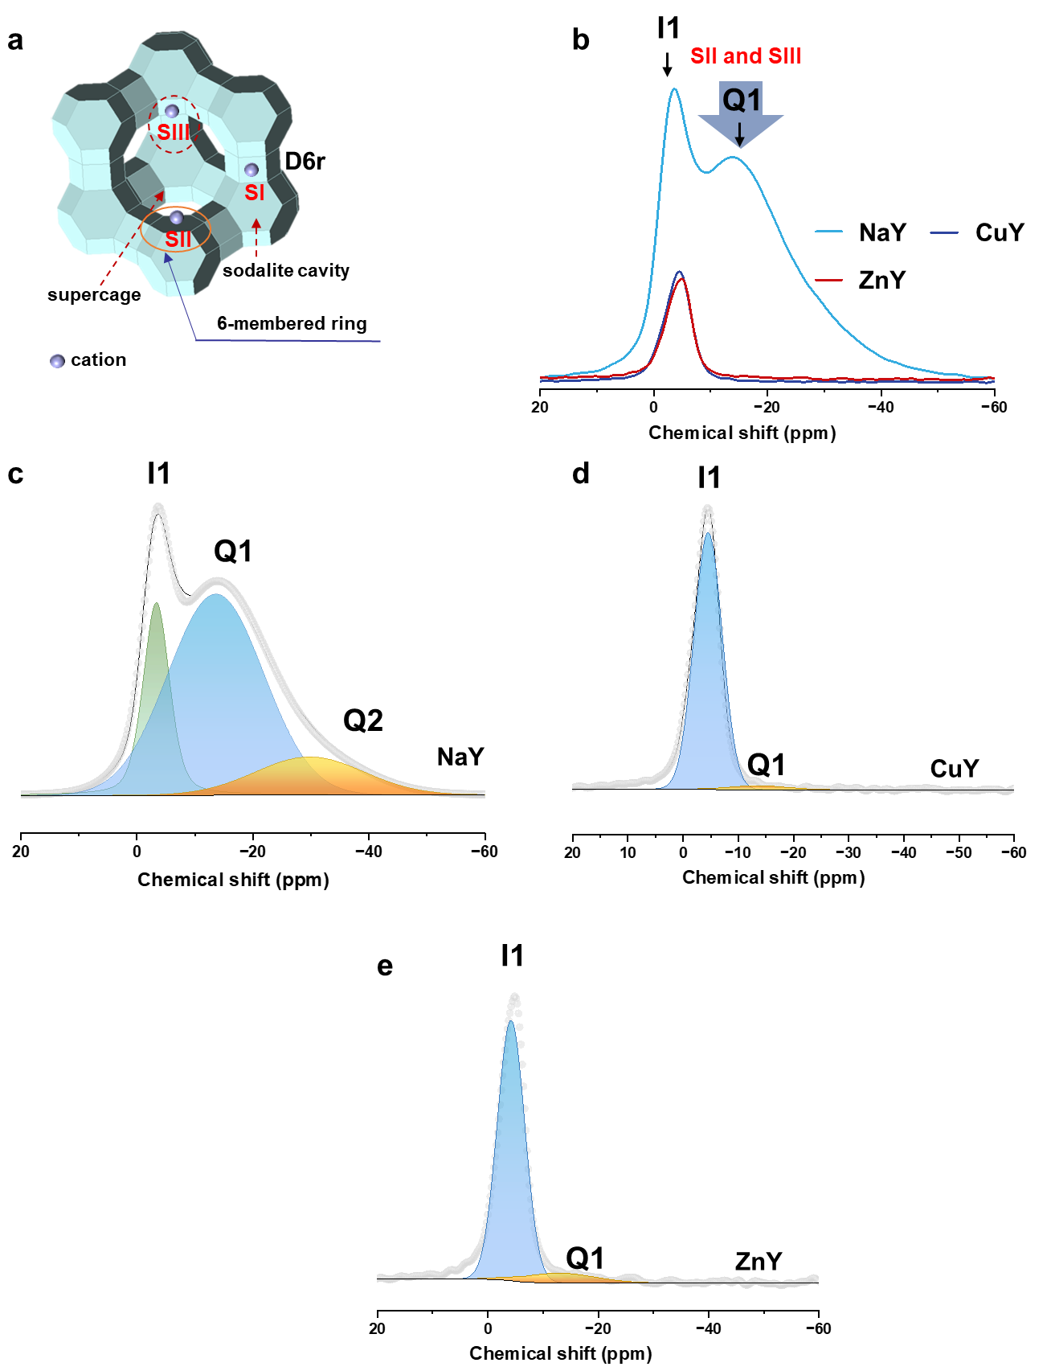
Supplementary Fig. 6. (a) Structure of zeolites Y with cation positions SII and SIII in supercages, SI′ and SII′ in sodalite units, and SI in the centers of hexagonal prisms¹. (b) ²³Na MAS NMR spectra of pristine zeolites NaY, CuY, ZnY, and ZnY-FU. Peak fit results of ²³Na MAS NMR spectra of zeolites (c) NaY, (d) CuY, and (e) ZnY. I1: sodium cations in the centers of hexagonal prisms, Q1: sodium cations in supercages, Q2: sodium cations in sodalite units.

The ²³Na NMR results of ZnY, CuY and ZnY-FU results indicate that sites SII and SIII in the FAU supercages were exchanged first, which is consistent with previous reports¹. It further demonstrates that the FU ligands coordinate with Cu²⁺ and Zn²⁺ ions located at either site SII or site SIII, both of which are closed to the pore entrance within the 12-membered ring channels.
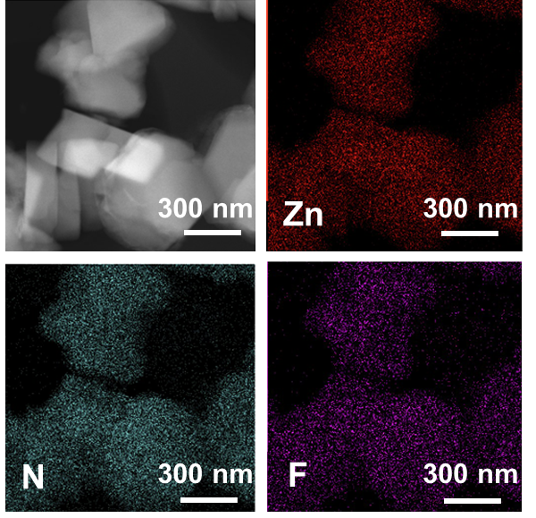
Supplementary Fig. 7. HAADF-STEM image of ZnY-FC and the corresponding energy-dispersive x-ray mapping images for Zn, N, and F elements.
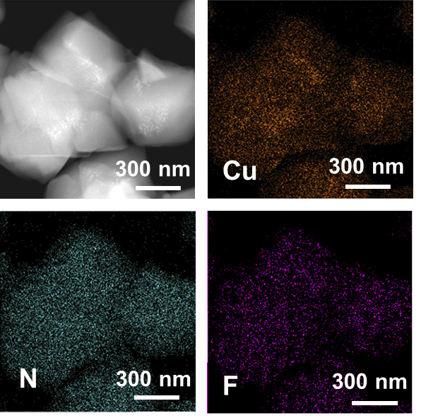
Supplementary Fig. 8. HAADF-STEM image of CuY-FU and the corresponding energy-dispersive x-ray mapping images for Cu, N, and F elements.
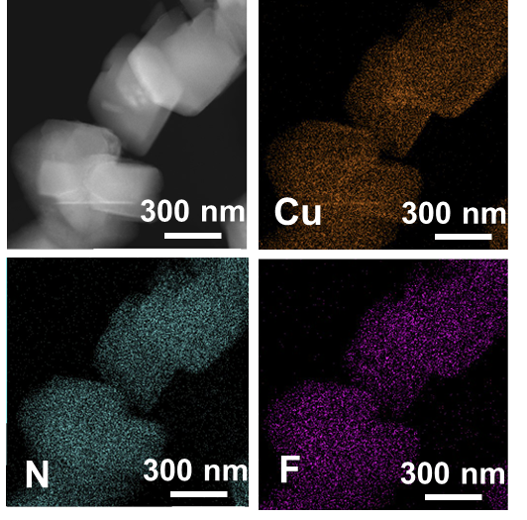
Supplementary Fig. 9. HAADF-STEM image of CuY-FC and the corresponding energy-dispersive x-ray mapping images for Cu, N, and F elements.
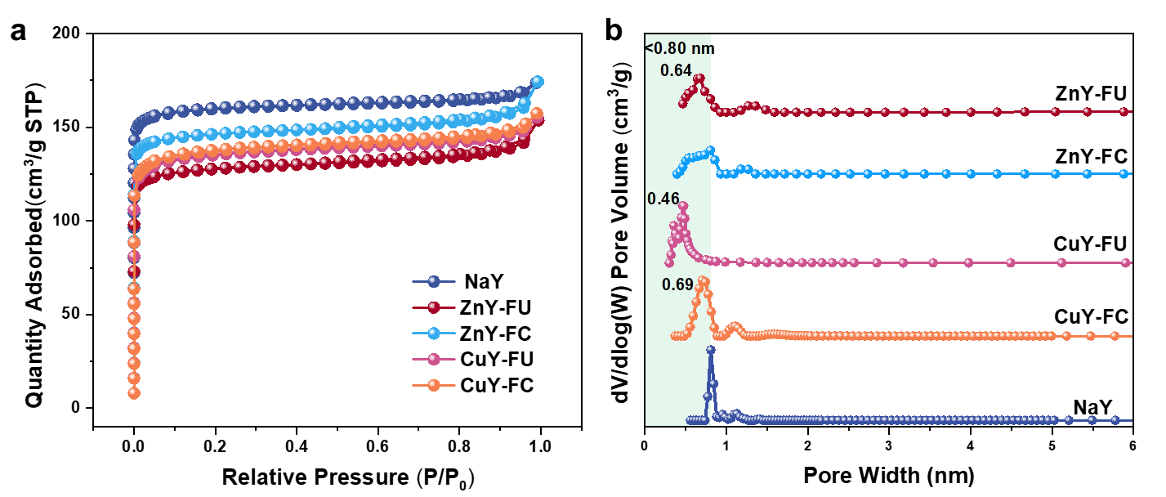
Supplementary Fig. 10. (a) N₂ adsorption-desorption isotherms at -196 °C and (b) pore size distribution of NaY, ZnY-FU, ZnY-FC, CuY-FU, and CuY-FC.
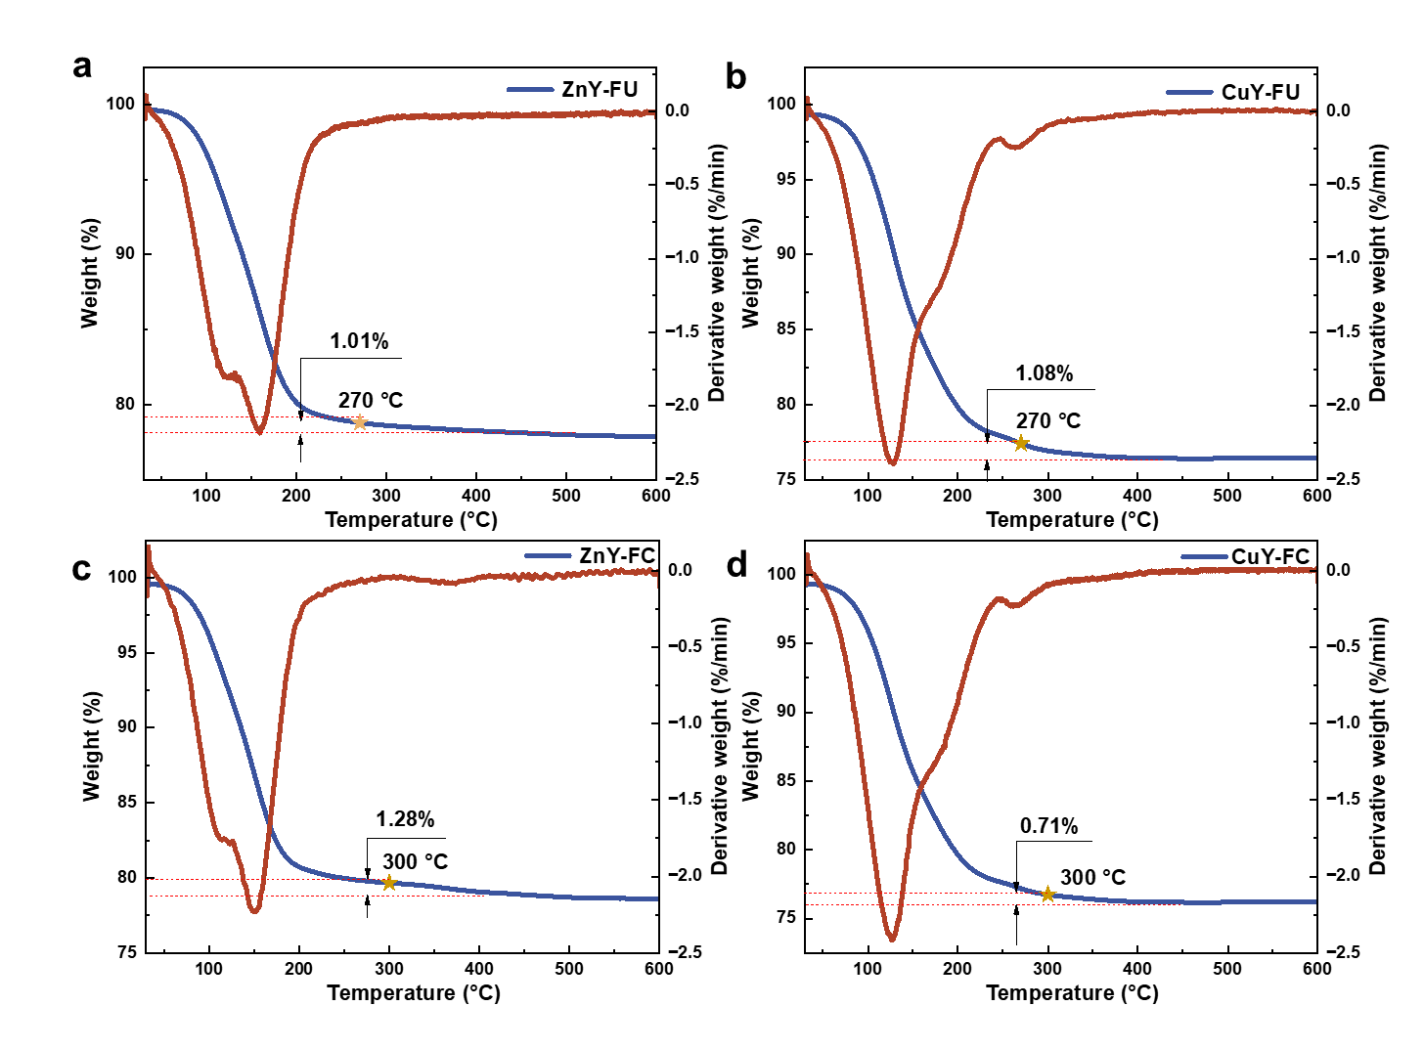
Supplementary Fig. 11. The TG-DSC curves of (a) ZnY-FU, (b) CuY-FU, (c) ZnY-FC and (d) CuY-FC.

The TG-DSC curves of ZnY-FU, CuY-FU, ZnY-FC and CuY-FC exhibit a weight loss of approximately 1% following the decomposition temperature of organic ligands^{2,3}, which is consistent with the C contents in Supplementary Table 2.

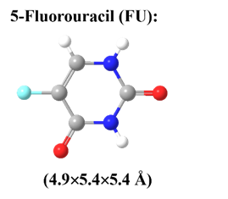
Supplementary Fig. 12. Chemical structures and molecular dimensions of 5-fluorouracil.

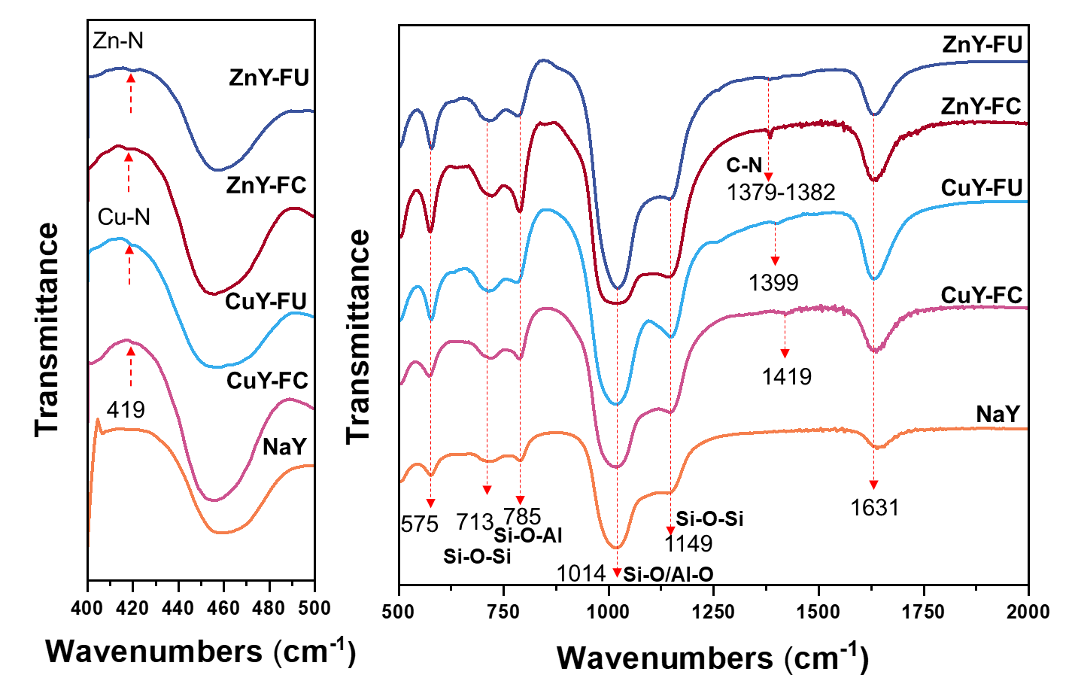
Supplementary Fig. 13. FTIR spectra of ZnY-FU, ZnY-FC, CuY-FU, CuY-FC and NaY.
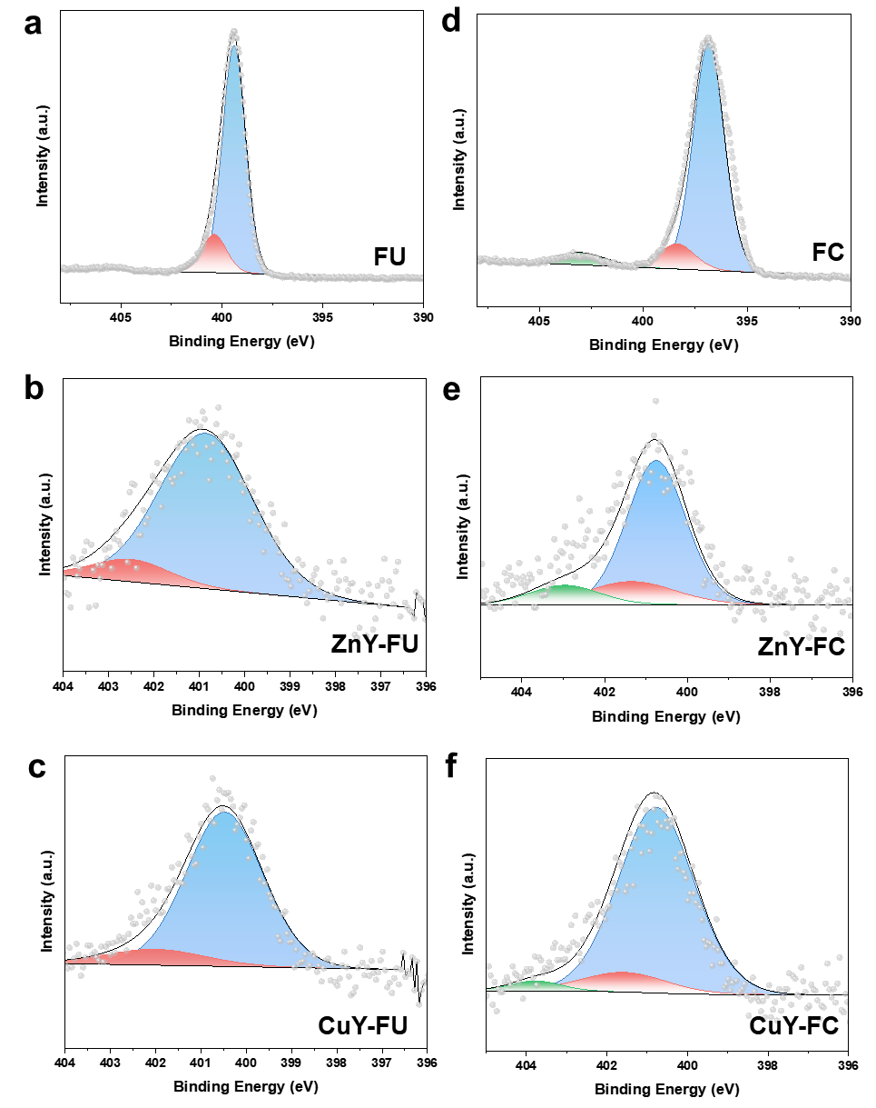
Supplementary Fig. 14. N1s XPS spectra of (a) FU, (b) ZnY-FU, (c) CuY-FU, (d) FC, (e) ZnY-FC, (f) CuY-FC.
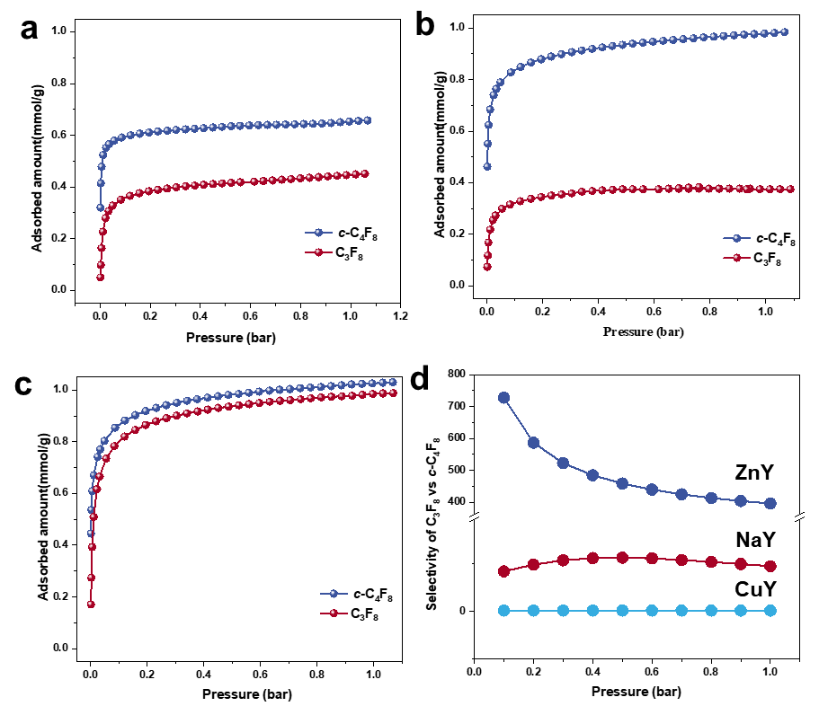
Supplementary Fig. 15. c-C₄F₈ and C₃F₈ adsorption isotherms of (a) NaY, (b) ZnY, (c) CuY; (d) IAST adsorption selectivity (c-C₄F₈/C₃F₈, 5:95, v/v) and 0.1 bar for different porous solids at 25 °C.

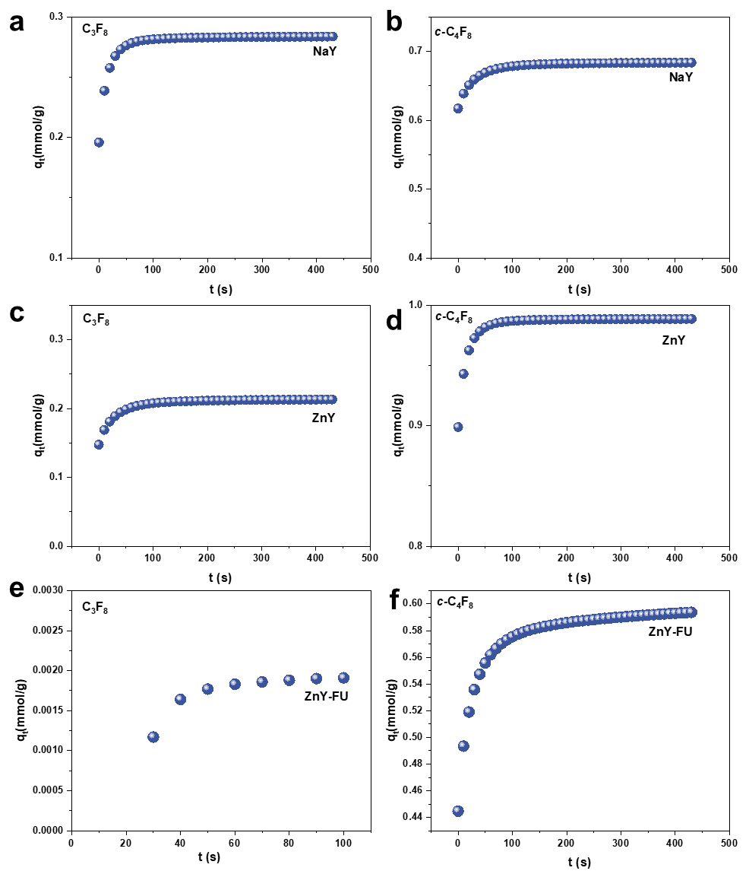
Supplementary Fig. 16. C₃F₈ and c-C₄F₈ adsorption kinetic profiles for (a, b) NaY, (c, d) ZnY and (e, f) ZnY-FU at 25 °C.
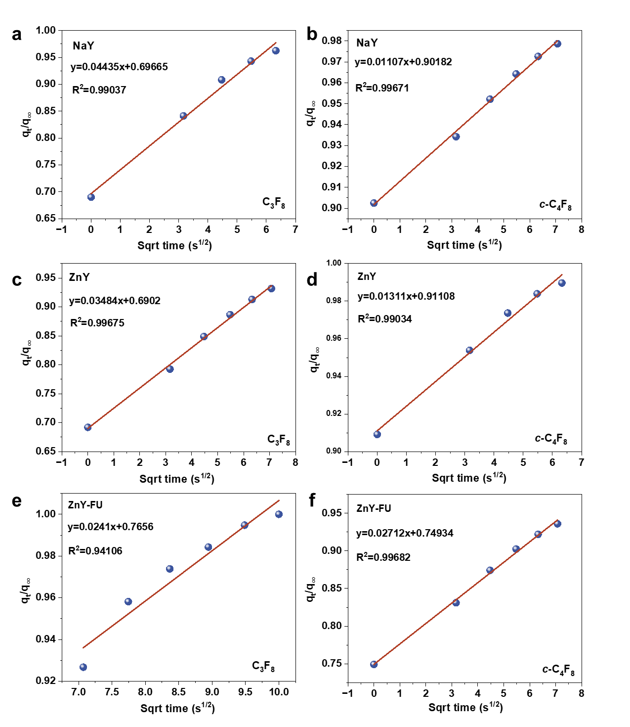
Supplementary Fig. 17. Linear fittings for the kinetic profiles for (a, b) NaY, (c, d) ZnY and (e, f) ZnY-FU at 25 °C.

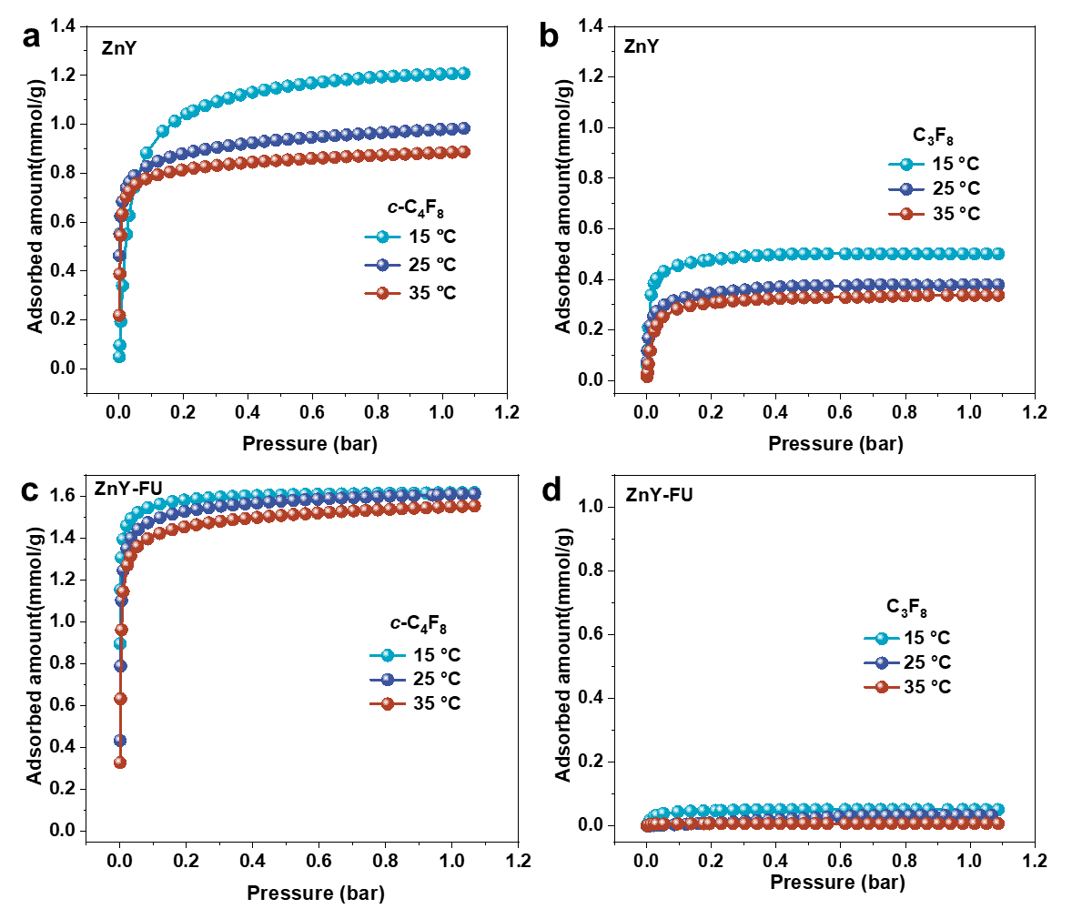
Supplementary Fig. 18. The c-C₄F₈ and C₃F₈ adsorption isotherms of (a, b) ZnY and (c, d) ZnY-FU at 15 °C, 25 °C and 35 °C.
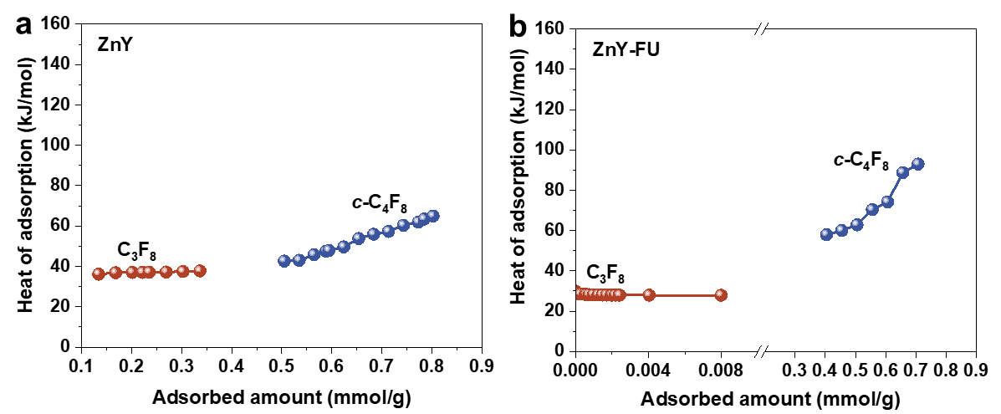
Supplementary Fig. 19. Isosteric heats of adsorption (Q_{st}) as a function of C₃F₈ and c-C₄F₈ uptakes for (a) ZnY and (b) ZnY-FU.

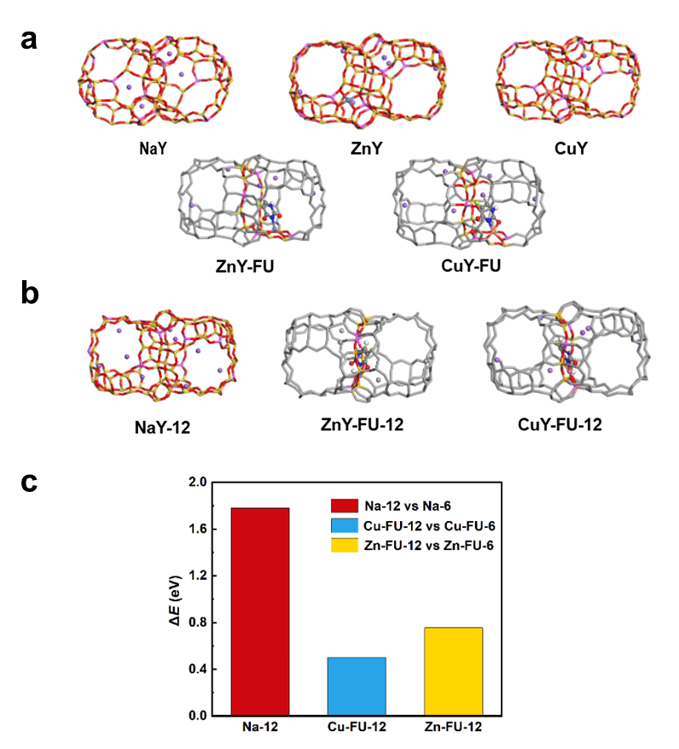
Supplementary Fig. 20. Structural configurations and energies of different zeolite systems with or without FU. (a) NaY, CuY, ZnY zeolites with or without FU. (b) Ion and ligand positioning in 12-MR structures (c) Comparison of energies for different zeolite systems.

The constructed NaY structure is presented in Figs. 20a. The 12-membered ring structure shown in Figs. 20b, structures with Na⁺ located in 12-membered rings and 6-membered rings were tested, with relative energies shown as blue bars in Figs. 20c, reveals that Na⁺ exhibits greater stability when positioned at 6-membered ring centers. Based on the constructed NaY structure, two Na⁺ ions were removed and replaced with Cu²⁺ or Zn²⁺ to generate CuY or ZnY structures, respectively. FU ligands were subsequently introduced into these structures, and relative energies of FU ligands near 12-membered rings and 6-membered rings were examined, as indicated in Figs. 20c. FU ligands on 6-membered rings exhibit lower energy, with the structure shown in Figs. 20a. To emphasize structural features, color treatment was applied to the main ligand vicinity while other regions are presented in gray. The H atom coordinated with N on the FU ligand detaches from its original coordination position and adsorbs onto surrounding framework oxygen atoms, while the N coordinates with metal ions, slightly displacing metal ions from the stable 6-membered ring center. The metal ions and ligands collectively occlude part of the 12-membered ring pore.

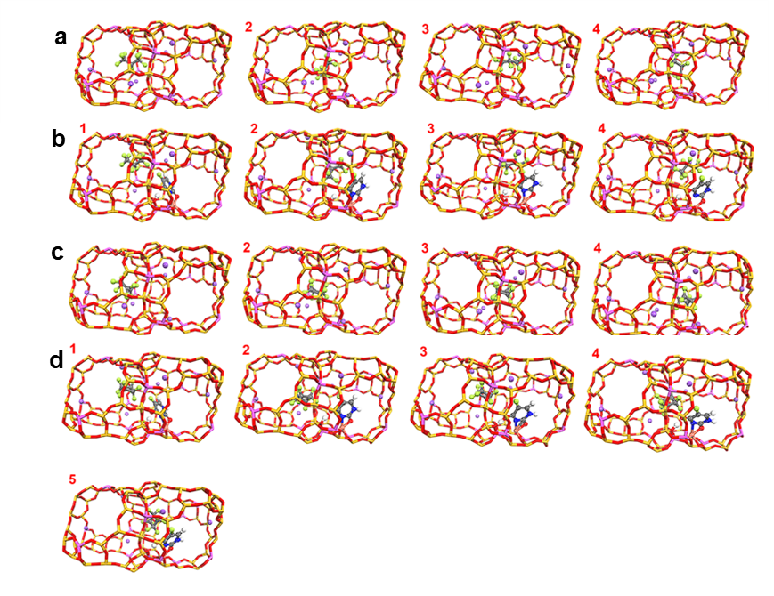
Supplementary Fig. 21. Representative geometries extracted from AIMD trajectories in Fig. 3 (a) NaY-C₃F₈. (b) CuY-FU-C₃F₈. (c)NaY-c-C₄F₈. (d) CuY-FU-c-C₄F₈.

As depicted in Figs. 21 (corresponding to Fig. 3 in manuscript), the attractive force between the C atom closest to the 12-MR and the Na⁺ ion in the same motion direction was monitored. AIMD simulations revealed that molecules initially displace the FU ligands through fluorine interactions. Continuous interaction with the FU ligands during passage prevents their return to the initial state of partial 12-MR ring occlusion, but the differences in energy barrier between these two gases is still not obvious. Additionally, the CuY-FU system consistently maintains both Cu-O and Cu-N connections throughout the process, resulting in elevated barriers compared CuY.

2. Supplementary Tables
Supplementary Table 1. The peak fit results of ³Na MAS NMR spectra.
Samples | Q1:I1 | Q1:(Q1+I1+I2)
NaY | 4.71 | 0.70
CuY | 0.02 | 0.02
ZnY | 0.09 | 0.09

Supplementary Table 2. Physical and chemical properties of the samples.
Sample | S_{BET}  (m²/g) | S_{micro}  (m²/g) | V_{micro}  (cm³/g) | Zn wt%  [a] | Cu wt%  [a] | C wt%  [b]
ZnY | 561 | 551 | 0.287 | 9.54 | — | 0.074
ZnY-FU | 505 | 463 | 0.179 | — | — | 0.306
ZnY-FC | 499 | 489 | 0.266 | — | — | 0.278
CuY | 569 | 558 | 0.219 | — | 9.48 | 0.083
CuY-FU | 533 | 521 | 0.207 | — | — | 0.451
CuY-FC | 541 | 530 | 0.211 | — | — | 0.154
[a] Zn and Cu content was measured by ICP-OES. [b] C content was measured by CS analysis instrument.

Supplementary Table 3. Fitting parameters of the DSLF model.
Parameters |  | q1 | b1 | n1 | q2 | b2 | n2 | R²
NaY | C₃F₈ | 5.1688 | 0.0122 | 0.2077 | 0.6716 | 0.0006 | 0.8061 | 0.9982
NaY | c-C₄F₈ | 0.3972 | 1.1183 | 0.8994 | 1.0060 | 0.0015 | 0.7143 | 0.9227
ZnY | C₃F₈ | 0.3912 | 0.2257 | 0.6824 | 0.3297 | 0.0004 | 0.2327 | 0.9931
 | c-C₄F₈ | 0.9738 | 0.8585 | 0.3939 | 1.5505 | 0.0008 | 0.5988 | 0.9996
CuY | C₃F₈ | 1.1380 | 0.6078 | 0.3525 | 0.6884 | 0.0007 | 0.6107 | 0.9997
 | c-C₄F₈ | 1.1380 | 0.6079 | 0.3525 | 0.6884 | 0.0007 | 0.6108 | 0.9997
ZnY-FU | C₃F₈ | 0.5311 | 0.0006 | 0.7657 | 0.7301 | 0.0007 | 0.8841 | 0.9155
ZnY-FU | c-C₄F₈ | 12.9033 | 0.0545 | 0.0806 | 0.7124 | 0.0007 | 0.7072 | 0.9998
ZnY-FC | C₃F₈ | 0.4032 | 0.0530 | 0.5156 | 0.3446 | 0.2751 | 0.9562 | 0.9998
ZnY-FC | c-C₄F₈ | 0.5535 | 1.1060 | 0.8549 | 1.3248 | 0.0926 | 0.2457 | 0.9999
CuY-FU | C₃F₈ | 3.7812 | 0.0017 | 0.3740 | 0.6619 | 0.0007 | 0.5423 | 0.9992
CuY-FU | c-C₄F₈ | 1.1842 | 0.5455 | 0.3241 | 0.5880 | 0.0006 | 0.5449 | 0.9733
CuY-FC | C₃F₈ | 0.1250 | 91.1975 | 0.9698 | 0.0211 | 5.5149 | 0.3695 | 0.9997
CuY-FC | c-C₄F₈ | 5.3057 | 0.0341 | 0.3672 | 0.5137 | 91.5058 | 0.5924 | 0.9998

Supplementary Table 4. Adsorbents for the separation of F-electronic specialty gases at 25 °C and 100 kPa.
Adsorbents | Uptakes/ mmol g⁻¹ |  | Selectivity/IAST | Ref.
c-C₄F₈/C₃F₈ | C₃F₈ | c-C₄F₈ | Selectivity/IAST | Ref.
GC-K1 | ~3.8 | 1.2ª | 3.7^{b} | ⁴
ZnY-FU | 0.03 | 0.97 | 1.7×10¹⁰ | This work
C₃F₆/C₃F₈ | C₃F₈ | C₃F₆
JXNU-21 | 0.77 | 1.33 | 15.6 | ⁵
Zn-bzc-CF₃ | negligible | 2.10 | 12 | ⁶
Zr-PMA | 0.76 | 2.64 | Not mentioned | ⁷
Ca-tcpb | 0.065 | 2 | >10000 | ⁸
Co-FA | 0.16 | ~2.0 | Not mentioned | ⁹
Mn-dhbq | 0.16 | 2.0 | Not mentioned | ¹⁰
Al-PMA | 0.047 | 1.75 | >10000 | ¹¹
C₃F₈/N₂ | C₃F₈ | N₂
A520 | 2.93 | 0.22 | 6034 | ¹²
CPOF-6 | 1.79 | ~0.1 | 148 | ¹³
c-C₄F₈/N₂ | c-C₄F₈ | N₂
CPOF-6 | 3.59 | ~0.1 | 1128 | ¹³
C₂ClF₅/C₃F₈ | C₃F₈ | C₂ClF₅
TMAZ-2 | 0.2 | 0.8 | 2.53^{c} | ¹⁴
Note: Measured at 25 °C and 100 kPa. a: Dynamic adsorption capacity; b: Dynamic selectivity; c: Henry selectivity.

Supplementary Table 5. Kinetic selectivities for the uptake of c-C₄F₈ over C₃F₈ in NaY, ZnY and ZnY-FU, expressed as the ratio of the two relevant diffusion time constants (D/r²).
Sample | D/r² (s⁻¹) |  | Kinetic Selectivity  (c-C₄F₈/C₃F₈)
Sample | c-C₄F₈ | C₃F₈ | Kinetic Selectivity  (c-C₄F₈/C₃F₈)
NaY | 1.07×10⁻⁵ | 1.72×10⁻⁴ | 0.06
ZnY | 1.50×10⁻⁵ | 1.06×10⁻⁴ | 0.14
ZnY-FU | 6.42×10⁻⁵ | 5.07×10⁻⁵ | 1.27

References
1. Hunger, M., Schenk, U. & Buchholz, A. Mobility of cations and guest compounds in cesium-exchanged and impregnated zeolites Y and X investigated by high-temperature MAS NMR spectroscopy. The Journal of Physical Chemistry B 104, 12230-12236 (2000).
2. Mohamed, H. S., Dahy, A. A. & Mahfouz, R. M. Isoconversional approach for non-isothermal decomposition of un-irradiated and photon-irradiated 5-fluorouracil. J. Pharm. Biomed. Anal. 145, 509-516 (2017).
3. Wang, X. J., You, J. Z. & Yu, F. Study on the thermal decomposition of emtricitabine. J. Anal. Appl. Pyrolysis 115, 344-352 (2015).
4. Li, X. et al. Dynamic adsorption separation of c-C₄F₈/C₃F₈ for effective purification of perfluoropropane electronic gas. Chem. Eng. Sci. 273, 118656 (2023).
5. Feng, Y. Q. et al. Purification of octafluoropropane from hexafluoropropylene/octafluoropropane mixtures with a metal-organic framework exhibiting high productivity. Inorg. Chem. Front. 12, 623-629 (2025).
6. Zheng, M. et al. Fluorinated MOF-based hexafluoropropylene nanotrap for highly efficient purification of octafluoropropane electronic specialty gas. Angew. Chem. Int. Ed. 63, e202401770 (2024).
7. Xia, W. et al. Hopping diffusion in wiggling nanopore architecture of MOF enabling synergistic equilibrium-kinetic separation of fluorinated propylene and propane. Angew. Chem. Int. Ed. 64, 202503505 (2025).
8. Xia, W. et al. Temperature-dependent molecular sieving of fluorinated propane/propylene mixtures by a flexible-robust metal-organic framework. Sci. Adv. 10, eadj6473 (2024).
9. Xia, W. et al. Bioinspired recognition in metal-organic frameworks enabling precise sieving separation of fluorinated propylene and propane mixtures. Nat. Commun. 15, eadj6473 (2024).
10. Sheng, L. et al. Temperature-responsive molecular sieving of fluorinated propylene and propane via a flexible metal-organic framework with high-density open metal sites. ACS Mater. Lett. 7, 2080-2087 (2025).
11. Xia, W. et al. Deep purification of perfluorinated electronic specialty gas with a scalable metal-organic framework featuring tailored positive potential traps. Sci. Bull. 70, 232-240 (2025).
12. Fang, Z. et al. A low-cost and stable metal-organic framework featuring electropositive microenvironment for efficient recovery of C3F8 electronic specialty gas and record C3F8/N2 separation. Chem. Eng. J. 516, 163987 (2025).
13. Chen, M. et al. Fluorine-induced gradient electric field in mesoporous covalent organic frameworks for efficient separation of polarized perfluorinated gases. Nat. Commun. 16, 5499 (2025).
14. Zhou, X. et al. Enhanced azeotropic C₂ClF₅/C₃F₈ separation by TMA⁺ exchanged MFI zeolites for ultrapure fluorine electronic gas. AIChE J. 70, e18354 (2024).

