The Unique Role of Low-Dose Aspirin in Diabetes: Evidence of Reduced TIA Without Increased Major Harm - A Systematic Review and Meta-Analysis of Trials Using Strict Low-Dose Aspirin Monotherapy

Supplemental Online Content

Appendix 1. Electronic Search Strategy
Figure 1. Preferred Reporting Items for Systematic Reviews and Meta-Analyses (PRISMA) Flowchart of Search Strategy and Included Studies

Figure 1. Outcome Data Sheet
Figure 3. Risk of Bias Assessments
Table 1. Risk of Bias Judgements in each study
Table 2. Certainty of Assessments

Appendix 1: Electronic search strategy

PubMed:
The PubMed search was conducted from inception to September 2025. The following search string was used, with filters for randomized controlled trials:
(((aspirin) AND (cardiovascular)) AND (diabetes)) AND (placebo)
Filters: Randomized Controlled Trial
Expanded MeSH-based Strategy:
(("aspirin"[Supplementary Concept] OR "aspirin"[All Fields] OR "aspirin"[MeSH Terms]
OR "aspirins"[All Fields] OR "aspirin s"[All Fields] OR "aspirine"[All Fields])
AND ("cardiovascular system"[MeSH Terms] OR ("cardiovascular"[All Fields] AND "system"[All Fields])
OR "cardiovascular system"[All Fields] OR "cardiovascular"[All Fields] OR "cardiovasculars"[All Fields])
AND ("diabete"[All Fields] OR "diabetes mellitus"[MeSH Terms] OR ("diabetes"[All Fields] AND "mellitus"[All Fields])
OR "diabetes mellitus"[All Fields] OR "diabetes"[All Fields] OR "diabetes insipidus"[MeSH Terms]
OR ("diabetes"[All Fields] AND "insipidus"[All Fields]) OR "diabetes insipidus"[All Fields]
OR "diabetic"[All Fields] OR "diabetics"[All Fields] OR "diabets"[All Fields])
AND ("placebo"[All Fields] OR "placebos"[Supplementary Concept] OR "placebos"[All Fields]
OR "placebo"[All Fields] OR "placebos"[MeSH Terms]))
AND (randomizedcontrolledtrial[Filter])

Figure 1. Outcome Data Sheet

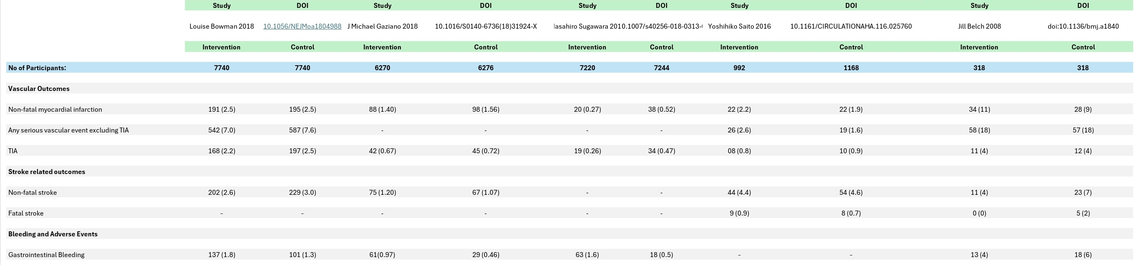

Figure 3. Risk of Bias Assessments

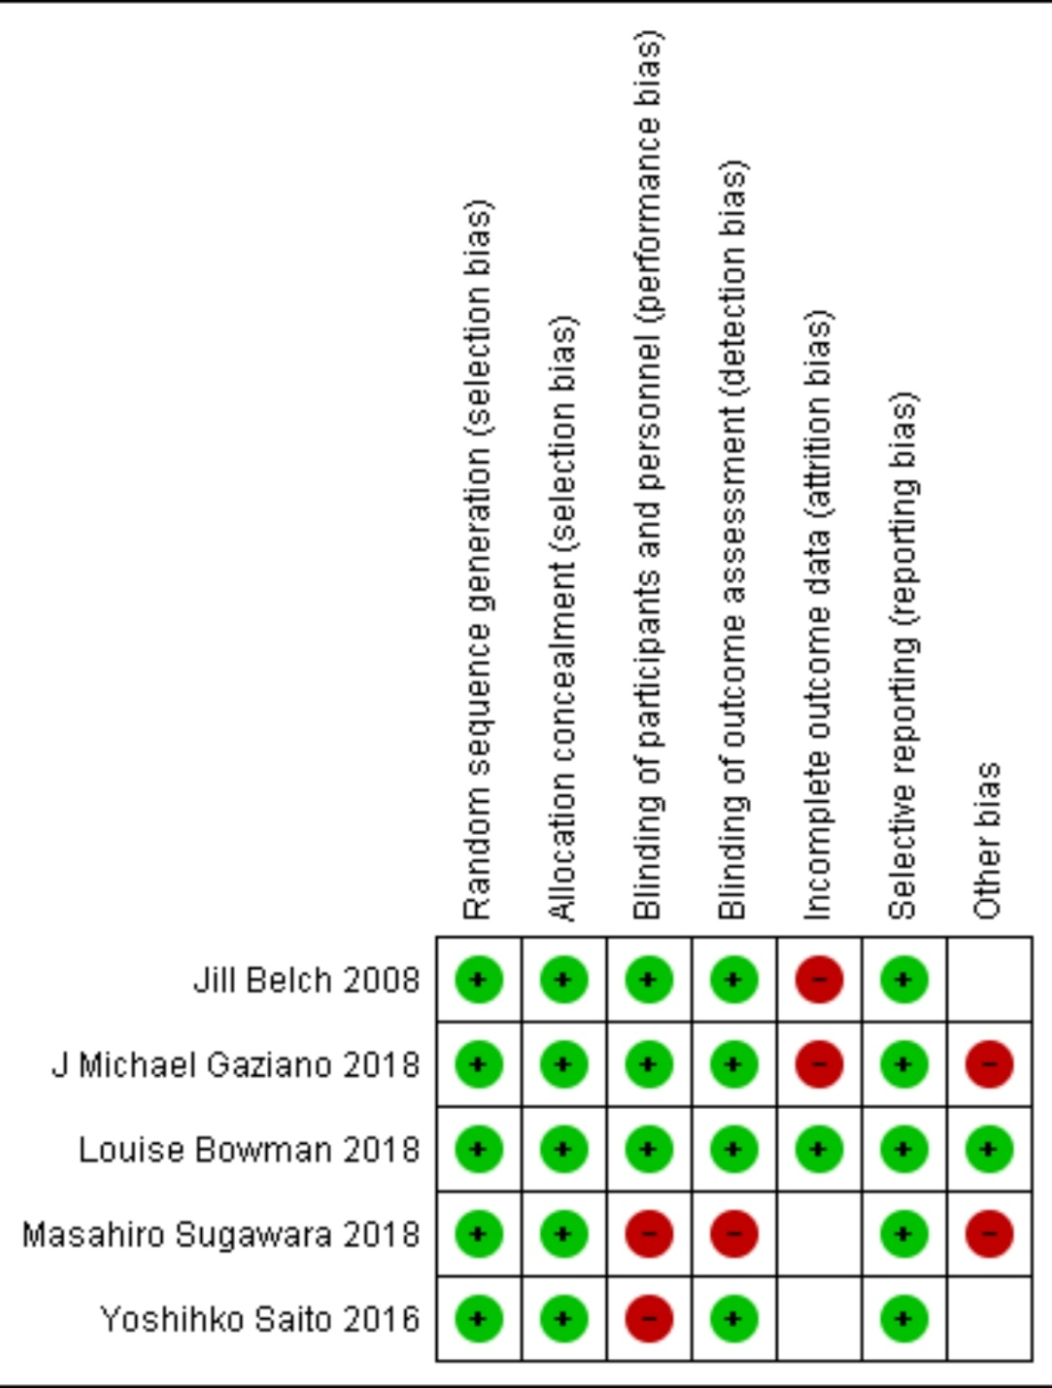

The POPADAD (Jill Belch 2008), ASCEND (Louise Bowman 2018), JPAD (Yoshihiko Saito 2016), JPPP-70 (Masahiro Sugawara 2018), and ARRIVE (J Michael Gaziano 2018) trials were generally assessed as having low risk of bias. Most domains, including random sequence generation, allocation concealment, blinding of outcome assessment, incomplete outcome data, and selective reporting, were judged low risk. The JPPP-70 and ARRIVE trials showed some concerns in blinding of participants and personnel, while the ARRIVE trial also showed high risk in the “other bias” domain. All unmarked boxes in the figure represent low risk assessments. Overall, the included trials were adjudicated to have a low risk of bias, supporting the validity of the pooled results.

Table 1. Risk of Bias Judgements in each study

Study | Risk Domain | Quote from Article | Author's Judgement | Risk Assigned
ARRIVE | Random sequence generation (Selection bias) | Eligible patients were randomly assigned (1:1) to receive aspirin or placebo, according to a computer-generated randomisation code using balanced permuted blocks of treatment group allocations. Randomisation was stratified by sex and study centre. | Randomisation method was clearly described and appropriate. | Low
ARRIVE | Allocation concealment (Selection bias) | ...the study investigator was informed of treatment assignment by an automated telephone system. | Centralised system ensured allocation concealment. | Low
ARRIVE | Blinding of participants/personnel (Performance bias) | Patients, investigators and their staff, the sponsor, and others involved in treating the patients or data collection and analysis were masked to the identity of the treatment. | Adequate blinding across all groups. | Low
ARRIVE | Blinding of outcome assessment (Detection bias) | All cases of myocardial infarction, stroke, cardiovascular death, unstable angina, transient ischaemic attack, and haemorrhagic events were adjudicated by an endpoint adjudication committee. During the study, the Executive Committee reviewed the cases while masked to treatment allocation. | Endpoints assessed by blinded adjudication. | Low
ARRIVE | Incomplete outcome data (Attrition bias) | Over the course of the study, which lasted 60 months on average… 29·6% of patients terminated the study prematurely (1843 [29·4%] in the aspirin group and 1875 [29·9%] in the placebo group). | Nearly one-third of participants discontinued, which raises concern despite balanced dropout. | High
ARRIVE | Selective reporting (Reporting bias) | The primary efficacy endpoint was a composite outcome consisting of time to first occurrence of confirmed myocardial infarction, stroke, cardiovascular death, unstable angina, or transient ischaemic attack. | Outcomes were prespecified and reported, though cancer outcomes were deferred (“The results about effects of aspirin on cancer incidence will be reported elsewhere”), leaving some uncertainty | Low
ARRIVE | Other bias | The funder of the study had a role in study design, data collection, data analysis, and data interpretation. | Direct involvement of the sponsor increases potential bias. | High
ASCEND | Random sequence generation (Selection bias) | Using minimized randomization, we then assigned eligible participants to receive 100 mg of aspirin once daily or a matching placebo tablet… | Randomization was clearly described and appropriate. | Low
ASCEND | Allocation concealment (Selection bias) | The aspirin and matching placebo (along with funding for packaging) were provided by Bayer (Germany)… After this run-in period of 8 to 10 weeks, participants remained eligible… Using minimized randomization, we then assigned eligible participants to receive 100 mg of aspirin once daily or a matching placebo tablet. | Central minimized randomization with matching placebo ensured concealment. | Low
ASCEND | Blinding of participants/personnel (Performance bias) | …assigned eligible participants to receive 100 mg of aspirin once daily or a matching placebo tablet; participants were also assigned to receive 1-g capsules containing n−3 fatty acid once daily or a matching placebo capsule. | Matching placebo tablets and capsules indicate double-blinding. | Low
ASCEND | Blinding of outcome assessment (Detection bias) | All the reports of possible primary or secondary outcomes were adjudicated centrally by clinicians who were unaware of the trial-group assignments in accordance with prespecified definitions. | Outcome adjudicators were blinded, reducing detection bias. | Low
ASCEND | Incomplete outcome data (Attrition bias) | At the end of the scheduled follow-up period, complete follow-up data were available for 15,341 participants (99.1%) who had undergone randomization… | Excellent follow-up rates (99.1%) minimize attrition bias. | Low
ASCEND | Selective reporting (Reporting bias) | The data analysis plan was finalized by the steering committee and was published while all the members were still unaware of the trial results… | Outcomes were prespecified, protocol published, and all key outcomes reported. | Low
ASCEND | Other bias | The trial was funded by the British Heart Foundation… Bayer (Germany) commented on the design of the trial, and both Bayer and Mylan commented on the draft of the manuscript but had no part in the collection, handling, analysis, or interpretation of the data or in the decision to submit the manuscript for publication. | Independent conduct reduces risk of sponsor influence. | Low
JPAD-Extension | Random sequence generation (Selection bias) | The randomization was performed as non-stratified randomization from a random number table. Personnel at the central trial coordinating center prepared sealed envelopes with random assignments and distributed them by mail to the physicians in charge at the study sites. | Adequate randomization procedure described. | Low
JPAD-Extension | Allocation concealment (Selection bias) | Personnel at the central trial coordinating center prepared sealed envelopes with random assignments and distributed them by mail to the physicians in charge at the study sites. | Central preparation of sealed envelopes suggests allocation was concealed from investigators. | Low
JPAD-Extension | Blinding of participants/personnel (Performance bias) | The JPAD trial was a multicenter, randomized, standard care–controlled, open-label, blinded endpoint trial conducted at 163 institutions throughout Japan. | Open-label design means participants and treating physicians were not blinded, increasing performance bias risk. | High
JPAD-Extension | Blinding of outcome assessment (Detection bias) | “All potential end points and hemorrhagic events were adjudicated by a central independent committee that was blinded to the group assignments in both the JPAD trial and the JPAD2 study. | Outcomes assessed by blinded adjudication committee. | Low
JPAD-Extension | Incomplete outcome data (Attrition bias) | During the follow-up period, 270 patients in the aspirin group stopped taking low-dose aspirin, and 109 patients in the no-aspirin group started taking aspirin. These 379 (15%) patients were excluded from the per-protocol analysis at the time their aspirin treatment changed… | Substantial crossover and exclusion in per-protocol analysis; though intention-to-treat analyses were also done, attrition/crossover may have biased results. | Unclear
JPAD-Extension | Selective reporting (Reporting bias) | The study protocol for the JPAD trial was registered at clinicaltrials.gov with the identifier NCT00110448 | Protocol registered, and primary/secondary outcomes reported as planned. | Low
JPAD-Extension | Other bias | In the per-protocol cohort, there were slight but significant differences between the aspirin and no-aspirin groups in terms of age, blood pressure, HbA1c, and creatinine at baseline. | Baseline imbalances after exclusions may have introduced residual bias. | Unclear
JPPP-70 | Random sequence generation (Selection bias) | A central computerized system was used to generate the random allocation sequence, and treatment allocations were disseminated to study investigators via the study website or by fax. | This indicates proper randomization with centralized control. | Low
JPPP-70 | Allocation concealment (Selection bias) | Same supporting quote as above. | The use of a central computerized system implies allocation concealment, as investigators did not control the assignment. | Low
JPPP-70 | Blinding of participants/personnel (Performance bias) | The JPPP was a multicenter, randomized, open-label, parallel-group clinical study. | Because the study was open-label, both participants and treating physicians knew the treatment assignment, which increases performance bias, especially in reporting adverse events. | High
JPPP-70 | Blinding of outcome assessment (Detection bias) | In addition, due to the open-label nature of the trial, patients receiving aspirin may have been more likely to report the occurrence of adverse events than those not receiving aspirin. | This directly acknowledges detection bias due to unblinded outcome assessment. | High
JPPP-70 | Incomplete outcome data (Attrition bias) | The frequency of non-adherence in the intervention group (i.e., patients who did not take aspirin) was 28.0% … and the frequency of contamination of the control group … was 5.2%. | High non-adherence and contamination threaten validity, but follow-up itself was adequate (median 5 years). Since the main trial was stopped early due to futility, attrition bias is possible but not fully quantifiable. | Unclear
JPPP-70 | Selective reporting (Reporting bias) | The primary endpoint was a composite of death from cardiovascular causes … The secondary endpoint was a composite of the primary endpoint plus transient ischemic attack, angina pectoris, and arteriosclerotic disease requiring medical or surgical intervention. | The trial was registered (NCT00225849), and prespecified primary and secondary outcomes were reported. | Low
JPPP-70 | Other bias | The study was terminated following interim analysis in May 2011, owing to likely futility.  Decreasing adherence levels in the group receiving aspirin and the increasing uptake of aspirin in the group not randomized to receive aspirin during the 5-year trial may have confounded between-group differences.  The subgroup that appeared to benefit … comprised just 3.5% of the original JPPP cohort; therefore, the possibility that these results occurred owing to chance cannot be ruled out. | Stopping early, non-adherence, contamination, and exploratory post-hoc subgroup analyses increase risk of bias. | High
POPADAD | Random sequence generation (Selection bias) | The allocation sequence used randomised permuted blocks of eight and was computer generated by the trial statisticians. | This shows a proper randomization process. | Low
POPADAD | Allocation concealment (Selection bias) | To ensure allocation concealment an independent pharmacist packaged the drugs into numbered containers. Recruiting nurses dispensed the trial drugs on the day of randomisation… | This indicates allocation was concealed from investigators and participants. | Low
POPADAD | Blinding of participants/personnel (Performance bias) | The placebo tablet and capsule were identical in appearance to the active tablet and capsule… The participants, research nurses, and staff involved in providing care were blinded to group assignment. | This shows adequate blinding of participants and study staff. | Low
POPADAD | Blinding of outcome assessment (Detection bias) | All primary and secondary end points were adjudicated on a blinded basis by the committee. | This confirms that outcome assessors were blinded. | Low
POPADAD | Incomplete outcome data (Attrition bias) | Overall, 1074 participants had their final follow-up in 2006, six had moved away and were lost to follow-up, one withdrew consent after four years, and 195 died during the trial. | Loss to follow-up was very small (<1%), so risk is low. But treatment discontinuation was high. | Unlcear
POPADAD | Selective reporting (Reporting bias) | The statistical analysis followed the plan determined at the start of the trial. The primary and secondary end points were measures of survival… All analyses were done on an intention-to-treat basis. | This indicates prespecified outcomes were reported, with no evidence of selective omission. | Low
POPADAD | Other bias | The cumulative percentage of patients who stopped taking the tablets… leading to a cumulative rate of 50% after five years. | High withdrawal (≈50% by 5 years) with unclear group differences and handling of missing data → risk of bias unclear. | Unclear

Table 2. Certainty of Assessments

