Supplementary Material for: Rank and payoff biases influence subject choices in a foraging task among sanctuary chimpanzees (Pan troglodytes)

Supplementary Figure 1: Control individual token choices showed no significant preference for black or blue
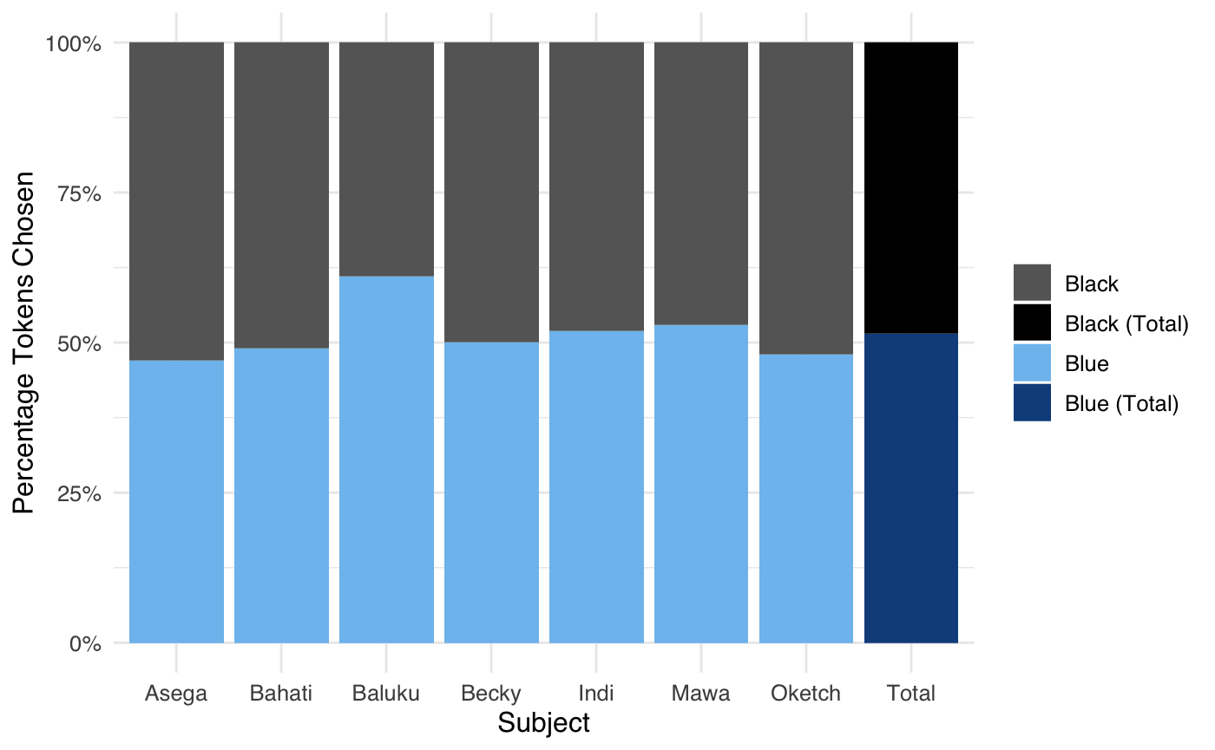

Supplementary Figure 2: Tokens stolen from each demonstrator
