APPENDIX

FIG. A.-1: PARTICIPATORY SYSTEM MAPPING CONCEPT.

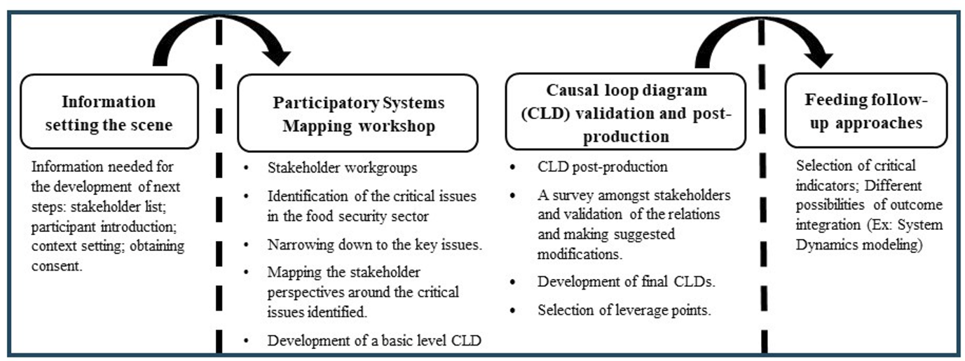
FIG. A.-2: DATA COLLECTION PROTOCOL

TABLE A.-1: INTERVIEWEE PROFILES
ID | Profile of the participants
Academicians/Experts
A1 | Political representative (Ministry, council)
A2 | Researchers in Sustainable Food Systems in Germany
Local Entrepreneurs/Businessmen
E1 | Representative of a large food production/retail
E2 | Local farmer – 1
E3 | Local farmer – 2
Food Logistics operator
TO1 | Logistics operator based in Germany
TO2 | Retailer based out of Germany
Local citizen
L1 | A local resident of Germany
L2 | A local resident of Germany

TABLE A.-2: INTERVIEWS: KEY QUESTIONS, PRODUCT TYPES, KEY STATEMENTS AND THE RELEVANCE TO SD MODEL

ID | Product Type | Question subject | Key Question | Key Statement | Relevance for SD Model
1 | Vegetables, fruit, potatoes | Production | Which main products and production processes dominate? | Wide range of products; fluctuating harvest volumes; limited storage capacity; waste mostly organic and recycled locally | Basis for regional production capacities, seasonality, waste streams
2 | Milk & Dairy Products | Production, logistics | How are goods processed and distributed? | Cold chains problematic; logistics costs high; interest in joint fresh produce logistics | Parameters relating to logistics bottlenecks, cost structures, regional cold chains
3 | Meat & Butchery | Production, sustainability | How is it produced? What waste is generated? | Waste, mainly offal, packaging; regional demand stable; high barriers to investment | Modeling of production costs, waste streams, investment barriers
4 | Baked goods & confectionery | Sales channels, marketing | Which distribution channels are used? | High importance of farm shops; low online sales; social media hardly used | Mapping digital marketing channels and demand fluctuations
5 | Beverages (alcoholic/non-alcoholic) | Sales, Marketing | Which channels work? | High dependence on regional retail trade; online sales hardly relevant; high logistical costs | Impact on sales channels and regional market dependencies
6 | Gastronomy | Sales channels, cooperation | How are regional products integrated? | Strong regional focus; limited staff; interest in cooperation with producers; low storage capacity | Feedback between demand from the catering industry and supply from producers
7 | Mixed businesses (production + catering) | All subject areas | Where do bottlenecks occur? | Combined production and kitchen requirements; interest in digital solutions; challenges with refrigeration and staffing | System coupling of production and catering in the SD model

TABLE A.-3: SELECTED PARAMETERS, EQUATIONS AND THE UNITS IN THE SD MODEL
Sl. No. | Details | Units
1 | Access to food = (0.3*Governance) + (0.2*Infrastructure) + (0.2*Resources) + (0.3*Average food prices/5000) | Dmnl
2 | Adult deaths= Population bet 18-65*Adult mortality rate | People/Year
3 | Agricultural land conversion= INTEG (Rate of conversion Agriculture, 166450) | sqkms
4 | Alternate energy production= INTEG (Fraction growth rate, Base production) | kWh/ (Year*People)
5 | Availability of food= (0.1*Export) + (0.2*Import) + (0.7*Production) | Dmnl
6 | Average food prices= Base price of food*(1+Cost of transportation imports/20) | Dmnl
7 | Birth fraction= RANDOM NORMAL (1,2,1.28,3,1.24) | Dmnl [0,1,0.1]
8 | Birth rate= Number of females*Birth fraction*RANDOM NORMAL (0.1, 0.2, 0.25, 2, 20.25) | People/Year
9 | CO₂ emissions= (Total fossil fuel demand*Pounds per gallon of CO₂) +Emissions due to imports | Tons
10 | Consumption level= Autonomous consumption+ (Marginal propensity*Average income) | Euros
11 | Cost of transportation imports= Fuel prices/Average mileage*Total food imports/120000/3.785 | Euros/Mile
12 | Cost of transportation last mile= IF THEN ELSE(Farm to fork switch=0, Fuel prices/Average mileage*Additional distance travelled per person/10, Fuel prices/Average mileage*Additional distance travelled per person/15) | Euros/Mile
13 | Dairy land conversion= INTEG (Rate of conversion Dairy-Rate of reconversion, 5300) | sqkms
14 | Distance covered by e-vehicles= Total distance to travel*EV fraction | miles
15 | Distance covered by fossil fuel vehicles= Total distance to travel*(1-EV fraction) | miles
16 | Electricity generated in the biogas plants= MAX(Total raw materials for biogas consumption/ 0.04*Seasonality,5e+06) | kWh/Year
17 | Emigration fraction= (1/SUSTAINABLE FOOD DYNAMICS INDEX) | Dmnl
18 | Emissions due to imports= Number of Ships*400000 | Tons
19 | Energy= MIN (Total energy production/Total energy required,1) | Dmnl
20 | Energy gap= Total energy required-Total energy production+ Alternate energy production -Electricity generated in the biogas plants | kWh/Year
21 | Export revenue=Total food exports*Average food prices | Euros
22 | Food security factor= (0.2*Access to food) +(0.4*Availability of food) +(0.1*Resource utilization factor) +(0.3*Stability of food supply chain) | Dmnl [0,1]
23 | Food storage infrastructure= Required storage/250 | Units
24 | Fossil fuel demand gap= Total fossil fuel demand-(Imported fossil fuel supply) -((1-Import dependency) *Total fossil fuel demand) | Gallons
25 | Fuel prices= Price lookup + Energy inflation trend | Euros/Gallon
26 | Gender ratio= 0.508 | Dmnl
27 | Geriatric deaths= (Population above 65/Average life post geriatric)+650000 | People/Year
28 | Geriatric rate= DELAY1(Adult rate,57) | People/Year
29 | Household consumption expenditure= Total number of households*Consumption level*Energy inflation trend/1.8 | Euros
30 | Immigrant gender ratio= 0.48 | Dmnl
31 | Immigration fraction= IF THEN ELSE (War factor=1, 0.025, 0.025*(1+Exponential factor during war (War factor))) | Dmnl
32 | Import revenue= Total food imports*Average food prices | Euros
33 | Imported fossil fuel supply= Total fossil fuel demand*Import dependency*War factor | Gallons
34 | Imports from Rest of world= IF THEN ELSE (War factor<0.8,1,0)*0.05 | Tons
35 | Imports from Russia= IF THEN ELSE (War factor<0.8,0,1)*0.1 | Dmnl [0,1,0.05]
36 | Imports from Ukraine= IF THEN ELSE(War factor<0.8,0,1)*0.3 | Dmnl [0,1,0.05]
37 | Infant deaths= Population below 18*Infant mortality rate | People/Year
38 | Infant mortality rate= 10/1000 | Dmnl
39 | Marginal yield reduction = WITH LOOKUP (Number of cultivation cycles, ([(1,0)-(3,1)],(1,1),(2,0.92),(3,0.6) )) | Dmnl
40 | Meat and dairy yield per sqkm= RANDOM NORMAL(20000,30000 , 25000, 2200, 247.1*0.5*0.2) | Tons/sqkm
41 | Net population= Population below 18+"Population bet 18-65"+Population above 65+Immigrant Population-Emigrant population | People
42 | Net revenue from food= Export revenue-Import revenue | Euros
43 | Number of cultivation cycles= 1 | Dmnl [1,2,1]
44 | Number of females= (Population bet 18-65*Gender ratio) + (Immigrant gender ratio*Immigrant population) | People
45 | Number of Ships= Total food imports/Average container capacity | Ships
46 | People in agriculture= Net population*Fraction involved in agriculture | People
47 | Per capita energy production= 7371.65 | kWh/Year/People
48 | Per capita GDP=43775 | Euros/People
49 | Population above 65= INTEG (Geriatric rate-Geriatric deaths, 1.827e+07) | People
50 | Population below 18= INTEG (Birth rate-Adult rate-Infant deaths, 1.3e+07) | People
51 | Population bet 18-65= INTEG (Adult rate-Adult deaths-Geriatric rate, 5.7e+07) | People
52 | Pounds per gallon of CO₂= 19.5 | Pounds/Gallon
53 | Rate of conversion Urban= Net population*Factor limiting urban localities*0.02/500 | Dmnl
54 | Rate of emigration= Net population*Emigration fraction*1.5 | People/Year
55 | Rate of immigration= Immigration fraction*Net population | People/Year
56 | Rate of reconversion= IF THEN ELSE(Dairy industry growth factor>0,0, -Dairy industry growth factor *Rate of conversion | Dmnl
57 | Required storage= (Storage infrastructure-Current storage)/Energy inflation trend | Units
58 | Resource utilization factor= (0.4*Energy)+(0.3*Water)+(0.3*Wellbeing) | Dmnl
59 | Soil and water quality lookup = WITH LOOKUP (1, ([(1,0) -(3,2)], (1,1), (1.07951, 1.14035), (1.17125,1.28947), (1.5443 | Dmnl
60 | Stability of food supply chain= (0.5*Alternative food consumption) +(0.2*Food storage infrastructure) +(0.3*Food suppl | Dmnl
61 | SUSTAINABLE FOOD DYNAMICS INDEX= MIN(100,(((70*Food securtiy factor) + (Sustainable lifestyle factor*30))^3)/3000) | Dmnl
62 | Total available food= Total food imports+ Total food production | Tons
63 | Total energy production= Per capita energy production*Net population | kWh/Year
64 | Total energy required= (Per capita energy requirement*Net population) | kWh/Year
65 | Total food imports= Meat and dairy imports+ Wheat deficit | Tons
66 | Total food production= Total meat and dairy yield+ Total wheat yield from agriculture | Tons
67 | Total fossil fuel demand= Distance covered by fossil fuel vehicles/Average mileage*0.419 | Gallons
68 | Total GDP= Per capita GDP*Net population | Euros
69 | Total land available in Germany= INTEG (Rate of reconversion-Rate of conversion Agriculture-Rate of conversion Dairy-R | sqkms
70 | Total meat and dairy yield= DELAY1(Dairy land conversion*Meat and dairy yield per sqkm,1)/10*(1+Growth rate) | Tons
71 | Total number of households= Net population/Average household size | People/House
72 | Total wheat yield from agriculture= Wheat yield per sqkm*Agricultural land conversion*0.11*Marginal yield reduction*Nu | Tons
73 | War factor= IF THEN ELSE (War from<=Time: AND: Time<=War duration to, RANDOM NORMAL (0.2,0.5,0.25,0.2,0.25),1) | Dmnl
74 | Wheat deficit= Additional wheat requirement-Wheat imports | Tons
75 | Wheat imports= (Imports from Rest of world +Imports from Russia +Imports from Ukraine) *Additional wheat requirement | Tons

