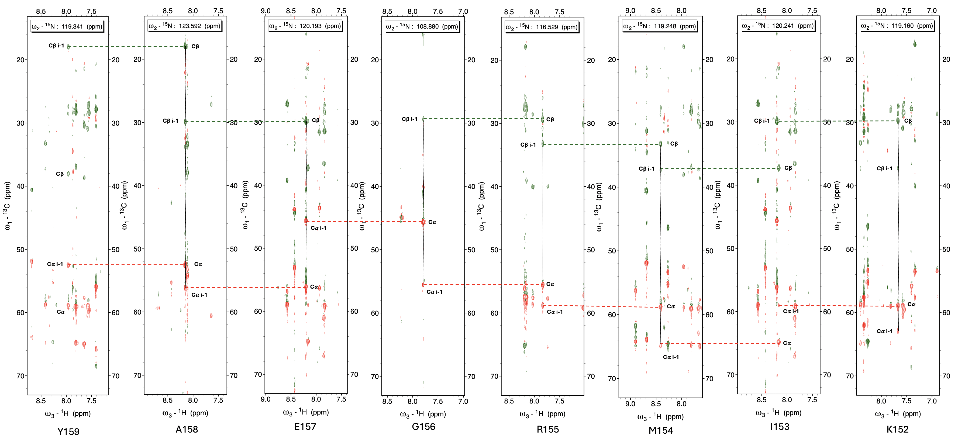
Supplementary Figure 1. TROSY-NHCACB spectra stripe plots from K152 to Y159 show backbone assignments strategy of MTT_{SA.} Each stripe plot has corresponding H_{N} chemical shifts, in which positive signals are colored red, and negative signals are colored green. The stronger peaks represent the current residue chemical shift (Cα_{i} and Cβ_{i} ), and weaker peaks represent the preceding residue chemical shift (Cα_{i-1} and Cβ_{i-1}). Backbone assignments are completed by finding identical Cα/Cβ pairs in another H_{N} group.

