Supplementary Material - S1
For the GOB confidence scores, a different value returns a different number of buildings (Figure S1). The highest confidence level available (0.9) is too strict and does remove too many buildings and since we are more interested in getting a good estimate of the number of buildings, rather than their precise outlines, we selected a lower interval (0.75) and validated it independently. We took a random sample of 1,000 buildings and marking if the detection was a correct ID of a building or not and a score of 0.75 was sufficient to remove invalid detections. 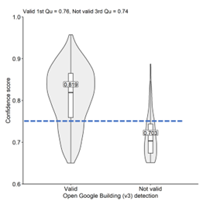
Figure S1. Number of buildings in the GOB database for different confidence scores and number of valid and non-valid detections for different thresholds.
Supplementary Material - S2
We used ICESat-2 altimetry data to produce an independent validation dataset of building heights over the city of Kuala Lumpur. SlideRule was used to aggregate all photons from the ATL03 Global Geolocated Photons product (Neumann et al., 2022) within a 5 m moving window (5 m length and step). Points with a minimum of three photons and a misfit root mean square error of less than one metre were retained. We separated these points into those that intersected building polygons (excluding a 1 m buffer from the building edge), and those intersecting the ground (within a buffer of 5-10 m) from building polygons. These buffers were chosen to reduce edge effects around the buildings due to horizontal georeferencing errors in the GOB dataset. Additionally, we excluded buildings where the topographic slope in a 20 m buffer around the building exceeded 10°. Where a building polygon had one or more aggregated ICESat-2 point from the roof and the adjacent ground, a median elevation was assigned for the roof and ground, which were differenced to derive the building height. The height of these buildings (n=926) were then compared with heights extracted from the BHE (Cai et al., 2023), and the World Settlement Footprint 3D building height products. The differences are reported in Table 1.

Table 1: Comparison between building height models and ICESat-2 derived building heights
Building height model | Root Mean Square Error (m) | Mean absolute error (m)
Deep learning (Cai et al., 2023) | 8.94 | 5.42
World Settlement Footprint 3D | 9.17 | 4.62

