Electronic Supplementary Material

Sociality Predicts Enhanced Auditory Thresholds and Binaural Hearing Processing Across Rodent Species

Luberson Joseph, Fabio A. Machado, and Elizabeth A. McCullagh

Corresponding author:
Elizabeth A. McCullagh
E-mail: elizabeth.mccullagh@okstate.edu
Department of Biology, Oklahoma State University (OSU), College of Arts and Sciences, Stillwater, Oklahoma 74078, USA

Content:
- Deoxyribonucleic acid (DNA) analysis
- Fig S1: Mean auditory brainstem response thresholds in solitary, monogamous, and group-living rodents across tested frequencies
- Fig S2: Mean click response thresholds in solitary, monogamous, and group-living rodents tested
- Fig S3: Example of ABR trace of each tested species
- Fig S4: Average peak latency of ABR waves I and IV determined with clicks of different intensities
- Table S1: Deviance Information Criterion (DIC) of all models
- References

Deoxyribonucleic acid (DNA) analysis
Tail tissue samples were used to genetically confirm species following the protocol described by Nicolas and colleagues¹. DNA samples were primarily incubated overnight in a mixture of Buffer ALT and Proteinase K at 56ºC for cells lysing. DNA were next extracted using a Qiagen DNeasy blood and tissue extraction kit (Qiagen Inc., Hilden, Germany), following the manufacturer’s guidelines. To monitor for potential DNA contamination, we performed blank readings in each extraction batch with no DNA sample (i.e., only water). We next measured the purity and concentration of the DNA extracted for each sample with a Thermo Scientific Nano-Drop (Fisher Scientific, Spectrophotometer, Nanodrop Life 6V 18W, Wilmington, DE). For all samples, the primer sequences (CCTACTCRGCCATTTTACCTATG) and (ACTTCTGGGTGCCAAAGAATCA) were used for amplifying the cytochrome c oxidase subunit I (COI) gene ^{2,3}. DNA samples were assayed in a 50 μL reaction comprising 25 μL Phusion Master mix, 2.5 μL reverse primer, 2.5 μL forward primer, and 20 μL mQ water. The total polymerase chain reaction (PCR) amplifications were performed using an Eppendorf Thermal Cycler (Eppendorf 6346000021 Mastercycler Nexus SX1 Thermal Cycler, California, USA) under the following criteria: initial denaturation at 95º C for 300 seconds; 35 cycles of denaturation at 94 º C for 30 seconds, annealing at 55 º C for 40 seconds, and an extension step at 72 º C for 90 seconds; followed by a second extension at 72 º C for 300 seconds. Amplified double-stranded PCR products were purified and sequenced at the Oklahoma State University’s Center for Genomic and Proteomic (Stillwater, Oklahoma, USA). Resulting sequencing were adjusted manually using the software 4peaks and compared with other COI sequences using the National Center for Biotechnology Information (NCBI) GenBank database to confirm species identity ^{4,5}.

Fig S1: Mean auditory brainstem response thresholds in solitary, monogamous, and group-living wild-caught rodents across tested frequencies (n = 90, 10 individuals per species). Error bars represent the standard error of the mean (SEM) at each tested frequency. Blue represents solitary species, pink indicates monogamous species and green represents group-living species.

Fig S2: Boxplots illustrating click response thresholds for the mine studied species (solitary = blue, monogamous = pink, group-living = green). The horizontal bars represent the minimum, the median and the maximum values. The whiskers represent the first and the fifth quantile.

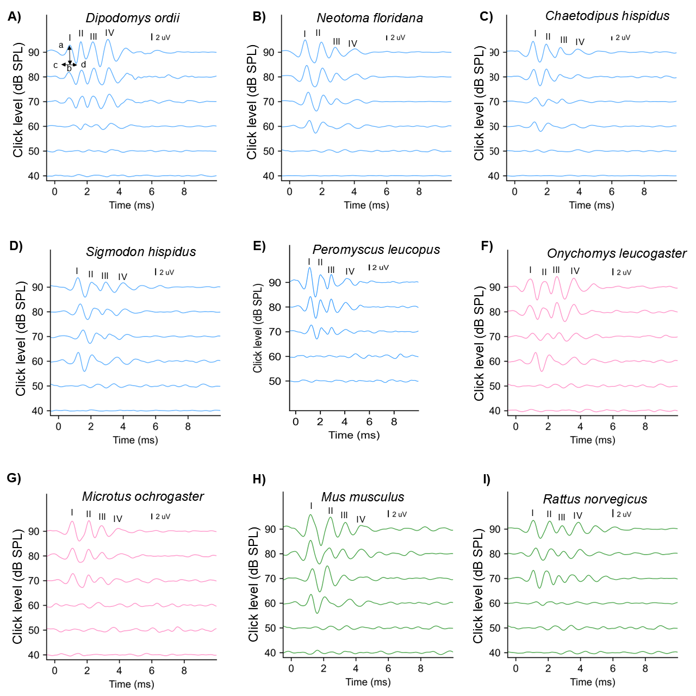
Fig S3: ABR traces to click stimuli for a representative male of the nine species included in this study (Fig 2A- 2I). Waves I – IV are labeled in the 90 dB SPL example for each individual. In figure 2A, the arrow labeled “ab” indicates how amplitude was measured, while cd arrow illustrates how latency was determined.

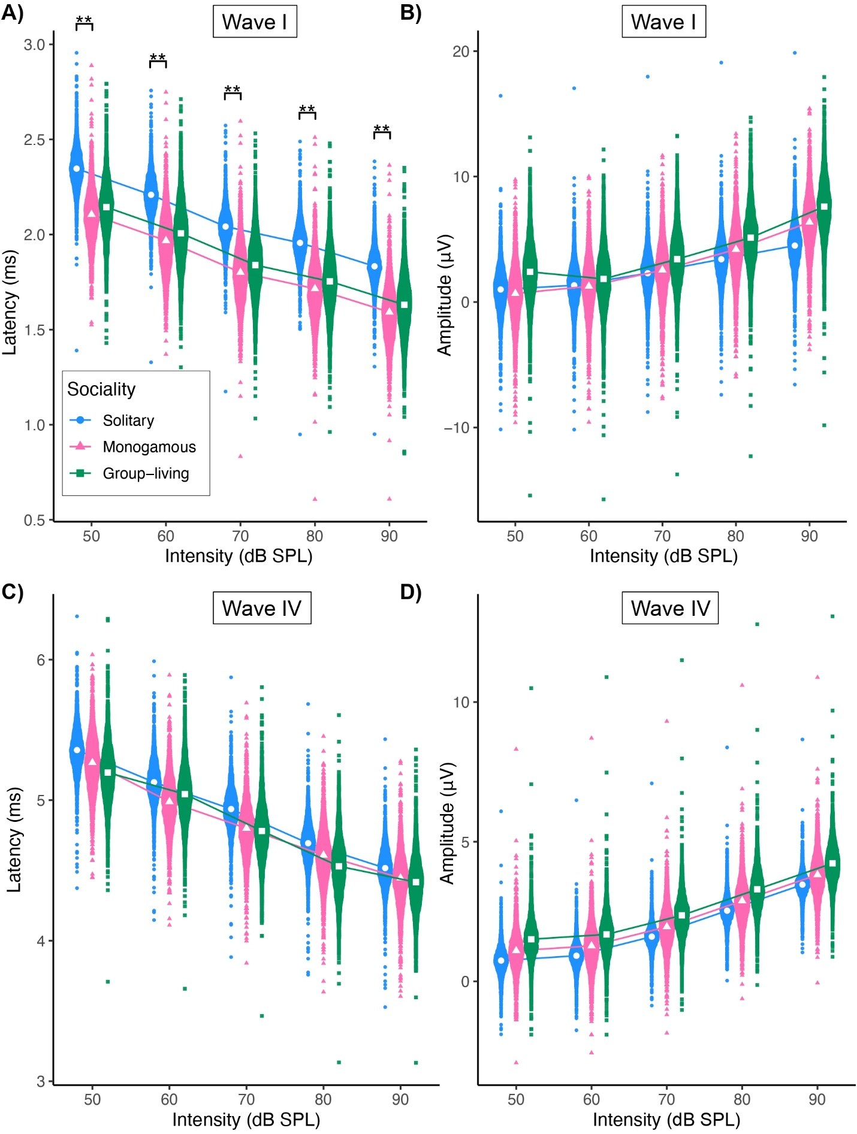
Fig S4: A. The average latency of ABR waves I determined with clicks of different intensities (blue represents solitary species, pink represents monogamous species, and green represents group-living species). B. The average ABR waves I amplitude determined with clicks of different intensities. C. The average latency of ABR wave IV determined with click of different intensities. D. The average ABR wave IV amplitude determined with clicks of different intensities. White circle (solitary), white triangle (Monogamous), and white square (Group-living) represent the mean value for each group. Significant differences were detected in ABR wave I latency across social groups. No significant differences were detected in ABR wave IV latency, wave I amplitude, and wave IV amplitude across social groups. Asterisks represent Bayesian statistical differences across social groups with p < 0.05 **.

Table S1: Deviance Information Criterion (DIC) of all models
TABLE 1
Deviance Information Criterion (DIC)
Measured variables | Null model | Additive model | Full model | Best model
Auditory thresholds | 5752.525 | 5752.839 | 5725.523 | Full
Click thresholds | - 539.0838 | - | - 601.8546 | Full
Interpeak latency | 854.0285 | 853.7561 | 869.6138 | Additive
Amplitude ratio | 378.27.2 | 377.7405 | 391.8661 | Additive
Normalized Latency | 904.0789 | 903.9037 | 880.9605 | Full
Relative Amplitude | 6169.966 | 6169.221 | 6163.805 | Full
Wave I amplitude | 2561.229 | 2561.105 | 2533.866 | Full
Wave IV amplitude | 2388.517 | 2388.181 | 2391.162 | Additive
Wave I Latency | 412.6882 | 412.2231 | 427.9876 | Additive
Wave IV latency | 756.7111 | 756.0618 | 772.1311 | Additive

REFERENCES
1. Nicolas, V. et al. Assessment of Three Mitochondrial Genes (16S, Cytb, CO1) for Identifying Species in the Praomyini Tribe (Rodentia: Muridae). PLOS ONE 7, e36586 (2012).
2. Ducroz, J. F., Volobouev, V. & Granjon, L. An Assessment of the Systematics of Arvicanthine Rodents Using Mitochondrial DNA Sequences: Evolutionary and Biogeographical Implications. Journal of Mammalian Evolution 8, 173–206 (2001).
3. Robins, J. H., Hingston, M., Matisoo-Smith, E. & Ross, H. A. Identifying Rattus species using mitochondrial DNA. Molecular Ecology Notes 7, 717–729 (2007).
4. Sayers, E. W. et al. Database resources of the National Center for Biotechnology Information. Nucleic Acids Research 49, D10–D17 (2021).
5. Sayers, E. W. et al. GenBank. Nucleic Acids Research 50, D161–D164 (2022).

