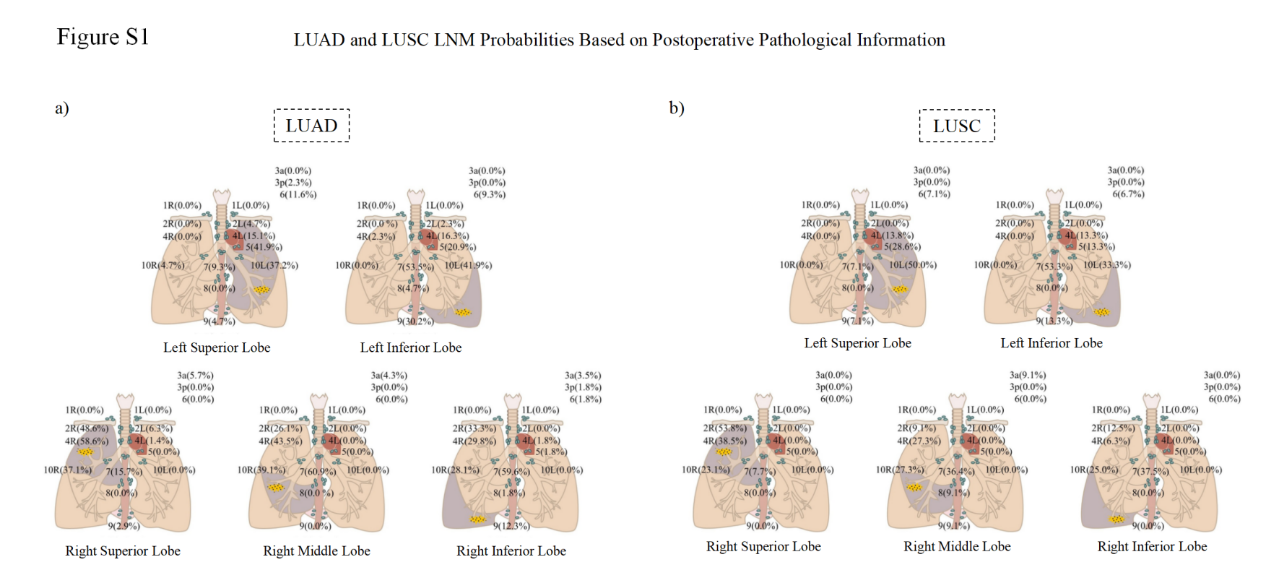
Fig.S1. LUAD and LUSC LNM Probabilities Based on Postoperative Pathological Information
a) For the LUAD patients, among 43 left superior lobe LUAD cases, level 5, 10L and 4L were identified as the three most frequent metastatic levels, and in 43 left inferior lobe cases, level 7, 10L and 9 predominated. For 70 right superior lobe tumors, level 4R, 2R and 10R represented the top metastatic sites, while 23 right middle lobe cases showed highest involvement at 7, 4R and 10R. Among 57 right inferior lobe LUAD patients, 7, 2R, 4R demonstrated the greatest metastatic frequency; b) For the LUSC patients, among 14 left superior lobe cases, level 10L, 5, and 4L demonstrated the highest metastatic frequencies; for 15 left inferior lobe cases, level 7, 10L and 9/4L predominated. In 13 right superior lobe tumors, 2R, 4R and 10R were most frequently involved, while 11 right middle lobe cases showed peak metastasis at 7, 4R and 10R. Among 16 right inferior lobe patients, level 7, 10R, and 2R comprised the top metastatic sites.
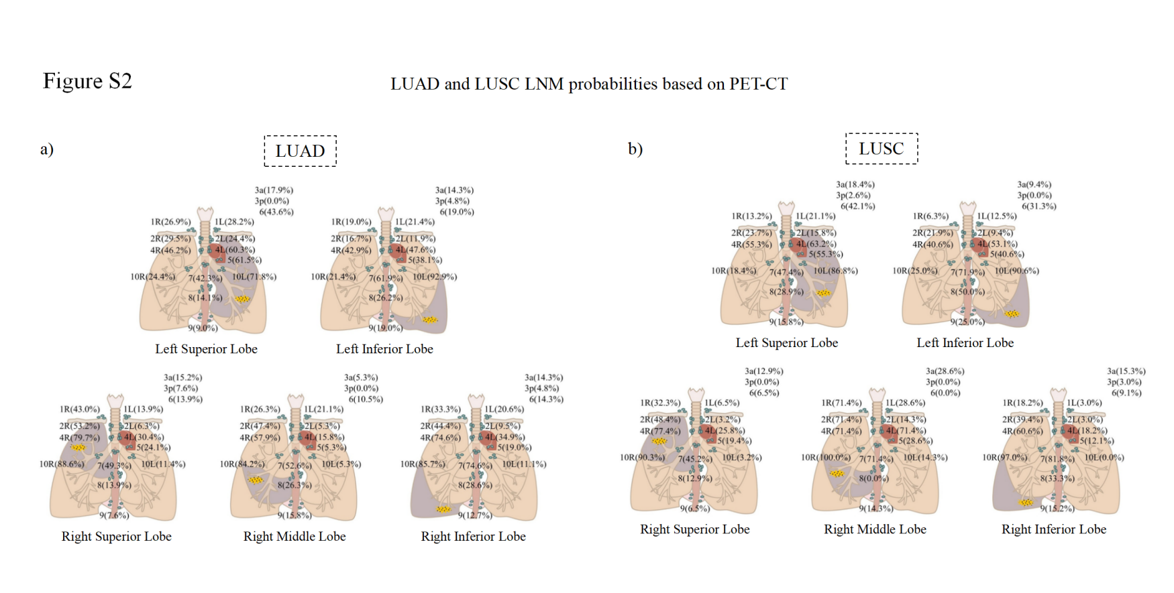
Fig. S2. LUAD and LUSC LNM Probabilities Based on PET-CT
a) For LUAD originating from different pulmonary lobes, the metastatic probabilities across nodal stations are presented in the figures. Specifically, for left superior lobe LUAD, the most common LNM sites were 10L, 5, 4L, 4R, and 6 (descending order), for the left inferior lobe LUAD, top 5 LNM sites were 10L, 7, 4L, 4R, and 5, in right superior lobe, they are 10R, 4R, 2R, 7, and 1R, in right middle lobe, they are 10R, 4R, 7, 2R, and 1R and in right inferior lobe, they are 10R, 4R, 7, 2R, and 4L; b) For LUSC originating from different pulmonary lobes, the metastatic probabilities across nodal stations are presented in the figures. Specifically, for the left superior lobe LUSC, primary metastatic stations were 10L, 4L, 4R, 5, and 7, in left inferior lobe, they are 10L, 7, 4L, 8, and 4R/5. For the right superior lobe LUSC, top 5 stage are 10R, 4R, 2R, 7, and 1R, in right middle lobe, they are 10R, 1R, 2R, 4L, 4R, and 7, in right inferior lobe, they are 10R, 7, 4R, 2R, and 8.

Table.S1 NSCLC LNM probabilities Based on Postoperative Pathological Data
LNM probabilities | LUAD |  |  |  |  | LUSC
LNM probabilities | Left Superior Lobe  n=43 | Left Inferior Lobe  n=43 | Right Superior Lobe  n=70 | Right Middle Lobe  n=23 | Right  Inferior Lobe  n=57 | Left Superior Lobe  n=14 | Left Inferior Lobe  n=15 | Right Superior Lobe  n=13 | Right Middle Lobe  n=11 | Right  Inferior Lobe  n=16
1L | 0 | 0 | 0 | 0 | 0 | 0 | 0 | 0 | 0 | 0
1R | 0 | 0 | 0 | 0 | 0 | 0 | 0 | 0 | 0 | 0
2L | 4.7% | 2.3% | 0 | 0 | 0 | 0 | 0 | 0 | 0 | 0
2R | 0 | 0 | 48.6% | 26.1% | 33.3% | 0 | 0 | 53.8% | 9.1% | 12.5%
3a | 0 | 0 | 5.7% | 4.3% | 3.5% | 0 | 0 | 0 | 9.1% | 0
3p | 2.3% | 0 | 0 | 0 | 1.8% | 0 | 0 | 0 | 0 | 0
4L | 15.1% | 16.3% | 1.4% | 0 | 1.8% | 13.8% | 13.3% | 0 | 0 | 0
4R | 0 | 2.3% | 58.6% | 43.5% | 29.8% | 0 | 0 | 38.5% | 27.3% | 6.3%
5 | 41.9% | 20.9% | 0 | 0 | 1.8% | 28.6% | 13.3% | 0 | 0 | 0
6 | 11.6% | 9.3% | 0 | 0 | 1.8% | 7.1% | 6.7% | 0 | 0 | 0
7 | 9.3% | 53.5% | 15.7% | 60.9% | 59.6% | 7.1% | 53.3% | 7.7% | 36.4% | 37.5%
8 | 0 | 4.7% | 0 | 0 | 1.8% | 0 | 0 | 0 | 9.1% | 0
9 | 4.7% | 30.2% | 2.9% | 0 | 12.3% | 7.1% | 13.3% | 0 | 9.1% | 0
10L | 37.2% | 41.9% | 0 | 0 | 0 | 50% | 33.3% | 0 | 0 | 0
10R | 4.7% | 0 | 37.1% | 39.1% | 28.1% | 0 | 0 | 23.1% | 0 | 25%

LNM probabilities | LUAD |  |  |  |  |  | LUSC
LNM probabilities | Left Superior Lobe  n=78 | Left Inferior Lobe  n=42 | Right Superior Lobe  n=79 | Right Middle Lobe  n=19 | Right  Inferior Lobe  n=63 |  | Left Superior Lobe  n=38 | Left Inferior Lobe  n=32 | Right Superior Lobe  n=31 | Right Middle Lobe  n=7 | Right  Inferior Lobe  n=33
1L | 28.2% | 21.4% | 13.9% | 21.1% | 20.6% |  | 6.5% | 21.1% | 12.5% | 28.6% | 3%
1R | 26.9% | 19% | 43% | 26.3% | 33.3% |  | 32.3% | 13.2% | 6.3% | 71.4% | 18.2%
2L | 24.4% | 11.9% | 6.3% | 5.3% | 9.5% |  | 3.2% | 15.8% | 9.4% | 14.3% | 3%
2R | 29.5% | 16.7% | 53.2% | 47.4% | 44.4% |  | 48.4% | 23.7% | 21.9% | 71.4% | 39.4%
3a | 17.9% | 14.3% | 15.2% | 5.3% | 14.3% |  | 12.9% | 18.4% | 9.4% | 28.6% | 15.2%
3p | 0 | 4.8% | 7.6% | 0 | 4.8% |  | 0 | 2.6% | 0 | 0 | 3%
4L | 60.3% | 47.6% | 30.4% | 15.8% | 34.9% |  | 25.8% | 63.2% | 51.3% | 71.4% | 18.2%
Table.S2 NSCLC LNM Probabilities Based on PET-CT Data

LNM probabilities | LUAD |  |  |  |  |  | LUSC
LNM probabilities | Left Superior Lobe  n=78 | Left Inferior Lobe  n=42 | Right Superior Lobe  n=79 | Right Middle Lobe  n=19 | Right  Inferior Lobe  n=63 |  | Left Superior Lobe  n=38 | Left Inferior Lobe  n=32 | Right Superior Lobe  n=31 | Right Middle Lobe  n=7 | Right  Inferior Lobe  n=33
4R | 46.2% | 42.9% | 79.7% | 57.9% | 74.6% |  | 6.5% | 21.1% | 12.5% | 28.6% | 3%
5 | 61.5% | 38.1% | 24.1% | 5.3% | 19% |  | 32.3% | 13.2% | 6.3% | 71.4% | 18.2%
6 | 43.6% | 19% | 13.9% | 10.5% | 14.3% |  | 3.2% | 15.8% | 9.4% | 14.3% | 3%
7 | 42.3% | 61.9% | 49.3% | 52.6% | 74.6% |  | 48.4% | 23.7% | 21.9% | 71.4% | 39.4%
8 | 14.1% | 26.2% | 13.9% | 26.3% | 28.6% |  | 12.9% | 18.4% | 9.4% | 28.6% | 15.2%
9 | 9% | 19% | 7.6% | 15.8% | 12.7% |  | 0 | 2.6% | 0 | 0 | 3%
10L | 71.8% | 92.9% | 11.4% | 5.3% | 11.1% |  | 25.8% | 63.2% | 51.3% | 71.4% | 18.2%
10R | 24.4% | 21.4% | 88.6% | 84.2% | 85.7% |  | 77.4% | 55.3% | 40.6% | 71.4% | 60.6%
Continued Table S2 NSCLC LNM Probabilities Based on PET-CT Data

Table S3 Comparison of Overall LNM Rates Between Postoperative LUAD and LUSC
LNM Levels | The number and rate of LNM |  | P value
LNM Levels | LUAD (n=281) | LUSC (n=141) | P value
1L | - | - | -
1R | - | - | -
2L | 3(1.3%) | 0% | 0.347
2R | 59(25.0%) | 10(14.5%) | 0.067
3a | 7(3.0%) | 1(1.4%) | 0.488
3p | 2(0.8%) | 0% | 0.443
4L | 15(6.4%) | 4(5.8%) | 0.866
4R | 69(29.2%) | 9(13.0%) | 0.007
5 | 28(11.9%) | 6(8.7%) | 0.462
6 | 10(4.2%) | 2(0.7%) | 0.615
7 | 86(36.4%) | 20(29.0%) | 0.253
8 | 3(1.3%) | 1(1.4%) | 0.909
9 | 24(10.2%) | 4(5.8%) | 0.269
10L | 34(14.4%) | 12(17.4%) | 0.542
10R | 53(22.5%) | 10(14.5%) | 0.151
L-IPLN | 51(21.6%) | 14(20.3%) | 0.814
R-IPLN | 83(35.2%) | 18(26.1%) | 0.151
Note: "-" indicates undissected lymph node stations.
Table S4 Comparison of LNM Rates Between LUAD and LUSC (Left Lung vs. Right Lung, Postoperative Pathology Data)
LNM Level | Left Lung (n=115) |  |  |  | Right Lung (n=190)
LNM Level | LUAD(n=86) | LUSC(n=29) | p Value |  | LUAD(n=150) | LUSC(n=40) | p Value
1L | - | - | - |  | - | - | -
1R | - | - | - |  | - | - | -
2L | 3(3.5%) | 0% | 0.308 |  | - | - | -
2R | - | - | - |  | 59(39.3%) | 10(25.0%) | 0.094
3a | - | - | - |  | 7(4.7%) | 1(2.5%) | 0.544
3p | 1(1.2%) | 0% | 0.560 |  | 1(0.7%) | 0% | 0.605
4L | 13(15.1%) | 4(13.8%) | 0.862 |  | 2(1.3%) | 0% | 0.463
4R | 1(1.2%) | 0% | 0.560 |  | 68(45.3%) | 9(22.5%) | 0.009
5 | 27(31.4%) | 6(20.7%) | 0.270 |  | 1(0.7%) | 0% | 0.605
6 | 9(10.5%) | 2(6.9%) | 0.572 |  | 1(0.7%) | 0% | 0.605
7 | 27(31.4%) | 9(31.0%) | 0.971 |  | 59(39.3%) | 11(27.5%) | 0.168
8 | 2(2.3%) | 0% | 0.407 |  | 1(0.7%) | 1(2.5%) | 0.313
9 | 15(17.4%) | 3(10.3%) | 0.363 |  | 9(6.0%) | 1(2.5%) | 0.378
10L | 34(39.5%) | 12(41.4%) | 0.861 |  | - | - | -
10R | 2(2.3%) | 0% | 0.407 |  | 51(34.0%) | 10(25.0%) | 0.279
L-IPLN | 51(59.3%) | 14(48.3%) | 0.300 |  | - | - | -
R-IPLN | - | - | - |  | 83(55.3%) | 18(45.0%) | 0.245

Table S5
Correlation of LNM Grades in LUAD Patients (n=236, Postoperative Pathology Data)
 | Level (LNM number) | Relevant levels
 | 1L(0) | -
 | 1R(0) | -
 | 2L(3,+) | -
 | 2R(59,+) | 4R(42,++)
 | 3a(7,+) | -
 | 3p(4,+) | -
 | 4L(15,+) | 6(4,++)
 | 4R(69,+) | 2R(42,++)
 | 5(28,+) | -
 | 6(10,+) | 4L(4,++)
 | 7(86,+) | 9(18,++),
 | 8(3,+) | -
 | 9(24,+) | 7(18,++)
 | 10L(34,+) | 9(9,++)
 | 10R(53,+) | -
 | L-IPLN (51,+) | -
 | R-IPLN (83,+) | -
Note: “+” indicates positive metastasis in one lymph node level; “++” denotes dual positivity in both levels
Table S6 Comparison of LNM Rates Between LUAD and LUSC (Left Lung vs. Right Lung, PET-CT Data)
LNM  Levels | Left Lung (n=190) |  |  |  | Right Lung (n=232)
LNM  Levels | LUAD(n=120) | LUSC(n=70) | P value |  | LUAD(n=161) | LUSC(n=71) | P value
1L | 31(25.8%) | 12(17.1%) | 0.167 |  | 28(17.4%) | 5(7.0%) | 0.038
1R | 29(24.2%) | 7(10.0%) | 0.016 |  | 60(37.3%) | 21(29.6%) | 0.258
2L | 24(20.0%) | 9(12.9%) | 0.210 |  | 12(7.5%) | 3(4.2%) | 0.357
2R | 30(25.0%) | 16(22.9%) | 0.739 |  | 79(49.1%) | 33(46.5%) | 0.716
3a | 20(16.7%) | 10(14.3%) | 0.664 |  | 22(13.7%) | 11(15.5%) | 0.713
3p | 2(1.7%) | 1(1.4%) | 0.899 |  | 9(5.6%) | 1(1.4%) | 0.148
4L | 67(55.8%) | 41(58.6%) | 0.713 |  | 49(30.4%) | 19(26.8%) | 0.571
4R | 54(45.0%) | 34(48.6%) | 0.634 |  | 121(75.2%) | 49(69.0%) | 0.330
5 | 64(53.3%) | 34(34.7%) | 0.526 |  | 32(19.9%) | 12(16.9%) | 0.594
6 | 42(35.0%) | 26(37.1%) | 0.766 |  | 22(13.7%) | 5(7.0%) | 0.147
7 | 59(49.2%) | 41(58.6%) | 0.210 |  | 96(59.6%) | 46(64.8%) | 0.457
8 | 22(18.3%) | 27(38.6%) | 0.002 |  | 34(21.1%) | 15(21.1%) | 0.999
9 | 15(12.5%) | 14(20.0%) | 0.166 |  | 17(10.6%) | 8(11.3%) | 0.873
10L | 95(79.2%) | 62(88.6%) | 0.099 |  | 17(10.6%) | 2(2.8%) | 0.047
10R | 28(23.3%) | 15(21.4%) | 0.762 |  | 140(87.0%) | 67(94.4%) | 0.093
L-IPLN | 38(31.7%) | 26(37.1%) | 0.441 |  | 5(3.1%) | 0 | 0.133
R-IPLN | 3(2.5%) | 2(2.9%) | 0.882 |  | 62(38.5%) | 28(39.4%) | 0.894

Table S7
Comparison of LNM Rates Between LUAD and LUSC (Left Lobes, PET-CT Data)
LNM  Levels | Left Superior Lobe (n=116) |  |  |  | Left Inferior Lobe (n=74)
LNM  Levels | LUAD(n=78) | LUSC(n=38) | P value |  | LUAD(n=42) | LUSC(n=32) | P value
1L | 22(28.2%) | 8(21.1%) | 0.409 |  | 9(21.4%) | 4(12.5%) | 0.317
1R | 21(26.9%) | 5(13.2%) | 0.095 |  | 8(19.0%) | 2(6.3%) | 0.111
2L | 19(24.4%) | 6(15.8%) | 0.292 |  | 5(11.9%) | 3(9.4%) | 0.728
2R | 23(29.5%) | 9(23.7%) | 0.512 |  | 7(16.7%) | 7(21.9%) | 0.571
3a | 14(17.9%) | 7(18.4%) | 0.951 |  | 6(14.3%) | 3(9.4%) | 0.552
3p | 0 | 1(2.6%) | 0.150 |  | 2(4.8%) | 0 | 0.211
4L | 47(60.3%) | 24(63.2%) | 0.763 |  | 20(47.6%) | 17(53.1%) | 0.639
4R | 36(46.2%) | 21(55.3%) | 0.357 |  | 18(42.9%) | 13(40.6%) | 0.847
5 | 48(61.5%) | 21(55.3%) | 0.518 |  | 16(38.1%) | 13(40.6%) | 0.825
6 | 34(43.6%) | 16(42.1%) | 0.880 |  | 8(19.0%) | 10(31.3%) | 0.225
7 | 33(42.3%) | 18(47.4%) | 0.606 |  | 26(61.9%) | 23(71.9%) | 0.369
8 | 11(14.1%) | 11(28.9%) | 0.056 |  | 11(26.2%) | 16(50.0%) | 0.035
9 | 7(9.0%) | 6(15.8%) | 0.275 |  | 8(19.0%) | 8(25.0%) | 0.538
10L | 56(71.8%) | 33(86.8%) | 0.072 |  | 39(92.9%) | 32(90.6%) | 0.727
10R | 19(24.4%) | 7(18.4%) | 0.472 |  | 9(21.4%) | 8(25.0%) | 0.717
L-IPLN | 18(23.1%) | 10(26.3%) | 0.702 |  | 20(47.6%) | 16(50.0%) | 0.839
R-IPLN | 2(2.6%) | 0 | 0.319 |  | 1(2.4%) | 2(6.3%) | 0.403

Table S8
Comparison of LNM Rates Between LUAD and LUSC (Right Lobes)
LNM  Levels | Right Superior Lobe (n=110) |  |  |  | Right Inferior Lobe (n=96)
LNM  Levels | LUAD(n=79) | LUAS(n=31) | P value |  | LUAD(n=63) | LUAS(n=33) | P value
1L | 11(13.9%) | 2(6.5%) | 0.275 |  | 13(20.6%) | 1(3.0%) | 0.020
1R | 34(43.0%) | 10(32.3%) | 0.299 |  | 21(33.3%) | 6(18.2%) | 0.117
2L | 5(6.3%) | 1(3.2%) | 0.519 |  | 6(9.5%) | 1(3.0%) | 0.245
2R | 42(53.2%) | 15((48.4%) | 0.652 |  | 28(44.4%) | 13(39.4%) | 0.635
3a | 12(15.2%) | 4(12.9%) | 0.760 |  | 9(14.3%) | 5(15.2%) | 0.909
3p | 6(7.6%) | 0 | 0.115 |  | 3(4.8%) | 1(3.0%) | 0.687
4L | 24(30.4%) | 8(25.8%) | 0.635 |  | 22(34.9%) | 6(18.2%) | 0.087
4R | 63(79.7%) | 24(77.4%) | 0.787 |  | 47(74.6%) | 20(60.6%) | 0.156
5 | 19(24.1%) | 6(19.4%) | 0.567 |  | 12(19.0%) | 4(12.1%) | 0.387
6 | 11(13.9%) | 2(6.5%) | 0.275 |  | 9(14.3%) | 3(9.1%) | 0.465
7 | 39(49.3%) | 14(45.2%) | 0.691 |  | 47(74.6%) | 27(81.8%) | 0.424
8 | 11(13.9%) | 4(12.9%) | 0.888 |  | 18(28.6%) | 11(33.3%) | 0.629
9 | 6(7.6%) | 2(6.5%) | 0.835 |  | 8(12.7%) | 5(15.2%) | 0.739
10L | 9(11.4%) | 1(3.2%) | 0.180 |  | 7(11.1%) | 0 | 0.047
10R | 70(88.6%) | 28(90.3%) | 0.795 |  | 54(85.7%) | 32(97.0%) | 0.086
L-IPLN | 2(2.5%) | 0 | 0.371 |  | 3(4.8%) | 0 | 0.203
R-IPLN | 28(35.4%) | 8(25.8%) | 0.333 |  | 30(47.6%) | 17(51.5%) | 0.717

Table S9
Correlation of Different Grades of LNM in Patients with LUAD (n=281) and LUSC(n=141) based on PET-CT.
LUAD(n=281) |  | LUSC(n=141)
Level (LNM number) | Relevant levels | Level (LNM number) | Relevant levels
1L(59,+) | 1R(38,++),3a(25,++),4L(45,++),6(35,++) | 1L(17,+) | 1R(9,++),2L(9,++), L-IPLN (9,++)
1R(89,+) | 1L(38,++),2L(24,++),2R(67,++),10R(72,++) | 1R(28,+) | 1L(9,++),2R(23,++)
2L(36,+) | 1R(24,++),4L(31,++),6(23) | 2L(12,+) | 1L(9,++),
2R(109,+) | 1R(67,++),4R(99,++) | 2R(49,+) | 1R(23,++),4R(45,++),8(20,++)
3a(42,+) | 1L(25++),6(25++) | 3a(21,+) | 6(11,++),9(7,++)
3p(11,+) | - | 3p(2,+) | -
4L(116,+) | 1L(45++),2L(31++),4R(87++),7(83++),10L(71++) | 4L(60,+) | 4R(46,++),7(50,++)
4R(175,+) | 2R(99++),4L(87++),7(119++),10R(130++) | 4R(83,+) | 2R(45,++),3a(20,++),4L(46,++),10R(60,++)
5(96,+) | 10L(64++) | 5(46,+) | 6(24,++)
6(64,+) | 1L(35++) | 6(31,+) | 3a(11,++),5(24,++)
7(155,+) | 4L(83++),4R(119++),8(48++), L-IPLN (31++), R-IPLN (51++) | 7(87,+) | 4L(50,++),8(34,++), R-IPLN (27,++)
8(56,+) | 7(48++) | 8(42,+) | 2R(20,++),9(13,++),10L(26,++)
9(32,+) | 2R(18++),10L(19++), L-IPLN (12++), R-IPLN R(15++) | 9(22,+) | 8(13,++), R-IPLN (9,++)
10L(112,+) | 4L(71++),5(64++),9(19++),10R(39++), L-IPLN (41++) | 10L(64,+) | 5(33,++), L-IPLN (25++)
10R(168,+) | 1R(72++),4R(130++), R-IPLN (63++) | 10R(82,+) | 4R(60,++)
L-IPLN (43,+) | 5(64++),7(31++),9(12++),10L(41++) | L-IPLN (26,+) | 8(14,++),10L(25,++)
R-IPLN (65,+) | 7(51++),9(15++),10R(63++) | R-IPLN (30,+) | 7(27++),9(9,++)
Note: “+” indicates positive metastasis in one lymph node level; “++” denotes dual positivity in both levels.

