Supplementary Materials

Tuberculosis Incidence and Mortality Trends in Mainland China, 2004-2024: Control Program and Elimination Progress

1 Methods
1.1 SARIMA Fitting and Forecasting Process
1.1.1 Incidence:
(1)Stationarity Test
Stationarity is a prerequisite for SARIMA modeling. The Augmented Dickey-Fuller (ADF) test was applied to the preprocessed training set data (d_train) to verify stationarity. The null hypothesis of the test is "the sequence is non-stationary"; a p-value < 0.05 rejects the null hypothesis, indicating a stationary sequence. Results showed an ADF test statistic of -6.4395, a lag order of 5, and a p-value of 0.01, confirming that the training set data meets the stationarity requirement and is suitable for subsequent model parameter fitting.
- Non-White Noise Test
To ensure the modeling data contains extractable valid information (e.g., trends, seasonality), the Box-Ljung test was performed on the stationary training set data. The null hypothesis is "the sequence is white noise (no valid information)"; a p-value < 0.1 rejects the null hypothesis, indicating a non-white noise sequence. Results revealed a test statistic (X-squared) of 109.82, degrees of freedom (df) of 24, and a p-value < 0.001, confirming significant non-random fluctuation characteristics in the data, which is of modeling value.
- Residual White Noise Test
After model fitting, residual analysis was conducted to verify the sufficiency of information extraction. The Box-Ljung test was applied to the residuals of the SARIMA model (sarima_model$residuals). The null hypothesis is "the residuals are white noise (sufficient information extracted)"; a p-value > 0.05 accepts the null hypothesis, indicating the model does not miss valid information and exhibits good fitting performance. Results showed a test statistic (X-squared) of 32.902, degrees of df of 24, and a p-value of 0.1062, demonstrating that the model residuals satisfy the white noise property. The model has fully captured the time series patterns of tuberculosis incidence in China, confirming its validity and reliability.

1.1.2 Death
- Stationarity Test
Stationarity is a prerequisite for SARIMA modeling. The Augmented Dickey-Fuller (ADF) test was applied to the preprocessed training set data (d_train) to verify stationarity. The null hypothesis of the test is "the sequence is non-stationary"; a p-value < 0.05 rejects the null hypothesis, indicating a stationary sequence. Results showed a Dickey-Fuller test statistic of -5.8895, a lag order of 5, and a p-value of 0.01, confirming that the training set data meets the stationarity requirement and is suitable for subsequent model parameter fitting.
(2)Non-White Noise Test
To ensure the modeling data contains extractable valid information (e.g., trends, seasonality), the Box-Ljung test was performed on the stationary training set data. The null hypothesis is "the sequence is white noise (no valid information)"; a p-value < 0.1 rejects the null hypothesis, indicating a non-white noise sequence. Results revealed a test statistic (X-squared) of 87.806, degrees of freedom (df) of 24, and a p-value of 3.316e-09, confirming significant non-random fluctuation characteristics in the data, which is of modeling value.
(3)Residual White Noise Test
After model fitting, residual analysis was conducted to verify the sufficiency of information extraction. The Box-Ljung test was applied to the residuals of the SARIMA model (sarima_model$residuals). The null hypothesis is "the residuals are white noise (sufficient information extracted)"; a p-value > 0.05 accepts the null hypothesis, indicating the model does not miss valid information and exhibits good fitting performance. Results showed a test statistic (X-squared) of 22.727, degrees of freedom (df) of 24, and a p-value of 0.536 (> 0.05), demonstrating that the model residuals satisfy the white noise property. The model has fully captured the time series patterns of tuberculosis mortality in China, confirming its validity and reliability.

1.2 Calculation Formulas of Evaluation Indicators
(1)Mean Squared Error(MSE):
(2)Root Mean Squared Error(RMSE):
$$RMSE=\sqrt{\frac{1}{n}×\sum_{i=1}^{n}{{(Y_{i}−P_{i})}^{2}} }$$
(3)Mean Absolute Error(MAE):
$$MAE=\frac{1}{n}×\sum_{i=1}^{n}{|Y_{i}}−P_{i}|$$
(4)Mean Absolute Percentage Error(MAPE):
$MAPE=(\frac{1}{n})×\sum_{i=1}^{n}{(\frac{|Y_{i}−P_{i}|}{Y_{i}}}$)$×100$
(5)Symmetric Mean Absolute Percentage Error(sMAPE):
$$sMAPE=\frac{\text{1}}{\text{n}}\sum_{\text{i=1}}^{\text{n}}{\text{|}\frac{{\text{Y}}_{\text{i}}\text{-}{\text{P}}_{\text{i}}}{\frac{{\text{Y}}_{\text{i}}\text{+}{\text{P}}_{\text{i}}}{\text{2}}}}\text{|}×100\%$$
In these formulae, n represents the sample size, $Y_{i}$ represents the monthly actual incidence/death rate of tuberculosis for each month, and $P_{i}$ represents the predicted incidence/death rate.

TableS1. SARIMA parameter selection for tuberculosis incidence
SARIMA Model Specification | AICc Value
ARIMA(0,1,0)(0,1,0)[12] | 291.9749
ARIMA(0,1,0)(0,1,1)[12] | 271.3647
ARIMA(0,1,0)(0,1,2)[12] | 273.349
ARIMA(0,1,0)(1,1,0)[12] | 233.1834
ARIMA(0,1,0)(1,1,1)[12] | 181.3777
ARIMA(0,1,0)(1,1,2)[12] | 183.2752
ARIMA(0,1,0)(2,1,0)[12] | 182.9489
ARIMA(0,1,0)(2,1,1)[12] | 170.8715
ARIMA(0,1,0)(2,1,2)[12] | 169.6691
ARIMA(0,1,1)(0,1,0)[12] | 273.4581
ARIMA(0,1,1)(0,1,1)[12] | 250.2817
ARIMA(0,1,1)(0,1,2)[12] | 252.1987
ARIMA(0,1,1)(1,1,0)[12] | 206.0766
ARIMA(0,1,1)(1,1,1)[12] | 172.9456
ARIMA(0,1,1)(1,1,2)[12] | 173.6157
ARIMA(0,1,1)(2,1,0)[12] | 157.0221
ARIMA(0,1,1)(2,1,1)[12] | 157.8881
ARIMA(0,1,1)(2,1,2)[12] | 159.8173
ARIMA(0,1,2)(0,1,0)[12] | 272.6219
ARIMA(0,1,2)(0,1,1)[12] | 249.2137
ARIMA(0,1,2)(0,1,2)[12] | 251.3427
ARIMA(0,1,2)(1,1,0)[12] | 198.0262
ARIMA(0,1,2)(1,1,1)[12] | 165.8177
ARIMA(0,1,2)(1,1,2)[12] | 167.601
ARIMA(0,1,2)(2,1,0)[12] | 149.6831
ARIMA(0,1,2)(2,1,1)[12] | 148.6903
ARIMA(0,1,3)(0,1,0)[12] | 272.7257
ARIMA(0,1,3)(0,1,1)[12] | 250.9453
ARIMA(0,1,3)(0,1,2)[12] | 253.1012
ARIMA(0,1,3)(1,1,0)[12] | 200.0319
ARIMA(0,1,3)(1,1,1)[12] | 167.7142
ARIMA(0,1,3)(2,1,0)[12] | 151.7407
ARIMA(0,1,4)(0,1,0)[12] | 269.2418
ARIMA(0,1,4)(0,1,1)[12] | 249.842
ARIMA(0,1,4)(1,1,0)[12] | 201.3513
ARIMA(0,1,5)(0,1,0)[12] | 271.3887
ARIMA(1,1,0)(0,1,0)[12] | 278.9293
ARIMA(1,1,0)(0,1,1)[12] | 257.0416
ARIMA(1,1,0)(0,1,2)[12] | 258.6023
ARIMA(1,1,0)(1,1,0)[12] | 222.211
ARIMA(1,1,0)(1,1,1)[12] | 174.9417
ARIMA(1,1,0)(1,1,2)[12] | 176.5276
ARIMA(1,1,0)(2,1,0)[12] | 160.9754
ARIMA(1,1,0)(2,1,1)[12] | 151.8448
ARIMA(1,1,0)(2,1,2)[12] | 152.0857
ARIMA(1,1,1)(0,1,0)[12] | 280.0633
ARIMA(1,1,1)(0,1,1)[12] | 256.7437
ARIMA(1,1,1)(0,1,2)[12] | 258.71
ARIMA(1,1,1)(1,1,0)[12] | 213.087
ARIMA(1,1,1)(1,1,1)[12] | 169.8491
ARIMA(1,1,1)(1,1,2)[12] | 171.4277
ARIMA(1,1,1)(2,1,0)[12] | 147.4949
ARIMA(1,1,1)(2,1,1)[12] | Inf
ARIMA(1,1,2)(0,1,0)[12] | 269.4121
ARIMA(1,1,2)(0,1,1)[12] | 249.1294
ARIMA(1,1,2)(0,1,2)[12] | 251.2776
ARIMA(1,1,2)(1,1,0)[12] | 205.071
ARIMA(1,1,2)(1,1,1)[12] | 166.2831
ARIMA(1,1,2)(2,1,0)[12] | 142.5566
ARIMA(1,1,3)(0,1,0)[12] | 271.5026
ARIMA(1,1,3)(0,1,1)[12] | 251.19
ARIMA(1,1,3)(1,1,0)[12] | 206.15
ARIMA(1,1,4)(0,1,0)[12] | 271.5067
ARIMA(2,1,0)(0,1,0)[12] | 251.7884
ARIMA(2,1,0)(0,1,1)[12] | 243.7617
ARIMA(2,1,0)(0,1,2)[12] | 245.2535
ARIMA(2,1,0)(1,1,0)[12] | 193.6201
ARIMA(2,1,0)(1,1,1)[12] | 169.4814
ARIMA(2,1,0)(1,1,2)[12] | 170.8765
ARIMA(2,1,0)(2,1,0)[12] | 151.0033
ARIMA(2,1,0)(2,1,1)[12] | 143.0213
ARIMA(2,1,1)(0,1,0)[12] | 251.199
ARIMA(2,1,1)(0,1,1)[12] | 243.7409
ARIMA(2,1,1)(0,1,2)[12] | 245.2635
ARIMA(2,1,1)(1,1,0)[12] | 173.0242
ARIMA(2,1,1)(1,1,1)[12] | Inf
ARIMA(2,1,1)(2,1,0)[12] | Inf
ARIMA(2,1,2)(0,1,0)[12] | 253.2116
ARIMA(2,1,2)(0,1,1)[12] | 245.8913
ARIMA(2,1,2)(1,1,0)[12] | 172.0451
ARIMA(2,1,3)(0,1,0)[12] | 255.2291
ARIMA(3,1,0)(0,1,0)[12] | 248.5722
ARIMA(3,1,0)(0,1,1)[12] | 243.9788
ARIMA(3,1,0)(0,1,2)[12] | 244.7978
ARIMA(3,1,0)(1,1,0)[12] | 187.816
ARIMA(3,1,0)(1,1,1)[12] | 168.7096
ARIMA(3,1,0)(2,1,0)[12] | 152.2979
ARIMA(3,1,1)(0,1,0)[12] | 247.3796
ARIMA(3,1,1)(0,1,1)[12] | 244.2847
ARIMA(3,1,1)(1,1,0)[12] | 175.92
ARIMA(3,1,2)(0,1,0)[12] | 248.5377
ARIMA(4,1,0)(0,1,0)[12] | 240.0066
ARIMA(4,1,0)(0,1,1)[12] | 237.175
ARIMA(4,1,0)(1,1,0)[12] | 182.9299
ARIMA(4,1,1)(0,1,0)[12] | 242.1627
ARIMA(5,1,0)(0,1,0)[12] | 242.9696
SARIMA:Seasonal Autoregressive Integrated Moving Average; AICc:Corrected Akaike Information Criterion

TableS2. SARIMA parameter selection for tuberculosis death
SARIMA Model Specification | AICc Value
ARIMA(0,1,0) | -1436.606
ARIMA(0,1,0) | -1434.585
ARIMA(0,1,0)(0,0,1)[12] | -1446.566
ARIMA(0,1,0)(0,0,1)[12] | -1444.518
ARIMA(0,1,0)(0,0,2)[12] | -1447.413
ARIMA(0,1,0)(0,0,2)[12] | -1445.336
ARIMA(0,1,0)(1,0,0)[12] | -1442.504
ARIMA(0,1,0)(1,0,0)[12] | -1440.434
ARIMA(0,1,0)(1,0,1)[12] | -1452.589
ARIMA(0,1,0)(1,0,1)[12] | -1450.541
ARIMA(0,1,0)(1,0,2)[12] | -1450.565
ARIMA(0,1,0)(1,0,2)[12] | -1448.497
ARIMA(0,1,0)(2,0,0)[12] | -1446.101
ARIMA(0,1,0)(2,0,0)[12] | -1444.007
ARIMA(0,1,0)(2,0,1)[12] | -1452.901
ARIMA(0,1,0)(2,0,1)[12] | -1450.783
ARIMA(0,1,0)(2,0,2)[12] | -1450.85
ARIMA(0,1,0)(2,0,2)[12] | -1448.707
ARIMA(0,1,1) | -1442.019
ARIMA(0,1,1) | -1439.993
ARIMA(0,1,1)(0,0,1)[12] | -1453.604
ARIMA(0,1,1)(0,0,1)[12] | -1451.552
ARIMA(0,1,1)(0,0,2)[12] | -1456.653
ARIMA(0,1,1)(0,0,2)[12] | -1454.574
ARIMA(0,1,1)(1,0,0)[12] | -1451.49
ARIMA(0,1,1)(1,0,0)[12] | -1449.4
ARIMA(0,1,1)(1,0,1)[12] | -1465.356
ARIMA(0,1,1)(1,0,1)[12] | -1463.381
ARIMA(0,1,1)(1,0,2)[12] | -1463.24
ARIMA(0,1,1)(1,0,2)[12] | -1461.243
ARIMA(0,1,1)(2,0,0)[12] | -1468.924
ARIMA(0,1,1)(2,0,0)[12] | -1466.809
ARIMA(0,1,1)(2,0,1)[12] | -1484.535
ARIMA(0,1,1)(2,0,1)[12] | -1482.395
ARIMA(0,1,1)(2,0,2)[12] | -1482.434
ARIMA(0,1,1)(2,0,2)[12] | -1480.267
ARIMA(0,1,2) | -1441.227
ARIMA(0,1,2) | -1439.181
ARIMA(0,1,2)(0,0,1)[12] | -1451.892
ARIMA(0,1,2)(0,0,1)[12] | -1449.818
ARIMA(0,1,2)(0,0,2)[12] | -1455.41
ARIMA(0,1,2)(0,0,2)[12] | -1453.315
ARIMA(0,1,2)(1,0,0)[12] | -1449.834
ARIMA(0,1,2)(1,0,0)[12] | -1447.722
ARIMA(0,1,2)(1,0,1)[12] | -1464.668
ARIMA(0,1,2)(1,0,1)[12] | -1462.739
ARIMA(0,1,2)(1,0,2)[12] | -1462.566
ARIMA(0,1,2)(1,0,2)[12] | -1460.605
ARIMA(0,1,2)(2,0,0)[12] | -1468.1
ARIMA(0,1,2)(2,0,0)[12] | -1465.968
ARIMA(0,1,2)(2,0,1)[12] | -1483.986
ARIMA(0,1,2)(2,0,1)[12] | -1481.826
ARIMA(0,1,3) | -1439.141
ARIMA(0,1,3) | -1437.072
ARIMA(0,1,3)(0,0,1)[12] | -1450.087
ARIMA(0,1,3)(0,0,1)[12] | -1447.982
ARIMA(0,1,3)(0,0,2)[12] | -1453.286
ARIMA(0,1,3)(0,0,2)[12] | -1451.162
ARIMA(0,1,3)(1,0,0)[12] | -1447.953
ARIMA(0,1,3)(1,0,0)[12] | -1445.811
ARIMA(0,1,3)(1,0,1)[12] | -1462.971
ARIMA(0,1,3)(1,0,1)[12] | -1460.96
ARIMA(0,1,3)(2,0,0)[12] | -1466.457
ARIMA(0,1,3)(2,0,0)[12] | -1464.293
ARIMA(0,1,4) | -1438.896
ARIMA(0,1,4) | -1436.834
ARIMA(0,1,4)(0,0,1)[12] | -1447.943
ARIMA(0,1,4)(0,0,1)[12] | -1445.813
ARIMA(0,1,4)(1,0,0)[12] | -1445.859
ARIMA(0,1,4)(1,0,0)[12] | -1443.689
ARIMA(0,1,5) | -1451.129
ARIMA(0,1,5) | -1449.055
ARIMA(1,1,0) | -1439.465
ARIMA(1,1,0) | -1437.433
ARIMA(1,1,0)(0,0,1)[12] | -1451.13
ARIMA(1,1,0)(0,0,1)[12] | -1449.081
ARIMA(1,1,0)(0,0,2)[12] | -1453.206
ARIMA(1,1,0)(0,0,2)[12] | -1451.133
ARIMA(1,1,0)(1,0,0)[12] | -1449.963
ARIMA(1,1,0)(1,0,0)[12] | -1447.883
ARIMA(1,1,0)(1,0,1)[12] | -1460.95
ARIMA(1,1,0)(1,0,1)[12] | -1458.977
ARIMA(1,1,0)(1,0,2)[12] | -1458.832
ARIMA(1,1,0)(1,0,2)[12] | -1456.832
ARIMA(1,1,0)(2,0,0)[12] | -1460.97
ARIMA(1,1,0)(2,0,0)[12] | -1458.856
ARIMA(1,1,0)(2,0,1)[12] | -1468.508
ARIMA(1,1,0)(2,0,1)[12] | -1466.369
ARIMA(1,1,0)(2,0,2)[12] | -1466.41
ARIMA(1,1,0)(2,0,2)[12] | -1464.246
ARIMA(1,1,1) | -1446.416
ARIMA(1,1,1) | -1444.352
ARIMA(1,1,1)(0,0,1)[12] | -1455.753
ARIMA(1,1,1)(0,0,1)[12] | -1453.651
ARIMA(1,1,1)(0,0,2)[12] | -1458.314
ARIMA(1,1,1)(0,0,2)[12] | -1456.215
ARIMA(1,1,1)(1,0,0)[12] | -1461.975
ARIMA(1,1,1)(1,0,0)[12] | -1462.048
ARIMA(1,1,1)(1,0,1)[12] | -1469.603
ARIMA(1,1,1)(1,0,1)[12] | -1468.496
ARIMA(1,1,1)(1,0,2)[12] | -1467.953
ARIMA(1,1,1)(1,0,2)[12] | -1466.766
ARIMA(1,1,1)(2,0,0)[12] | -1474.682
ARIMA(1,1,1)(2,0,0)[12] | -1473.422
ARIMA(1,1,1)(2,0,1)[12] | -1483.637
ARIMA(1,1,1)(2,0,1)[12] | -1481.63
ARIMA(1,1,2) | -1438.134
ARIMA(1,1,2) | -1436.058
ARIMA(1,1,2)(0,0,1)[12] | -1448.829
ARIMA(1,1,2)(0,0,1)[12] | -1446.736
ARIMA(1,1,2)(0,0,2)[12] | -1452.257
ARIMA(1,1,2)(0,0,2)[12] | -1450.149
ARIMA(1,1,2)(1,0,0)[12] | -1460.06
ARIMA(1,1,2)(1,0,0)[12] | -1460.021
ARIMA(1,1,2)(1,0,1)[12] | -1469.48
ARIMA(1,1,2)(1,0,1)[12] | -1468.483
ARIMA(1,1,2)(2,0,0)[12] | -1474.263
ARIMA(1,1,2)(2,0,0)[12] | -1472.994
ARIMA(1,1,3) | -1436.018
ARIMA(1,1,3) | -1433.917
ARIMA(1,1,3)(0,0,1)[12] | -1446.932
ARIMA(1,1,3)(0,0,1)[12] | -1444.807
ARIMA(1,1,3)(1,0,0)[12] | -1458.189
ARIMA(1,1,3)(1,0,0)[12] | -1458.177
ARIMA(1,1,4) | -1444.491
ARIMA(1,1,4) | -1442.348
ARIMA(2,1,0) | -1440.334
ARIMA(2,1,0) | -1438.262
ARIMA(2,1,0)(0,0,1)[12] | -1450.5
ARIMA(2,1,0)(0,0,1)[12] | -1448.419
ARIMA(2,1,0)(0,0,2)[12] | -1453.353
ARIMA(2,1,0)(0,0,2)[12] | -1451.262
ARIMA(2,1,0)(1,0,0)[12] | -1453.027
ARIMA(2,1,0)(1,0,0)[12] | -1450.98
ARIMA(2,1,0)(1,0,1)[12] | -1470.478
ARIMA(2,1,0)(1,0,1)[12] | -1469.006
ARIMA(2,1,0)(1,0,2)[12] | -1468.464
ARIMA(2,1,0)(1,0,2)[12] | -1466.919
ARIMA(2,1,0)(2,0,0)[12] | -1472.601
ARIMA(2,1,0)(2,0,0)[12] | -1470.53
ARIMA(2,1,0)(2,0,1)[12] | -1487.002
ARIMA(2,1,0)(2,0,1)[12] | -1484.964
ARIMA(2,1,1) | -1438.241
ARIMA(2,1,1) | -1436.145
ARIMA(2,1,1)(0,0,1)[12] | -1448.387
ARIMA(2,1,1)(0,0,1)[12] | -1446.281
ARIMA(2,1,1)(0,0,2)[12] | -1451.209
ARIMA(2,1,1)(0,0,2)[12] | -1449.093
ARIMA(2,1,1)(1,0,0)[12] | -1456.53
ARIMA(2,1,1)(1,0,0)[12] | -1455.505
ARIMA(2,1,1)(1,0,1)[12] | -1470.369
ARIMA(2,1,1)(1,0,1)[12] | -1469.323
ARIMA(2,1,1)(2,0,0)[12] | -1474.698
ARIMA(2,1,1)(2,0,0)[12] | -1472.854
ARIMA(2,1,2) | -1438.335
ARIMA(2,1,2) | -1436.249
ARIMA(2,1,2)(0,0,1)[12] | -1448.23
ARIMA(2,1,2)(0,0,1)[12] | -1446.121
ARIMA(2,1,2)(1,0,0)[12] | -1455.315
ARIMA(2,1,2)(1,0,0)[12] | -1454.835
ARIMA(2,1,3) | -1436.427
ARIMA(2,1,3) | -1434.32
ARIMA(3,1,0) | -1437.448
ARIMA(3,1,0) | -1435.342
ARIMA(3,1,0)(0,0,1)[12] | -1447.134
ARIMA(3,1,0)(0,0,1)[12] | -1445.032
ARIMA(3,1,0)(0,0,2)[12] | -1449.711
ARIMA(3,1,0)(0,0,2)[12] | -1447.62
ARIMA(3,1,0)(1,0,0)[12] | -1456.82
ARIMA(3,1,0)(1,0,0)[12] | -1454.917
ARIMA(3,1,0)(1,0,1)[12] | -1473.954
ARIMA(3,1,0)(1,0,1)[12] | -1473.054
ARIMA(3,1,0)(2,0,0)[12] | -1475.156
ARIMA(3,1,0)(2,0,0)[12] | -1473.208
ARIMA(3,1,1) | -1435.472
ARIMA(3,1,1) | -1433.336
ARIMA(3,1,1)(0,0,1)[12] | -1445.199
ARIMA(3,1,1)(0,0,1)[12] | -1443.06
ARIMA(3,1,1)(1,0,0)[12] | -1455.315
ARIMA(3,1,1)(1,0,0)[12] | -1453.483
ARIMA(3,1,2) | -1435.133
ARIMA(3,1,2) | -1433.054
ARIMA(4,1,0) | -1435.649
ARIMA(4,1,0) | -1433.507
ARIMA(4,1,0)(0,0,1)[12] | -1446.676
ARIMA(4,1,0)(0,0,1)[12] | -1444.528
ARIMA(4,1,0)(1,0,0)[12] | -1457.654
ARIMA(4,1,0)(1,0,0)[12] | -1455.816
ARIMA(4,1,1) | -1435.253
ARIMA(4,1,1) | -1433.09
ARIMA(5,1,0) | -1438.867
ARIMA(5,1,0) | -1436.706
SARIMA:Seasonal Autoregressive Integrated Moving Average; AICc:Corrected Akaike Information Criterion

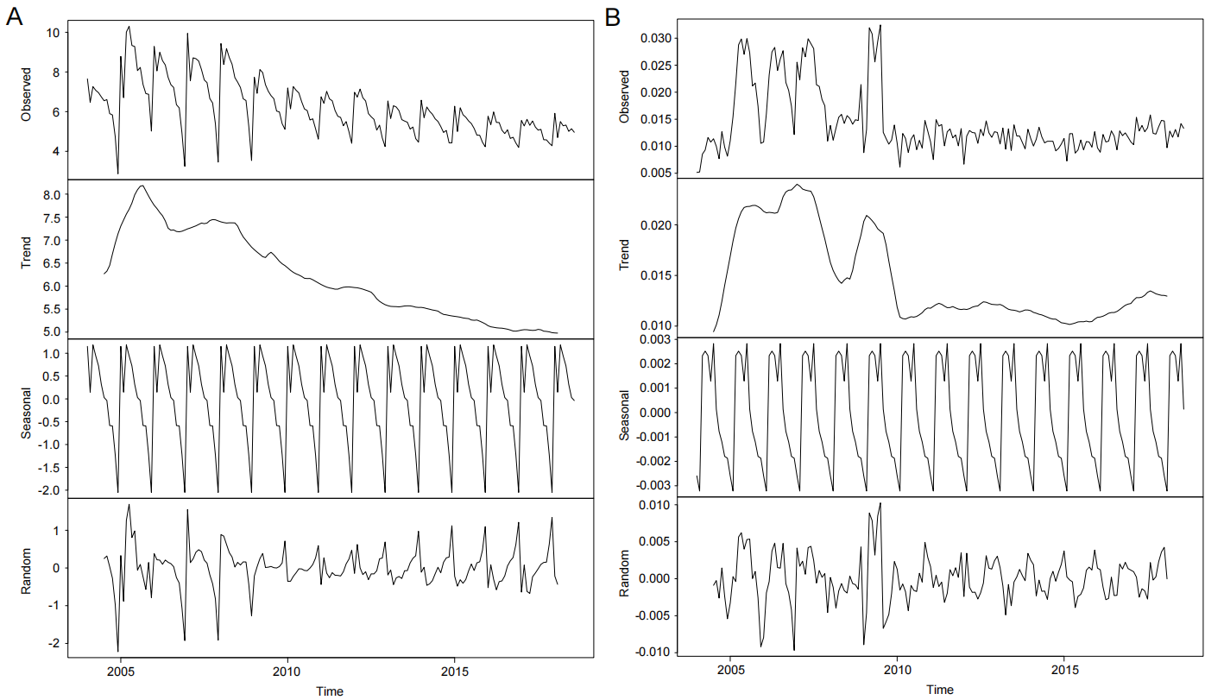Figure S1. Decomposition plots of trend, seasonal, and random components in the training set (A. Incidence rate; B. Mortality rate)

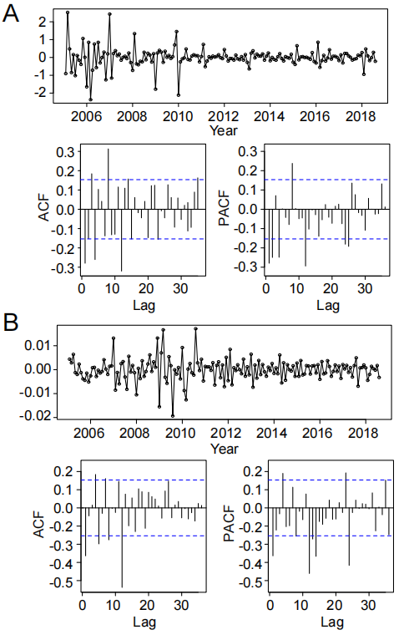
FigureS2. Autocorrelation Function and Partial Autocorrelation Function Plots of the Differenced Series (A. Incidence rate; B. Mortality rate)

Results
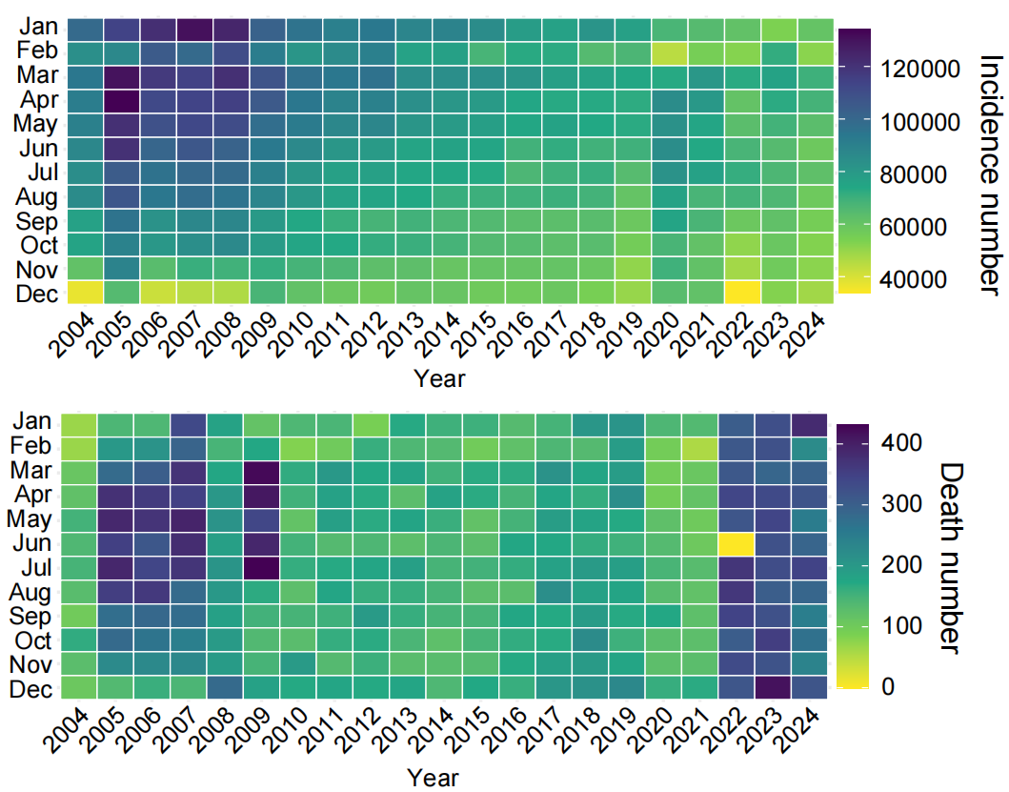
FigureS3. Temporal Distribution of Tuberculosis Incidence and Mortality Counts

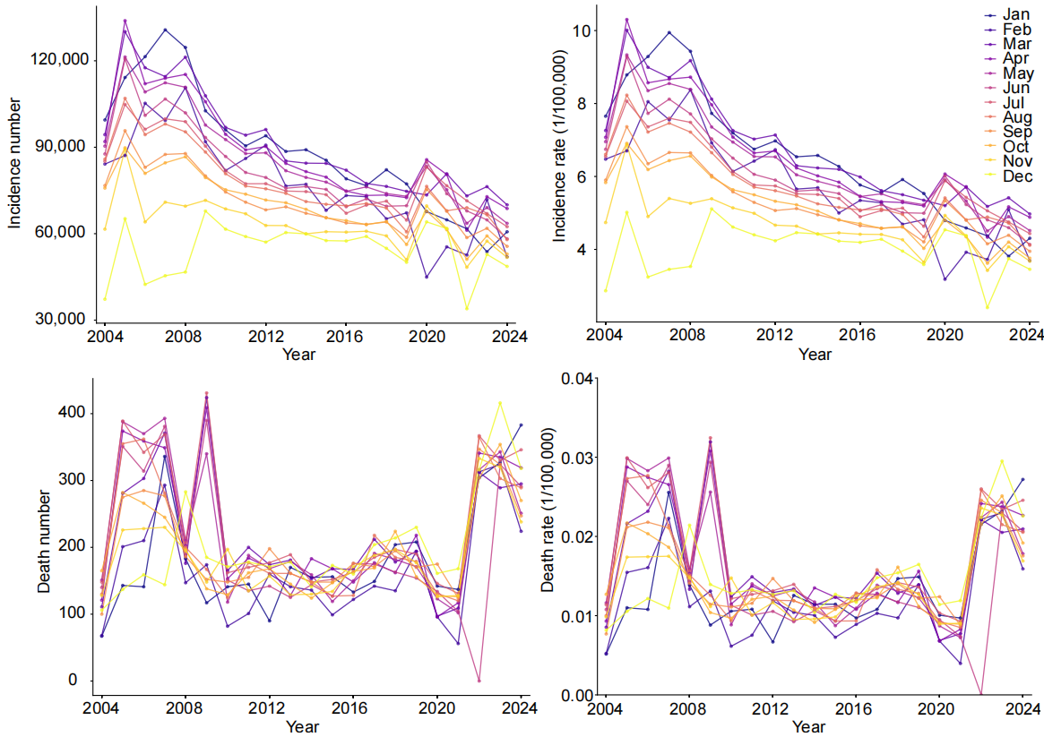
FigureS4. Temporal Distribution of Tuberculosis Incidence and Mortality rate

TableS3. Fit and Forecast Performance Evaluation of SARIMA Model for Tuberculosis Incidence
Data Type | Sample Size | MSE | RMSE | MAE | MAPE | sMAPE
Training Set (Fit) | 176 | 0.2097 | 0.458 | 0.2677 | 4.13 | 4.13
Test Set (Forecast) | 76 | 0.3183 | 0.5642 | 0.4248 | 9.83 | 9.39
Notes: MSE: Mean Squared Error, RMSE: Root Mean Squared Error, MAE: Mean Absolute Error, MAPE: Mean Absolute Percentage Error, sMAPE:Symmetric Mean Absolute Percentage Error.

TableS4. Fit and Forecast Performance Evaluation of SARIMA Model for Tuberculosis death
Data Type | Sample Size | MSE | RMSE | MAE | MAPE | sMAPE
Training Set (Fit) | 176 | 0 | 0.0034 | 0.0024 | 17.42 | 16.62
Test Set (Forecast) | 76 | 0 | 0.0069 | 0.0059 | Inf | 39.85
Notes: MSE: Mean Squared Error, RMSE: Root Mean Squared Error, MAE: Mean Absolute Error, MAPE: Mean Absolute Percentage Error, sMAPE:Symmetric Mean Absolute Percentage Error.

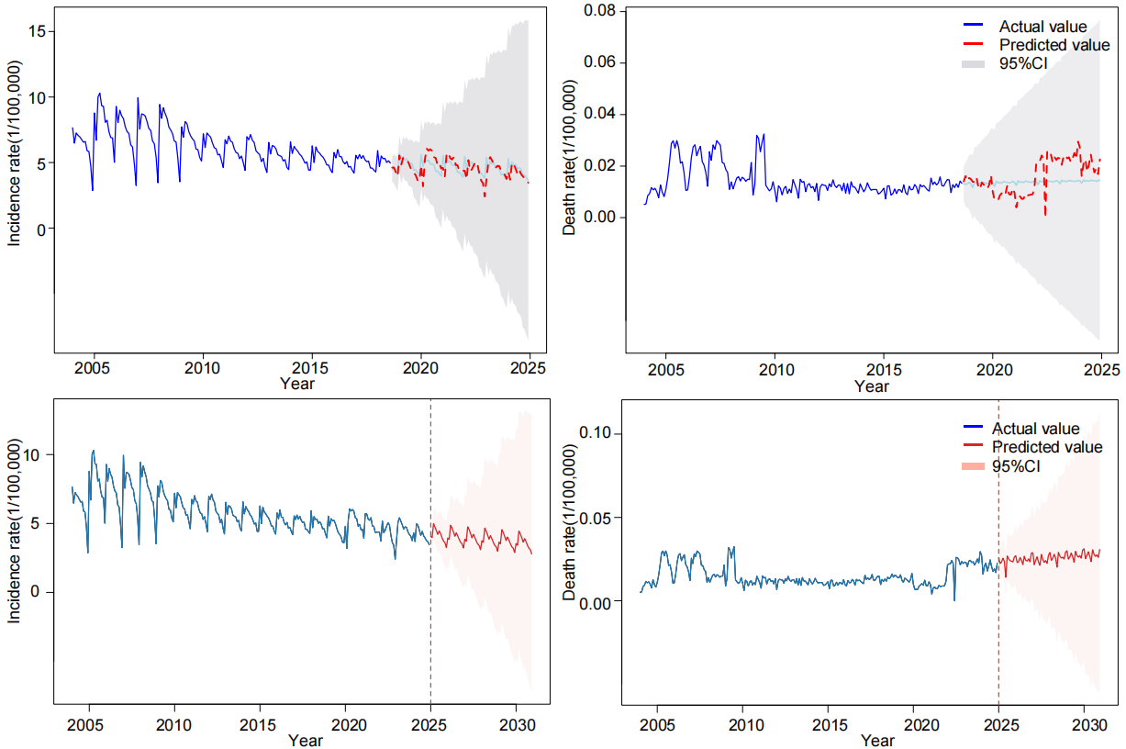
FigureS5 Fitting and Forecasting of Tuberculosis Incidence and Mortality in Chinese Mainland

TableS5. Monthly Incidence Rate Prediction Results in the Chinese Mainland from 2025 to 2030
Year | Month | Predict | 95%CI_lower | 95%CI_upper
2025 | 1 | 4.059146788 | 3.106315023 | 5.011978553
2025 | 2 | 3.979145356 | 2.826820093 | 5.131470619
2025 | 3 | 4.987698224 | 3.779193488 | 6.19620296
2025 | 4 | 4.738556476 | 3.45022797 | 6.026884982
2025 | 5 | 4.478401609 | 3.12567321 | 5.831130009
2025 | 6 | 4.209451495 | 2.791084249 | 5.627818741
2025 | 7 | 4.454800929 | 2.975367038 | 5.93423482
2025 | 8 | 4.250421332 | 2.711682941 | 5.789159722
2025 | 9 | 3.95625677 | 2.360680081 | 5.551833458
2025 | 10 | 3.724275522 | 2.073711316 | 5.374839727
2025 | 11 | 3.612413716 | 1.908678001 | 5.316149431
2025 | 12 | 3.253435455 | 1.498121194 | 5.008749716
2026 | 1 | 3.945355953 | 1.955611878 | 5.935100029
2026 | 2 | 3.86054694 | 1.726146876 | 5.994947003
2026 | 3 | 4.872191443 | 2.649826447 | 7.094556439
2026 | 4 | 4.675848174 | 2.356553029 | 6.995143319
2026 | 5 | 4.379933518 | 1.972589809 | 6.787277227
2026 | 6 | 4.069603022 | 1.57534075 | 6.563865295
2026 | 7 | 4.321040755 | 1.74358285 | 6.898498659
2026 | 8 | 4.100797943 | 1.442428889 | 6.759166998
2026 | 9 | 3.844233256 | 1.107471931 | 6.58099458
2026 | 10 | 3.632317068 | 0.819295797 | 6.445338339
2026 | 11 | 3.528334912 | 0.641087957 | 6.415581868
2026 | 12 | 3.218801413 | 0.259181361 | 6.178421465
2027 | 1 | 3.864719165 | 0.653892417 | 7.075545914
2027 | 2 | 3.713336647 | 0.333675144 | 7.092998151
2027 | 3 | 4.758591283 | 1.266812827 | 8.250369738
2027 | 4 | 4.558158532 | 0.944897951 | 8.171419114
2027 | 5 | 4.265334927 | 0.539776062 | 7.990893793
2027 | 6 | 3.959836102 | 0.123177564 | 7.79649464
2027 | 7 | 4.215188771 | 0.271401037 | 8.158976506
2027 | 8 | 3.987604353 | -0.060817693 | 8.036026399
2027 | 9 | 3.730133259 | -0.420149115 | 7.880415633
2027 | 10 | 3.514436555 | -0.735320685 | 7.764193795
2027 | 11 | 3.410658783 | -0.936275187 | 7.757592753
2027 | 12 | 3.095802661 | -1.34619168 | 7.537797002
2028 | 1 | 3.751672812 | -0.94570143 | 8.449047053
2028 | 2 | 3.631520661 | -1.250903315 | 8.513944637
2028 | 3 | 4.660923587 | -0.354786999 | 9.676634173
2028 | 4 | 4.455631664 | -0.701999219 | 9.613262546
2028 | 5 | 4.165951359 | -1.124868182 | 9.4567709
2028 | 6 | 3.863512823 | -1.559204089 | 9.286229734
2028 | 7 | 4.116287851 | -1.434391721 | 9.666967422
2028 | 8 | 3.894104774 | -1.781977316 | 9.570186863
2028 | 9 | 3.632250784 | -2.166391257 | 9.430892826
2028 | 10 | 3.415731342 | -2.502986499 | 9.334449184
2028 | 11 | 3.310853713 | -2.725530282 | 9.347237709
2028 | 12 | 2.992133644 | -3.159675062 | 9.14394235
2029 | 1 | 3.649299158 | -2.755065529 | 10.05366384
2029 | 2 | 3.523282713 | -3.075636689 | 10.12220212
2029 | 3 | 4.555685282 | -2.192898075 | 11.30426864
2029 | 4 | 4.353150092 | -2.552555827 | 11.25885601
2029 | 5 | 4.061629624 | -2.993326767 | 11.11658602
2029 | 6 | 3.757166905 | -3.445713383 | 10.96004719
2029 | 7 | 4.010627617 | -3.336481819 | 11.35773705
2029 | 8 | 3.786897683 | -3.701954528 | 11.27574989
2029 | 9 | 3.527175061 | -4.100668317 | 11.15501844
2029 | 10 | 3.311516585 | -4.452878278 | 11.07591145
2029 | 11 | 3.207118682 | -4.691447773 | 11.10568514
2029 | 12 | 2.890855063 | -5.139649536 | 10.92135966
2030 | 1 | 3.546154393 | -4.742048274 | 11.83435706
2030 | 2 | 3.418848238 | -5.075157661 | 11.91285414
2030 | 3 | 4.451894814 | -4.206541755 | 13.11033138
2030 | 4 | 4.248712112 | -4.581116042 | 13.07854027
2030 | 5 | 3.957636669 | -5.036214216 | 12.95148755
2030 | 6 | 3.653714201 | -5.502883478 | 12.81031188
2030 | 7 | 3.907188616 | -5.408636506 | 13.22301374
2030 | 8 | 3.683480572 | -5.789170996 | 13.15613214
2030 | 9 | 3.42333724 | -6.203474308 | 13.05014879
2030 | 10 | 3.207387837 | -6.571199263 | 12.98597494
2030 | 11 | 3.102909712 | -6.825114345 | 13.03093377
2030 | 12 | 2.786009635 | -7.289242737 | 12.86126201
CI:Confidence Interval
TableS6. Monthly Death Rate Prediction Results in the Chinese Mainland from 2025 to 2030
Year | Month | Predict | 95%CI_lower | 95%CI_upper
2025 | 1 | 0.025868401 | 0.017982285 | 0.033754516
2025 | 2 | 0.022347211 | 0.01308278 | 0.031611642
2025 | 3 | 0.023316146 | 0.013208804 | 0.033423489
2025 | 4 | 0.025569523 | 0.014486619 | 0.036652428
2025 | 5 | 0.02349467 | 0.011530319 | 0.035459021
2025 | 6 | 0.014122379 | 0.001336119 | 0.026908638
2025 | 7 | 0.026862864 | 0.01330451 | 0.040421219
2025 | 8 | 0.025092622 | 0.010803826 | 0.039381419
2025 | 9 | 0.024027172 | 0.0090435 | 0.039010843
2025 | 10 | 0.023725987 | 0.008078268 | 0.039373706
2025 | 11 | 0.023325106 | 0.007040394 | 0.039609817
2025 | 12 | 0.026263915 | 0.009366207 | 0.043161623
2026 | 1 | 0.02700241 | 0.008763004 | 0.045241815
2026 | 2 | 0.022917754 | 0.003728466 | 0.042107042
2026 | 3 | 0.023424735 | 0.003401838 | 0.043447632
2026 | 4 | 0.025980432 | 0.005115274 | 0.04684559
2026 | 5 | 0.024353936 | 0.002682412 | 0.04602546
2026 | 6 | 0.0216989 | -0.000750284 | 0.044148083
2026 | 7 | 0.026709474 | 0.0035087 | 0.049910248
2026 | 8 | 0.024282493 | 0.000353723 | 0.048211263
2026 | 9 | 0.023844769 | -0.000790493 | 0.048480031
2026 | 10 | 0.025118307 | -0.000203744 | 0.050440357
2026 | 11 | 0.023343552 | -0.002647146 | 0.04933425
2026 | 12 | 0.028703096 | 0.002060527 | 0.055345665
2027 | 1 | 0.028759071 | 0.000758553 | 0.056759589
2027 | 2 | 0.021643747 | -0.007358619 | 0.050646113
2027 | 3 | 0.024270503 | -0.00562916 | 0.054170166
2027 | 4 | 0.026372046 | -0.004441011 | 0.057185103
2027 | 5 | 0.023216893 | -0.008480012 | 0.054913798
2027 | 6 | 0.021236556 | -0.011320457 | 0.053793568
2027 | 7 | 0.027771901 | -0.005623056 | 0.061166858
2027 | 8 | 0.024801308 | -0.009411077 | 0.059013693
2027 | 9 | 0.023078139 | -0.011932594 | 0.058088872
2027 | 10 | 0.024100375 | -0.011690903 | 0.059891652
2027 | 11 | 0.022463853 | -0.014091307 | 0.059019013
2027 | 12 | 0.027334898 | -0.009968505 | 0.064638301
2028 | 1 | 0.028993533 | -0.0103005 | 0.068287566
2028 | 2 | 0.024251901 | -0.016411473 | 0.064915275
2028 | 3 | 0.025595878 | -0.016267626 | 0.067459382
2028 | 4 | 0.027882586 | -0.015221577 | 0.070986749
2028 | 5 | 0.02560169 | -0.018702713 | 0.069906094
2028 | 6 | 0.020186273 | -0.025287135 | 0.065659681
2028 | 7 | 0.029060864 | -0.017552207 | 0.075673936
2028 | 8 | 0.026761062 | -0.020964469 | 0.074486593
2028 | 9 | 0.025662508 | -0.023150135 | 0.074475151
2028 | 10 | 0.026166598 | -0.023709467 | 0.076042664
2028 | 11 | 0.025038947 | -0.025878337 | 0.07595623
2028 | 12 | 0.029185133 | -0.022752499 | 0.081122764
2029 | 1 | 0.030020869 | -0.023634799 | 0.083676538
2029 | 2 | 0.024951067 | -0.030081315 | 0.079983449
2029 | 3 | 0.026259875 | -0.030043714 | 0.082563464
2029 | 4 | 0.028616996 | -0.028972839 | 0.08620683
2029 | 5 | 0.02639709 | -0.032447565 | 0.085241745
2029 | 6 | 0.02309299 | -0.036980534 | 0.083166515
2029 | 7 | 0.02965486 | -0.031622875 | 0.090932595
2029 | 8 | 0.027124375 | -0.035334359 | 0.089583108
2029 | 9 | 0.026154627 | -0.037463185 | 0.08977244
2029 | 10 | 0.027132874 | -0.037623274 | 0.091889022
2029 | 11 | 0.025587427 | -0.040287388 | 0.091462243
2029 | 12 | 0.030457317 | -0.036517484 | 0.097432119
2030 | 1 | 0.031163417 | -0.037592086 | 0.099918921
2030 | 2 | 0.02527707 | -0.044933624 | 0.095487764
2030 | 3 | 0.027176178 | -0.044389549 | 0.098741904
2030 | 4 | 0.029402274 | -0.0435358 | 0.102340347
2030 | 5 | 0.026754098 | -0.047527693 | 0.10103589
2030 | 6 | 0.023484141 | -0.052117741 | 0.099086022
2030 | 7 | 0.030636306 | -0.046262989 | 0.107535601
2030 | 8 | 0.027971802 | -0.050203378 | 0.106146982
2030 | 9 | 0.026636308 | -0.052794266 | 0.106066882
2030 | 10 | 0.027510531 | -0.053155902 | 0.108176963
2030 | 11 | 0.026033675 | -0.055849965 | 0.107917315
2030 | 12 | 0.030715698 | -0.05236732 | 0.113798715
CI:Confidence Interval

