Supplementary Material
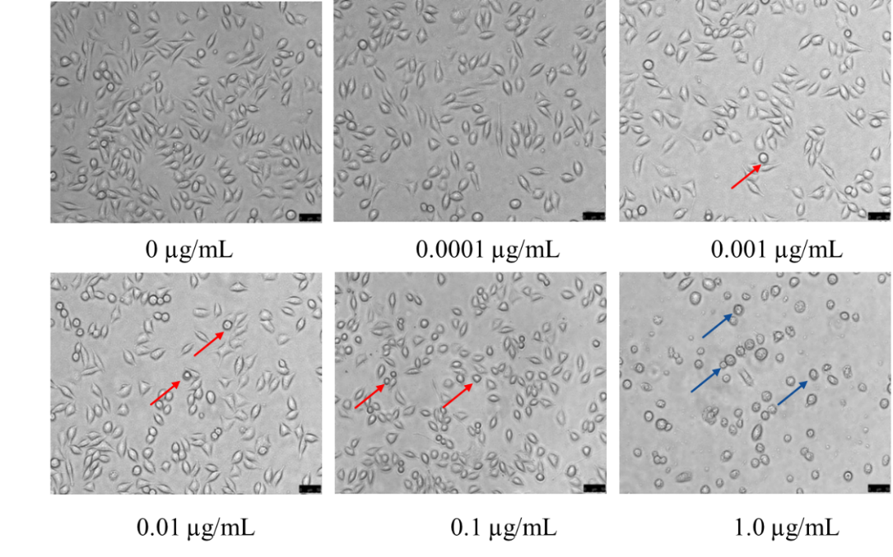
Fig. S1. The effect of MeHg exposure for 24 h on the morphology of SH-SY5Y cells
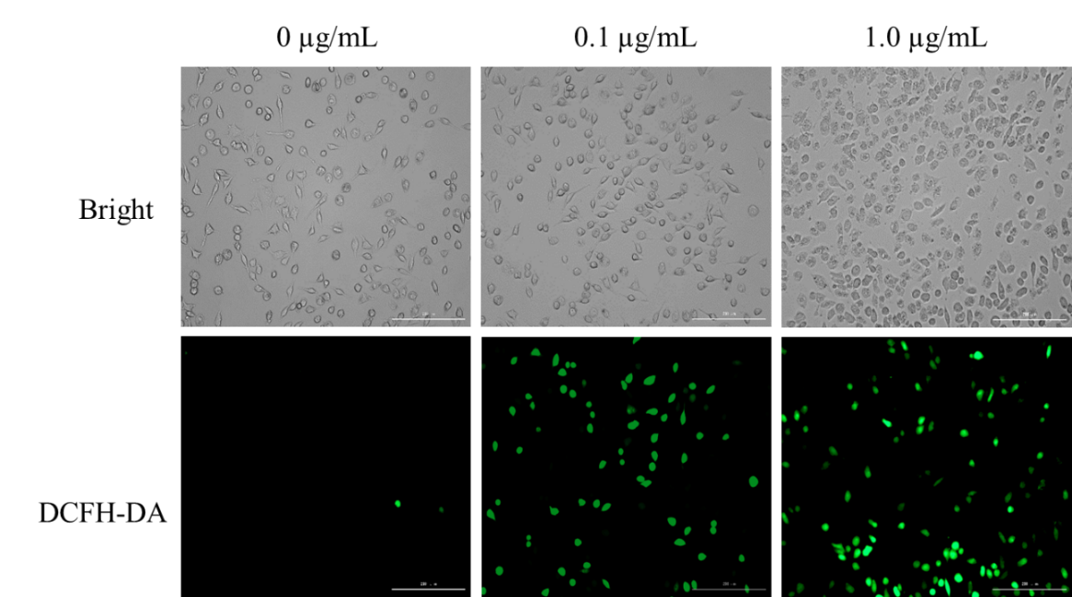
Fig. S2. The effect of MeHg on ROS in SH-SY5Y cells were tested using single staining with DCFH-DA probe and observed by fluorescence microscope

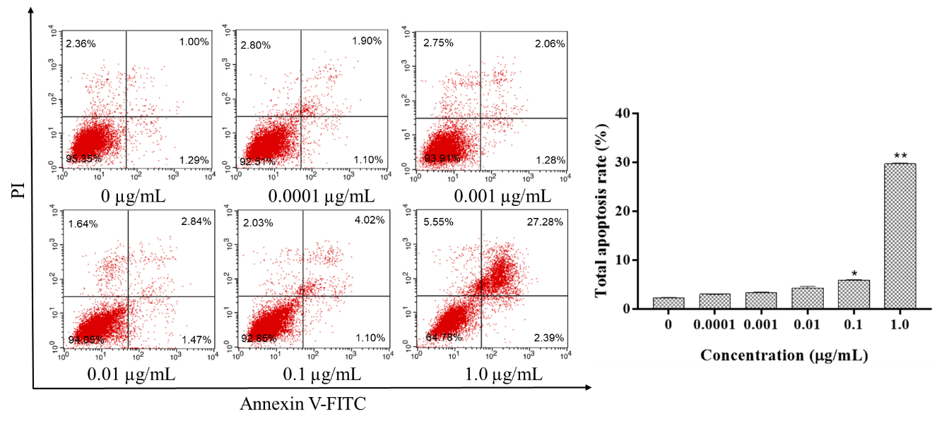
Fig. S3. The effect of MeHg on the apoptosis rate in cells. SH-SY5Y Cells were exposed to MeHg for 24 h, and detect the apoptosis of cells by FCM using AnnxinV/PI double staining. The values were presented as mean ± SEM (n = 3). Significant differences with the control group were designated as *P<0.05, **P <0.01.
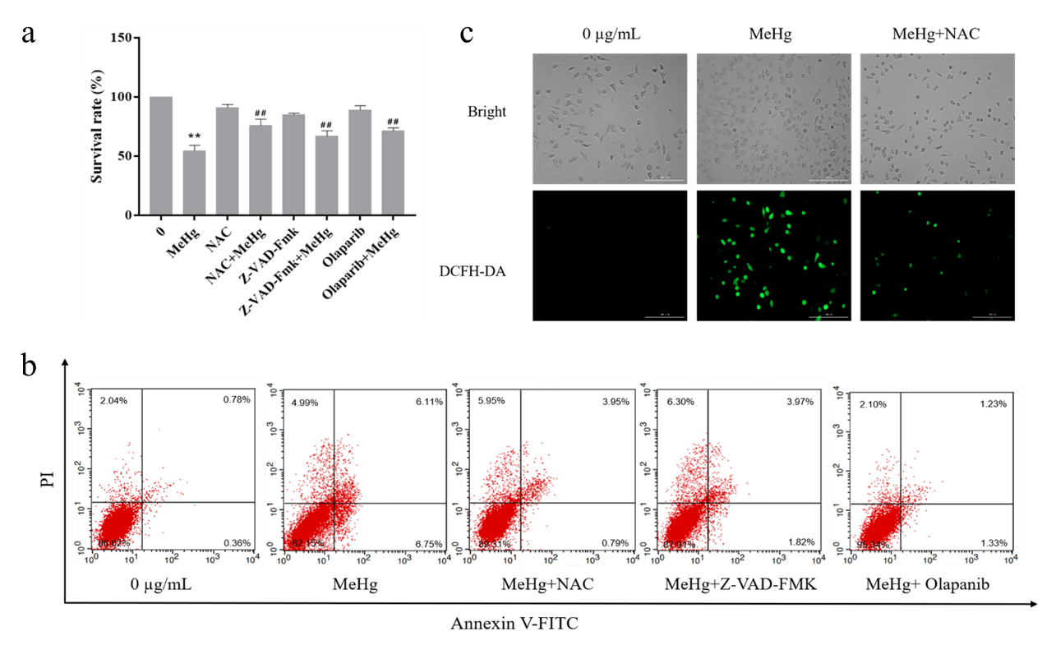
Fig. S4. (a) The SH-SY5Y cells were pretreated with 7.5 µM NAC for 1 h, 50 µM Z-VAD-FMK and 0.5 µM Olaparib for 3 h. The effect of 0.1 µg/mL MeHg on the survival rate of SH-SY5Y cells was detected by MTT assay. The values were presented as mean ± SEM (n = 3). Comparison with control group (**P <0.01). Comparison with MeHg group (##P <0.01). (b) The SH-SY5Y cells were pretreated with NAC, Z-VAD-FMK and olaparib. FCM was used to detect the effect of MeHg on the apoptosis rate of SH-SY5Y cells. (c) NAC pretreated cells for 1 h, and then incubated with MeHg for 3 h, the intracellular ROS levels were observed by fluorescence microscope.

