Supplementary Information

Machine learning force field molecular dynamics simulation of SEI formation on lithium metal

Norio Takenaka ¹, Taiga Iwata ¹, Théophane Bernhard ¹, and Atsuo Yamada ^{1,2}
- Department of Chemical System Engineering, School of Engineering, The University of Tokyo, Hongo 7-3-1, Bunkyo-ku, Tokyo 113-8656, Japan
- Sungkyunkwan University Institute of Energy Science & Technology (SIEST), Sungkyunkwan University, Suwon-si 16419, Korea

Corresponding Author *E-mail: yamada@chemsys.t.u-tokyo.ac.jp

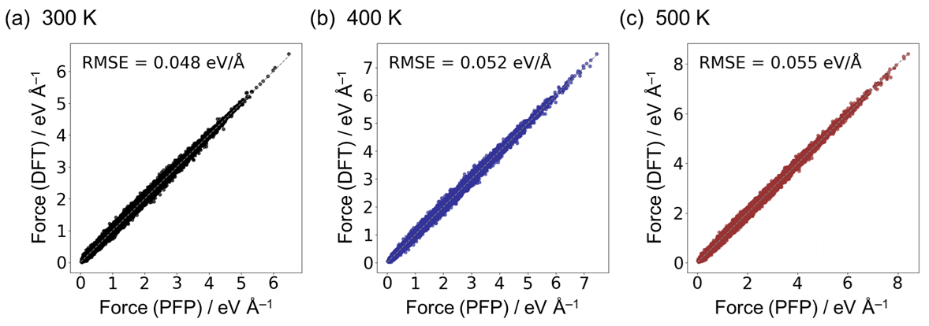
Supplementary Figure 1. Comparison of PFP and DFT forces for bulk LiFSI/EC electrolytes sampled at (a) 300, (b) 400 and (c) 500 K.
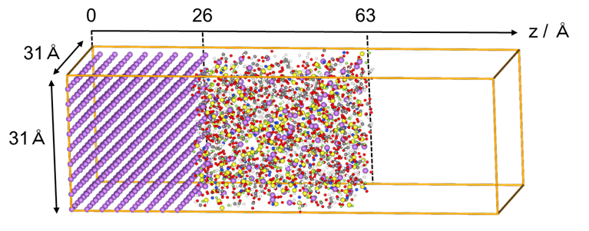
Supplementary Figure 2. Initial configuration of the interfacial model comprising Li metal and LiFSI/EC electrolyte. The example shown corresponds to the high-concentration electrolyte (LiFSI/EC, 1:1.5 molar ratio).

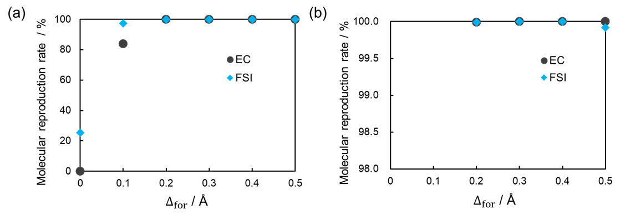
Supplementary Figure 3. (a) Molecular reproduction rate of intact EC and FSI– at different values of $∆_{for}$. (b) Enlarged view of the 98–100% region from panel (a). $∆_{for}$ ≥ 0.2 Å adequately accounts for bond elongations arising from thermal fluctuations and intermolecular interactions in the bulk electrolyte. However, $∆_{for}$ ≥ 0.5 Å leads to spurious S–S bonds in some FSI–, indicating that such large thresholds are not appropriate.

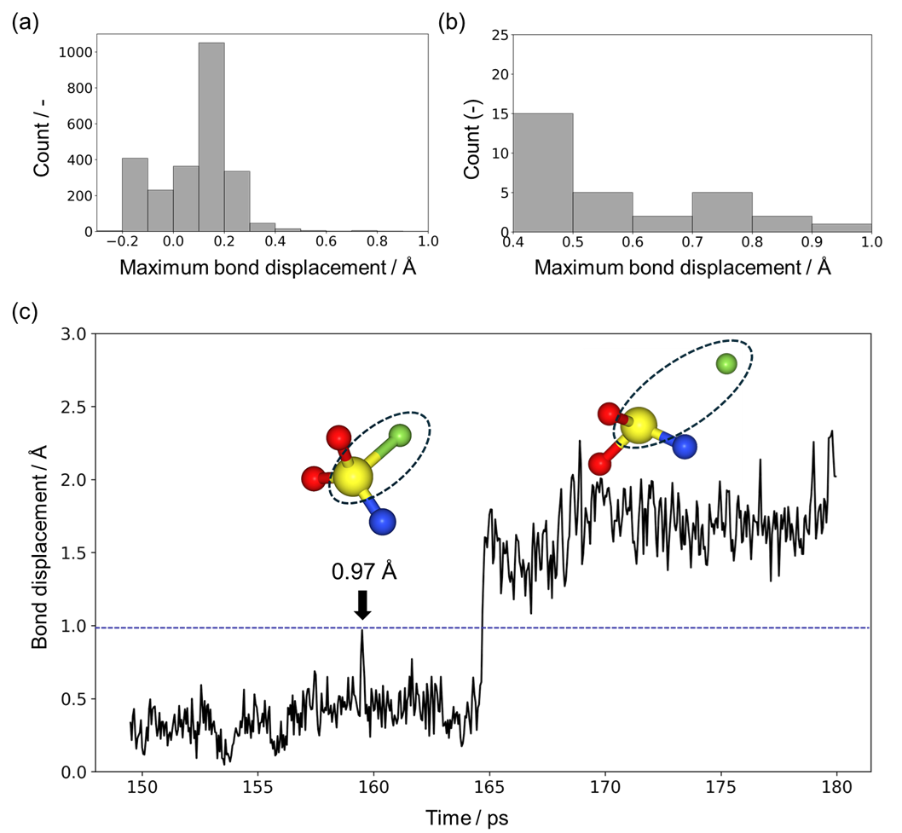
Supplementary Figure 4. (a) Histogram of the maximum bond elongation observed for each bonded pair during the interfacial MD simulation, expressed as the deviation from the sum of the covalent radii of the two atoms. (b) Enlarged view of the histogram shown in panel (a). (c) Maximum bond elongation detected for the S–F bond in the FSI– decomposition product NSO₂F, together with the temporal evolution of the bond length before and after the maximum elongation event. The vertical axis is referenced to the sum of the covalent radii. In the simulation, the S–F bond in NSO₂F exhibited the largest elongation and continued to fluctuate for more than 4 ps after reaching this maximum without undergoing dissociation.

Supplementary Table 1. The numbers of solvent and ion molecules used in the electrolyte models for the lithium metal–electrolyte interface.
Electrolyte  (salt-to-solvent molar ratio, n:n) | N  (Li⁺) | N  (FSI–) | N  (EC) | N  (Total atoms)
LiFSI/EC (1:13.8) | 21 | 21 | 289 | 3100
LiFSI/EC (1:4.0) | 59 | 59 | 237 | 2960
LiFSI/EC (1:1.5) | 108 | 108 | 161 | 2690

