Supporting Information
Electrochemically synthesized Nitrogen-doped Carbon Dots as Fluorescence Nano-sensors for the Selective Screening of Tetracyclines
Martina Piletti,ª, Zoe Vanboucq^{b}, Labrini Sygellou,^{c} Hazel Neillª, Dario Angelone,ª Sanathana Konugolu Venkata Sekar,ª Farzan Gityª, Aidan J. Quinn,ª Daniela Iacopinoª*
ª Tyndall National Institute, University College Cork, Lee Maltings Complex, Dyke Parade, Cork, Ireland
^{b} Institut de la Matière Condensée et des Nanosciences (IMCN), Molecular Chemistry, Materials and Catalysis (MOST), Université catholique de Louvain (UCLouvain), Place Louis Pasteur 1 box L4.01.02, B-1348 Louvain-la-Neuve, Belgium
^{c} Institute of Chemical Engineering Sciences, Foundation for Research and Technology-Hellas (FORTH/ICE-HT), Patras 265 04, Greece

AFM characterization of N-CDs
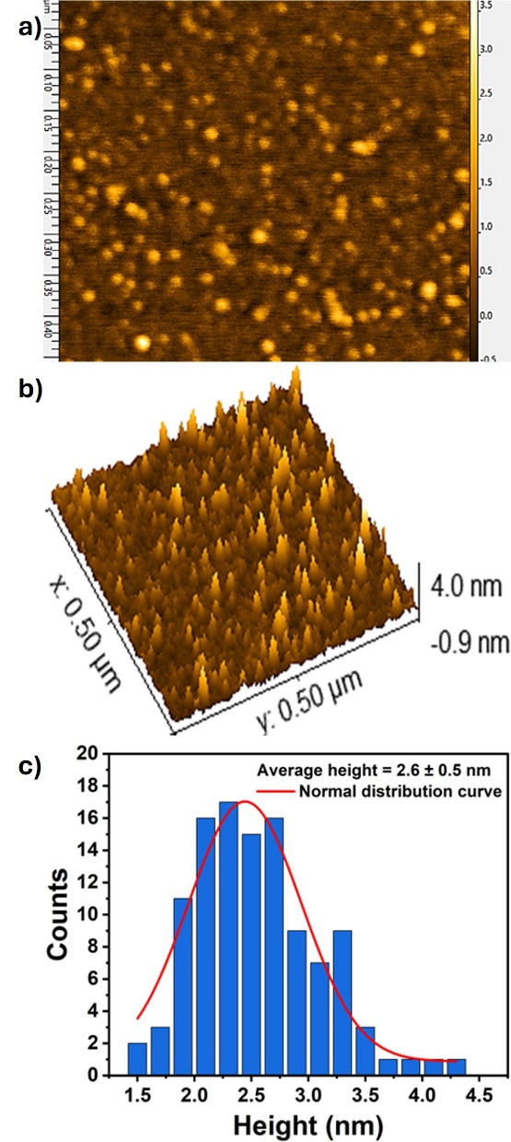
Fig. S1. (a) AFM 0.5x0.5 μm² scan area. (b) AFM 3D heightmap. (c) Particles size distribution histogram measured by AFM.

XPS characterization of N-CDs
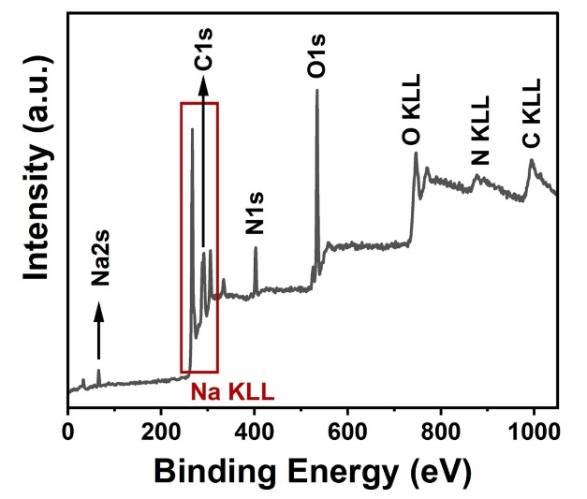
Fig. S2. XPS spectrum of N-CDs
The atomic percentages of carbon, nitrogen, and oxygen, as presented in Table S1, were calculated from the intensities (peak area) of the XPS peaks, weighted with the corresponding Relative Sensitivity Factors (RSF) and considering the analyzer’s transmission characteristics.
Table S1. Atomic percentages of carbon (C), oxygen (O), sodium (Na), and nitrogen (N) in the sample.
 | C | O | N
Sample (%) | 48.8 | 24.8 | 11.5

Table S2. Atomic concentrations (%) of the different kinds of C, N, and O.
 |  | Sample (%)
C 1s | C-C sp² | 39.1
C 1s | C-C sp³ | 6.3
C 1s | C-O | 11.7
C 1s | C=O | 30.9
C 1s | COOH | 12.0
N 1s | Pyridinic-like N | 45.9
N 1s | Amine-like N | 54.1
O 1s | C=O | 24.2
O 1s | C-O | 75.8

Lifetime measurement at different excitation wavelength
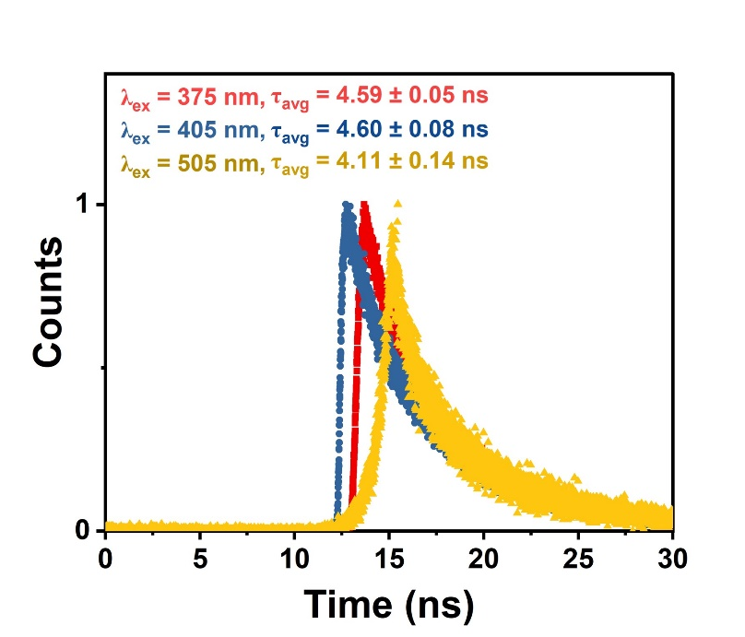
Fig. S3. Fluorescence decays of N-CDs recorded at excitation wavelengths of 375 nm, 405 nm, and 505 nm

Optimization of experimental parameters
To enhance the analytical performance of the N-CDs as fluorescent nanosensors, two key experimental parameters, N-CD concentration and incubation time, were investigated and optimized at room temperature.
In the incubation time study, it was observed that the addition of increasing concentrations of CTC to a 1 mg/mL N-CDs solution resulted in a progressive increase of the fluorescence intensity over the 0 to 4 hours incubation time. The kinetics of the CTC-N-CDs interaction proved beneficial for sensing applications, as the time-dependent fluorescence increase improved the overall sensitivity of the nanosensor system. Notably, the fluorescence enhancement was directly correlated with the CTC concentration in solution, as shown in Fig. S4. and summarized in Table S3. When 1.5 mL of 5 µM CTC were added to 1.5 mL of N-CDs solution, the fluorescence intensity increased by 27.5% after 1.5 hours, 30.5% after 2.5 hours and by 40.7% after 4 hours of incubation, compared to the freshly prepared samples, measured immediately (Fig. S4b.). A more pronounced enhancement was observed at higher CTC concentrations. When the same analysis was conducted at CTC 25 µM, the recorded fluorescence intensity increased by 114.7%, 119.5%, and 148.2% after 1.5, 2.5, and 4 hours, respectively (Fig. S4c.). At even higher concentrations of antibiotic, the detector response became saturated, while at low concentrations (0.5 µM), only minor fluorescence increases were recorded, 1.5%, 1.8%, and 3.2% after 1.5, 2.5, and 4 hours, respectively (Fig. S4a,d.). The percentage increases were calculated using Eq. S1. In contrast, the incubation time study with TET (600 µM) revealed that its quenching effect on the fluorescence of N-CDs was independent of incubation time. The standard error associated with the mean of the three PL measurements shown in Fig. S4e. was below 3%, demonstrating the reproducibility of the data. The concentration of 600 µM was chosen to represent the upper detection limit, ensuring that if no further quenching or spectral shifts occurred at this concentration, lower concentrations could reasonably be assumed to exhibit time-independent behaviour as well. As shown in Fig. S4e., the fluorescence intensity remained consistent for incubation times of 0, 1.5, and 3 hours. Based on these experiments, an incubation time of 1.5 hours was selected as the optimal condition, offering a balance between enhanced sensitivity and practical analysis duration.
The concentration-dependent fluorescence emission of N-CDs is shown in Fig. S4f. A concentration of 1 mg/mL was chosen for the sensing experiments as it provided sufficiently strong fluorescence under 410 nm excitation to enable effective quenching upon interaction with the analytes. At the same time, the fluorescence intensity under 350 nm remained low enough to allow for the detection of even subtle fluorescence enhancements. Although increasing the N-CD concentration to 2 mg/mL resulted in a slightly higher fluorescence intensity at 410 nm (Fig. S 4f.), potentially improving sensitivity, the gain was marginal relative to the additional material required. Therefore, 1 mg/mL was identified as the optimal working concentration, offering an efficient balance between analytical performance, material economy, and reduced waste generation.
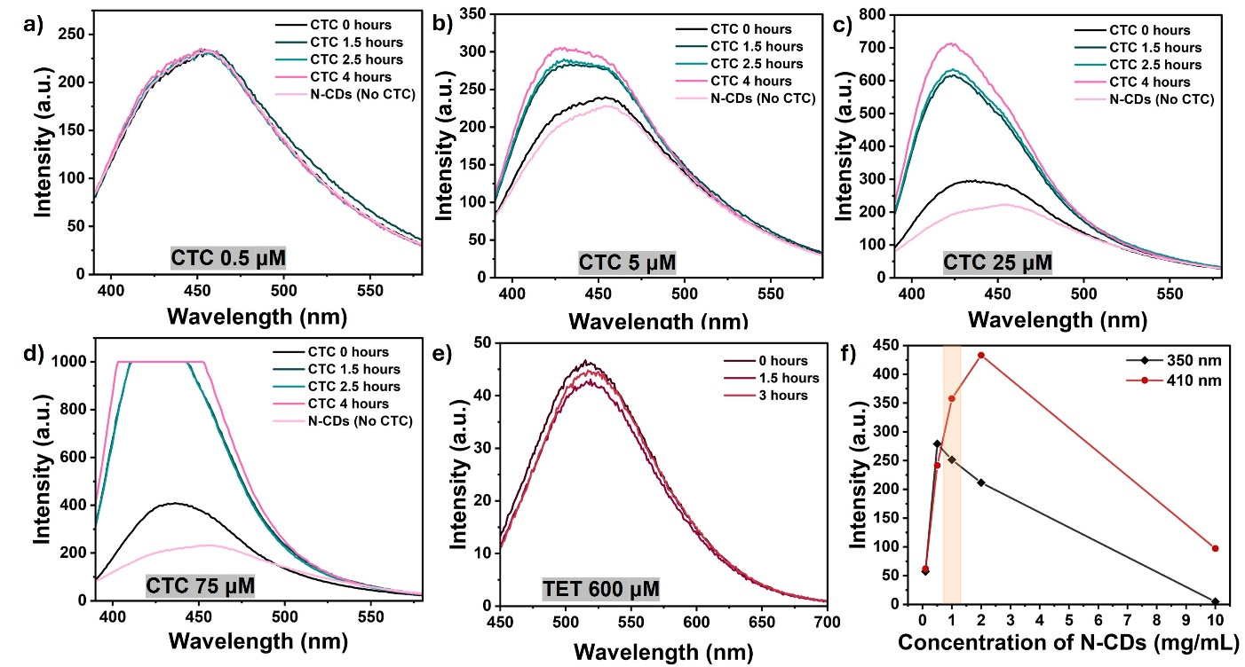
Fig. S4. Fluorescence spectra of N-CDs (excited at 350 nm) at different incubation times (0–4 h) without CTC and with (a) 0.5 µM CTC, (b) 5 µM CTC, (c) 25 µM CTC, (d) 75 µM CTC. (e) Fluorescence spectra of N-CDs (excited at 350 nm) in presence of TET 600 µM at different incubation times (0-3 hours). (f) Trend of N-CDs fluorescence intensity at various concentrations (0.1-10 mg/mL) in aqueous solution at excitation wavelengths 350 nm and 410 nm.

Table S3. Fluorescence intensities registered at different incubation times for different concentrations of CTC added to N-CDs (1 mg/mL). Equal volumes of antibiotic solution and N-CD suspension were used (1.5 mL each).
 | Fluorescence Intensity (a.u.)
Concentration CTC added | 0 hours | 1.5 hours | 2.5 hours | 4 hours
CTC 0.5 μM | 199.09 | 202.10 | 202.60 | 205.41
CTC 5 μM | 216.12 | 275.58 | 282.14 | 304.11
CTC 25 μM | 286.99 | 616.09 | 630.03 | 712.20
CTC 75 μM | 389.66 | 1000.00* | 1000.00* | 1000.00*
*Saturated PL signal, corresponding to the upper detection limit of the instrument (1000 a.u.)
The increase in fluorescence over time was evaluated using the formula:
$\% increase of PL=\frac{I_{t}-I_{0}}{I_{0}}×100$ (Eq. S1)
Where $I_{t}$ is the fluorescence intensity at the given times (1.5 hours, 2.5 hours, 4 hours) an $I_{0}$ is the fluorescence intensity of the solution of CTC and N-CDs freshly prepared and measured immediately (no incubation time).
Table S4. Fluorescence intensity increase (%) calculated using equation Eq. S1 and the fluorescence intensities reported in Table S3.
 | Fluorescence intensity increase (%)
Concentration CTC added | 1.5 hours | 2.5 hours | 4 hours
CTC 0.5 μM | 1.5 | 1.8 | 3.2
CTC 5 μM | 27.5 | 30.6 | 40.7
CTC 25 μM | 114.7 | 119.5 | 148.2
CTC 75 μM | 156.6 | 156.6 | 156.6

Simultaneous detection of TET and CTC
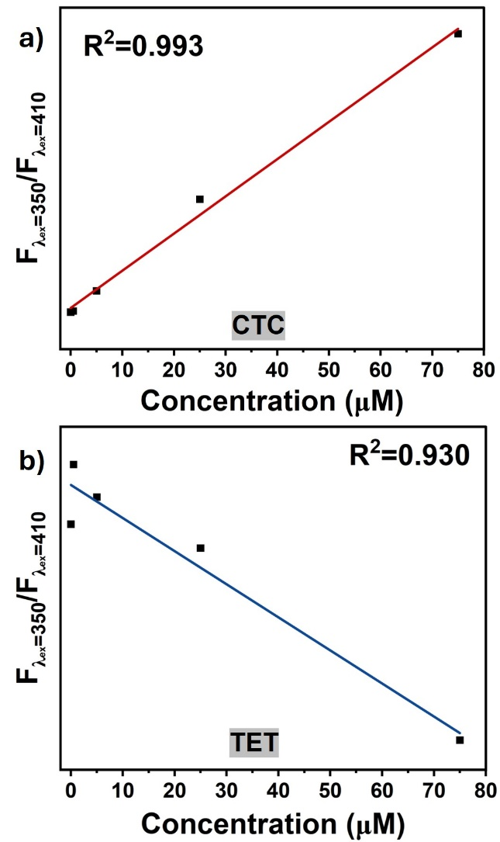
Fig. S5. Linear correlation between F (λ_{ex}=350 nm)/F (λ_{ex}=410 nm) values and (a) CTC concentrations in the range 0-75 µM or (b) TET concentrations in the range 0-75 µM (R² associated with the linear fitting.)

Fluorescence quenching and fluorescence enhancement mechanism
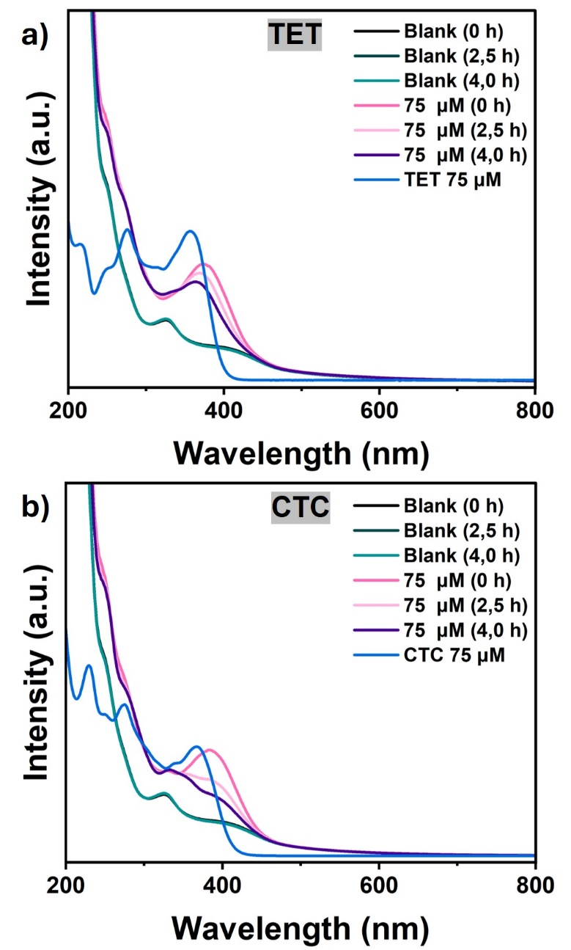
Fig. S6. UV-vis absorption of (a) N-CDs in time (0-4h), N-CDs in presence of 75 µM TET in time(0-4h), and TET 75 µM; (b) N-CDs in time (0-4h), N-CDs in presence of 75 µM CTC in time(0-4h), and TET 75 µM.

Evaluation of HPLC vs. N-CDs fluorescence sensing methods
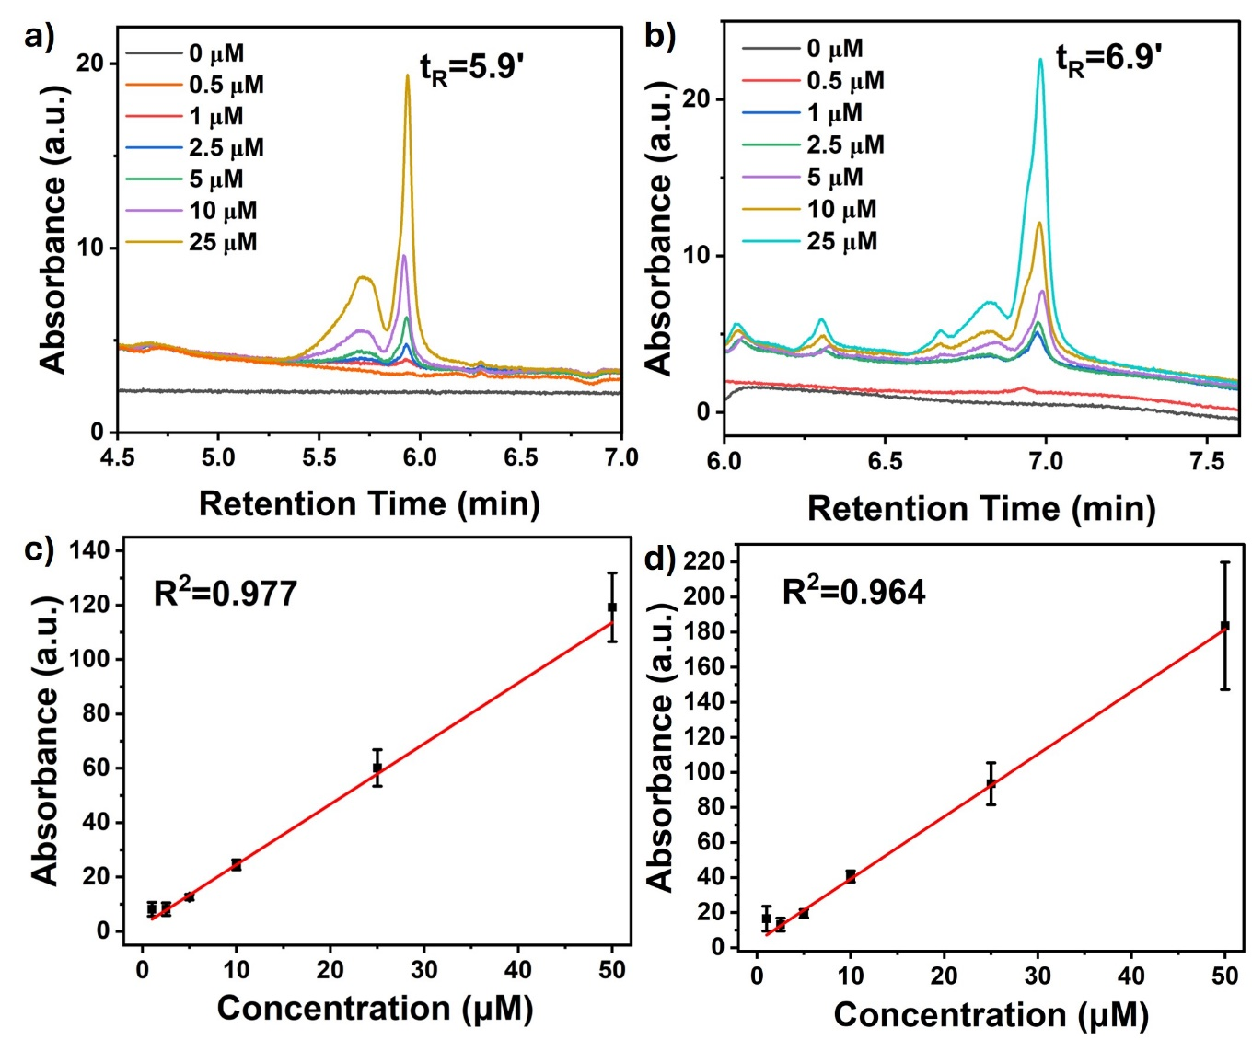
Fig. S7. HPLC-UV chromatograms for (a) TET (0–50 µM) and (b) CTC (0–50 µM). Linear calibration plots showing the correlation between integrated peak area and concentration for (c) TET and (d) CTC over the range 0–50 µM. (R² associated with the linear fitting).
The column was equilibrated for several minutes and at least two blanks of pure methanol were run before the analyses of the tetracyclines. Because of their polar nature, tetracyclines are usually determined by reverse phase (RP) chromatography¹. TET and CTC were injected separately and as shown in the chromatogram (Fig. S7a, b), they eluted with a retention time of 5.9 minutes and 6.9 minutes, respectively. Only the most intense peak, ascribed to the parent compound, was considered for building the calibration curve. Minor peaks could be referred to UV-active trace impurities or degradation products, whereas the prominent peaks on the side of the main ones could be attributed to the tetracyclines epimers which coelute because of their structural similarity². This HPLC-UV method could be optimized to obtain a higher sensitivity.
For both the method considered, the LOD and LOQ were calculated using the calibration curve-based residual standard deviation method: $LOD=\frac{{3×S}_{\frac{y}{x} }}{m }$ and $LOQ=\frac{{10×S}_{\frac{y}{x} }}{m }$, where $S_{\frac{y}{x} }$is the standard deviation of the residuals from the linear regression and $m$ is the slope of the calibration curve³. The results are reported in Table 5.
Table S5. Limits of detection (LOD) and quantification (LOQ) for TET and CTC obtained using HPLC and N-CDs–based fluorescence sensing methods.
 | Method | LOD (µM) | LOQ (µM)
TET | HPLC | 1.17 | 3.91
 | Fluorescence (N-CDs) | 2.59 | 8.64
CTC | HPLC | 0.72 | 2.40
 | Fluorescence (N-CDs) | 0.30 | 1.00

Antibiotics detection in real life samples
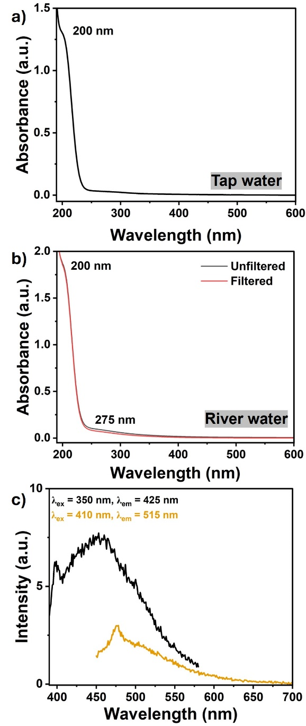
Fig. S8. UV-vis absorption of (a) tap water and (b) river water. (c) Fluorescence spectra of filtered river water at excitation wavelengths 350 nm and 410 nm.
Table S6. Parameters for TET and CTC in tap water
Parameters | Tetracycline | Chlortetracycline
Linearity (µM) | 0-25 | 0-25
Slope | -0.00326 | 0.03296
Intercept | 1.00626 | 0.997711
Correlation coefficient (R²) | 0.983 | 0.997
Regression equation | y = -0.00345 x + 1.00731 | y = 0.03296 x + 0.997711
LOD (µM) | 9.6 | 0.4
LOQ (µM) | 31.8 | 1.3

Table S7. Parameters for TET and CTC in river water
Parameters | Tetracycline | Chlortetracycline
Linearity (µM) | 0-25 | 0-25
Slope | -0.00362 | 0.02541
Intercept | 0.99696 | 1.00177
Correlation coefficient (R²) | 0.995 | 0.988
Regression equation | y = -0.00362 x + 0.99696 | y = 0.02541 x + 1.00177
LOD (µM) | 7.8 | 1.4
LOQ (µM) | 25.9 | 4.5

References
1. Ng, K. & Linder, S. W. HPLC Separation of Tetracycline Analogues: Comparison Study of Laser-Based Polarimetric Detection with UV Detection. Journal of Chromatographic Science 41, 460–466 (2003).
2. Lafossas, C., Benoit-Marquié, F. & Garrigues, J. C. Analysis of the retention of tetracyclines on reversed-phase columns: Chemometrics, design of experiments and quantitative structure-property relationship (QSPR) study for interpretation and optimization. Talanta 198, 550–559 (2019).
3. Lambarki, L. Z. et al. Comparison of approaches for assessing detection and quantitation limits in bioanalytical methods using HPLC for sotalol in plasma. Sci Rep 15, 5472 (2025).

