Supplementary Figure 1. Schematic overview of the CMS protocol
(A) Illustrations of different stressor procedures applied in CMS mouse model. (B) Color-coded schedule of stressors administered to mice over a five-week period and each color corresponds to a specific stressor, as indicated in the key. (C) Table summarizes the time and frequency of each stressor across days of the week.
Supplementary Figure 2. Long-term DBS NAcLat decreased GABA_{B1}R expression in the dopamine neurons of VTA in CMS mouse
(A) Experimental process of long-term DBS intervention in CMS model mice. CMS model was established during five weeks, the VTA-DA GABA_{B1}R staining was tested after two weeks’ DBS. (B) Mice were bilaterally implanted with DBS electrode in the NAcLat area, and long-term DBS (at 130HZ) treatment for two weeks. (C) Schematic of electrode implantation in bilateral NAcLat. (D) The c-fos expression of VTA DA neurons in the Control, CMS and CMS-DBS groups. (E) Brain slices immunostaining was carried out after long-term DBS treatment in rnascope for GABA_{B1}R expression in VTA DA neurons. (F) Brain slices immunostaining was carried out after long-term DBS treatment in rnascope for GABA_{B1}R expression in VTA GABA neurons. (G) The Gabbr1 expression intensity in the DA neurons of Control, CMS and CMS-DBS groups. (H) The Gabbr1 expression intensity in the GABA neurons of Control, CMS and CMS-DBS groups. All data are expressed as mean ± SEM. Multiple t-test analysis for (G) and (H).
Supplementary Figure 3. Transfecting GABA_{B1}R in VTA dopamine neurons augment depression susceptibility during chronic mild stress
(A) Experimental process of the virus injection (AAV₉-TH-Gabbr1/AAV₉-TH-mcherry) and chronic mild stress modeling. (B) left: the virus injection of AAV₉-TH-mcherry/AAV₉-TH-Gabbr1-mcherry in the VTA. right: representative images of overexpression GABA_{B1}R in the VTA DA neurons (TH-Gabbr1). (C) The force swim immobile time in the Control, CMS, CMS^{TH-mcherry} and CMS^{TH-Gabbr1} groups subjecting 21 days of CMS. (D)-(E) The time spent in center and total distance were tested in the Control, CMS, CMS^{TH-mcherry} and CMS^{TH-Gabbr1} groups subjecting 21 days of CMS. (F) Track diagram of spontaneous activity in OFT about the Control, CMS, CMS^{TH-mcherry} and CMS^{TH-Gabbr1} groups. (G) Experimental process of the virus injection (AAV₉-Gabbr1-RNAi/AAV₉-TH-vehicle) and chronic mild stress modeling. (H) left: the virus injection of AAV₉-TH-vehicle/ AAV₉-Gabbr1-RNAi in the VTA; right: the representative GABA_{B1}R expression in the VTA. (I) The force swim immobile time in the Control, CMS, CMS^{TH-vehicle} and CMS^{TH-Gabbr1-RNAi} groups subjecting 35 days of CMS. (J)-(K) The time spent in center and total distance were tested in the Control, CMS, CMS^{TH-vehicle} and CMS^{TH-Gabbr1-RNAi} groups subjecting 35 days of CMS. (L) Track diagram of spontaneous activity in OFT about the Control, CMS, CMS^{TH-vehicle} and CMS^{TH-Gabbr1-RNAi} groups. All data are expressed as mean ± SEM. Multiple t-test analysis for (C)-(E) and (I)-(K).
Supplementary Figure 4. Inhibition of VTA-GABA_{B1}R increased the CMS mice’s center exploration time in open field test
(A-B) Experimental scheme of the intraperitoneally CGP35348 (1mg/kg/d) administration for fourteen days in the Control and CMS groups. (C) Track diagram of spontaneous activity after CGP35348 administration for 0 day, 3 days, 7 days, 10 days and 14 days in the OFT. (D) Line graph: the change of total distance during CGP administration in the Control and CMS groups. (E) Line graph: the time spent in the center during CGP administration in the Control and CMS groups. All data are expressed as mean ± SEM. Multiple t-test analysis for (B) and (D), n=4.

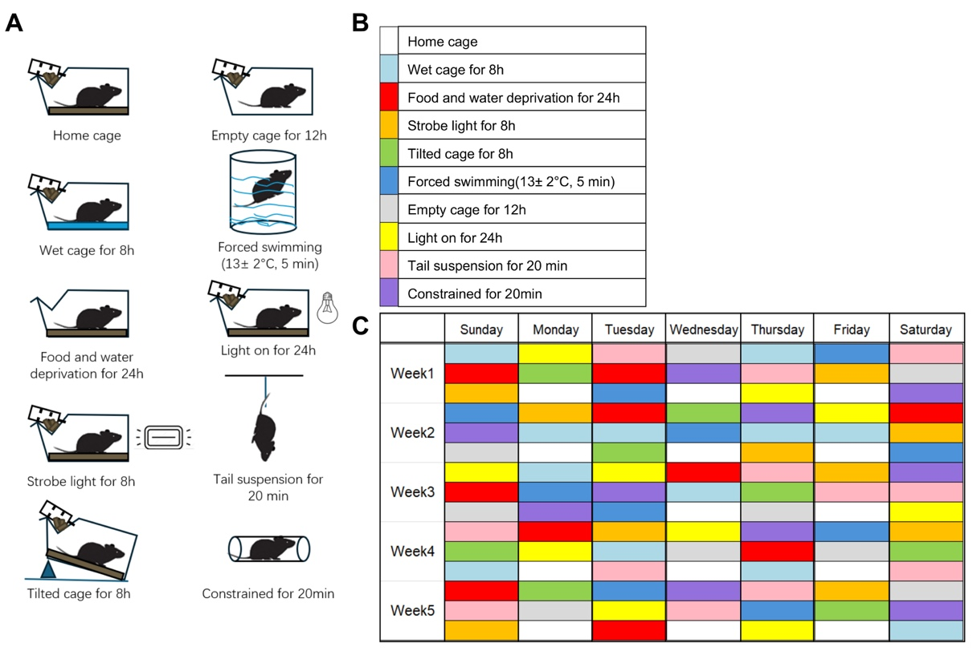
Supplementary Figure 1

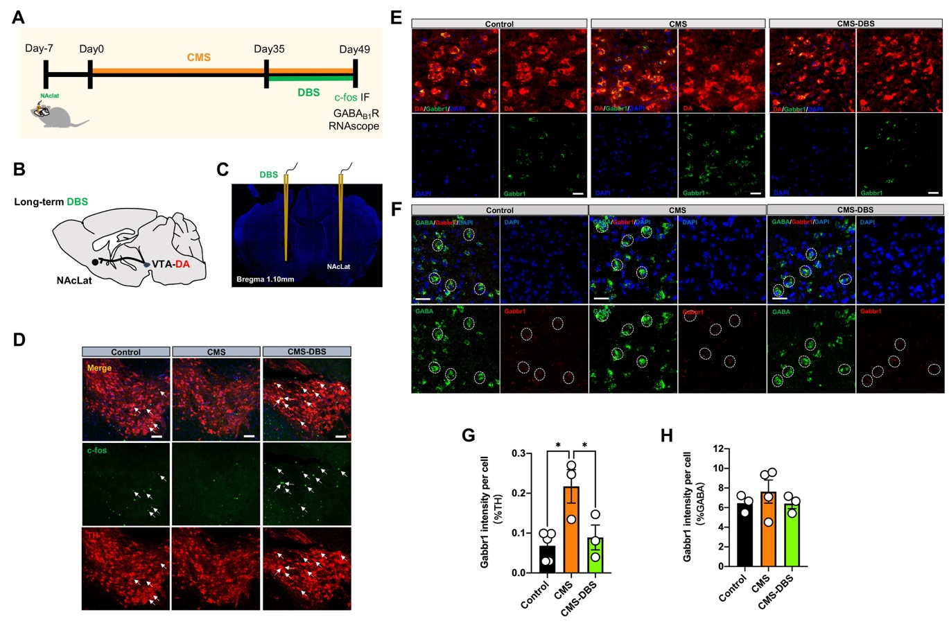
Supplementary Figure 2

Supplementary Figure 3
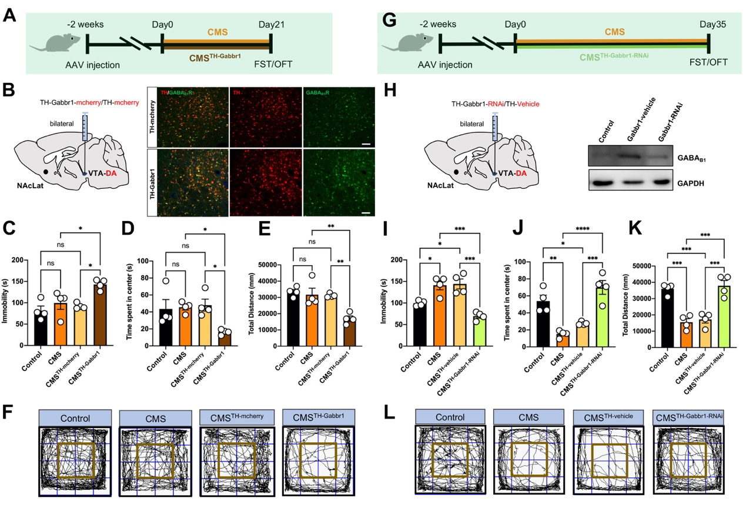
Supplementary Figure 4
