Supplementary Information for
Variations and sensitivity analysis of reference evapotranspiration during 2010-2019 in the Zhangye farmland oasis, Northwest China
Miao Fang¹*
¹ Northwest Institute of Eco-Environment and Resource, Chinese Academy of Sciences, Lanzhou, 730000,China
*corresponding.author@ mfang@lzb.ac.cn

This file includes:
Supplementary Figures S1 to S7
Supplementary Tables S1 to S2

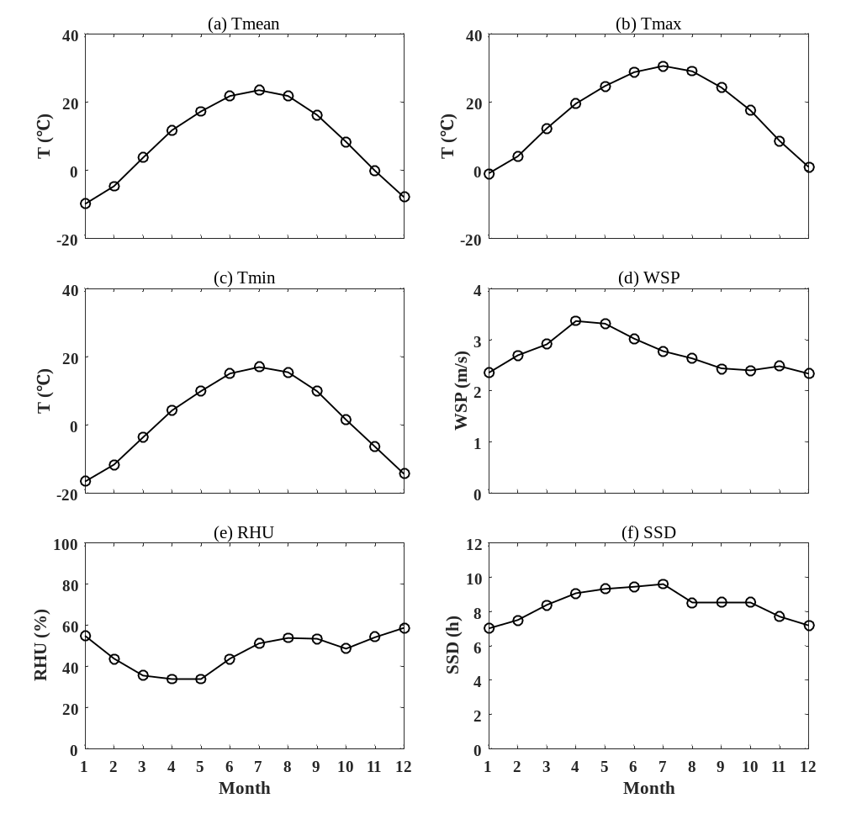
Figure S1. Multi-years mean of monthly meteorological factors.

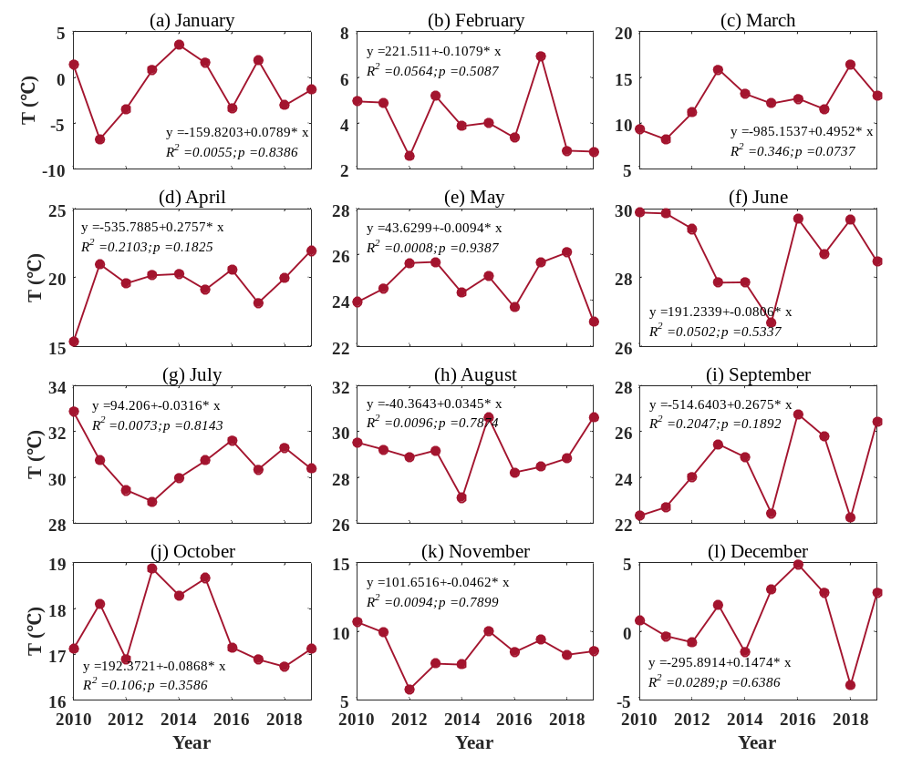
Figure S2. Variations and trends of T_{max} in each months during 2010-2019.

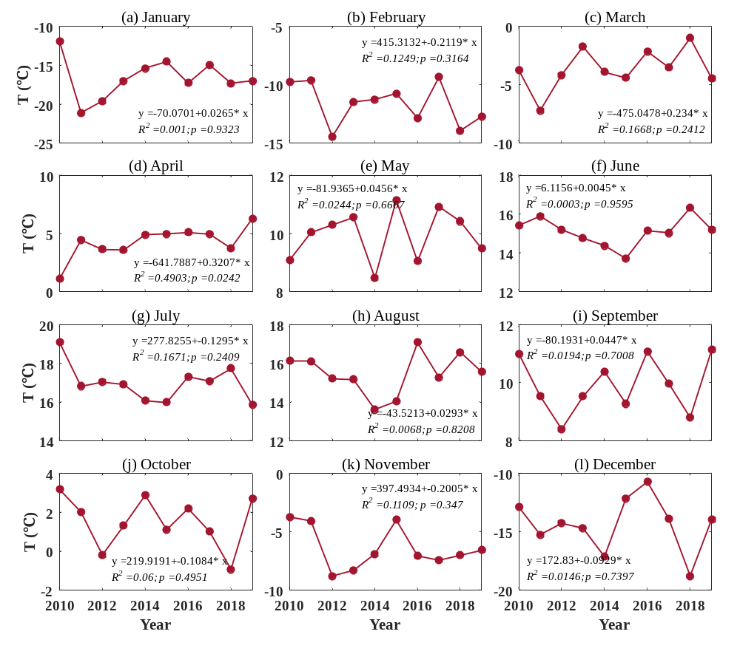
Figure S3. Variations and trends of T_{min} in each months during 2010-2019.

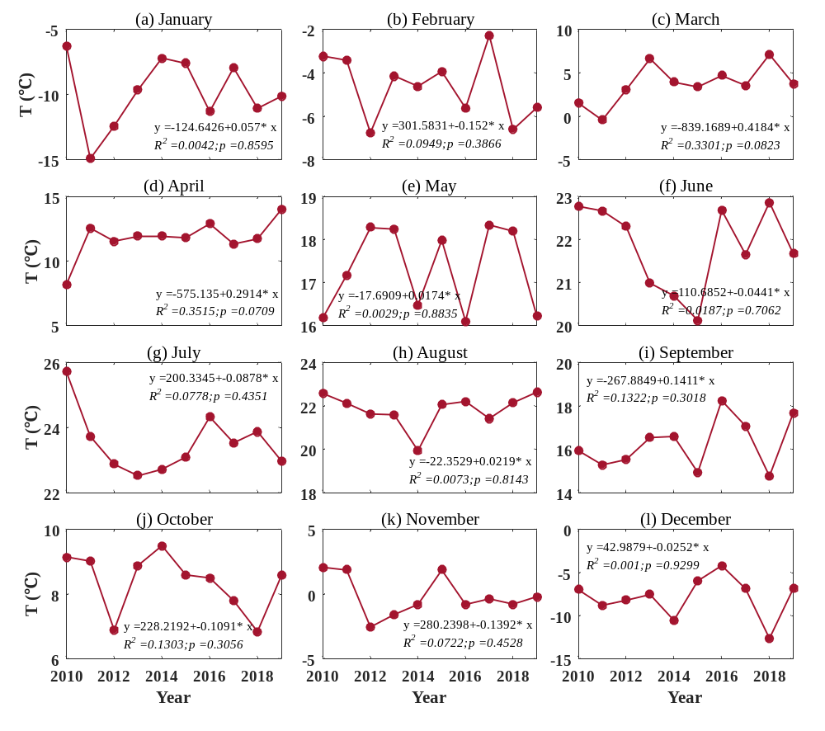
Figure S4. Variations and trends of T_{mean} in each months during 2010-2019.

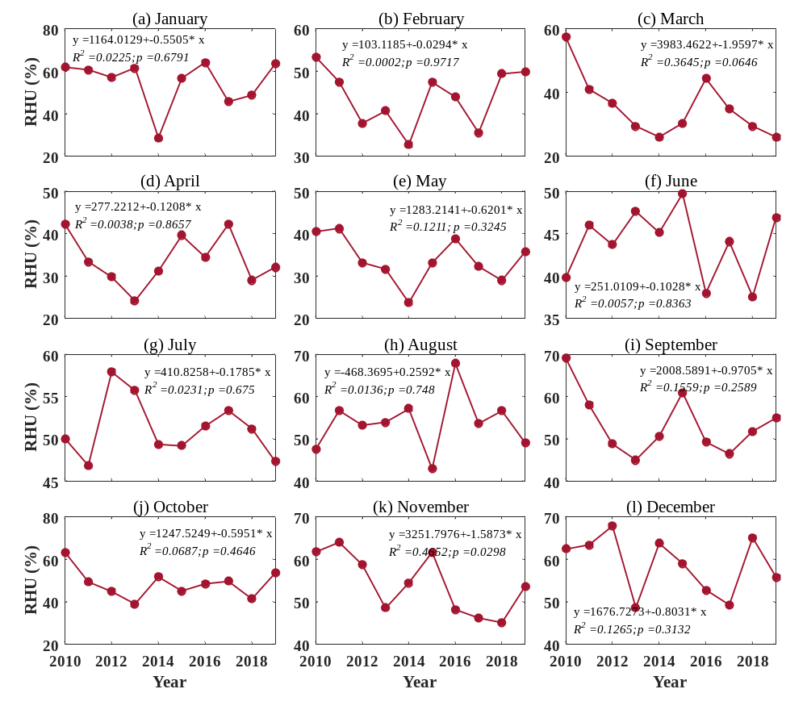
Figure S5. Variations and trends of RHU in each months during 2010-2019.

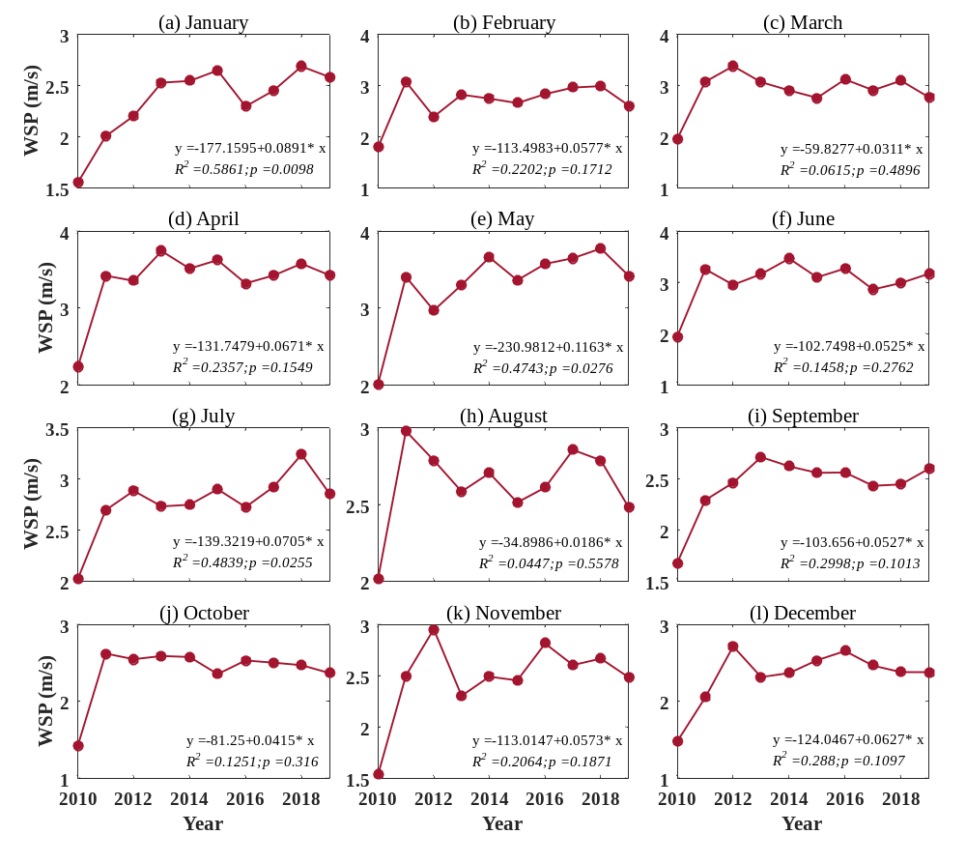
Figure S6. Variations and trends of WSP in each months during 2010-2019.

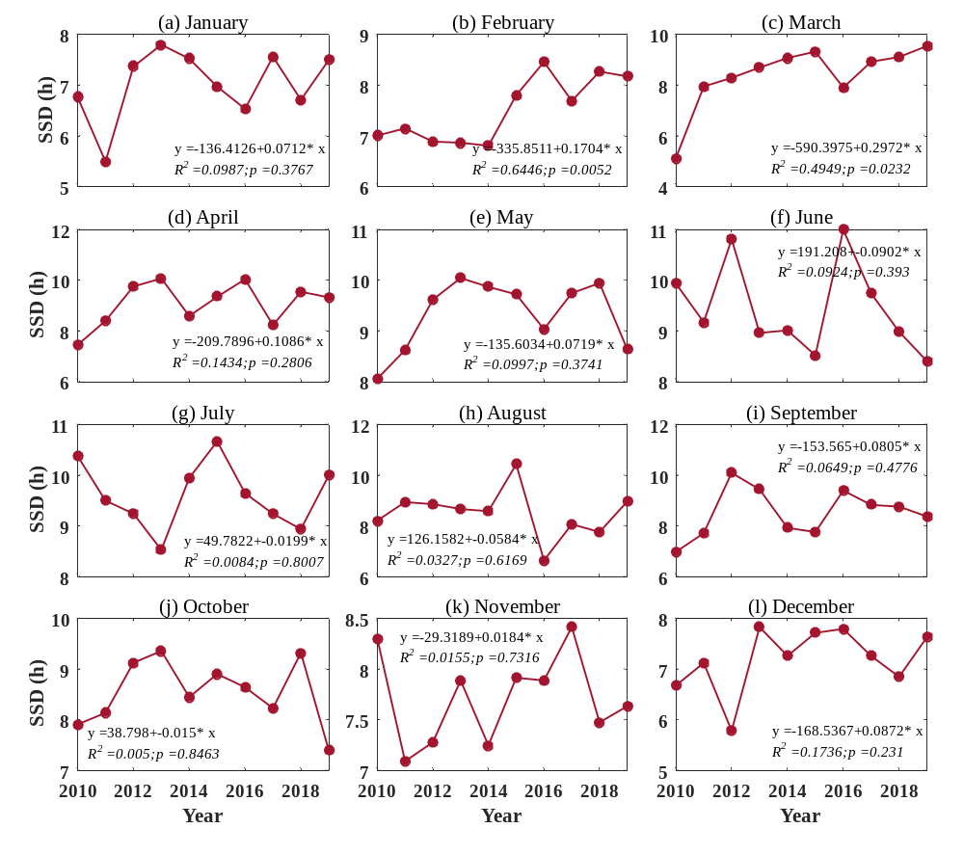
Figure S7. Variations and trends of SSD in each months during 2010-2019.
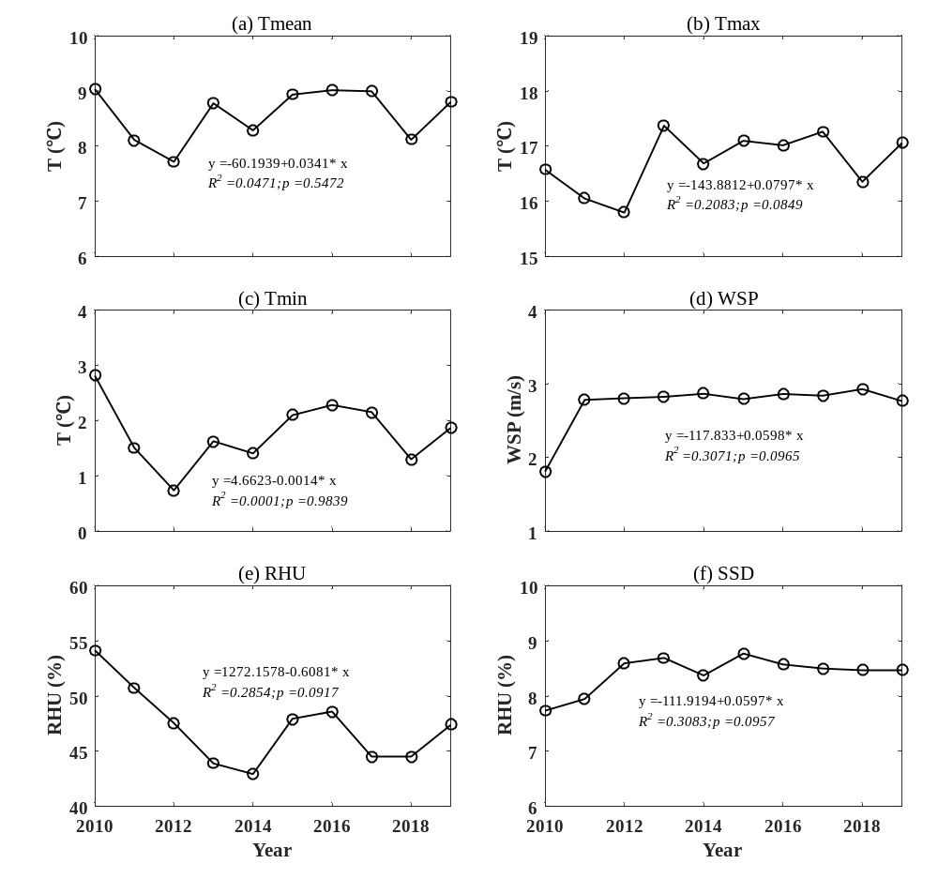
Figure S8. Variations and trends of yearly meteorological factors during 2010-2019

Table S1. Statistics of original daily SCs derived from the two ET₀ equations.
ET₀ equation | original SC | T_{max} | T_{min} | T_{avg} | RHU | WSP | SSD
The FAO-56 Penman-Monteith formula | Max | 1.14 | 0.39 | 0.49 | -0.03 | 0.48 | 0.52
The FAO-56 Penman-Monteith formula | Min | -0.39 | -0.37 | -0.83 | -4.33 | -0.27 | 0.00
The FAO-56 Penman-Monteith formula | Mean | 0.40 | 0.02 | -0.04 | -0.51 | 0.22 | 0.24
The Hargreaves equation | Max | 2.64 | 1.62 | 0.64 | ---- | ---- | ----
The Hargreaves equation | Min | -1.66 | -3.57 | -4.74 | ---- | ---- | ----
The Hargreaves equation | Mean | 0.56 | -0.14 | 0.08 | ---- | ---- | ----
Table S2. Statistics of absolute values of daily SCs derived from the two ET₀ equations.
ET₀ equation | Absolute SC | T_{max} | T_{min} | T_{avg} | RHU | WSP | SSD
The FAO-56 Penman-Monteith equation | Max | 1.14 | 0.39 | 0.83 | 4.33 | 0.48 | 0.52
The FAO-56 Penman-Monteith equation | Min | 0.00 | 0.00 | 0.00 | 0.03 | 0.00 | 0.00
The FAO-56 Penman-Monteith equation | Mean | 0.43 | 0.10 | 0.08 | 0.51 | 0.22 | 0.24
The Hargreaves equation | Max | 2.64 | 3.57 | 4.74 | ---- | ---- | ----
The Hargreaves equation | Min | 0.00 | 0.00 | 0.00 | ---- | ---- | ----
The Hargreaves equation | Mean | 0.60 | 0.43 | 0.52 | ---- | ---- | ----

