Supplementary File 1: Clinical profile, lifestyle pattern and nutritional intake of newly diagnosed¹ young-onset T1D and T2D
Variables | T1D | T2D | p-Value
Symptoms at presentation, n (%)
Osmotic | 461 (57.0) | 188 (27.2) | <0.001
Weight loss | 225 (29.7) | 94 (14.0) | <0.001
Infections | 110 (16.2) | 113 (16.9) | 0.858
General check-up* | 76 (12.0) | 233 (37.1) | <0.001
Others** | 110 (16.0) | 111 (16.4) | 0.889
DKA | 169/1576 (10.7) | 10/1208 (0.8) | <0.001
Family History, n (%)
Single parent | 843/2928 (28.8) | 1508/3173 (47.5) | <0.001
Both Parents | 170/2928 (5.8) | 1005/3173 (31.7) | <0.001
No parental history | 1915/2928 (65.4) | 660/3173 (20.8) | <0.001
Lifestyle, n (%)
Smoking (Yes) | 155/3332 (4.6) | 549/4774 (11.5) | <0.001
Alcohol Intake (Yes) | 344/3332 (10.3) | 850/4774 (17.8) | <0.001
Physical Activity (Yes) | 1370/4755 (28.8) | 395/5392 (7.3) | <0.001
Nutrient Intake
Calories (Kcal/Day) | 1308 ± 441 | 1410 ± 449 | <0.001
Carbohydrates (g/day) | 214 ± 78 | 234 ± 80 | <0.001
Carbohydrates (%E) | 65 ± 9 | 66 ± 9 | 0.037
Protein (g/day) | 43 ± 16 | 46 ± 17 | 0.002
Protein (%E) | 13 ± 4 | 13 ± 4 | 0.397
Fat (g/day) | 31 ± 18 | 32 ± 19 | 0.216
Fat (%E) | 21 ± 9 | 20 ± 9 | 0.071
¹Symptoms at presentation, lifestyle pattern and nutritional intake was extracted only for the participants who diagnosed diabetes at their first visit to the clinic.
*Pre-operative checkup, Pre-pregnancy checkup, Annual checkup, etc.
**Breathing difficulty, Neuropathic symptoms, Leg pain, Stomach discomfort, Menstrual problems

Supplementary File 3: Duration-wise microvascular complications of young-onset T1D and T2D
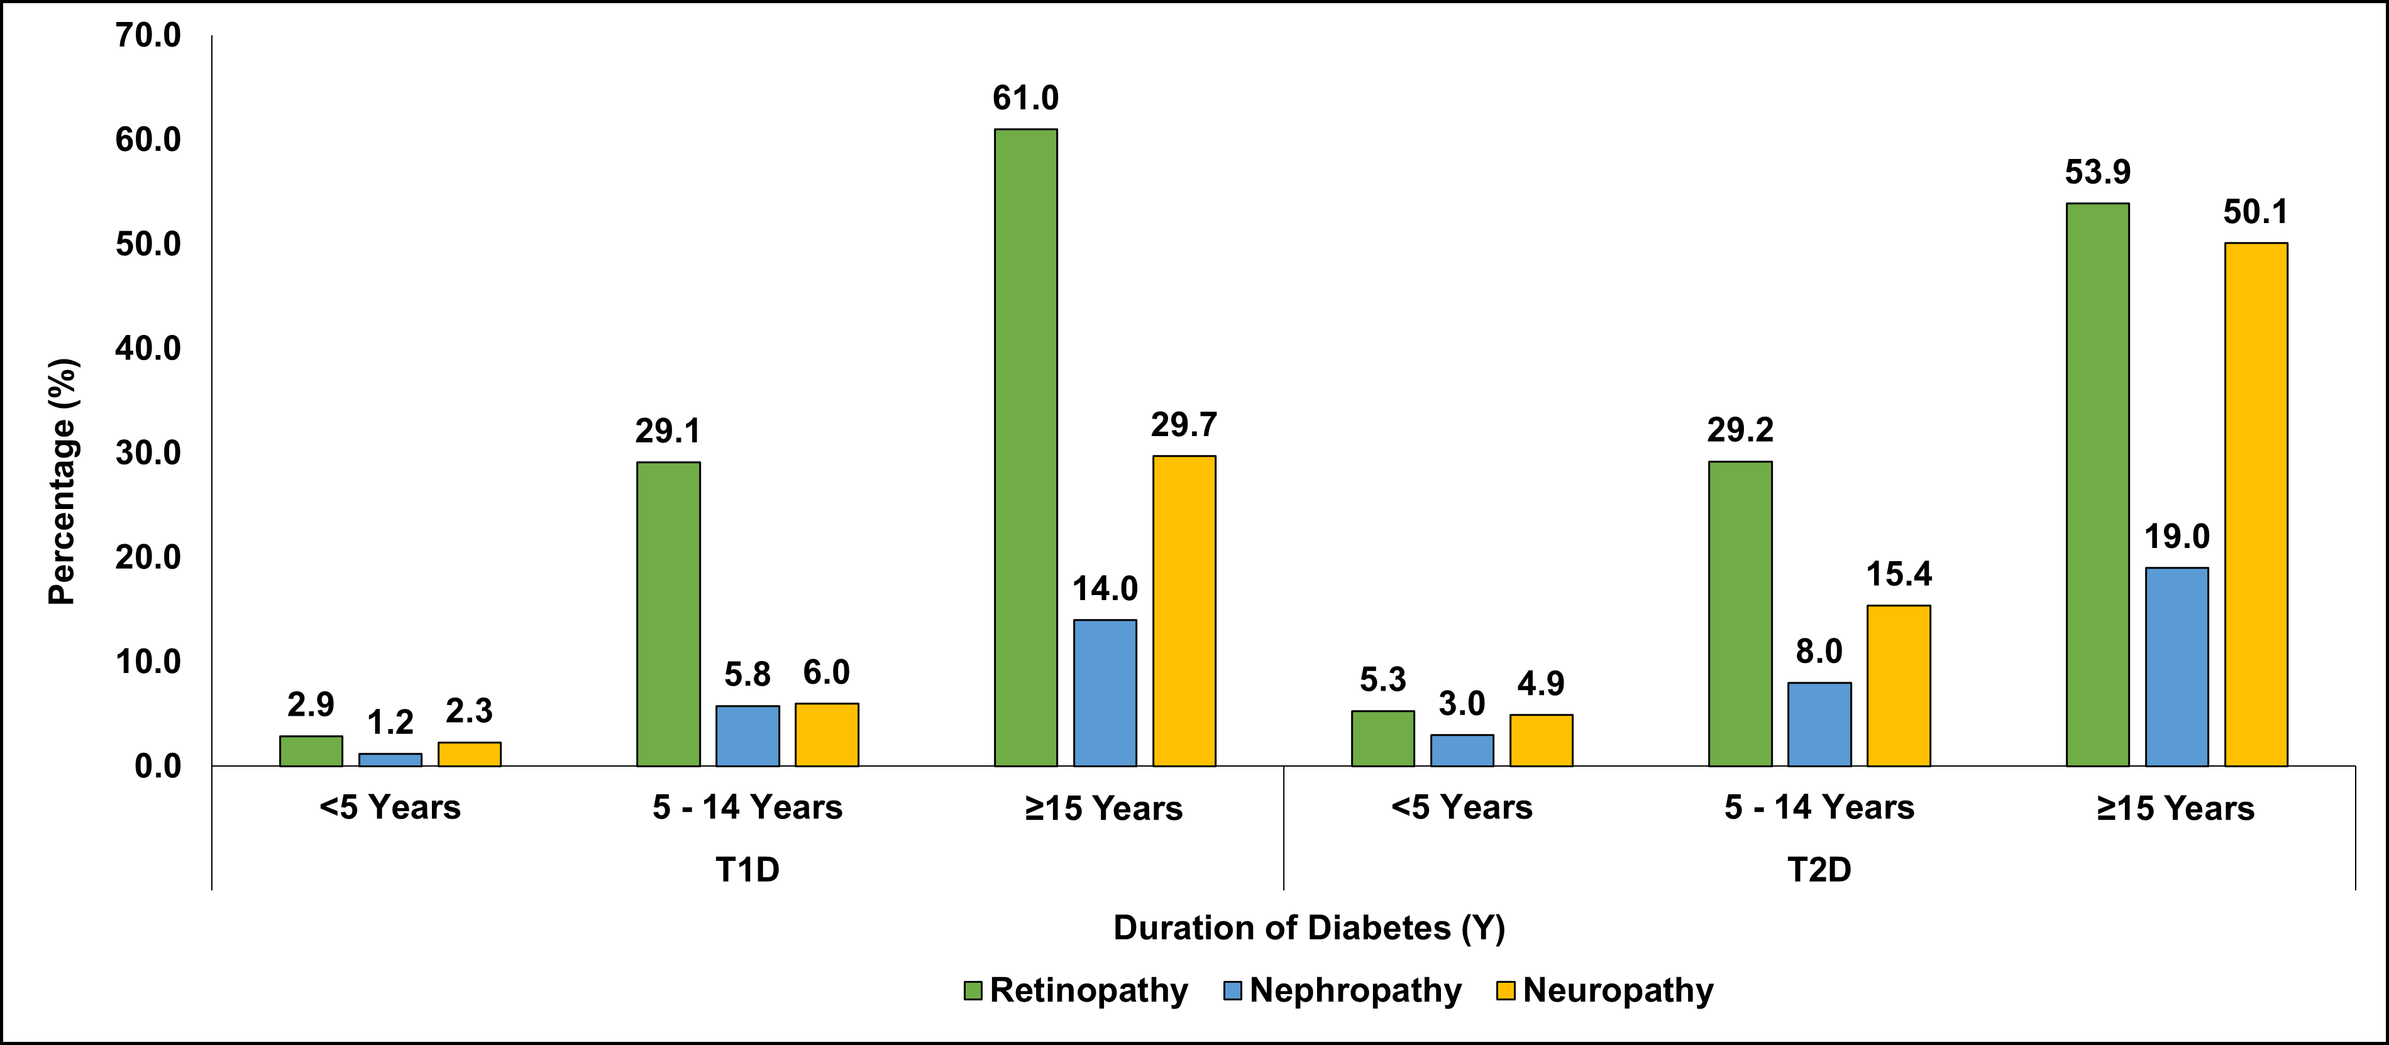
Retinopathy: NPDR and PDR positive; Nephropathy: urine albumin-to-creatinine ratio >600 µg/mg; Neuropathy: Neuropathy: mean vibratory perception threshold (VPT) at the great toes was ≥20 V.

Supplementary File 4: SHAP Analysis of Factors Influencing T1D Classification
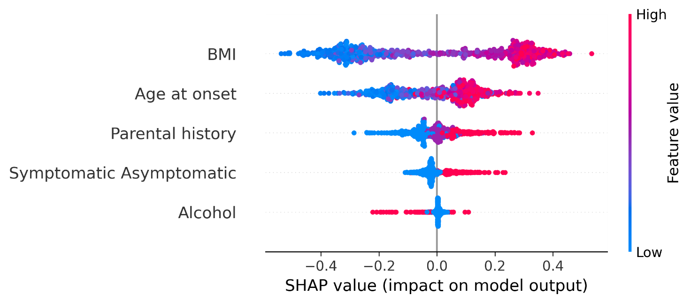
*The dots falling on the negative side (left of 0) indicate T1D, while those on the positive side (right of 0) indicate T2D.

Supplementary File 5 (A & B): Seasonal incidence of young-onset T1D and T2D
