Bias-targeted deep learning enhances short-range heavy rainfall forecasts
Supplementary Information
Tao Tang^{1#}, Wenqiang Shen^{1#}, Jiaolan Fu², Ping He³, Hao Qian^{1*} and Ling Luo^{1*}
¹ Zhejiang Meteorological Observatory, Hangzhou 310002, China
² National Meteorological Center, Beijing 100081, China
³ School of Earth Science, Zhejiang University, Hangzhou 310058, China
#These authors contributed equally to this work.
*Corresponding to yoru.007@163.com; luoling040806@163.com
Including:
Supplementary Figure 1.
Supplementary Figure 2.
Supplementary Figure 3.
Supplementary Figure 4.
Supplementary Figure 5.
Supplementary Table 1.
Supplementary Table 2.
Supplementary Table 3.
Supplementary Table 4.
Supplementary Table 5.

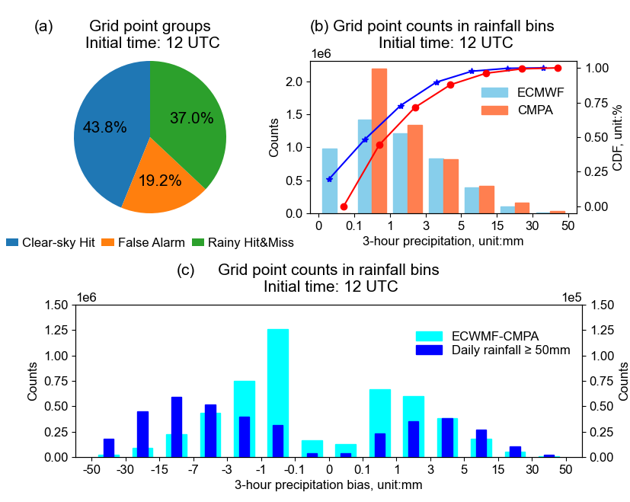
Supplementary Figure 1. Biases in ECMWF precipitation forecasts over the Yangtze River Delta (YRD). (a)-(c) Same as (b)-(d) in Figure 1, but for the results based on the ECMWF forecasts initialized at 12 UTC.

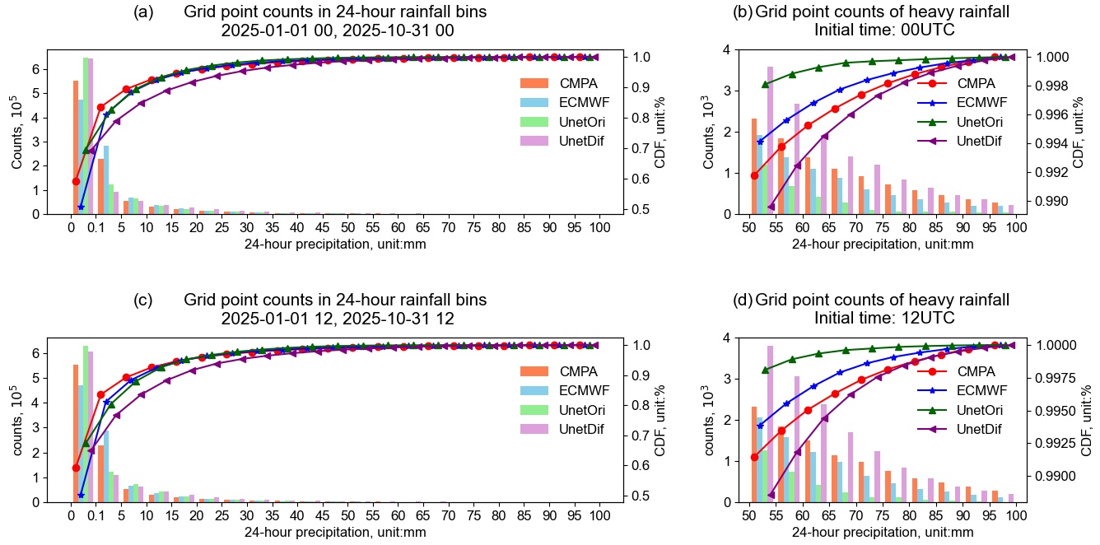
Supplementary Figure 2. Number of grid points and cumulative distribution functions in each precipitation intensity bin over the YRD region. (a) Daily precipitation forecasts initialized at 00 UTC with a 36-hour lead time. The number of grid points and the cumulative distribution function in each bin are represented by bar and marker, respectively. CMPA, ECMWF, UnetOri, and UnetDif are represented by orange, blue, green, and purple, respectively.
(b) Same as (a), but for the details of precipitation range from 50 to100 mm per day. (c), (d), Same as (a), (b), but for results initialized at 12 UTC.

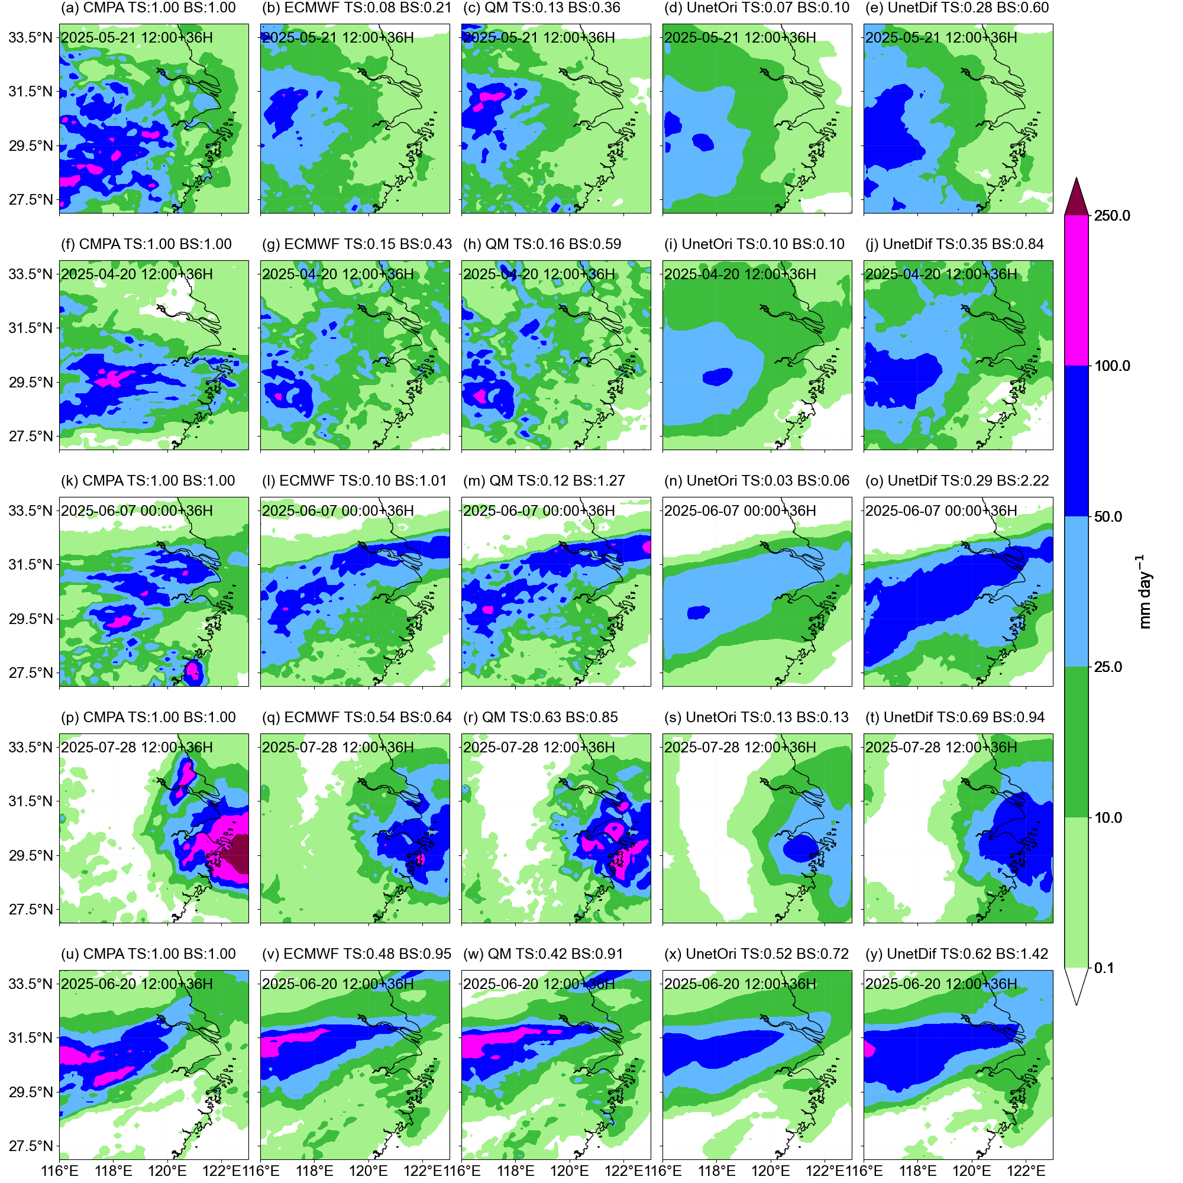
Supplementary Figure 3. Five heavy rainfall events over the YRD region with the largest TS improvement by UnetDif compared to ECMWF. Spatial distributions of 24-hour rainfall for forecasts initialized at 12 UTC on 21 May 2025 with a 36-hour lead time: (a) CMPA observations, (b) ECMWF raw forecasts, (c) quantile mapping, (d) UnetOri, and (e) UnetDif.
(f)-(j), (k)-(o), (p)-(t), (u)-(y), Same as (a)-(e), but for forecasts initialized at 12 UTC on 20 April 2025, 00 UTC on 7 June 2025, 12 UTC on 28 July 2025, and 12 UTC on 20 June 2025, respectively.

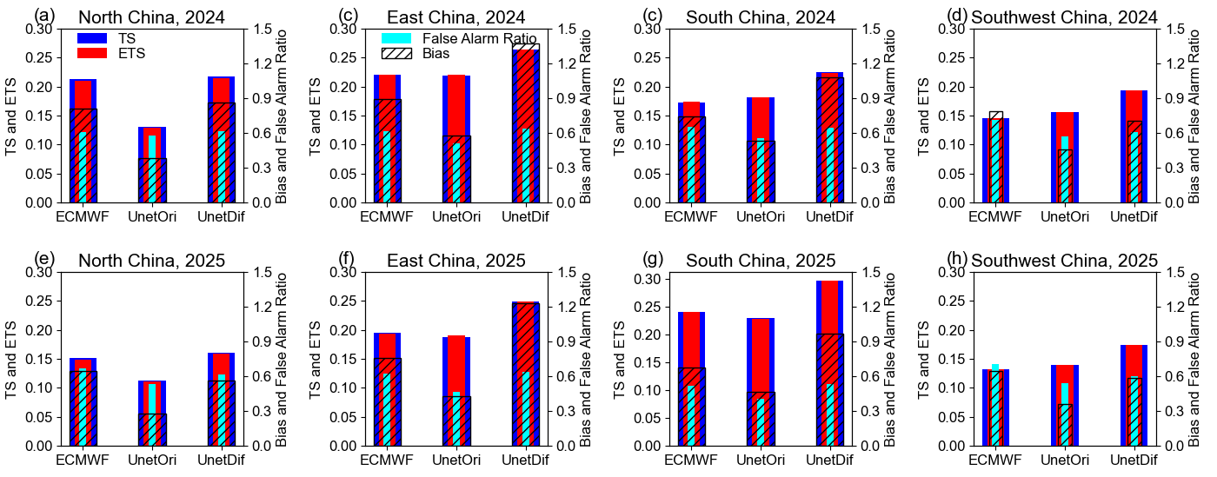
Supplementary Figure 4. Prediction skill of heavy rainfall over four regions of China at a 36-hour lead time. (a)-(d) Same as (b)-(e) in Figure 4, but for the evaluation of hindcast results from 1 January 2024 to 31 December 2024. (e)-(f) Same as (a)-(d), but for the hindcast results from 1 January 2025 to 31 October 2025.

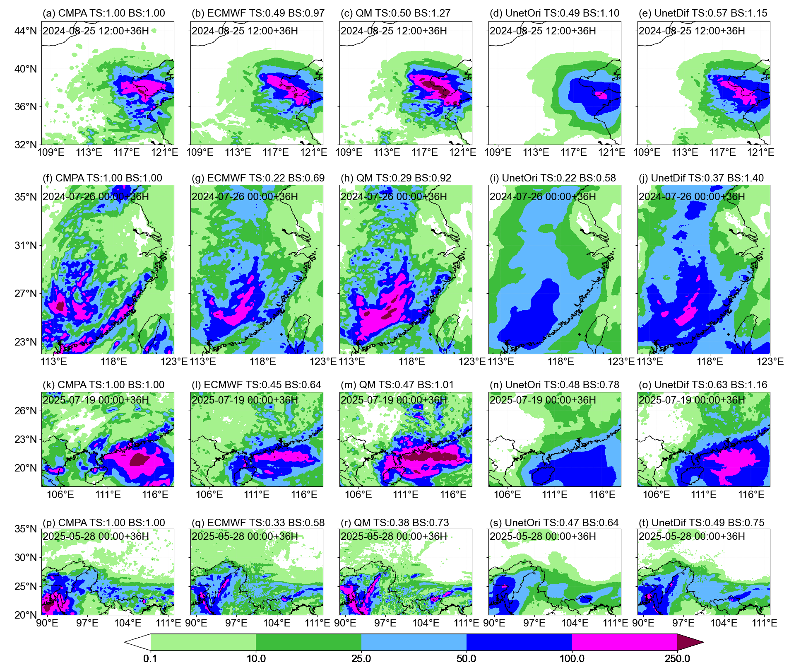
Supplementary Figure 5. Heavy rainfall event in each region with the largest UnetDif improvement relative to ECMWF forecasts. (a)-(e) Same as (a)-(e) in Supplementary Figure 3, but for the precipitation forecasts initialized at 12 UTC on 25 August 2024 over North China. (f)-(j), (k)-(o), (p)-(t) Same as (a)-(e), but for the precipitation forecasts initialized at 00 UTC on 26 July 2024 over East China, 00 UTC on 19 July 2025 over South China, 00 UTC on 28 May 2025 over Southwest China, respectively.

Supplementary Table 1. Five regions examined in this study and their corresponding training, validation and testing periods.
Region | Initial time  (HH) | Lead time  (3-hourly) | Sampling  period | Sample size | Testing  period
Yangtze River Delta | 00 | 15-36 | 1 Jan 2019-31 Dec 2024 | 8*575 | 1 Jan-31 Oct 2025
Yangtze River Delta | 00 | 27-48 | 1 Jan 2019-31 Dec 2024 | 8*503 | 1 Jan-31 Oct 2025
Yangtze River Delta | 00 | 39-60 | 1 Jan 2019-31 Dec 2024 | 8*542 | 1 Jan-31 Oct 2025
Yangtze River Delta | 12 | 15-36 | 1 Jan 2019-31 Dec 2024 | 8*503 | 1 Jan-31 Oct 2025
Yangtze River Delta | 12 | 27-48 | 1 Jan 2019-31 Dec 2024 | 8*549 | 1 Jan-31 Oct 2025
Yangtze River Delta | 12 | 39-60 | 1 Jan 2019-31 Dec 2024 | 8*500 | 1 Jan-31 Oct 2025
North China | 00 | 15-36 | 1 Jan 2019-31 Dec 2023 | 8×232 | 1 Jan 2024-31 Oct 2025
East China | 00 | 15-36 | 1 Jan 2019-31 Dec 2023 | 8×644 | 1 Jan 2024-31 Oct 2025
South China | 00 | 15-36 | 1 Jan 2019-31 Dec 2023 | 8×637 | 1 Jan 2024-31 Oct 2025
Southwest China | 00 | 15-36 | 1 Jan 2019-31 Dec 2023 | 8×709 | 1 Jan 2024-31 Oct 2025
North China | 12 | 15-36 | 1 Jan 2019-31 Dec 2023 | 8×210 | 1 Jan 2024-31 Oct 2025
East China | 12 | 15-36 | 1 Jan 2019-31 Dec 2023 | 8×612 | 1 Jan 2024-31 Oct 2025
South China | 12 | 15-36 | 1 Jan 2019-31 Dec 2023 | 8×626 | 1 Jan 2024-31 Oct 2025
Southwest China | 12 | 15-36 | 1 Jan 2019-31 Dec 2023 | 8×707 | 1 Jan 2024-31 Oct 2025

Supplementary Table 2. Variables used in the study.
Variable name | Unit | Level | resolution
relative humidity | Percent(%) | 500, 700, 850, 925hPa | 0.25×0.25
specific humidity | g kg⁻¹ | 500, 700, 850, 925hPa | 0.25×0.25
vertical velocity | Pa s⁻¹ | 500, 700, 850, 925hPa | 0.25×0.25
temperature | ℃ | 500, 700, 850, 925hPa | 0.25×0.25
u-wind component | m s⁻¹ | 500, 700, 850, 925hPa | 0.25×0.25
v-wind component | m s⁻¹ | 500, 700, 850, 925hPa | 0.25×0.25
potential vorticity | K m² kg⁻¹ s⁻¹ | 500, 700, 850, 925hPa | 0.25×0.25
geopotential height | gpm | 500, 700, 850, 925hPa | 0.25×0.25
total column water vapor | mm | Single Level | 0.125×0.125
total cloud cover | Percent(%) | Single Level | 0.125×0.125
low cloud cover | Percent(%) | Single Level | 0.125×0.125
large-scale precipitation | mm | Single Level | 0.125×0.125
convective precipitation | mm | Single Level | 0.125×0.125
precipitation | mm | Single Level | 0.125×0.125
topography height | m | Single Level | 0.05×0.05
CMPA | mm | Single Level | 0.05×0.05

Supplementary Table 3. Evaluation scores of different methods at various lead times and thresholds over Yangtze River Delta.
Lead Time | Model | ACC | Bias | TS  10 | Bias  10 | ETS  10 | TS  25 | Bias  25 | ETS  25 | TS  50 | Bias  50 | ETS  50 | FAR  50
36h | ECMWF | 0.774 | 1.213 | 0.427 | 1.078 | 0.426 | 0.314 | 0.883 | 0.310 | 0.194 | 0.702 | 0.189 | 0.606
 | QM | 0.809 | 0.932 | 0.399 | 0.939 | 0.398 | 0.292 | 0.917 | 0.288 | 0.195 | 0.993 | 0.189 | 0.672
 | UnetOri | 0.820 | 0.772 | 0.454 | 1.039 | 0.453 | 0.339 | 0.730 | 0.338 | 0.131 | 0.258 | 0.128 | 0.437
 | UnetDif | 0.817 | 0.809 | 0.445 | 1.463 | 0.445 | 0.333 | 1.497 | 0.331 | 0.237 | 1.23 | 0.230 | 0.653
48h | ECMWF | 0.766 | 1.204 | 0.406 | 1.106 | 0.407 | 0.295 | 0.951 | 0.290 | 0.176 | 0.774 | 0.170 | 0.657
 | QM | 0.801 | 0.929 | 0.381 | 0.970 | 0.379 | 0.280 | 0.998 | 0.274 | 0.178 | 1.095 | 0.171 | 0.711
 | UnetOri | 0.803 | 0.753 | 0.424 | 1.085 | 0.426 | 0.315 | 0.849 | 0.312 | 0.151 | 0.467 | 0.147 | 0.588
 | UnetDif | 0.809 | 0.827 | 0.423 | 1.461 | 0.422 | 0.314 | 1.427 | 0.313 | 0.213 | 1.191 | 0.206 | 0.677
60h | ECMWF | 0.760 | 1.206 | 0.381 | 1.113 | 0.382 | 0.277 | 0.962 | 0.272 | 0.151 | 0.805 | 0.145 | 0.701
 | QM | 0.794 | 0.929 | 0.362 | 1.001 | 0.363 | 0.266 | 1.041 | 0.273 | 0.164 | 1.149 | 0.157 | 0.736
 | UnetOri | 0.801 | 0.739 | 0.396 | 1.062 | 0.395 | 0.293 | 0.828 | 0.290 | 0.116 | 0.343 | 0.113 | 0.591
 | UnetDif | 0.803 | 0.782 | 0.401 | 1.477 | 0.400 | 0.298 | 1.548 | 0.295 | 0.196 | 1.327 | 0.189 | 0.711

Supplementary Table 4. TS of the top 20 heavy rainfall events ranked by number of heavy rainfall grid points at a 36-hour lead time over YRD.
Initial time  (YYYY-MM-DD HH) | Number of heavy rainfall grid points (CMPA) | ECMWF | QM | UnetOri | UnetDif | UnetDif-ECMWF
2025-05-30 12 | 752 | 0.334 | 0.305 | 0.301 | 0.406 | 0.072
2025-07-29 00 | 704 | 0.336 | 0.405 | 0.143 | 0.388 | 0.052
2025-06-19 00 | 649 | 0.647 | 0.639 | 0.653 | 0.622 | -0.025
2025-04-11 00 | 586 | 0.183 | 0.201 | 0 | 0.134 | -0.049
2025-05-21 12 | 564 | 0.079 | 0.132 | 0.074 | 0.284 | 0.205
2025-05-31 00 | 552 | 0.504 | 0.485 | 0.313 | 0.452 | -0.052
2025-06-14 12 | 534 | 0.327 | 0.392 | 0.048 | 0.346 | 0.019
2025-05-07 12 | 509 | 0.136 | 0.144 | 0.193 | 0.208 | 0.072
2025-06-19 12 | 501 | 0.610 | 0.608 | 0.048 | 0.738 | 0.128
2025-06-14 00 | 464 | 0.289 | 0.320 | 0.184 | 0.402 | 0.113
2025-07-28 12 | 458 | 0.537 | 0.627 | 0.133 | 0.685 | 0.148
2025-06-20 12 | 394 | 0.483 | 0.417 | 0.523 | 0.616 | 0.133
2025-07-29 12 | 390 | 0.498 | 0.406 | 0.499 | 0.408 | -0.09
2025-05-22 00 | 385 | 0.125 | 0.153 | 0.033 | 0.196 | 0.071
2026-06-06 12 | 353 | 0.355 | 0.346 | 0.078 | 0.408 | 0.053
2025-04-20 12 | 345 | 0.154 | 0.158 | 0.095 | 0.352 | 0.198
2025-06-07 00 | 341 | 0.098 | 0.123 | 0.025 | 0.290 | 0.192
2025-05-27 12 | 338 | 0.196 | 0.253 | 0.012 | 0.251 | 0.055
2025-04-10 12 | 334 | 0.176 | 0.189 | 0.006 | 0.177 | 0.001
2025-06-20 00 | 325 | 0.316 | 0.331 | 0.125 | 0.257 | -0.059

Supplementary Table 5. TS of the top 5 heavy rainfall events ranked by number of heavy rainfall grid points at a 36-hour lead time over four regions of China.
Region | Initial time  (YYYY-MM-DD HH) |  | heavy rainfall grid points (CMPA) | ECMWF | QM | UnetOri | UnetDif | UnetDif-ECMWF
North China |  | 2024-08-25 00 | 1311 | 0.598 | 0.571 | 0.599 | 0.602 | 0.004
 |  | 2025-06-18 12 | 1032 | 0.207 | 0.216 | 0.216 | 0.280 | 0.073
 |  | 2024-07-04 12 | 1029 | 0.421 | 0.453 | 0.443 | 0.486 | 0.065
 |  | 2025-08-26 12 | 1023 | 0.202 | 0.280 | 0.280 | 0.149 | -0.053
 |  | 2024-08-25 12 | 932 | 0.488 | 0.496 | 0.494 | 0.572 | 0.084
East China |  | 2024-07-25 00 | 1931 | 0.493 | 0.490 | 0.527 | 0.553 | 0.060
 |  | 2024-10-30 12 | 1780 | 0.553 | 0.483 | 0.525 | 0.585 | 0.032
 |  | 2024-07-26 00 | 1709 | 0.225 | 0.285 | 0.216 | 0.370 | 0.145
 |  | 2024-07-25 12 | 1685 | 0.364 | 0.412 | 0.408 | 0.477 | 0.113
 |  | 2024-07-24 12 | 1559 | 0.543 | 0.546 | 0.583 | 0.572 | 0.029
South China |  | 2025-07-19 12 | 2270 | 0.407 | 0.511 | 0.392 | 0.509 | 0.102
 |  | 2025-07-19 00 | 2178 | 0.447 | 0.468 | 0.475 | 0.633 | 0.186
 |  | 2025-07-20 12 | 1786 | 0.586 | 0.571 | 0.544 | 0.617 | 0.046
 |  | 2025-07-20 00 | 1784 | 0.521 | 0.580 | 0.568 | 0.482 | -0.039
 |  | 2024-09-06 00 | 1759 | 0.627 | 0.625 | 0.633 | 0.590 | -0.037
Southwest China |  | 2024-06-30 00 | 2854 | 0.349 | 0.334 | 0.289 | 0.312 | -0.037
 |  | 2024-06-30 12 | 2831 | 0.336 | 0.360 | 0.234 | 0.356 | 0.02
 |  | 2025-05-29 00 | 2722 | 0.469 | 0.508 | 0.333 | 0.543 | 0.074
 |  | 2025-05-28 00 | 2520 | 0.327 | 0.377 | 0.470 | 0.488 | 0.161
 |  | 2025-05-28 12 | 2481 | 0.521 | 0.533 | 0.459 | 0.619 | 0.098

