Supplement
Defining and Quantifying “opportunity resources” as impact metrics for optimized CSU care in Germany

Table S1. Values used for the creation of the transition matrix.
Parameter | Baseline | Intervention | Unit | Variable name in the code
Time Symptomatic -> Diagnosis | 104.3 | 104.3 | Weeks | 1/time_symptomatic_to_diagnosed
Probability to be diagnosed | 73% | 85% | % | p_diag
Time Diagnosis -> Treatment | 13 | 13 | Weeks | 1/time_diag_to_treatment
Probability to be treated | 64% | 73% | % | p_treatment
Time Treatment -> Outcome 1 | 8 | 5 | Weeks | 1/time_treatment_to_o1
Probability O1 Uncontrolled | 61% | 61% | % | p_o1_uncontrolled
Proportion Controlled in O1 Controlled + Symptom-free | 91% | 88% | % | proportion_controlled_outcome_1
Time Treatment Escalation 1 | 20 | 7 | Weeks | 1/time_escalation_1
Probability O2 ≠ Uncontrolled | 81% | 77% | % | p_escalation_1_to_outcome
Proportion Controlled in O2 Controlled + Symptom-free | 87% | 83% | % | proportion_controlled_outcome_2
Time Treatment Escalation 2 | 32 | 8 | Weeks | 1/time_escalation_2
Probability O3 = Symptom-free | 79% | 84% | % | p_escalation_2_to_outcome

The transition matrix was constructed as follows:
$$\left[\begin{matrix}X_{1} & 0 & t_{sym →diag}p_{diag} & t_{sym →diag}\left(1 - p_{diag}\right) & 0 & 0 & 0 & 0 & 0 \\ 0 & X_{2} & 0 & t_{diag →treat}p_{treat} & t_{diag →treat}\left(1 - p_{treat}\right) & 0 & 0 & 0 & 0 \\ 0 & 0 & X_{3} & 0 & 0 & 0 & 0 & 0 & 0 \\ 0 & 0 & 0 & X_{4} & 0 & t_{treat →o1}p_{o1≠unc} & t_{treat →o1}\left(1 - p_{o1 unc}\right)p_{o1 ctrl} & t_{treat →o1}\left(1 - p_{o1 unc}\right)\left(1 - p_{\left\{o1 ctrl\right)}\right) & 0 \\ 0 & 0 & 0 & 0 & X_{5} & 0 & 0 & 0 & 0 \\ 0 & 0 & 0 & 0 & 0 & X_{6} & t_{esc1}p_{esc1 →out}p_{o2 ctrl} & t_{esc1}p_{esc1 →out}\left(1 - p_{o2 ctrl}\right)+ t_{esc2}p_{esc2 →out} & t_{esc2}\left(1 - p_{esc2 →out}\right) \\ 0 & 0 & 0 & 0 & 0 & 0 & X_{7} & 0 & 0 \\ 0 & 0 & 0 & 0 & 0 & 0 & 0 & X_{8} & 0 \\ 0 & 0 & 0 & 0 & 0 & 0 & 0 & 0 & X_{9} \end{matrix}\right]$$
Where $X_{i}=1-\sum_{i≠j }{a_{ij}}$.

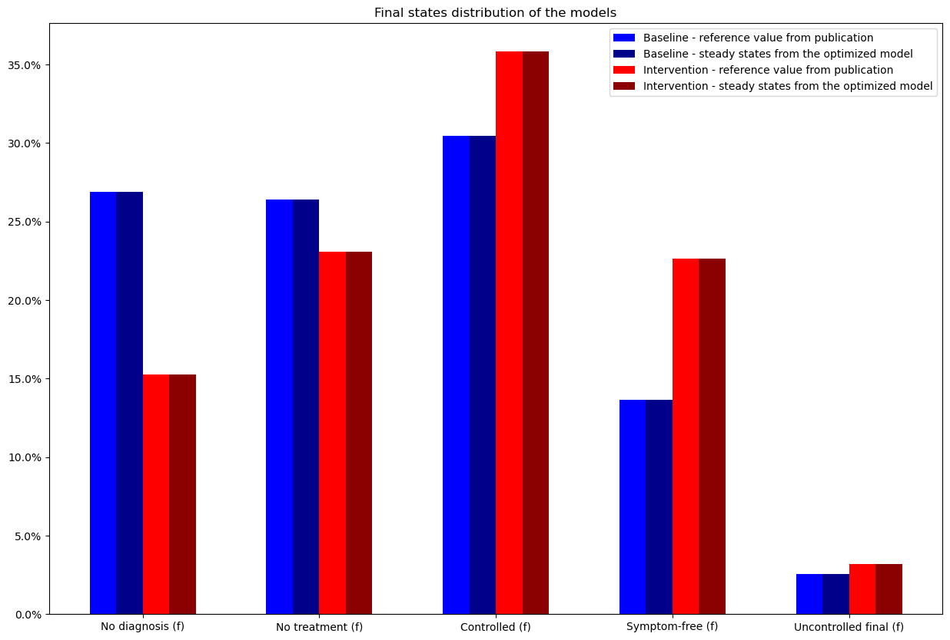
Figure S1: Finale states distribution of the models.
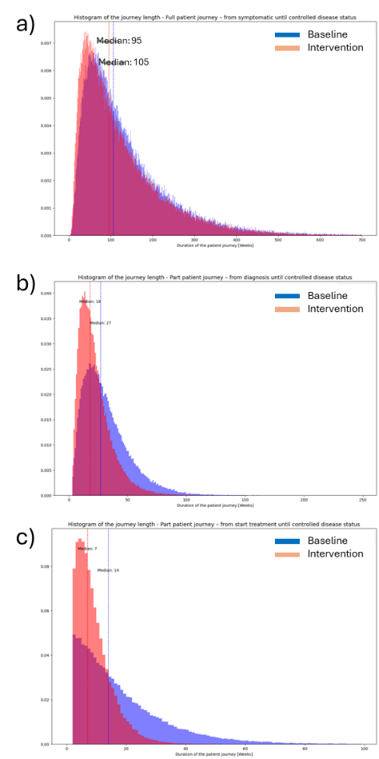
Figure S2: Histograms of patient journey time from a) symptomatic state, b) diagnosis and c) start of treatment to controlled disease state, showing the current state (blue) and after interventions (orange); purple indicates overlapping regions.

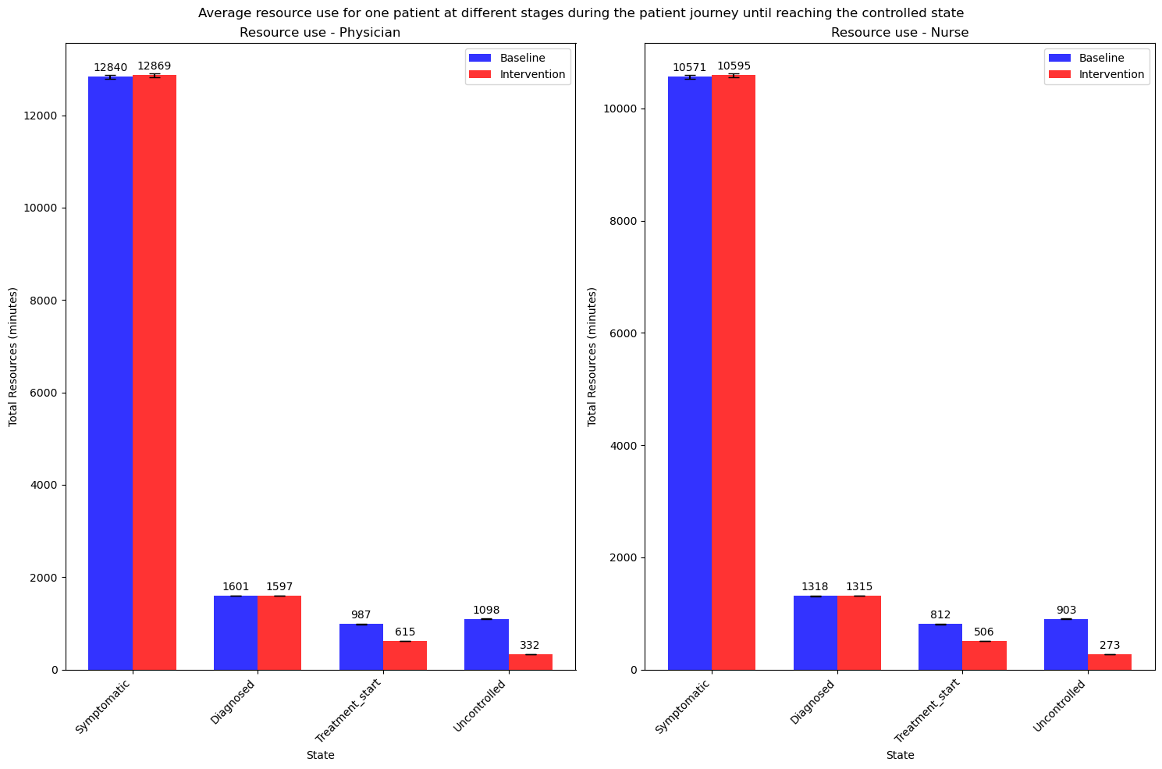
Figure S3: Annual resource utilisation (minutes) for one CSU patient in Germany, comparing the current state (blue) with projected values after interventions (red) for a) physicians and b) care personnel (e.g., nurses).

