Supplementary Figure 1. Subgroup Analysis of Diagnostic Performance for LVSD Detection in LBBB Patients.
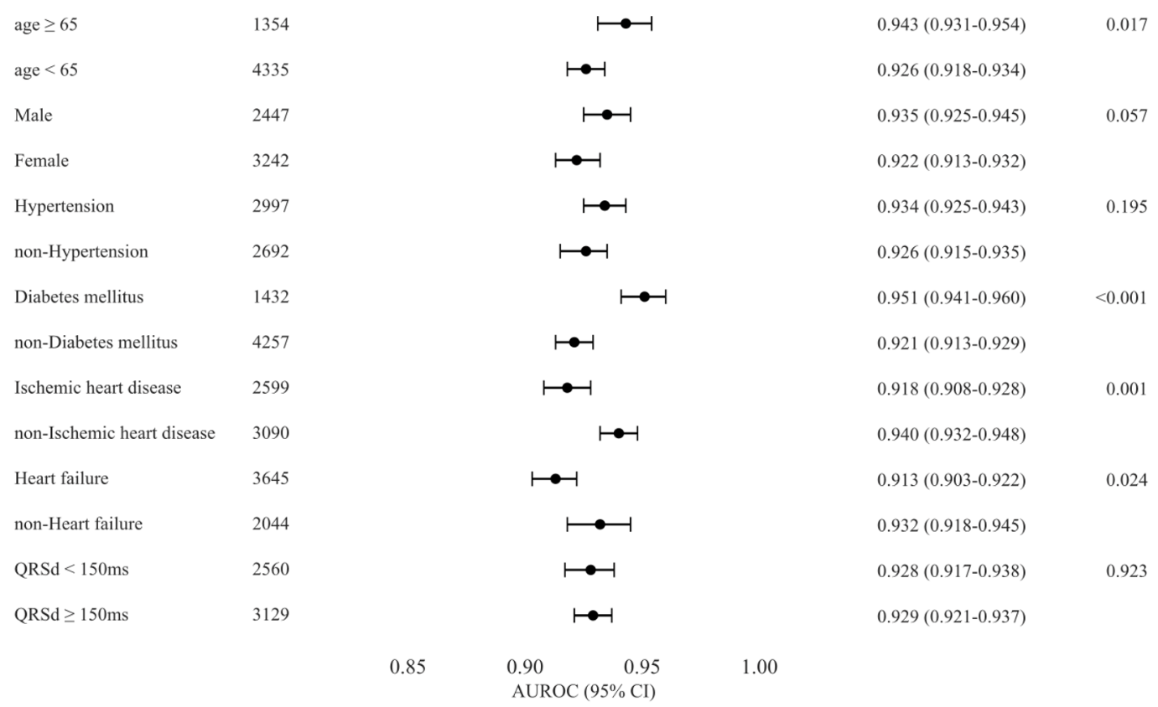
Diagnostic performance metrics across clinically relevant subgroups demonstrate consistent high performance with AUROC >0.91 in all categories.
LVSD, Left Ventricular Systolic Dysfunction; LBBB, Left Bundle Branch Block; AUROC, Area Under the Receiver Operating Characteristic curve.

Supplementary Table 1. Sensitivity analysis of the AiTiALVSD Model at Representative Cutoff Values.
Cutoff | Sensitivity | Specificity | PPV | NPV
20 | 0.949 | 0.679 | 0.699 | 0.944
30 | 0.907 | 0.788 | 0.771 | 0.915
40 | 0.856 | 0.862 | 0.830 | 0.884
50 | 0.791 | 0.909 | 0.873 | 0.846
60 | 0.680 | 0.952 | 0.918 | 0.791
70 | 0.569 | 0.975 | 0.948 | 0.742
80 | 0.445 | 0.987 | 0.965 | 0.693
90 | 0.263 | 0.994 | 0.973 | 0.632

Sensitivity, specificity, positive predictive value (PPV), and negative predictive value (NPV) are shown for each cutoff.
PPV, positive predictive value; NPV, negative predictive value.

Supplementary Table 2. Subgroup Analysis of Diagnostic Performance for LVSD Detection in LBBB Patients
AiTiALVSD | AUROC | AUPRC |  | Sensitivity |  | Specificity |  | PPV |  | NPV
AiTiALVSD | (95% CI) |  | (95% CI) |  | (95% CI) |  | (95% CI) |  | (95% CI) |  | (95% CI)
Age <65  (n=1354) | 0.943 |  | 0.93 |  | 0.993 |  | 0.477 |  | 0.591 |  | 0.989
Age <65  (n=1354) | (0.931–0.954) |  | (0.913–0.945) |  | (0.986–0.998) |  | (0.442–0.511) |  | (0.563–0.619) |  | (0.977–0.997)
Age ≥65  (n=4335) | 0.926 |  | 0.908 |  | 0.975 |  | 0.471 |  | 0.595 |  | 0.959
Age ≥65  (n=4335) | (0.918–0.934) |  | (0.893–0.921) |  | (0.967–0.982) |  | (0.453–0.491) |  | (0.578–0.611) |  | (0.948–0.971)
Male  (n=2447) | 0.935 |  | 0.94 |  | 0.982 |  | 0.422 |  | 0.663 |  | 0.954
Male  (n=2447) | (0.925–0.945) |  | (0.927–0.953) |  | (0.975–0.989) |  | (0.393–0.451) |  | (0.641–0.683) |  | (0.935–0.971)
Female  (n=3242) | 0.922 |  | 0.875 |  | 0.976 |  | 0.5 |  | 0.532 |  | 0.972
Female  (n=3242) | (0.913–0.932) |  | (0.858–0.893) |  | (0.967–0.984) |  | (0.477–0.519) |  | (0.511–0.552) |  | (0.962–0.981)
HTN  (n=2997) | 0.934 |  | 0.921 |  | 0.979 |  | 0.478 |  | 0.576 |  | 0.968
HTN  (n=2997) | (0.925–0.943) |  | (0.909–0.932) |  | (0.970–0.986) |  | (0.456–0.501) |  | (0.556–0.599) |  | (0.956–0.980)
Non-HTN  (n=2692) | 0.926 |  | 0.906 |  | 0.98 |  | 0.467 |  | 0.613 |  | 0.964
Non-HTN  (n=2692) | (0.915–0.935) |  | (0.887–0.923) |  | (0.972–0.987) |  | (0.442–0.494) |  | (0.592–0.634) |  | (0.950–0.978)
DM  (n=1432) | 0.951 |  | 0.958 |  | 0.996 |  | 0.438 |  | 0.682 |  | 0.990
DM  (n=1432) | (0.941–0.960) |  | (0.947–0.967) |  | (0.991–1.000) |  | (0.402–0.473) |  | (0.655–0.708) |  | (0.976–1.000)
Non-DM  (4257) | 0.921 |  | 0.89 |  | 0.972 |  | 0.481 |  | 0.56 |  | 0.961
Non-DM  (4257) | (0.913–0.929) |  | (0.875–0.904) |  | (0.964–0.979) |  | (0.463–0.501) |  | (0.541–0.579) |  | (0.950–0.972)
IHD  (n=2599) | 0.918 |  | 0.916 |  | 0.973 |  | 0.411 |  | 0.604 |  | 0.942
IHD  (n=2599) | (0.908–0.928) |  | (0.903–0.928) |  | (0.964–0.982) |  | (0.385–0.436) |  | (0.582–0.625) |  | (0.924–0.961)
Non-IHD  (n=3090) | 0.94 |  | 0.911 |  | 0.986 |  | 0.518 |  | 0.584 |  | 0.981
Non-IHD  (n=3090) | (0.932–0.948) |  | (0.893–0.925) |  | (0.979–0.992) |  | (0.496–0.541) |  | (0.563–0.605) |  | (0.973–0.989)
HF  (n=3645) | 0.913 |  | 0.928 |  | 0.983 |  | 0.386 |  | 0.684 |  | 0.943
HF  (n=3645) | (0.903–0.922) |  | (0.916–0.939) |  | (0.977–0.988) |  | (0.362–0.409) |  | (0.667–0.699) |  | (0.925–0.960)
Non-HF  (n=2044) | 0.932 |  | 0.826 |  | 0.961 |  | 0.554 |  | 0.351 |  | 0.983
Non-HF  (n=2044) | (0.918–0.945) |  | (0.790–0.855) |  | (0.941–0.978) |  | (0.531–0.577) |  | (0.323–0.378) |  | (0.974–0.990)
QRSd <150ms  (n=2560) | 0.928 |  | 0.878 |  | 0.967 |  | 0.547 |  | 0.537 |  | 0.968
QRSd <150ms  (n=2560) | (0.917–0.938) |  | (0.857–0.897) |  | (0.955–0.978) |  | (0.522–0.572) |  | (0.512–0.564) |  | (0.956–0.979)
QRSd ≥150ms  (n=3129) | 0.929 |  | 0.931 |  | 0.986 |  | 0.392 |  | 0.631 |  | 0.965
QRSd ≥150ms  (n=3129) | (0.921–0.937) |  | (0.919–0.943) |  | (0.980–0.992) |  | (0.367–0.418) |  | (0.612–0.649) |  | (0.949–0.979)

PPV, positive predictive value; NPV, negative predictive value; HGN, hypertension; DM, diabetes mellitus; IHD, ischemic heart disease; HF, heart failure.

