Table SI 1. Previous modelling works and results obtained on Olive pomace
Biomass | Technology type/conditions | Main findings | Method used | References
Olive stones impregnated by lead | - Perkin Elmer ther- mobalance model STA 6000  under heating rates of 5, 10 and 20 ◦C/min, from 200 ◦C (573 K) up to 800 ◦C (1073 K) | the thermal decomposition of hemicellulose and cellulose were shifted to higher temperatures in the presence of lead.  small increase in the values of activation energy was presented | - Flynn–Wall–Ozawa (FWO method)  - Kissinger–Akahira–Sunose (KAS method)  - Friedman (FR method) | (Martín-Lara et al. 2017)
olive pomace, olive tree pruning and olive kernels | - Pyrolysis tests of OWRs were carried out by  thermogravimetric analyzer TGA-701, Leco  - heated from ambient temperature to 1,023 K  - heating rates: 2, 5, 10, 15 K/min | The activation energy and pre-exponential factor obtained by Kissinger method were invariant for the whole pyrolysis experiment  Experimental results showed that the values of activation energy and pre-exponential factor are in good agreement | - Flynn–Wall–Ozawa (FWO method)  - Kissinger–Akahira–Sunose (KAS method)  - Friedman (FR method) | (Khalideh Al bkoor Alrawashdeh et al. 2017)
Olive Kernel (OK) undigested sewage sludge (SS) and municipal solid waste (MSW) | - Perkin Elmer thermogravimeter TGA/DTG  - heating rate thermal programs, i.e. 5, 10,20,30 and 40°C  TG/MS Analysis | the modified IPR model developed for the  kinetic evaluation and the deconvolution of DTG pyrolysis thermograms of all the examined raw samples, fitted the experimental results with great accuracy | - Independent Parallel Reaction model (IPR) | (Sfakiotakis and Vamvuka 2018)
Lignocellulosic forest residue (LFR) and olive oil residue (OOR) | - TA Instruments SDTQ600 model thermal analyzer from room temperature to 900 °C  - heating rate (5, 10, 20, and 50 °C/min)  MATLAB® R2014b software was used to develop network models | results showed that above α > 0.7, the ANN predicted data started to show deviations from the experimental data  the calculated activation en- ergies were still close to the experimental ones.  ANN can be an alternative and promising tool which allows adjustment flexibilit | - Artificial Neural Network (ANN)  - Flynn–Wall–Ozawa (FWO method)  - Kissinger–Akahira–Sunose (KAS method)  - Friedman (FR method) | (Çepelioğullar et al. 2018)
Olive mill solid waste and wastewater | - Rheometrix Scientific STA 1500 TGA analyser  - heating rates (2, 10, 20 and 50 °Cmin-1) between 25 and 900 °C | The values of activation energy of the OMSW and COMWW vary in different thermal degradation temperature ranges  the increase in heating rate, the decomposition process is Shifted to a higher temperature zone  activation energy obtained for the decomposition of hemicelluloses and cellulose derived | - Flynn–Wall–Ozawa (FWO method)  - Friedman (FR method)  - Vyazovkin | (Guida 2017)
Lignocellulosic biomasses: peach, plum and olive pits, marc, stalk and sawdust | - TGA -50 SHIMADZU  - Heating rate 5,10 and 15K/min  - Temperature between 302 and 1173K/min  - Atmosphere was inert for pyrolysis and 79%N2 and 21% of O2 for the combustion | he weight loss is not affected when the heating rate is varied  the activation energy was not linearly dependent on conversion for both studied thermal processes  The obtained results of both methods were similar  results are reliable and predict | - Flynn-Wall-Ozawa (FWO)  - DAEM | (Fernandez et al. 2018)
Olive pomace | - Thermogravimetric analysis at several heating rate (5, 15, 20, 25 and 30°C/min), 600°C and 2h hold time | Results showed that the activa- tion energy was not constant according to the conversion rates, due to the evolution of the biomass composition.  Syngas analyses indicate that CO and CO₂ were emitted throughout the whole pyrolysis reaction whereas C_{n}H_{m} low hydrocarbons were emitted at higher temperatures  Good properties of the biochar revealing its potential as amendment | - Kissinger–Akahira–Sunose (KAS method) | (Ghouma et al. 2017)
Olive tree prunning | - thermobalance Perkin Elmer, model STA 6000  - under nitrogen atmosphere  - heating rates (5, 10, 15, 20 and 25 °C/min)  - hold time: 60 min | Torrefaction of olive tree pruning could not be modeled by isoconversional kinetics for one-step global reaction  Pseudo-mechanistic model provided a good agreement with the experimental data; therefore, the kinetic parameters obtained could be used to predict olive tree pruning torrefaction. | - Flynn–Wall–Ozawa (FWO method)  - Kissinger–Akahira–Sunose (KAS method)  - Friedman (FR method) | (Martín-Lara et al. 2017)
olive tree pruning (PR) two- (2PH) and three-phase (3PH) olive pomace and their blends | - Leco TGA 701 thermal analysis system  - Heating rates (10, 15, 20 and 25 °C/ min) in the temperature range from 30 °C to 1000 °C. | With the increase of PR content in the blends, reactivity is improved, revealing non-additivity behaviour, especially for PR-2PH blends. The minimum apparent activation energy was obtained for 25PR752PH mixture, which was 77.8 kJ/mol by OFW and 82.2 kJ/mol by Vyazovkin | - Ozawa–Flynn–Wall (OFW)  - Vyazovkin | (Buratti et al. 2016)
Olive Pomace and Refuse derived fuel | - Thermogravimetric analysis at several heating rate (10, 20, and 30°C/min), 20-800°C and 2h hold time | The addition of RDF to olive pomace decreased the activation energy, decreased the peak temperatures, increased the number of pyrolysis stages (decomposition of plastics and inorganic carbonate based additives), and increased the time required for higher conversion rates. | - Coats and Redfern method | (Aydemir 2014)

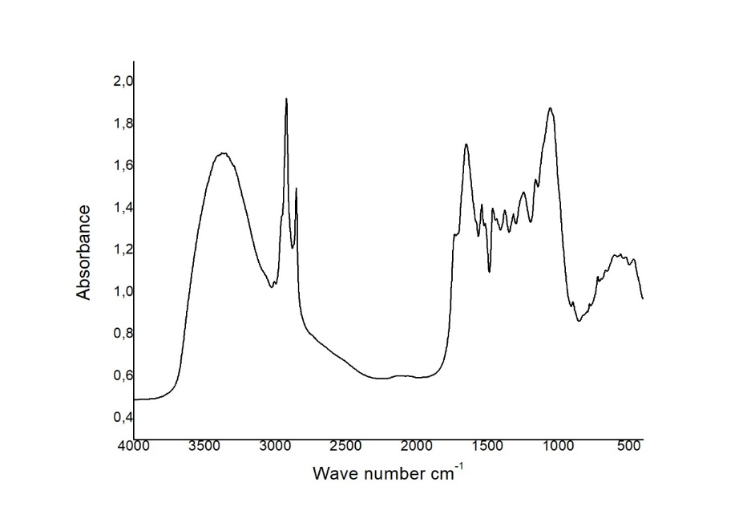
a
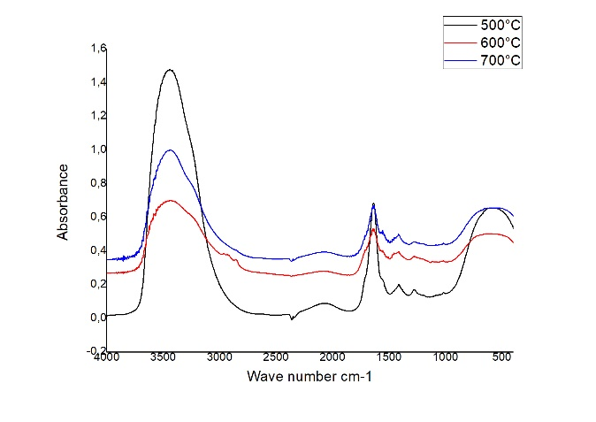  b | 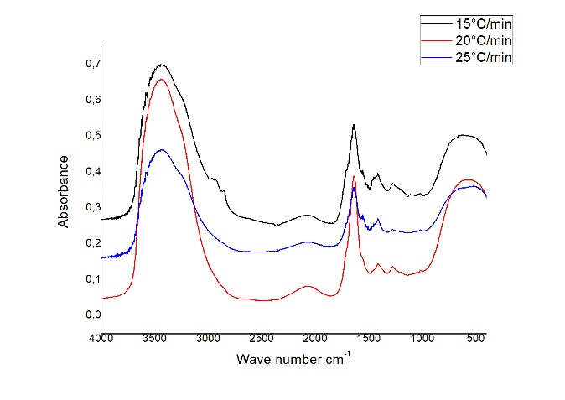
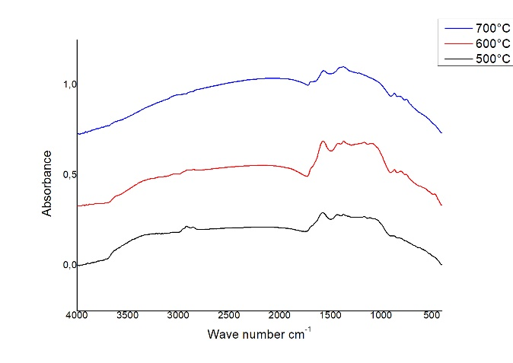  c | 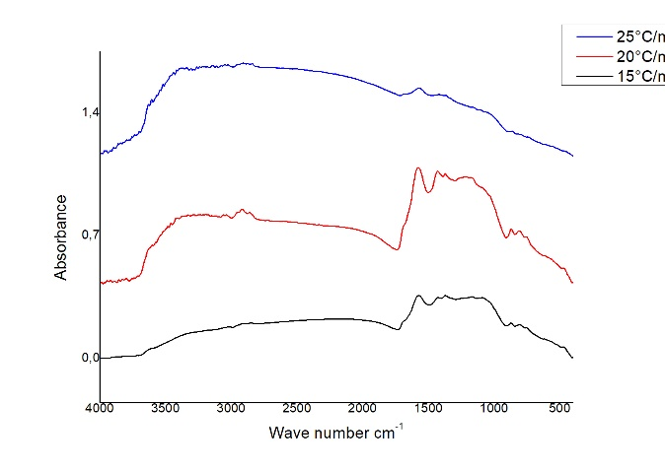
Figure SI 1 : OPW FTIR spectra of raw material (a) , pyrolytic oil (b) and biochar (c).

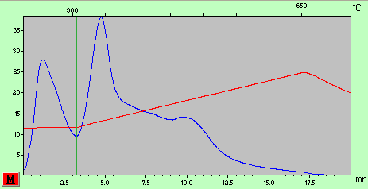
Figure SI 2 : OPW Rock eval pyrograms

Table SI 2. GC-MS results of POW pyrolytic oil obtained at 600 °C and 15 °C/min (peak areas. %)
Peak # | Ret Time | % | famille | formule
1 | 6.847 | 0.7 | Phenol. TMS derivative | C9H14OSi
2 | 8.436 | 0.3 | o-Cresol. TMS derivative | C10H16OSi
3 | 8.64 | 0.4 | p-Cresol. TMS derivative | C10H16OSi
4 | 8.842 | 0.4 | p-Cresol. TMS derivative | C10H16OSi
5 | 10.351 | 0.2 | 3.5-Dimethylphenol. TMS derivative | C11H18OSi
6 | 10.614 | 0.4 | nd | nd
7 | 11.492 | 0.6 | Phosphoric acid | C9H27O4PSi3
8 | 12.253 | 1.3 | Catechol. 2TMS derivative | C12H22O2Si2
9 | 13.645 | 0.6 | 4-Methylcatechol | C7H8O2
10 | 13.795 | 0.5 | p-Trimethylsiloxynitrobenzene | C9H13NO3Si
11 | 13.839 | 0.5 | 3-Methylcatechol | C7H8O2
12 | 14.747 | 0.3 | Decanoic acid. TMS derivative | C13H28O2Si
13 | 14.94 | 0.6 | nd | nd
14 | 16.507 | 0.3 | nd | nd
15 | 18.066 | 6.8 | Dodecanoic acid. TMS derivative | C15H32O2Si
16 | 21.063 | 3.7 | Myristic acid. TMS derivative | C17H36O2Si
17 | 21.79 | 1.3 | Palmitic acid | C16H31N
18 | 22.123 | 0.3 | Palmitic acid | C17H34O2
19 | 23.825 | 11.0 | Palmitic Acid. TMS derivative | C19H40O2Si
20 | 24.281 | 1.3 | Oleic acid nitrile | C18H33N
21 | 24.334 | 0.9 | Oleic acid nitrile | C18H33N
22 | 24.515 | 1.9 | 9-Octadecenoic acid (Z)-. methyl ester | C19H36O2
23 | 24.591 | 1.7 | Hexadecanenitrile | C16H31N
24 | 24.832 | 0.4 | Methyl stearate | C19H38O2
25 | 25.966 | 3.9 | 9.12-Octadecadienoic acid (Z.Z)-. TMS derivative | C21H40O2Si
26 | 26.079 | 33.9 | 9-Octadecenoic acid. (E)-. TMS derivative | C21H42O2Si
27 | 26.14 | 10.5 | Oleic Acid. (Z)-. TMS derivative | C21H42O2Si
28 | 26.348 | 7.7 | Stearic acid. TMS derivative | C21H44O2Si
29 | 27.069 | 0.7 | 9.12-Octadecadienoic acid (Z.Z)-. TMS derivative | C21H40O2Si
30 | 28.366 | 1.43177335 | oleoamide | C₁₈H₃₅NO
31 | 28.433 | 1.13856685 | nd | nd
32 | 28.658 | 1.13536311 | Arachidic acid. TMS derivative | C23H48O2Si
33 | 30.4 | 0.85719016 | 1-Monopalmitin. 2TMS derivative | C25H54O4Si2
34 | 30.814 | 0.45575842 | Behenic acid. TMS derivative | C25H52O2Si
35 | 32.165 | 0.42408483 | 1-Monooleoylglycerol. 2TMS derivative | C27H56O4Si2
36 | 32.396 | 1.09140811 | nd | nd
37 | 32.829 | 0.31986733 | Lignoceric acid. TMS derivative | C27H56O2Si

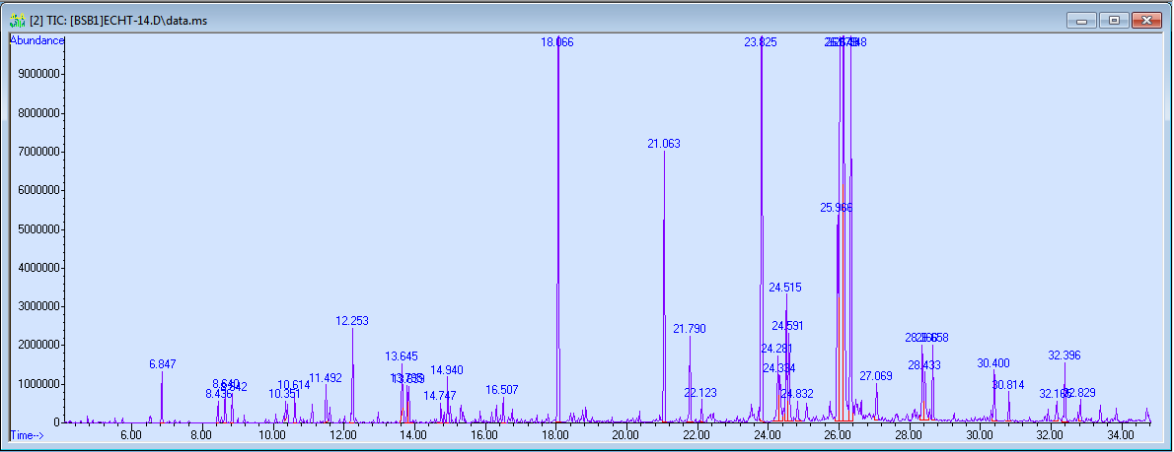
Figure SI 3 TIC of bio-oil produced at 600°C

