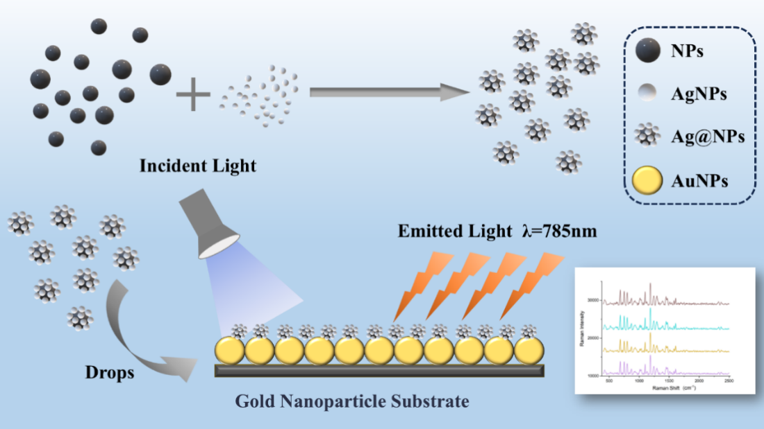
Scheme 1. The principle of NPs detection involves the addition of silver nanoparticles to the sample solution, which facilitates their adsorption onto the surface of NPs. This process enhances the Raman scattering signal, thereby enabling the identification and characterization of NPs via Surface-Enhanced Raman Spectroscopy (SERS).

