From Encounters to Memory: Molecular Mechanisms of Interspecific Individual Recognition in L. dimidiatus
Daniele Romeo¹; Celia Schunter^{1,2}
¹Swire Institute of Marine Science, School of Biological Sciences, The University of Hong Kong, Pokfulam Rd, Hong Kong SAR
²State Key Laboratory of Marine Pollution, City University of Hong Kong, Hong Kong, Hong Kong SAR, China

Supplementary Figures
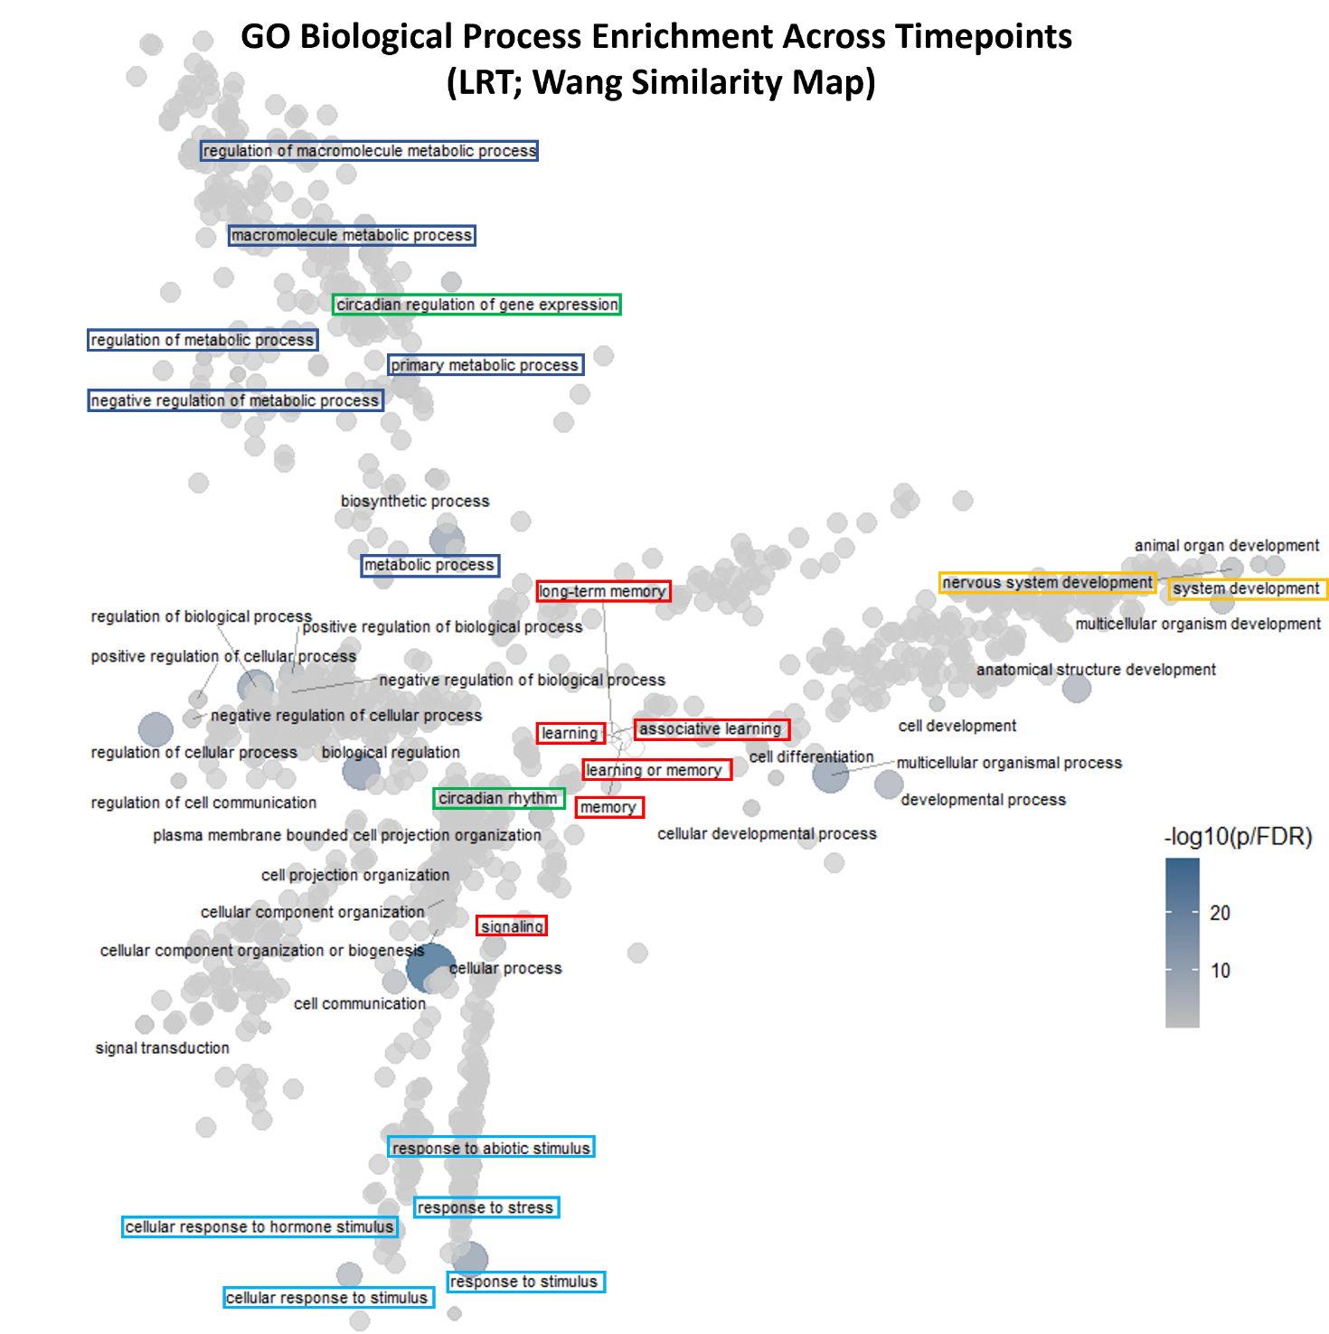
Supp. figure 1) Semantic map of GO Biological Process enrichment across timepoints (LRT). Pairwise GO term similarity was computed with the Wang measure and embedded in 2D using classical MDS (multidimensional scaling); thus, points that are closer are more semantically similar, while the axes have no inherent meaning (only relative distances matter). Point size reflects term size (Count), color scale shows −log10(p/FDR). Colored label boxes mark thematic groups: red = learning & memory, green = circadian rhythm, dark blue = metabolism, light blue = responses to stimulus/stress, and yellow = nervous system development.

