Supplementary materials for

Size-dependent performance and adaptive mechanisms of anammox granular sludge under fluctuating low-temperature conditions

S1: EPS extraction and 3D-EEM analysis
The soluble EPS (S-EPS), loosely-bound EPS (LB-EPS) and tightly-bound EPS (LB-EPS) were analyzed based on the method provided by Zhang et al. (2024). The specific steps were presented as fellows: taking 15mL of sludge and putting it into a 50mL centrifuge tube for extraction by high-speed centrifugation. (1) Centrifugation was set at 6000rpm for 10min, and the test tube was taken out and the supernatant was absorbed to obtain S-EPS. (2) LB-EPS was obtained by mixing 0.5% NaCl solution with water bath at 60℃ for 1min to the same volume, centrifugation at 6000rpm for 10min and taking out the test tube and absorbing the supernatant. (3) Add 0.5% NaCl solution to the same volume, then put it in a water bath at 80° for 45min, then centrifuge it at 15000rpm for 20min to obtain the supernatant TB-EPS. The contents of protein (PN) and polysaccharides (PS) of S-EPS, LB-EPS and TB-EPS were determined by improved Lowry Folin method (Frølund et al., 1995) and Anthrone Method (Loewus, 1952). In this study, three-dimensional excitation-emission matrix (3D-EEM) analysis was performed for the extracted S-EPS, LB-EPS and TB-EPS. The detail determination method was same to Zhang et al. (2024).
References
Loewus, F.A., 1952. Improvement in anthrone method for determination of carbohydrates. Anal. Chem. 24, 219.
Frølund,, B., Griebe, T., Nielsen, P.H., 1995. Enzymatic activity in the activated-sludge floc matrix. Appl. Microbiol. Biotechnol. 43, 755-761.
Zhang, S., Lai, L.Y., Wang, T.X., Jin, W.L., Yi, R.R., Chen, D.Z., Jin, R.C., Yang, G.F., 2024. Response of anammox to organics with different degradation characteristics and exposure time: Performance, sludge characteristics and bacterial community. Sci. Total Environ. 951, 175650.
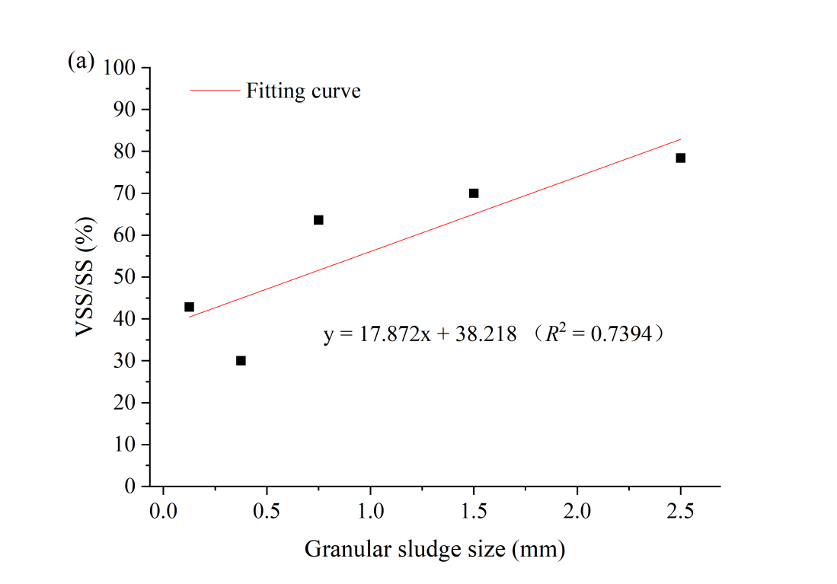
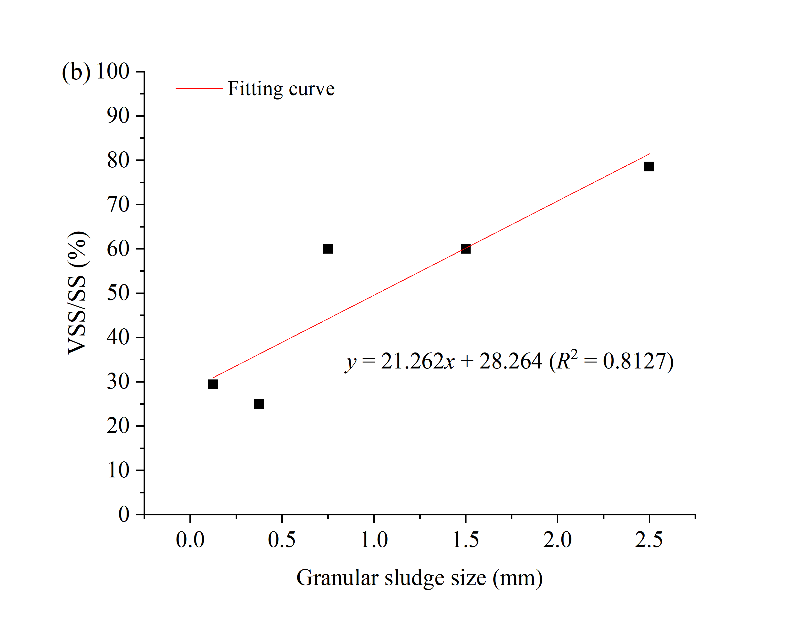
Fig. S1 The fitting curves of VSS/SS and granular sludge size in both reactors: (a) R₁, and (b) R₂

S2: 3D-EEM analysis
While no characteristic peaks were detected in S-EPS or LB-EPS, and TB-EPS exhibited multiple fluorescence peaks across all samples: Tyrosine-like proteins (Peaks A/D/J: 270-280/300-320 nm; 270-280/305-310 nm), Tryptophan-like proteins (Peaks B/E/K/G: 270-280/340-360 nm; 270-280/340-350 nm), Aromatic proteins (Peaks C/F/H/L: 220-230/310-350 nm; 220-230/340-350 nm), and Fulvic acid (Peak I: 230-250/470-490 nm) (Chen et al., 2003; Xu et al., 2022). Three dominant protein-like (PN) peaks were consistently observed in both suspended and settled sludge, aligning with the typical 2-6 peak range reported for anammox systems (Liu et al., 2018). Notably, granular sludge >0.5 mm showed significantly higher PN content than smaller fractions, suggesting particle size-dependent EPS composition (section 3.4.4).

(a)
(b)
(d)
(c)
Fig. S2 3D-EEM spectra of TB-EPS in suspended and settled sludge from reactors R₁ and R₂: (a) suspended sludge in R₁, (b) settled sludge of R₁, (c) suspended sludge in R₂, (d) settled sludge of R₂.
(a)
(b)
(c)
(d)
(f)
(e)
(h)
(g)
(j)
(i)
Fig. S3 3D-EEM of TB-EPS of sludge with different particle sizes in reactors R₁ and R₂: (a) R₁ >2mm, (b) R₁ 1-2mm, (c) R₁ 0.5-1mm, (d) R₁ 0.25-0.5mm, (e) R₁ < 0.25mm, (f) R₂ >2mm, (g) R₂ 1-2mm, (h) R₂ 0.5-1mm, (i) R₂ 0.25-0.5mm, (j) R₂ < 0.25mm.

Table S1 Alpha diversity of different anammox granular sludge samples
Sample | Gene number | Shannon | Simpson
R1-Ⅰ | 1009213 | 11.473675 | 0.000055
R1-Ⅱ | 1017917 | 11.742368 | 0.000054
R1-Ⅲ | 1040385 | 11.746531 | 0.000043
R1-Ⅳ | 939352 | 11.517908 | 0.000052
R2-Ⅰ | 950792 | 11.384139 | 0.000059
R2-Ⅱ | 961355 | 11.304182 | 0.000077
R2-Ⅲ | 1004534 | 11.470334 | 0.000061
R2-Ⅳ | 1090160 | 11.740349 | 0.000050
R₁ >2mm | 971068 | 11.307367 | 0.000081
R₁ 1-2mm | 1057481 | 11.793009 | 0.000042
R₁ 0.5-1mm | 1013926 | 11.285253 | 0.000096
R₁ 0.25-0.5mm | 1452545 | 12.36878 | 0.000028
R₁ <0.25mm | 1415618 | 12.619993 | 0.000013
R₂ >2mm | 1093614 | 11.472393 | 0.000063
R₂ 1-2mm | 1096514 | 11.685085 | 0.000048
R₂ 0.5-1mm | 1277295 | 12.003093 | 0.000042
R₂ 0.25-0.5mm | 1400492 | 12.576363 | 0.000017
R₂ <0.25mm | 1291254 | 12.64745 | 0.000013
Table S2 Relative abundance of AnAOB species (unit: %)
Samples | Candidatus_Brocadia_fulgida | Candidatus_Brocadia_sinica | Candidatus_Jettenia_caeni | Candidatus_Kuenenia_stuttgartiensis
R1-I | 5.74 | 4.91 | 18.77 | 4.15
R1-II | 4.28 | 4.03 | 15.38 | 2.80
R1-III | 5.83 | 4.66 | 12.51 | 3.35
R1-IV | 9.36 | 6.64 | 14.31 | 3.77
R1 <0.25mm | 2.89 | 2.17 | 1.79 | 4.80
R1 0.25-0.5mm | 7.55 | 4.81 | 2.54 | 4.94
R1 0.5-1mm | 15.89 | 9.61 | 5.59 | 6.48
R1 1-2mm | 9.25 | 6.13 | 8.38 | 3.99
R1 >2mm | 5.76 | 5.39 | 23.70 | 2.64
R2-I | 8.94 | 6.58 | 17.70 | 4.10
R2-II | 3.84 | 4.41 | 23.73 | 4.82
R2-III | 8.57 | 6.53 | 16.13 | 6.57
R2-IV | 6.45 | 5.19 | 16.08 | 3.35
R2 <0.25mm | 1.56 | 1.47 | 1.01 | 5.14
R2 0.25-0.5mm | 4.97 | 3.34 | 1.74 | 4.64
R2 0.5-1mm | 9.16 | 5.89 | 4.76 | 4.94
R2 1-2mm | 7.66 | 5.77 | 12.98 | 6.32
R2 >2mm | 8.14 | 6.38 | 18.08 | 4.73
Table S3 Relative abundance of nitrogen removal related genes in granular sludge with different sizes (unit: %)
Sludge size | ＞2mm |  | 1-2mm |  | 0.5-1mm |  | 0.25-0.5mm |  | <0.25mm
 | R₁ | R₂ | R₁ | R₂ | R₁ | R₂ | R₁ | R₂ | R₁ | R₂
HOX | 4.63 | 4.65 | 5.13 | 4.85 | 4.69 | 4.82 | 5.15 | 4.87 | 5.12 | 5.15
nirK | 2.04 | 1.75 | 0.97 | 1.40 | 0.82 | 0.85 | 0.77 | 0.70 | 0.94 | 0.78
nirS | 1.06 | 1.07 | 1.39 | 1.30 | 0.92 | 1.09 | 1.28 | 1.20 | 1.52 | 1.45
nirB | 1.39 | 1.07 | 0.85 | 0.89 | 0.45 | 0.40 | 0.42 | 0.38 | 0.49 | 0.54
hzs | 2.67 | 4.46 | 5.71 | 4.96 | 7.53 | 6.61 | 4.27 | 3.54 | 1.62 | 1.14
hdh | 0.41 | 0.41 | 0.60 | 0.60 | 0.57 | 0.77 | 0.91 | 0.88 | 0.97 | 0.99
hao | 5.61 | 5.43 | 4.28 | 4.81 | 4.67 | 3.67 | 2.68 | 2.03 | 1.45 | 1.10
nxrA | 8.13 | 7.51 | 5.78 | 6.43 | 5.96 | 5.00 | 5.10 | 4.24 | 4.96 | 4.14
nxrB | 2.66 | 2.42 | 2.72 | 2.64 | 2.85 | 2.60 | 3.07 | 2.65 | 3.14 | 2.91
amo | 0.07 | 0.04 | 0.31 | 0.06 | 0.84 | 0.24 | 0.49 | 0.29 | 0.32 | 0.29
narG | 2.82 | 4.63 | 5.93 | 5.14 | 7.62 | 6.76 | 4.40 | 3.69 | 1.79 | 1.33
nasA | 2.98 | 4.80 | 6.16 | 5.32 | 7.71 | 6.91 | 4.53 | 3.83 | 1.96 | 1.52
nrfA | 3.07 | 3.03 | 2.44 | 2.71 | 2.42 | 2.35 | 1.87 | 1.66 | 1.57 | 1.39
nirA | 0.03 | 0.02 | 0.03 | 0.03 | 0.02 | 0.04 | 0.04 | 0.05 | 0.05 | 0.05
nosZ | 0.14 | 0.14 | 0.18 | 0.16 | 0.14 | 0.16 | 0.27 | 0.23 | 0.26 | 0.33
norB | 0.88 | 0.95 | 1.09 | 1.03 | 0.89 | 1.20 | 1.29 | 1.30 | 1.33 | 1.24
Table S4 Relative abundance of nitrogen removal related genes at different operational stages in both anammox reactors (unit: %)
Stage | Ⅰ |  | Ⅱ |  | Ⅲ |  | Ⅳ
 | R₁ | R₂ | R₁ | R₂ | R₁ | R₂ | R₁ | R₂
HOX | 4.92 | 4.79 | 5.18 | 5.05 | 5.11 | 4.82 | 4.64 | 5.00
nirK | 1.75 | 1.65 | 1.83 | 2.16 | 1.67 | 1.68 | 1.43 | 1.67
nirS | 1.06 | 0.83 | 1.55 | 1.39 | 1.43 | 1.19 | 1.00 | 1.22
nirB | 1.10 | 0.97 | 1.05 | 1.51 | 0.91 | 1.08 | 0.92 | 1.01
hzs | 1.93 | 2.56 | 2.82 | 1.49 | 3.45 | 4.00 | 4.20 | 4.50
hdh | 0.51 | 0.50 | 0.61 | 0.48 | 0.55 | 0.54 | 0.44 | 0.57
hao | 3.96 | 4.01 | 4.54 | 4.83 | 4.34 | 5.30 | 4.69 | 4.93
nxrA | 7.27 | 7.21 | 7.13 | 7.61 | 6.53 | 7.19 | 7.05 | 7.02
nxrB | 2.88 | 3.07 | 2.51 | 2.69 | 2.50 | 2.69 | 2.89 | 2.54
amo | 0.06 | 0.07 | 0.19 | 0.04 | 0.21 | 0.08 | 0.05 | 0.02
narG | 2.10 | 2.68 | 3.06 | 1.71 | 3.70 | 4.16 | 4.38 | 4.71
nasA | 2.27 | 2.81 | 3.30 | 1.93 | 3.95 | 4.32 | 4.56 | 4.92
nrfA | 2.62 | 2.58 | 2.75 | 2.76 | 2.65 | 2.74 | 2.73 | 2.83
nirA | 0.02 | 0.02 | 0.03 | 0.02 | 0.04 | 0.03 | 0.03 | 0.02
nosZ | 0.13 | 0.15 | 0.17 | 0.16 | 0.15 | 0.16 | 0.17 | 0.22
norB | 0.88 | 0.75 | 1.16 | 0.81 | 1.06 | 0.86 | 0.85 | 1.08

